

Student name: Nuro Aligas
Student ID:2131283
Module name: BMHP6020
Module code: Methodology Poster
Supervisor’s name: Konstantina Mari

Use of Al Acknowledgement:

“I confirm that I have not used any Al tools in the research and creation of this assignment. I confirm that I have not presented any Al generated materials as my own work. I confirm I have copies of my drafts, notes, and other resources I used, which I may be asked to provide in evidence”

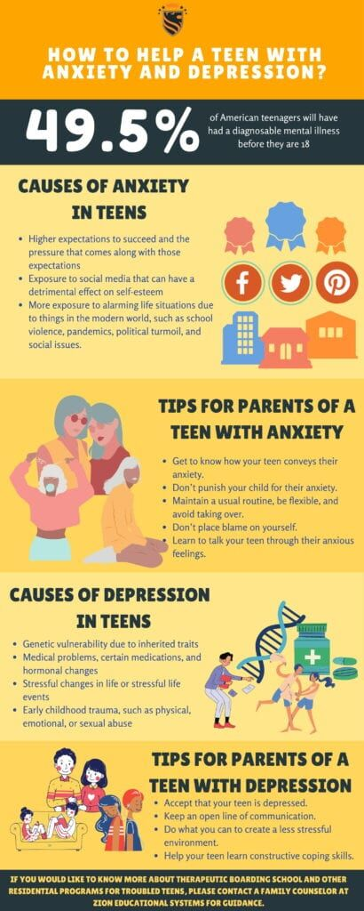  Source: https://www.zioneducationalsystems.com/how-to-help-a-teen-with-anxiety-and-depression/  Methodology and methods:  - The research is conducted with qualitative data from secondary resources (Mishra and Alok, 2022, p.30).  - Systematic literature review exploring the societal perception on mental illness and obesity (Kirongo and Odoyo, 2020, p.33).  - Systematic literature review considering 10 peer reviewed journal articles. |  | How to prevent depressions and anxiety in teenagers with obesity in the United Kingdom  Aim of your project: The aim of the research study will be to identify and evaluate effective ways to prevent depression and anxiety among the teenagers with obesity in the UK.  Objectives:  - To identify the factors related to the prevalence of obesity among the teenagers in the UK.  - To evaluate the adverse impacts of depression and anxiety among the teenagers with obesity in the UK.  - To analyse the effective ways to prevent depression and anxiety in teenagers with obesity in the UK.  - To recommend suitable strategies through which the teenagers in the UK can overcome anxiety and depression related to obesity. |  | 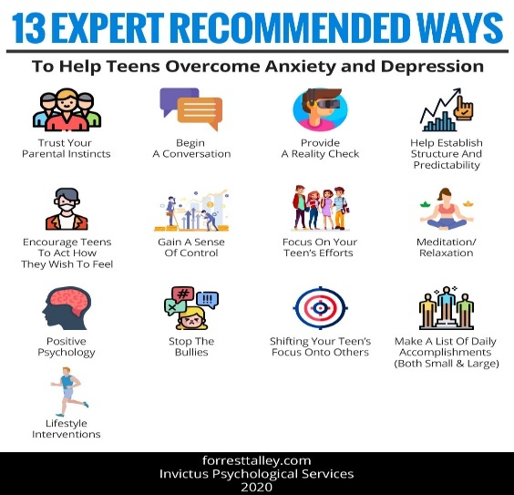  Source: https://forresttalley.com/blog-anxiety-depression-trauma-ptsd-positivepsychology/depressed-amp-anxious-teens-experts-give-parents-practical-advice-on-how-to-help  Exclusions criteria:  - Non-peer-reviewed articles  - Secondary research studies  - Research on non-UK populations  - Non-English Language  - Published before 2016
Data collection method:  Data base:  - Google scholar is one of the effective databases considered in the data collection.  - UWTSD library is a significant resource to accumulate data with relevant information.  Keywords:  - The researcher considered keywords “anxiety”, “obesity”, “teenagers”, “depression”, “prevent”, “UK” and “ways” to access suitable journals and articles.  Inclusions criteria:  - Peer-reviewed journal articles  - Primary research studies  - Studies on UK population  - English language  - Published between 2016-2025 |  |  |  | Ethical consideration  - The research study considered the ethical dimension and kept the data in the secured format.  - The researcher followed GDPR act 2018.  - The information is not manipulated by any means and solely the secondary sources are utilised for the academic purpose.  - Maintained academic integrity by acknowledging the contribution of sources with proper citation and referencing.
Data Analysis:
- The research focuses on secondary qualitative methods with thematic analysis.
- Thematic analysis demonstrates the development of key patterns regarding the findings from qualitative data for considering research results (Christou, 2022, p.80).
- Thematic analysis is the base of qualitative research offering a flexible and accessible process to analyse, recognise and report parameters with respect to qualitative data ( Mattimoe et al., 2022, p.5).
- The 10 secondary resources are collected and critically analysed under 4 themes generated in relation to adverse impact, prevalence, preventive inventions and actions for anxiety and depression within teenagers suffering from obesity in the UK.

References
Christou, P. A., (2022). How to use thematic analysis in qualitative research. Journal of Qualitative Research in Tourism, 3(2), 79-95.
Kirongo, A., and Odoyo, C., (2020). Research philosophy design and methodologies: A systematic review of research paradigms in information technology. Global Scientific Journals, 8(5), 33–38.
Mattimoe, R., Hayden, M., Murphy, B., and Ballantine, J., (2021). Approaches to analysis of qualitative research data: A reflection on the manual and technological approaches. Accounting, Finance & Governance Review, 27(1), 1-16.
Mishra, S. B., and Alok, S., (2022). Handbook of research methodology. Educreation publishing.
Mukumbang, F. C., Kabongo, E. M., and Eastwood, J. G., (2021). Examining the application of retroductive theorizing in realist-informed studies. International Journal of Qualitative Methods, 20, 16094069211053516.

