Student Self-Evaluation

Module | World Building

This document helps facilitate the assessment of the module listed above.

Please evaluate your project or projects under each heading using the guidelines provided. Add visuals as necessary to support your evaluation. Consider each section in relation to your submitted website/social media outcomes, and your process and engagement with the timetabled sessions.

Name | Seren Davies

Website Link | https://snrenephotography.wixsite.com/seren-davies

Part One: Engagement with Literature Skills (10%)

Artist, Website and Social Media Research

Include at least 3 artist websites. Discuss and evaluate in relation to how successfully they communicate the artists’ work and what you can take and learn from in relation to your own web presence.
Choose the same or different artists and discuss how they use social media to brand their work.
Consider structure (style, clarity, pattern etc.), content (image, text, multimedia etc.), navigation, responsiveness (across computer, phone, tablet etc.) and statement.

Use visuals and include links to the sites discussed.
Response:

Mark Griffiths’ website presents his work in a clear and professional way. The layout is a clean design, and it makes it easy to view the work without any distractions. The website itself is easy to navigate which helps the viewer to find what they are looking for easily.
Whereas Olivia Bee’s website presents her work in a more creative and expressive way. Just like Griffiths’ website Bee’s website also has a clean layout and is also easy to navigate.
Griffiths’ website shows how to display work in a clear and professional way, while Bee’s website shows how to show creativity and your own personal style.

https://www.markgriffithsphotography.com/home

http://www.oliviabee.com

Mark Griffiths and Olivia Bee both use social media to show their work.
Griffiths uses social media in a professional and consistent way to support his photography. On his social media he shares his images but also posts updates about projects.
His social media shows how professional he is, and it helps the viewers to understand what type of work he does.
Olivia Bee uses her social media in a more personal and expressive way just like her website. She shares her images on her social media that reflect her creative style and moments of her life which help the viewers to feel more connected to her work.
Their websites aren’t that much different from computer to mobile the layouts are still the same but with Bee’s website on mobile the only difference is instead of the bar the the top of the screen with all the different things to select there is only three lines in the corner of the screen where they come up to be able to find what you need.
Overall, Mark Griffiths and Olivia Bee

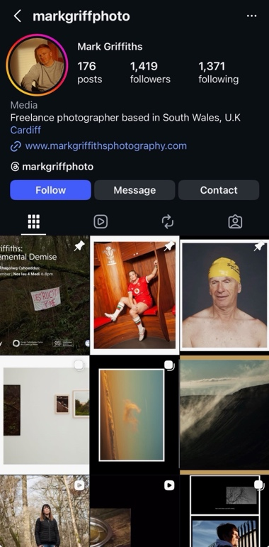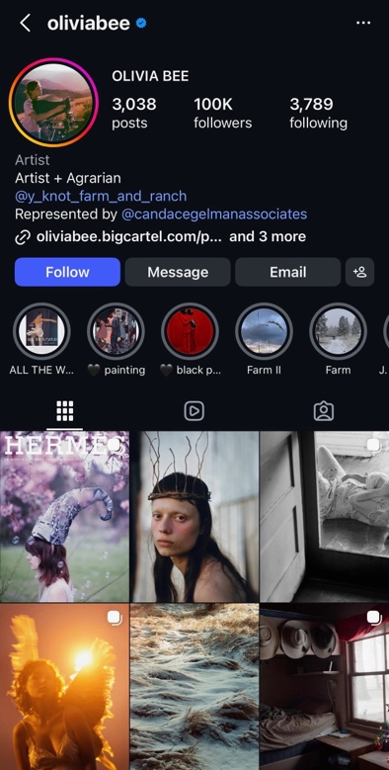

Part Two: Knowledge and Understanding Skills (20%)
Applied Skills
In this section, students should discuss and evaluate the application of existing and newly acquired skills, and knowledge to their outcomes.
How have you ensured consistency of design on your site; how have you linked your social media exposure to your more personalised web ‘voice’?
Approx. 200-300 words.

Response:
During the time I spent developing my website, I’ve applied both existing and newly acquired skills to achieve a good outcome, such as my understanding of image selection and the layout organization of the website, which helped me to shape the basic structure of my website.
I’ve ensured consistency of design on my website by keeping the same text font, colour pallet and layout style throughout the whole website while keeping these things the same it has helped to make the website easy to navigate.
I’ve linked my social media to my website keeping a similar style and content across both although the difference between the website and my social media is my website is more organized whereas my social media account is more personal, even so the images I share on social media are the exact same images I’d have up on my website.

Part Three: Cognitive and Intellectual Skills (20 %)

Editing and Audience Engagement

Discuss the process of editing your work for web use: selection, placement into specific galleries, different approaches to website and social media, sequencing, scale etc.
How are you presenting yourself to both a professional and a lay audience?

Use visuals as necessary.
Approx. 200-300 words
Response:

Editing my work for my website involved carefully choosing which images best represented my skills. Instead of selecting all my images I chose the images that showed good quality and a range of different styles.

Placemat for my work on my website I decided to have my work shown on one page with a range of many different images and when you select an image you can then view them as a slide making it simple and easy for the viewer.

I’ve presented myself professionally by keeping my website clean, simple and organized which helped me make it easy for the viewers to understand by using simple navigation and a clean layout design.

Part Four: Practical Skills (30%)
Practical Work Submission

Please provide a link to your website in the appropriate box.
Consider who you follow and engage with on social media; do you communicate with an art/photography audience and, if so, provide examples of career-related targeting?
Now that you have engaged with this process, discuss the strengths and weaknesses of your site and current social media.

This module is about setting up a process that builds on what you already have but should always evolve, with new refinements as you develop as an artist.

Approx. 400-500 words.

Response:

On my social media I don’t follow many as my account is new, but I do aim to communicate with a photography focused audience.
I do follow some photographers which are like my style of work which by following professional photographers it helps me to be able to understand how photographers present themselves on social media I also follow some galleries.
With my website one of its main strengths is how it presents my work clearly and professionally.

The images are well organized, and the layout of the website is easy to navigate and using good quality images it’s also accessible on multiple devices such as computer and mobile.
Another one of the strengths are by adding my social media links to the website it helps build more of an audience.

This module has shown me that building a strong online presence is something that takes time. I can improve my website and use my social media more and add more work overtime. Which in the future I plan to post more images on both my social media and my website and try and make it as regular as I can.

Part Five: Transferrable Skills for Life and Professional Practice. (20%)

Engagement with Taught and Studio (non-timetabled) Sessions; Professional Engagement

Have you participated in all tutorials and group seminars, and completed all the related tasks?
Present work to a professional standard with a view toward professional audiences and potential clients and collaborators.
Consider how your web and social media presence might help in your approach to external groups as you approach your final degree year.

How good has your time management been throughout the module?
Approx. 250-350 words.
Response:

Throughout this module I have attended the tutorials.
As I approach my final degree year, I have considered how my website and social media presence might help by connecting to external groups such as clients and using a website helps me to be able to present work professionally, clearly and effectively which helps make the viewer understand my style and skills.

My management throughout this module has been quite good and I’ve managed to make sure I set myself deadlines to get parts of the work done such as getting research and then creating my website.

