- Literature Review
In Welsh schools, the measures taken to secure quality and accountability effectively are under reform, with the current Education Minister Kirsty Williams asserting that, in evaluating the quality of the Welsh education, every child should be taken into account (Williams, 2018).
The issue of how to secure quality in education is one that educationalists and politicians have attempted to resolve for many years. Indeed, internationally there is debate about the best practices when it comes to accountability for the quality in education. There are several models of accountability which could be applied to education, and Eraut (1994) discusses issues around accountability in schools, particularly that of professional accountability. He outlines three aspects of professionalism itself: specialist knowledge, autonomy and service. This professionalism leads, he continues, to accountability to clients (also a moral responsibility), other stakeholders, and professional colleagues. Consequently, it can be argued that school accountability should reflect its responsibility to pupils, parents and other stakeholders, whilst also acknowledging and utilising the expertise of the teaching profession.
A number of practices and policies over the years have led to the current system in Wales, with Brundrett and Rhodes (2011) describing the 1980s onwards as an era of quality and accountability. This period of high accountability followed the post-war period, in which government and society largely trusted teachers, as professionals, to ensure that standards were high. Following the 1944 Education Act Whilst Local Authority advisers were responsible for monitoring quality, this was not an intrusive role, and inspections were rare and also tended to be advisory in nature.
The 1970s saw calls for greater school accountability, prompted in some part by the William Tyndale Junior School affair. During 1975 and 1976, many members of staff at the school, including the headteacher Terry Ellis, introduced a more child-centred approach that was seen as radical by some of the more traditional staff and also by the wider community, including parents. Children were given choice and freedom in their work and play, which some in the community felt came at the expense of academic progress and good discipline. Davis (2002) describes the affair and how it highlighted issues in school management and accountability. There was conflict between the school managers and the Inner London Education Authority (ILEA) over how, or whether, to intervene in the affair, as parents began withdrawing their children from the school. At this time, inspections were rare and their purposes were not well defined. Therefore, a visit from an inspectorate did little to calm the crisis. Whilst some pupils benefitted from a highly personalised education, Davis (2002) comments that these were more likely to be the disadvantaged children. Higher attaining pupils were less likely to receive teacher attention and their parents were angered by the lack of challenge. The ILEA came under criticism for its handling of the affair, and it highlighted the autonomy of schools and teachers, along with the role of parents as stakeholders in education. This prompted calls for greater accountability within education.
These calls came from the highest level, with the then-Prime Minister James Callaghan making his Ruskin speech in October 1976. In this speech, he called for improved standards and highlighted a need for teachers and schools to meet the needs of parents and industry as well as the children. Callaghan also called for closer links between local authorities, schools, teachers, parents, pupils and industry and also hinted at the need for a national curriculum of core knowledge. This signposted a shift in culture, from what happened in schools being the domain of teachers, to greater accountability and more outside influence. Waters (2013) suggests that the speech came at time when there was a shift from high level of trust in schools, with low accountability, to a time of low trust and high accountability in schools. Indeed, the Ruskin speech was the first time that a Prime Minister had raised questions over standards in education and it heralded greater political involvement in what happened in schools.
The 1980 Education Act made it compulsory for all schools in England and Wales to have a governing body for this first time, with parents and teachers both needing to be represented on the governing body. Farrell and Law (1997) outline how the 1986 and 1988 Acts developed the role of governing bodies, giving them greater power and allowing for wider representation amongst its members and establishing the need for an annual Governors’ report and meeting for parents. The differing members of the governing bodies could be said to provide wider accountability, as they could include individuals from industry, for example. The annual report and meeting also could be seen as further accountability measures, making the governing body and its work more visible to other parents, although Farrell and Law (1997)’s research suggested that governing bodies experienced a lack of engagement from other parents and low attendance of the meetings.
As well as strengthening the role of governing bodies, the Education Reform Act 1988 centralised education in England and Wales, with the implementation of the National Curriculum and its prescribed content. Alongside the content of the curriculum, assessment arrangements were introduced, with pupils to be tested at the end of each Key Stage. Whilst the curriculum and assessment arrangements were centralised, the 1988 Act introduced LMS, or Local Management of Schools. This gave greater power to headteachers and governing bodies in the management of schools, including managing budgets. More pupils meant more money for schools in this marketplace approach. Grant-maintained schools went a step further, being financed directly from government rather than via the LEA. GM schools with more pupils could access more money, which led to some aggressive recruitment of pupils by some in the new educational marketplace the Conservative government had established. Brundrett and Rhodes (2011) highlight the irony in these developments, with schools being given more local control in some ways, but increased accountability in the form of league tables.
School league tables were published based on examination results. Pierson (1998) discussed how these league tables were a compromise from the original proposals, which were for published data to be much wider ranging. Pierson goes on to explain that the league tables were a feature of a market approach to education, with more parental choice in the school their children attended. More information would allow parents to make these judgements. The assessment arrangements were, therefore, more contentious than the concept of the national curriculum, according to Pierson (1998).
League tables were introduced in 1992 and published pupils’ GCSE performance, thereby creating a system of accountability based on results, as acknowledged by Leckie and Goldstein (2017). The league tables were used to identify underperforming schools and informed inspections. Leckie and Goldstein synthesise literature which commented on league tables, and explain that a perceived shortcoming of the league tables in their original form was that they did not take into account school context and, with the focus of the tables being the percentage of pupils achieving 5 or more A* to C grades, it led schools to focus on C/D borderline pupils as these could make a difference to the accountability figures. This may have resulted in pupils at other attainment levels losing out in terms of teacher attention and allocation of resource. The government refined the data used in the tables, introducing valued added data. This used intake data to predict pupil performance at GCSE and reported the actual performance and how much it was above or below the predicted outcomes. Again, Leckie and Goldstein state, this did not take into account individual school contexts and issues such as deprivation. This led to a contextualised value added system, where pupil details such as gender and eligibility for Free School Meals were taken into account. However, the government, in its 2010 Schools White Paper, put forward the views that the public found the contextualised value added data difficult to understand, and that it set low expectations for pupils of certain ethnicities or socio-economic backgrounds. These tensions highlight the contentious nature of league tables as part of the accountability system.
Further accountability came from The Education (Schools) Act (1992) and its establishment of OFSTED (Office for Standards in Education) in England and Estyn in Wales. This was an effort to move on from the perceived decline in standards that had been overseen by Her Majesty’s Inspectors of Schools (HMIs). OFSTED’s independent inspections and public reports were, it was said, to improve standards and quality in education. The inspection reports are available to all parents, giving them more information about schools as key stakeholders in their children’s education.
1999 brought Welsh devolution, and with education now a devolved issue dealt with by the Welsh Assembly, Wales was able to independently shape its policies for securing quality and accountability, including inspection. Egan and Marshall (2007) comment on school improvement in Wales. Unlike the disappointment other commentators express about Wales’ PISA performance, they point out that outcomes at Key Stages 1 to 3 had improved, implying development in quality. However, they acknowledge that attainment at Key Stage 4 gave some cause for concern. A gender gap was evident, with girls outperforming boys in core subject indicators (the target level in English or Welsh, Mathematics and Science), and the overall percentage of pupils achieving expectation in core subject indicators had dipped. Egan and Marshall assert that a strategy had not yet been developed on a national level to address these issues. However, there have been several Welsh Government initiatives aimed at addressing school improvement and accountability.
In England, the change from a Conservative to a Labour government saw an effort by David Miliband, then schools minister, in 2004 to streamline the accountability framework in England. Brundrett and Rhodes (2011) proport that the aim of this was to strike a better balance between internal and external processes for securing quality and accountability. The inspection process has developed towards one that sought to verify schools’ own self-evaluation practice. This self-evaluation, coupled with benchmarked national data, became the emphasis of accountability in English education, but the three hallmarks of 1990s’ accountability remained: tests, tables and inspection. In Wales, meanwhile, the Common Inspection Framework (Estyn, 2010) aimed to refine the process so that the system was more open and consistent. This was a response to, what empirical evidence implies was, perceived inconsistencies in inspection processes and differences in inspection teams, resulting in an inspection system that could be seen to lack fairness and validity.
In Wales, disappointment with performance in PISA led to the introduction of the School Effectiveness Framework (SEF) in 2008. This looked to improve quality through building collective capacity through tri-level reform at a national, local and school level. The OECD points out that many of the higher scoring countries in PISA surveys, including Australia and the Netherlands, have secure quality, assessment and evaluation systems that feed into improvement, and that the challenge was for Wales to achieve this. Welsh Government have taken steps that move towards a more effective self-improving system that uses self-evaluation as a significant part of its accountability and quality processes. With schools in Wales becoming more autonomous, there is, the OECD (2017) argues, a need to monitor their performance. Until Key Stage 4 and external examinations, end of Key Stage outcomes are gathered through teacher assessment. The outcomes at all Key Stages are used in the All Wales Core Data Sets.
Whilst the inspection process was refined to become what could be called a light touch, in other ways the Labour administration increased centralised control over not only what was taught in terms of the curriculum in England, but also how it was taught with the introduction of the Literacy and Numeracy Hours, which were even broken down into fifteen-minute prescribed sections. Waters (2016) argues that education at this time became more politicised than it had ever been, with not only the Secretary of State for Education being an easily recognisable name, but with education being of significant importance for the Prime Minister, a huge shift from the time of the Ruskin Speech, when Callaghan’s interest in education was highly unusual.
When the United Kingdom government power shifted to the Conservative/Liberal Democrat Coalition in 2014, Michael Gove (Secretary of State for Education, 2010 – 2014) introduced measures to make schools more autonomous, granting automatic eligibility to schools rated as outstanding by OFSTED. Academies are schools which are directly funded from government and outside of the control of the Local Authority.
The World Bank (2011) discussed the role of government in public sector accountability as part of a consideration of accountability in education. It outlines two routes of accountability, shown in figure 1, which may include or exclude the state. It found that the most effective countries give schools autonomy to make decisions and control resources, with teachers being accountable for results. The results are data that the citizens (in this case parents and pupils) can use to hold schools accountable. This is a more direct or short route of accountability. This would appear to support Gove’s policy of increasing school autonomy.

Figure 1:

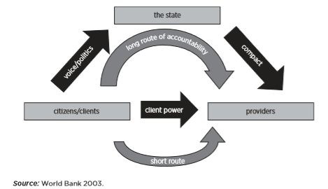
Taken from World Bank (2011)

Harris (2011) discusses system improvement and accountability in Wales, synthesising a range of evidence and her own experience as a senior professional advisor to the Welsh Assembly Government. She acknowledges that international comparisons, such as PISA outcomes, are drivers for greater improvement in education attainment. She suggests that previous attempts at improvement have failed to be effective for a number of reasons. Firstly, this is because they placed emphasis on external accountability measures such as publishing performance data (such as in league tables). Secondly, she asserts that there has been a focus on short-term gains, arguably from politicians, which have not necessarily been effective for sustained improvement. This would concur with the World Bank’s conclusion that a lack of state involvement is a feature of effective accountability systems. Thirdly, improvement efforts have not been effective in their implementation, with areas identified for development but a lack of clarity on how to go about this, concurring with Egan and Marshall.
Wales stopped using league tables in 2001, but introduced a banding system in 2011. This system drew on indicators including GCSE results, but also attendance, the proportion of eFSM pupils (eligible for free school meals) and relative improvement. The bands, from 1 (highest) to 5 (lowest), were used to identify schools in need of support, and those who could share good practice. The OECD (2017) synthesises criticisms made of the banding system, including the idea that banding, like league tables, still ranks schools against each other. Furthermore, banding outcomes did not always reflect the findings of Estyn, which implies a lack of validity. Headteachers also expressed a lack of trust in the system due to apparently inexplicable changes in band from one year to another. Empirical evidence implies a perception amongst school leaders that the banding system in this form was open to abuse, due to the system looking at progress over time without taking into account any difference between cohorts. Making a little progress every year could make a school look favourable in the banding system. Criticisms like these led to reform of the system in later years.
In 2012, Welsh government released the document Improving Schools (Welsh Government, 2012) which outlined aims to improve literacy and numeracy levels and reduce the impact of socioeconomic factors on pupil attainment. In addressing some ideas in Improving Schools, Welsh Government increased national control, despite mirroring England in terms of the inspection framework becoming more streamlined and self-evaluation more of a priority. The National Reading and Numeracy Tests were introduced in May 2013. The OECD (2017) assert that the aim of the LNF and the National Tests was to provide stakeholders with a clearer understanding of pupil’s learning and performance in these skills. The Literacy and Numeracy Framework (LNF) became a statutory in September 2013 (Welsh Government, 2013) and was an addition to the existing national curriculum. Empirical evidence suggests that National Test results provide schools with data that is included in self-evaluation and school development and improvement processes.
Whilst Improving Schools was ambitious in its scale, the OECD (2017) reported that many teachers felt that the large number of reforms it covered could lead to difficulties in implementing all of its measures, possibly resulting in what they termed “reform fatigue” within the profession. Nevertheless, school improvement continued to be high on the Welsh Government’s agenda. The drive towards more school self-evaluation in Wales included publication of the guidance document School Development Plans (Welsh Government, 2014), with figure 2 showing the document’s overview of the development planning cycle.
Figure 2, School Development Planning Cycle:
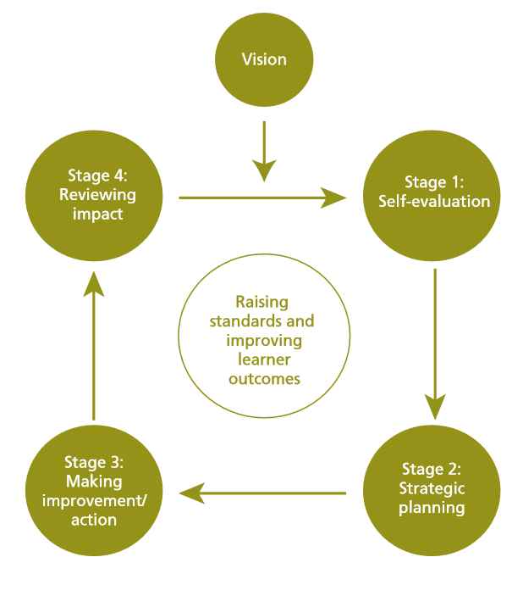
From School Development Plans (Welsh Government, 2014)

This reflects a move towards greater consistency in the quality and effectiveness of self-evaluation processes across Wales, in response to Estyn’s 2012–13 annual report, which reported that over a quarter of Welsh schools could improve their self-evaluation processes. The document gave guidance on how schools should use quantitative and qualitative data as part of the process, which reflects the approach taken in other countries which do well in PISA, according to the OECD (2014).
The Welsh drive for school improvement has led to the establishment of four regional consortia. This has moved focus on school improvement from local authorities to the consortia, although the process of establishing and defining roles and responsibilities between the local authorities has, according to the OECD (2014), not always been clear cut, especially as local authorities have a statutory responsibility for education. However, there has been time for the consortia to develop their roles in the years since the OECD report. At present, they provide levels of support which reflect the school’s categorisation. These range from the green category for the strongest schools, through yellow, amber and then red for the weakest schools. The quantity of support provided ranges from four (green schools) to up to twenty five days (red schools). Welsh Government (2018) outline that categorisation takes into account a range of outcomes (including attainment and progress), the school’s self-evaluation and systems for improvement and evaluation of the self-evaluation. This system is seen by school leaders, empirical evidence suggests, as fairer than the original banding system.
The National Model for Regional Working (Welsh Government, 2015) endeavoured to clarify the roles and responsibilities of schools, local authorities and consortia. It outlined an annual cycle of school improvement as part of this guidance (see figure 3).

Figure 3, Annual cycle of school improvement (Welsh Government 2015):
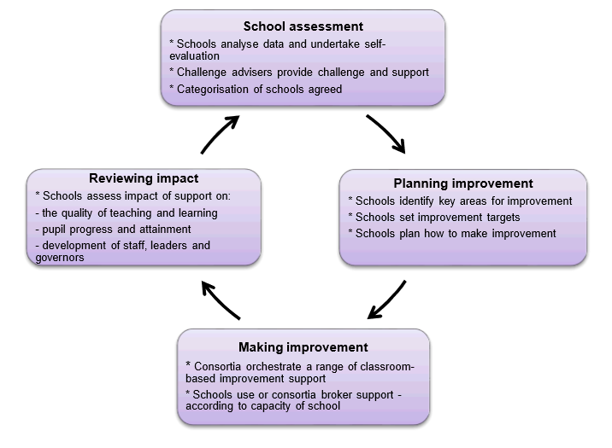
This shared an effective system, a recognised feature of successful schools (Brundrett and Rhodes, 2011). The document also introduced the role of challenge advisers, educators with a proven track record in school improvement and employed either full or part time by consortia, to the process of school improvement. The OECD (2017) reported that most governors and headteachers they spoke to felt that challenge advisers were fairly and offered useful support, although provision in core subjects was perceived to be stronger than in other curriculum areas.
Collaboration has also been encouraged between schools in Wales in order to improve quality. The OECD (2014) concluded that this could be useful in developing practice, but truly free collaboration might be hindered by accountability measures. The OECD’s comments imply that Wales’ accountability measures prevent schools from collaborating freely as they perceive themselves to be competitors in a marketplace. The My Local School website allows stakeholders including parents to see school results and other accountability data, for example, which could be seen as contributing to a market place approach. This business model reflects a productivity model of accountability. An improvement or process model is reflected in a self-evaluation based system.
The drive to improve quality is also represented by the Welsh Government’s reforms to teacher training and continuing professional development. The new professional and leadership standards for teachers have been introduced gradually and are statutory for all teachers from September 2018 (Welsh Government, 2017).
Accountability measures in terms of outcomes in Wales are also changing. Instead of focusing on pupils achieving certain proportions of certain grades, schools will be measured on average point scores for literacy, numeracy and science GCSE qualification. Education Minister Kirsty Williams (2018) acknowledges that C/D borderline pupils have, in the past, become the focus due to their potential significance in improving school accountability outcomes, and that this has meant that pupils working at other levels may have consequently become less of a priority. The average point scores should, therefore, improve equity in provision and attention for pupils at all levels, as each one will contribute to the average point score.
The next steps in developing the Welsh accountability system are likely to be set out in work between Estyn, the OECD and Welsh education professions, which has been tasked with developing a toolkit for self-evaluation and school improvement that can contribute to the facilitation of a system of self-improving schools. How Wales continues to refine its accountability processes will be important, so that accountability meets the needs of the forthcoming new curriculum instead of driving its implementation.
(ii) Report
As Literacy Coordinator in a large south Wales comprehensive school, part of my role involves evaluating the National Reading Test (NRT) results for years 7 to 9. Whilst the test results are not used in any performance indicators, they are part of the information used by the school in self-evaluation, with a view to improving standards. With the average points score for a literacy-based GCSE forming part of the national Key Stage 4 accountability measures in 2019, (Williams, 2018), standards of literacy remain a high priority in terms of both professional and moral accountability.
Bernhardt (2013) proposes that data analysis can be used with school improvement processes to help schools understand results and how they have achieved those results. Therefore, analysis of National Reading Test results may help to establish whether our teaching and learning of reading strategies within the school are effective, where strengths lie and where there are areas for improvement.
The Local Authority (LA) produces a spreadsheet which outlines the school’s performance in the NRTs, along with the performance across both the LA and Wales. This information is shown in an anonymised form in figure 4. Whilst comparisons with other schools can fail to take into account differences in context, nonetheless this information does give some idea of the pupils in School A’s relative performance in the tests.

Figure 4:
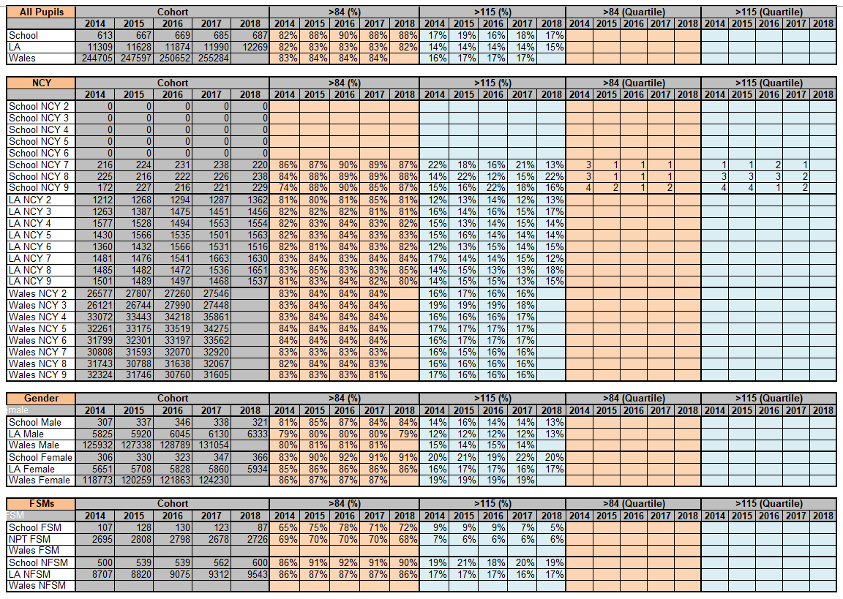

A SWOT analysis (figure 5, overleaf) was carried out on the data for 2018 shown in figure 4. A SWOT analysis can be used in planning and decision making in business, but also in organisations and for individuals, and can help to facilitate improvement (Fine, 2010). The acronym SWOT stands for Strengths, Weaknesses, Opportunities and Threats. This SWOT analysis therefore outlines the areas of relative strength and weakness in the test results, as well as the potential opportunities and threats there are for improving practice and performance.

Figure 5:
Strengths | Weaknesses
- Above LA in both >84 and >115  - Above LA for FSM >84  - Above LA for both males and females >84 | - Below LA in FSM >115  - Males achieving >115 has dropped from the previous year  - >115 has dropped from the previous year in years 7 and 9
Opportunities | Threats
- Set classes in English allow for pupils to be challenged at an appropriate level, including those at the top end  - Extra-curricular clubs run by English staff are being relaunched  - School library staffing is being improved for the new academic year, allowing for more support for pupils in wider reading  - Consortium-produced diagnostic spreadsheet can be used to target areas for development (at a year group and individual pupil level)  - INSET time for Literacy training | - Year 7 is not set in English. Could this make it difficult to stretch the top end?  - Pupils may be stretched in their commitment to extra-curricular activities  - Possible staff resistance/lack of confidence in teaching reading in non-language subjects  - Time needed for analysis of diagnostic data, both by Literacy Coordinator and class teachers  - Possible lack of parental support for wider reading at home

The SWOT analysis highlights that, overall, more pupils in School A achieve a standardised score of above 84 and above 115 in the NRTs in comparison with other LA schools. This is the case for both male and female pupils scoring above 84. These are strengths of the school. However, the percentage of FSM (Free School Meal) pupils achieving above 115 is below that of the LA as a whole. Scrutiny of the data also reveals that the percentage of males achieving above 115 has dropped in comparison with the previous year, as have the percentages of year 7 and 9 pupils achieving above 115. This suggests that it could be appropriate to target achievement of standardised scores above 115 as an area for improvement.
The local education consortium produces a diagnostic tool to aid analysis of the National Tests. This is an Excel spreadsheet that has functions which allow the generation of specific targets for pupils. This gives the opportunity to use item-level data to identify strengths and weaknesses in pupils’ NRT answers. The implication of this is that question types or skills can then be targeted in an effort to raise performance, which should help to increase performance at the top end (identified as a weakness by the SWOT analysis).
The cohort’s item level responses were entered into the diagnostic spreadsheets for each year group, and the tools used to identify the two skills that pupils found most difficult. These were established by identifying the questions with the lowest mean correct answer. The skills were identified as follows:
- Year 7: sequencing; identifying the purpose of text features
- Year 8: locate and retrieve synonymous match; identifying the purpose of text features
- Year 9: locate and retrieve synonymous match; identifying the purpose of text features
Having identified these targets for improvement, the skill of identifying the purpose of text features was prioritised for action and intervention in the forthcoming academic year, as it appeared as an area for development in all three year groups.
Firstly, the National Test results and the findings of the diagnostic tool will be shared with all staff during INSET time. The target skill will be identified and explained to the staff, and the relevant questions from the National Tests will also be shared with the staff so that they understand the kinds of questions that draw upon these skills.
Strategies will be shared with the staff that can be used to develop both their own and pupils’ understanding of text features and their purposes. Staff will then be asked to collaborate within their departments to identify opportunities in the Schemes of Learning to address these skills in their reading tasks. A member of the English department (as a literacy specialist) will support each department in this task. This is intended to minimise the potential threat of staff lacking confidence in their literacy expertise.
Staff will be asked to trial these resources and strategies and report back to their departments, with literacy representatives from each department sharing best practice in a literacy PLC meeting. This can then allow for wider sharing and cascading of good practice. As the school uses the IRIS Connect system, which allows recording of lessons for professional reflection, staff willing to share lessons which draw on the skill will be invited to do so. This will enable further evaluation of the strategies and resources that have been developed, as well as potentially the sharing of good practice.
As English teachers are the drivers of literacy, teachers of top set English groups in years 8 and 9 would be asked to prioritise the targeted skill, especially in the approach to the National Tests. From their experience supporting their link departments, the English teachers can highlight where pupils have used the school across the curriculum, reinforcing that reading is a cross-curricular skill. Teachers of year 7 mixed ability classes will be reminded of the need to highlight this skill, particularly to pupils who achieved standardised scores of over 110 in their year 6 National Reading Tests.
When the National Reading Test results are analysed next year, the mean scores for questions that use the skill of identifying the purpose of text features will be examined to see if there has been and improvement in pupils’ performance and, by implication, use of this skill. The mean scores for 2019 will be compared with the mean scores for 2018. Priorities for further intervention and action will be made based upon any increase or decrease in the mean score for the skill.
Furthermore, pupils achieving standardised scores of 110 and over would be targeted for a wider reading programme. This would see them joining a wider reading group, run by the school librarian, and being given recommendations of stretching texts in the school library. These challenging texts would then be discussed within the reading group. This should be particularly useful for Free School Meals pupils, who may not have the resources to have their own books at home. As the school librarian is a specialist English teacher, she will be able to facilitate the discussion so that it covers the target skills from the diagnostic, as well as other higher-order reading skills such as inference. The parents of the targeted pupils would be informed of this and invited into school to visit the library. At this meeting, they would be informed about the wider reading group and its aims, and how they can support it at home. The SWOT analysis does acknowledge that the target pupils may already have extra-curricular commitments, so these will need to be taken account of so that the pupils are not over-stretched and their wellbeing is protected.
The impact of the reading group will be measured using an anonymised pupil survey and the results of the targeted pupils who participate in the reading group will be scrutinised when next year’s National Reading Test standardised scores are released. Again, the outcomes of these evaluations will be used to prioritise and inform future intervention and practice.
As literacy coordinator, I will feed back to both staff and governors on the effectiveness of the interventions. Schemes of learning and resources will be evaluated and refined based on their impact and staff and pupil feedback, as part of a process of self-evaluation and self-improvement.
Therefore, it can be seen that this accountability project uses data as a tool to identify strengths and weaknesses, which are outlined in a SWOT analysis. The opportunities and threats from the SWOT analysis inform action to be taking to address areas for development. Finally, the effectiveness of the action will be evaluated in order to inform future practice.
(iii) Leadership Standards Evaluation
As part of my accountability and improvement measures based upon reading and the National Reading Test scores, I drew upon skills from the leadership standards. The professional standards for teaching and leadership have been reformed and the new arrangements will be statutory from September 2018 (Welsh Government, 2017). The previous standards were in place at the start of my project and therefore used when evaluating my leadership of the accountability and improvement measures (Welsh Government, 2011).
I decided to use a RAG (red, amber, green) rating system when evaluating my achievement or otherwise of each leadership strand. Red indicates either that the standard was not applicable for this particular accountability process, or that I felt it had or would not be achieved. Amber indicates that some aspects of the standard are met, or that the standard is not securely met. Green indicates that I am confident that the standard has been met.
Firstly, in terms of creating strategic direction, my analysis and proposals reflect many of the standards, with some being partially met (see figure 6).
Figure 6:
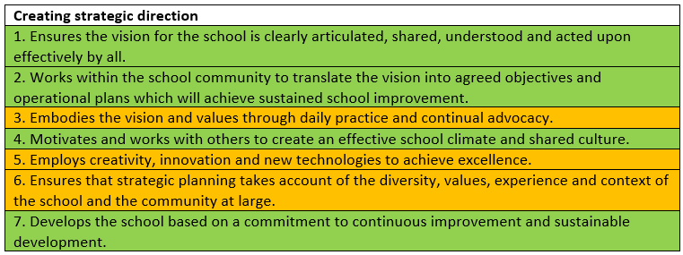
As my intervention includes staff training and collaboration in INSET and Adds sessions, I will be addressing standards 1, 2, 4 and 7. When I share the National Reading Test results and data, and identifying and discussing the targeted skill with staff, I will be making clear the vision for improvement. This will, it is hoped, make staff more willing to engage with and act upon the vision. Therefore, standard 1 should be addressed. The plan for developing the targeted skill by creating subject-specific resources and identifying opportunities for teaching and learning to address it, reflects standard 2. As a classroom teacher as well as Literacy Coordinator, I will be putting the strategies into practice myself, but it may not be addressed daily or be possible to make this visible to all staff, hence the rating of amber for standard 3. I will, though, endeavour to be visual as an advocate for the intervention. Standard 4 will be addressed, as collaboration and use of staff with specialist skills will be used to facilitate staff confidence in the teaching and learning of the targeted skill. A rating of amber was given to standards 5 and 6. This is because the plan draws upon technology to aid in the diagnostic analysis of the pupils’ National Reading Test answers, but this is not particularly innovative or new technology. It will also draw upon the creativity of staff to develop strategies for the teaching and learning of the targeted skill. Whether this will achieve excellence, though, will remain to be seen when next year’s National Reading Test results are published, and the pupils’ responses analysed. The process takes account of the school’s diversity in terms of gender and draws upon the experience of staff to support and collaborate with colleagues who may be less confident in literacy teaching and learning. The diagnostic results take account of diversity in terms of gender and the pupils as individuals as it is able to generate individual targets. However, this is the only way it appears that the intervention addresses this standard. For these reasons, a rating of amber was awarded.
The second set of leadership standards are concerned with Leading learning and teaching. Figure 7 shows how the analysis and intervention were evaluated against these standards.
Figure 7:
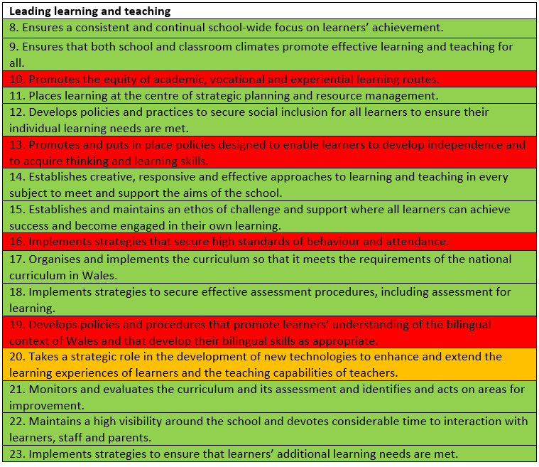
Standards 8, 9, 11, 12, 14, 15, and 17 have been rated as green, as the analysis of the data and the development and implementation of the intervention focus on raising standards of learners’ achievement through collaboratively developed and agreed practices, addressing pupils’ individual learning needs. The use of the diagnostic tool to interpret pupils’ results and the refining of schemes of learning addresses standard 21. Standard 22 is met by the INSET training, literacy link staff meetings and parent/carer meetings which will make me a visible leader in this improvement intervention. In particular, the strategies and practices that are implemented will address More Able and Talented (MAT) pupils’ needs, which reflects standard 23. An amber rating was given to standard 20, as technology is being used strategically to identify learning needs and improve provision and practice for pupils and teachers; however, this technology is not particularly new. Some standards are not addressed by the intervention, and have therefore been rated as red.
The next set of leadership standards deals with developing and working with others. The evaluation of how these standards have been addressed is shown in figure 7.
Figure 8:
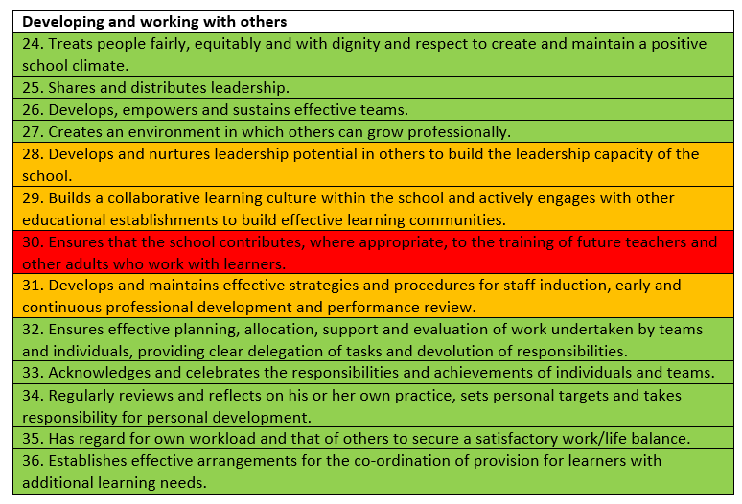
Only standard 30 was rated as red, as it is not expected that trainee teachers will be involved in developing the intervention. Most other standards have been rated as green. This is due to the collaborative nature of many aspects of the intervention. Colleagues will be working together to refine schemes of learning to enhance existing provision and practice which develops the targeted skill, as well as taking advantage of other opportunities to develop its teaching and learning. This will allow the acknowledgement and celebration of the work that has been undertaken, as well as evaluation of the effectiveness of the intervention. I will also review my own practice and the effectiveness of the intervention as part of the process. Standards 28 and 29 have been rated amber, as there is some potential for the development of leadership skills in others, such as the English teachers working with the departments and the Literacy link staff from each department, but this is not on a wide scale. The use of English department staff as leads with cross-curricular subject areas allows them to develop their own leadership skills. The department Literacy link staff will also develop their leadership skills by sharing good practice and feeding back good practice from other departments in the literacy PLC group. Furthermore, the intervention is based within the school, rather than making use of collaboration with other educational establishments (other than the local consortium), which again implied an amber rating was more appropriate than green.
The next set of standards deal with managing the school and the evaluation of these standards is shown in figure 9.
Figure 9:
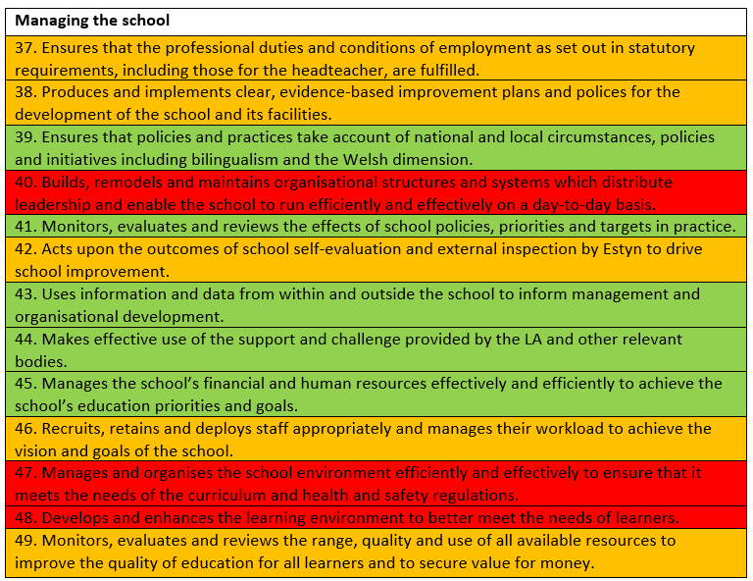
The intervention deals with fewer of these standards. Three were rated as red as these related to a higher level of leadership. Furthermore, it is not anticipated that the intervention will have an impact upon the physical learning environment. Several of the standards were ranked as amber. Standards 37 and 38 begin to be addressed as the intervention will aid staff in fulfilling their statutory duties. Regarding standard 42, the intervention is part of the School’s self-evaluation processes and targets school improvement. However, it is not addressing Estyn inspection recommendations in this instance, hence that standard’s rating of amber. The other two amber rated standards were not rated as green, as they address only some aspects of the extensive goals and resources of the school.
The standards regarding securing accountability and their RAG ratings are shown in figure 10.
Figure 10:
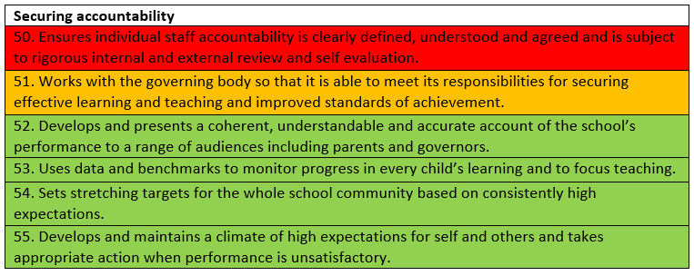
As standard 50 encapsulates the whole school approach to staff accountability it was rated as red, as my leadership of this project can perhaps only be perceived to touch upon its review and self-evaluation aspects. Whilst the intervention follows those processes, perhaps giving some weight to an amber rating, it is not a driver of the processes and systems across the school. As the governing body will be informed of the intervention and its impact, standard 51 was rated as amber. The governing body will not be involved throughout the process which suggested a green rating would be too strong. Greater involvement of the governing body could, therefore, be an area to explore in a future self-evaluation and improvement project.
The other four standards in this set, though, have been rated as green. This reflects the meetings that will be held with parents, how the National Reading Test data has been used both to identify areas for improvement based on overall results, and also in the diagnostic tool to analyse and target skills for individual and groups of pupils. It sets a challenging target in terms of moving more pupils to achieve standardised scores of over 115 in the next National Reading Tests, the highest levels of attainment. It also sets high standards in terms of the quality of provision that will be required to address the targeted skill, taking action on performance in areas where it is less strong.
The leadership standards that deal with strengthening the community focus are shown with their RAG ratings in figure 11.
Figure 11:
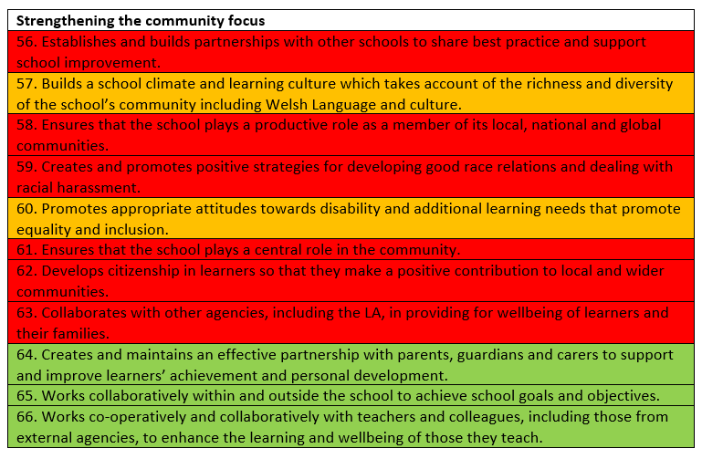
Three standards are reflected in the data analysis and the intervention: 64, 65 and 66. The sessions for parents and carers allow standards 64 and 65 to be met, as they should facilitate the development of a partnership between home and school that supports the pupils in improving their reading skills, which is an objective of the improvement project. The final standard, 66, reflects the collaboration between staff within the school, and the use of the consortium’s diagnostic tool. Staff across all curriculum areas will be involved in developing the resources and Schemes of Learning to enhance pupils’ skills in identifying the purpose of text features. The diagnostic tool draws upon the skills and expertise of consortium colleagues, who identify the skill predominantly used in each of the test questions.
Whilst the RAG rating system has some subjectivity, I endeavoured to be honest in my ratings. Some of the ratings depend on stages of the intervention that are yet to come; in these instances I considered the expected outcome. Therefore, revisiting this evaluation of the standards at the end of the whole process in summer of 2019 will allow for more accurate ratings.
As a leader, the evaluation indicates that the leadership standards demonstrated by this strategy are strongest in creating strategic direction, leading learning and teaching, developing and working with others and securing accountability. These were the standards that were most relevant to my role as Literacy Coordinator within my school. The relatively weak leadership standard areas were managing the school and strengthening the community focus. This is because many of these standards related to whole school issues which are beyond the remit of the Literacy Coordinator role. As part of my continuing professional development, I aim to reinforce the leadership standards that I have addressed, improve in those areas I have begun to work towards, and seek opportunities to develop in the areas rated as red. This, I believe, will aid me in securing quality and accountability for the pupils in School A.

