Assessment Component 1: Individual Report
Netflix
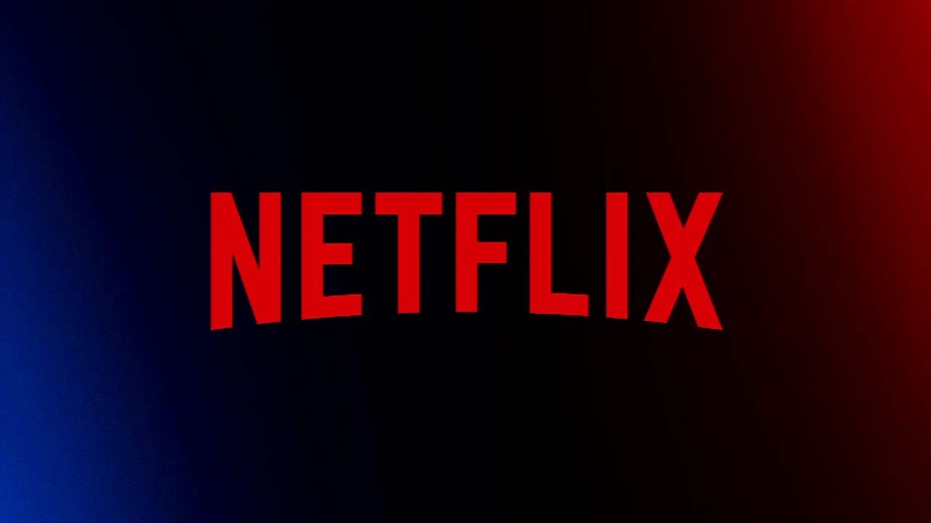

Executive Summary
Netflix is a global streaming entertainment services firm that provides a variety of services to its clients. This report will examine the role of management accounting tools and techniques in assisting financial decision-making for Netflix, one of the world's largest entertainment streaming companies. In particular, the analysis focuses on Netflix's business model, its cost structure, its organisational budget and the assignment of metrics for success, alongside its sustainability strategies. The results of this research show that management accounting is successfully leveraged by Netflix to reduce costs, enhance profitability and guide strategic decision-making via budgeting and keeping track of the key performance indicators as well as performance analysis. In 2024, probably obtained US$39 billion in income, highlighting robust financial results and industry expansion. The report suggests that other aspects of predictive analytics, content investment assessment and sustainable accounting practices be improved to aid sustainable growth and long-term competitiveness.
Table of Contents
1. Introduction 4
1.1 Company Background 4
1.2 Management accounting and its Importance 5
2. Cost Analysis and Business Model 5
2.1 Business/Revenue Model 5
2.2 Cost Structure Analysis 6
2.3 Management Accounting Application 9
3. Financial Planning and Budgeting 9
3.1 Role of Budgeting 9
3.2 Analysis of Current-Year Financial Changes 10
3.3 Factors that influence Budget Decisions 12
3.4 Variance Analysis and Performing Forecasts 13
4. Performance Measurement and Decision-Making 13
4.1 Financial and Non-Financial KPIs 13
4.2 Strategic Decisions Supported by KPIs 14
5. Sustainability and Ethical Considerations 15
5.1 Introduction to Sustainability in Financial Decision-Making 15
5.2 Ethical Considerations in Cost Management and Pricing Strategies 15
5.3 The effects on long-term performance 16
6. Conclusion and Recommendations 17
6.1 Conclusion 17
6.2 Recommendations 17
Reference list 19

1. Introduction

1.1 Company Background
Netflix (2025) is quoted as a global entertainment streaming and subscription video-on-demand company. The company was founded in 1997 and is headquartered in Los Gatos, California, USA, and is one of the world's largest streaming platforms. As of 2024, Netflix has more than 300 million paying subscribers in over a hundred countries and makes about of about the sum of US$39 billion in revenue (Figure 1.1). Its core products and services are streaming of TV series, movies and documentaries, mobile games and original television content productions, all targeted to a global audience.
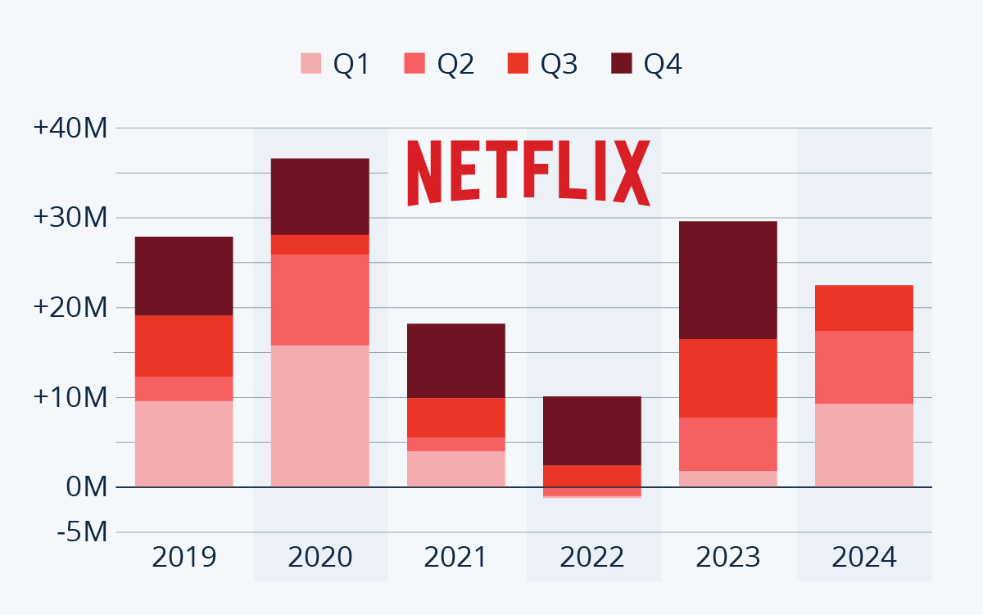
Figure 1.1: Netflix Performance Growth till 2024
(Source: Netflix, 2024)

Netflix is chosen for this report because they are one of the principal world companies that plays an active role in the streaming media industry, and relies heavily on management accounting for budgeting, investing in content, and assessing performance. Being a rapidly growing company with a business model based on information, significant content investments and a changing revenue policy, this is a very interesting context to discuss the implementation of management accounting in a highly competitive digital sector.

1.2 Management accounting and its Importance
According to Li et al., (2023), management accounting relates to the task of gathering, analysing and disseminating financial and non-financial information to facilitate managerial decision-making. It is instrumental in planning, budgeting, performance measuring and controlling the cost of the organisation. This is especially significant for Netflix, as it plays a crucial role in making informed decisions about content investments, pricing strategies, and the allocation of resources and profitability.

2. Cost Analysis and Business Model

2.1 Business/Revenue Model
Netflix's business model is one of subscription-based streaming services, with revenue coming mainly from its monthly membership fees from subscribers all over the world (Netflix, 2025). Netflix has provided different subscription policies, such as Standard with Ads, Standard and Premium, so as to serve diversified customer segments and generate revenues to the maximum extent. Continuing subscriber growth and enhanced monetisation tactics have seen total Netflix revenue grow to US$33.7 billion in 2023 and a predicted figure of US$39.0 billion for 2024 (Table 2.1).
Netflix, which has taken a subscription model, has faced several issues—such as customer attrition, saturation in developed countries and facing increased competition in streaming markets—also. However, as described by van Es (2023), payments and subscriptions can lead to customer churn—and ultimately growth issues—due to the need for them. To resolve these issues, Netflix subscribed to a paid subscription model with advertisements and implemented restrictions on passwords sharing, expanded their investment on original projects, creating multiple revenue streams and ensuring better customer retention. In 2024, Netflix doubled down on its advertising efforts and made additional money in addition to subscriptions. It also generates value by investing in original content across the various content media like films, TV shows and documentaries thereby affecting the acquisition and retention of subscribers. Such a business model gives Netflix the advantage in the entertainment and media space in today's global world.
Revenue Stream | Revenue (US$ Billion) | Percentage (%)
Subscription Revenue | 35.5 | 91
Advertising Revenue | 2.0 | 5
Licensing and Other Revenue | 1.5 | 4
Total Revenue | 39.0 | 100
Table 2.1: Revenue Breakdown (2024)
(Source: Created by the researcher based on the data from Netflix, 2024)

2.2 Cost Structure Analysis
Netflix (2024) reports that the cost of content is the biggest expense that Netflix has. Certainly, Netflix has significant fixed costs arising from production investment in original TV shows, technological investments to support its infrastructure, its software investments, and long-term content licensing investments. These costs are fairly predictable in spite of fluctuations in subscribers in the short term.
In digital businesses, an understanding of cost behaviour is vital since the successful cost allocation of costs is crucial to business strategy (Varaniūtė, Žičkutė and Žandaravičiūtė 2022). The major variable costs for Netflix are content delivery, customer support and processing operating costs, payment operations costs and marketing expenses that fluctuate according to growth in the subscriber base. To illustrate the relevance of content investment to its operations, Netflix reported about US$17.0 billion of content amortisation expenses in 2024.
Content costs make up the biggest proportion (55%) of total costs at Netflix, reflecting the company's significant reliance on original productions and licensing expenditures. The cost of technology, infrastructure and marketing all account for a total of 34%, proving Netflix's innovation in the platform, service deals and customer acquisition (Table 2.2). The diagram makes it clear that how management is able to control content expenditure is vitally important to sustainable profitability and competitive advantage (Figure 2.2).
Cost Category | Amount (US$ Billion) | Percentage (%)
Content Costs | 17 | 55
Marketing | 2.8 | 9
Technology and Development | 3.2 | 10
General and Administrative | 1.6 | 5
Infrastructure and Delivery | 4.5 | 15
Other Costs | 1.9 | 6
Total Costs | 31 | 100
Table 2.2: Cost Structure (2024)
(Source: Created by the researcher based on the data from Netflix, 2024)
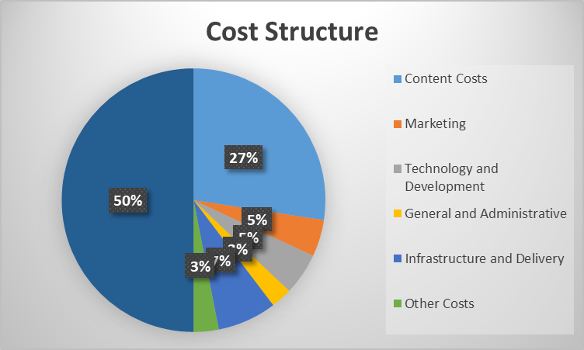
Figure 2.2: Cost Structure Chart (2024)
(Source: Created by the researcher based on the data from Netflix, 2024)

2.3 Management Accounting Application
According to Li et al., (2023), management accounting provides support for the performance of the organisation through cost analysis, planning and decision-making processes. Netflix used cost-volume-profit analysis to determine the profitability of increases in subscribers. Content production is relatively high in terms of fixed costs, so more subscribers equals higher content contribution margins, higher overall contribution margins and hence higher profitability.
Netflix also implemented some other cost control measures like budget monitoring and content investment reviews as well as performance-based expenditure evaluation. Cost behaviour analysis helps management understand the nature of costs and thus aids in the process of forecasting and allocating resources more effectively; specifically, it helps management differentiate between fixed cost and variable cost. These practices help Netflix maximise its value for all shareholders and manage costs and support sustainable growth in the fiercely competitive streaming environment.

3. Financial Planning and Budgeting

3.1 Role of Budgeting
Calvin et al., (2022) have highlighted that budgeting is an essential management accounting tool for managing an organisation and allocating resources optimally to achieve organisational goals. Netflix (2024) highlights that they used budgeting to predict revenues, allocate content budgets, and keep an eye on operating expenses around the world. The budgeting process consists of determining the goals of the financial resources and forecasting the amount of money required and checking the performance against desired results.
Strategic planning is facilitated by budgeting because it allows investments to be made in areas that include content development, technology innovation and international expansion. Netflix regularly reviews the budget, ensuring that operational activities match with business goals and that the management team has the ability to proactively optimise for changing market conditions, resulting in long-term profitability.

3.2 Analysis of Current-Year Financial Changes
Netflix (2025) stated that the company earned revenue in 2024 of 15.8% higher than the revenue recorded in 2023 (US$33.7 billion). Subscriber growth, price changes and the increase of subscription models based on advertising accounted for this growth (Table 3.2.1).
Results from the Annual Report of Netflix (2025) showed that its operating income rose from around US$7.0 billion in 2023 to US$10.4 billion in 2024, leading to an improvement in operating margin from 21% to 27%. The upturn points to better revenues and cost-effectiveness (Figure 3.2.1).
Higher expenditure towards content creation, technological advancements and expansion spending on the global marketing push also pushed up Netflix's operating expenses. Expense growth was also less than revenue growth, helping to increase profitability. According to the information on both Google Finance and Yahoo Finance, investors' confidence was boosted in 2024 when Netflix continued to beat the market. The company therefore managed to improve its financial condition and hold on to its competitive position in the global streaming market.
Year | Operating Expenses (US$ Billion)
2022 | 24.8
2023 | 26.7
2024 | 28.6
Table 3.2.1: Operating Expense Trend
(Source: Created by the researcher based on the data from Netflix, 2024)
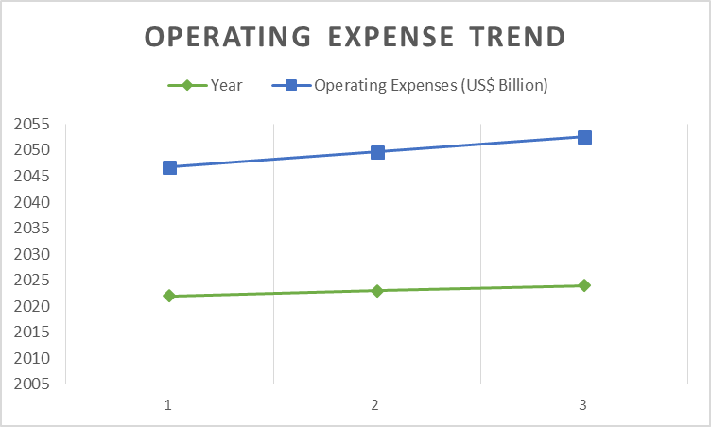
Figure 3.2: Operating Expense Trend
(Source: Created by the researcher based on the data from Netflix, 2024)
Year | Revenue (US$ Billion)
2022 | 31.6
2023 | 33.7
2024 | 39
Table 3.2.2: Revenue Growth
(Source: Created by the researcher based on the data from Netflix, 2024)
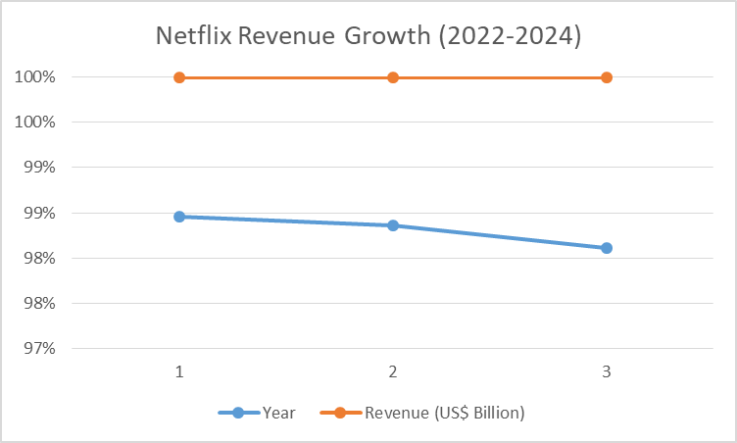
Table 3.2.2: Netflix Revenue Growth (2022-2024)
(Source: Created by the researcher based on the data from Netflix, 2024)

3.3 Factors that influence Budget Decisions
Netflix (2025) identified that internal and external forces have a large bearing on the popularity of the company's budgeting methods. In its finances, Netflix is spending a massive amount of money on content production and acquisition, which are vital to bring in and keep subscribers. The company also allocates resources for foreign expansion and innovations in technologies, such as enhancement of its streaming platform and recommendation algorithms. Budget needs are further driven up by higher labour costs for content creators, actors and technology employees.
From the outside, inflation increases the production, marketing and operating costs of Netflix, forcing changes in spending plans. Further, Netflix faces strong competition from Disney+, Amazon Prime Video, and Max, which drives the firm to make more investments in content and innovation to secure market share and keep customers. Financial instability could affect consumer spending habits, causing Netflix to adapt their pricing policies and make adjustments to its spending plans to remain profitable and market share holder.

3.4 Variance Analysis and Performing Forecasts
According to Pargmann and Berding (2024), variance analysis helps an organisation see if there have been any discrepancies between actual performance and the Budget expectations, and who to manage when the variances occur. Netflix relies on forecasting models, subscriber analytics, and financial performance data to make better plans for the future, optimise resources and accommodate sustainable growth goals.

4. Performance Measurement and Decision-Making

4.1 Financial and Non-Financial KPIs
KPI | 2023 | 2024
Revenue (US$ Billion) | 33.7 | 39.0
Operating Margin (%) | 21 | 27
Net Income (US$ Billion) | 5.4 | 8.7
Paid Subscribers (Million) | 260 | 300+
EPS (US$) | 12.03 | 19.83
Table 4.1: Netflix Key Performance Indicators (2024)
(Source: Created by the researcher based on the data from Netflix, 2024)
Netflix (2025) identified key financial performance indicators (KPIs) as those that allow an evaluation of the organisation's efficiency and profitability. The market revenue growth, operating margin, net income growth, and return on assets (ROA) are among the Netflix financial performance metrics that are tracked. Netflix claimed revenue of around US$39.0 billion in 2024, up from US$33.7 billion in 2023, and its operating margin rose from 21% to 27% at the same time. The net income also jumped to US$8.7 billion from US$5.4 billion, reflecting higher profitability.
van Es (2023) pointed out that in digital streaming companies, not only are financial KPI relevant, but also those from other areas. There are some metrics that Netflix uses to monitor subscriber growth, customer retention, how engaged customers are in viewing its content, the level of popularity, and customer satisfaction. Netflix managed to surpass 300 million paid members worldwide in 2024 through effective customer acquisition and retention measures. The business uses viewing hours and viewing metrics to measure the content. The overall picture of the financial and non-financial indicators should give the management a complete picture for evaluating business performance and backing strategic decision-making.

4.2 Strategic Decisions Supported by KPIs
Travis Pritlove of Netflix (2025) illustrated that KPI monitoring is important to undertake to inform key business decisions that inform the entire organisation. Managers backed growth in revenue and subscriber numbers as the rationale for moving into the advertising-supported subscription business, which would seek out price-sensitive users while generating new revenue streams for Netflix. The company also used data from subscribers to understand what type of content is successful and thereby prioritise resources in relation to high-performing productions.
Management accounting information helps to link financial results to operational performance indicators and enables evidence-based decision-making, according to Li et al., (2023). By analysing viewing trends and user engagement, Netflix can prioritise content investments and pricing decisions. Original productions, for instance, have received investments of more than US$17 billion per year, thanks to this high demand by viewers. In addition, the profitability indicators helped make decisions about the restrictions on password sharing and led to increased add-ons to subscribers and better revenues. By leveraging the analysis of KPIs, Netflix has successfully sustained its path towards competitive advantage and a sustainable growth model within the ever-changing landscape of the streaming market.

5. Sustainability and Ethical Considerations

5.1 Introduction to Sustainability in Financial Decision-Making
Netflix (2024) stated that sustainability is becoming an increasingly integral part of Netflix's financial decision-making. Netflix's sustainability strategies involve investing in sustainable production processes, renewable energies, carbon reduction programs and more, showing that it considers the three pillars of environmental, social and governance (ESG) in its business strategy. The company strives to lower the carbon footprint of content production and to offer content production that is responsible towards the environment.
Organisations can integrate environmental and social impacts into financial planning and resource allocation decisions using a sustainability accounting framework, as suggested by Schaltegger et al., (2022). Netflix takes sustainability principles into account when assessing investments and business operations to create long-term value for stakeholders as well as generate profits. In 2024, Netflix maintained its focus on quantifying and minimising its emissions across its production supply chain, as well as advancing responsible business practices. These programs help minimise risk, ensure compliance with government regulations and boost corporate image. Netflix's inclusion of sustainability metrics in financial decision-making enhances its sustainability capabilities and mitigates the mounting consumer and corporate demand for sustainability efforts.

5.2 Ethical Considerations in Cost Management and Pricing Strategies
In the global marketplace, ethical business practices are crucial, as stressed by Meilani et al., (2025). As Netflix faces many ethical difficulties over pricing selections and the reach and utilisation of customer information, other topics include customer privacy and content accessibility and responsible use of customer information. The firm aims to offer clear pricing models that are also competitive to customers in various markets.
According to Garcia-Torea, Larrinaga and Luque-Vílchez (2023), ethical cost management is a balance of profit targets and the interests of stakeholders. For example, Netflix does this with a responsible approach to suppliers, equitable treatment and adherence to data protection laws for staff. Ethical decision-making demonstrates respect for customers and helps the brand's reputation and organisational sustainability.

5.3 The effects on long-term performance
The researchers of Rahi et al., (2022) stated that sustainability and ethics go a long way in driving long-term organisational success. Globbl's efforts in ESG initiatives, responsible governance, and transparency in business practices further instil confidence among investors, cultivate good stakeholder relationships, and drive sustainable profit-maximisation. All of these enhance the company's long-term competitive strengths.
Sustainability Area | Initiative
Environmental | Carbon emission reduction programmes
Energy | Renewable energy adoption
Production | Sustainable filming practices
Governance | ESG reporting and transparency
Social Responsibility | Diversity, equity and inclusion programmes
Table 5.3: Key Sustainability Initiatives at Netflix
(Source: Created by the researcher based on the data from Netflix, 2024)

6. Conclusion and Recommendations

6.1 Conclusion
A good example of management accounting that is aiding a modern digital business, Netflix, is strong. The revenue model based on subscription-fee-based business strategies drove some US$39 billion in revenue for Netflix in the year 2024 and helped the company to achieve better profitability results. The company's management of the budget and financial planning allowed it to optimise its resource allocation to help the company pursue expansion projects in the international market. Financial and non-financial KPIs enabled strategic decisions on pricing, content investment and customer engagement to be made. Additionally, sustainability, coupled with ethical considerations, is more and more woven into financial planning processes, helping Netflix to strengthen stakeholder value, corporate reputation and long-term business performance as a result.

6.2 Recommendations
Recommendation 1: Improve one to three predictive analytics for budget prediction
Pargmann and Berding (2024) concluded that the use of advanced forecasting methods will provide better budgeting accuracy and better resource allocation. The larger point is that Netflix should be able to improve the capabilities of predictive analytics through the use of AI in budgeting and financial planning. This would help in better demand forecasting, minimise uncertainties and facilitate better investment decision-making.
Recommendation 2: Enhance Cost Efficiency with Content Performance Analysis
As highlighted by Li et al., (2023), it is crucial to connect the cost management process to the results. Advanced net performance analytics should be kept in use to assess the performance of Netflix's content investments so that resources are spent on productions that have the greatest potential for audience engagement and profitability. This would help keep costs under control and boost ROI.
Recommendation 3: Expand Sustainability Accounting Practices
Citing the theory of Schaltegger et al., (2022), which stated that Sustainability accounting adds value to the value of an organisation over a long period of time. Netflix needs to broaden the usage of ESG performance measuring and reporting systems, which can enhance transparency, stakeholder trust, and lead to sustainable growth opportunities. A better approach to sustainability accounting could also aid strategic decision-making at Netflix, and strengthen its foothold in global markets.

Reference list
Bui, B., Houqe, M.N. and Zahir-ul-Hassan, M.K. 2022 ‘Moderating Effect of Carbon Accounting Systems on Strategy and Carbon Performance: A CDP Analysis’, Journal of Management Control, 33(4), pp. 483–524. Available at: https://link.springer.com/article/10.1007/s00187-022-00346-7
Garcia-Torea, N., Larrinaga, C. and Luque-Vílchez, M. 2023 ‘Bridging the Understanding of Sustainability Accounting and Organizational Change’, Organization and Environment, 36(1), pp. 17–38. Available at: https://www.researchgate.net/publication/359571562_Bridging_the_Understanding_of_Sustainability_Accounting_and_Organizational_Change
Li, Y., Zhang, Y., Wang, H. and Xu, X. 2023 ‘Measuring Management Accounting Practices Using Textual Analysis’, Management Accounting Research, 58, Article 100818. Available at: https://www.sciencedirect.com/science/article/pii/S1044500522000361
Meilani, N., Montolalu, A.M., Osmond, E.Y. and Mais, R.G. 2025 ‘Analisis Sustainability dan ESG pada Netflix sebagai Perusahaan Digital Global’, Triwikrama: Jurnal Ilmu Sosial, 10(6). Available at: https://cibangsa.com/index.php/triwikrama/article/view/10793
Pargmann, J. and Berding, F. 2024 ‘Integrating Sustainability in Controlling and Accounting Practices: A Critical Review and Implications for Competences in German Vocational Business Education’. Available at: https://arxiv.org/abs/2406.02314
Qu, L., Wang, Z., Sun, C. and Yin, L. 2022 ‘Application of ABB in Environmental Management Accounting: Incorporating MFCA into the Budget Process’, Frontiers in Environmental Science, 10, Article 963903. Available at: https://www.frontiersin.org/articles/10.3389/fenvs.2022.963903/full
Rahi, A.F., Johansson, J., Fagerström, A. and Blomkvist, M. 2022 ‘Sustainability Reporting and Management Control System: A Structured Literature Review’, Journal of Risk and Financial Management, 15(12), p. 562. Available at: https://www.mdpi.com/1911-8074/15/12/562
Schaltegger, S., Christ, K., Wenzig, J. and Burritt, R.L. 2022 ‘Corporate Sustainability Management Accounting and Multi-Level Links for Sustainability: A Systematic Review’, International Journal of Management Reviews, 24(4), pp. 551–577. Available at: https://www.researchgate.net/publication/357892580_Corporate_sustainability_management_accounting_and_multi-level_links_for_sustainability_-_A_systematic_review
Thomas, J., Yao, W., Zhang, F. and Zhu, W. 2022 ‘Meet, Beat and Pollute’, Review of Accounting Studies, 27(3), pp. 1038–1078. Available at: https://link.springer.com/article/10.1007/s11142-022-09694-0
van Es, K. 2023 ‘Netflix and Big Data: The Strategic Ambivalence of an Entertainment Company’, Television and New Media, 24(6), pp. 656–672. Available at: https://journals.sagepub.com/doi/full/10.1177/15274764221125745
Varaniūtė, V., Žičkutė, I. and Žandaravičiūtė, A. 2022 ‘The Changing Role of Management Accounting in Product Development: Directions to Digitalization, Sustainability and Circularity’, Sustainability, 14(8), p. 4740. Available at: https://www.mdpi.com/2071-1050/14/8/4740
Websites
Netflix, Inc. (2024) Environmental, Social and Governance Report 2024. Available at: https://about.netflix.com/en/esg [Assessed on: 16th June 2026]
Netflix, Inc. (2025) Form 10-K Annual Report for Fiscal Year 2024. Available at: https://www.annualreports.com/HostedData/AnnualReportArchive/n/NASDAQ_NFLX_2024.pdf [Assessed on: 16th June 2026]
Netflix, Inc. (2023) Form 10-K Annual Report for Fiscal Year 2022. Available at: https://www.annualreports.com/HostedData/AnnualReportArchive/n/NASDAQ_NFLX_2022.pdf [Assessed on: 16th June 2026]
Netflix, Inc. (2024) Investor Relations: Financial Statements and Quarterly Results. Available at: https://ir.netflix.net/financials/quarterly-earnings/default.aspx [Assessed on: 16th June 2026]

