Element 1 – Evaluation of Two Reflective Models.
For this element I have chosen the Reflective Models of Donald Gibbs and David Kolb. Both these models can assist practitioners to reflect on their practice to ensure quality services for children.
By reviewing our practice, we as practitioners can develop our ability to critically reflect on our activities and improve the standards of experiences for our children. By using reflective models such as Gibbs and Kolb practitioners are able to follow steps in the process of reflection. If we look at both models we can determine that they are both cyclic and guide you through thinking about what happened in your activity. Both are easy to use and straightforward to follow. Both models can be used to reflect alone, either by recording or writing your experience. By reflecting we learn from our experiences thus leading to new and if necessary more appropriate ways of doing things. John Dewey identified three characteristics or attitudes of people who reflect: open-mindedness, responsibility and whole-heartedness. (Lindon, 2012). In possessing these characteristics we apply the ability to reflect with genuine enthusiasm, be able to accept consequences and not blame others and show no prejudice. These attributes apply if you are reflecting alone or in a group, for example, a Community of Practice. Gibbs model certainly supports reflecting within a group, his model differs to the majority as he includes feelings; including the necessity for considering how you, others including the children within your group feel and how they could impact on the outcome of the reflection and to acknowledge that discussing how you feel can be difficult for some and that our emotions can play a part in how we react and behave in situations. Dewey also suggests that by reflecting within a group you consider the situation from different perspectives as the opinions of others are discussed. Gibbs model offers many advantages, the model can be used for stand alone experiences as well as in a group reflection, it allows you to reflect in deeper detail due to the amount of steps involved, allows you revisit the same activity over a period of time and can then give you a more balanced and accurate judgement allowing you to plan to include any improvements or strengths you may have discussed. It is also ideal for using when coaching collegues especially within the education sector.
Kolb’s model is a simpler model to understand, it is adaptable and flexible in that you can begin your reflection at any part of the cycle although you need to complete the cycle for the process to be effective. Whereas Gibbs model is more suitable for use within group reflection, Kolb’s model has certainly been created with educators in mind. Being an educational theorist, Kolb in his writings pointed out the importance of experience in the learning process. Although on the surface Kolb’s model appears simpler, he uses more complex academic language. This could be difficult to understand and decipher and could lead to the model being difficult to implement. Even with the more complex headings his model is very user-friendly and with fewer steps allows for more critical thinking around your experience. Although the process of reflecting can highlight both the positives and negatives of a situation, Kolb’s model does not allow for planning, thus excluding the continuation of improvement of any weakened areas. The four cycles of learning and the four learning styles within Kolbs model offer a holistic perspective on reflection. Although with Gibbs model the number of steps could be seen to be confusing to an inexperienced reflector as there seems to be no definite starting point to the model.
Donald Schὄn developed his ideas within the educational profession (Hargreaves & Page, 2013) and created his theory. It is a very simple theory to understand. To be able to reflect in action and reflect on action. Both Gibbs and Kolb’s models are reflect on action models, both being reactive to the scenario, offering reflection after the event. This process is simpler for non-experienced reflectors or for a practitioner that is unfamiliar with an activity. Being able to reflect in action or be pro-active requires experience and a deeper knowledge of when an activity or situation is not going to plan and having the experience and confidence to be able to adapt or change according to the circumstances.
Sometimes we need to reflect at a deeper level, this is sometimes easier to achieve within a group. Dewey certainly acknowledges that. In their article Creating Conditions for Reflective Practice in Early Childhood Education, Venninen et al (2012) look at how reflection can take on different layers. Their study shows how the depth of reflection can vary even within the same discussion and that reflection is a phenomenon that changes dynamically during discussions, when participants move on different reflective levels. (Venninen et al. 2012). Their study looked at reflection on a micro and macro level and concluded that by reflecting on both levels, practitioners gained the ability to discuss in-depth and ensure the impact on the children’s experiences was positive. By taking on a superficial level of reflection and listening to the views and opinions of others we can look deeper into the reasons why what happened happened. Another study into reflection by Josephine Bleach (2014) concluded that by continual reflection practitioners gained the opportunity to improve their pedagogical knowledge and in turn their professional development.
By becoming reflective practitioners we ensure that we develop and improve in our ability to deliver quality services to our children. We all know that children learn when they are enjoying themselves and being able to critical reflect should ensure that the needs of each individual child is met in a professional inclusive manner. If we look at the Reggio Emilia approach, their continuous reflecting contributes to the well-being of the child. Bronfrenbrenner’s Ecological Systems Theory, where he places the child firmly at the centre of needs should also be considered when reflecting to ensure that the needs of the child are paramount when we interact and support children.
However, reflecting on our practice can only make for positive outcomes if the process of reflection is embraced and becomes part of our practice. We frequently read in the newspapers how often councils fail with the safeguarding of vulnerable children despite the continuing reflecting and promises of improved quality of services. By not learning from our reflective processes we are condemning children to a poor standard of education from unprofessional staff.
Element 2 – Briefing Paper
Reflective Practice
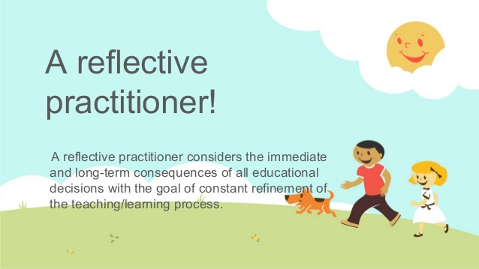
What is Reflective Practice and why it is important for Early Years Practitioners.
Reflective Practice is a clear way in which we can identify problems, consider our own actions and be able to understand and give justification for the choices we have made. It also allows us to identify any possible courses of action of improvement that may be required. It is a process of continual review of our practice to ensure we deliver a high-quality provision for our children.

How can I become a reflective practitioner?
By reflecting we are able to make sense of what we have done or seen. Thinking about our experience allows us to develop professionally and look at ourselves and how we behave and react to certain situations. Critically reflecting is not easy especially if you are an inexperienced practitioner. Several theorists have created a model for reflecting, these can be particularly useful, as they provide steps on how to manage the process of reflection.
Models of Reflection:
I have included two models of reflection to help with the process of reflective practice. The first is a model by Graham Gibbs, it uses a cyclic set of questions to guide you through the process of thinking about what happened, including your thoughts, feelings and actions. This model is straightforward to use and allows the options of reflecting alone or within a group. If you would like to know more about this model go to : https://www.ed.ac.uk/reflection/reflectors-toolkit/reflecting-on-experience/gibbs-reflective-cycle
Model 2.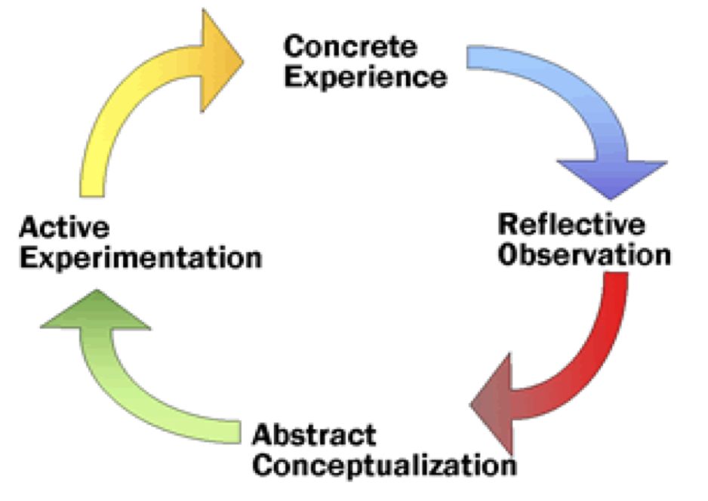
Model 1.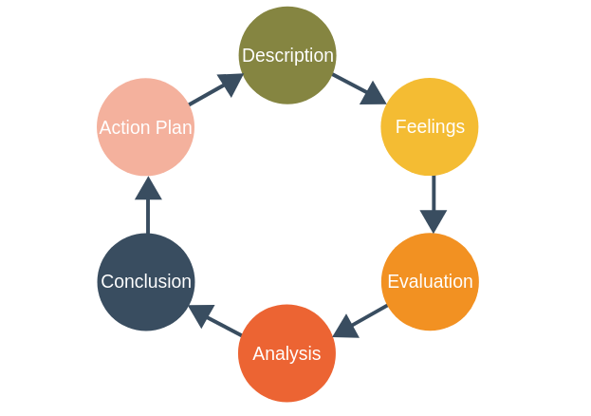

My second model is by is by David Kolb,again this uses a cyclic set of questions but is a shorter sequence. This model lends itself to an educational setting and although it uses more complex language is easy to follow. It is particularly user friendly and you can begin your reflection form any point although you must complete the cycle to reach an outcome. For more information about Kolb’s model visit: https://www.leedsscp.org.uk/LSCB/media/Images/pdfs/Kolb-learningcycle.pdf

Whilst the process of reflecting has the potential to improve practice, for example, it may make you more open to learning and responsive to others (Hargreaves & Page 2013) it is also important to remember our settings policies and services. We must bear in mind the Data Protection policy and also the Additional Learning Needs and Tribunal Act and the Early Years Foundation Phase Framework. By working within the guidelines of our setting we ensure that we respect our collegues and the children in our care. We must also remember the articles set out in the UNCRC, these articles protect our children and ensure they are given a voice.
By continually reflecting on our practice not only do we ensure high quality experiences for the children but we also are given the opportunity to improve and develop professionally, many studies have shown the correlation between the two, Bleach in her study (2014) suggests that regular and ongoing CPD programmes, particularly those which provide scope for reflexivity, support practitioners to develop as professionals and contribute positively to the development of quality practice in their setting.
Element 3 – Reflective Log.
Brief Description of the Activity:
This activity is part of Ceredigion County Council’s TRANDEP intervention. This intervention has been designed for children struggling to learn the welsh language. The intervention sessions are tailored to the needs of each individual child after an initial assessment. The sessions include audio and visual memory games, phoneme and grapheme work initially using the letters t, r, a, n, d, e, p followed by m, c, o, i before moving on to the alphabet.
Aim/Objective of the Activity:
To learn the phonemes and graphemes of t, r, a, n, d, e, p. Be able to identify and use correctly in words.
My Role:
To engage the children using games and multiple resources enabling them to confidently recognise the chosen letters. I model the sounds of the letters, any specific words we are working on and create sentences for the children to repeat. I have to ensure that the children engage with me and each other and that they understand the activities. I work with two children in year 2, both aged 6, and with varying abilities. One comes from an English language home and has difficulty in pronouncing and differentiating letter sounds. The other child comes from a welsh speaking home but has a learning delay and struggles with basic language. All activities must be fun and each element of the session needs to be quite short in time as each session only lasts 45 minutes. There are 5 elements to each session. My role is to ensure that each element of the intervention is covered, I do this by giving the children a choice of activities and where necessary adapt them to their abilities whilst not making it look obvious to each child that they are not working at the same level. We began this session by playing an audio memory game, listing a string of unconnected words. The aim is to remember at least 6 in order. I read out the words and in turn each child repeats what I have read in order. The next activity is to lay the letters t, r, a, n, d, e, p cards on the table in the shape of the rainbow. These cards are used to associate the phoneme and grapheme and we create simple consonant, vowel, consonant and consonant, vowel, consonant, consonant words. I use a list of words provided with the intervention. This activity is one of the most difficult and the one that needs the most adapting so I find that I have to reflect and change throughout to ensure that each child feels confident and achieves the goals of the session. We end the time with a game, usually a spelling card game called ‘Trugs’. This is the children’s favourite game and is a time to enjoy and have some fun, it also reinforces re-reading words we have worked on during the session and allows the children to make a simple sentence including the word on the card. I always end a session by thanking the children for their time and input and they always ask when they can come again!
Challenging Aspects, Why?
Ensuring that each element of the intervention is covered in each session without using the same activities is a challenge, a variation of the same activity is required to ensure continuity, as is ensuring that each activity is available at different academic levels to ensure that each child is able to reach their potential. Time as it is for everyone is a major challenge. Being able to offer the full 45 minutes twice a week ensuring no overuse of each resource and finding the time to acquire and produce sufficient quality resources is a continual issue. On a more personal level it is sometimes difficult to motivate yourself to continue with a specific activity if the children are showing signs of little or no progress. Being patient sometimes can pose as a challenge; what seems obvious to me does not to a child and especially one that struggles with letters and sounds, this can lead to a feeling of frustration and failure and self-doubt.
Knowledge I Demonstrated:
In delivering this intervention I have been given the opportunity to help children that are struggling with letters and pronunciation. My understanding of the welsh language has developed and I feel confident that I am able to introduce the required phonemes and graphemes to the children in an enjoyable and stress-free way. I use the skills from the training sessions such as understanding the necessity of audio and visual games in improving working memory skills, of using both hands when moving cards around, to ensure that both sides of the brain engage and using exercises to develop coordination and balance.
Skills I Demonstrated:
I think that during each session I demonstrate an ability to be able to adapt and change the activities if the children are struggling or not engaging with the task. Ensuring the children are comfortable with each task and introducing what is required using language the children understand and to be able to simplify that language if needed. Although I am sure not everyone would agree with me, I think that having a sense of humour is important, children learn when they are having fun and I am happy to take the brunt of a joke and I also encourage the children to share funny stories. This is a good tactic when the children are becoming tired or loosing concentration during an activity. Showing empathy and concern for the children is also a skill and I think it is one of my strong points.
Values I Demonstrated:
I use my understanding of the ALN guidelines to ensure that each of the children are respected and are given a voice to choose the activities in each session. I also thank the children at the end of each session, to show my appreciation of their hard work during the session.
What could be done differently in future? Why?
I have very little control on the elements of the intervention as these have been set out by Ceredigion County Council’s Education Department but I do have the ability to choose which options are included in each session and to use the resources of my choice. If I could change anything it would be to have a designated room in school to use for my groups. I have to find any available space if the spare classroom is in use, sometimes this is outside the boys’ toilets!!! This is not ideal and can impact on the children’s concentration and enjoyment of the session. This also draws attention from the other pupils and can cause embarrassment to the children in my group.

Element 4 - Personal Development Plan
Area for further development | Why? | How? | Who/Where? | When?
Using Hwb | Improve my knowledge of apps on hwb and my ability to help the children in class. | Training courses | Provided by Ceredigion County Council | From Sept 2020 onwards
Undertake the implementation of ‘Pause Points’ yoga intervention | Encourage the children to relax and improve classroom concentration | Using videos and guide books | Llangwyryfon Primary School | Sept 2020 onwards
Develop my knowledge of Autism Spectrum Disorder | To help me in my role as the school’s ‘Autistic Champion’ | Training Courses  Books | Online courses and courses provided by Ceredigion County Council | From August 2020 onwards
Develop my knowledge of ADHD | To enable me to assist and support children in school | Training Courses  Books | Online courses and courses provided by Ceredigion County Council | From August 2020 onwards
Develop further my knowledge of Dyslexia and Dyspraxia | To enable me to support children and also include strategies within my inclusion groups | Training Courses  Books | Online courses and courses provided by Ceredigion County Council | From August 2020 onwards
Complete level 5 and 6 | Gain my degree | Lectures and home study | University of Wales Trinity Saint David | July 2021.

References:
Bleach, J. (2014). Developing Professionalism Through Reflective Practice and Ongoing Professional Development 22(2) pp.185-197. Available at: https://dxdoi.org/10.1080/1350293X.2014883719 (Accessed: 3rd June 2020).
Brown, N. Reflective model according to Kolb .Available at: https://www.nicole-brown.co.uk/reflective-model-according-to-kolb/ (Accessed 8th June 2020.)
Dewey. Available at: https://ajguesdon.worldpress.com/john-dewey-how-we-think-reflective-practice-journals-and-learning-logs/ (Accessed 11th June 2020).
Early Years Foundation Stage. Available at: https://eyfs.info/articles.html/teaching-and-learning/reflective-practice-what-is-reflection-why-should-it-inform-our-oractice-and-what-does-it-involve-r256 (Accessed 8th June 2020).
Finlay, L. Reflecting on Reflective Practice. Available at: https://www.oro.open.ac.uk/68945/1/finlay-%282008%029-reflective-on-reflective-oractice-PBPL-paper-52.pdf. (Accessed 7th June 2020).
Gibbs 1. Available at: https://www.ed.ac.uk/reflection/reflectors-toolkit/reflecting-on-experience/gibbs-reflective-cycle (Accessed 9th June 2020).
Gibbs 2. Available at: https://www.youtube.com/watch?v=-gbczrO1Rf4 (Accessed 9th June 2020).
Hargreaves, J. and Page, L. (2013). Reflective Practice. Cambridge: Polity Press.
https://doi.org/10.1080/00131881.2020.1711790 (Accessed 5th June 2020).
Image 1: Available at: https://www.bing.com/images/search?view=detailV2&ccid=wYxHT8qx&id=B2B212493D9CADA20AD52561B5E0A07DBDCE85E9&thid=OIP.wYxHT8qxgW5Swr-7YW6gvAHaEK&mediaurl=http%3a%2f%2fimage.slidesharecdn.com%2fteachingyoungchildren-140307182401-phpapp02%2f95%2fteaching-young-children-2-638.jpg%3fcb%3d1394216747&exph=359&expw=638&q=what+is+reflective+practice+early+years&simid=608010800165159916&ck=946971634755B8AA13DAA97D24360C38&selectedIndex=306&ajaxhist=0 (Accessed : 13th June 2020.)
Image 2: Available at: https://www.bing.com/images/search?view=detailV2&ccid=zzQUhJik&id=A752B24ACBE44BE9D07A6EBAB88DC7C0911B87BC&thid=OIP.zzQUhJikNQc5-TJpLYVirQHaFP&mediaurl=https%3a%2f%2fd32ogoqmya1dw8.cloudfront.net%2fimages%2fintrogeo%2fservice%2fkolb_learning_cycle.png&exph=664&expw=938&q=kolb%27s+reflective+cycle&simid=607990626756657657&ck=0B4498742EA9C9B82E10CA9C782ADA26&selectedIndex=13&ajaxhist=0 (Accessed 13th June 2020).
Image 3. Available at: https://www.bing.com/images/search?view=detailV2&ccid=30rMq0hZ&id=C1588FA81E02764B325CBA97D756295955E2B3C6&thid=OIP.30rMq0hZ8AZ6GVdlzR57-gHaFy&mediaurl=https%3a%2f%2fexpertprogrammanagement.com%2fwp-content%2fuploads%2f2019%2f05%2fGibbs-Reflective-Cycle.png&exph=500&expw=640&q=gibbs+reflective+cycle&simid=608019166717412379&ck=58E391D456E8A1B138A8479B75174B7F&selectedIndex=12&ajaxhist=0 (Accessed 13th June 2020).
Kolb 1. Available at: https://www.youtube.com/watch?v=ObQ2DheGOKA (Accessed 8th June 2020.)
Kolb 2. Available at: https://leedsscp.org.uk/LSCB/media/images/pdfs/kolb-learning-cycle.pdf (Accessed 8th June 2020.)
Kolb 3. Available at: https://www.youtube.com/watch?v=-v74nRbwSNqk (Accessed 9th June 2020).
Lindon, J. (2012). Reflective Practice and Early Years Professionalism, Linking Theory and Practice. 2nd edn. Hodder Education.
Markkanen, P. Vἅlimἅki, M. et.al. (2020). A Reflective Cycle: Understanding Challenging Situations in a School Setting. Available at:
McDonagh, M. (2020).’Baby P Council in Dock Again’, The Daily Mail,21st May 2020,p.14-15.
Venninen, T. Leinonen, J. et.al. (2012). Creating Conditions for Reflective Practice in Early Childhood Education. Available at: https://ijccep.springeropen.com/articles/10.1007/2288-6729-6-1-1 (Accessed 3rd June 2020).
What is Reflective Practice?: Available at : https://www.cipd.co.uk/Images/reflective-practice-guide_tcm18-12524.pdf (Accessed 10th June 2020).

