Academic Skills
LCBB4006 – Component 1
Sameena Hassan

This report will be identifying and demonstrating ‘the importance of research skills and referencing which includes paraphrasing, in-text citation and referencing’ for students. The reason we are writing this report to help gather information for students which will be useful with our future essays and reports and how we can make sure we are doing the necessary to ensure we are being as successful as possible.
Academic skills are the tools that we use on a daily basis as a student to help us learn effectively and efficiently. We use them differently as it suits each students requirement and students explore different strategies throughout their studies. These can be discovered in different ways such as academic writing, critical thinking, group work, note making and any sort of preparation for exams alongside reading, referencing, revision and presentation skills. The reason why academic skills are important is because this helps us students learn and remember all the necessary facts which are required to be remembered for future exams and preparations and which will provide us with the life long skills to use in the future in our day to day routine. Academic skills also entail the ability to manage time effectively, research, reference, analyse to reflect. Academic skills is important for students as it gives you the power to feel more control of your studies. Better organised and can help you meet new challenges to be achieved and progressed throughout your studies.
The importance of research skills is that it gives you the freedom to find all needed information and use it accordingly and effectively. It also provides you with the right to be able to create different strategy methods to collate the information which you require answers too and to be able to reach to conclusions quicker. By gathering your information, this gives you the ability to synthesize and be able to communicate all your gathered information in spoken formats and written. Research skills are increasingly transferable and can be adapted to many settings including the workplace.
Paraphrasing is a ‘restatement of someone else’s thoughts or ideas into our own words. Where we must always cite the source when paraphrasing. Whereas plagiarism is the use of another published or unpublished piece of work without their consent or acknowledgement. So when using their work, you are using their work it must be referenced into your work so you are backing up and using the right format.
Referencing skills is the skill which allows you to acknowledge the source of the information acquired and how it can be used correctly into your piece of work. It provides a better understanding to the reader on how you have used the work of others to develop or back up your own ideas and arguments. The importance of referencing skills for a student is greatly appreciated as throughout your education, you would need to draw up many assignments and reports which if you use the correct referencing skills, will provide you with greater marks and understanding. As we understood throughout our module on how we reference using the Harvard referencing handbook which also uses the in-text citations such as ‘. (Pears and Shields, 2016, p. 6). In text citations is used when referring to a source of information within the text of your assignment to show where it has come from. This is a abbreviation format detailed of the source which is being referred to and generally does include the author’s or the editor’s surname, year of the publication and if need be the page numbers.
Below, here is an example of referencing as shown in our Harvard handbook for the different ways which can be used for referencing.
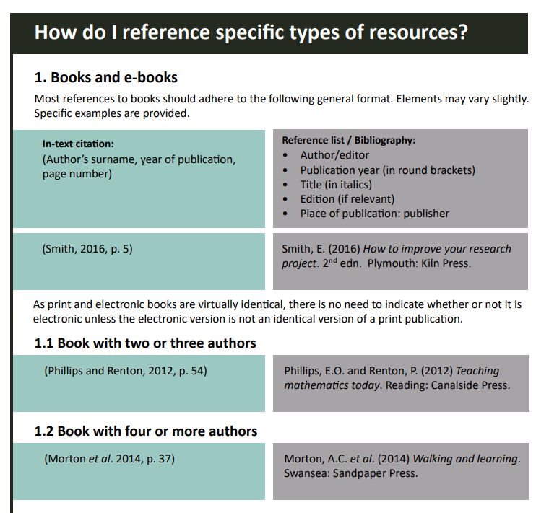
The suggested skills that a successful student would need to develop for an effective and enhanced development of research skills would be to have good management skills and time skills which allowed you to plan out any work given, ensuring you are researching and getting all the sources which you require and if you don’t understand something about the assignment, that you are asking your lecturer. Having the appropriate written and oral communication skills is also vital as this will help you complete your assignments appropriately. Following with having the knowledge and understanding of the research skills, paraphrasing, academic skills which has been analysed, these are also great skills to incorporate in your everyday learning for day to day. Students need to ensure they can work well in a team environment as throughout your studies, this can be very beneficial for yourself and other members in your class as you share different ideas and information which maybe you did not have the knowledge on which allows you to enhance your knowledge to a better understanding of. There are also study skills support available at UWTSD, which can be utilized to help you learn certain skills if required which the support below is offered ensuring you book a timeslot so you are getting the 1-1 support.
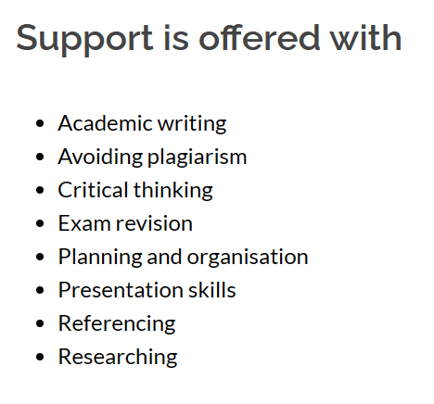
Concluding this report, we have identified all the different skill set which is required for a successful student to thrive in their education and which also provide you with the lifelong skills to use in the future job role you take as all these skills are used on a day to day basis in our lives. If you are using all the skill set provided in class correctly alongside the handbooks which are provided and having the ability to locate the information using different platforms such as internet, books etc. This will allow your education experience be unique and successful as possible.

Referencing :
Home - Introduction to research skills - LibGuides@Southampton at University of Southampton Library (soton.ac.uk) (accessed 1st July 2023) – what is research skills
Harvard-eng_v.1.2.pdf (uwtsd.ac.uk) -referencing accessed 2nd July 2023
Academic Skills | UWTSD – accessed 1st July 2023
Study Skills Support | University of Wales Trinity Saint David (uwtsd.ac.uk) accessed 20th July 2023

