Destination Management: Rye, East Sussex

Module Title: Sustainable Hospitality and Tourism Management
Module Code: BMIH5006
Name: Sufia Islam Munni
Student ID: 2015036
Lecturer: Ruth Taylor Davies

Contents
Destination Management: Rye, East Sussex 1
1
Introduction 3
Sustainability of Rye, East Sussex by three pillars 4
Life Cycle Model of Butler in Rye, East Sussex 7
Doxey’s Irridex Model of Rye, East Sussex 9
Recommendation 10
Reference 11

Introduction
Rye, a wonderful destination for visitors, besets with natural beauty and historically prominent to visitors over the time. As an off bid place for tourists, it is a worthy one but dramatically crowd become intensified as tourism sector upgrades the capability and reform the structures. For long term sustainability of this tourist destination, authority focuses on three pillars model where economic, social, and environmental aspects are considered to reduce vulnerability of future threat by pragmatic steps properly. Life cycle model also depicts current and future the stages of Rye, East Sussex where tourism sectors can be estimated their performance in according with the stages. Another model which is known as Doxey’s Irridex model ranging from euphoria to irritation is the best way to find out the sustainable way operate the tourism and hospitality sectors with environment friendly. These all the model and process are the parameters to be sustainable of Rye, East Sussex (McDonald, J.R., 2009).

Sustainability of Rye, East Sussex by three pillars
Tourist destinations always give amusement, pleasure the visitors by their attractive shape, view, scenery and landscapes. These are the curious mystery to be explored for the visitor to become refreshed and mind satisfaction by spend a while around it where meet a different level of relaxation and place part from crowded cities. Full of excitement and alluring ardor for these places always give some extra of view angle. Rye is one of such gems, nestled in the picturesque county of East Sussex, England. With its rich history, medieval charm, and idyllic surroundings, Rye has emerged as a captivating tourist destination, enchanting visitors from around the world. Rye's story unfolds along its winding cobbled streets, lined with timber-framed houses that whisper tales of centuries gone by (Stipanović, C., Rudan, E. and Zubović, V., 2022). The town's medieval architecture, fortified walls, and centuries-old landmarks create a captivating ambiance, transporting visitors to a bygone era. From the towering spire of St Mary's Church to the haunting ruins of Camber Castle, Rye stands as a living testament to its storied past Rye has an alluring beauty for which captivates visitors along with its prominent history, mesmerizing architectures and landscapes. Three pillar approach is the best ways to be sustainable of tourism sector like Rye, East Sussex where economic, social and environmental issues are considered meticulously. By considering the local context, culture, heritage, and maintaining a sound environment, Rye can preserve its unique character and provide a memorable experience for generations to come (Spracklen, K. and Spracklen, B., 2014).
The first pillar, economic sustainability, revolves around supporting local businesses and encouraging responsible tourism practices. In the local context of Rye, this can be achieved by prioritizing partnerships with local suppliers and artisans. For example, restaurants and shops can source ingredients and products from nearby farms and craftsmen, promoting a vibrant local economy while preserving the authenticity of the region. Additionally, fostering entrepreneurship among residents can contribute to economic sustainability. The town can provide business development resources, such as mentorship programs or small business grants, to encourage the establishment of new enterprises that align with Rye's cultural heritage and values (Trower, S., 2012).
The second pillar, social sustainability, focuses on preserving the quality of life for both residents and visitors while respecting local customs and traditions. Rye's strong sense of community and rich cultural heritage provide a solid foundation for social sustainability initiatives. The town can organize regular community events, such as fairs, festivals, and historical reenactments, to engage both residents and visitors. These events not only celebrate Rye's heritage but also encourage interaction and understanding between locals and tourists. Moreover, Rye can support local artisans by promoting their crafts and providing platforms, such as art exhibitions or craft markets, where they can showcase their work. By nurturing the cultural identity of Rye, the town can ensure that tourism enhances rather than erodes its social fabric (Anwar, K., 2019).
The third pillar, environmental sustainability, is crucial for preserving Rye's natural landscapes and minimizing the ecological footprint of tourism. Rye's close proximity to the coastline and surrounding countryside presents opportunities to showcase the importance of environmental stewardship. The town can establish nature trails, where visitors can explore the area's diverse ecosystems while learning about conservation efforts. Additionally, Rye can promote sustainable transportation options, such as cycling or walking tours, to reduce reliance on cars and minimize carbon emissions. Encouraging waste reduction and recycling is another vital aspect of environmental sustainability. Rye can implement comprehensive recycling programs, distribute educational materials to tourists, and collaborate with local businesses to promote the use of eco-friendly products and packaging (Speakman, M. and Sharpley, R., 2012).
By implementing these three pillars in a holistic and integrated manner, Rye can ensure the long-term sustainability of its tourism industry while preserving its local context, culture, heritage, and sound environment. The synergy between these pillars is crucial to maintaining a delicate balance between economic growth, social well-being, and environmental preservation. For instance, supporting local artisans not only contributes to economic sustainability but also promotes the town's cultural heritage and fosters social cohesion. Similarly, prioritizing eco-friendly practices not only safeguards the environment but also enhances Rye's appeal as an environmentally conscious destination (Spracklen, K., 2016).
It is crucial to identify the key practices, regulations and organizations responsibility for implementation through ensuring the sustainable development of Rye, East Sussex, the popular tourist destination of UK. All the efforts of tourism and hospitality sector play a vital effects in shaping the tourism destination. Rye, East Sussex is subject to various environmental regulations and practices that aim to protect its natural resources and minimize the impact of tourism activities (Kirshenblatt-Gimblett, B., 1998). Organizations such as Natural England and local conservation groups work to safeguard the region's biodiversity and promote sustainable practices. They collaborate with local authorities and businesses to implement regulations related to waste management, energy conservation, and the protection of natural habitats. Additionally, environmental impact assessments are conducted to evaluate the potential consequences of tourism development projects. Preserving the cultural and heritage aspects of Rye is essential to maintain its authenticity and appeal. Historic England is responsible for protecting and conserving the historic buildings, landmarks, and cultural sites within the destination. They work closely with local planning authorities to ensure that tourism development aligns with the region's cultural character and heritage. By implementing regulations and guidelines, they contribute to sustainable tourism practices that respect the local culture and history (Hanley, N., Wright, R.E. and Vic, A., 1998).
In the end, it is the collective efforts of residents, businesses, and visitors that will shape the sustainable future of Rye. By embracing these principles and implementing practical initiatives, Rye can continue to thrive as a beloved tourist destination while preserving its local identity, rich history, and natural splendor. As a beginner student, the journey toward sustainability may be a learning process, but with dedication and collaboration, Rye can set an example for other tourist destinations, inspiring a future where responsible tourism and preservation go hand in hand. As the popularity of Rye as a tourist destination continues to grow, it is crucial to ensure the sustainability of its tourism industry. Sustainability goes beyond mere preservation; it encompasses the harmonious integration of economic, social, and environmental factors. By adopting a three-pillar approach, Rye can safeguard its unique character while providing a memorable and sustainable experience for visitors (Kahn-Harris, K., 2006).

Life Cycle Model of Butler in Rye, East Sussex
Rye, East Sussex which has a charming and historically resourceful significant town, is captivated visitors growth over the years. In order to find out the sustainable development, Life Cycle model of Butler is can be applied. This model helps to identify the different stages of tourist destination places and provides current situations and possibility of future aspects. By examining Rye through the lens of Butler's model, we can identify key challenges and opportunities, and propose strategies for its continued success.
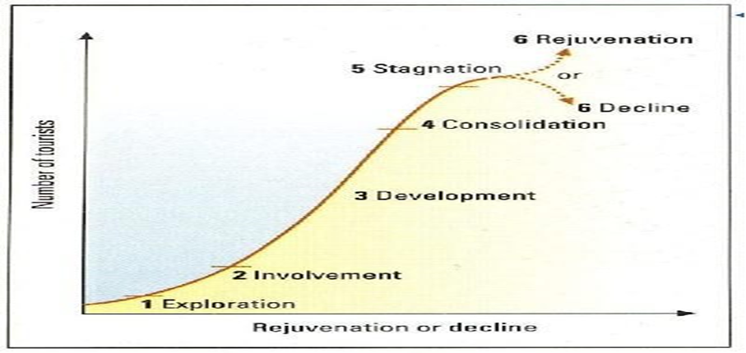
Rye, in its early days, was an undiscovered gem with limited tourism infrastructure. At this stage, adventurous travelers seeking unique experiences and off-the-beaten-path destinations began exploring the town. The historic charm, cobbled streets, and preserved architecture attracted a niche group of visitors (Burdsey, D. and Burdsey, D., 2016).
As Rye gained recognition, more visitors started to discover its appeal. The involvement stage witnessed a surge in tourism, accompanied by increased investment in accommodation, restaurants, and attractions. The local community began to actively engage in the tourism industry, recognizing its economic potential. To leverage this stage, Rye could collaborate with local businesses and stakeholders to enhance the visitor experience through the development of sustainable infrastructure, such as eco-friendly accommodations and locally sourced culinary offerings (Altinay, L. and Kozak, M., 2021).
With the growth of tourism, Rye entered the development stage. This phase witnessed a significant increase in visitor numbers, leading to the expansion of facilities and services. However, it also introduced challenges related to overcrowding, strain on resources, and potential degradation of the destination's authenticity (Baker, M.J. and Cameron, E., 2008).
In the consolidation stage, Rye has established itself as a popular and well-known tourist destination. Visitor numbers stabilize, and the focus shifts towards maintaining sustainability and enhancing the visitor experience. Rye could invest in cultural events and festivals that celebrate its heritage, promote local artisans and craftsmen, and foster community engagement. Without proactive management, destinations can enter a phase of stagnation or decline. Rye must guard against this by continuously innovating and adapting to changing visitor preferences. This could involve diversifying offerings, promoting sustainable tourism practices, and embracing emerging technologies to enhance the visitor experience. Collaborating with neighboring destinations or regional tourism organizations can also help attract new markets and extend the destination's appeal (Bessière, J., 2018). By applying Butler's Life Cycle Model, we gain valuable insights into the evolution of Rye, East Sussex, as a tourist destination. It is crucial for Rye to navigate the different stages effectively, addressing challenges and seizing opportunities.

Doxey’s Irridex Model of Rye, East Sussex
Doxey’s Irridex model gives a clear view for basic understanding of the tourist destination stages, ranging from euphoria to irritation. By using this model, we easily find out the current situation of Rye, east Sussex where it belongs according to stages perameters. Based on the model, Rye, at its initial stage, likely experienced the "Euphoria" stage, where visitors were captivated by its unique charm, historical significance, and picturesque setting. During this stage, tourists are enthusiastic and often share positive experiences, contributing to the destination's reputation and attracting more visitors (Hu, W. and Wall, G., 2005).
As Rye's popularity grew, it likely entered the "Apathy" stage. In this stage, the destination experiences an overwhelming influx of tourists, which can lead to overcrowding, strain on resources, and a decline in the quality of the visitor experience. Locals may start to feel disenchanted by the negative impacts of tourism, leading to a sense of apathy and frustration (Sweet, R., 2012).
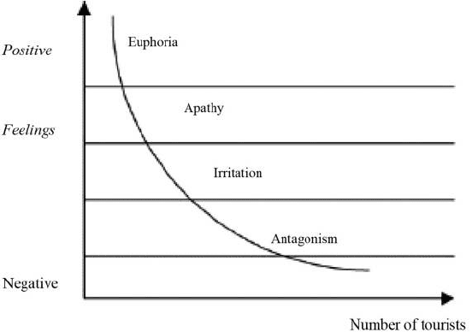
To determine the current stage, it is essential to assess whether Rye has progressed further along the model. If measures have been taken to address the challenges and manage the impacts of tourism effectively, Rye may have moved into the "Annoyance" stage. In this stage, the local community becomes more vocal about the negative consequences of tourism, including issues such as congestion, noise, and environmental degradation. It is crucial to identify these concerns and address them to prevent further deterioration of the destination's appeal (Singh, T.V., 2004).
By analyzing visitor reactions and considering the feedback from the local community, it is possible to determine the stage at which Rye, East Sussex currently stands within Doxey's Irridex Model. This understanding is vital for destination managers and stakeholders to implement strategies and initiatives that foster sustainable tourism development and mitigate any negative impacts (Jardosh, el at, 2003).

Recommendation
Rye, East Sussex, an alluring and historically sound tourist’s destination, captivates visitors all the time where visitors crowd are increasing daily. In order to maintain a healthy and sustainable tourist destination, three pillars of economic, social and environmental factors are crucially considered where all the balance makes a healthy tourist destination area. As visitors crowds is increasing day by day, authority has to be implement Butler life cycle model with every stage performance in order to find out the current and future position of Rye, East Sussex as well as the deviation. From Butler life cycle model, tourism sectors also get used to doing future trends in order to overcome new vulnerability and threats. Lastly, Doxey’s Irridex model also helps to identify the sustainable model of Rye, East Sussex where sustainability is the core issue of the tourism (Le Guin, U.K., 2017).

