THE PROJECT OF THE STAR BAR RESTAURANT CUSTOMER SATISFACTION IMPROVEMENT

STUDENT NAME: KE LIAO
STUDENT NUMBER: 1904617

CONTENTS
EXCUTIVE SUMMARY…………………………………………………………1
1: Project Introduction………………………………………………………………...2
2: Environmental Analysis ……………………………………………………………3
2.1: The quantitative data………………………………………………………….. 4
2.2: The qualitative data from the questionnaire………………………………….. 5
2.3: The Star Bar TOWS analysis …………………………………………..……6
2.4: The needed improvement of customer services summary ………………….. 7
3: Operational Requirements………………………………………………………....8
3.1: Questionnaire delivery …………………………………………………….. 8
3.2: The development of improvement strategies……………………………..….8
3.3: Needed Resources for implementation ……………………………………..11
3.4: Time-schedule for the implementation ……………………………………13
4: Financial Projections…………………………………………………………….14
5: Recommendations and Findings ………………………………………………..16
Reference list……………………………………………………………………….18
Appendices…………………………………………………………………………20

EXECYTUVE SUMMARY

Main findings – research
Questionnaire trends revealed that that the Star Bar’s target customers are primarily students in Swansea, and students’ word-of-mouth maintains its way of publicity.

Questionnaires also revealed that the taste of noodles and rice were not cooked well, need improvement.

Finally, 40.86% of all the respondents showed the willing that the service attitude needed improvement. 10% of customers commented that sometimes there were only two waiters in the restaurant, and 42.25% of respondents said they want the waiting-time of the dishes could be shorter.

The TOWS analysis
The TOWS analysis shows the opportunities and challenges of the Star Bar’s business in Swansea, which revealed that overcoming the shortcoming of customer services like waiting-time, quicker response, better cooked rice and noodles could usher in more potential customers.

Complimentary cold dishes strategy
For those who fill the questionnaire could be given away a plate of cold dishes in the Star Bar restaurant, which attracted over 70 customers completing the questionnaires.

Recruiting and training employees strategy
Through the hunting-job websites, like LinkedIn and Glassdoor could find the needed employees, and the website of PATRIOT could provide onsite and online training for the employees

- Project Introduction
Nowadays, the eating habits of western has a radical alteration reflects towards the opening of Chinese restaurants (Roberts, 2004). Also, with the impact of financial flows and better migration policies in both China and the UK, more Chinese students choose the UK to chase higher education (Iannelli, 2014). Owing to these reasons, numerous Chinese students coming to Swansea for chasing higher education, and lots of Chinese settling and immigrating here to start their own business, nearly 20 Chinese restaurants have emerged in Swansea. Despite the growing number of Chinese restaurants springing up, it does not mean the performance of Chinese restaurant is becoming better. A myriad of problems is exposed in a trip ranking website, tripadvisor.co.uk, where mixed reviews of Chinese restaurants are unfolded. Then, it is necessary to figure out the problem of why Chinese restaurants ranked low among the local restaurants.

In this project, the Star Bar was chosen as the target restaurant for its accessing customer satisfaction through delivering online questionnaires to its customers. Unlike buying material products or simple service business, hospitality customer experiences are an amalgam of services and products (Pizam, 2016). Marketing experts observed that customer satisfaction in the restaurant consist of the three-element: focusing on the material product like food and beverages; emphasising the behaviour and attitude of the employees; concerning the ambience such as the building, the layout and the furnishing or lighting (Reuland et al., 1985). Therefore, the above three were considered in the designing of the questionnaire.

Then, the aim of undertaking this report is for improving customer satisfaction of the Star Bar restaurant, which would retain the customer and attract more customer in the future. The objectives of this report are conducting and analysing the survey and developing improvement strategies. The project provides strategies including how the Star Bar training staff to cook noodles and rice better, how investing in better cooking equipment, how employing more staff, and how making a reasonable pring.

The PRINCE2 methodology was applied to instruct the whole life cycle of the project, which contains seven parts: Starting up a project, initiating a project, directing a project, controlling a stage, managing product delivery, managing stage boundaries, and closing a project (VANÍČKOVÁ, 2017).

- Environmental Analysis
2.1 The quantitative data
The questionnaire identified the following trends in quantitative data:

Before analysing the quantitative data, one thing that needed to be noted is that all the questionnaires are delivered to 71 customers of the Star Bar, and all the respondents are Chinese.

The majority of respondents to the questionnaire were female, counting 59.15% of majority, which could mean that females have greater patience and propensity to take part in questionnaires than men. This data will be taken into account because those questionnaires were designed an extra part named recommendation, which may affect the validity of the results.

The most apparent age group among the respondents was 18-30 years old, with a majority of 90.14%. Also, the occupation group among the respondents was students, with data of 85.92%. These two factors could have some linkage of revealing the target consumer of the Star Bar.

It needs to be mentioned that 40.85% of respondents showed that they are not satisfied with the update of dishes in the Star Bar.

Also, 40.85% of all the respondents expressed that the service attitude needed improvement, and three people added extra suggestions on the questionnaire said that sometimes the whole restaurant only two waiters. What is more, the question of the waiting-time for dishes unfolded this problem, only 11.27% of respondents chose the option satisfied.

As once mentioned previously, food and beverage take up a significant position in the hospitality sector. However, 43.66% of respondents had encountered the circumstance that the chosen dishes were unavailable in the Star Bar. Moreover, the taste of pasta – the same as Chinese noodle, and rice was not that met respondents satisfaction. 38.03% of respondents chose the option that they wanted the Star Bar to make some improvement on the noodle and rice.

69.01% of all the respondents conveyed that they liked the spicy food in the Star Bar, and 64.79% of respondents expressed their satisfaction on food flavour. Most of all, 66.20% of respondents showed that they thought the pricing of the Star Bar was rather pricey. These sample size for the questionnaire are disproportionately weighted in the aspect of one particular food flavour and price, which may affect the validity of the data (Burgess, 2001).

2.2 The qualitative data from the questionnaire
From the occupation and age group of all the respondents, it can be concluded that the Star Bar’s target customers are primarily students in Swansea, and students’ word-of-mouth maintains its way of publicity. Also, the disproportionate percentage of respondents expressed that their pricing was relatively higher than other Chinese restaurant had a degree of credibility that is because most of the respondents had a high frequency in visiting this restaurant.

Observing the respondents preferred tasty and their approval on the Star Bar’s flavour, it can be concluded that the Star Bar restaurant features in spicy flavour and their food always cooked in spicy. Also, From the response of the taste of noodle and rice, most of the respondents expressed these two staple foods were not cooked well. Moreover, nearly half of the respondents had encountered the circumstance of being informed without the chosen food. All of these factors unfolded an essential problem of this restaurant for the food quality, which accounts for a vital factor in customer satisfaction (Ryu, Lee, and Kim, 2012).

As for the service quality, it mainly focused on the performance of employees like whether employees are always willing to help customers and whether enough employees are providing prompt and quick service (Ryu, Lee, and Kim, 2012). However, on the question of rating service attitude, 40.86% of all the respondents showed the willing that the service attitude needed improvement. Moreover, on the review of the Star Bar’s website, 10% of customers commented that sometimes there were only two waiters in the restaurant, and 42.25% of respondents said they want the waiting-time of the dishes could be shorter, which means the Star Bar needed to recruit more staffs.

2.3 The Star Bar TOWS analysis
INTERNAL FACTORS
EXTERNAL FACTORS |  | STRENGTHS(S)  1. The Star Bar restaurant enjoys an excellent location in the consumption centre with a large stream of people.  2. The Star Bar offers a variety of food with Chinese characteristics, such as tofu and dumplings.  3. The Star Bar also develop delicate dishes with local characteristics, such as beef dishes and sweet-sour fish, which could meet the taste needs of many people.  4. Well-quality equipment and distinct dining ambience. | WEAKNESSES(W)  1. The waiting-time before dishes offer a bit of long, and the waiters are understaffed.  2. waiters are all unexperience students.  3. Be a lack of well-designed practicable organisation rules and practice code.  4. Some food cannot be adapted by local, such as pork liver and chicken feet.  5. The pricing in the Star Bar is relatively higher than other Chinese restaurants.
EXTERNAL FACTORS | OPPORTUNITIES(O)  1. In recent years, the hospitality and tourism industry has dramatical development. A large number of foreigner visitors come to Swansea for business or travel.  2. Intercultural communication factor is an opportunity for the Star Bar business, for more local people want to try Chinese food and know about Chinese culture.  3. The majority population of Asian will come to Swansea, as it is convenient for travelling and exchange of learning here with numerous Chinese restaurants  4. Unique Chinese food will bring diversity food choice in Swansea. | SO  - Take advantage of its location, and do some promotions to attract visitors, such as Chinese people can enjoy a 10% discount if they bring local people to dinner, which can also improve the intercultural communication between the local people and Chinese people.  - Develop more delicate dishes combined with both Chinese and local characteristics.  - Launching two menus, one is for Chinese visitors or students with authentic Chinese characteristics. The other one is for local people with improved flavour. | WO  - Design detailed restaurant practice code and timetable for its employees.  - Recruit more waiters and trained them at least one week, and teach them the necessary skill in the restaurant.  - Pre-arrange the needed food in menus, and hire 2-3 chefs. Then, it will shorten the waiting- time.  - Some foods with unique characteristics, or generally, can not be accepted by local customers, should be extra marked an underlined or informed in advance.
EXTERNAL FACTORS | TREATS(T)  1. As a new star in Swansea restaurant business, it will be difficult for the Star Bar to build customer loyalty and trust in Swansea market.  2. The Chinese restaurant is limited in the UK market, owing to the factors as polices, global economic fluctuation.  3. The Star Bar faces enormous pressure of competition from other Chinese restaurants as they offer a similar dining experience and food.  5. The potential threat is the rising price of certain Chinese foods. | ST  - Know other Chinese restaurant’s strengths and roll out the Star Bar’s speciality.  - Build customer loyalty and trust by designing some customer services like take-out, membership, or specific discount day.  - Develop specific supply chain then stabilise the sale prices. | WT  - Train student employees and improve employee’s sense of belonging through material incentives.  - In terms of such unaccepted food like chicken feet and pork liver, see how competitors handle them.  - Improve the quality of its customer services and create a comfortable dining ambience for customers.

2.4 To sum up the needed improvement customer services of the Star Bar restaurant
According to the previous questionnaire data and TOWS analysis of the Star Bar resutaurant, some new propositions could be designed in order to improve the Star Bar’s business performance.
- Recruit at least two more waiters and two chefs, guaranteeing the employees will provide prompt and quick service (Almohaimmeed, 2017)
- Train new employees and design practical practice code.
- Relatively lower pricing, research shows that satisfaction and price are almost always inversely related (Keiningham, 2014).
- Develop new dished combined with the local and Chinese characteristics to attract more local people.
- Broden more taste of food, not limited in spicy.

- Operational Requirements
3.1 Questionnaire delivery
The initial stage of the research process was in the form of an online questionnaire, designed and distributed through the online platform Wjx.cn (see Appendices). The questionnaire was designed to capture data about customer satisfaction of the Star Bar restaurant customers, and utilise a mix of related questions to yield mixing qualitative and quantitative information (Bryman, 2017).

The first phase of the survey was to gather qualitative data through a conversation with the manager of the Star Bar restaurant, for this method raise more issues through broad and open-ended inquiry (Choy, 2014). At this phase, a comprehensive survey of this restaurant was implemented, by which the relevant information was dug out such as the size of its dining area; the number of its service persons, chefs, and tables; and the pay of its employees. The second phase of the survey was to collect quantitative data by distributing online questionnaires for the customers of the Star Bar restaurant, for this method facilitated numerical data for groups and captured the explicit extents of agreement or disagreement from its respondents (Choy, 2014).

The survey was piloted through a closed group on wechat, a Chinese communication application, which allowed the responses to be monitored online to detect any anomalies, and also feedback would be given to the responses. The questionnaire was distributed in its final draft in November and was redistributed in December to gather more potential responses until more than 60 respondents.

3.2 The development of improvement strategies
Given the previously mentioned new propostions of the Star Bar restaurant, some improvement strategies have been set here.

- Job-hunting websites strategies
Regarding the understaffed waiters and chefs in the Star Bar, the project utilised job-hunting websites in an attempt to recruite employees.

LinkedIn and Glassdoor were selected as part of the job-hunting websites strategy. The LinkedIn strategy gave job-hunting people the ability to showcase their profile, expertise, recommendations and connections. Also, LinkedIn allowed the restaurant to gain exposure to hiring managers and recuiters. The Glassdoor platform permitted the Star Bar restaurant showcased its compensation, benefits and perks to attract their potential employees. Through these two channels, the Star Bar restaurant could recruite its employees who meet its requirements.

- Reducing waiting-time strategies
Surpassing 40% of respondents required a shorter period of wating-time. Also, most of them complained that the service was too slow, waiting a long time for the waiters.

As for reducing the waiting-time, the key is to clear tables as soon as possible and reduce the processes of bill payment that would distract waiters from other tasks. Therefore, the digital dining system could be installed, allowing customers to pay at their table through an automated system which empowers them to leave when they want. Also, the Star Bar could provide tablets installed with entertainment games for its

- Equipment investing strategies
Nearly 40% of respondents wanted the Star Bar to make some improvement on the noodles and rice. So, the Star Bar could invest in better equipment for cooking rice and noodles. Then, a qualified rice cooker and pot would be needed. However, a new restaurant does not always need all new equipment (Loffredo, 2015). The Star Bar restaurant could purchase quality used restaurant equipment in a second-hand market. Also, the Star Bar could lease restaurant equipment in Bar & Catering Supply Co, The Catering Warehouse, or RACS, Swanse restaurant equipment store, to lease needed equipment. Moreover, the Star Bar could utilise online shopping website such as e-Bay, Amazon, to buy second-hand equipment.

- Training staff strategies
As a Chinese restaurant, rice and noodles are Chinese specialties. However, 38% of respondents showed discontent with the Star Bar’s rice and noodles. Also, through the qualititative research, 40.85% of all the respondents expressed that the service attitude needed improvement.

As a new restaurant, in order to ensure that the new establishment thrives on being a renowned brand, the only way is to keep training new staff members (Sullivan, 2013). The first thing that needs to do is creating and upgrading the Star Bar’s training plan. Dividing the service staff into four parts: the bar, dining, kitchen, hosting and serving, among others, each part is taking charge of their job. Then, restaurant managers are advised to ensure that the experienced staff, especially department heads, will give guidance and observance to the actions of the new staff. Also, the Star Bar could provide external training for its employees, such as onsite training or via online classes.

Moreover, as for improving service attitude, the perform employee evaluation is a valuable exercise, which would help to track the employee’s progress and determine whether the employee is a valued member of the team (Raza, 2015). The Star Bar restaurant could provide employee performance reports containing data and information collected daily, weekly and monthly. From this data, a performance review of each employee can be created.

- Updating menus strategies
From the quantative analysis that 69.01% of respondents showing their satisfaction on the Star Bar’s spicy flavour, which means that the fearture of the Star Bar is for cooking food spicy. However, from the restaurant’ name, it does not suggest that this resraurant is specially for Sichuan cuisine, known for is spicy food in China. Then, in order to attract more customers and broaden more taste of food and develop new dishes, some updating menu strategies have been fomulated.

The first way is the DIY approach, such as billboard and small backboard, putting the board outside the restaurant. In the board, the Star Bar could write down its weely dishes with color highlighters to attract potential customers. Also, combining the weekly dishes and corresponding sales volume could better understand the characteristic of the Star Bar.

Also, the high-tech approach could be adapted. As an alternative to printed menus, the Star Bar could opt to present customers with digital tablets cantainning their menus. Moreover, the Star Bar could place the customers’ order directly on the tablet, letting your customers know the waiting-time clearly.

3.3 Needed Resources for implementation
The following chat shows the resources needed in the project:

resources | 1.The current status of the Star Bar restaurant:  - The number of its service people  - The payment of its employees and manager  - The quality of its cooking equipment  - The waiting-time before food arriving  - The pricing of its food  - The form of proving menus  - The pricing of its competitors: SICHUAN SAVOUR, YUMMY GARDEN and WILD SWAN.  2. The application of Wjx questionnaire website  3. The design of an online questionnaire  4. seventy-one cold dishes for the people who complete the questionnaire  5. one digital tablet for updating menu  6. two second-hand cooker equipment and two second-hand pot for cooking noodles  7. onsite training for employees
people | 1.The needed recruited employees:  - Two more waiters to reduce the waiting-time of dishes  - Two more chefs to cook quicker  - One restaurant manager  2. seventy-one customers of the Star Bar to complete the questionnaires  3. three volunteers: one people design the questionnaire; one people deliver the questionnaire; one people collect quantitative data
technology | 1. Applying online questionnaires website  2. Gantt chart used to design the time-chedule for completion  3. Telephone used to make a conversation or interview with the STAR BAR’s boss.
data | 1. Colleting seventy-one online questionnaires about the STAR BAR’s customer satisfaction.  2. Colleting quantative and qualitative data.

3.4 Time-schedule for implementation
The whole time-shcedule setting was under the guidance of the PRINCE2 project life cycle methodology (VANÍČKOVÁ, 2017). In the initiating project stage, The first thing is to select a target restaurant for this project (VANÍČKOVÁ, 2017). Undoubtedly, qualitative research would be impleted to make a comprehensive analysis of the target restaurant by making a conversation with its boss. At this stage, asking the permission of its boss was important. Also, through the conversation, the current status of the restaurant should be noted. Then, online customer satisfaction questionnaires should be delivered after the process of designing and piloting. After analysing the qualitative and quantitative data, A TOWS analysis of the Star Bar was completed, which shows the opportunities and challenges of the restaurant. Based on the TOWS analysis, qualitative and quantitative data, new propositions of the restaurant were designed.

In the stage of directing the project, the new propositons should be under control. Therefore, different tasks and possible risk were identified in this stage.

In the stage of service delivery management (VANÍČKOVÁ, 2017), work requirements and work process were identified in detail. It includes the needed resources, people, facilities and time schedule. Then, the output of this stage established a comprehensive offer of services, calculating the cost of this project implementation.

In this project, it mainly focused on the clear objectives and the process of its implementation. Therefore, compared with agile methods, waterfall methods boasts such merits as a clear process and predictable domain (Kisielnichi, 2017). Moreover, this project is not that complex, so that the linear process of the waterfall method will be well-adopted (Andrei, Casu-pop, and Boiangiu, 2019). Also, for the uncertainty process of recruiting employees, the purchase of cooking equipment could be made at the same time. The following is a Gannt chart using the waterfall method:

- Financial Projections
In the process of operation, there are two primary spends in the project: the first one is the permission to use the Wjx application, the other one is the complimentary cold dish for the respondents. The cold dishes price was according to the Star Bar restaurant, and the price of cooking equipment was from the onling shopping website eBay. The setting of a manager and waiters’ salary were from the Star Bar, and the training cost for employees was from the website GMS (GMS, 2019). It said that each organisation spend an average of 1,208£ per employee on training and development.
The following is the financial table of this project for one month:
Items | Description | Quantity | Cost | Total
Wjx.com website | Using for passing online questionnaires | 1 | 10£ | 10£
Cold dishes | Using for giving away to those who fill the questionnaires | 71 | 3£ | 213£
volunters | designing the questionnaire; delivering the questionnaire; collecting quantitative data | 3 | 0 | 0
Second-hand cooker | Using for cooking rice | 2 | 1295£ | 2590£
Second-hand pot | Using for cooking noodles | 2 | 50£ | 100£
waiters | salary for waiters | 2 | 765£ | 1530£
Restaurant manager | Salary for manager | 1 | 4118£ | 4118£
Digital tablet | Using for updating menus | 1 | 414£ | 414£
Onsite training | For employees training programs | 2 | 1,208£ | 2,416£
Total cost |  |  |  | 11,391£

Through this table, knowing the total cost of the improvement was 11,391£. The montly profit of the Star Bar restaurant is 28,750£. Then, the improvement of this restaurant would break even on costs in one month.

- Recommendations & Findings
In conclusion, the quantative research methodogy for the project reflected the limitations identified in the questionnaire size and anonymous form filler. Even though nineteen questions had been designed for the target customers, but many flaws had presented in the question design, such as the setting of answer without precision. The other factor was that the survey only yielded a small sample size (Basias and Pollalis, 2018), among which some samples were invalid data, such as some respondents choosed all the “dissatisfied” or the “satisfied” options.

Also, from the survey of results, most respondents satisfied with the flavour of the Star Bar. However, one of the limitations was that the main source of the customer was Chinese overseas students, which means the restaurant’ primary promotion way was the word-of-mouth. The other limitation was that most local people unaccepted spicy food. Combing these two factors, it demonstrated that the business of the Star Bar restaurant was vulnerable to the economic environment. However, according to the rating website review and literature of Roberts (2004), more and more UK people were willing to try Chinese food, which shows the participation in the UK was indeed transferrable to the local people in Swansea.

From the stragies of recruiting employees, the job-hunting website of Glassdoor and LinkedIn could recruit its needed employees. However, the unexposure of the qualitative information was that the primary source of its employees was the overseas students coming from mainland, HongKong or Taiwan. The Star Bar restaurant did not rely on recruiting employees in other ways.

From the stragies of training employees, the onsite training or online training was indispensable for the development of employees. Actually, from the unexposure of qualitative information, most of the employees without profeshional training, who were only followed or taught by more experienced ones. Addition, the risk asseement of this traing stragies was high for the sake of small business restaurant would be unreluctant to spend too much money on this.

The process of time schedule implementation was flawed, for the process of recruiting employees was uncertainty, and the employees who needed training was unsure also, which resulted in the exact amount of money was uncertainty.

Ultimately, within each step of schedule implementation, there were no methods to be set for identifying the projects progress and the levels of control over the project. It also needed to be mentioned that the toal cost control in this project had not been involved (Goh and Hall, 2013).

Recommendations:
- Some techniques of control management could be utilised to control the trend of poject, such as Cash flow, cost contrl method and trend analysis (Montes-Guerra, Gimena, Perez-Ezcurdia, and Diez-Silva, 2014).
- Social medida platforms could be added to speed up the process of recruiting employees, such as twitter and Instagram. Also, which platform could yield a broader audience should be considered.
- The project should collect more qualitative information from the owner of the target restaurant, such as how much of their budget and how many empoyees needed training.

Reference list
- ALMOHAIMMEED, B.M.A., 2017. Restaurant Quality and Customer Satisfaction. International Review of Management and Marketing, 7(3),.
- ANDREI, B., CASU-POP, A., GHEORGHE, S. and BOIANGIU, C., 2019. A STUDY ON USING WATERFALL AND AGILE METHODS IN SOFTWARE PROJECT MANAGEMENT. Journal of Information Systems & Operations Management, , pp. 125-135.
- ARENDT, S.W., ROBERTS, K.R., STROHBEHN, C., ELLIS, J., PAEZ, P. and MEYER, J., 2012. Use of qualitative research in foodservice organizations. International Journal of Contemporary Hospitality Management, 24(6), pp. 820-837.
- Bryman, A., 2017. Quantitative and qualitative research: further reflections on their integration. In Mixing methods: Qualitative and quantitative research (pp. 57-78). Routledge.
- Burgess, T.F., 2001. Guide to the Design of Questionnaires. A general introduction to the design of questionnaires for survey research, 30(4), pp.411-432.
- BASIAS, N. and POLLALIS, Y., 2018. Quantitative and Qualitative Research in Business & Technology: Justifying a Suitable Research Methodology. Review of Integrative Business and Economics Research, 7, pp. 91-105.
- Choy, L.T., 2014. The strengths and weaknesses of research methodology: Comparison and complimentary between qualitative and quantitative approaches. IOSR Journal of Humanities and Social Science, 19(4), pp.99-104.
- FIRMENICH, J., 2017. Customisable framework for project risk management. Construction Innovation, 17(1), pp. 68-89.
- GOH, J. and HALL, N.G., 2013. Total Cost Control in Project Management via Satisficing. Management Science, 59(6), pp. 1354-1372.
- Iannelli, C. and Huang, J., 2014. Trends in participation and attainment of Chinese students in UK higher education. Studies in Higher Education, 39(5), pp.805-822.
- Keiningham, T., Gupta, S., Aksoy, L. and Buoye, A., 2014. The high price of customer satisfaction. MIT Sloan Management Review, 55(3), p.37.
- KISIELNICKI, J. and MISIAK, A.M., 2017. EFFECTIVENESS OF AGILE COMPARED TO WATERFALL IMPLEMENTATION METHODS IN IT PROJECTS: ANALYSIS BASED ON BUSINESS INTELLIGENCE PROJECTS. Foundations of Management, 9(1), pp. 273-286.
- MONTES-GUERRA, M., GIMENA, F.N., PÉREZ-EZCURDIA, M.A. and DÍEZ-SILVA, H.M., 2014. THE INFLUENCE OF MONITORING AND CONTROL ON PROJECT MANAGEMENT SUCCESS. International Journal of Construction Project Management, 6(2), pp. 163-184.
- NGUYEN, Q., NISAR, T.M., KNOX, D. and PRABHAKAR, G.P., 2018. Understanding customer satisfaction in the UK quick service restaurant industry. British Food Journal, 120(6), pp. 1207-1222.
- PIZAM, A., SHAPOVAL, V. and ELLIS, T., 2016. Customer satisfaction and its measurement in hospitality enterprises: a revisit and update. International Journal of Contemporary Hospitality Management, 28(1), pp. 2-35.
- Reuland, R., Coudrey, J. and Fagel, A., 1985. Research in the field of hospitality. InternationalJournal of Hospitality Management, Vol. 4 No. 4, pp. 141-146.
- RYU, K., LEE, H. and KIM, W.G., 2012. The influence of the quality of the physical environment, food, and service on restaurant image, customer perceived value, customer satisfaction, and behavioral intentions. International Journal of Contemporary Hospitality Management, 24(2), pp. 200-223.
- Raza, I., 2015. Impact of training and development on employee performance.
https://www.theseus.fi/bitstream/handle/10024/97788/Raza_Imran.pdf;sequence=1
- SULLIVAN, J., 2013. How restaurant managers can quickly address challenges. Nation's Restaurant News, .
- Stacey Linn., 2015. The True Cost of Employee Training Programs.
https://www.groupmgmt.com/blog/post/2015/06/02/The-True-Cost-of-Employee-Training-Programs.aspx
- VANÍČKOVÁ, R., 2017. Application of PRINCE2 Project Management Methodology. Studia Commercialia Bratislavensia, 10(38), pp. 227-238.

Appendices
Q1: What is your gender (male or female)
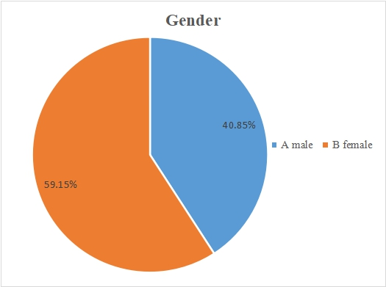

Q2: What is your age?
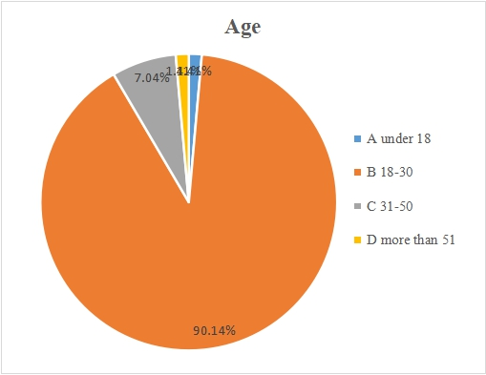

Q3: What is your occupation?
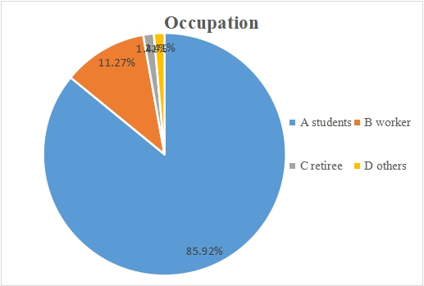

Q4: How often do you go to the Star Bar?
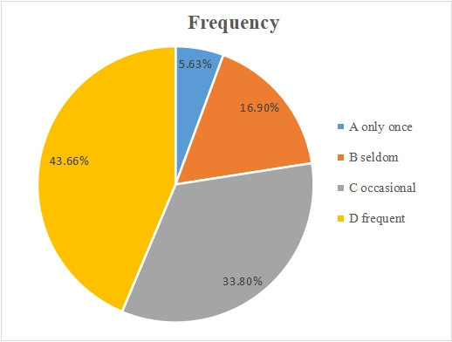

Q5: Are you satisfied with the portion sizes in the Star Bar?
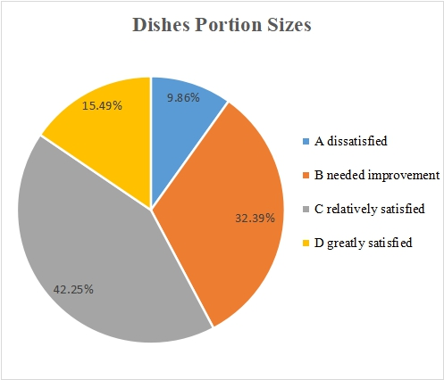

Q6: Are you satisfied with the freshness of the dishes in the Star Bar?
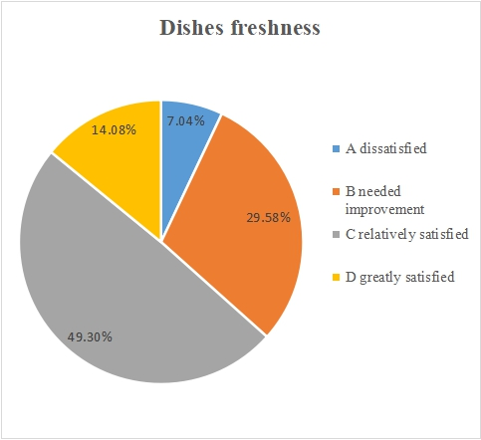

Q7: Are you satisfied with the update of the dishes in the Star Bar?
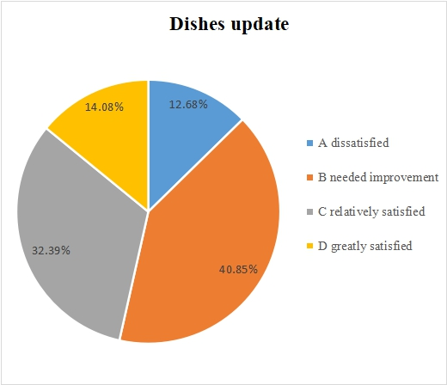

Q8: Are you satisfied with the service attitude of the staff in the Star Bar?
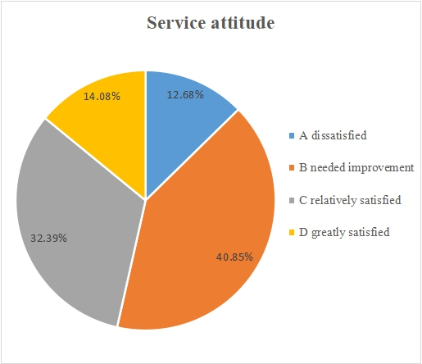

Q9: Are you satisfied with the sanitary condition of the Star Bar?
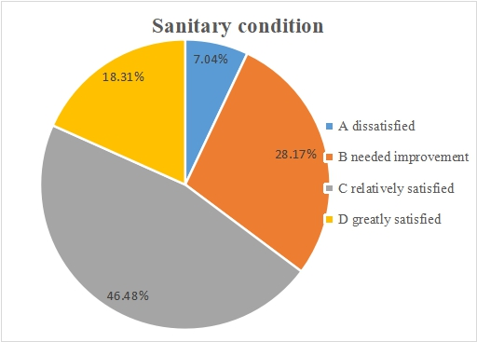

Q10: Are you satisfied with the disinfection of tableware in the Star Bar?
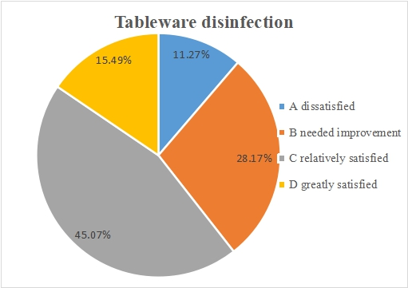

Q11: Are you satisfied with the dishes waiting-time of the Star Bar?
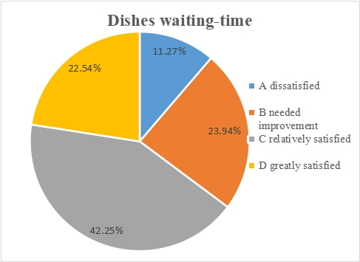

Q12: Are you satisfied with the dining environment in the Star Bar?
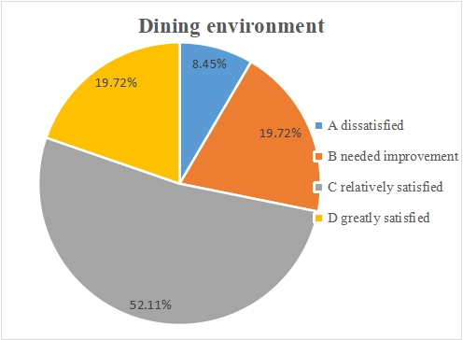

Q13: Are you satisfied with the rice in the Star Bar?
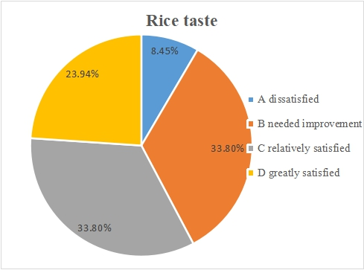

Q14: Are you satisfied with the pasta in the Star Bar?
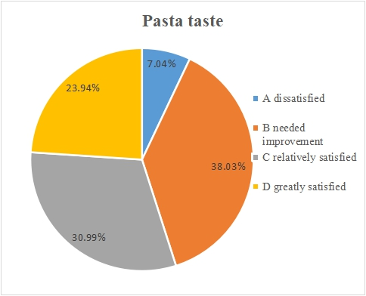

Q15: During meal time, have you ever encountered the circumstance that chosen dishes are unavailable in the Star Bar?
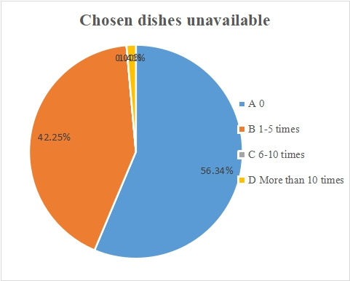

Q16: How do you think of the food flavour in the Star Bar?

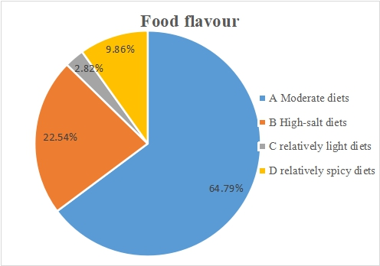

Q17: What kind of flavour would you like in the Star Bar?
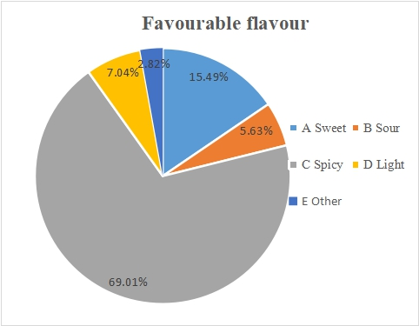

Q18: What is your overall satisfaction with the Star Bar?
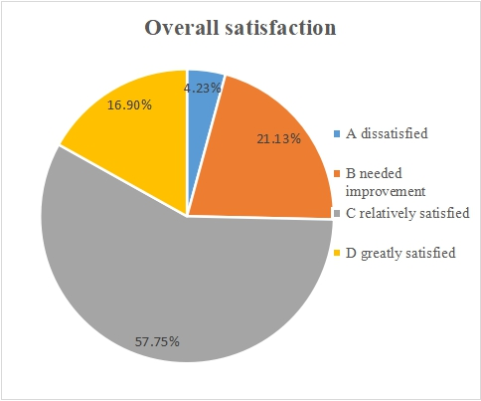

Q19: What do you think of the prices at the Star Bar?


