Design for Protest: An Inquiry into the Feminist Movement and major influences from the Suffrage Movement.

Bethany Curtis 1700923
BA Graphic Design
Word Count: (6567)
Supervisor: Donna Williams

Contents

Introduction 3

Chapter 1 - The Suffrage Movement 5
- The Origin of Feminist Design
- Artists of the Suffrage Campaign – Lowndes and the Artist’s Suffrage League
- Artists of the Suffrage Campaign – The Suffrage Atelier
- A Corporate Identity and Political Merchandising
- Tackling Anti-Suffragist Backlash
- The Power of the Spectacle
- WWI
- Gaining the Vote
- WWII

Chapter 2 – Feminist Protest Design 60’s through to 90’s 19
- The Emergence of the Second Wave
- Women’s Liberation, and Identity
- Developing a Visual Language
- The Dinner Party
- Sheila Levrant de Brettville
- Even Angrier
- Barbara Kruger
- Guerrilla Girls

Chapter 3 – 21st Century Feminist Protest Design 30
- An advancement in Technology
- The Women’s March
- For all Womankind
- Online

Conclusion 34

Introduction
Graphic expression in its many forms has played a significant role in the battle for women’s rights in feminist movements. Ever since the late 19th century, women through to the present day have been fighting for equality and using design to voice their opinion and protest their rights. But how?

This inquiry aims to analyse the origin of feminist protest design. I will research what caused women to take charge and utilise their design skills to become heard in society. My aim is to research and develop my knowledge about the women and organisations behind monumental pieces of feminist design, analysing what made their design stand out amongst others. I aim to get an understanding of the methods and strategies used within movements, that helped build a visual identity and achieve support for their cause. I will establish a timeline that documents monumental and major design that has developed since the origin.

Chapter One will discuss the emergence of feminism, showing research from the infamous works of the Suffrage movement and paying homage to them. For propaganda purposes, I will specifically be examining the ways in which they utilised design and graphics to protest and voice their opinions. I will undertake research into how the suffrage campaign came to be suspended, and how new opportunities for women arose.

Chapter Two will explore monumental pieces of second wave feminist design. I will discuss how the women during this period took a large amount of inspiration from the Suffrage movement, and how they adapted these methods and strategies for their cause. Chapter Three will bring us to recent years and will be focused on 21st century feminist protest design. What impact has the advancement of technology had?

I will take reference largely from McQuiston, as her books on this topic are particularly insightful. I have also found an interesting variety of sources and up to date journal articles on the online library.

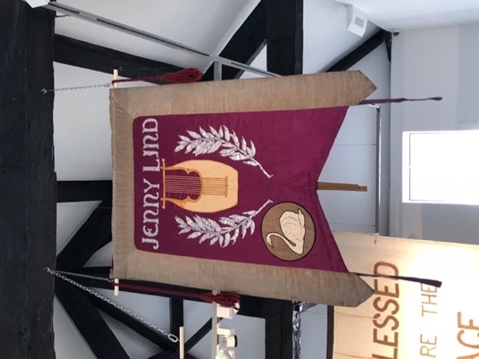
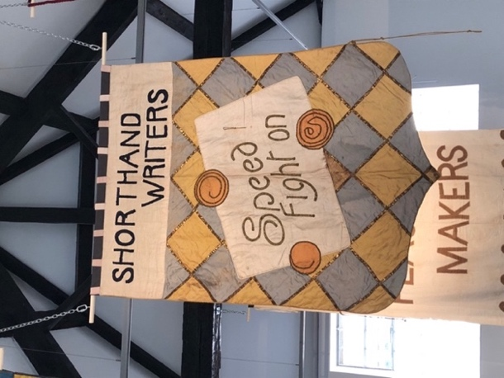
Overall, I am enthusiastic to learn more about significant feminist design created for protest. I want to gain a better understanding of specific moments in history that have made women feel compelled enough to use their graphic voice and stand up for themselves. I attended an exhibition BANNER – 100 years of protest last year in the New Brewery Arts Centre, Cirencester. I felt so empowered and overwhelmed upon viewing original Suffrage banners which were on loan from ‘The Women’s Library’ collection (Fig 1, 2). It made me appreciate the lengths that this movement and many others since went to, enabling a better place for me as a woman in today’s society. This is ultimately the reason I chose this subject path for my individual inquiry.
Fig.1 & 2 Suffrage Banners

Chapter 1
The Suffrage Movement
In this chapter I will discuss the emergence of feminism. I will be researching the suffrage movement and the ways in which they utilised design in their fight to gain the women’s right to vote. I will specifically be looking at the women and groups behind the movement’s art and how they tackled backlash.

The Origin of Feminist Design
It was during the mid-nineteenth century that feminism emerged. By the 1900s there was a rapid acceleration of agitation particularly focused around the women’s right to vote. The Suffrage movement was born and the efforts and promises of emancipation quickly began. In Britain, the National Union of Women’s Suffrage Societies (NUWSS) formed in 1897, led by Millicent Fawcett. Separate from NUWSS, the Women’s Social and Political Union (WSPU) emerged in 1903. This group was led by the Pankhurst’s. The groups held a very different view of how the vote for women should be achieved, and this would in later years of the campaign cause upset between the groups. Fawcett and the NUWSS believed reasonable debate and persuasion was the way to win the vote for women. However, the WSPU adapted a very clear and corporate militant attitude and strategy, led by the motto “Deeds not Words”. They set out to tackle this issue in achieving the vote by any means necessary.

You can distinctively see the differences between the groups from their visual identities (Fig 3, 4). Their distinctive colour schemes are an obvious differentiation, and the intricacy in the WSPU angel trumpeter stands boldly next to the more simplistic approach for the NUWSS. Sylvia Pankhurst was a trained artist and therefore made a profound impact by employing her skills for the WSPU. Her symbolic ‘angel of freedom’ became an important image in the campaign.

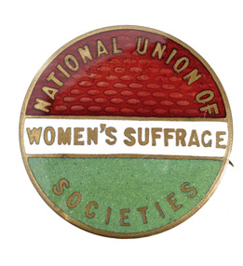
Fig.3 NUWSS Badge

Fig 4. WSPU Logo

Artists of the Suffrage Campaign – Lowndes and the Artist’s Suffrage League
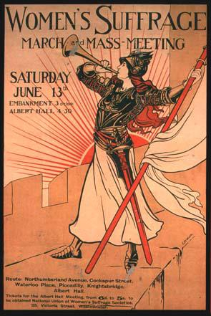
The graphics of the British Suffrage movement symbolises the beginning of feminist movements and women utilising design and graphics, to broadcast and protest for their rights (Fig 5, 6). This set a precedent for the decades to follow and modern feminist movement have since then studied this heritage, for methods and strategies that they would incorporate for inspiration in their movement. Art and design played a dominant role in the movement’s communication. Two separate groups dedicated specifically to design were set up during the movement’s active years. In 1907 the Artist’s Suffrage League (ASL) formed, and in 1909 the Suffrage Atelier was established.
Fig. 5 The Bugler Girl

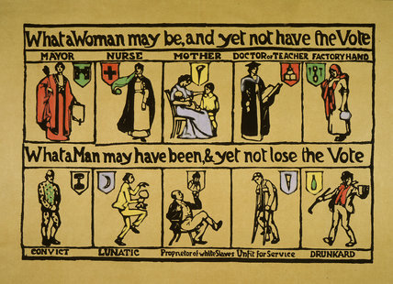
Fig. 6. What a Woman May Be …

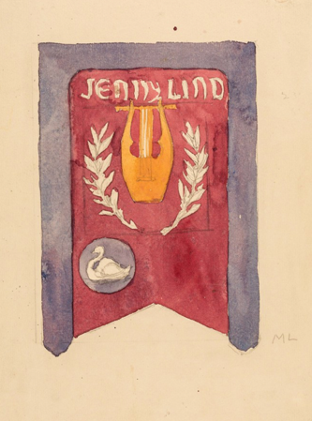
The Artist’s Suffrage League consisted of a mixture of artists, illustrators and engravers, and initially they were to assist preparations for the NUWSS’ first procession of a large scale. Mary Lowndes was leader of the Artist’s Suffrage League from 1907. She is credited for the majority of their banner design and is a major contributor across all of their work. Lowndes was a woman passionate to revive needlework in order to produce the designs of the banners. This revival was an act purposely designed to confront the prejudice that needlework was a poor feminine skill. As Parker (2010, p. 197) states in their hands, embroidery was employed not to transform the place and function of art, but to change ideas about women and femininity. At the same time, banners of the trade union movement, which her work drew comparison with, were now being manufactured as opposed to previously being embroidered by women. Suffrage banners, were often created using a variety of different techniques and with the combination of this variety, were finished to a high-quality standard. To design the banners, Lowndes would sketch out her designs and fill them in with watercolour (Fig 7, 8). She was a highly skilled stained-glass artist, allowing her to put the principles of her craft to good effect in the ASL.
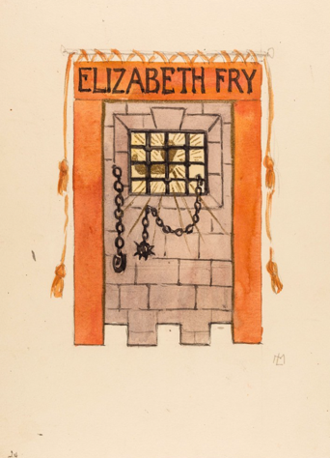
Fig. 7 Lowndes Sketch
Fig. 8 Lowndes Sketch

June the 13th, 1908 was a monumental day in Suffrage history. 13,000 women joined in procession to the Albert Hall in London, where a mass meeting was to occur. A total of 770 banners were created specifically for the procession. Pankhurst (2005, p. 242) describes this monumental day
It was a striking pageant with its many gorgeous banners, richly embroidered and fashioned of velvets, silks and every kind of beautiful material and the small bannerettes showing us innumerable patches of brilliant and lovely colour, each one varying both in shape and hue. (Pankhurst 2005, p. 242)

It was acknowledged widely across newspapers and said to have been the most effective political procession the country had witnessed. I can only imagine the impact the 770 banners would have made. The making must have been a very lengthy process to undertake by hand. This shows the dedication and effort they gave to their cause.

Christina Bloom, was the UK’s first female press photographer who captured some of the most renowned images of the monumental procession in the movement of gaining the right to vote (Fig 9 & 10, Bloom, 1910)
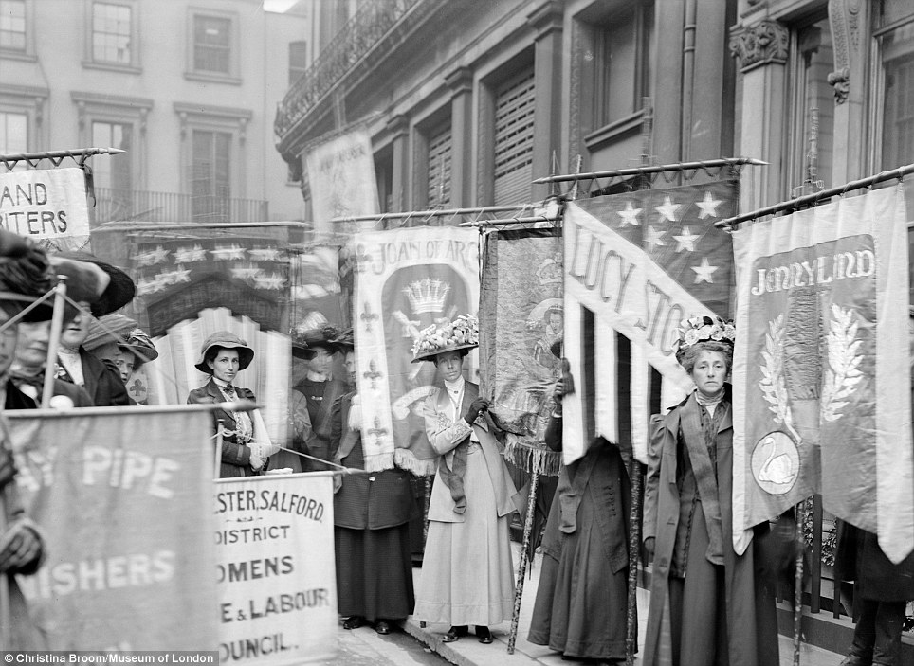
Fig. 9 Prisoner’s Pageant

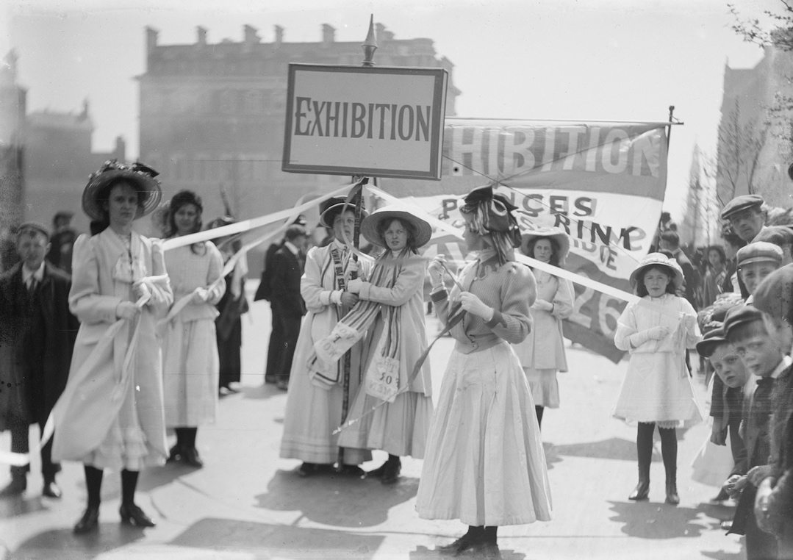
Fig. 10 Young Suffragettes

Artists of the Suffrage Campaign – The Suffrage Atelier
The Suffrage Atelier alike the ASL, labelled themselves as an arts and crafts group working for women’s suffrage. However, whereas the Artist’s Suffrage League was made up of established artists, the Suffrage Atelier encouraged amateurs to submit designs. As Reckitt (2019, p. 46) explains
The Suffrage Atelier safeguarded traditional skills while promoting the acquisition of new ones, but it is also a case study in enlightened reciprocity, where artists and designers could support a political cause while reaping practical benefits, valuable experience and lifelong skills. (Reckitt 2019, p. 46)

This therefore offered opportunity and encouraged women with an interest in art immensely. Encouraging women to express their views on women gaining the right to vote, not only enables the support of a political cause but brings light upon the movement too, which is valuable to both the organisation and the individuals. Women who had not been fortunate enough to gain an art’s education would then develop their skills as artists and designers. This was valuable for them because it gave them the opportunity to become politically vocal too.

A Corporate Identity and Political Merchandising
The WSPU created a highly recognisable visual identity with supporters of the group by its adoption of the purple, white and green colour scheme. A wide range of leaflets and pamphlets were distributed, adhering to the colour scheme. A wide extent of merchandise was also sold in these colours, making the WSPU one of the first groups to use merchandising politically. Purple signified dignity, white for purity and green for hope. According to Pethwick Lawrence cited in Reckitt (2019, p. 41)

the colours enable us to make that appeal to the eye which is so irresistible. The results of our processions is that this movement becomes identified in the mind of the onlooker with colour, gay sound, movement and beauty. (Reckitt 2019, p. 41)

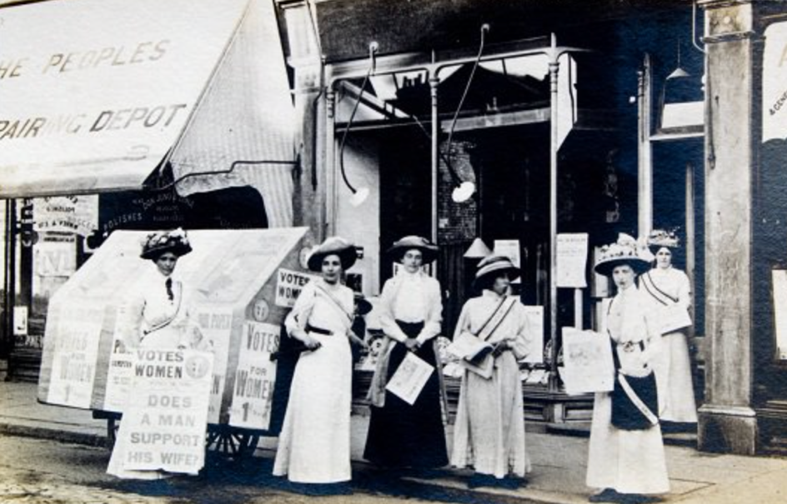
The suffragette movement, in particular the designs and strategies of the WSPU show an impressive early example of brand marketing. Embodied with an innovative and modern concept, a corporate identity was created for political purposes. The lively and focused passion the groups within the movement had for promotion and creating a bold visual statement, created a compelling way to draw in and obtain supporters. The author McQuiston (1997, p. 34) declares then, as now, corporate identity did not consist merely of surface images or decoration. It involved a coordinated programme of communications strategies. I agree with this statement that McQuiston makes, and this is something that I think is essential to the success of an organisation or group. With the success of the WSPU’s use of colour, many other groups adopted this idea too. WSPU had a network of stores across the country (Fig 11), which pamphlets and postcards were distributed at alongside the selling of a huge range of merchandise in the tri-colour scheme. (Fig 12, 13) It was a way to promote the groups objectives, and the profits would go back into the campaigns.
Fig. 11 Wimbledon WSPU Shop

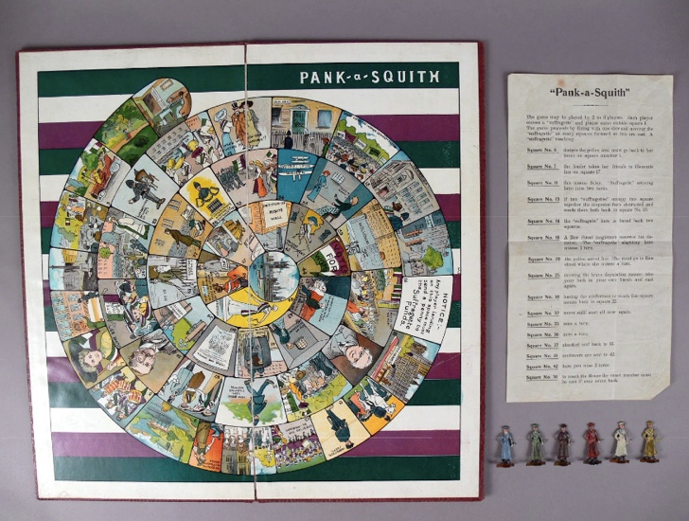
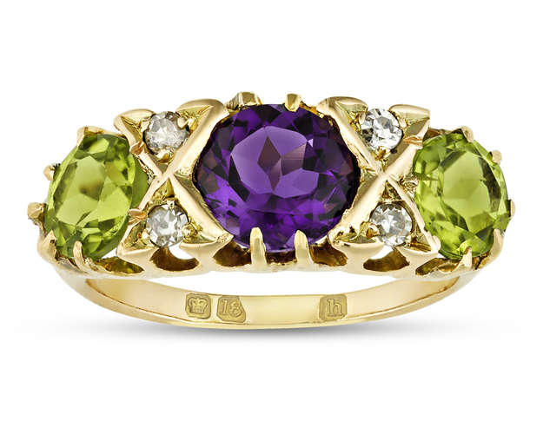
Fig. 12. WSPU Merchandise

Fig. 13 WSPU Merchandise

Tackling Anti-Suffragist Backlash
Backlash came from anti-suffragist campaigners who also adapted the use of graphics to voice their opinion. However, the efforts of visuals of the anti-suffrage propaganda cannot be complemented on its quality. Suffrage design overall excelled because of the fundamental way in which goals and beliefs were communicated so effectively, regardless of differences in strategies between groups. Their art usage was a strategic method to counter the anti-suffrage movement. The anti-suffrage movement built up an ugly representation of the feminist suffragettes. However, the suffragette’s understood the use of the spectacle. Their infamous embroidered banners were accompanied with parasols embroidered in WSPU Suffrage colours and carried in the marches. Parker (2010, p. 198) explains there was nothing naive in the suffrage use of embroidery. They were familiar with methods and materials of pictorial embroidery. They understood the use of symbolic materials. The movement proved their femininity, but not so much so that it would be used against their demand to vote. The choice of their banner content portrayed femininity incorporated with strength. Paint and collage would be purposely used alongside embroidery during the making of the banners, so it was not the only method of medium chosen.

Amongst their image-building tactics, they also employed a ‘suffragette uniform’. The uniform consisted of a skirt, white golf jersey, a simple hat and the regalia worn over the right shoulder and fastened under the left arm. (Fig 14) As a sign of loyalty to their cause, they were encouraged to wear the colours at all times. As McQuiston (1997, p. 37) points out this shrewd and manipulative use of fashion and femininity challenged the stereotype of the hysterical, ugly suffragette and gained the movement support from both press and public. By employing this uniform which remains within the tri-colour scheme, proposed by Emmeline Pethwick Lawrence, the group created a distinctive visual identity, which immediately supporters of the cause would recognise. I can imagine the uniform would create a particularly breath-taking view on procession days, whilst the women would march the streets in them. The uniform was elegant and feminine, therefore deferring the backlash of anti-suffragist supporters.
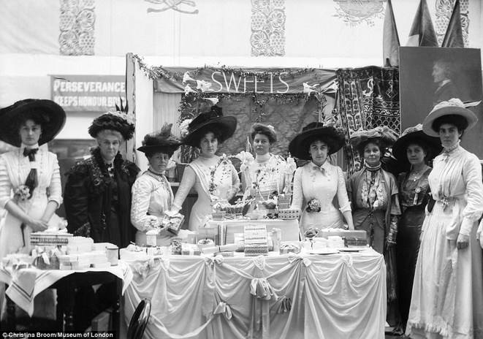
Fig. 14 Uniform

The Power of the Spectacle
The banners created by the Suffrage movement would often celebrate and commemorate historical female heroines to show the movements patriotism. One particular banner was dedicated to ‘Queen Victoria, Queen and Mother’, another method to counter the anti-suffrage movement. Parker (2010, p. 200) describes this in the following quote
Here the campaigners harnessed the queen’s popularity to their cause. Acclaiming her as Queen and Mother countered anti suffrage propaganda that God had ordained women to raise children, not to take part in political life. (Parker 2010, p. 200)

They understood the power of the spectacle. The addition of the word mother alongside the Queen’s title completely transforms the meaning. They wanted to prove to non-supporters that women should and can take part in political life, alongside being a mother at home.

WWI
Britain declared war on Germany on the 4th of August 1914, therefore the campaign for women’s suffrage was suspended. As war advanced, more men were sent to the front. Women had no choice but to step up and take on a range of occupations that would have previously been male dominated. This supported the movements cause. The contribution of women to the war effort represented the imagination of some of the country’s women.

Those who took on the job of artist correspondent for the British illustrated press almost only consisted of males. The exception to this was Helen McKie, British artist and illustrator. Being in Russia at the time war was declared, allowed her to be near the front in France and Belgium. This enabled her to have the opportunity to sketch and record the scenes that she has witnessed around the UK, as a member of staff for The Bystander and The Graphic newspapers (Fig 15).
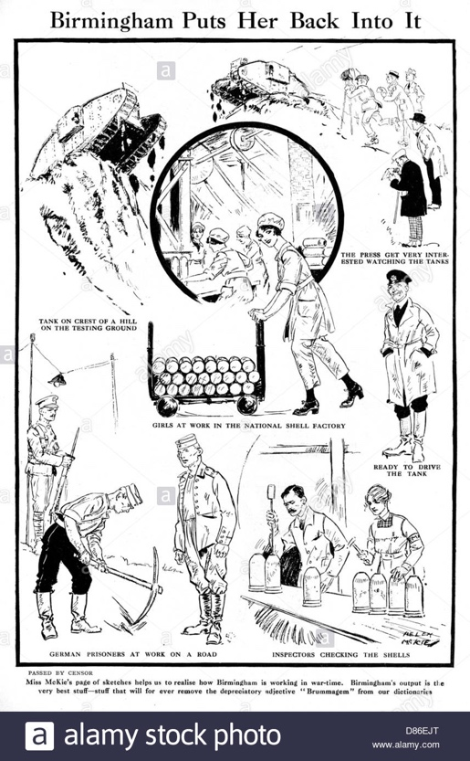
Fig. 15 Birmingham Puts Her Back Into It

In Reckitt’s words (2019, p. 63) The Bystander chose to highlight their roving reporter’s gender as an asset. McKie was successfully broadcasting the strength and commitment of an independent working women. The Bystander saw this as an asset to their company that made them stand out against others. This independence of working women would become more prominent during the second world war.

Gaining the Vote
During the war, political opinion shifted slightly. Women had played an important role in the war efforts of the country and the government were keen to reward them for this. On the 6th of February 1918, the first act to allow women the right to vote in Britain finally came into law (Fig 16). Woman over the age of thirty were entitled to vote, but there was still restriction on this. 8.5 million women were entitled to vote in the general election of 1918. The suffrage movement were disappointed in the restrictions and hoped that alike men, women over the age of 21 would have the right to vote.
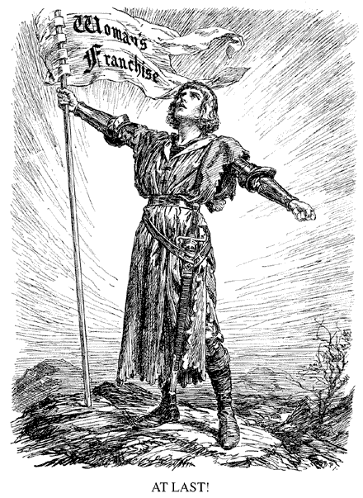
Fig. 16 At Last!

Slowly over time, more doors of opportunity were opened to women. In 1919 it become illegal to exclude women from jobs because of their sex. Then, in 1928 the representation of the people act entitled everyone over the age of 21 the right to vote.
WWII
On the 3rd of September 1939, WWII was declared, meaning a horrific time for the country again. Moreover, an opportunity for women to take the roles of the men again. Dame Laura Knight was an English Artist. In 1936 the Ministry of Supply commissioned her to create a painting of an ordnance factory worker, Ruby Loftus. Loftus was a 21-year-old worker at the Royal Ordnance Factory in Newport, Gwent. Knight was Britain’s highest profile women artist at the time. The painting was an enticement, to drive recruitment into factories (Fig 17).
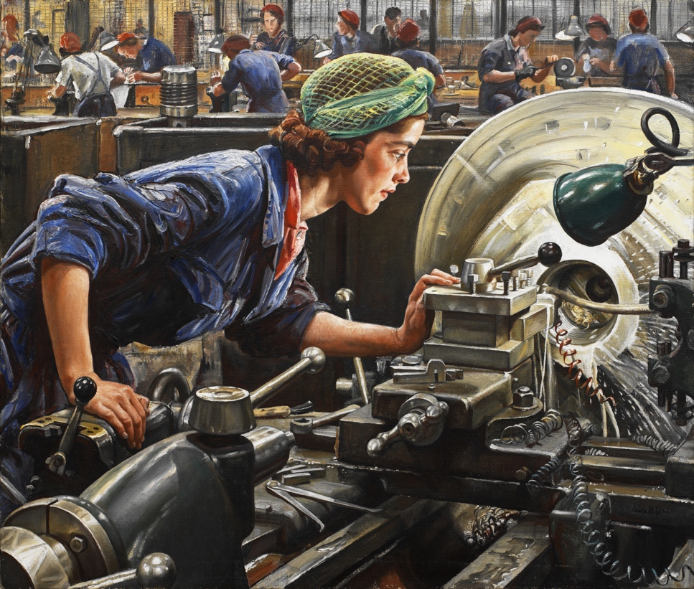
Fig. 17 Ruby Loftus Screwing the Breech Ring

McKiernan (2010, p. 421) observes that Laura Knight painted life with simple and sensitive honesty and her skills in capturing movement, form and colour excel in this painting. I find it heroic that young woman were predominately taking over the roles of highly skilled jobs that would have previously been done by men. This painting emits luminosity and presents a light of insight into the role that this woman was eagerly learning to master while men were at war. It is a powerful image to use for recruitment.
In conclusion of this chapter, it is clear that the Suffrage Movement was particularly strong both in its methods and strategies. The way they utilised design to protest their cause, to create such sights and beautiful craftsmanship was remarkable. I feel the WSPU did a particularly exceptional job of establishing a visual identity that is infamous to this day. When war was declared women had to take on jobs previously done by men, this inspired drive and commitment in the women. I think it was empowering for them and for their future careers, and definitely gave them an independence and confidence. In the next chapter I am going to move forward in time, to the revival of feminist design that started in the 60s.
Chapter 2
Feminist Protest 60’s through to 90’s
This chapter will be focusing on the revival of feminist design in the 60’s and how this came about. I will be focusing on monumental pieces of feminist protest design during this time, through to the 21st century. The Suffrage movement can be credited largely for inspiring women of this time for methods and strategies to put forward in their practice.

The Emergence of the Second Wave
Betty Friedan was a feminist activist and writer. As Freidan emphasises (2001) the only way for a woman, as for a man, to find herself, to know herself as person, is by creative work of her own. The 1960’s saw the rise of The Women’s Liberation Movement when Betty Freidan’s, The Feminine Mystique was published in 1963. The book explored the idea of women gaining fulfilment outside of the traditional housewife role. The book was very popular and gained a reach of 3 million readers, completely shaking up society. Women had these ideas and opinions themselves before reading the book, but Friedan helped them realise the severity of discrimination they were facing. Women were angry and it was time to take action.

Women’s Liberation, an Identity
A mass movement of women’s liberation, containing small groups and groups of thousands in collectives, were increasing at a rapid speed by 1970 with the same goal of abolishing the oppression of women. The movement claimed a strong symbol to help establish an identity for themselves in their fight for rights – the female biological sign (Fig 18). According to McQuiston (1997, p. 82) It served to tie the movement together. Transcending languages and cultures, it became a visual password for feminists around the world. The strength of the symbol was in its simplicity. This allowed for anyone to be able to draw and copy it anywhere, therefore spreading the identity and presence of the movement and raising its profile. It still is heavily produced as a feminist political symbol today.
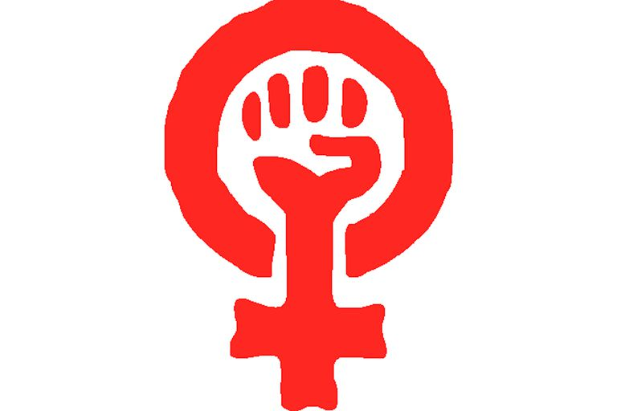
Fig. 18 Women’s Liberation Movement Symbol

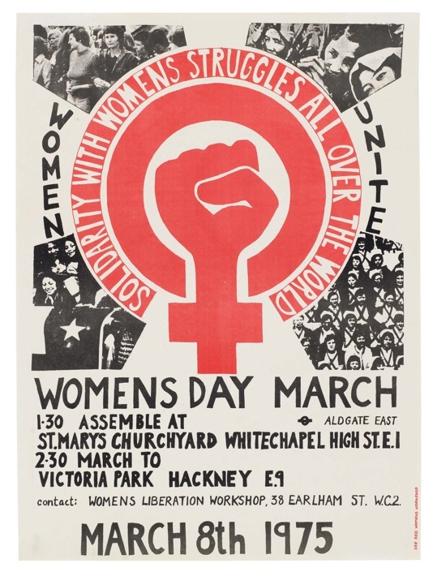

Fig. 19 Womens Day March Poster, 1975

Developing a Visual Language

Following in the footsteps of the campaign for Suffrage, The Women’s Liberation Movement heavily involved protest and public demonstration. The movement was strong in its methods, with the frequent use of graphic formats conducting the movement to challenge, shock and provoke their audience and rebel against traditional authority. In McQuiston’s (1997, p. 78) view

A visual language developed that expressed women’s struggles and concerns. Created by amateurs and professionals, it marked the beginning of a more democratic use of art and design as communication tools.
(McQuiston 1997, p. 78)

Women artists and designers were now confident enough to utilise their skills to express their views and opinions. As a designer myself, this is something I feel is very important. Within my work I aim to contribute to making a positive difference.

Through networking, the movement were building the ‘sisterhood’ notion of solidarity for liberation. Connecting countries and cultures, went hand in hand with connecting with women’s culture and design of the past. McQuiston (1997, p. 82) believes that there were direct actions and great sacrifices to be admired; there were also graphic elements to be borrowed or appreciated. It is clear that the British suffrage societies were a great inspiration for the modern feminists.

The Dinner Party
A popular project to emerge during the studies of herstory during the second wave of feminism was Judy Chicago’s The Dinner Party (1973-9). Her art installation to monumentalize great women, includes a series of entryway banners, a ceremonial table to represent 39 historical female figures, heritage panels and a heritage floor (Fig 20).
The Dinner Party has been a focus of attention at the Elizabeth A. Sackler Center for Feminist Art since 2007, in Brooklyn Museum. But prior to this has been shown in exhibition spaces across the world.
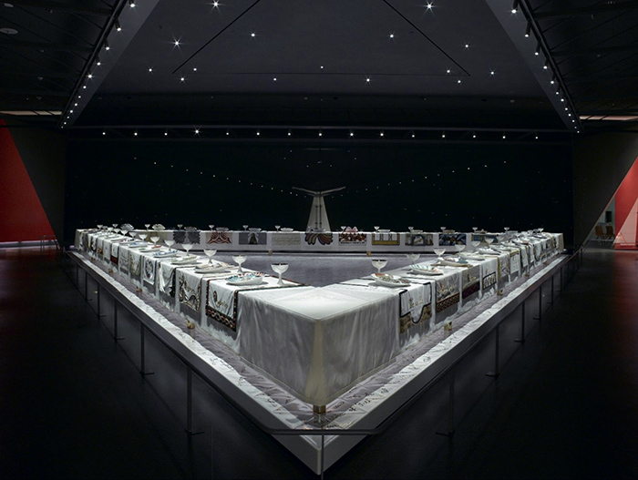
Fig. 20. The Dinner Party

The installation invites the audience to walk around the table of the dinner party (Fig 21). Each place at the table is set for a historical female figure. The plates are set on a needlework runner (Fig 22), that brings light upon the women it represents and their story. In Levin’s view (2007, p. 87) Chicago honoured crafts, which are usually known as popular or “low art” and generally relegated to women and domesticity. Needlework was a skill that was traditionally taught as part of domestic science for girls, a skill employed for women to use at home, in their housewife role. According to Hopkins cited in Levin (2007, p. 87) Chicago, with deliberate irony had employed “women’s techniques” in a woman’s context to create a major feminist statement. This can be supported by Parker’s (2010, p. 198) statement that there was a renewed interest in political needlework and banners for use in a modern context. The Suffragette’s infamously revived this skill during their fight of gaining the women’s right to vote. It was an act purposely designed to confront the prejudice that needlework was a poor feminine skill. Chicago employed this technique again, to make an ironic stand within her installation.
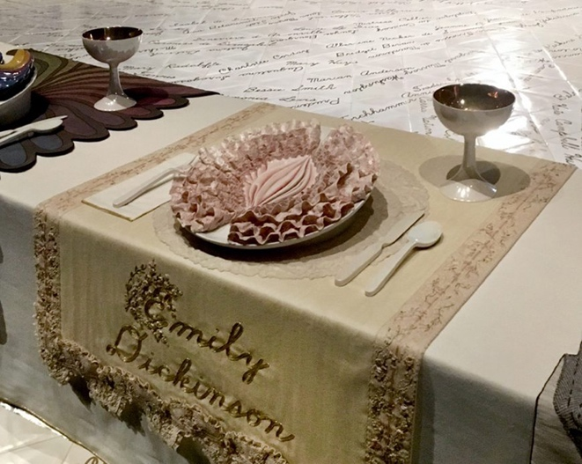
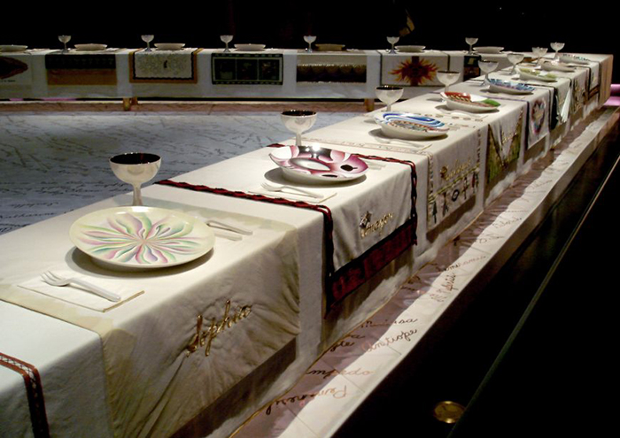
Fig. 21 The Dinner Party

Fig. 22 The Dinner Party

Chicago caused controversy with The Dinner Party, and had trouble getting museums to show her installation because of this. During this time period the art world was dominated with formalist criticism. A question of the time was, should art convey political meaning? Art critics called it bad art. However, Danchuk (2015, p. 191) believes the Dinner Party is the single most important work of feminist art and culture since its production. I believe it a monumental piece of feminist art.

Sheila Levrant de Brettville

Colour even became political. Sheila Levrant de Brettville explored the importance of colour in relation to women in her urban installation ‘pink’ (1974). Her urban installation is made up of a series of squares (Fig 23). Some are filled in by women, explaining what pink means to them, whilst others are left bare, allowing the viewer to add their own thoughts. This is an early example of her poly-vocal approach to graphic design. This approach proposed a new design purpose in feminist design, in an inclusive process. McQuiston (1993, p. 153) observes that Sheila de Brettville pioneered a relationship between design and feminism. De Brettville was well known in her continued efforts to explore feminist design strategies. Whilst doing so she would cast light on old graphic design traditions and tools. She worked by reassessing design and process and exploring the new. McQuiston adds (1997) de Brettvilles experiments and writings were at the cutting edge of a surge of graphic art and design work.

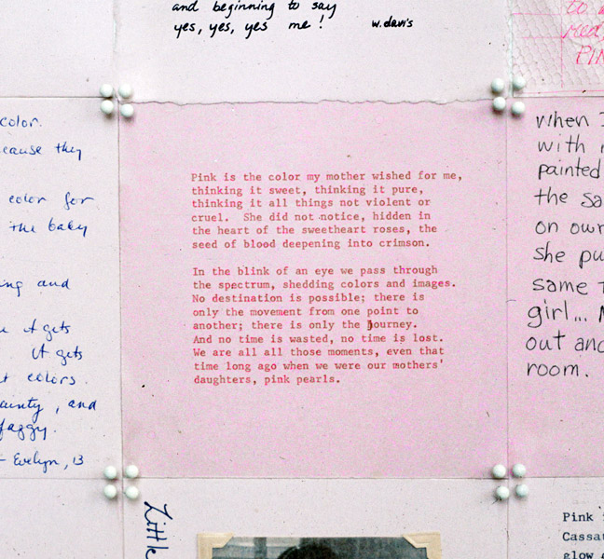
Fig. 23 Pink

De Brettville was so invested in exploring feminist design strategies she initiated a Women’s Design Program at CalArts. This program encouraged and allowed women to use their own personal voice and get their experiences heard through teaching and offering print facilities. This is very much alike how the Suffrage Atelier encouraged women in the same way during their cause.

Even Angrier
By the end of the 1970s women were openly expressing and promoting the value of women and women’s ideas and work. There was a complete shift in vision. It was in the 80s that international feminism became truly united. Feminist graphics had developed at this point, becoming more direct and even angrier. A greater intensity of resistance emerged, on a greater level, with art and design activists laying down foundations of a new visual language. It was during this period that art activists, such as Barbara Kruger, began to take to the urban environment to disseminate their art. Billboards became a very popular way to voice critical statements and agitate. Demanding such an overwhelming, direct place in people’s sights and thoughts. Billboards have now become almost obsolete as the ease of connectivity on social media means it is an incredibly powerful way to advertise.

Barbara Kruger

Feminist artist Barbara Kruger is renowned for her distinctive black and white photo montages of declarative statements and symbolic images. She makes addressing complex issues look simple in her signature style of bold sans serif typography. The contrast she creates with red and monochrome completely demands your attention, creating immensely powerful design. Kruger uses design techniques in such a way that cleverly conveys a sense of urgency and call for action within her work with photography. Linker (1990, p. 12) describes her work as cropped enlarged and juxtaposed with strident verbal statements or phrases. It is impressive how her work dramatically stands out by the way she cleverly crops photographs.

During the late 90s feminism, met a huge conflict in the American pro-life and pro-choice debates, which had been building up over the previous decade. Kruger’s ‘Your Body is a Battleground’ (Fig 24), designed specifically for the 1989 march on Washington, became a graphic icon for women. It was a particularly heated topic and this image enabled women an icon for their anger surrounding abortion rights. Kruger’s work registers a profound change in the feminist movement. The image consists of a silkscreened photograph of a women’s face, which has been split down the middle in two, creating a strong central divide and a positive and negative exposure. Although the design was created for specific event, the statement Kruger made is timeless and I think this is what makes the image so powerful.
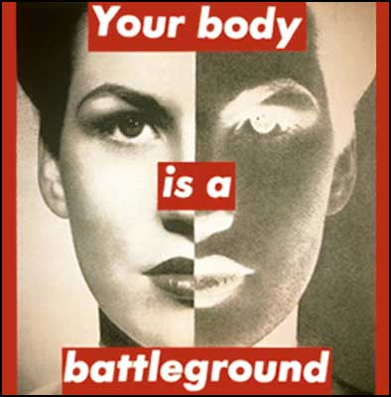
Fig. 24 Your Body is a Battleground

Guerrilla Girls
Feminist artists took a pivotal role in the experimental art of the 70’s in the US, but in the 80s when art was seen as an investment more than ever, it was clear in museum exhibitions and galleries, that women or artists or colour were not being taking seriously. This made the Guerrilla Girls rage. Chadwick & Guerrilla Girls (1995, p. 7) describe how they rapier wit to fire volley after volley of carefully researched statistics at art world audiences. To embarrass and lay bare those institutions and individuals who were not rightly representing the work of women and artists of colour (Fig 25, 26). What started with posters plastered around the walls of the city, evolved into commissioned magazine spreads, with the likes of Vogue and New York Times featuring their work. By 1987, they had built an extremely visible presence in the public eye.
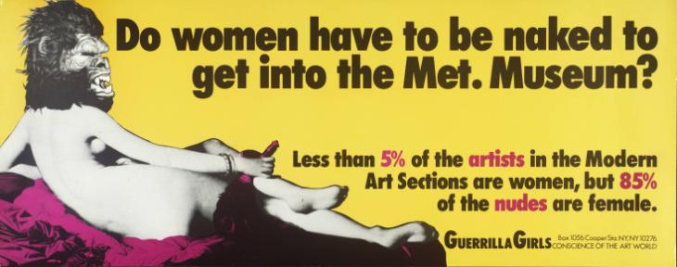
Fig. 25 Do women have to be naked to get into the Met. Museum?

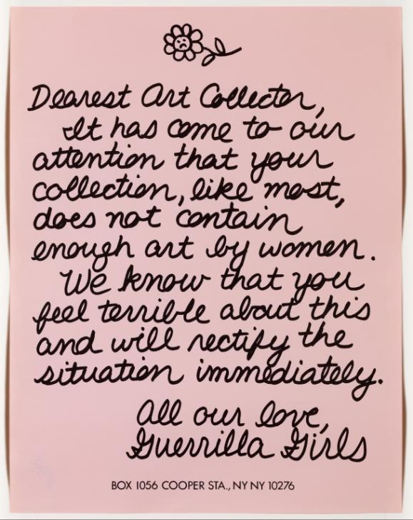
Fig 26. Dearest Art Collector

The Guerrilla Girls took to the urban environment in 1985, they gained instant infamous praise. McQuiston (1993) remarks how they would interfere with the process of billboard advertising to reclaim an imposition on public space. Striking back and attacking what they believed were offensive adverts or concepts. The Guerrilla Girls were a completely anonymous group, and this worked in their favour.
In their own view (1995, p. 9)
Guerrilla Girls have overturned the apple cart and produced a collective identity that draws attention to the ways in which those who wield power do so by excluding and withholding as well as conferring recognition, with it, success. (Chadwick & Guerrilla Girls 1995, p. 9)

This anonymity allowed them to protect their careers against any controversy or revenge. The Guerrilla Girls would never give their real names, and instead each member would identify as a past art heroine, such as the likes of Frieda Kahlo and Georgia O’Keeffe. This felt enormously empowering for them as women having to develop from birth the importance of having a certain appearance for social and public acceptance.

As stated by Chadwick & Guerrilla Girls (1995, p. 7), the movement saw the suffragettes as their ‘Suffragist Sisters’. The use of the word sisters emits a strong sense of community. I picture a family setting, and the way traditions are passed down through families. This is much alike how feminists of the Women’s Liberation movement carried on traditions originally initiated by the Suffragettes. Adopting methods and adapting them to fit their cause and the struggles of women in society at that time. Feminist presses of this time were keen to research ‘‘herstory’ and bring unsung feminist heroines into limelight. This is again like the Suffragette’s would do whilst marching in processions with banners highlighting female heroines.

In summary of this chapter, I believe that there were very monumental pieces of feminist protest design created during this period. Women cleverly took inspiration and utilised strategies and methods from the Suffrage Movement, adapting their approach to suit the time and message that they wanted to convey. Moreover, they broke boundaries by adopting new methods to get their design into public spaces. They did this by curating exhibitions and advertising in the streets via posters and on billboards, enabling them to reach audiences of a wider scale. It is easy to interpret that women in society then had built up more courage. They were more outspoken and women independently outside of feminist movements were proudly producing feminist art and fighting for it to become seen. In the upcoming chapter I am going to progress forward to the 21st century.

Chapter 3
21st Century Feminist Protest Design
This chapter will begin with investigating the impact that the advancement of technology continues to have for feminist protest design. Questioning, is the fourth wave of feminism purely online?

An advancement in Technology
The transition into the 21st century saw the vision that the late 90’s had a glimpse into, come to life. New technologies and the internet became another medium for feminist women and movements to use their voice. The options that new technologies gave was an opportunity for more creativity. Women were able to empower, and connect like never before, whilst digital technology was also a scope for education and research.

For all Womankind
In 2016, New York based Irish graphic designer Deva Pardue founded For All Womankind, a design initiative for Fempowerment. The initiative works to raise money for women’s charities that benefit the advancement of women’s rights and equality.
Pardue gained attention for the initiative when she released her freely available ‘Femme Fists’ design (Fig 27) prior to The Women’s March 2017. Pardue aimed to create a more feminine version of the iconic clenched first, as she felt ones in feminist history still looked too manly.
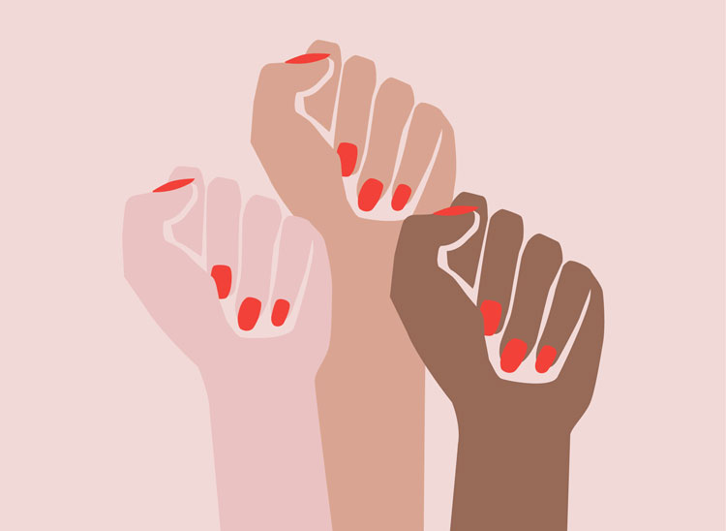
Fig. 27 Femme Fists

Due to the ease of connectivity feminists now have available to them, via the internet and social media, the design went viral. It was shared by celebrities such as Naomi Campbell and Rihanna, whilst more than 4000 people in the US alone downloaded the design. Pardue, as cited in Morley (2017) states when it comes to protest art, the importance of immediacy can’t be underestimated. Saying something with as little clutter as possible resonates the most (Fig 28, 29). This simple statement beautifully designed to capture feminism in society created a bold impact upon many and aided the fight and public demonstration of The Women’s March 2017.

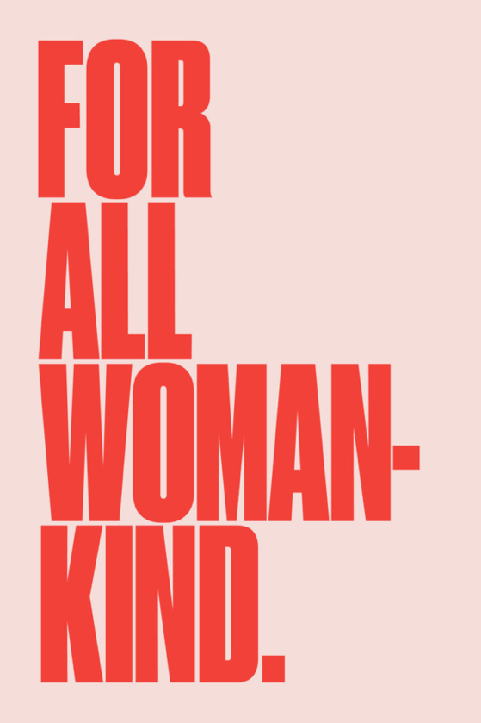
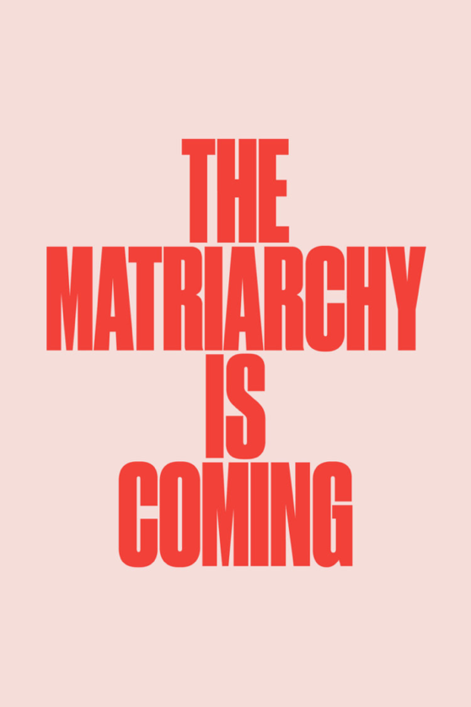
Fig. 28, 29 For all Womankind

Women’s March
To protest politically, public demonstrations continue to be a powerful way to demand attention. Donald Trump was inaugurated on 20th January 2017. On the 21st of January 2017 hundreds of thousands of people took to the streets of Washington. They were passionate about the women’s activism they had created. Milligan explains (2018) it gave voice to frustrations and grievances women had been grumbling more quietly about for years. Fig 30, 31 shows designs by Pardue being used in protest at the Washington and New York Women’s March.
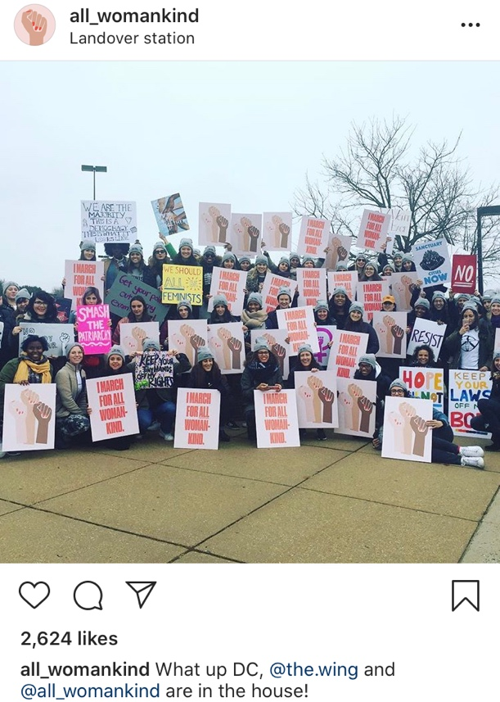
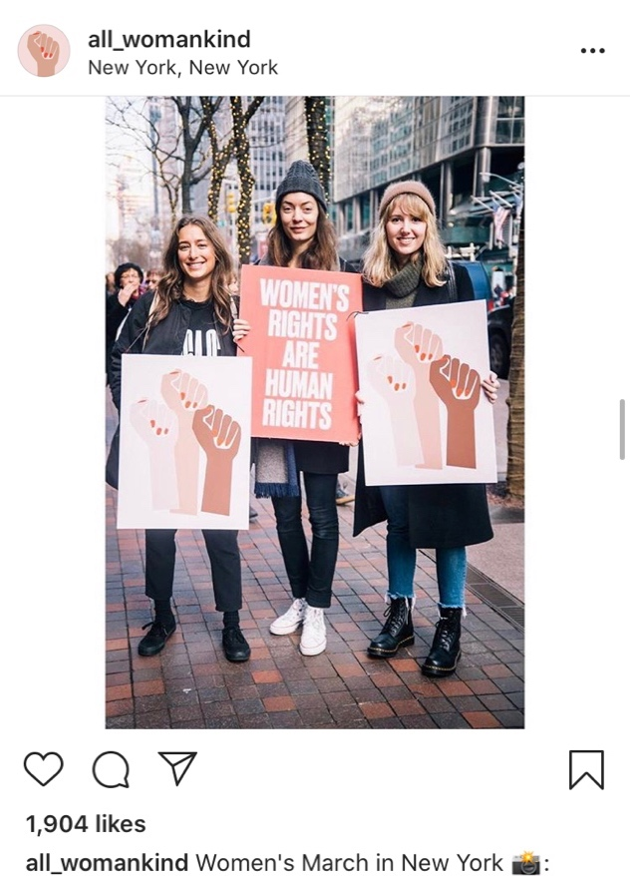
Fig. 30, 31 For all Womankind Instagram posts The Women’s March

Online
Now more than ever before, the internet is playing a more significant role in feminist activity. Munro remarks (2013, p. 23) that it is increasingly clear that the internet has facilitated the creation of a global community of feminists who use the internet both for discussion and activism. Nevertheless, whether the discussion is aiding political action has been put to dispute. However, Teresa Shook put out a call for protest in a group on Facebook, as a reaction to the victory of Trump. This call for protest was what the development of The Women’s March stemmed from. The march has happened annually around the world since the first women’s march in 2017 and allows women to continue strongly in their efforts to fight for action.

Conclusion
The Suffrage campaign was cleverly devised by the movement’s adoption of a key number of methods and strategies. For instance, a strong corporate identity, political merchandising and image building tactics, such as the power of the spectacle and using humour. Cowman (2007, p. 261) reports that suffragettes could be seen actively deploying humour as a deliberate tactic; to diffuse hostility. They would play on the insults fired at them by anti-suffragists and the media. The combination of these strategies is what I believe enabled them an ingenious, powerful campaign. In addition, I believe the graphics of the Suffrage Movement was the most captivating way they protested their cause.
The power of art in the suffrage campaign was revealed in The Women’s library exhibition ‘Art for Vote’s Sake’, a celebration of the suffrage centenary in 2003. Liddington (2005, p 201) explains how the exhibition
wove skilfully between the WSPU’s adept use of photography and picture-politics (like its suffragette poster-parade), and the NUWSS’s capturing the visual high-ground with its rich pageantry of processions and embroidered banners. (Liddington 2005, p. 201)
The women utilised techniques like traditional embroidery, to the most up to date printing technologies. The iconic banners of Mary Lowndes are infamous to the cause.
It is certain that the declaration of WWI, brought opportunity for women. Fair (1976, p. 280) states that by April 1916 Walter Long, Chairman of the Local Government Board, estimated that some 275,000 women were engaged in work in substitution for men in the industrial occupations alone. Women were productive in occupations that were not expected of women at the time. Opinions changed, those who had previously not approved of women’s suffrage, were now commending women for their efforts.
Fair (1976, p. 284) voices that the most notable conversion was that of Violet Markham, once head of anti-suffragists. The efforts of women in war work converted her to become a suffragette. Women’s efforts to the war, allowed women to gain confidence outside of the home. This opportunity became a driving force and ultimately powered the efforts of the fight for women’s equality and rights in the following decades. However, some women were still opposed and firmly believed in the traditional idea that women should stay at home.
This may bring into question, has women’s freedom and choices to work, impacted on child rearing, has the needs of family been impacted by the women’s movement? Bowlby as cited in Viciedo (2011, p. 44) states that the steady growth of evidence that the quality of the parental care which a child receives in his earliest years is of vital importance for his future mental health. Carneiro (2015, p. 365) explains that in Norway working mothers are entitled to a full year of paid leave and an additional year of job protection. Supported by evidence, it is my belief that if improved entitlements were globally available, parents would have the choice to stay at home and the reassurance of going back to work smoothly afterwards. This would not only support the women’s wellbeing and choices, but also supports the family unit.
Ultimately, feminists have thoughtfully studied the protest design of the suffrage movement for inspiration. Besides, looking at their strategies and methods they devised. McQuiston (1997, p.12) reflects that the early suffrage movement broke the ground and set a precedent for women’s expression; the analysis of the Women’s liberation Movement then defined that expression and gave it a fresh momentum.
The protest design that the Suffrage movement and the major influences which grew from this that I have chosen to highlight, have had a strong and harsh impact. This was essential to their cause, as it showed the women’s fiery passion in their fight and furthermore demanded attention.
It is clear that in recent years the advancement of technology has had a huge impact on the fight for women’s rights and feminist protest design. The ease of connectivity and unity that the internet allows feminists is very powerful. I am not certain whether the ‘fourth wave’ of feminism is amongst us, and discussion over whether the terminology of the waves is accurate is ongoing for feminists. Nevertheless, women are increasingly utilising technology for activism and discussion in a positive way.

Evidently, the discussion of women online is positively aiding political action. For instance, the emergence of the annual women’s march was established from a call for action on an online forum, as a reaction of resilience to the victory of Trump. Keneally as cited in Finneman (2010, p. 109) states that more than one million women worldwide participated in the movement, in 2017 events alone. This was a huge statement for feminist activism on a global scale. Now, a political event that happens annually, all over the world in the fight for women’s rights and equality. Women are continuously encouraged to be politically active, whilst voicing their opinions and employing their skills to create powerful pieces of design for protest.

Furthermore, the internet allows feminists to vastly promote their movement. In 2017 Hollywood producer Harvey Weinstein was brought to the limelight with allegations of sexual assault. In response to this, Alyssa Milano encouraged women to speak up about the act on twitter. The hashtag #MeToo gained widespread attention and began trending on the social media platform. Mendes, Ringrose and Keller (2018, p. 236) reports the idea was to showcase the magnitude of the problem of sexual violence. The hashtag was used 12 million times just after 24 hours of her tweet. This shows the huge impact social media can have for a movement.
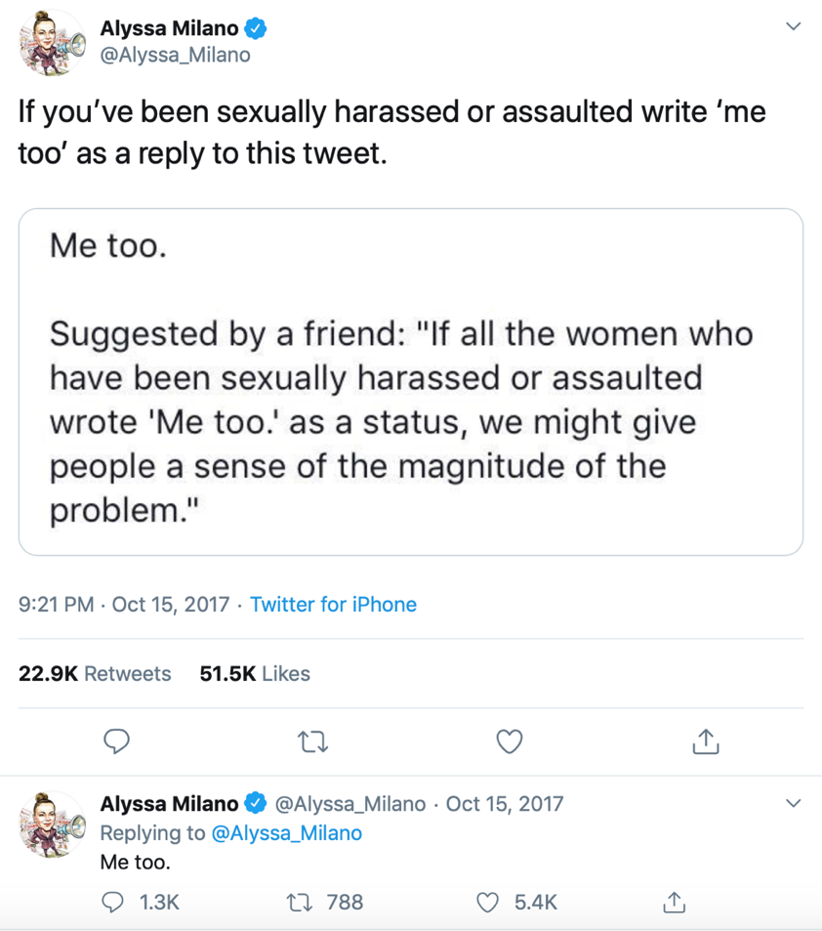

Fig. 32 Alyssa Milano Me Too Tweet

Feminist protest is increasingly being discussed and planned online now. Grady reports (2010) that feminist action is conceived and propagated online. But women continually are demonstrating publicly, although technology is continuously aiding women to fight for their rights. After conducting my research, I believe that feminist protest is not purely contained to the online world.

There are opposing opinions on the impact that technology is having on design for protest. Cubbage as cited in Wainwright (2018) voices that technology has really democratised the medium. It could be considered that anyone with a smartphone is a designer, can now share their work instantly with a global audience. This is an opportunity for future, ongoing personal research.

As I come to the end of my independent inquiry. I feel very passionate about the importance of utilising skills that I have learnt in my practice to aid the fight for equality. As a female designer my continued aim is to utilise my skills for the higher ethos of visual communication and make a positive contribution to society as a whole.

Bibliography
Carneiro, P., Vs. Løken, K., G. Salvanes, K. (2015) A Flying Start? Maternity Leave Benefits and Long-Run Outcomes of Children. Journal of Political Economy. 123(3), pp. 365-412

Chadwick, W. & Guerrilla Girls. (1995) Confessions of the Guerrilla Girls. London: Pandora.

Cowman, Krista. (2007) “Doing Something Silly”: The Uses of Humour by the Women’s Social and Political Union, 1903-1914. International Review of Social History, 52(S15), pp. 259-274.

Danchuk, J. (2015) The Dinner Party: Judy Chicago and the power of popular feminism, 1970-2007, The Journal of American Culture, 38 (2), pp. 191-192.

Fair, J.D. (1976) The Political Aspects of Women’s Suffrage during the First World War. Albion: A Quarterly Journal Concerned with British Studies. 8(3), pp. 274-295.

Finneman, T. (2018) The Greatest of Its Kind Ever Witnessed in America Journalism History. 44(2), pp. 109-116.

Friedan, B. (2001) The Feminine Mystique. New York: Norton.

Grady, C. (2010) The waves of feminism, and why people keep fighting over them, explained. Available at: https://www.vox.com/2018/3/20/16955588/feminism-waves-explained-first-second-third-fourth. (Accessed: 27th Aug 2019).

Levin, G. (2007) Art Meets Politics: How Judy Chicago’s Dinner Party Came to Brooklyn, Dissent, 54 (2), pp. 87-92.

Liddington, J. (2005) Era of Commemoration: Celebrating the Suffrage Centenary, History Workshop Journal. 59(1), pp. 194-218.

Linekar, K. (1990) Love for Sale. New York: Harry N. Abrams.

McKiernan, M. (2010) Dame Laura Knight Ruby Loftus Screwing a Breech-ring 1943, Occupational Medicine, 60 (6), pp. 421-22.

McQuiston, L. (1993) Graphic agitation: social and political graphics since the sixties. London: Phaidon.

McQuiston, L. (1997) Suffragettes to She-Devils Women's Liberation and Beyond. London: Phaidon.

Milligan, Susan. (2018) Marching to Power, U.S. News - The Report, pp.2–5.

Mendes, K., Ringrose, J. & Keller, J. (2018) #MeToo and the promise and pitfalls of challenging rape culture through digital feminist activism. European Journal of Women’s Studies. 25(2), pp. 236-246.
Morley, M. (2017) How Feminist Movements Co-opt Graphic Design to Express Themselves. Available: https://eyeondesign.aiga.org/how-feminist-movements-co-opt-graphic-design-to-express-themselves/. (Accessed: 1st November 2019)
Munro, E. (2013) Feminism: A Fourth Wave? Political Insight. 4(2), pp. 22–25.

Pankhurst, S. (2015) The Suffragette: The History of the Women's Militant Suffrage Movement. New York: Courier Dover Publications.

Parker, R. (2010) The subversive stitch: Embroidery and the making of the feminine. London: IB Tauris.

Reckitt, H. (2019) The Art of Feminism Images that Shaped the Fight for Equality. London: Tate Publishing LTD.

Vicedo, M. (2011) The social nature of the mother’s tie to her child: John Bowlby’s theory of attachment in post-war America. British Journal for the History of Science. 44(3), pp. 401-426.

Wainwright, O. (2018) From Trump to Brexit: how bad graphics triumphed over sleek design. Available: https://www.theguardian.com/artanddesign/2018/mar/28/posters-protest-artworks-hope-to-nope-pink-pussyhat . (Accessed: 8th November 2019)

List of Illustrations

Figure Page

1: Author’s Image (2018) Suffrage Banner [Embroidery] 4

2: Author’s Image (2018) Suffrage Banner [Embroidery] 4

3: NUWSS (n.d.) NUWSS Badge [Pin Badge] Available at: https://womanandhersphere.com/tag/nuwss/ 6

4. WSPU (n.d.) WSPU Logo [Logo] Available at: https://alisonwilliamswriting.wordpress.com/2014/07/15/emmeline-pankhurst-deeds-not-words/ 6
5. Watts, C (1908) The Bugler Girl [Illustration] The Art of Feminism 7

6. Suffrage Atelier (1912) What a Woman May Be… [illustration] The Art of Feminism 7

7. Lowndes, M (1908) Lowndes Sketch [Watercolour Sketch] Available at: https://vads.ac.uk/large.php?uid=78533&sos=0 8

8. Lowndes, M (1908) Lowndes Sketch [Watercolour Sketch] Available at: https://artsandculture.google.com/exhibit/the-suffrage-banners-of-mary-lowndes-lse-library/WgLSU4yA_bcqLA?hl=en 8

9. Bloom, C (1910) The Prisoners Pageant [Photography] Available at: https://hyperallergic.com/221868/a-look-at-the-suffrage-movement-with-the-uks-first-female-photojournalist/ 10

10. Bloom, C (1910) Young Suffragettes [Photography] Available at: https://hyperallergic.com/221868/a-look-at-the-suffrage-movement-with-the-uks-first-female-photojournalist/ 10

11. WSPU (n.d.) Wimbledon WSPU Shop [Photography] Available at: https://www.exploringsurreyspast.org.uk/shops-of-the-suffrage-campaign/ 12

12. WSPU (1909) WSPU Merchandise [Board Game] Available at: https://www.indietours.biz/blog/2018/9/30/a-109-year-old-suffragette-board-game 13

13. WSPU (1910) WSPU Merchandise [Jewellery] Available at: https://www.rauantiques.com/blog/suffragette-jewelry/ 13

14. Bloom, C (1910) Uniform [Photography] Available at: https://www.museumoflondon.org.uk/discover/march-women-photographing-suffragettes-broom 14

15. Mckie, H (1918) Birmingham puts her back into it. [Illustration] The Art of Feminism 16

16. Bernard, P (1918) At Last! [Illustration] Available at: https://www.nationalarchives.gov.uk/education/britain1906to1918/g4/cs4/g4cs4s10.htm 17

17. Knight, L (1942) Ruby Loftus Screwing the Breech Ring [Illustration] The Art of Feminism 18

18. Women’s Liberation Movement (1970) Symbol [Badge] Suffragettes to She-Devils 20

19. Women’s Liberation Movement (1975) Womens Day March [Poster] Available at: https://commons.wikimedia.org/wiki/File:Women’s_Day_March_(1975).jpg 21

20. Chicago, J (1974-97) The Dinner Party [installation] Available at: https://www.brooklynmuseum.org/exhibitions/dinner_party 22

21. Chicago, J (1974-97) The Dinner Party [installation] Available at: https://www.brooklynmuseum.org/exhibitions/dinner_party 23

22. Chicago, J (1974-97) The Dinner Party [installation] Available at: https://www.brooklynmuseum.org/exhibitions/dinner_party 23

23. Levrant De Brettville, S (1974) Pink [installation] Suffragettes to She-Devils 24

24. Kruger, B (1989) Your Body is a Battleground [Poster] Love for Sale 27

25. Guerrilla Girls (1989) Do women have to be naked to get into the Met.Museum? [Screenprint on Paper] Confessions of the Guerrilla Girls 28

26. Guerrilla Girls (1986) Dearest Art Collector [Screenprint on Paper] Confessions of the Guerrilla Girls 28

27. Pardue, D (2016) Femme Fists [Poster] The Art of Feminism 31

28. Pardue, D (2016) For all Womankind [Poster] Available at:
https://forallwomankind.com/posters 32

29. Pardue, D (2016) For all Womankind [Poster] Available at:
https://forallwomankind.com/posters 32

30. For all Womankind (2017) Instagram Post [Social Media] Available at: https://www.instagram.com/forallwomankind/ 33

31. For all Womankind (2017) Instagram Post [Social Media] Available at: https://www.instagram.com/forallwomankind/ 33

32. Milano, A (2017) Me Too Tweet [Social Media] Available at: https://twitter.com/alyssa_milano/status/919659438700670976?lang=en 38

