Programs in C and documentation

Part C

By Donna Wright
Contents
Part C (Implementation) 3
Function based exercise: Pairs. 3
1.1 Problem breakdown 3
1.1.1 Generate and mask random pairs 3
1.1.2 Allow user to select and compare cards 3
1.1.3 Hard mode 3
1.1.4 Record amount of moves taken 4
1.2 Annotated code 4
1.3 Testing 4
1.3.1 Generate and shuffle list of words 4
References 5

Part C (Implementation)

Function based exercise: Pairs.

1.1 Problem breakdown
The purpose of this exercise is to build a card matching game, allowing a player to try and find matching pairs in as few moves as possible. The player will initially be presented with six pairs which will be shuffled. The player should be allowed to reveal the identity of two items at a time in order to locate all pairs.

Generate and mask random pairs
In this stage the pairs need to be declared and their placement randomised. The shuffled placement should not be visible to a player. In order to generate random numbers in C, two additional libraries are required. These are <stdlib.h> and <time.h>.
- Add additional libraries to code
- Create array of numbers
- Use ()swap and ()randomize to shuffle numbers

Invite user to play
This stage requires input from the user
- Print a 4x3 table of letters
- Ask user to select the letter of the first card they wish to turn
- Store players choice
- Ask player to select the second letter they wish to turn
- Store players choice
- Display random numbers linked to the letters chosen and advise if a match

Continuous play
Player needs to be allowed to continue to select cards with an aim to find all pairs
- Create while loop to allow player to keep playing for as long as they want
- In each loop allow player should be able to select 2 cards to compare
- In each loop print cards selected
- Advise player whether their turn resulted in a match
- Ask player if they wish to continue
- Continue until all cards matched or player chooses to end the game

Record turns and advise of matches //I was unable to code this stage
This stage would look to ‘turn the cards back’, record the number of turns and advise of matches so far. It would also end the game when all matches have been found.
- Clear screen if player chooses to continue
- Record number of turns taken
- Record matches made

1.2 Annotated code
#include <stdio.h>
#include <stdlib.h>
#include <time.h>

void swap(int *a, int *b)
{
int temp = *a;
*a = *b;
*b = temp;
}

void randomize(int pairs[], int n)
{
srand(time(NULL));
int i;
for (i = n - 1; i > 0; i--)
{
int j = rand() % (i + 1);
swap(&pairs[i], &pairs[j]);
}
}

void main()
{
int pairs[12] = {100,200,300,400,500,600,100,200,300,400,500,600};
int card1, card2;
int n = sizeof(pairs) / sizeof(pairs[0]);
int i;
char choice;

randomize(pairs, n);

printf("The aim of the game is to find the pairs\nThe following values are hidden bedind the cards:\n");
printf("100\n200\n300\n400\n500\n600\n\nDo you want to play?\n");
scanf(" %c", &choice);

while (choice == 'y' || choice == 'Y') //both uppercase and lowercase covered
{
printf(" 0 1 2 3\n");
printf(" 4 5 6 7\n");
printf(" 8 9 10 11\n\n");

printf("Enter the number of the first card you would like to turn: ");
scanf("%d", &card1);
printf("Enter number of the second card you would like to turn: ");
scanf("%d", &card2);

if (pairs[card1] == pairs[card2])
{
printf("You found %d - %d\n", pairs[card1], pairs[card2]);
printf("It's a match!\n");
printf("Do you wish to continue?\n");
scanf(" %c", &choice);

}
else
{
printf("You found %d - %d\n", pairs[card1], pairs[card2]);
printf("Unlucky, that's not a match\n");
printf("Do you wish to continue?\n");
scanf(" %c", &choice);

}
if (choice == 'n' || choice == 'N') //both uppercase and lowercase covered
{
printf("\nYou're no fun!\n");
}

}
//list all cards after sfuffle
printf("Thanks for playing, the cards are revealed below:\n");
printf(" %d %d %d %d\n", pairs[0],pairs[1],pairs[2],pairs[3]);
printf(" %d %d %d %d\n", pairs[4], pairs[5], pairs[6], pairs[7]);
printf(" %d %d %d %d\n", pairs[8], pairs[9], pairs[10], pairs[11]);
}

1.3 Testing

1.3.1 Generate and shuffle list of words
Program shuffles the declared array of words to random locations.
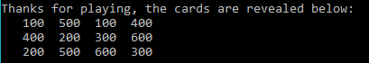
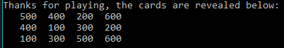
Result: program ran as expected.
Player given result of turn:
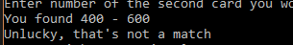
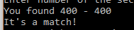
Result: Program ran as expected.

1.3.2 Invitation to play

Player is invited to play and prompted to enter card selections. Following this they are informed whether selection is a match and selected ‘cards’ revealed to user.

Invite to play (y entered by player):

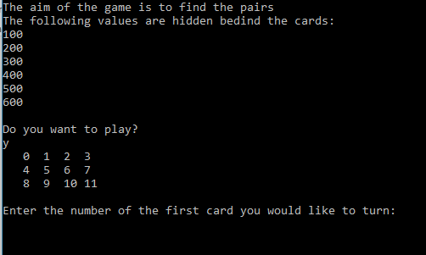
Result: program ran as expected.
Invite to play (n entered by player):
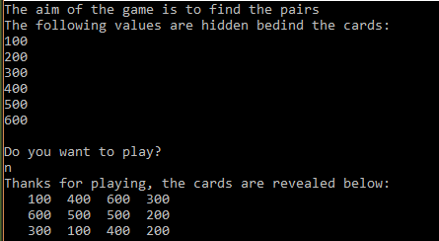
Result: program ran as expected.
Invite to play (invalid entry by player)
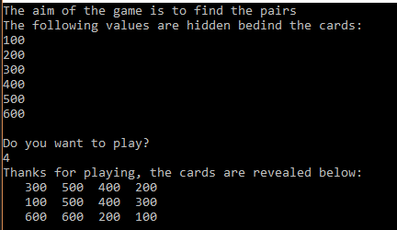
Result: program did not run as expected. Whilst game ended, invalid entry did not come up
User enters valid ‘choices’:
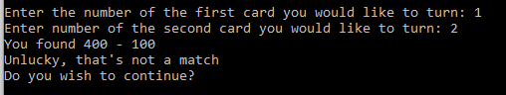
Result: program ran as expected.

Player enters invalid ‘choices’:
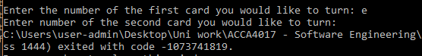
Result: program failed.

1.3.3 Continuous play
Player advised whether they found a match and asked if they wish to continue:
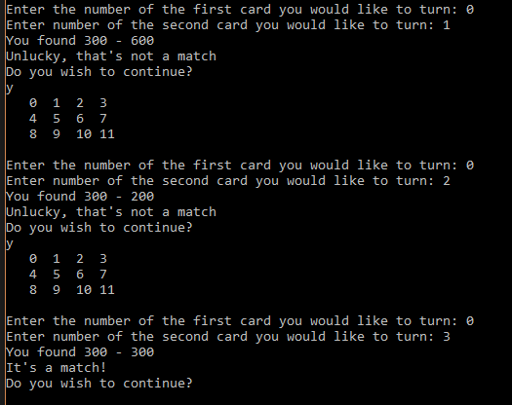
Result: Program ran as expected.
User allowed to exit game:
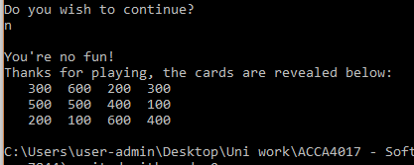
Result: Program ran as expected.
Player entered invalid entry:
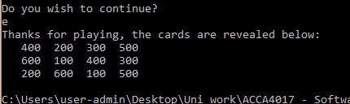
Result: Program ended.

References

[1] | M. McGrath, C Programming, vol. 4th edition, Warwickshire: In easy steps, 2014.

