Effective Team- Working and Communication

The difference between Tuckman and Belbin
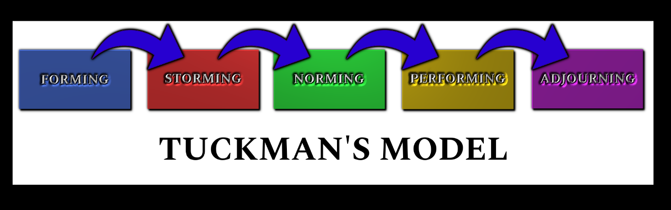

Dr Bruce Tuckman, a psychology professor identified four stages of development in 1965- Forming Storming Norming Performing model. Also, in 1070s he joined a fifth stage, Adjourning. The Forming Storming Norming Performing theory is an elegant and helpful explanation of team development and behaviour. Tuckman’s model explains that as the team develops maturity and ability, relationships establish, and the leader changes leadership style.
Tuckman’s Team & Group Development Model help us understand the stage of development a team goes through at work, but it also applies to groups of friends, networking groups, volunteering organizations- in fact it applies anywhere you interact regularly with others in a group setting. Learning about this model can help you at work and at home, and it can also help you help with your customers – whatever kind of coach you are.
Tuckman’s model helps managers, leaders and team members notice what stage their team is at, helping team members to process and acknowledge the inevitable conflicts and changes during group development also helps teams and groups accelerate through the group stages with awareness and compassion for each other and improve team performance.

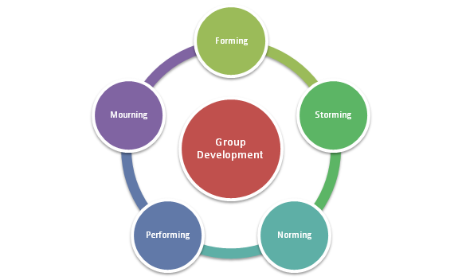

- Stage 1: Forming Individual roles and responsibilities are unclear. Leader must be prepared to answer all the questions about the team’s purpose, objectives and external relationships.

- Stage 2: Storming –Team members position as they attempt to establish, who might receive challenges from team members.

- Stage 3: Norming – The team may engage in fun and social activities the commitment and unity is strong

- Stage 4: Performing- The team can work towards achieving the goal, and to attend to relationship, style and process issues along the way.

- Stage 5: Adjourning- The Adjourning phase is certainly very relevant to the people in the group and their well-being.
Tuckman theory is a simple easy way to understand how groups develop and training people how to work together.

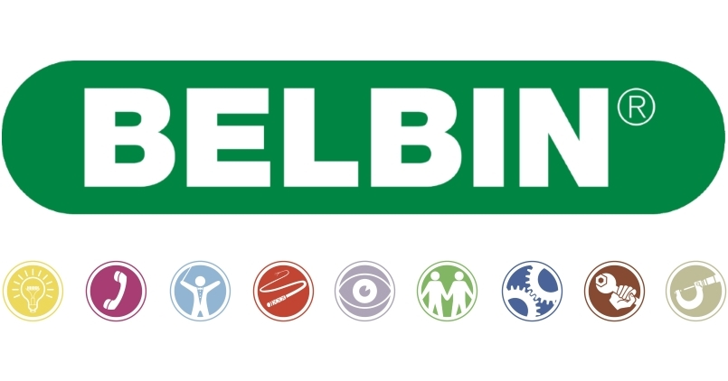

Dr Meredith Belbin worked with the Henley Management College to try to discover a way to predict the success of teams in the early 1970s. In the period of 5 years he established that there are certain clusters or patterns of behaviour which can be used to predict team success in specific kinds of projects. He also established that no one team was ever perfect to every task. Belbin eventually identified 8 and then later 9 such clusters. He called these clusters team roles, defined as ‘a tendency by an individual to behave, contribute or interrelate with others in a team in certain ways.’
Dr Meredith Belbin management psychologist in order to understand what strengths any team member may bring to a team, came up with a simple way to predict the effectiveness of teams. Team Roles refer to the kind od behaviour individuals display when they are part of a team Dr Belbin defines 9 roles that can be recognised when individuals work in teams.
- The Implementer: Believes in converting ideas into briefs and then working through the brief.
- The Resource Investigator: Believes in searching for new opportunities and developing new contacts.
- The Plant: Believes in overcoming complex intellectual challenges with creative solutions.
- The Monitor Evaluator: Believes in analysing every idea and thinking every action through to ensure the right decisions.
- The Specialist: Believes in offering in-depth knowledge about a specific topic with ease and pleasure.
- The Completer Finisher: Believes in seeing things through by perfecting every small detail.
- The Co-ordinator: Believes in everyone working together to achieve the team’s shared goals.
- The Team Worker: Helping team members achieve their goals to improve team performance.
- The Shaper: Overcoming challenges by making things happen.

Belbin Team Roles the theory is to understand the fact that the team lies are made up of unique individuals each with their own personality traits, situations and ambitions. In order to understand what strengths any team member may bring to a team.

References
- BusinessBalls ‘ Tuckman : Forming , Storming, Norming , Performing model’ https://www.businessballs.com/team-management/tuckman-forming-storming-norming-performing-model/ (2013)

- Inspiring Leadership ‘Leadership Foundation’ file:///C:/Users/tamar/Downloads/bruce_tuckman_s_stages_of_team_development_.pdf (2013)

- The coaching ‘ Tuckman's Team and Group Development Model’ https://www.thecoachingtoolscompany.com/get-your-team-performing-beautifully-with-this-powerful-group-development-model/(2014)

- OffLimits ‘Belbin Team Roles Definition and Theory Explained’ https://www.actiondays.co.uk/team-building-blog/belbin-team-roles-definition-and-theory-explained/?gclid=EAIaIQobChMIneDd4Kjj5QIVQtTeCh1KTgHJEAAYASAAEgKdAvD_BwE (2018)

- University of Cambridge ‘ Management Technology Policy ‘ https://www.ifm.eng.cam.ac.uk/research/dmg/tools-and-techniques/belbins-team-roles/ (2016)

- MC ‘ High performing teams : Belbin’s Team Roles’ https://www.managementcentre.co.uk/high-performing-teams-belbins-team-roles/ (2019)

