Student name : Mohammed Raju
Module code : BMIH5006
Module Lead : Lisa Knight

Aviation Transport in the Hospitality Industry and Its Environmental Impact

- Your name and student number
- The module title and module code
- Your lecturer’s name
- AI Acknowledgement
Table of Contents
Executive Summary 3
1. Introduction 4
2. Main Findings 4
2.1 Role of Aviation in the Hospitality Industry 4
2.2 Environmental Impact of Aviation 6
2.3 Challenges in Reducing Aviation’s Environmental Damage 7
2.4 Possible Solutions and Sustainable Practices 9
A. Technological Advancements in Aviation 9
B. Carbon Offsetting and Airline Initiatives 9
C. Policy and Industry Regulations 11
D. Consumer Awareness and Travel Behavior 11
3. Conclusion 12
Reference: 13

Executive Summary
Hospitality transport is a pivot within the tourism industry, offering the transport of travellers and goods amongst the global hospitality destinations. Aviation is the foremost mode of transportation among various modes of transport for international tourism, and it helps link people with hotels, resorts, and hospitality businesses worldwide. It is, however, widely used, and this use has resulted in considerable environmental damage. Sustainability requires a new approach.
The impact of aviation on the environment is analysed in this report, and the key issues are carbon emissions, air pollution, noise pollution, biodiversity loss and waste generation. Greenhouse gas emissions from the aviation industry are highly evident as no natural environment can remain intact when left exposed to pain inflicted by climate change and the aviation industry. To tackle these challenges, many sustainable alternatives have been invented. In addition, these include carbon offset programs, the adoption of Sustainable Aviation Fuel (SAF), and electric and hydrogen-powered aircraft developments, and this use has resulted in considerable environmental damage—the sustainability footprint. Governments and regulatory bodies have also made policy changes to enforce greener practices in aviation. Sustainability strategies such as those already implemented by industry leaders like British Airways, Lufthansa or Scandinavian Airlines were established to lead the industry to a more responsible future. Key recommendations are then presented to airlines, hospitality businesses, and policymakers to continue to invest in green transportation and encourage sustainable travel practices.

1. Introduction
Hospitality transport refers to the movement of tourists, business travelers, and goods that support the global hospitality industry. It is fundamental in facilitating international tourism, enabling seamless access to hotels, resorts, and other hospitality-related businesses. Efficient transport networks contribute to the growth of tourism and hospitality, ensuring smooth business operations while enhancing the overall guest experience. Transport is a critical pillar of the hospitality sector, influencing global business travel, international events, and leisure tourism. Airports are gateways to major hospitality hubs, with airlines connecting travelers to destinations worldwide. Hotels and resorts rely heavily on efficient air travel to attract guests, particularly in remote or internationally recognised locations. This report focuses on aviation (air travel) as the chosen mode of transport. It remains the most widely used long-distance transport option, offering high-speed connectivity across continents. International hotel chains and luxury resorts depend on aviation to drive customer demand, making it an indispensable component of the hospitality industry. However, this reliance has significant environmental consequences, including carbon emissions, air pollution, and biodiversity loss (Shahriar and Khanal, 2022).
This report aims to assess the environmental impact of aviation and explore sustainable solutions that can mitigate these challenges. By analysing industry initiatives and innovations, the report aims to provide insights into how hospitality businesses can adopt greener transportation strategies.

2. Main Findings

2.1 Role of Aviation in the Hospitality Industry
Aviation plays a fundamental role in the hospitality industry, providing fast, efficient, and global connectivity that facilitates tourism and business travel. It enables travelers to reach hospitality destinations, including hotels, resorts, and major event venues, with ease. Without aviation, international tourism would be significantly restricted, limiting the reach of hospitality businesses and reducing visitor numbers in key tourism markets (Peeters and Papp, 2024).
The aviation industry also serves as a key driver of economic growth, contributing significantly to tourism revenue and employment. Airports and airlines help attract international visitors, supporting local economies and generating demand for hotels, restaurants, and entertainment venues (Khatter, 2023). Additionally, aviation plays a crucial role in luxury and business travel, where speed, comfort, and convenience are essential for high-net-worth individuals and corporate clients attending global conferences, meetings, and exclusive hospitality experiences.
Industry examples highlight the strong relationship between aviation and hospitality. Dubai International Airport (DXB) is a central global hub that attracts millions of tourists annually, boosting the city's luxury hospitality sector (DUBAIRPORTS, 2025). The airport provides seamless connections to renowned hotels and resorts, positioning Dubai as a premier travel destination. Similarly, Singapore Changi Airport integrates tourism and hospitality services by offering transit hotels, high-end shopping, entertainment hubs, and business lounges, enhancing the overall travel experience (Singapore Airport Hotel, 2024).
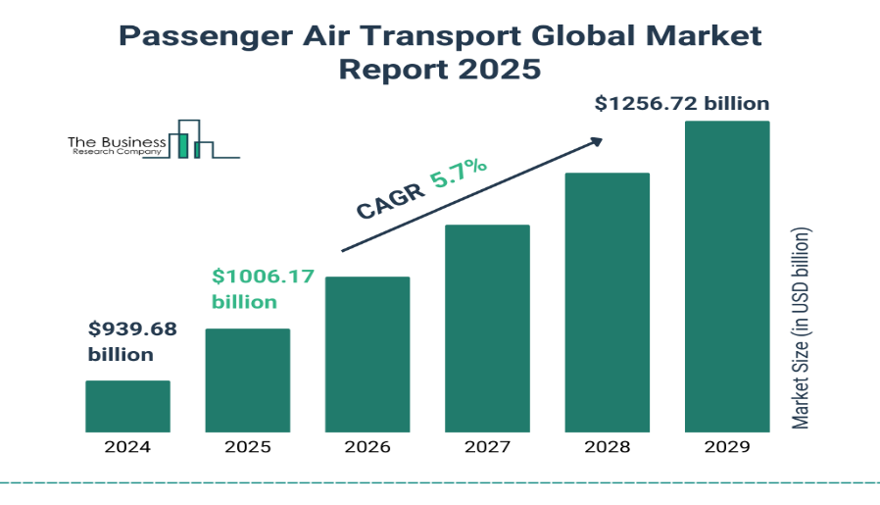
Graph 1: Air Passenger Global Market Growth (2024–2029)
Source: (Pohuda, Ivchenko and Pohuda, 2024)

As air travel demand grows, Graph 1: Air Passenger Global Market Growth (2024–2029) will illustrate the increasing reliance on aviation in hospitality. The data highlights the necessity for sustainable innovations in aviation to mitigate its environmental impact while supporting the industry’s expansion.

2.2 Environmental Impact of Aviation
Aviation significantly contributes to environmental degradation, affecting air quality, noise levels, biodiversity, and waste management. As global air travel demand continues to rise, these challenges become more pressing for the hospitality and tourism industries. One of the most critical environmental concerns is carbon emissions. The aviation industry accounts for 2–3% of global CO₂ emissions, with aircraft burning large amounts of fossil fuels. This contributes to climate change, causing rising temperatures, extreme weather events, and disruptions to tourism-dependent economies. Flights, in addition to releasing nitrogen oxides (NOx) at higher altitudes, also contribute to air quality deterioration and the formation of ground-level ozone, further degrading the air quality of urban areas (Samunderu, 2024).
Apart from environmental pollution, noise pollution is one of the most serious problems, especially for communities in the vicinity of large airports. The repeated sounding of aircraft into the sky and back to the ground resulted in a very high level of decibels and many health problems as a result, like stress, sleep disturbances and hearing impairment. Aviation also affects biodiversity as well as human health. Huge habitat destruction has resulted from airport expansions, disrupting local ecosystems and threatening wildlife. Because regions that are promoting ecotourism depend on conservation for their sustainable tourism, other sources of aviation waste include end-of-life aircraft parts, engine and cabin filters, aircraft light bulbs, cabin finishings and single-use plastics created via catering waste and excess fuel disposal during airline operations. The lack of efficient waste management strategies exacerbates environmental pollution, affecting destinations that rely on pristine natural landscapes for hospitality (Farinelli, 2024).
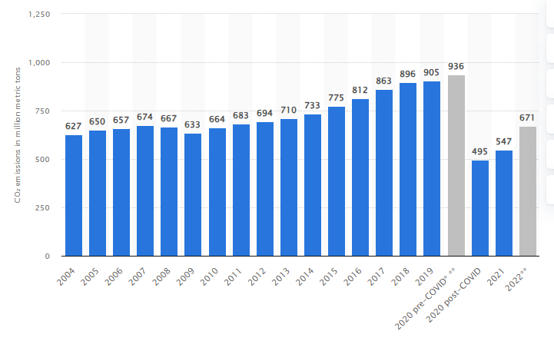
Graph 2: Carbon dioxide emissions from commercial aviation worldwide.
Source: (Leal Filho et al., 2023)
A case study of Heathrow Airport highlights these environmental challenges. As one of the world’s busiest airports, Heathrow faces high carbon emissions and air traffic congestion. In response, the airport has implemented air quality deterioration and the formation of ground-levels and waste recycling initiatives to mitigate its impact (Al-Sulaiti et al., 2023).

2.3 Challenges in Reducing Aviation’s Environmental Damage
Despite increasing awareness of aviation’s environmental impact, several challenges hinder the industry's transition to sustainable practices. The high dependency on fossil fuels remains a primary obstacle. Jet fuel continues to dominate because alternative energy sources, such as sustainable aviation fuel (SAF), hydrogen, and electric propulsion, are still in the early stages of development. Unlike road transport, where electric vehicles are becoming mainstream, aviation requires advanced energy solutions to achieve the same efficiency and range (Khatter, 2023).
The slow transition to sustainable alternatives is largely due to high research and development (R&D) costs. While companies invest in electric and hydrogen aircraft, technological limitations and regulatory approvals delay large-scale adoption. Airlines are hesitant to adopt new, unproven technologies, fearing operational risks and passenger safety concerns. Cost barriers further complicate sustainability efforts. Green technologies, including SAF and carbon offset programs, significantly increase operational expenses (Bartle, Lutte and Leuenberger, 2021). Airlines operating on thin profit margins, particularly low-cost carriers (LCCs), struggle to integrate these innovations without passing costs to consumers. This creates a price disparity between conventional and sustainable flights, discouraging mass adoption. Another challenge is government regulations. There exists a pressing concern in this respect coming from the international agencies like the ICAO and various regional bodies concerned with the formulation and implementation of stringent sustainable legislations that aid enforcement remains slow and irregular. An agriculturally oriented society cares much about economic development, disregarding environmental policies which hamper the adoption of green airline mandates.
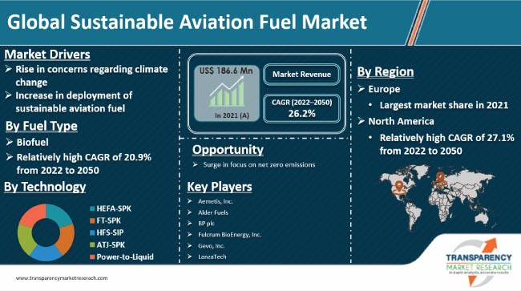
Graph 3: Airline Sustainability Initiatives vs. Cost Impact
Source: (Watson et al., 2024)
The European Union’s Sustainable Aviation Policy is picked as one of the key examples of such a system is the Emissions Trading System (ETS) for airlines introduced by the EU. In this policy, carriers are charged for their carbon emissions and are, therefore, more motivated to invest in cleaner technology. However, providing these regulations at low costs to low-cost airlines is a financial difficulty which manifests in concerns around fairness and feasibility (Zavadskas, Grubliauskas and Vaišis, 2024).

2.4 Possible Solutions and Sustainable Practices
To tackle aviation’s environmental challenges, it is necessary to find a multi­faceted approach with technological innovations, airline initiatives, regulatory policies and consumer awareness. These solutions can be used in support of sustainable air travel practices in the hospitality industry (Xiong et al., 2023).

A. Technological Advancements in Aviation
The development of such Sustainable Aviation Fuel (SAF) solutions, including biofuels and synthetic fuels, is one of the most promising solutions. SAF can significantly reduce carbon emissions and immediately comprise an alternative to fossil-based jet fuel. For instance, Lufthansa has invested heavily in biofuels to achieve a carbon-neutral future, which is followed by the rest of the airlines. Electric and hydrogen powered aircraft are both other breakthroughs in green aviation. The Airbus ZeroE Concept is an aircraft prototype that is powered by hydrogen and that could enter service in 2035 (Airbus, 2025). Even though large-scale implementation is still a decade off, hydrogen and electric aircraft are a long-term zero-emission solution to conventional planes.

B. Carbon Offsetting and Airline Initiatives
In addition, airlines are investing in reforestation projects and renewable energy in order to lighten or offset their emissions. The net-zero strategy of British Airways is one of the leading examples of using sustainable aviation fuels and carbon offset initiatives to reduce their environmental impact. Sustainable tourism partnerships further encourage responsible travel. To achieve carbon-neutral flight with accommodation, eco-friendly hospitality brands are collaborating with airlines. Marriott’s Green Travel Initiatives promote sustainable tourism by integrating green certifications into hotel and airline partnerships (Onifade et al., 2023).
Airline | Sustainability Initiative | Impact on Carbon Emissions | Challenges & Limitations
British Airways | Net Zero by 2050, Carbon Offsetting, Investment in SAF | Moderate reduction through carbon offsets and biofuel trials | High cost of SAF, reliance on offsetting rather than direct emission cuts
Lufthansa | Biofuel-powered flights, Green Fare program | Significant CO₂ reduction on select routes | Limited biofuel supply, higher ticket prices
Scandinavian Airlines (SAS) | Electrification of short-haul flights, CO₂-based pricing model | Encourages sustainable choices and reduces emissions for regional flights | Electric aircraft technology is still in development
Air France-KLM | CORSIA participation, fuel-efficient fleet renewal | Gradual reduction in CO₂ emissions | Costly fleet upgrades, regulatory uncertainties
Delta Airlines | Large-scale carbon offset projects, SAF commitments | Helps offset emissions but does not directly eliminate them | Carbon offset credibility concerns, SAF supply constraints
Qantas | Waste reduction, biofuel investments, net zero by 2050 | Waste management success, emission reductions through SAF | High operational costs for sustainable initiatives
Table 1: Comparison of Airline Carbon Reduction Strategies

C. Policy and Industry Regulations
Measures enforced globally are vital in putting sustainability in place. The Carbon Offsetting and Reduction Scheme for International Aviation (CORSIA) was introduced by the International Civil Aviation Organization (ICAO) to limit emissions. In addition, governments are also providing incentives (in the form of monetary rewards) for eco-friendly aviation technologies (Becken and Hughey, 2021). Using Scandinavian Airlines as a case, regimes address how regulatory frameworks of sustainable aviation can be driven. Green travel policies have been implemented by the airline, fuel efficient aircraft and passenger incentives to reduce emissions and encourage environmentally friendly tourism.

D. Consumer Awareness and Travel Behavior
Sustainable travel habits are crucial for reducing aviation’s environmental impact. Airlines are encouraging carbon-conscious bookings, offering passengers carbon offset options and eco-friendly flight choices. The rise of slow travel—favoring longer stays over frequent short-haul flights—further supports sustainability (Anguridze, Kokashvili and Maisuradze, 2023).
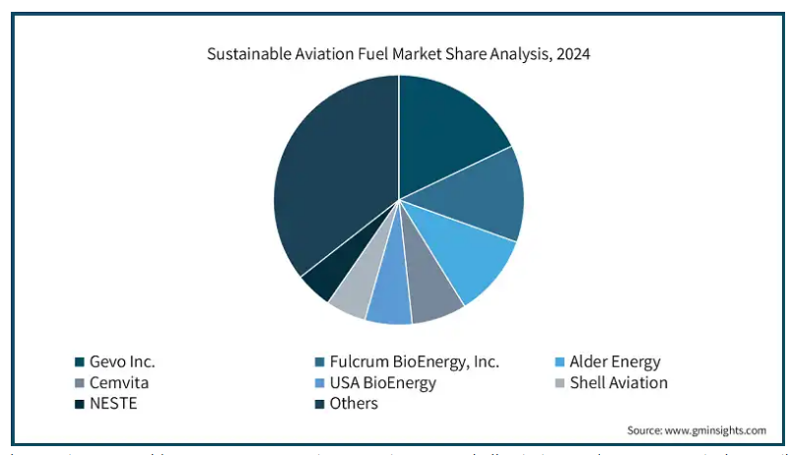
Graph 4: Sustainable Aviation Fuel Market Share
Source: (Farinelli, 2024)
The shift from short-haul flights to high-speed rail in Europe is a notable trend. For example, Eurostar competes with short-haul flights by offering a low-carbon alternative for travel between major European cities (Ben Youssef and Zeqiri, 2022).

3. Conclusion
Aviation plays a critical role in the hospitality industry by facilitating global travel and boosting economic growth. However, it also presents significant environmental challenges, including carbon emissions, air pollution, noise pollution, waste generation, and biodiversity loss. These issues threaten not only the environment but also the long-term sustainability of the hospitality and tourism sectors.
To mitigate aviation’s impact, various technological and policy-driven solutions have been explored. Sustainable Aviation Fuel (SAF) and carbon offset programs provide short-term solutions, while electric and hydrogen-powered aircraft offer long-term sustainability goals. However, these advancements require substantial investment, research, and industry-wide collaboration. Furthermore, government regulations, consumer awareness, and sustainable tourism partnerships are essential in accelerating the adoption of green aviation practices. For a sustainable future, airlines, hospitality businesses, and policymakers must work together to integrate environmentally friendly travel initiatives. Hotels and resorts should partner with sustainable airlines, while governments must enforce stricter emissions regulations and support green aviation technology. Additionally, travelers should be encouraged to make conscious choices, such as selecting carbon-neutral flights and alternative transportation options where feasible.

Reference:
Airbus, 2025.First ZEROe engine fuel cell successfully powers on. Available at : https://www.airbus.com/en/newsroom/stories/2024-01-first-zeroe-engine-fuel-cell-successfully-powers-on [Access on:03.03.2025].
Al-Sulaiti, K., Abbas, J., Al-Sulaiti, I. and Shah, S.A.R., 2023. Resetting the hospitality redux through country-of-origin effects: Role of tourism, culture, transportation and restaurants selection in Arab countries. Country origin effects, 193.
Anguridze, O., Kokashvili, D. and Maisuradze, A., Air Passenger Market Analysis of International Airports of Georgia (2018-2023).
Bartle, J.R., Lutte, R.K. and Leuenberger, D.Z., 2021. Sustainability and air freight transportation: Lessons from the global pandemic. Sustainability, 13(7), p.3738.
Becken, S. and Hughey, K.F., 2021. Impacts of changes to business travel practices in response to the COVID-19 lockdown in New Zealand. Journal of Sustainable Tourism, 30(1), pp.108-127.
Ben Youssef, A. and Zeqiri, A., 2022. Hospitality industry 4.0 and climate change. Circular Economy and Sustainability, 2(3), pp.1043-1063.
DUBAIRPORTS, 2025. Dubai International (DXB). Available at :lhttps://dubaiairports.ae/corporate/our-story/dxb-dubai-international#:~:text=DXB%20%2D%20a%20global%20hub,as%20the%20world's%20preeminent%20airport. [Access on:03.03.2025].
Farinelli, S., 2024. Aviation Industry and Sustainability: Impact of Air Transport on Climate Change, Sustainability in Airlines and End-users Awareness and Preferences.
Javanmard, M.E., Tang, Y. and Martínez-Hernández, J.A., 2024. Forecasting air transportation demand and its impacts on energy consumption and emission. Applied Energy, 364, p.123031.
Khatter, A., 2023. Challenges and solutions for environmental sustainability in the hospitality sector. Sustainability, 15(15), p.11491.
Khatter, A., 2023. Challenges and solutions for environmental sustainability in the hospitality sector. Sustainability, 15(15), p.11491.
Leal Filho, W., Ng, A.W., Sharifi, A., Janová, J., Özuyar, P.G., Hemani, C., Heyes, G., Njau, D. and Rampasso, I., 2023. Global tourism, climate change and energy sustainability: assessing carbon reduction mitigating measures from the aviation industry. Sustainability science, 18(2), pp.983-996.
Onifade, S.T., Gyamfi, B.A., Bekun, F.V. and Altuntaş, M., 2022. Significance of air transport to tourism-induced growth hypothesis in E7 economies: exploring the implications for environmental quality. Tourism: An International Interdisciplinary Journal, 70(3), pp.339-353.
Peeters, P. and Papp, B., 2024. Pathway to zero emissions in global tourism: opportunities, challenges, and implications. Journal of Sustainable Tourism, 32(9), pp.1784-1810.
Pohuda, N., Ivchenko, L. and Pohuda, O., 2024. Methodological approaches to the functioning of the passenger transportation market: Airline, road and railway segments.
Samunderu, E., 2024. The Scope of the Global Aviation Industry. In The Economic Effects of Air Transport Market Liberalisation: A Perspective Analysis of the Single African Air Transport Market (SAATM) (pp. 1-116). Cham: Springer Nature Switzerland.
Shahriar, M.F. and Khanal, A., 2022. The current techno-economic, environmental, policy status and perspectives of sustainable aviation fuel (SAF). Fuel, 325, p.124905.
Singapore Airport Hotel, 2024. Singapore Changi Airport Hotel Guide. Available at : https://www.singaporeairporthotel.com/ [Access on:03.03.2025].
Watson, M.J., Machado, P.G., Da Silva, A.V., Saltar, Y., Ribeiro, C.O., Nascimento, C.A.O. and Dowling, A.W., 2024. Sustainable aviation fuel technologies, costs, emissions, policies, and markets: A critical review. Journal of cleaner production, 449, p.141472.
Xiong, C., Khan, A., Bibi, S., Hayat, H. and Jiang, S., 2023. Tourism subindustry level environmental impacts in the US. Current Issues in Tourism, 26(6), pp.903-921.
Zavadskas, S., Grubliauskas, R. and Vaišis, V., 2024. Strategic analysis of Vilnius airport’s growth trajectory and noise regulation compliance.

