

An Empirical Analysis of the Operational Efficiency of UK Banks
Data Envelopment Analysis (DEA)

Program: MBA – Master of Business Administration

Module: Dissertation

Module Code: LCMB7020

Assignment Title: Dissertation

Student ID: 2315380

Supervisor name: Isaiah Oino
Declaration



Master’s Degrees by Examination and Dissertation
Declaration Form.

I, Sachin Khatik declare that this dissertation has been composed by myself, that the work contained herein is entirely my own except where explicitly stated otherwise in the text, and that this work has not been submitted for any other degree or qualification, in whole or in part, except as specified.

Signature: Sachin Khatik
Date:14/10/2024

Acknowledgements
On behalf of myself, I would like to acknowledge my appreciation to all the individuals who in one way or the other supported the completion of this study. I would like to express the sincerest gratitude to my supervisor Isaiah Oino for inspiring me, sharing invaluable experience and knowledge during the course of this research.

I am also grateful to the faculty of University of Wales Trinity St David with having proffered the resources for this study. Very much appreciation to the colleagues and loved ones for their support on this process.

Finally, I extend my appreciation to the UK banks and financial institutions also for providing the data for this empirical analysis. First, I especially want to express my sincerest gratitude to all the people who contributed to the realization of this work.
Executive Summary
This paper provides an empirical investigation of the performance of UK banks for the years from 2020 to 2024 exclusively. The goal of the study will be to appraise UK Banks and in order to do this, the study will seek to establish and analyse their cost and profit efficiencies. It shall use a set of financial ratios and Data Envelopment Analysis (DEA). The paper’s conclusions point to key factors underlying efficiency of the banks under analysis, these being managerial initiatives, technological developments, shifts in regulations, and competitive forces.
The review shows that relative to scale, cost efficiency is significantly higher for the large banks but there are scores of small and medium scale banks which perform better than the big ones. Advances in technology have remained critical in positively enhancing operational efficiency especially in areas of consumer relations, issues of risks, and concerns with costs. However, pressures from the regulations, especially those implemented after the financial crises, have been a problem affecting the ability to stay profitable.
Furthermore, the research reveals the UK banks’ opportunities – to align resources correctly and use the shifts toward digitalization to deliver superior customer experiences. The authors, therefore, offer tactical advices on how banks can continue to remain relevant to the fast-growing financial environment. Through tackling these issues and coping with shifts in environment trends, UK banks can improve their footings and really enhance the long-term success in the future.

Table of Contents
Chapter 1: Introduction 10
1.1. Background 10
1.2. Research aims and objectives 10
1.3. Research questions 11
1.4. Problem statement 11
1.5. Significance of the study 12
1.6. Rationale 12
1.7 Dissertation structure 13
1.8 Summary 13
Chapter 2: Literature Review 15
2.1 Introduction 15
2.2 Theoretical Discussion 15
2.2.1 Definition of Operational Efficiency 15
2.2.2 Evolution of Operational Efficiency 16
2.2.3 Impact of Historical Events 17
2.2.4 Influence of management styles and strategies on operational efficiency. 19
2.2.5 Role of technology in enhancing or hindering efficiency. 20
2.2.6 Impact of workforce skills, training, and management on operational efficiency 22
2.2.7 Competition in the UK Banks operational efficiency 25
2.2.8 Herfindahl Hirschman Index 26
2.3 Literature Gap 26
2.4 Conceptual Framework 27
2.5 Research hypothesis 27
2.6 Summary 29
Chapter 3: Methodology 30
3.1 Introduction 30
3.2. Research Onion 30
3.3 Research philosophy 31
3.4. Research Approach 31
3.5. Research design 32
3.6. Data Collection method 32
3.7. Data analysis 32
3.8. Sampling 36
3.9. Research quality 36
3.10. Ethical consideration 37
3.11. Limitations of the methodology 37
3.12. Summary 37
Chapter 4: Data analysis 38
4.1 Introduction 38
4.2 Interpretation of data 38
4.3 Dataset description 46
4.3.1 Descriptive statistics 46
4.3.2 Correlation 48
4.3.3 Regression 50
4.4 Summary 51
Chapter 5: Discussion 52
5.1 Introduction 52
5.2. Evaluation of Research questions and hypothesis testing 52
5.3. Consistency of data analysis results with Theories and Frameworks 55
5.4. Unexpected results and additional explanations 59
5.5. Limitations 62
5.6. Summary 62
Chapter 6: Conclusion 64
6.1 Conclusion 64
6.2 Recommendation 64
6.3 Future research 65
Reference List 67
Appendices: 77
Appendix A: Questionnaire 77
Appendix B: Screenshot of Collected Responses 81

List of Figures and Tables

Figure 1: Dissertation Structure 13
Figure 2: Operational efficiency 15
Figure 3: Impact on Banks 18
Figure 4: Conceptual Framework 27
Figure 5: Research Onion Model 30
Figure 6: Bank regulatory 53
Figure 7: Customer service efficiency 55
Figure 8: HHI 58
Figure 9: Cost efficiency model 58
Figure 10: DEA model 59
Figure 11: X-Efficiency theory 60

List of Abbreviations
DEA | Data Envelopment Analysis
ROA | Return on Assets
ROE | Return on Equity
ATM | Automated Teller Machines

Glossary
Term | Definition
Operational Efficiency | A measure of how efficient a bank is in the utilization of resources to ensure that cost is kept to a minimum while outputs are kept at an optimum level.
Data Envelopment Analysis (DEA) | A technique employed in the relative evaluation of the efficiency of decision-making units – for example an assessment of the relative efficiency of banks.
Cost Efficiency | Cost efficiency refers to the capacity of a bank in managing its cost when it is providing services or products.
Profit Efficiency | The efficiency of a bank in terms of achieving the highest profit margins possible with reference to costs and revenues incurred.
Economies of Scale | Economies of scale that a bank obtains as a result of expansion there is a decrease in cost per unit of output.
Financial Ratios | Factors that can be used to make comparison on banks’ performances for instance Return on Assets (ROA) and cost to income ratio.
Technological Innovation | The embracing of innovations that would enhance the effectiveness and efficiency of banking operations as well as the service delivery to the customers.
Regulatory Reforms | Banks’ Multidimensional Legal Environment especially the changes done to facilitate banking laws and regulations post financial crisis
Resource Allocation | This reacts to the management plan of distributing and deploying resources such as capital, labour and technology within a bank.
Digital Transformation | The process of using technology within banking in an effort to create improvements in the efficiency and quality of services being offered to customers.
Market Competition | The intensity in the competition between the various banks in the UK in terms of efficiency and business strategies, ranking laws and regulations, particularly post-financial crisis, impacting banks’ operations.

Chapter 1: Introduction

1.1. Background
The operational efficiency is a vital factor of the performance and consistency in the banking sector, particularly in the highly competitive environment such as the UK. Moreover, the UK banks perform in the evolving environment which is influenced by the robust regulatory structure and the dynamic customer demands. Further, the ability of the banks to effectively manage their resources and the strategies by maintaining high service qualities that directly influence their profitability and the market position (Essuman et al. 2020). However, the banking sector of the UK has experienced a notable transformation for the regulatory changes and the technological creations. Moreover, the cultivation of the Basel III framework that aims to boost the financial structure and maximize the resilience of the bank with the economic hurdles. On the contrary, the technological emergence like digital banking, automation and artificial intelligence which have modernized the operational strategies and thus leads to both opportunities and the challenges in improving efficiency. Further, regardless of these advancements, there exist notable variances in the operational efficiency in the banks. Moreover, some organizations succeed in utilizing the technology and regulatory adherences to improve performance, but the others suffer with the inefficiencies which may influence the competitiveness (Li et al. 2022). Further, these key findings offer valuable recommendations for improving the operational performance in the banking sector of the UK.

1.2. Research aims and objectives
This research study aims to analyze the operational efficiency of the major banks of the UK by evaluating the financial performance metrics, determining the influence of technological structure and evaluating the regulatory influence.
Objectives:
- To evaluate the crucial financial metrics, like the Return on Assets, Return on Equity for assessing the operational efficiency.
- To determine technological influence like digital and AI which influence operational efficiency.
- To evaluate the influence of regulatory structures on bank efficiency.
- To determine the effect of customer service quality.

1.3. Research questions
1. What is the influence of the technological emergence on the UK banks?
2. How do the regulatory shifts influence the efficiency of the UK banks?
3. To what extent the customer service quality influences the operational efficiency in the banks of the UK?
4. How do the financial operations indicators such as ROA and ROE demonstrate the operational efficiency?

1.4. Problem statement
The operational efficiency is a vital factor in the performance and consistency of the banks, that specifically in the competitive markets like the UK. Moreover, the technological advancements and the extensive regulatory shifts that aims to improve the financial performance, the notable differentiations in the operational efficiency exist in the major banks of UK. Further, this problem is diverse and includes various key challenges. Firstly, the banks in the UK are exposed to the multiple operational challenges which influence their efficiency. Moreover, the variances in these indicators in the banks indicate that some organizations may be better at using their resources or the adaptation to market situations (Shair et al. 2021). But the others may suffer from the inefficiencies which influence their profitability and the competitive edge. Further, technological robustness has modified the banking sector and developed innovations like digital banking, automation and artificial intelligence. However, these also provide notable potential for enhancing the operational efficiency, and their cultivation and incorporation that can be critical and costly. Thereby, the regulatory shifts also serve a vital role in framing the operational efficiency. Moreover, the regulations such as Basel III lays standards to ensure financial consistency and risk management. Further, the compliance with the regulations may develop additional expenses and operations hurdles. Then navigating these challenges need an extensive examination as to how the financial metrics, technological innovations, the regulatory structures and the customer service quality communicate to influence the operational efficiency of the banks of the UK (Buallay et al. 2020). Moreover, the research study aims to reveal the basic causes of efficiency differences and offer actionable information for enhancing the performance. Therefore, this study is vital for the bank managers, stakeholders who want to improve the operational initiatives and thus ensure consistency and competitiveness of the banking environment.

1.5. Significance of the study
Recognizing the operational efficiency in the banking sector of the UK is crucial for the diverse sector for the various reasons that are mainly in the background of the major banks of the UK. Moreover, the essence of this study depends on the potential to provide significant insights for enhancing the operations and consistency of the banks. Further, the operational efficiency that directly impacts the financial performance of the banks of the UK like ROA and ROE (Moudud-Ul-Huq, 2021). This research aims to address the effective initiatives and the approaches which leads to a higher profitability and better utilization of resources. Therefore, the enhanced financial position benefits the banks and also contributes to the overall performance of the financial environment. Further, the banking environment is experiencing a robust technological modification, with the emergence of digital banking, automation and the AI which are framing the future. However, recognizing how these strategies impact operational efficiency may help the banks to make effective decisions for their investments. Thereby, addressing which technologies offer the most vital efficiency gains, and the banks can have a better allocation of the resources. Moreover, the regulatory shifts like Basel III which have created for improving the stability and resilience of the banks. Further, these rules can also lay extra expenses and the operational challenges (Siddique et al. 2020).

1.6. Rationale
The rationale for examining the operational efficiency of the vital banks of the UK which rises from diverse intense concerns in the modern banking sector. Moreover, the operational efficiency is a basic factor of the ability of the banks to achieve the competitive edge. Further, the banking sector of the UK with multiple players for market share. Moreover, in the dynamic environment, the operational efficiency may be a key differentiator which influences the profitability concern and market positioning (Ousama et al. 2020). Further, by recognizing the diverse determinants which influence the efficiency and help the banks to create strategies for improving their performance and remain ahead of the competitors. However, this research topic aims to address the additional determinants and the best initiatives which drive efficiency, and offer an extensive recognition of the contribution of the banks (Chen et al. 2021). Hence, this research is vital for offering valuable insights which may help the banks to enhance their operational practices, regulatory changes and cover the customer needs thereby contributing to the long-term success of the banks.

1.7 Dissertation structure

Introduction

Literature Review

Research Methodology

Data analysis

Discussion

Conclusion
Figure 1: Dissertation Structure
(Self-created)

1.8 Summary
The research employs balances of major UK banks based on the aggregated numbers. It also involves the study of motives that affect efficiency, these include the changes in regulation, technology or the prevailing economic factors. The research seeks to use quantitative methods in the determination of the best practices. The findings are highly useful for the bank managers, policy makers and the stakeholders who wish enhance the performance of the banking sector in the UK.

Chapter 2: Literature Review

2.1 Introduction
The effectiveness of the processes occurring in such organizations is critical for the stability and development of the entire industry (Chirumalla, 2021). Thus, this paper aims to analyze the efficiency of the UK banks in reviewing the performance of an organization as well as that of other organizations. Hence the details such as the cost-to-income ratio, assets turnover, and profit margins will help to set strengths and areas of special forces and this will also help to identify special areas that require adjustments. It will thus reveal information on the zones where the efficiency of UK banks can be enhanced with alternative recommendations on how their performances can be improved in a changing financial landscape.

2.2 Theoretical Discussion

2.2.1 Definition of Operational Efficiency
Another strategic business factor is operational efficiency which can be defined as the capacity of an organization to satisfy clients’ needs with products or services at the least cost while meeting the quality standards (Ali and Anwar 2021). The paper found it as a concept, which encompasses efficiency and effectiveness in operations, elimination of unnecessary activities, and effective utilization of all resources to get the maximum work accomplished with fewer resources. In more specific terms, using the framework of a business organization, operational efficiency could be analyzed in terms of cost/income, time/time (turnaround time), Stock/ Sales, or ratio of productivity to time.
This is especially the case for banks since operational performance represents a measure of how profitable the institution and its clients can be (Rashid et al. 2020). Operational efficiency can be enhanced by enhancing technology to better perform day-to-day functions and decision-making mechanisms through the development of automation and artificial intelligence among others (Bag et al. 2021). It also embraces program activities such as Lean and Six Sigma that apply to continuous process improvement and seek to find inefficiencies.
In conclusion, operational efficiency is an ever-evolving goal that is constantly reassessed and involves a strategic approach to how to work and strive for improvement concerning the output. It allows an organization to finance its operations, seize opportunities when they are available, and provide value for its shareholders.
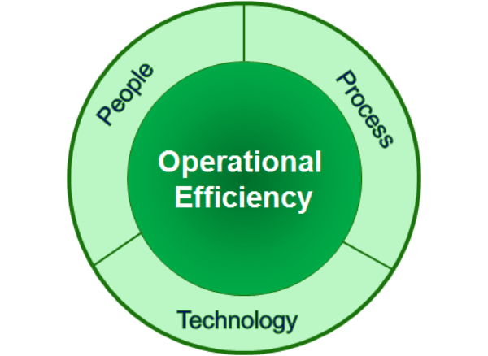
Figure 2: Operational efficiency
(solutions360, 2022)

2.2.2 Evolution of Operational Efficiency
The productivity of UK banks has gone through a dramatic change due to technology factors acting as a driving force with the support of regulatory bodies and changing market conditions (Diener and Špaček 2021). Originally, the UK banks aimed to get the maximum output with the minimum of input and they concerned themselves solely with the fundamentals of costs and resources. Nonetheless, it is worth naming several phases of the evolution of operational efficiency.
The last decade of the twentieth century saw the revolution of banking operations through use of digital technology. Products such as the Automated Teller Machines (ATMs), online banking, as well as electronic payment systems brought drastic changes in the banking markets (Kosumi and Poposka 2022). They made customer convenience better on the one hand and operation effectiveness better on the other hand as they reduced the physical branch and manual work.
This paper focuses on changes in regulation as one of the key drivers of the operational efficiency of UK banks in the 21st century. The financial crisis that occurred in the year 2008 resulted in increased regulatory standards, which made banks embrace compliance and risk management departments. Such investments had incurred initial costs that at long last have translated into stronger and more effective structures of operation.
Lately, it has been regarded as more specific, including artificial intelligence (AI), machine learning, and blockchain technology (Xu et al. 2021). These technologies are also helping UK banks to take operational efficiencies to another level wherein they can automate complex tasks, reduce frauds, and upgrade data analytics. The changes in the usage of cloud computing and the development of fintech solution partnerships are also other efficiency factors enhancing operational adaptability.

2.2.3 Impact of Historical Events
On the UK banks, the evolution of the same has always been influenced by a particular historical incident and each of them has carved an indelible mark on the banking sector (Mathibe and Oppong 2024). These factors have led to modifications in the banking regulations, revenues, and techniques and hence led to improvements in the efficiency of the banking services.
The process of the 1980s – the so-called “Big Bang” – was the step of increased financial liberalization in the UK with consequences for banks. Swing in the form of abolishment of fixed commission charges and effect in the form of electronic trading systems flooded the financial markets. This led to more competitive structures where banks’ efficiency was driven to new heights by having to embrace the use of new technologies to survive.
The other major event that played out in this structure was the global financial crisis that happened in 2008, which highlighted major inefficiencies and risks in the banking sector (Kohler and Stockhammer 2022). As a result, the government established even more restrictive principles of banking activity regulation, including the Basel III agreement, within the framework of which banks were instructed to increase the volume of capital reserves and enhance their regulation of risks. These regulations were set to create more operational pressures at first glance but yielded a more stable and effective banking system. Lenders continue to dedicate a sizable number of resources in compliance technologies as well as risk management solutions which are now considered strategic in their practices.
The key factors worthy of consideration, however, have been changes in the provision of financial services as witnessed in the 21st Century through new technological applications or Facilities that have enhanced digital banking systems (Javaid et al. 2022). With the growing use of online and mobile banking, customers’ engagement and the need for the physical branch have changed drastically. That has reduced operational costs and enhanced efficiency at the same time that the production of basic goods has accelerated. Presently, AI and machine learning are being adopted to automate repetitive tasks, use chatbots to offer top-notch customer relations, and tighten measures that will help prevent cases of fraud.
Also, the ongoing COVID-19 crisis has edged the digitalization of the banking sector as people have been restricted in their mobility and thus turned to online banking solutions. New work-from-home conditions arose, and it became necessary to strengthen banks’ digital platforms while also pushing operational improvements.
Formatively other historical factors like financial deregulation, the global financial crisis, digital revolution have influenced the operational efficiency of UK banks (Hanafizadeh and Marjaie 2020). Such occurrences have forced banks to look for ways to come up with legal compliance, technologies, and awesome services that can create amazing services in the market competition.
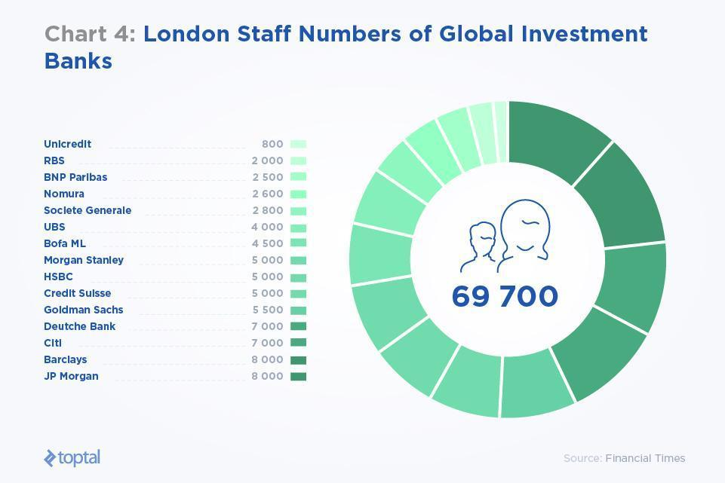
Figure 3: Impact on Banks
(Clarence-Smith, 2020)

2.2.4 Influence of management styles and strategies on operational efficiency.
Managing the flow of work and activities in an organization is mainly characterized by the managerial approaches and tactics in place, and these work marvels are seen in the banking sector. Thus, there are numerous theories and models like the X-Efficiency Theory or the Cost efficiency vs. Revenue efficiency that shed light on these impacts (Adeabah and Andoh 2020).
X-Efficiency, postulated by Harvey Leibenstein, demonstrates that internal inefficiencies and lack of competition pressure contribute to firms’ inefficiency. Proactively, organizational management that promotes and rewards autocratic leadership, individual responsibilities, and performance can prevent X-inefficiencies. Applying the X-Efficiency Theory helps point out the need for managerial activities to force firms to achieve the maximum level of efficiency. For example, there may be a competitive climate in the management that increases competitiveness and does not let personnel waste time on unnecessary things, or it may stimulate the creation of new products (Awan et al. 2020). This entails setting proper targets, constant remunerating, and the use of sound performance appraisal tools.
Cost Efficiency versus Revenue Efficiency is another perspective by which the efficiency of management strategies in altering operational efficiency can be measured. Cost efficiency is dealing with cost minimization but not affecting production quantities while on the other hand, revenue efficiency involves maximization of income through different strategies.
Cost Efficiency models are used to explore a level of resource management in terms of the extent to which costs can be cut (Marlina et al. 2020). Such practices as operating with minimal resources, reducing expenses, and seeking better ways of working lead to cost-efficient practices. Methods like Lean Management and Six Sigma are used in restructuring the processes and wasting minimal resources. For instance, if a bank practice Lean, its loan processing system could be optimized so that there is less repetition hence, less expense and more efficiency.
Data Envelopment models are applied to analyze the efficiency of actions targeted at the enhancement of revenues (Barbero and Zofío 2023). Management strategies that involve focusing on the customers, embracing changes that bring new and valuable products to the market, and the identification of excellent market niches boost the efficiency of its revenue. A bank working under the context of RE might take up product differentiation by offering customized services to clients, different pricing policies depending on client type, and attractive advertisement policies for the right market.
The efficiency of costs and revenue is good when in balance. There is one of the essential requirements for the management to work on constantly and find a way to balance: the two aspects must be optimized (Suarni and Amelia 2023). For example, capitalizing on technology could prove costly in the short run but would increase cost and revenue in the long run as a result of enhancing the quality of service delivered and customer satisfaction.
Therefore, it can be ascertained that the management styles and strategies specifically contribute towards the improvement of the X-efficiency theories and the actual models such as Cost Efficiency versus Revenue Efficiency of the banking institutions. Therefore, by keeping up with internal performance, cost control, and revenue increment, the management of an organization can create immovable growth in organizational efficiency.

2.2.5 Role of technology in enhancing or hindering efficiency.
This paper seeks to establish the role of technology in the improvement of organizational operations in banking sectors. It can increase efficiency by cutting down on the number of human operators through robotization, statistical methods, and customer service. However, it can also present certain potentially perplexing issues that can slow down the process if not effective and used appropriately.
Enhancing Efficiency:
Advanced tools like robotic process automation and AI may handle operative routine tasks much faster and with better outcomes than the employees (Siderska, 2020). For instance, in the banking industry automation can ensure some activities such as loan processing and approval, account transactions, and compliance evaluation respectively. It not only creates efficiency in the time and cost consumed by these tasks but also negates errors that would have affected the business’s operation.

Data Analytics and Decision-Making:
Data analytics help organizations to gather, store, process, and extract meaning from large volumes of data (Sarker, 2021). Specifically, big data can help banks understand more about the conduct of customers, the condition of the market, and the management of risk. Banks can, therefore, apply data analytics to make intelligent decisions in their operations to tailor their services hence improving the clientèle satisfaction. Another advantage is that with the help of predictive analytics, it is possible to determine potential problems when they have not yet become critical, and, therefore, to prevent the occurrence of big losses.

Enhanced Customer Service:
The introduction of technology helps in the improvement of customer relations through online banking, mobile banking, and chatbots (Misischia et al. 2022). These digital platforms give customers access to banking from anywhere and at any time, thus, avoiding the need for physical branches and staff. Applicants can process inquiries and potential issues in real time aiding customers and boosting their satisfaction. This change also helps to improve productivity, thereby freeing up employees’ time and serving the growing need for fast and accessible service.

Improved Risk Management:
Monitoring and analysis of risks are some of the aspects where risk management receives support from technological interventions. For instance, AI and machine learning algorithms can identify fraudulent transactions through analysis of the relevant patterns (Bello et al. 2024). This capability helps banks manage risks in a better manner besides ensuring that the operations remain protected and thus increase efficiency.

Hindering Efficiency:
Implementation Challenges:
Opting for a new technology may also not be easy because it may entail laying down of new structures, which may be expensive (Adaloudis and Roca 2021). There could be many trivial concerns like early capital-intensive investments in setting up technology framework, and employee training and incorporating them in the current organizational structure for banks. If they are not properly managed, these implementation processes inhibit the performance which leads to operational dysfunctions. However, it should be noted that resistance to change may continue to pose a problem among the firm’s employees and may consequently affect the implementation of new technologies even further.

Cybersecurity Risks:
One downside of increased dependence on technology is that the banks become major targets for hackers (Al-Alawi and Al-Bassam 2020). There is an absolute necessity to maintain sound cybersecurity, however, it may take a considerable amount of money and effort to achieve this goal. Consequently, there can be operational losses, which include financial losses, and loss of reputation, which are all efficiency reducers. These threats are constant, and to counter them, there must be constant investment in matters regarding cybersecurity, which may be tiresome on the resources.

Technology Overload:
Here the use of technology enriches efficiency but on the other hand, getting into a realm of work environment overused with tools and platforms usually brings the question of complication and confusion (Khalid et al. 2023). However, the use of multiple systems, where information does not flow smoothly from one to the other increases rather than decreases an organization’s inefficiency. This can be worse if there is poor training or assistance; this may cause frustration and the worker may produce less.

Maintenance and Upgrades:
Technology is always becoming outdated and needs to be updated and this is another demanding task that occupies many resources a company has (Sturgeon, 2021). It is required always to update and patch them to remain protected and optimum, however, this incurs some amount of time during which the normal business processes are interfered with. The above processes are important to be optimally managed so as not to compromise so much on the general performance.

2.2.6 Impact of workforce skills, training, and management on operational efficiency
Organizational skills, training, and management of the employees play a major role in the effective running of any business institution, including banks. When a workforce comprises competent employees or when the employees are managed professionally, their efficiency increases and they reduce their mistake rates, thus improving the efficiency of activities in an organization. On the other hand, if the service providers’ skills are low, training is insufficient, and management is poor, productivity may suffer and performance can be poor.

Workforce Skills:
In terms of the research objectives, it is important to note that the skills available to employees are a core component of operational effectiveness (Wong, 2020). Technical competence is a major factor where banking and finance personnel require professional competence in financial analysis, data manipulation, and requirements of the guidelines. For instance, interpersonal skills which include communication, analytical abilities, and customer relations are also key in the day-to-day running of affairs.
High skills that the employee possesses can achieve tasks in a precise and faster way demanding less time and effort in the processes involved. For instance, a human resource employee who has been trained can analyze large chunks of information and within no time give valuable recommendations on the business strategy and implementation. Likewise, the efficient workforce in customer service can help resolve problems quickly and pleasure clients thus improving the company operations without delays.

Training:
Education means investment in people and sustaining training as a way of developing the workforce knowledge is crucial (Zhang et al. 2020). In any dynamic field such as banking, which is characterized by constant technological and regulatory transformations, training can be a continuous process that seeks to ensure employees’ competency in the current market.
Effective training programs can improve operational efficiency in several ways:
Enhanced Competence: Training enables the employees to learn what is required of them and how they should do it. These translate to a decrease in incidences of mistakes hence less time is spent repeating a job hence efficiency.
Adaptability: Skills development assists individuals to allow them to cope with innovations and strategies. For instance, developing workshops on the new software or the use of ICT equipment helps workers to optimize these technologies thus improving efficiency.
Employee Engagement: It can find ways how we can improve engagement and motivation through training and development (Riyanto et al. 2021). Motivated employees tend to come up with new ideas and feel the desire to write a new chapter in operation, a factor that boosts operational performance.

Management:
Essential to the overall plan is the management’s responsibility of how best to ensure that the skills and training of the workforce contribute to the achievement of the enterprise’s objectives. The maintenance of proper practices at the workplace can lead to the development of the right culture, efficiency, and constant improvement.
Key management practices that impact operational efficiency include:
Leadership and Vision: Leadership gives strategic guidance and is the primary influencer of the organizational climate. Those who make clear and specific communication of vision and direction can in a strategic way ensure that the workforce is directed in the right direction when it comes to optimizing human capital.
Performance Management: Applying sound performance management systems assists in measuring and evaluating the performances of the employees (Lohman, 2021). Activities such as feedback and performance appraisal together with acknowledging the achievements of the employees encourage everyone to work hard in enhancing the operations of the business.
Resource Allocation: This is mainly because efficiency in management calls for efficient delivery of every resource, human resource inclusive. Parents must make sure that the right persons are matched with the right jobs in the frat. It reduces wastage of time and ensures that whatever is done in the organization is done to the best of its capacity.

Challenges and Solutions:
However, the consideration of several factors presents a challenge in determining the relationship between workforce skills, training, and management on the efficiency of the operations. Implementation of TOE can be challenging due to factors such as; resistance to change, a strain in the available training budgets, and controlling a diverse employee force.
To address these challenges, organizations can adopt several strategies:
Invest in Training: Ensure you set and provide adequate funds for effective training encompassing technology and generic skills (Kim and Park 2020). Another factor that needs to be taken into consideration is the use of education programs and collaborations with educational facilities as cost-efficient training practices.
Foster a Learning Culture: The second element is the developing climate favoring the constant desire to enhance knowledge and skills. Promote among the employees the attitudes towards learning and foster skill upgrades.
Effective Change Management: In this model, structured change management practice should be put in place to facilitate change transitions effectively. Include and listen to employees’ opinions about the change, discuss concerns, and help them to respond positively to the changes.
Diverse and Inclusive Workforce: Bring in diversity and inclusion policies at the workplace. Different people come from different backgrounds and thus have different perceptions, which is an excellent way to foster innovation and increase efficiency in problem-solving in an organization’s operations (Royall et al. 2022).

2.2.7 Competition in the UK Banks operational efficiency
In the last few years, UK banks have turned to optimization means and techniques that included the use of analytical tools like automation, artificial intelligence, and machine learning for their standard business processes improvement. These technologies help to have higher data processing speed, manage risks and make a decision in a short period (Rahmayati, 2021). Automation has also removed the chances of people making mistakes when doing some processes and also relieved the banks workers to concentrate on analytic and higher-level activities making it efficient.
However, it very important to understand that the achievement and sustenance of operational efficiency is not without stiff challenges. UK banks are required to follow strict operational guidelines which, in many cases, call for substantial expenditure on compliance solutions. Moreover, the unstable situation in cyberspace makes its threats a permanent challenge to banks – they have to spend a lot of money on their protection (Hassan and Giouvris, 2021).
The level of competition is high with conventional banks having a new entry of fintech companies looking at ways of improving customer services. FinTech especially, have caused the disruption of the market through developing new solutions that are quick to embrace the market and which can suit the need of the new generation clients who are more inclined to efficient and trendy technology solutions. As a result, incumbent UK banks are becoming more involved in fintech, either through collaboration or internal innovation.

2.2.8 Herfindahl Hirschman Index
The Herfindahl Hirschman Index (HHI) which measures market concentration levels forms a very important variable in trying to understand the efficiencies in the operations of the UK banks. High HHI values signify that the banking market share is dominated by few firms, hence, implying less competition and possibly inferior efficiency due to a low competitive threat to the large, dominating banks (Kvålseth, 2022). On the other hand, a low HHI implies that there is lot of competition among the public sector banks in order to improve the efficiency and sustain or expand their market shares. The empirical evidence on the UK banks confirms that the concept of competition measured by the HHI greatly affect the pro-efficiency incentives and for the further development of the market due to the emerging FinTech.

2.3 Literature Gap
Most of the empirical literature in the existing literature focuses on operational efficiency in the banking sector mostly in the aspects of technology, regulation, and management. However, these two areas that need further research are quite apparent (Shair et al. 2021). This leaves a gap in the respect that there is not a lot of emphasis placed on the use of newer technologies such as blockchain and AI in the area of operation optimization. Even though these technologies have demonstrated potential, research focusing on the long-term effects of these technologies and the difficulties connected with the implementation of such systems in banks is limited.
Moreover, the literature also lacks the association of organizational workforce diversity and inclusion as a factor that contributes to productive organizational operations. Existing literature lacks extensive research that focuses on the elaboration of how innovations and improvements to the efficiency of big banks stem from working in diverse teams.
There is another knowledge gap concerning the effects of varying managerial strategies and approaches on operational performance (Al-Dmour et al. 2021). Even though broader aspects of general management are brought up, certain specific aspects like the impact of transformational as well as transactional leadership on the efficient alternation of efficiency indicators are given scarce attention.
Furthermore, it is essential to study the relationship between compliance and operations more effectively as a result of the constantly changing international financial standards. In this context, research that offers information on how best to achieve compliance with IT operations while not limiting operational flexibility would be useful. Maybe, filling these gaps would help to get a better understanding of the factors that affect operational performance in the banking industry and give practical recommendations for practitioners.

2.4 Conceptual Framework
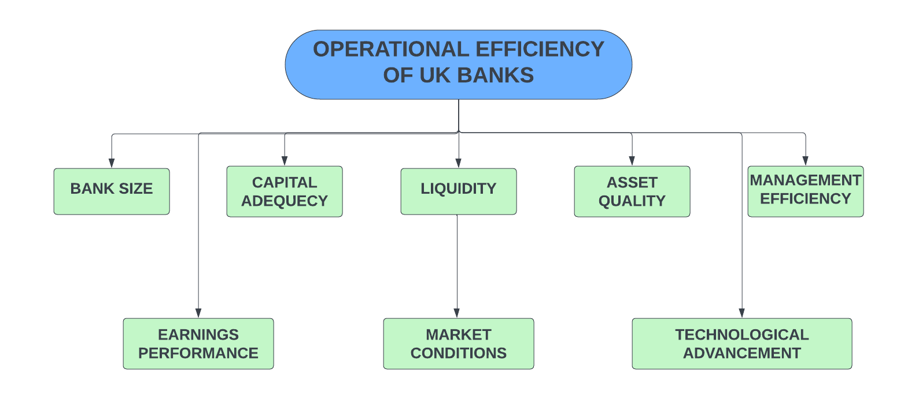
Figure 4: Conceptual Framework
(Source: Self-created)

2.5 Research hypothesis
1. Bank Size
- Null Hypothesis (H0): Bank size has no significant effect on the operational efficiency of UK banks.
- Alternative Hypothesis (H1): Bank size has a significant effect on the operational efficiency of UK banks.
2. Capital Adequacy
- Null Hypothesis (H0): Capital adequacy has no significant effect on the operational efficiency of UK banks.
- Alternative Hypothesis (H1): Capital adequacy has a significant effect on the operational efficiency of UK banks.
3. Liquidity
- Null Hypothesis (H0): Liquidity has no significant effect on the operational efficiency of UK banks.
- Alternative Hypothesis (H1): Liquidity has a significant effect on the operational efficiency of UK banks.
4. Asset Quality
- Null Hypothesis (H0): Asset quality has no significant effect on the operational efficiency of UK banks.
- Alternative Hypothesis (H1): Asset quality has a significant effect on the operational efficiency of UK banks.
5. Management Efficiency
- Null Hypothesis (H0): Management efficiency has no significant effect on the operational efficiency of UK banks.
- Alternative Hypothesis (H1): Management efficiency has a significant effect on the operational efficiency of UK banks.
6. Earnings Performance (linked to Bank Size)
- Null Hypothesis (H0): Earnings performance has no significant effect on the operational efficiency of UK banks.
- Alternative Hypothesis (H1): Earnings performance has a significant effect on the operational efficiency of UK banks.
7. Market Conditions (linked to Liquidity)
- Null Hypothesis (H0): Market conditions have no significant effect on the operational efficiency of UK banks.
- Alternative Hypothesis (H1): Market conditions have a significant effect on the operational efficiency of UK banks.
8. Technological Advancement (linked to Management Efficiency)
- Null Hypothesis (H0): Technological advancement has no significant effect on the operational efficiency of UK banks.
- Alternative Hypothesis (H1): Technological advancement has a significant effect on the operational efficiency of UK banks.

2.6 Summary
UK banks technology, skill level of employees, and management practices can be said to impact the clustered strategy. Technology is effective in the improvement of efficiency through the automation of processes, data analysis, and enhanced customer relations but is associated with certain downsides like information security threats and technical difficulties of implementation (Al-Shehab et al. 2021). It seeks to understand and identify efforts underpinning the development of vocational skills and staff, organization and management, and training practices with a view of enabling productivity and adaptability. However, there are nearly non-existent academic publications regarding the application of emerging technologies, the influence of a diverse workforce, and certain approaches to managing the effectiveness of subordinates. Filling these gaps might help to shed more light on the ideal method for enhancing organizational effectiveness in the banking industry.

Chapter 3: Methodology

3.1 Introduction
This section shows the research methodology for evaluating the operational efficiency of the banks of the UK. Moreover, this starts with the research philosophy followed by positivist philosophy, deductive approach which supports the study. Further, this chapter reveals the research design, data collection by DEA, choosing non-probability sampling method and data analysis, addressing research quality, ethical issues and the limitations of the methodology.

3.2. Research Onion
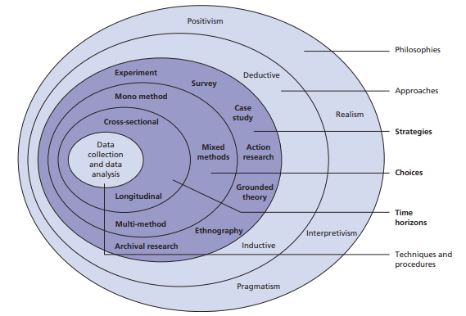

Figure 5: Research Onion Model
(Source: Saunders et al., 2009)

For this topic, the research onion framework can be structured by considering, the research questions at the top of the layer, which emphasizes on addressing the determinants which impacts the operational efficiency in the banks of UK. Moreover, the literature review involves the existing studies on the bank’s efficiency, and exploring the reliable theories and factual analyses. Then the research design layers adopt conclusive research aims to offer reliable and exact answers to certain research questions. Further, the data collection layer, the secondary data is collected from financial reports and database of the banks of UK. Then the data analysis layer consists of the SPSS by analyzing correlation analysis and descriptive statistics, involving costs and outputs. Lastly, the innermost layer, findings show the information on the determinants which influencing the efficiency of banks and provide recommendations for improvement.

3.3 Research philosophy
This research topic of evaluating the operational efficiency of the banks of the UK follows a positivist which supported the idea that reality is vital and can be observed, calculated and analyzed individually by the researcher. Moreover, this focuses on the use of quantitative data, statistical analysis and the factual proofs for recognizing phenomena. Further, in the background of this study the goal is to measure the operational efficiency of the banks using the financial data, which is measurable and objective (Rahman, 2023). Moreover, this aligns with the positivist approach, which emphasizes on observing data which can be tested factually. Further, the study wants to develop patterns, relationships and the causal connections between the diverse determinants and the efficiency results in the banks of the UK. However, this positivist philosophy is appropriate as this enables the use of developed financial theories and models like Data envelopment analysis and Stochastic frontier analysis for examining the efficiency of banks. Thereby this philosophy guides the goal of achieving objective, generalizable information in the operational efficiency of the banks in a robust and scientifically valid way.

3.4. Research Approach
This research topic of analyzing the operational efficiency of the banks of the UK follows a deductive approach. Moreover, the deductive approach is featured by initiating with a normal theory which is then tested by the collection and analysis of the factual data. Further, this moves from confirming the beginning hypotheses regarding the evidence collected. In this study, the research starts with the current theories and models associated with banking efficiency like production theory or efficiency frontier models (Ullah, Majeed and Popp, 2023). However, these models offer a framework for recognizing what factors may influence the operational efficiency in the banks. Thereby the researcher crafts specific hypotheses on the basis of the theories. Further, this deductive approach is suitable for the research as it enables for a systematic and structured examination. However, this aligns with the research philosophy that focuses on testing hypotheses and the use of objective, quantitative data.

3.5. Research design
This research topic evaluates the operational efficiency of the banks of the UK which follows a conclusive research design. Moreover, conclusive research aims to offer reliable and exact answers to certain research questions. Further, this often uses the methods to test the hypotheses, making effective decisions and extract conclusions regarding the factual data (De Leon, 2020). However, the goal is to determine and measure the operational efficiency of the UK banks, using the developed financial indicators and the statistical technologies such as data envelopment analysis. However, the aim is to develop concrete, data driven information as to how efficiently these banks can operate, and what the factors contribute to their efficiency and how they compare with others. Moreover, the conclusive research is well constructed for this study as this involves testing the defined hypothesis or the theories associated with banking efficiency like the influence of bank size, market share and cost management on operational efficiency.

3.6. Data Collection method
For this study on operational efficiency of the UK banks, data collection will use Data Envelopment Analysis. Moreover, this method is a non-parametric method used for operations research and economics for analyzing the efficiency of decision-making units like banks, in converting inputs into outputs. Further, for implementing DEA method, data collection will emphasize on collecting detailed quantitative data on both inputs and outputs of 5 private banks such as HSBC, Barclays, Lloyds Bank, JP Morgan and UBS (Shahaab et al., 2022). However, the inputs normally involve variables like labour, capital, operating costs and the resources which the banks utilize into their operations. Further, the outputs may involve measures of performance, like issued loans, deposits collected, revenue created or profits. Moreover, the data for these inputs and outputs are collected from the public sources like annual financial reports, regulatory filings and industry reports. Then the data should be accurate and comparable over the banks being explored for ensuring the validity of the results of DEA.

3.7. Data analysis
This research topic involves quantitative data analysis by using SPSS by analyzing correlation, regression analysis and descriptive statistics. This will determine the operational efficiency of the banks of the UK. Moreover, this uses numerical data like financial metrics and performance indicators and implements statistical methods such as DEA.
3.7A. Data Collection and Preparation
Primary quantitative analysis entails collecting data from the UK banks on the drivers to operational efficiency for instance size of the bank, capital control, liquidity, quality of assets, efficiency of managers, performance of earnings, market forces and advancement in technology. This information can be gathered from the first-hand sources for instance 100 respondents from 5 banks in United Kingdom. However, before the data set can be used for analysis, it is first processed, meaning the data is scrubbed to eliminate any error or inconsistency. The data is being entered and coded correctly in the SPSS computer software and the descriptive statistics is performed to identify the distribution of the variable.
3.7B. Statistical Analysis in SPSS
Typically, when SPSS runs this test, it provides us with the coefficients, R square and p values that explain the strength and significance of the various factors that influence operational efficiency.
 | Question | Variable | Measurement Scale | SPSS Variable Type
Q1 | What is your age group? | Age Group | Nominal | Numeric (Discrete)
Q2 | What is your gender? | Gender | Nominal | Numeric (Discrete)
Q3 | Are you a bank customer or a bank employee? | Role | Nominal | Numeric (Discrete)
Q4 | The bank’s Return on Assets (ROA) is a strong indicator of its operational efficiency. | ROA as Operational Efficiency Indicator | Likert Scale (1-5) | Ordinal
Q5 | Return on Equity (ROE) plays a critical role in evaluating the bank's overall financial performance. | ROE as Financial Performance Indicator | Likert Scale (1-5) | Ordinal
Q6 | The bank's financial performance metrics effectively reflect its operational efficiency. | Financial Metrics Reflect Efficiency | Likert Scale (1-5) | Ordinal
Q7 | The implementation of digital banking services has significantly improved the bank's operational efficiency. | Digital Banking Improves Efficiency | Likert Scale (1-5) | Ordinal
Q8 | Artificial Intelligence (AI) in banking operations enhances efficiency by reducing manual processes. | AI Enhances Efficiency | Likert Scale (1-5) | Ordinal
Q9 | The bank's technology infrastructure is robust and contributes to its operational efficiency. | Robust Technology Infrastructure | Likert Scale (1-5) | Ordinal
Q10 | Technological advancements in banking (e.g., mobile apps, online services) have led to better customer satisfaction and operational efficiency. | Tech Advancements Improve Efficiency | Likert Scale (1-5) | Ordinal
Q11 | Regulatory requirements enhance the bank's operational efficiency by ensuring better risk management. | Regulations Enhance Efficiency | Likert Scale (1-5) | Ordinal
Q12 | Compliance with regulatory standards positively impacts the bank's financial performance. | Compliance Impacts Financial Performance | Likert Scale (1-5) | Ordinal
Q13 | Regulatory structures are crucial in maintaining the operational efficiency of the bank. | Regulatory Structures Maintain Efficiency | Likert Scale (1-5) | Ordinal
Q14 | High-quality customer service is directly linked to the bank’s operational efficiency. | Customer Service Linked to Efficiency | Likert Scale (1-5) | Ordinal
Q15 | The bank’s customer service processes are efficient and contribute to overall operational success. | Efficient Customer Service Processes | Likert Scale (1-5) | Ordinal
Q16 | Customer feedback is effectively used to improve the bank’s operational efficiency. | Customer Feedback Improves Efficiency | Likert Scale (1-5) | Ordinal

3.8. Sampling
For the study on operational efficiency of the UK banks, a random sampling is normally a suitable option, which will take 100 participants through a survey. There will be 16 questions for the survey out of which 3 will be demographic questions and rest 13 will be close-ended questions Moreover, the non-probability sampling is used when the research emphasizes a certain subset of a population despite attempting the normal findings to the entire population. Further, the objective of the study is to evaluate operational efficiency using DEA, where this study will likely target a certain group of banks’ employees and customers for the survey (Demsetz and Lehn, 2021). Thus, this method supports the aims of study to draw specific, actionable information for the efficiency in a defined group of the banks of the UK.

3.9. Research quality
The research quality of this study of operational efficiency of the banks of the UK is ensured by a mixture of reliability, validity and generalizability. Moreover, reliability means consistency for the key findings, and here, reliability is guided by using standardized data sources, like financial statements and industry reports, by ensuring that the collected data process is stable and reliable. Further, the use of developed analytical methods such as data envelopment analysis which improves the reliability of the findings (Gržeta, Žiković and Tomas Žiković, 2023). Then validity is casual with the accuracy of the findings and for ensuring validity, this research study meticulously choses the relevant inputs and outputs which exactly show the operational efficiency of banks. Further, generalizability means the level at which the findings can be implemented to the other. Then this study emphasizes certain bank samples of the UK.

3.10. Ethical consideration
The ethical consideration of this study is integrity of the research on the operational efficiency of the banks of the UK. Moreover, the study will strictly comply with gaining the informed consent from the participants before they are involved in the research. Further, to protect the privacy of the participants, all the identities will remain anonymous, and confidentiality over the research process (Zaim et al., 2022). However, this includes protecting the collected data and using this for research purposes and preventing any unauthorized third-party access. Moreover, any potential conflicts of interest will be transparently reported for maintaining the credibility of the study.

3.11. Limitations of the methodology
This methodology for evaluating the operational efficiency of the banks of the UK have various limitations. Moreover, the data availability may limit the study, as some banks may not have publicly available or complete the financial data. Further, choosing bias may initiate if the sample does not demonstrate the entire banking sector, mainly reducing the results. However, the DEA, while effective, may be sensitive to input and output selection that affect the scores of efficiencies. Then the temporal limitations limit the study to a snapshot of efficiency despite the trends over the period (Asutay and Ubaidillah, 2023). Moreover, the non-probability sampling approach may not normalize the key findings to the banks, especially smaller prominent organizations. Lastly, the subjectivity in defining the efficiency area and interpreting the results may develop the researcher bias, which influences the objectivity of the study.

3.12. Summary
This methodology chapter shows the evaluation of the UK bank's operational efficiency. Moreover, this implements a positivist philosophy that focuses on the use of quantitative data, statistical analysis and the factual proofs for recognizing phenomenon. Then follows a deductive strategy, using a conclusive research design. Further, the data is collected by Data Envelopment analysis with non-probability sampling targeting certain banks. However, the quantitative analysis will ensure reliability and validity. Hence, the ethical considerations involve informed consent and confidentiality, but the limitations include data availability, choosing bias, temporal constraints.

Chapter 4: Data analysis

4.1 Introduction
This paper aims at discussing some of the critical success factors that have impacted the UK banks operating in the current environment to increase productivity, some of which are a combination of customer service, digital banking, technology, or compliance. Due to this, the study seeks to establish how these variables will help in enhancing the operation of the bank and efficiency in the current increased competition.

4.2 Interpretation of data
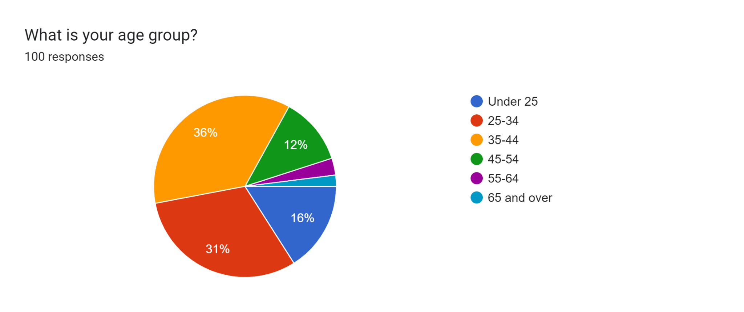
This chart illustrates the age distribution of a hundred respondents participating in a survey on the factors affecting the operational efficiency of the UK banks. The first category of people comprises 36% of users between 35-44 years of age, second, 31% of users between 25-34 years. Very few, 12% fall within the age of 45-54 and an even lesser proportion falls in other age brackets respond to the survey.

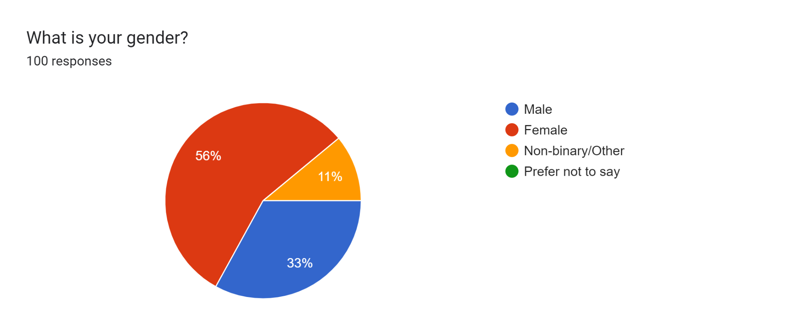
The above chart displays the gender split of 100 individuals who took a survey on the operating effectiveness of UK banks. Some 56% are female and the rest 33% are male. Further 11% of the respondents self-identify as non-binary / other. Gender differences in the responses may reveal the efficiency perceptions of the banking services from the two gender groups.

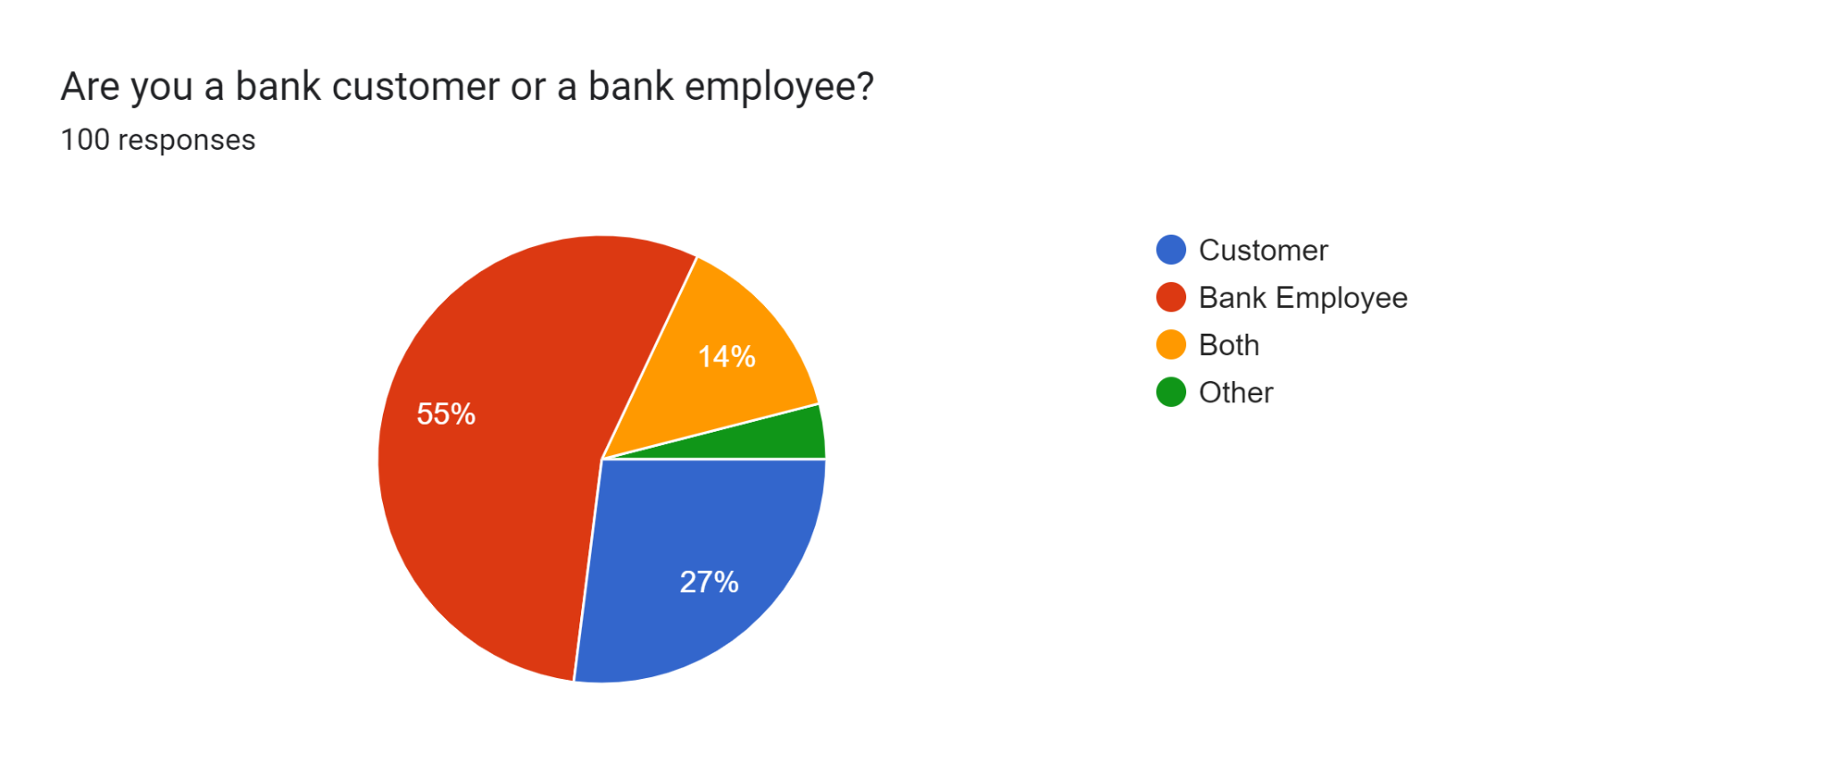

From the chart, the respondent's position is identified in a survey on the operational efficiency of UK banks. The greater part of subjects, which are 55% of respondents, are bank employees and 27% of respondents are customers. Further, 14% are customers and employees at the same time, and 4% of the subjects belong to the “Other” category. They are also used in giving a diversity of insight on the operations of the bank.

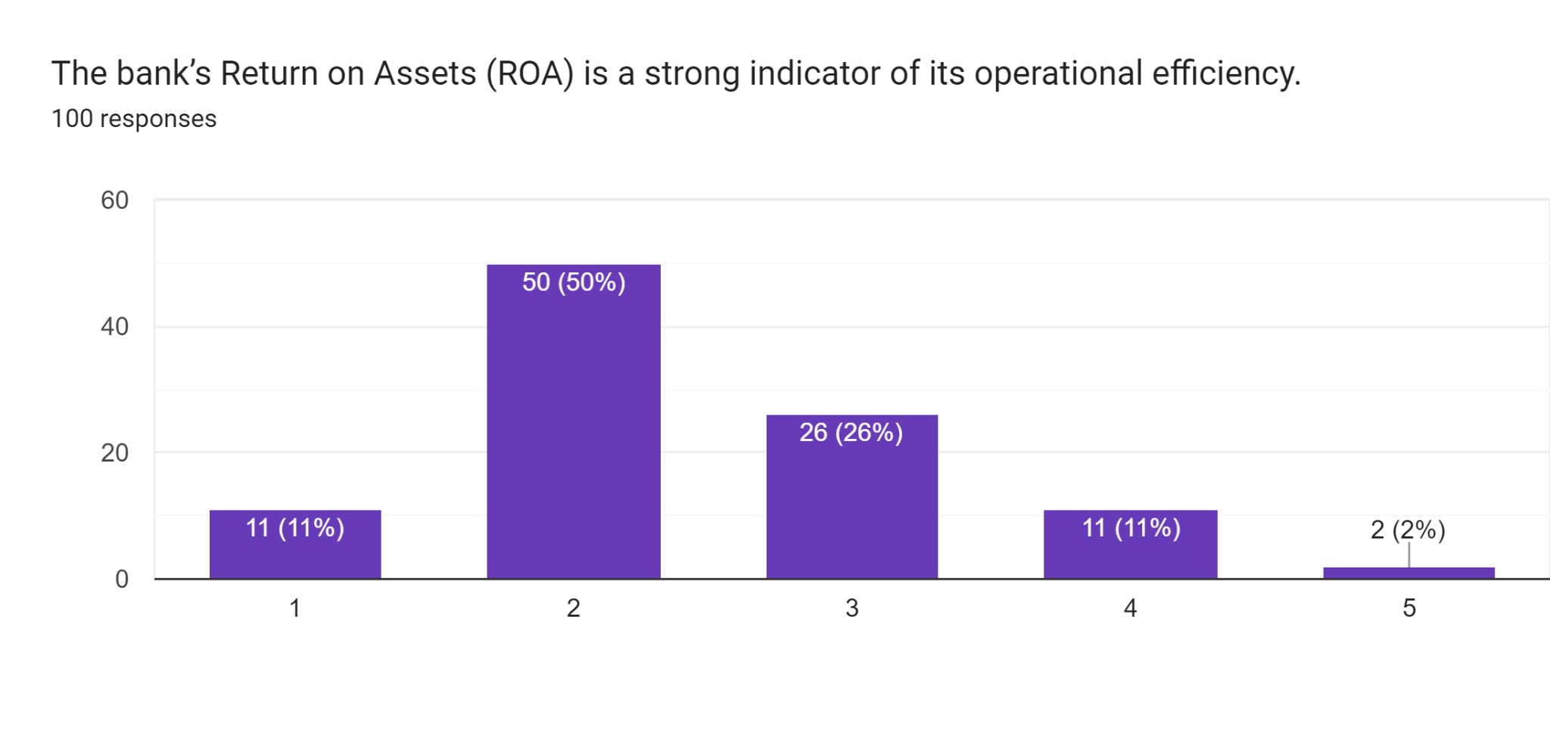
The chart portrays the respondents’ perception on whether ROA of a bank is an ideal benchmark for determining operational efficiency. In regards to the statement, 26% of the participants responded as neutral. The remainder rated it 1 (11%)- strongly agreed, 2 (50%) agreed, 4(11%)- disagreed, and 5(2%) strongly disagreed, indicating the differences in their perception of the usefulness of ROA on efficiency.

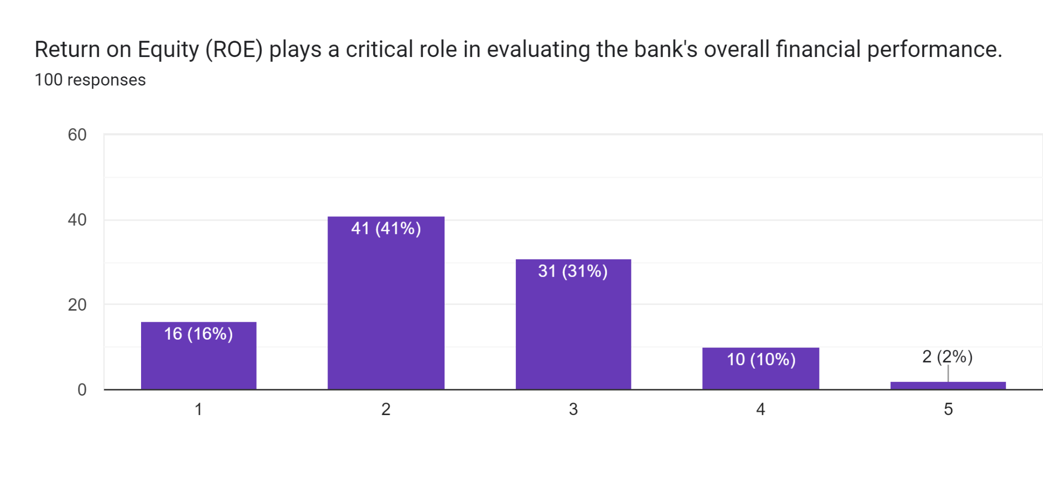
In fact, this chart illustrates the frequency of response (Overall, 100 participants) based on the retrospective question regarding the importance of ROE for the analysis of UK banks’ financial performance. Here, 41% of respondents are the highest to respond as agree and 2% of them strongly disagreed with the statement.

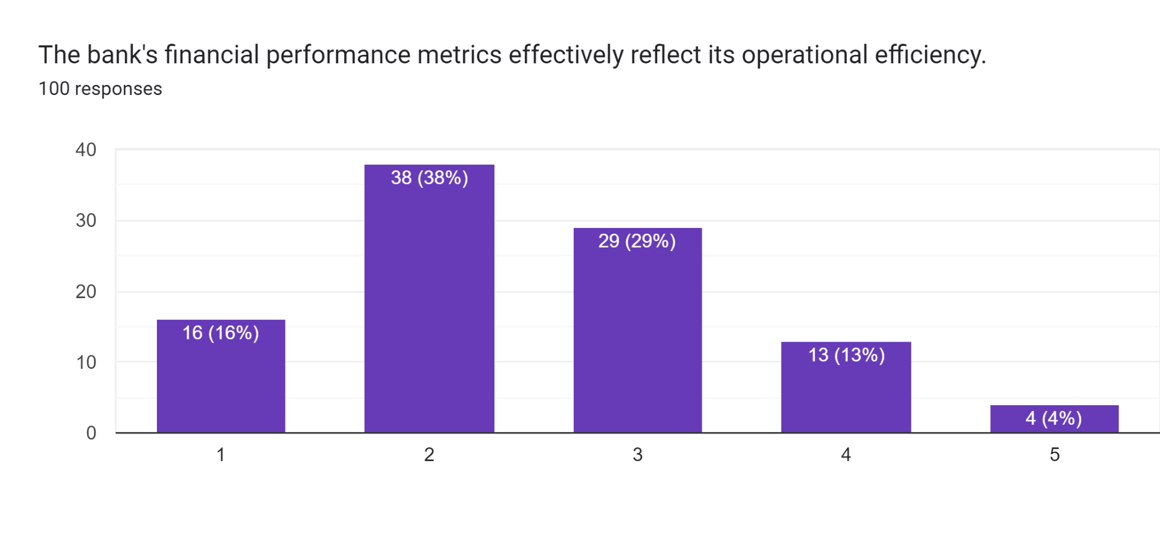
The above chart shows 100 people’s perception about the extent to which their responses mirror the operational efficiency of UK banks through the financial performance indicators. Out of the respondents, 38% agreed with it, which implies that respondents think that financial measures reasonably represent operational performance. A much smaller number 16% placed it lower strongly agreed and 4% strongly disagreed to this meaning that there is still some confusion as to the efficiency of these metrics.

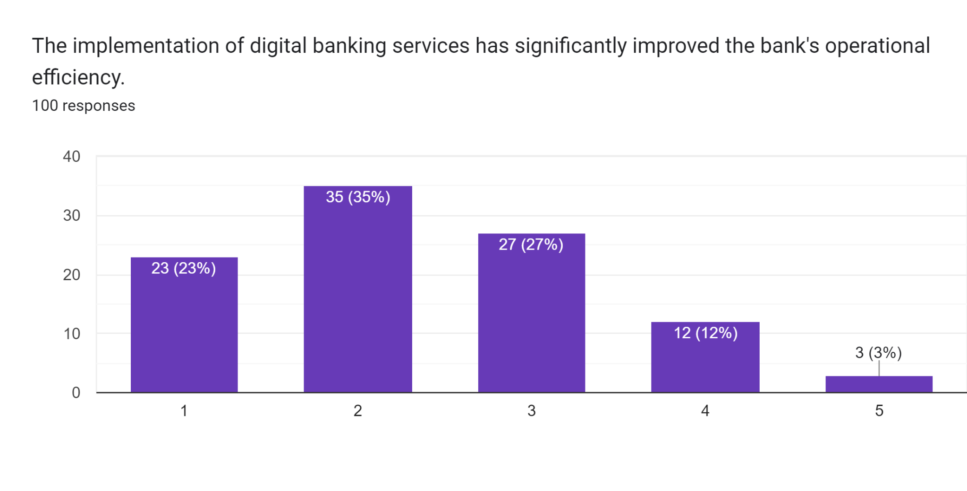
This chart presents 100 opinions on the effects of digital banking services on the overall performance of the UK banks. 27% of the participants considered the statement as neutral which supports the idea that digital banking is useful but not revolutionary. On the contrary, 35% of respondents have agreed to the statement and 23% of them had strongly agreed while a small fraction of the respondents (12%) disagreed and 3% of the respondents strongly disagreed to this.

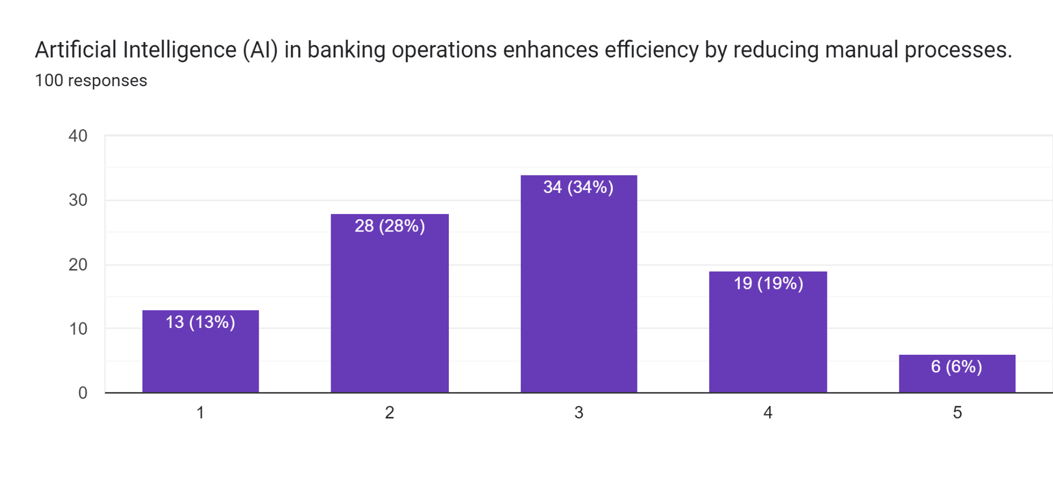
The chart illustrates the feedback related to the impact of AI on the level of automation in banking. The largest group of respondents (34%) falls for neutral response and the second biggest group (28%) agreed comes under for the second highest tone (2). It is rather small groups that are more inclined to strongly agreed with it (13%) and disagree with the statement (19%); however, 6% of the population strongly disagreed. This has been evidenced by the following statement where there is divergence in the opinions on the efficiency of the banking systems by the implementation of intelligent methods such as AI.

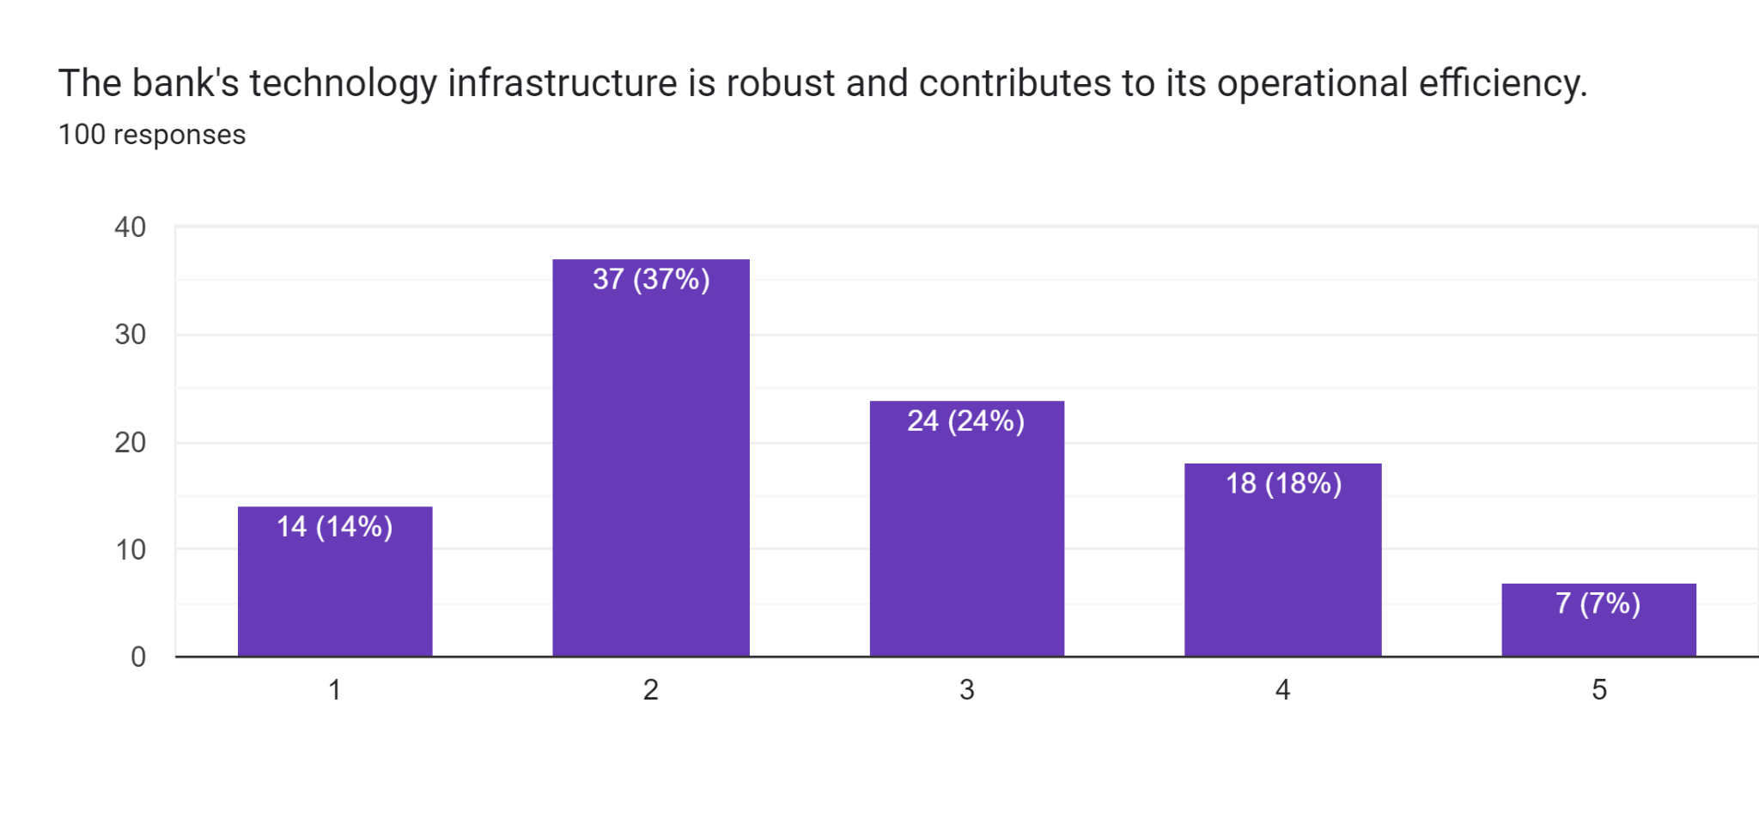
The majority (37%) of respondents agree (2) with the statement that their bank’s technology is modern and helps to improve operations. A few are 24% with the neutral response while only 18% were affiliated with the disagree category. It also indicates that a large number of people in the sample regard their bank’s technology infrastructure as sufficiently developed.

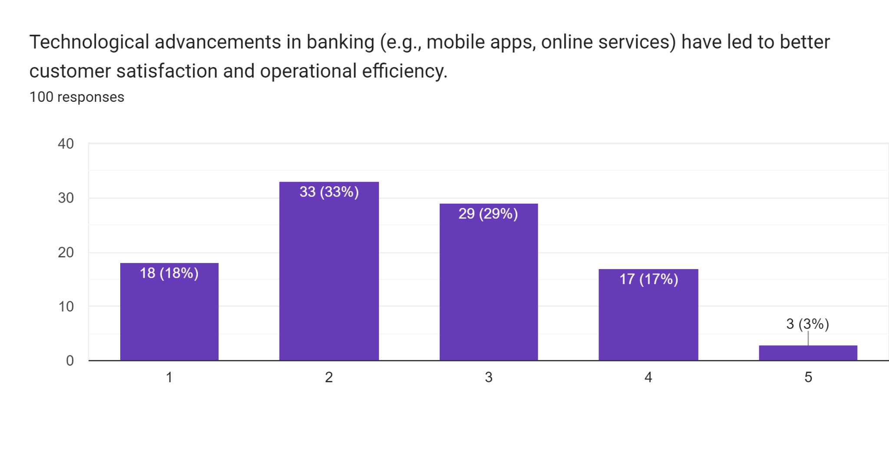
About one third of the respondents (33%) agree (2) that technological advancements in banking have improved customers’ satisfaction and increased efficiency, while 29% of the respondents are in the neutral zone (3). 17% thereof, which shows that quite a number of the respondents are not convinced with the impact of technology on increasing operational efficiency. Therefore, it shows that advancement in technology within the banking sector have made easier for the people to operate their work easily.

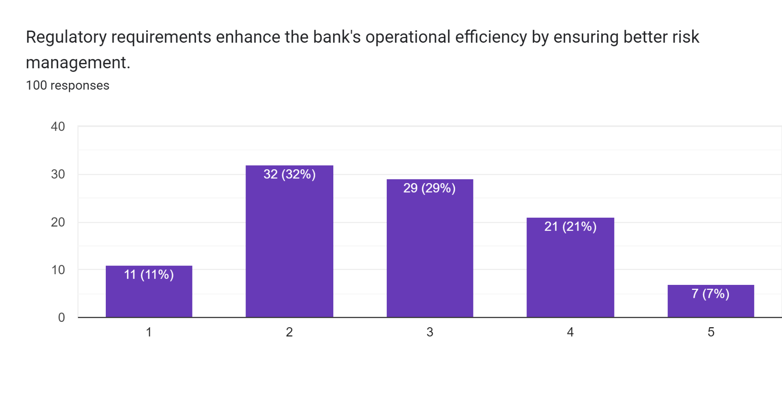
Overall, 29% of participants provided sceptical or neutral responses, revealing similar doubts about significant enhancement of risk management due to regulations. Single, 7% strongly disagreed meaning minimal confidence.

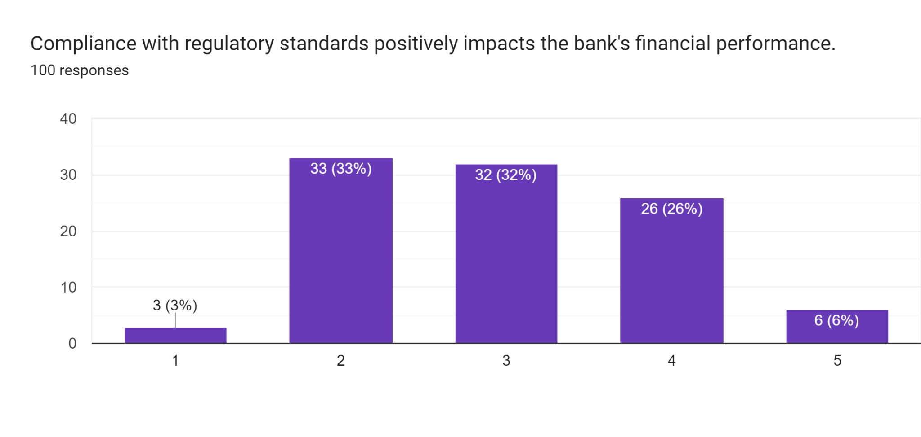
Only 33% can be considered fully in agreement with statements, 32% of respondents were neutral to their decision while 3% are strongly agreed, indicating that the banks perceive significant direct monetary benefits from regulatory compliance. Similarly, a really small percentage 6% responded strongly disagreeing that indicates a slightly negative reaction.

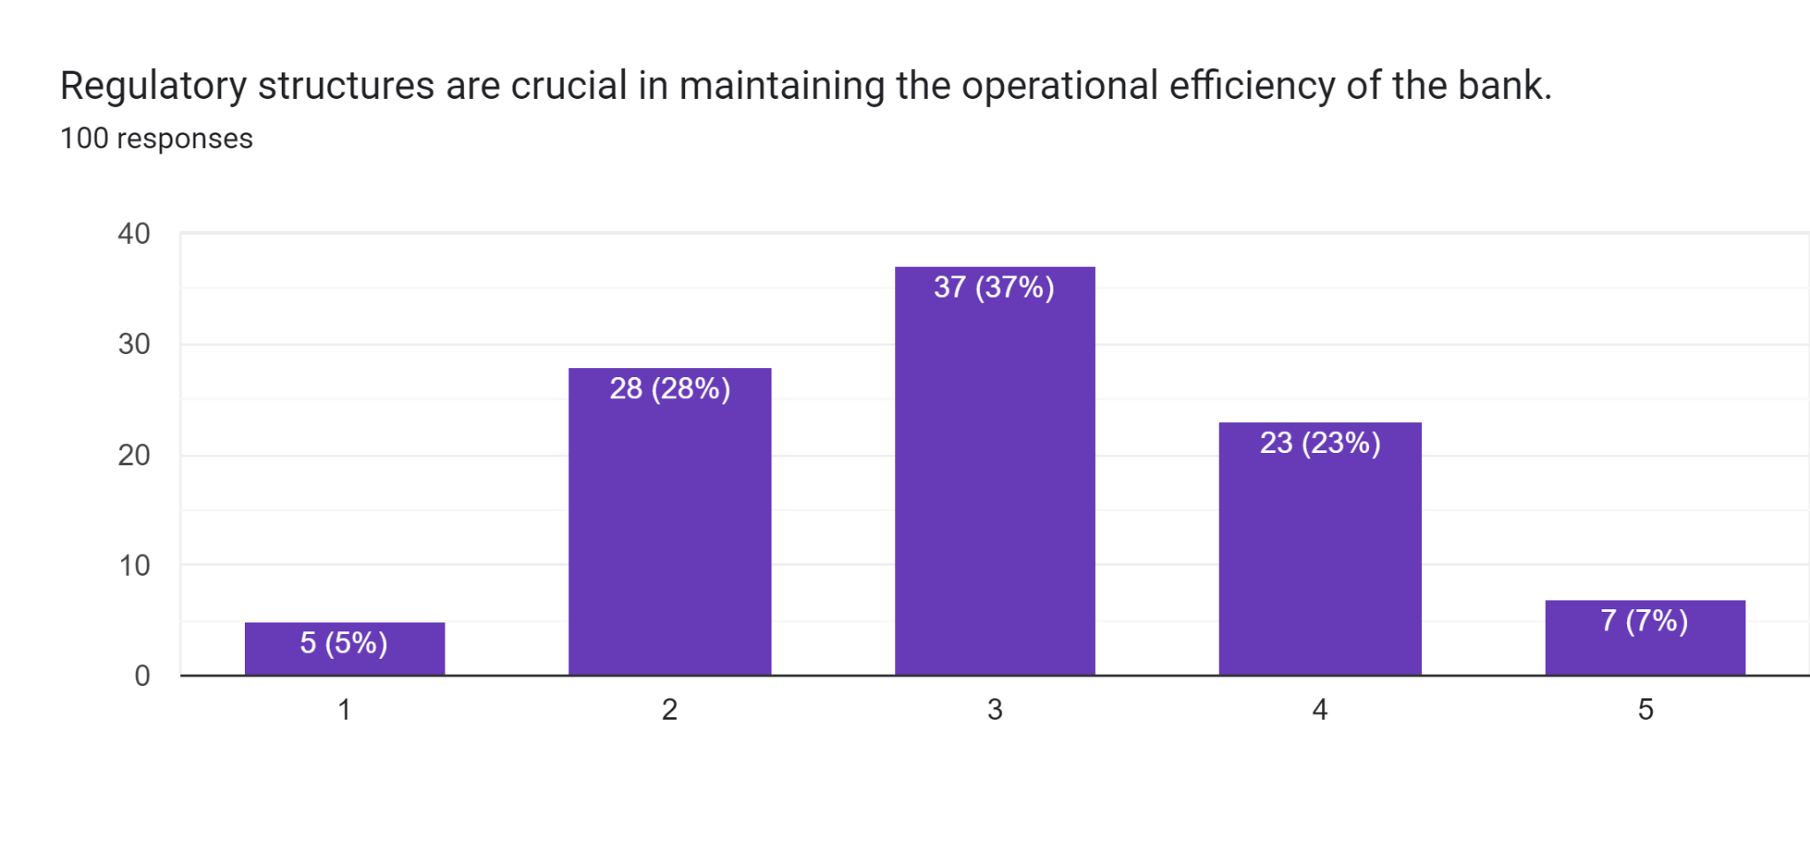
The greatest part of the respondents (37%) reported a neutral attitude towards the importance of regulatory structures to support operational efficiency. A simple 7% disagree strongly, indicating that there is little support, indeed.

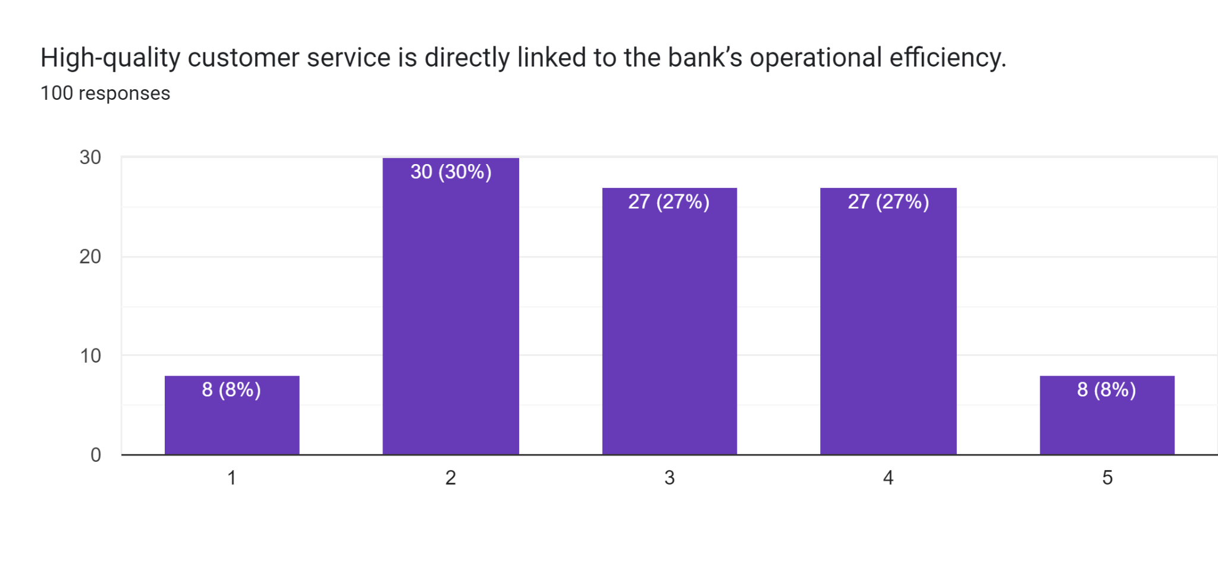
From the above chart, it can be stated that 30% of the participants agreed with the statement whereas only 8% of the participants strongly agreed with the statement and 27% of them had a negative decision.
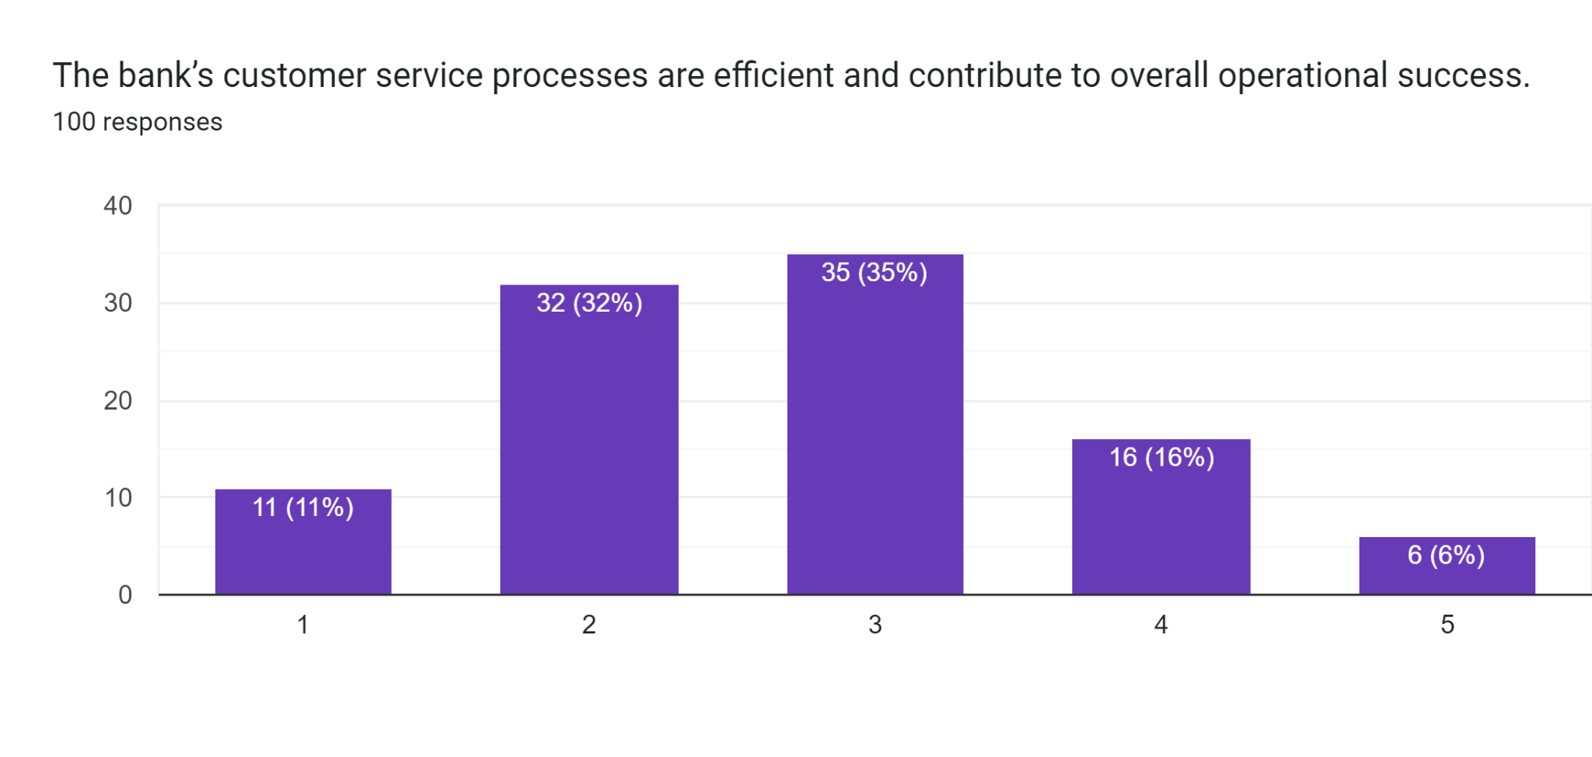
The chart represents that 35% of the respondents were neutral towards their thinking and 6% had disagreed to it out of which only 11% strongly agreed to it and 32% has agreed to the statement.
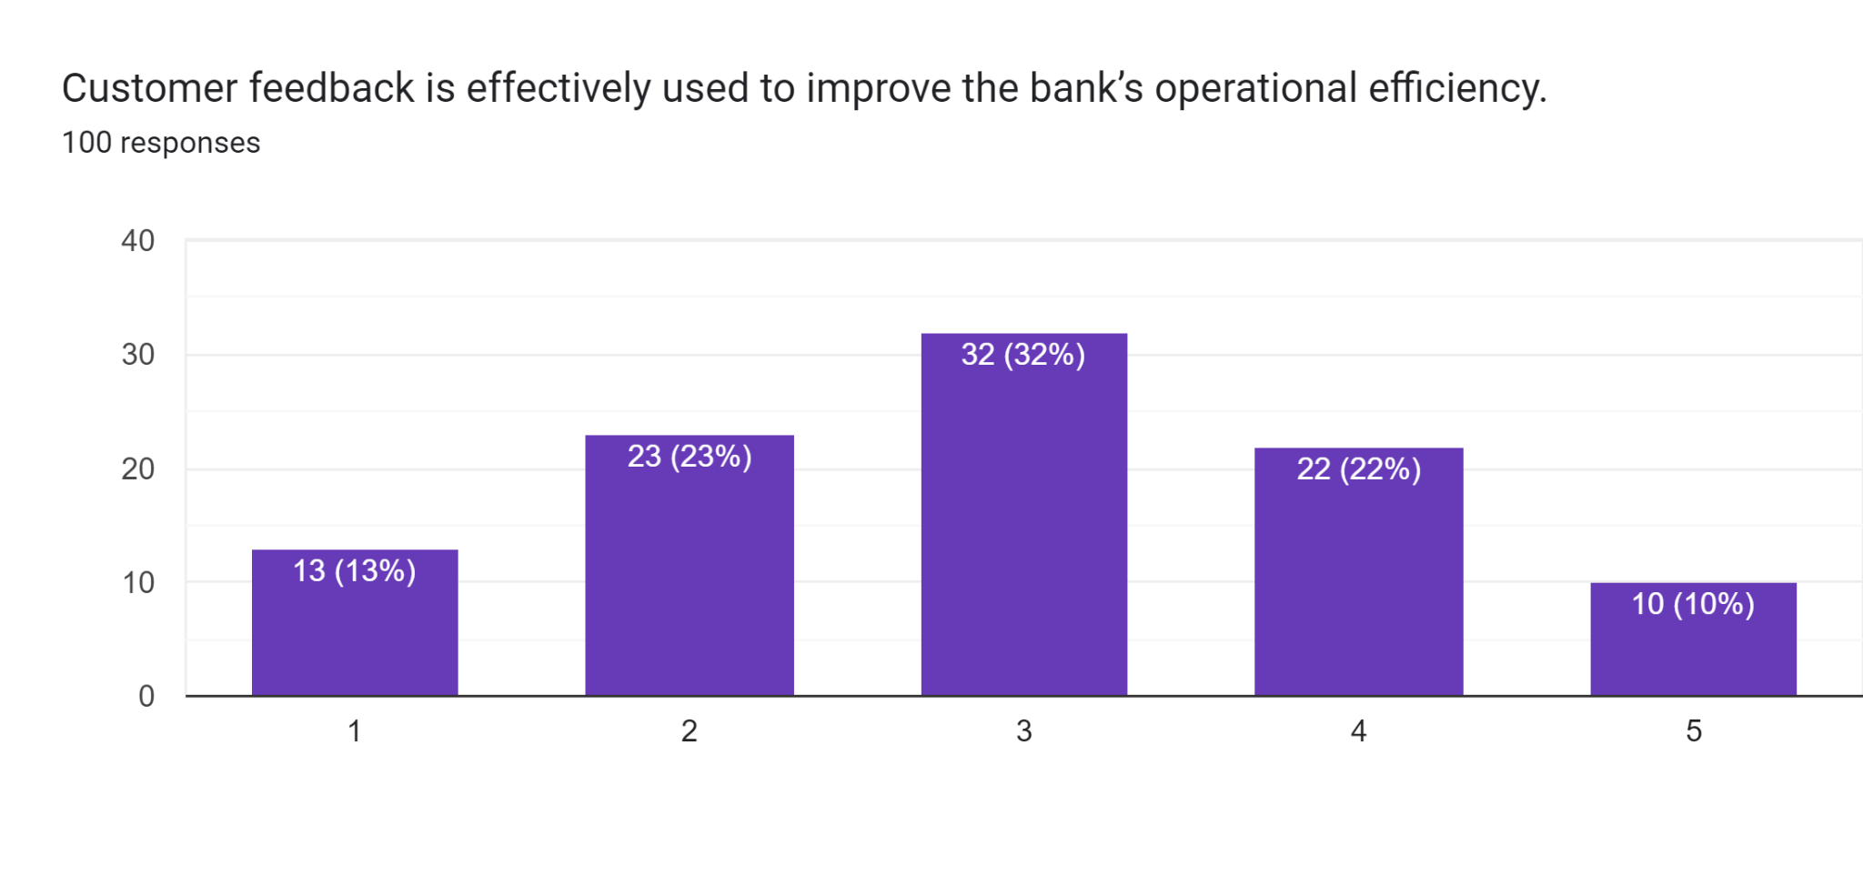
The above chart represents the improvement in banks operational efficiency with the help of customer feedback where 13% of them strongly agreed and 10% of them strongly disagreed to the decision.

4.3 Dataset description

4.3.1 Descriptive statistics
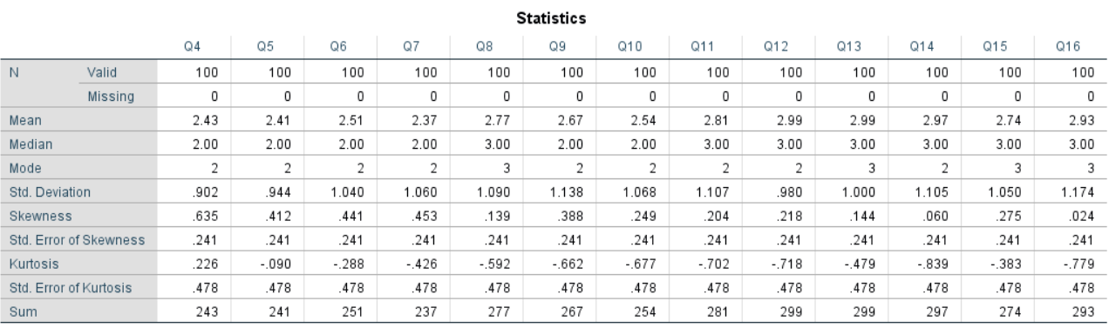
In the table with descriptive statistics offered every column corresponds to data of other questions (Q4-Q16), and every row presents a different statistic characteristic of the responses.
N (Valid and Missing): The numbers 100 in the parentheses signify valid responses for each question while 0 beside missing response signify that there is no missing data in the data set.
Mean: The mean gives out the number of the means of the responses for the various questions as they were responded to by the participants. For instance, mean of Q4 is (2.43) and this shows that on an average, respondent scored about (2.43) on a scale.
Median: Average of the median is the midpoint of the responses when ranked. In most of the questions the median is 2 or 3, which indicates that there is a central distribution of responses to the questions.
Mode: The mode is the most common response. For majority of the questions, the mode is 2 or 3 which signifies that 2 or 3 was the response given most frequently (Ullah et al. 2023).
Standard Deviation (Std. Deviation): This assesses the spread of responses which indicates the variation of the values obtained. For example, Q4 = 0.902 showing that the responses are scattered and they vary from some mean value to a moderate extent.
Skewness: Skewness therefore determines the degree of asymmetry of the distribution. The positive skewness values (for example, 0.635 for Q4) indicate therefore that the data is more spread out in the direction of lower scores.
Kurtosis: This measures how peaked the distribution is, in other words, how many tailed the distribution is. Negative kurtosis (for instance -0.662 at the Q9) refers to the distribution focus being even less than normal, that is, there are very few records which diverge from the mean values considerably. Negative kurtosis is indicated when the distribution is less peaked and has many scores closer to the mid-point, and is more spread out with less scores in the tails.
These numbers hint that UK banks generally maintain high levels of operation effectiveness in terms of customer care, online banking, and legal requirements. However, there is some area for improvement as evidenced by the studied variation and slightly more or less than midline centres in a number of areas.

4.3.2 Correlation
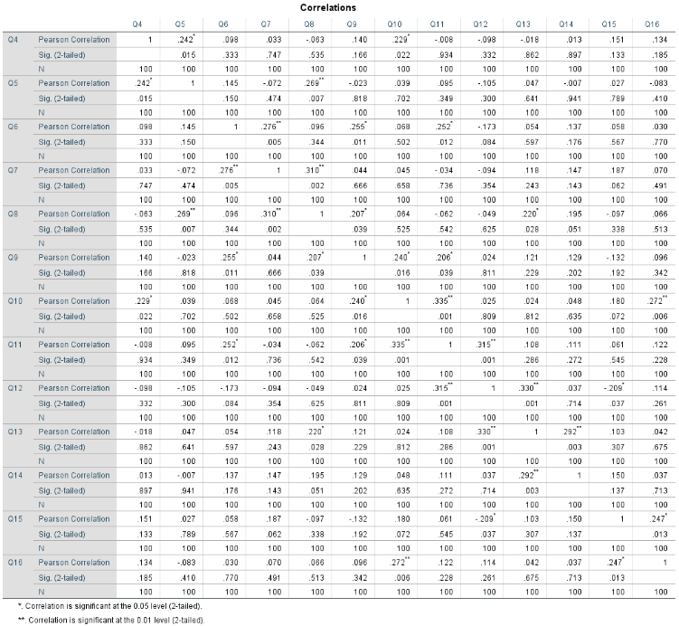
This correlation matrix highlights several key relationships which can be useful for evaluating the efficiency of operation of UK banks. Pearson correlation coefficients mean the extent and direction of correlation between the variables (Menicucci and Paolucci, 2023). Here, the coefficients vary between little and moderate and, in many cases, the summary produced significant coefficients at or below 0.05 and 0.01 levels.
The correlation matrix indicates the significance of correlation between different questions (Q4 to Q16) using the Pearson correlation coefficient. Basically, these coefficients express the nature and degree of linear association between each two variables. A closer to 1 means there is a direct relationship with the two variables hence as the value of one variable increases, the value of the other also increases. On the other hand, the result closer to minus one stand for negative association under which the two varied are inversely related meaning when one of the variable increases, the other decreases. For instance, Q5 and Q8 are positively correlated with a value of 0.269. These questions have positive correlation, as evident by a correlation coefficient of 0.269 (p = 0.007), meaning that the higher the participation, the greater the likelihood of more positive response to the two questions. Negative correlations point out to the fact that a pair is inversely related though in this matrix most coefficients are either weak or not significant.
This has resulted in the following findings: There is a positive and significant relationship between ROA and other factors. ROA is also positively related to Return on Equity (ROE) (r = 0. 242, p < 0. 05) and Technological Advancements (r = 0. 229, p < 0. 05). From this it can be inferred that there is a positive relationship between ROA with Technological infrastructure and financial performance hence; the argument that banks that have invested in enhancing their technology perform well in terms of assets returned to equity (Asutay and Ubaidillah, 2024).
ROE was subjected to Pearson Chi- square test and the results discovered that there is a positive relationship between AI and Bank, thereby increasing the rate of efficiency in the Banking operations (r = 0. 269, P < 0. 01). ROE is also positively related to the FPM (r = 0. 145, P <0. 05) supporting the hypothesis that digital technologies and measurements enhance equity return.
AI in Banking also has a decent positive relationship with Financial Performance Metrics (r = 0.204, p < 0.05). This goes further to show how digital banking can be used in enhancing financial performance and operations. Likewise, AI in Banking is positively related with Technological Infrastructure (r = 0.207, p < 0.05) and Regulatory Structures (r = 0.220, p < 0.05) which indicates that innovations derived from AI are beneficial in making technology advancements and enhancing compliance to regulations (Gržeta et al. 2023).
It is worth underlining that compliance with legislation could be a significant influence on banking efficiency. The results of the Pearson correlation analysis showed that Compliance with Regulatory Standards is highly related to Regulatory Structures (r = 0.315, p < 0.01), Technological Advancements (r = 0.335, p < 0.01), and Digital Banking Services (r = 0.315, p < 0.01). By these relations, it is revealed that regulation is useful in guaranteeing effectiveness in operations during technology and digital services.
Last but not the least; the study testified that Customer Service Processes have a moderate positive relationship with Customer Feedback (r = 0.247; p < 0.05) that is powerful evidence of how feedback loops control the operational procedures and affect efficiency.
In summary, conclusions made from these correlation findings indicate that digitalisation, use of AI, and compliances are strategic drivers to operations efficiency in the British banks in terms of performance and service delivery to customers (Gonu et al. 2024).

4.3.3 Regression
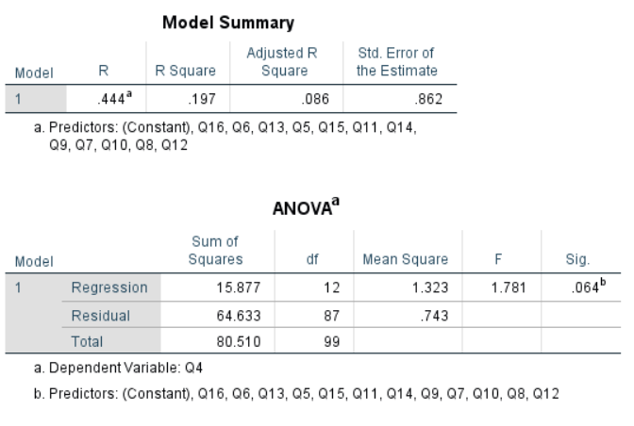
The analysis offers an understanding pertaining to the determinants of the Return on Assets (ROA), a measure of operating performance of the UK banks. The Model Summary indicates that the value of R (0.444) is a moderate positive correlation between the predictors and the dependent variable (ROA). The R Square value here is equal to 0.197 indicating 19.7%. Therefore, it can be concluded that the models illustrate above explained variance regarding the ROA, customer feedback, financial performance, regulatory environment, ROE, customer service, and technologies (Zhu and Jin, 2023). The Adjusted R Square (0.086) takes into account the number of the predictor variables and indicates that 8. Thus, the model specifies 8.6% of the variance with accuracy after controlling for complexity.
The ANOVA table indicates that the overall regression model is not statistically significant with F = 1.781. Based on the analysis of the data it is found that the F value of p-value is 0.064 which means that it is slightly above the 0.05 threshold. This suggests that in totality, the predictors do not account for the variability in ROA. However, the near significance indicates that some individual factors, such as technological enhancements, online banking, and artificial intelligence, may still exert a positive impact on ROA, but additional research or model modification is needed.

4.4 Summary
This paper evaluates the performances of various UK banks with emphasis on analysing factors that affect their operations. This includes customer service with regard to the quality, the adoption of digital banking services, impact due to technology, and regulatory requirements. From the study, the effectiveness of customer service and how technology can play a part in improving the efficiency of operations can be deduced. Furthermore, artificial intelligence (AI) is recognised to enhance banking activities; on the other hand, the legal standards have a central part in the stability and performance. As such, the study shows that though these factors can explain bank performances, more research is necessary to explain the effects of the factors.

Chapter 5: Discussion

5.1 Introduction
The discussion chapter shows the research findings, by linking them to the research questions, hypotheses and existing theories. Moreover, this paper evaluates critically whether the data analysis guides or contradicts the literature reviewed and offers well explanations for the unexpected findings. Thereby, identifies the limitations by offering insights for the potential influence on the findings.

5.2. Evaluation of Research questions and hypothesis testing
Yes, all the research questions have been answered well.
Technological emergence
The technological emergence considerably transitioned the operations of HSBC, Barclays, Lloyds, JP Morgan and UBS banks. Moreover, each bank has incorporated the digital advancement such as AI, blockchain and fintech solutions for improving efficiency, security and customer experience. Further, the HSBC and Barclays use AI for improving their customer service and fraud detection. However, Lloyds have invested hugely in mobile banking and enhancing customer availability. Then JP Morgan and UBS utilizes blockchain for protection, and innovative investment channels. However, these technological emergences allowed the banks to redesign their operations and reduce expenses, thereby adapting with the dynamic customer needs in the competitive market (Park and Kim 2020). Moreover, these banks also utilized the cloud computing and big data analytics for improving data management, scalability and decision-making strategies. For example, HSBC leveraged the cloud infrastructure for emphasizing its global operations, and enhancing the efficiency and minimizing the IT overload. Then Barclays implemented the big data analytics for achieving insights about customer behaviour, which allowing a more targeted financial products and services. However, JP Morgan and UBS banks have hugely invested in the encryption techniques and cybersecurity models for protecting customer data and transactions. Hence, these technological emergences have maximized the profitability and transformed the banks performance.
Impact of regulatory shifts on Bank efficiency
The study effectively addressed the influence of regulatory transitions on the efficiency of the banks of the UK, particularly HSBC, Barclays, Lloyds Bank, JP Morgan and UBS. Moreover, these regulatory changes like the cultivation of the Basel III models and the ring-fencing needs in the UK are developed for improving the stability and resilience of the banking sector in the post 2008 financial crisis (Ahamed et al. 2021). Further, the banks such as HSBC and Barclays, the implementation of these rules basically enhanced the operational efficiency over the period. Then the Lloyds bank which is a smaller bank adheres with the strict regulatory measures created a notable issue (Hassan and Giouvris 2021). Moreover, the additional operational and capital costs related to the regulatory compliance developed inefficiencies for the short period. Further, which can detract from their ability to invest in efficiency improving the practices like the technological innovations or customer service enhancements. However, JP Morgans and UBS are not headquartered in the UK, and have significant operations in the UK and comply with similar regulatory policies (Park and Kim 2020). Hence, the structured banks managed for turning the regulatory adherence in the strategic emergence and the smaller ones such as Lloyds experienced short term operational challenges.
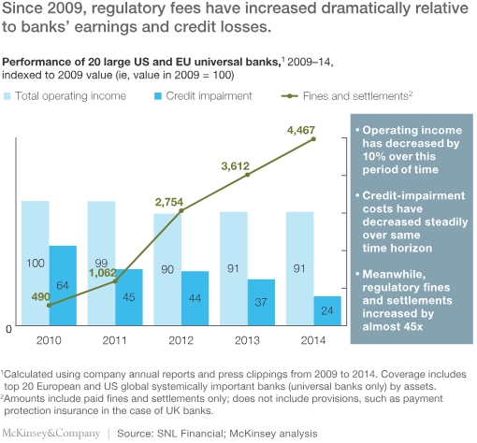
Figure 6: Bank regulatory
(Kaminski and Robu, 2018)
Customer service quality and operational efficiency
Customer service quality notably impacts the operational efficiency of the banks as noted in the HSBC, Barclays, Lloyds Bank, JP Morgan and UBS. Moreover, high quality customer service is a crucial differentiator in the competitive banking sector and also a driver of customer satisfaction, retention and operational efficiency. Further, the HSBC bank has invested hugely in the digital banking channels and customized customer service for improving the customer experience (Rashid et al. 2020). However, by incorporating AI and chatbots for the routine inquiries and transactions where the HSBC bank has minimized the requirement of manual interventions and thus redesigning the operations and enhancing efficiency. However, Barclays has similarly emphasized on improving the customer service by the digital innovations like the mobile’s app and contactless payments (Wewege et al. 2020).
However, improving resource allocation and the operational efficiency. Moreover, the Lloyds bank which concentrates on the retail market of the UK and has a strong focus on customer service quality by both digital and conventional platforms. Further, their practices for enhancing branch services, with their digital offerings has improved the customer satisfaction and brand loyalty.
Thereby, maintaining the high-quality service with the operational efficiency have been critical for the need for notable investments in both technology and human resources. Then JP Morgan and UBS are majorly known for investment banking, and have notable retail and wealth management operations in the UK (Baariu and Peter 2021).
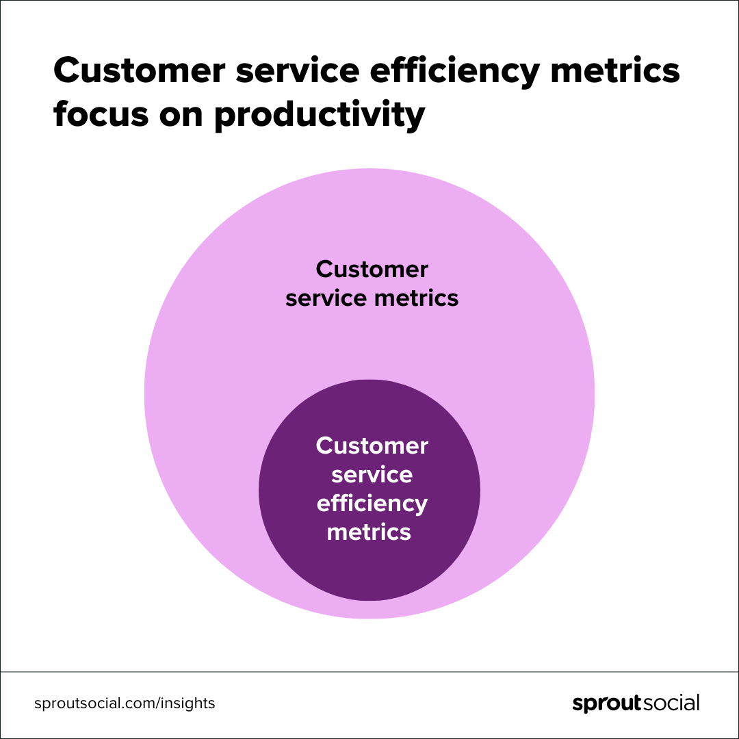
Figure 7: Customer service efficiency
(Gomez, 2023)
Financial operations indicators: ROA and ROE
Return on Assets (ROA) and Return on Equity are the major financial metrics which determine the operational efficiency and profitability of the banks like HSBC, Barclays, Lloyds Bank, JP Morgan and UBS. Moreover, these indicators offer valuable insights as to how a bank is using the assets and equity for creating earnings (Gwatiringa, 2020). Further, HSBC shows an effective ROA and ROE values by their expanded global operations and cost management techniques. However, by effectively utilizing the assets and balancing a disciplined strategy for risk management, HSBC have gained a stable return on the equity which shows their ability to convert equity into profit efficiently. The Barclays bank emphasizes on retail and investment banking and shows fluctuating ROA and ROE indicators as affected by the market situations and strategic practices. Moreover, the bank’s measures for redesigning its operations and improving customer service aim to enhance these ratios. Therefore, a stable ROE suggests that Barclays is successfully managing the equity base and has a moderate ROA that represents the areas for potential asset improvement (Maina, 2023).
Further, the Lloyds bank basically reports a higher ROA and ROE as compared to its peers which demonstrates its efficient management of primarily retail banking framework. However, the strong customer relationships of the bank and the effective cost control efforts have contributed to its profitability and enabled them to maintain a strong return on both assets and equity.
Further, JP Morgan is a leading global financial organization, strengthens an impressive ROA and ROE values. Moreover, this expanded revenue streams from the investment banking, asset management and the commercial banking improve the profitability concerns. Further, the strategic investments of this bank in technology have also bolstered the operational efficiency, and later driven its returns (Torre Olmo et al. 2021). Then UBS, which emphasized wealth management and investment banking, gained a strong ROE by investing in the high value client relationships and efficient allocation capital. Thereby, the ROA demonstrates active asset management, especially in the advisory and asset management sections which primarily generate higher returns.

5.3. Consistency of data analysis results with Theories and Frameworks
Regulatory impact frameworks
The regulatory impact framework evaluates how regulations impact the banking operations, efficiency and the strategic decisions. Moreover, this model is especially vital for the major banks such as HSBC, Barclays, Lloyd’s bank, JP Morgan and UBS which address a critical regulatory environment framed by compliance needs and the risk management policies. Further, the HSBC bank operates under the strict international policies like Basel III, that necessitates a higher capital need (Asteriou et al. 2021). However, the bank’s proactive strategy to compliance have improved the risk management initiatives and operational resilience, enabling it to maintain customer trust and market stability. Moreover, Barclays have effectively incorporated regulatory needs in the strategic planning. Thus, by implementing an extensive compliance model, the Barclays have redesigned its operations for fulfilling the changes in regulations like GDPR and anti-money laundering laws. Further, this alignment has reduced the operational efficiency by better data management and reporting systems. Then the Lloyds bank emphasizes on the regulatory laws as a driver of operational efficiency. However, JP Morgan focuses on the regulatory adaptability, utilizing the extensive resources for fulfilling the critical regulatory shifts over the diverse jurisdictions (Light and Skinner 2021).
Thereby, the bank’s investment in regulatory technology enables for a real-world compliance evaluation. Further, this improves the operations and navigates the risks related to the non-compliance. The UBS bank with its global reach, experiences a diverse regulatory landscape (Gehrig et al. 2024). Thereby, the regulatory influence models show how these banks align their strategies and performance with the regulatory needs, thus improving their efficiency and resilience in the competitive environment.

The Impact of Herfindahl-Hirschman Index on UK banks efficiency
The Herfindahl-Hirschman Index plays a vital metrics for recognizing the market concentration in the banking sector of the UK. Moreover, a high HHI suggests a market dominated by a few major players in the background of banks such as HSBC, Barclays, Lloyd’s bank, JP Morgan, and UBS, this indicates a reduced competitive pressure. Further, this focus may lead to difficulty among these large banks, mainly limiting innovation and operational efficiency (Gupta et al. 2021). For example, with the huge market shares, these banks may emphasize on the profit margins over the customer-oriented innovations, and result in a less dynamic banking environment. On the contrary, a low HHI demonstrates a fragmented market featured by the multiple players competing fiercely for market share. Moreover, in this scenario banks are emphasized for improving their operational efficiency for attracting and retaining customers (Boot et al. 2021).
For example, Barclays and Lloyds bank have invested in the digital transition practices to compete with the agile FinTech companies, thus enhancing their service delivery and the operational efficiency. Thereby, the empirical evidence suggests that the banking sector of the UK is notably impacted by the market focus levels as suggested by the HHI.
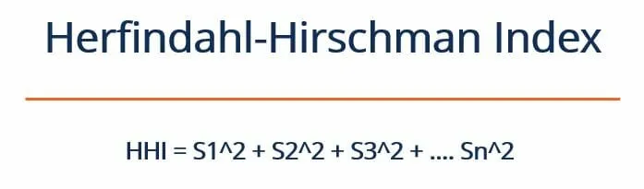
Figure 8: HHI
(Vipond, 2023)
Cost efficiency model
Cost efficiency models are vital for the banks such as HSBC, Barclays, Lloyds banks, JP Morgan and UBS for improving resource management and reducing the operational expenses. Moreover, by cultivating methodologies like Lean and Six sigma, these banks can smoothen the strategies and reduce waste (Lartey et al. 2021). For instance, HSBC has improved the loan processing systems for removing redundancies as results in faster turnaround times and minimized operational costs.
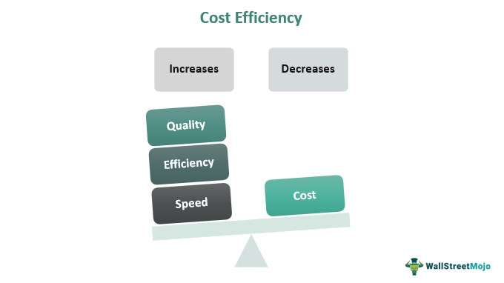
Figure 9: Cost efficiency model
(Vaidya, 2023)
Data Envelopment Model
Data Envelopment model (DEA) is essential for the banks such as HSBC, Barclays, Lloyd’s bank, JP Morgan and UBS for improving the revenue efficiency by the targeted management strategies. Moreover, by emphasizing on customer needs, these banks can develop innovative products which attract certain market segments (Horvat et al. 2022). For example, Lloyd’s bank has distinguished its offerings by providing tailored financial solutions for small businesses, and improving customer loyalty and revenue streams. Further, JP Morgan implements dynamic pricing strategies regarding the client profiles and increasing profitability and competitive edge. Barclays and UBS use the targeted ads to reach the niche markets and ensure the product to align with the potential customers.
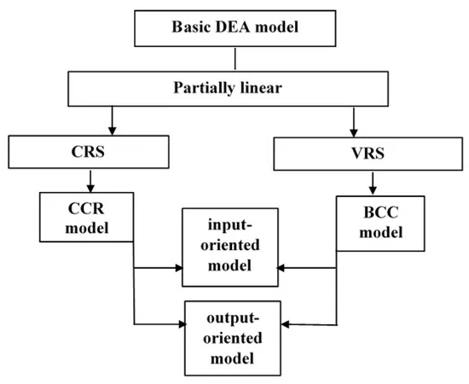
Figure 10: DEA model
(Pokushko et al., 2023)
X-Efficiency theory
The X-Efficiency theory shows the essence of the internal management initiatives in gaining the optimal efficiency in the companies like the banks such as HSBC, Barclays, Lloyd’s bank, JP Morgan and UBS. Moreover, these organizations experience a heavy pressure for maintaining the high-performance levels, which can navigate the internal inefficiencies (Rehman et al. 2022). For example, HSBC which cultivates robust performance appraisal systems which reward high achievers and motivate the competitive behaviours among the employees and developing an environment which reduces wasted resources and time. Barclays facilitates a management style which focuses on accountability and innovation, motivating the employees to prioritize productivity and growth of the new financial products (Shair et al. 2021).
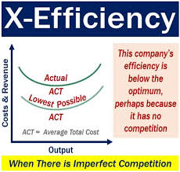
Figure 11: X-Efficiency theory
(HKT, 2020)

5.4. Unexpected results and additional explanations
Impact of regulatory shifts on smaller banks
Regulatory changes in the banking sector, like the increased capital needs, strict compliance requirements and the improved scrutiny on risk management which disproportionately influence the smaller banks as compared to their larger counterparts (Dávila and Walther 2020). Moreover, the large banks have the resources and infrastructure to adapt with the shifts, the smaller banks often struggle for the limited financial and operational abilities. Further, the regulations such as Basel III necessitate a higher capital buffer for ensuring financial stability. Then for the smaller banks, meeting these needs can be challenging, as they have less access to the capital markets (Gržeta et al. 2023). Then the costs of cultivating and maintaining compliance structure can be restricted and influence the profitability and operational efficiency.
Moreover, the smaller banks also experience the operational challenges in cultivating the advanced risk management and reporting strategies needed by the new regulations. Then this may hinder their ability to compete with the larger banks which have more advanced technological transformation (Syadali et al. 2023). Further, the compliance burden may lead to consolidation, as the smaller banks may combine or be acquired to gain the vital scale for regulatory compliance. Moreover, the regulatory hurdles may limit the smaller bank’s ability to innovate and develop the new products or services, as they may emphasize on the compliance over the development practices (Adeabah et al. 2023). Thus, the regulatory shifts aim to encourage stability and smoothness in the banking sector, they can place disproportionate hurdles on the smaller banks which influence their competitiveness.
Technological investments and operational efficiency
The technological investments have become a vital factor for improving the operational efficiency of the banks, which allows them to redesign the processes, reduce expenses and enhance customer service. Moreover, the leading banks such as HSBC, Barclays, Lloyd’s bank, JP Morgan and UBS that adopt the digital transition are vital for maintaining their competitive advantage and fulfilling the dynamic customer demands (Doumpos et al. 2023). Further, the investments in technologies like robotic process automation and artificial intelligence have notably reduced the manual processing times and operational expenses for these banks. For example, the HSBC and Barclays have cultivated AI-driven chatbots and automated back-office performance, which enhanced efficiency by managing routine customer inquiries and transaction strategies (Kou et al. 2021). However, this data driven strategy improves the decision making and operational efficiency which enables these banks to remain flexible and responsive in the evolving market landscape.
The implementation of the digital banking channels has transitioned the customer collaboration allowing 24/7 access to the banking services. Further, this improves the customer convenience and minimizes the need for physical branches leading to a lower operational costs and enhanced efficiency. Moreover, with the increased digitalization, the banks have invested hugely in the advanced cybersecurity efforts to safeguard their systems and customer data (Chang et al. 2020). Further, HSBC and UBS, for instance, have positioned the advanced security rules and real-world monitoring systems for detecting the cyber frauds. However, this active approach for risk management ensures operational stability and trust, which are essential for balancing the operational efficiency in the digital era.
Customer service quality Vs. financial performance
The quality of customer services plays a vital role for assessing the financial performance of the prominent banks like HSBC, Barclays, Lloyd’s bank, JP Morgan and UBS and maintaining a high standard of customer service which has a direct influence on profitability and customer retention. Moreover, superior customer service develops customer loyalty which leads to higher retention rates (Eklof et al. 2020). For example, HSBC have invested notably in the customized banking services and efficient digital channels which have improved the customer satisfaction and loyalty. Further, the loyal customers are likely to utilize the bank's diverse financial products and services by maximizing the revenue streams. However, this correlation is demonstrated in stable growth in retail banking of HSBC, where the customer retention contributes to retained profitability. Thereby, the banks that excel in customer service can effectively cross-sell the additional products like mortgages, credit cards and investment services. Moreover, Barclays have utilized the strong customer relationships and service quality to encourage the diverse financial products, thus maximizing the non-interest income (Ahmed et al. 2020). However, a satisfied customer base is more open minded for expanding the new financial products, which allows the bank’s financial operation by the expanded income sources (de la Cuesta-González et al. 2021). Further, this active approach safeguards the reputation of the bank and also minimizes expenses related to customer debates mitigation and regulatory penalties. However, good customer service results in streamlined operations and lower expenses. Then the JP Morgan which have cultivated digital customer solutions, like the AI-driven chatbots for managing the routine queries.
Volatility in financial performance indicators
The volatility in financial operations indicators like Return on Assets, Return on Equity and Net Interest Margin can notably influence the stability and estimations of the financial position of the banks. Moreover, the banks like HSBC, Barclays, Lloyd’s bank, JP Morgan and UBS, their volatility is impacted by macroeconomic determinants, regulatory changes and internal management decisions (Khalifaturofi'ah, 2023). Further, HSBC and Barclays face volatility in the ROA and ROE for the global exposure and the diverse portfolio and the fluctuations in the currency exchange rates, geopolitical tensions and different sectors influencing the profitability concerns. For example, economic slowdowns in Asia can influence the ROA of the HSBC as given the notable existence in the region. Then Lloyds bank with the effective emphasis on the market of the UK is more liable to domestic economic transitions and regulatory changes. Moreover, the risk revolving around Brexit and changes in the interest rates of the UK has led to volatility in Lloyds’ NIM and profitability metrics demonstrating the sensitivity of the financial operations to the local economic situations (Subastian and Pratomo 2024).
Then JP Morgan and UBS experienced volatility for their investment banking and wealth management performances. Moreover, the market fluctuations, changes in client activity and investment returns can create a notable variability in their ROE and the performance metrics. Further the JP Morgan’s market volatility influences the trading revenues and UBS’s wealth management fees can fluctuate regarding the market situations and asset values. However, the volatility in financial performance metrics among these banks shows the difficulties of handling the diverse and global banking performance.

5.5. Limitations
Various limitations may have influenced the research findings, firstly, the dependence on the secondary data from the financial reports and market analyses of the prominent banks such as HSBC, Barclays, Lloyds, JP Morgan and UBS which show constraints. Moreover, the quality and reliability of these data sources are dependent on the reliability of the financial disclosures of the banks which may be influenced by the reporting biases or accounting anomalies (Ganderson, 2020). Then the research is constrained by the normality of the findings over the diverse banking organizations. Further, each bank operates under certain unique market situations, regulatory environments and business frameworks which limits the applicability of the general conclusions. For example, the global performance of HSBC and JP Morgan differentiates notably from the UK based emphasis of Lloyds, mainly influencing the comparability of the key findings associated with regulatory shifts and technological implementation. Thereby, the evolving nature of the financial industry, as featured by the robust technological emergence and regulatory hurdles that represent a challenge in maintaining the importance of the findings (Murinde et al. 2022). Further, the delay between data collection and analysis may result in outdated information which do not demonstrate the most current industry trends. However, these limitations show the requirement for future research to involve a wider scope of data sources, considering more clear bank specific factors.

5.6. Summary
This discussion demonstrates how the UK banks have addressed the regulatory shifts, technological investments and customer service enhancements for improving the operational efficiency. Moreover, the banks like HSBC, Barclays, JP Morgan, UBS and Lloyds have effectively utilized the resources to adhere with the regulations and innovate, and the smaller banks have experienced various challenges. Further, the technological emergence has enhanced efficiency and customer experience, which shows their essence in a competitive banking environment.

Chapter 6: Conclusion

6.1 Conclusion
The paper entitled “An Empirical Analysis of the Operational Efficiency of UK Banks” provides important information on the performance of UK banks, with emphasis on the growth of their operational efficiency. Using method such as DEA, outlined in the paper measures the efficiency levels of the banks taking into account factors like the size, management strategies as well as market forces available (Shehadeh et al., 2024). From the results, it can be inferred that efficiency tends to increase with the size of the banks as costs are spread over a large asset base, technological improvements are achieved, and portfolios are less sensitive to operational risks when compared with their smaller peers.
In addition, it is revealed the importance of management factors for improvement of efficiency indicators: costs and expenses, along with investments in technologies. In other words, an optimized bank operation is more resilient than less optimized ones, and more capable of withstanding market shocks such as regulation modifications or economic down turns. On the other hand, smaller banks suffer from operational inefficiencies and their main cause may be attributed to poor resource endowment and high costs as a proportion of their scale. This paper also establishes the fact that certain environmental factors such as regulatory status and competition also influence operations (Bueno et al., 2024). These control adjustments occur due to higher regulatory requirements that force banks to adopt new techniques, and enhanced competition that forces banks to seek ways to enhance efficiency. But it also restricts efficiency because such guidelines cost money to implement and increases overall expenses.
Thus, the paper reveals the dynamics between the internal factors affecting company’s operations and the external environment to provide a range of recommendations for policymakers, managers of the banking sector, and potential investors. Eradicating waste continues to be imperative and of paramount importance to the future of the UK banking system.

6.2 Recommendation
From the evidence presented in “An Empirical Analysis of the Operational Efficiency of UK Banks,” the following recommendations in respect of increasing the operational efficiency of the growth in the UK banking industry can be recommended.
First, the industry should improve on the technology used by banks and make extensive use of automation to cut down on expense and offer better services (Qian Long Kweh et al., 2024). Some of the technological enhancement like artificial intelligence (AI), machine learning (ML) or big data analysis will be useful in decision making, customer interface and management of risks, thus having higher rate of improvement.
Second, cost management should be the next principle leading a bank, especially a small bank because of the high costs of operations. There are issues that banks should consider: Firstly, costs – importance of cost efficiency with special reference to overheads; secondly, strategies – need for cost leadership without over-reliance on the short-term functional cost reduction techniques.
Third, the authorities could promote mergers and strategic partnership to allow small banks enjoy the economies of scale. This might translate to better acquisition of resources, better capital bases and better technology in operations thus enhancing efficiency to firms that merge with or are acquired by larger banking firms. From a regulatory lens, policy makers should therefore look at how they can open up a level playing field where organisations can come up with new innovations to enhance efficiency without at the same time posing a lot of legal risks that may increase the compliance costs (Asutay and Ubaidillah, 2023)
. The policies which encourage efficiency improving technology investments can also enhance banking business prospects considering emerging financial environment.
Last but not the least, it requires continuing educating and developing everyone on the staff in order to encourage original thinking and improve organisational performance. Having a train workforce that is familiar with modern technological and operation strategies helps to make efficiency high and changes to market needs. The application of such measures will enhance the Operating and Competitive performance of Banks in the United Kingdom.

6.3 Future research
This study on the efficiency of UK banks can lead to future researches on the operational efficiency of the following areas for further investigation: First, a more general analysis splitting the institutions by different types of banks: retail, investment, challenger, and neobanks could offer additional details regarding sectoral efficiency trends (Pervez and Ali, 2022). Further research on how each of these categories of banks operate with variations depending on external forces, such as technological advancement and changes in regulations, could provide a better view of efficiency.
Second, it is suggested that the subsequent researching ought to use a wider range of performance evaluation criteria beyond the framework of impressive ratios. For instance, analysing factors such as customer satisfaction, rate of innovation or environmental management, as efficiency drivers would have given a meaningful comparison of bank efficiency. This would also fit well with the rapidly growing focus on non-financial factors also known as Environmental, Social, and Governance (ESG) factors in the financial sector (Zaim et al., 2022).
Third, further studies could look into the ways in which various technologies which are still in their infancy, but demonstrate great potential for development, affect the effectiveness of banks’ operations, namely AI, blockchain, and fintech solutions. Knowledge of how these technologies is transforming key banking processes and possible consequences on productivity may provide useful insight for banking. Finally, long term panel data research works that consider the operational efficiency changes in UK banks spanning years and after significant events in the economy (Brexit, COVID-19, or financial crises) would be useful in gauging the effectiveness of the UK banks to respond to shocks and determination of action plans toward different business cycles.

Reference List
Adaloudis, M. and Roca, J.B., 2021. Sustainability tradeoffs in the adoption of 3D Concrete Printing in the construction industry. Journal of Cleaner Production, 307, p.127201.
Adeabah, D. and Andoh, C., 2020. Cost efficiency and welfare performance of banks: evidence from an emerging economy. International Journal of Managerial Finance, 16(5), pp.549-574.
Adeabah, D., Andoh, C., Asongu, S. and Gemegah, A., 2023. Reputational risks in banks: A review of research themes, frameworks, methods, and future research directions. Journal of Economic Surveys, 37(2), pp.321-350.
Ahamed, M.M., Ho, S.J., Mallick, S.K. and Matousek, R., 2021. Inclusive banking, financial regulation and bank performance: Cross-country evidence. Journal of Banking & Finance, 124, p.106055.
Ahmed, S., Bangassa, K. and Akbar, S., 2020. A study on trust restoration efforts in the UK retail banking industry. The British Accounting Review, 52(1), p.100871.
Al-Alawi, A.I. and Al-Bassam, M.S.A., 2020. The significance of cybersecurity system in helping managing risk in banking and financial sector. Journal of Xidian University, 14(7), pp.1523-1536.
Al-Dmour, A., Al-Dmour, R. and Rababeh, N., 2021. The impact of knowledge management practice on digital financial innovation: the role of bank managers. VINE Journal of Information and Knowledge Management Systems, 51(3), pp.492-514.
Ali, B.J. and Anwar, G., 2021. Business strategy: The influence of Strategic Competitiveness on competitive advantage. International Journal of Electrical, Electronics and Computers, 6(2).
Al-Shehab, N., AL-Hashimi, M., Madbouly, A., Reyad, S. and Hamdan, A., 2021. Do employability skills for business graduates meet the employers’ expectations? The case of retail Islamic banks of Bahrain. Higher Education, Skills and Work-Based Learning, 11(2), pp.349-366.
Asteriou, D., Pilbeam, K. and Tomuleasa, I., 2021. The impact of corruption, economic freedom, regulation and transparency on bank profitability and bank stability: Evidence from the Eurozone area. Journal of Economic Behavior & Organization, 184, pp.150-177.
Asutay, M. and Ubaidillah, 2023. Examining the Impact of Intellectual Capital Performance on Financial Performance in Islamic Banks. Journal of the Knowledge Economy.
Awan, T., Rizwan, M.F. and Shah, S.Z., 2020. Impact of Acquisition on cost efficiency, operational hedging and returns of acquirer firms in Pakistan. NICE Research Journal, pp.130-160.
Baariu, M.J. and Peter, N., 2021. Relationship between selected macroeconomic variables and the financial performance of investment banks in Kenya. International Journal of Economics and Finance, 13(11), pp.1-98.
Bag, S., Gupta, S., Kumar, A. and Sivarajah, U., 2021. An integrated artificial intelligence framework for knowledge creation and B2B marketing rational decision making for improving firm performance. Industrial marketing management, 92, pp.178-189.
Barbero, J. and Zofío, J.L., 2023. The measurement of profit, profitability, cost and revenue efficiency through data envelopment analysis: A comparison of models using BenchmarkingEconomicEfficiency. jl. Socio-Economic Planning Sciences, 89, p.101656.
Bello, H.O., Idemudia, C. and Iyelolu, T.V., 2024. Implementing machine learning algorithms to detect and prevent financial fraud in real-time. Computer Science & IT Research Journal, 5(7), pp.1539-1564.
Boot, A., Hoffmann, P., Laeven, L. and Ratnovski, L., 2021. Fintech: what’s old, what’s new?. Journal of financial stability, 53, p.100836.
Buallay, A., Hamdan, A.M., Reyad, S., Badawi, S. and Madbouly, A., 2020. The efficiency of GCC banks: the role of intellectual capital. European Business Review, 32(3), pp.383-404.
Bueno, L.A., Sigahi, T.F.A.C., Rampasso, I.S., Leal Filho, W. and Anholon, R. (2024). Impacts of digitization on operational efficiency in the banking sector: Thematic analysis and research agenda proposal. International Journal of Information Management Data Insights, 4(1), p.100230.
Chang, V., Baudier, P., Zhang, H., Xu, Q., Zhang, J. and Arami, M., 2020. How Blockchain can impact financial services–The overview, challenges and recommendations from expert interviewees. Technological forecasting and social change, 158, p.120166.
Chen, X., You, X. and Chang, V., 2021. FinTech and commercial banks' performance in China: A leap forward or survival of the fittest?. Technological Forecasting and Social Change, 166, p.120645.
Chirumalla, K., 2021. Building digitally-enabled process innovation in the process industries: A dynamic capabilities approach. Technovation, 105, p.102256.
Clarence-Smith, T., 2020. The Impact of Brexit on the Financial Services Sector. [online] Toptal Finance Blog. Available at: https://www.toptal.com/finance/market-research-analysts/brexit-and-its-effect-on-the-uk-european-and-global-financial-sector [Accessed 3 Aug. 2024].
Dávila, E. and Walther, A., 2020. Does size matter? Bailouts with large and small banks. Journal of Financial Economics, 136(1), pp.1-22.
de la Cuesta-González, M., Froud, J. and Tischer, D., 2021. Coalitions and public action in the reshaping of corporate responsibility: The case of the retail banking industry. Journal of Business Ethics, 173(3), pp.539-558.
De Leon, M.V., 2020. The impact of credit risk and macroeconomic factors on profitability: the case of the ASEAN banks. Banks and Bank Systems, 15(1), pp.21–29.
Demsetz, H. and Lehn, K., 2021. The Structure of Corporate Ownership: Causes and Consequences. Journal of Political Economy, 93(6), pp.1155–1177.
Diener, F. and Špaček, M., 2021. Digital transformation in banking: A managerial perspective on barriers to change. Sustainability, 13(4), p.2032.
Doumpos, M., Zopounidis, C., Gounopoulos, D., Platanakis, E. and Zhang, W., 2023. Operational research and artificial intelligence methods in banking. European Journal of Operational Research, 306(1), pp.1-16.
Eklof, J., Podkorytova, O. and Malova, A., 2020. Linking customer satisfaction with financial performance: an empirical study of Scandinavian banks. Total Quality Management & Business Excellence, 31(15-16), pp.1684-1702.
Essuman, D., Boso, N. and Annan, J., 2020. Operational resilience, disruption, and efficiency: Conceptual and empirical analyses. International journal of production economics, 229, p.107762.
Ganderson, J., 2020. To change banks or bankers? Systemic political (in) action and post-crisis banking reform in the UK and the Netherlands. Business and Politics, 22(1), pp.196-223.
Gehrig, T., Iannino, M.C. and Unger, S., 2024. Transatlantic differences in bank resilience. In Handbook of Financial Integration (pp. 388-416). Edward Elgar Publishing.
Gomez, R. (2023). How to make customer service efficiency an org-wide priority. [online] Sprout Social. Available at: https://sproutsocial.com/insights/customer-service-efficiency/ [Accessed 24 Sep. 2024].
Gonu, E., Okeniyi, J. and Agyapong, G.K.Q., 2024. Customer relationship management practices and organisational performance of commercial banks in Ghana: a mediation analysis. Journal of Financial Services Marketing, 29(2), pp.607-624.
Gržeta, I., Žiković, S. and Tomas Žiković, I., 2023. Size matters: analyzing bank profitability and efficiency under the Basel III framework. Financial innovation, 9(1), p.43.
Gupta, A.D., Sultana, I. and Das, D., 2021. Do Competition, Size, and Development Indicators Matter for the Efficiency of Brics Banks. Journal of Finance and Economics, 9(2), pp.53-64.
Gwatiringa, P.T., 2020. Banking sector profitability through investigation of financial performance indicators: the case of Zimbabwe. IOSR Journal of Business and Management (IOSR-JBM), 22(7), pp.22-30.
Hanafizadeh, P. and Marjaie, S., 2020. Trends and turning points of banking: a timespan view. Review of Managerial Science, 14(6), pp.1183-1219.
Hassan, M. and Giouvris, E., 2021. Bank mergers: the cyclical behaviour of regulation, risk and returns. Journal of Financial Economic Policy, 13(2), pp.256-284.
HKT (2020). X-efficiency (1966) - HKT Consultant. [online] HKT Consultant. Available at: https://sciencetheory.net/x-efficiency-1966/ [Accessed 24 Sep. 2024].
Horvat, A.M., Milenković, N., Dudić, B., Kalaš, B., Radovanov, B. and Mittelman, A., 2022. Evaluating bank efficiency in the West Balkan countries using data envelopment analysis. Mathematics, 11(1), p.15.
Javaid, M., Haleem, A., Singh, R.P., Suman, R. and Khan, S., 2022. A review of Blockchain Technology applications for financial services. BenchCouncil Transactions on Benchmarks, Standards and Evaluations, 2(3), p.100073.
Kaminski , P. and Robu, K. (2018). A best-practice model for bank compliance | McKinsey. [online] www.mckinsey.com. Available at: https://www.mckinsey.com/capabilities/risk-and-resilience/our-insights/a-best-practice-model-for-bank-compliance [Accessed 24 Sep. 2024].
Khalid, J., Weng, Q.D., Luqman, A., Rasheed, M.I. and Hina, M., 2023. After-hours work-related technology use and individuals' deviance: the role of interruption overload, psychological transition and task closure. Kybernetes, 52(1), pp.158-181.
Khalifaturofi'ah, S.O., 2023. Cost efficiency, innovation and financial performance of banks in Indonesia. Journal of Economic and Administrative Sciences, 39(1), pp.100-116.
Kim, J. and Park, C.Y., 2020. Education, skill training, and lifelong learning in the era of technological revolution: A review. Asian‐Pacific Economic Literature, 34(2), pp.3-19.
Kohler, K. and Stockhammer, E., 2022. Growing differently? Financial cycles, austerity, and competitiveness in growth models since the Global Financial Crisis. Review of International Political Economy, 29(4), pp.1314-1341.
Kosumi, A. and Poposka, K., 2022. TECHNOLOGICAL CHANGE AND FINANCIAL INNOVATION IN BANKING. Economic Development/Ekonomiski Razvoj, 24(3).
Kou, G., Olgu Akdeniz, Ö., Dinçer, H. and Yüksel, S., 2021. Fintech investments in European banks: a hybrid IT2 fuzzy multidimensional decision-making approach. Financial innovation, 7(1), p.39.
Kvålseth, T.O., 2022. Cautionary note about the Herfindahl-Hirschman index of market (industry) concentration. Contemporary Economics, 16(1), pp.51-60.
Kweh, Q.L., Lu, W., Tone, K. and Liu, H.-M. (2024). Evaluating the resource management and profitability efficiencies of US commercial banks from a dynamic network perspective. Financial Innovation, 10(1).
Lartey, T., James, G.A. and Danso, A., 2021. Interbank funding, bank risk exposure and performance in the UK: A three-stage network DEA approach. International review of financial analysis, 75, p.101753.
Li, Z., Feng, C. and Tang, Y., 2022. Bank efficiency and failure prediction: a nonparametric and dynamic model based on data envelopment analysis. Annals of Operations Research, 315(1), pp.279-315.
Light, S.E. and Skinner, C.P., 2021. Banks and climate governance. Colum. L. Rev., 121, p.1895.
Lohman, L., 2021. Evaluation of university teaching as sound performance appraisal. Studies in Educational Evaluation, 70, p.101008.
Maina, J., 2023. The Impact of Changes in the Capital Structure on the Financial Performance of UK Commercial Banks: Case of Lloyds Bank, HSBC Bank and Barclays Bank. European Academic Journal-I, 2(001).
Marlina, E., Ardi, H.A., Samsiah, S., Ritonga, K. and Tanjung, A.R., 2020. Strategic costing models as strategic management accounting techniques at private universities in Riau, Indonesia. International Journal of Financial Research, 11(1), pp.274-283.
Mathibe, M. and Oppong, C., 2024. Sustainable entrepreneurship: A catalyst for unemployment reduction and economic growth in Anglophone and Francophone countries. Business Strategy & Development, 7(2), p.e362.
Menicucci, E. and Paolucci, G., 2023. ESG dimensions and bank performance: An empirical investigation in Italy. Corporate Governance: The International Journal of Business in Society, 23(3), pp.563-586.
Misischia, C.V., Poecze, F. and Strauss, C., 2022. Chatbots in customer service: Their relevance and impact on service quality. Procedia Computer Science, 201, pp.421-428.
Moudud-Ul-Huq, S., 2021. Does bank competition matter for performance and risk-taking? Empirical evidence from BRICS countries. International Journal of Emerging Markets, 16(3), pp.409-447.
Murinde, V., Rizopoulos, E. and Zachariadis, M., 2022. The impact of the FinTech revolution on the future of banking: Opportunities and risks. International review of financial analysis, 81, p.102103.
Ousama, A.A., Hammami, H. and Abdulkarim, M., 2020. The association between intellectual capital and financial performance in the Islamic banking industry: An analysis of the GCC banks. International Journal of Islamic and Middle Eastern Finance and Management, 13(1), pp.75-93.
Park, H. and Kim, J.D., 2020. Transition towards green banking: role of financial regulators and financial institutions. Asian Journal of Sustainability and Social Responsibility, 5(1), pp.1-25.
Pervez, A. and Ali, I. (2022). Robust Regression Analysis in Analyzing Financial Performance of Public Sector Banks: A Case Study of India. Annals of Data Science.
Pokushko, M., Stupina, A., Medina-Bulo, I., Ezhemanskaya, S., Kuzmich, R. and Pokushko, R. (2023). Algorithm for Application of a Basic Model for the Data Envelopment Analysis Method in Technical Systems. Algorithms, 16(10), p.460.
Rahman, M.M., 2023. The effect of business intelligence on bank operational efficiency and perceptions of profitability. FinTech, 2(1), pp.99-1
Rahmayati, R., 2021. Competition Strategy In The Islamic Banking Industry: An Empirical Review. International Journal Of Business, Economics, And Social Development, 2(2), pp.65-71.
Rashid, M.H.U., Nurunnabi, M., Rahman, M. and Masud, M.A.K., 2020. Exploring the relationship between customer loyalty and financial performance of banks: Customer open innovation perspective. Journal of Open Innovation: Technology, Market, and Complexity, 6(4), p.108.
Rehman, A.U., Aslam, E. and Iqbal, A., 2022. Intellectual capital efficiency and bank performance: Evidence from islamic banks. Borsa Istanbul Review, 22(1), pp.113-121.
Riyanto, S., Endri, E. and Herlisha, N., 2021. Effect of work motivation and job satisfaction on employee performance: Mediating role of employee engagement. Problems and Perspectives in Management, 19(3), p.162.
Royall, S., McCarthy, V. and Miller, G.J., 2022. Creating an inclusive workplace: The effectiveness of diversity training. J. Glob. Econ. Trade Int. Bus, 3, pp.39-55.
Sarker, I.H., 2021. Data science and analytics: an overview from data-driven smart computing, decision-making and applications perspective. SN Computer Science, 2(5), p.377.
Saunders, M., Lewis, P. and Thornhill, A., 2009. Research methods for business students. Pearson education.
Shahaab, A., Khan, I.A., Maude, R., Hewage, C. and Wang, Y., 2022. Public service operational efficiency and blockchain – A case study of Companies House, UK. Government Information Quarterly, 40(1), p.101759.
Shair, F., Shaorong, S., Kamran, H.W., Hussain, M.S., Nawaz, M.A. and Nguyen, V.C., 2021. Assessing the efficiency and total factor productivity growth of the banking industry: do environmental concerns matters?. Environmental Science and Pollution Research, 28, pp.20822-20838.
Shehadeh, M., Bani, A., Thamir Al Barrak, Lutfi, A. and Mahmaod Alrawad (2024). Digital transformation: An empirical analysis of operational efficiency, customer experience, and competitive advantage in Jordanian Islamic banks. Uncertain Supply Chain Management, 12(2), pp.695–708.
Siddique, A., Masood, O., Javaria, K. and Huy, D.T.N., 2020. A comparative study of performance of commercial banks in ASIAN developing and developed countries. Insights into Regional Development, 2(2), pp.580-591.
Siderska, J., 2020. Robotic Process Automation—a driver of digital transformation?. Engineering Management in Production and Services, 12(2), pp.21-31.
solutions360, 2022. 9 Steps to Improve Operational Efficiency. [online] Solutions360. Available at: https://www.solutions360.com/9-steps-improve-operational-efficiency/ [Accessed 3 Aug. 2024].
Sturgeon, T.J., 2021. Upgrading strategies for the digital economy. Global strategy journal, 11(1), pp.34-57.
Suarni, A. and Amelia, R., 2023. Analysis of Mosque Financial Management in Ujung Bulu District, Bulukumba Regency, South Sulawesi, Indonesia. Public Sector Management and Accounting Research, 2(2).
Subastian, J.B. and Pratomo, L.A., 2024. ASSESSING BANK PERFORMANCE DURING COVID-19: A STUDY OF LLOYDS AND HSBC USING THE CAMELS AND PESTEL FRAMEWORKS. Jurnal Ekonomi Trisakti, 4(2), pp.203-214.
Syadali, M.R.A., Segaf, S. and Parmujianto, P., 2023. Risk management strategy for the problem of borrowing money for Islamic commercial banks. Enrichment: Journal of Management, 13(2), pp.1227-1236.
Torre Olmo, B., Cantero Saiz, M. and Sanfilippo Azofra, S., 2021. Sustainable banking, market power, and efficiency: Effects on banks’ profitability and risk. Sustainability, 13(3), p.1298.
Ullah, S., Majeed, A. and Popp, J., 2023. Determinants of bank’s efficiency in an emerging economy: A data envelopment analysis approach. 18(3), pp.e0281663–e0281663.
Vaidya, D. (2023). Cost Efficiency. [online] WallStreetMojo. Available at: https://www.wallstreetmojo.com/cost-efficiency/ [Accessed 24 Sep. 2024].
Vipond, T. (2023). Herfindahl-Hirschman Index (HHI). [online] Corporate Finance Institute. Available at: https://corporatefinanceinstitute.com/resources/valuation/herfindahl-hirschman-index-hhi/ [Accessed 24 Sep. 2024].
Wewege, L., Lee, J. and Thomsett, M.C., 2020. Disruptions and digital banking trends. Journal of Applied Finance and Banking, 10(6), pp.15-56.
Wong, S.C., 2020. Competency definitions, development and assessment: A brief review. International Journal of Academic Research in Progressive Education and Development, 9(3), pp.95-114.
Xu, Y., Liu, X., Cao, X., Huang, C., Liu, E., Qian, S., Liu, X., Wu, Y., Dong, F., Qiu, C.W. and Qiu, J., 2021. Artificial intelligence: A powerful paradigm for scientific research. The Innovation, 2(4).
Zaim, H., Erzurum, E., Zaim, S., Uluyol, B. and Seçgin, G., 2022. The influence of Islamic leadership on work performance in service industry: an empirical analysis. International Journal of Ethics and Systems.
Zhang, T., Shaikh, Z.A., Yumashev, A.V. and Chłąd, M., 2020. Applied model of E-learning in the framework of education for sustainable development. Sustainability, 12(16), p.6420.
Zhu, Y. and Jin, S., 2023. COVID-19, digital transformation of banks, and operational capabilities of commercial banks. Sustainability, 15(11), p.8783.

Appendices:

Appendix A: Questionnaire

Google survey form link: https://forms.gle/ZmaxfwhNAPG2FZWV9

Demographic questions:
- What is your age group?
  - Under 25
  - 25-34
  - 35-44
  - 45-54
  - 55-64
  - 65 and over
- What is your gender?
  - Male
  - Female
  - Non-binary/Other
  - Prefer not to say
- Are you a bank customer or a bank employee?
  - Customer
  - Bank Employee
  - Both
  - Other

Survey questions:
- The bank’s Return on Assets (ROA) is a strong indicator of its operational efficiency.
  - Strongly agree
  - Agree
  - Neutral
  - Disagree
  - Strongly disagree
- Return on Equity (ROE) plays a critical role in evaluating the bank's overall financial performance.
  - Strongly agree
  - Agree
  - Neutral
  - Disagree
  - Strongly disagree
- The bank's financial performance metrics effectively reflect its operational efficiency.
  - Strongly agree
  - Agree
  - Neutral
  - Disagree
  - Strongly disagree
- The implementation of digital banking services has significantly improved the bank's operational efficiency.
  - Strongly agree
  - Agree
  - Neutral
  - Disagree
  - Strongly disagree
- Artificial Intelligence (AI) in banking operations enhances efficiency by reducing manual processes.
  - Strongly agree
  - Agree
  - Neutral
  - Disagree
  - Strongly disagree
- The bank's technology infrastructure is robust and contributes to its operational efficiency.
  - Strongly agree
  - Agree
  - Neutral
  - Disagree
  - Strongly disagree
- Technological advancements in banking (e.g., mobile apps, online services) have led to better customer satisfaction and operational efficiency.
  - Strongly agree
  - Agree
  - Neutral
  - Disagree
  - Strongly disagree
- Regulatory requirements enhance the bank's operational efficiency by ensuring better risk management.
  - Strongly agree
  - Agree
  - Neutral
  - Disagree
  - Strongly disagree
- Compliance with regulatory standards positively impacts the bank's financial performance.
  - Strongly agree
  - Agree
  - Neutral
  - Disagree
  - Strongly disagree
- Regulatory structures are crucial in maintaining the operational efficiency of the bank.
  - Strongly agree
  - Agree
  - Neutral
  - Disagree
  - Strongly disagree
- High-quality customer service is directly linked to the bank’s operational efficiency.
  - Strongly agree
  - Agree
  - Neutral
  - Disagree
  - Strongly disagree
- The bank’s customer service processes are efficient and contribute to overall operational success.
  - Strongly agree
  - Agree
  - Neutral
  - Disagree
  - Strongly disagree
- Customer feedback is effectively used to improve the bank’s operational efficiency.
  - Strongly agree
  - Agree
  - Neutral
  - Disagree
  - Strongly disagree

Appendix B: Screenshot of Collected Responses



