Reflecting Communities: The Impact of Police Diversity on Public Trust


Kimberley Collins: 2223837
Bachelor of Science: Professional policing
Submission Date: 6th May 2025
Supervisor: Mike Durke
University of Wales Trinity Saint David

Abstract:
This dissertation investigates the relationship between police diversity and public trust across England and Wales. As public confidence in policing continues to decline, this study explores whether demographic representation within police forces improves community perceptions of fairness, accountability, and legitimacy. Using a mixed-methods approach, the research combines quantitative data from a cross-sectional online survey of 175 participants with secondary sources from official reports, government publications, and academic literature. The analysis is structured around three core objectives: to assess the current state of police diversity, to examine regional variation in community trust, and to evaluate public perceptions of how well police forces reflect the communities they serve.
Findings indicate that while police diversity is broadly viewed as important for legitimacy, representation alone is not sufficient to build or restore trust. Respondents overwhelmingly supported the idea that a more diverse police force improves public confidence, but many also expressed scepticism about the effectiveness of diversity initiatives without accompanying institutional reform. Regional disparities were particularly notable, with the Metropolitan Police showing significantly lower public trust than forces such as South Wales Police. Survey responses also highlighted concerns about racial profiling, gender bias, and the perceived failure of police to deliver procedural fairness, especially among minority and younger communities.
This research concludes that demographic representation must be embedded within a wider strategy of systemic change, including greater transparency, accountability, and inclusive practices. While diversity is a vital starting point, genuine trust in policing requires addressing the structural and cultural barriers that continue to undermine community confidence.

Declaration:

This work has not previously been accepted in substance for any degree and is not being concurrently submitted in candidature for any degree.
This dissertation is being submitted in partial fulfilment of the requirements for the degree of Bachelor of Science: Professional Policing
This dissertation is the result of my own independent work and investigation, except where otherwise stated. Other sources are acknowledged in the Reference Section.
I hereby give consent for my dissertation, if accepted, to be available for photocopying and for interlibrary loan, and for the title and summary to be made available to outside organisations.
I hereby give consent for my dissertation, if accepted, to be available on the university’s IT system to those who have permission to access it.

Name: Kimberley Collins
Signed: K. Collins
Date: 25/04/2024

Acknowledgements:

I would like to express my sincere gratitude to my dissertation supervisor, Mike Durke, for their invaluable guidance, encouragement, and support throughout the development of this project. Their insight and feedback have been crucial to shaping this research.
I also wish to extend my thanks to all the lecturers and academic staff on the Bachelor f Science: Professional Policing programme at the University of Wales Trinity Saint David. Your dedication, knowledge, and support over the years have played a fundamental role in both this dissertation and my academic growth more broadly.
A special thank you to everyone who participated in the survey—your input was essential in bringing real-world perspectives to this study.
Finally, sincere thanks to my employers at Neuadd Drymmau who encouraged me to go ahead with the course and the time off to be able to get where I am and Co-op for their flexibility, understanding, and support, especially during busy academic periods. Your willingness to accommodate my studies has been instrumental in allowing me to complete my degree.

Contents
1. Chapter 1- Introduction 5
1.1 Objectives 6
1.2 Purpose of research 6
2. Chapter Two - Literature Review 8
2.1 Comprehensive overview of the current state of police diversity and its relationship with community trust. 8
2.2 Understanding the variation in community trust across different regions in England and Wales. 12
2.3 Assessing the current level of diversity within serving police officers and forces. 16
3. Chapter Three - Research Methods 18
3.1 Research Philosophy 18
3.2 Research Design 19
3.3 Data Collection Methods 19
3.3.1 Primary Data 19
3.4 Sampling Methods 20
3.5 Variables measured. 20
3.6 Data Analysis Methods 21
3.7 Limitations 21
3.8 Evaluation of methodology: 21
3.9 Ethics 22
4. Chapter Four - Findings 23
5. Chapter Five - Conclusion 34
6. References 38
7. Appendix: 46

Chapter 1- Introduction
Public confidence in the police declined from 70% in March 2021 to 62% in March 2022 (Tudor, 2023), driven by perceptions of racism and sexism. While many studies link police diversity to trust, few explore regional disparities.
Community trust in the police refers to the belief that police officers and the police institution will act reasonably, effectively, and with integrity during interactions with the public. It reflects the community's perception that the police can be relied upon to uphold justice and protect individuals' rights. Trust can be built through positive experiences, fair treatment, and transparent police actions (Brown and Hobbs, 2023).
Systemic issues within the police have long been a controversial issue in England and Wales. Numerous reports have exposed discriminatory policing cultures. For example, the Metropolitan Police conducted 49% of all national stop-and-searches, 80% of which targeted Black individuals (Home Office, 2021), reinforcing the perception of racial profiling and injustice. This fuels a narrative of injustice, eroding trust among the communities’ police are meant to serve. Similarly, high-profile cases of sexism within police forces have cast serious doubt on the institution's ability to ensure fairness and respect, further damaging public confidence.
While a diverse police force can foster stronger relationships, disparities in policing highlight systemic bias and suggest that representation alone cannot restore trust. Fair and inclusive practices must accompany diversity to build lasting confidence (Donohue, 2019). In line with this, the College of Policing (2024) defines diversity as recognising and valuing the unique differences of individuals, both within the organisation and in the communities it serves. Its diversity statement emphasises the importance of equality, diversity, and human rights. It highlights its commitment to creating an environment where diversity is welcomed and embraced across all aspects of its work.
Diversity within the police has been touted as a potential solution to these systemic issues, with advocates arguing that a police force that mirrors the communities it serves is better equipped to foster trust and reduce bias. However, by March 2022, out of 136274 officers, ethnic minorities made up 8.1% of police officers in England and Wales, compared to 18.3% of the general population. This stark disparity highlights the ongoing challenge of achieving representation and its potential impact on rebuilding public trust (Home Office, 2023). This disparity not only underscores the underrepresentation of ethnic minorities within the police but also raises questions about the accessibility of increasing diversity alone in rebuilding trust. More profound institutional reforms may be necessary.

1.1 Objectives
The diversity of serving police officers influences community trust across different regions of England and Wales. Given the global focus on diversity and inclusion, this research is particularly relevant to academics, policymakers, and police agencies interested in community trust and diversity (Hebl, 2024). It assesses whether greater diversity increases public trust, which is key to improving police–community relations.

  - Provide a comprehensive overview of the current state of police diversity and its relationship with community trust.
  - Understanding the variation in community trust across different regions in England and Wales.
  - Assess the current level of diversity within serving police officers and forces.

1.2 Purpose of research
Umbrella terms like “BAME” often mask underrepresentation of specific groups, creating misleading conclusions. By analysing variations in police diversity and trust across different regions, it seeks to determine whether greater diversity correlates with improved public perceptions of fairness, integrity, and accountability. Furthermore, it interrogates the limitations of diversity initiatives in addressing broader systemic challenges, such as racial profiling and inequitable policing practices.
Through this analysis, the dissertation aims to contribute to the ongoing discourse on diversity and trust in police forces. It provides insights into how police forces can better represent and serve their communities, fostering equitable and trusted policing practices across England and Wales. It also seeks to evaluate public perceptions and attitudes toward diversity within their local police forces and to examine the impact of this diversity on community trust. A central focus is on how community members view the representation of different demographic groups within their local police forces. Perceptions of diversity may vary significantly based on individual experiences, cultural context, and regional differences, influencing how communities evaluate the fairness, inclusivity, and legitimacy of police forces (Moir, 2024).
Additionally, this research investigates how specific demographic groups—such as women, ethnic minorities, and individuals from different age cohorts—perceive the level of diversity within the police. It explores whether these perceptions influence their trust in their local police force. For instance, ethnic minority groups may place greater emphasis on visible representation within the police, viewing it as an essential factor in ensuring equitable treatment and fairness (Moir, 2024). Similarly, younger individuals may have distinct attitudes shaped by their experiences and exposure to social issues, while older individuals may have more traditional views on policing. By examining these nuanced perspectives, this study aims to uncover whether perceptions of police diversity correlate with varying levels of trust among different demographic groups and how these relationships shape broader community attitudes toward police forces and officers.

Chapter Two - Literature Review

2.1 Comprehensive overview of the current state of police diversity and its relationship with community trust.

The lack of police diversity in England and Wales presents ongoing challenges to building public trust, particularly in urban and multicultural regions. As the College of Policing (2021) defines, diversity refers to the inclusion of individuals across various characteristics, such as ethnicity, gender, religion, disability, and culture, within the police force. A representative workforce is seen as crucial for enhancing legitimacy and community relations. By March 2022, 91.9% of officers were White, with only 8.1% from ethnic minorities, despite these groups forming 18.3% of the population (Home Office, 2022). In London, 46.2% of residents are ethnic minorities, yet only 16% of Met officers are BAME—up from 3% post-Stephen Lawrence Inquiry, but still not proportional. Conversely, some regions, such as North Wales (0.8%) and Cumbria (1.0%), reflect lower diversity in line with local demographics, but the national trend reveals a broader challenge in ensuring equitable representation across the country (Hills, 2021).

Umbrella terms like “BAME” often mask the underrepresentation of specific groups, creating misleading conclusions. The term was initially intended to highlight structural inequalities, but as Dacosta, Dixon-Smith and Singh (2021) argue, it oversimplifies the distinct experiences of different communities and fails to support targeted reform. For instance, Janet Hills (2021), Chair of the Metropolitan Black Police Association, has noted that while 16% of Metropolitan Police officers identify as BAME, this figure does not reflect the actual proportion of Black African or Caribbean officers, which remains significantly lower. This lack of meaningful change risks symbolic representation rather than genuine reform. This is particularly damaging for public trust, which depends not only on the presence of minority officers but on their meaningful inclusion across all ranks and roles. As Vasko (2024) and the College of Policing (2021a) argue, representation that lacks visibility and organisational impact fails to counter perceptions of institutional exclusion. Without reforms that address cultural and structural barriers, such as those identified by MacPherson (1999) and Hesketh and Stubbs (2023), the recruitment and progression of minority officers will remain limited, further eroding trust, especially in communities historically affected by over-policing and bias.

A striking example of these disparities is seen in the Metropolitan Police's stop-and-search practices. Although London is home to 60% of Black individuals in England and Wales, Black people are disproportionately targeted in 80% of these searches conducted by the Metropolitan Police, which accounts for 49% of all stop-and-search incidents nationally (Home Office, 2021). The National Sikh Police Association's 2021 survey on racial disparities in the UK police force revealed significant concerns about the treatment of ethnic minority officers (Chopra, 2021). Nearly half (47%) of respondents had considered leaving their career due to their treatment, with 62% reporting they had experienced some form of racism at work. Furthermore, 59% felt they had been passed over for opportunities due to racism or unconscious bias (Chopra, 2021). Despite these challenges, the data on promotions shows a stark disparity. In the year ending March 2020, of the 2,775 officers promoted, the overwhelming majority were White officers (2,558), while only 57 Asian officers, 52 from Mixed ethnic groups, 12 Black officers, and 10 officers from Other ethnic backgrounds (including Chinese) were promoted (Chopra, 2021).
While local demographics may partly explain minority representation in policing, the persistent overrepresentation of Black individuals in police encounters, particularly stop-and-search, underscores the deeper issue of racial profiling (Wilopo & Plümecke, 2024). Racial profiling in stop-and-search practices continues to erode trust. Though a diverse force is often seen as key to improving relations, representation alone cannot resolve embedded systemic inequalities (Nicholson-Crotty & Li, 2023; IOPCB, 2024b). These obstacles hinder advancement and reduce officers’ ability to bridge gaps with communities.

Crucially, trust in the police is shaped not just by who serves, but by how fairly the service operates. Even where representation exists, concerns about bias persist in minority communities (Nicholson-Crotty & Li, 2023). Addressing these concerns requires more than symbolic diversity; it demands transparency, accountability, and sustained cultural reform (Blair et al., 2021; Cooper, 2022). Transformative policing must confront systemic inequality and cultivate an inclusive environment where diversity is reflected in numbers and meaningful operational change. Without these shifts, representation risks becoming a superficial marker rather than a vehicle for legitimacy and equity.
Resistance to change within police forces, such as unwillingness to admit to biases or sticking to old ways of doing things, makes it even harder to improve diversity and fairness (UK Parliament, 2021). These issues make it difficult for minority officers to join or succeed in the force and contribute to a lack of trust from the public. Cultural resistance to change refers to the unwillingness of an organisation or group to adopt new ideas, practices, or policies, even when they are necessary for improvement (Shipton, 2023). In policing, this can mean clinging to traditional methods, attitudes, or norms, prioritising the status quo over progress. For example, officers may resist changes to increase diversity or improve community relations because they believe these changes challenge long-standing values or practices (Shipton, 2023). This resistance can slow or block efforts to address issues like discrimination, unfair treatment, or underrepresentation, making it harder to build trust and ensure fairness in policing (UK Parliament, 2021).
Brian Langston critiques traditional diversity initiatives within the UK police service, arguing that efforts to create a workforce that mirrors the demographic composition of communities, particularly in terms of race, gender, and ethnicity, have achieved limited success despite substantial investments. He highlights that, at the time of the article’s publication, only 5.5% of police officers identified as Black and Minority Ethnic (BME), compared to 14% of the general UK population and 40% in London. Representation was even lower at the Chief Officer level, with just 1% coming from ethnic minority backgrounds (National Police Autism Association, 2017).

Langston (National Police Autism Association, 2017) critiques the emphasis on “identity diversity” in policing and advocates instead for “cognitive diversity”—prioritising emotional intelligence, empathy, and the ability to understand community needs. He argues that recruiting officers based on these attributes is more effective in building public trust than focusing solely on demographic characteristics. While acknowledging that minority communities often seek representation due to justified concerns about discrimination, Langston contends that if policing were universally fair, the ethnicity of officers would become irrelevant. This perspective challenges current diversity initiatives by shifting focus from appearances to attitudes, suggesting that meaningful reform must prioritise how officers think and act, not just who they are.

In conclusion, the current state of police diversity in England and Wales underscores a pressing need for urgent and comprehensive reforms. The significant underrepresentation of ethnic minorities, coupled with discriminatory practices, is eroding community trust. While diversity is crucial, it must be paired with broader reforms to address systemic inequalities in policing institutions (Cooper, 2022). Only by fostering an inclusive culture, ensuring equitable practices, and engaging in transparent community relations can police forces hope to build and sustain trust with the communities they serve.

2.2 Understanding the variation in community trust across different regions in England and Wales.

Public trust in police forces varies significantly across regions in England and Wales and is shaped by local events, institutional culture, and historical experiences. Nowhere is this more evident than in London, where the Metropolitan Police has faced acute scrutiny following high-profile incidents, most notably the 2021 murder of Sarah Everard by a serving officer. The case heightened public concern over women’s safety and severely damaged confidence in the police (Gill, 2024). A survey between July 2022 and September 2023 found that only 40% of participants expressed trust in the Met — the lowest level across all English police forces (Pickering et al., 2024). While women generally reported higher trust than men across eight out of nine regions surveyed, the Met’s reputation suffered significantly among women, particularly in light of institutional failures to address misconduct (Vasko, 2024). The loss of trust is also evident among ethnic minority communities. The Met conducts 49% of all national stop-and-search operations, with 80% of these targeting Black individuals in London (Home Office, 2022). The Independent Office for Police Conduct (2024) reported that Black males aged 10–17 are stopped at a rate of 106 per 1,000 — nearly four times the rate of their White counterparts — and only 66% of young Black individuals said they would call the police if in danger, compared to 87% of White youths. This striking disparity reflects perceptions of racial profiling and systemic exclusion. As Donohue (2019) argues, such overrepresentation in police encounters is a major driver of community mistrust and alienation. These findings reinforce wider concerns about structural discrimination in policing practices and underline the risk that diversity efforts will be undermined unless accompanied by deeper cultural reform (Vasko, 2024; Independent Office for Police Conduct youth panel, 2024).

The find rate in stop-and-search highlights significant disparities in applying stop-and-search powers, particularly in drug-related searches. Research by Shiner et al. (2018) revealed that the find rate for drugs is lower for Black individuals compared to White individuals, suggesting that searches targeting Black people may often be based on weaker grounds for suspicion. Specifically, drug searches yielded results in 33% of cases for White suspects but only 26% for Black suspects, with similar disparities for possession-based searches and those triggered solely by the smell of cannabis (College of Policing, 2023b).

His Majesty’s Inspectorate of Constabulary and Fire & Rescue Services (HMICFRS, 2024b) urged forces to train officers to base decisions on “multiple strong grounds” instead of singular factors. It criticised the reliance on cannabis odour as justification for searches, highlighting that many officers ignored the College of Policing’s guidance that this smell alone usually isn't valid. Despite this, 7% of stop-and-search records cited cannabis odour as the sole reason. The College of Policing advises caution, stating that while cannabis odour may suggest suspicion, it must be backed by multiple objective factors to meet legal standards under PACE Code A (College of Policing, 2023b).
The Sarah Everard case profoundly impacted public confidence, particularly among women (Vasko, 2024). In London, female trust in the police fell to 34%, compared to 44% nationally (Pickering et al., 2024), exposing a gendered dimension to trust. For many women, especially those with experiences of gender-based violence, police are no longer seen as protectors but as potential threats (Vasko, 2024). Following the incident, a review of Metropolitan Police standards revealed that trust in the force had declined from 89% in 2016 to 66% by March 2022, with widespread concern that the service had lost legitimacy (Casey, 2023). This gender gap in trust highlights how personal experiences and societal norms influence perceptions of policing. Historically, police have been seen by men as upholders of order; however, women’s growing distrust reflects concerns over systemic misogyny and abuse of power. Research also shows male defendants are typically judged more harshly, suggesting deep-rooted gender biases in law enforcement and justice processes (Pica et al., 2019). The Everard case exemplified how these dynamics intersect, intensifying scrutiny of institutional culture and reinforcing calls for structural reform.

The Metropolitan Police's inconsistent recording of ethnicity in stop-and-search data worsens trust issues (HMICFRS, 2023a). In 84 of 280 records, ethnicity was not noted (HMICFRS, 2023a), hindering assessments of disproportionality and bias in policing. Although the Metropolitan Police states that Black individuals in London are 2.9 times more likely to be stopped than White individuals, lower than the national average of 4.1, missing data obscures the validity of these figures (HMICFRS, 2023a). Without accurate ethnicity data, it is difficult to determine if disparities stem from systemic bias or misrepresentation. The lack of transparency further diminishes public confidence, particularly among minority communities feeling targeted by police actions (Moir, 2024).

In contrast, South Wales Police presents a different narrative. Confidence in South Wales Police is high, with 74% of the public trusting their local force, per the Office of National Statistics (2024). The police have addressed issues of racial bias, which may explain the lack of public backlash compared to the Metropolitan Police. For example, Black individuals in South Wales are three times more likely to be stopped and searched than White individuals, a concerning but lower ratio than the national average (South Wales Police, 2023). Unlike the Metropolitan Police, South Wales Police openly acknowledges its shortcomings. Chief Constable Jeremy Vaughan recognised racist attitudes within the force, both overt and subtle, and admitted that Black communities have lost trust due to these systemic issues. He stated restoring this trust is a priority (South Wales Police, 2023). In response, South Wales Police has launched initiatives like the Anti-Racism Action Plan, which tackles racism within the force and seeks to improve community relations (Welsh Government, 2024).

The proactive steps taken by South Wales Police can be contrasted with the Metropolitan Police's response, which has been widely seen as more reactive and inconsistent. While the Metropolitan Police has implemented its own 'London Race Action Plan,' a comprehensive strategy that includes measures to address racial profiling, improve recruitment practices, and foster community relations (Metropolitan Police, 2024), the ongoing controversies and scandals have undermined the effectiveness of these efforts. The failure to address systemic issues such as misogyny and institutional racism within the force has only deepened the perception that reforms are not genuinely transformative (Moir, 2024). South Wales Police, by contrast, has shown a more authentic commitment to reform by actively engaging with its community, acknowledging problems, and being transparent about its efforts to tackle racial bias (HMICFRS, 2023c).

A comparison between the Metropolitan Police and South Wales Police, based on His Majesty’s Inspectorate of Constabulary and Fire and Rescue Services (HMICFRS, 2024a) Police Effectiveness, Efficiency and Legitimacy (PEEL) reports, highlights striking differences in performance and organisational culture—crucial factors in shaping public trust. The Metropolitan Police received a "Requires Improvement" rating for workforce support and "Inadequate" for crime investigation, revealing deep-rooted institutional and operational failings that undermine confidence in the force. In contrast, South Wales Police earned "Good" and "Adequate" ratings, reflecting a more stable environment and effective support for officers, which contributes to higher public confidence. These contrasts are further emphasised in stop-and-search practices: the Met has been criticised for inconsistently recording ethnicity data, impeding efforts to address racial disproportionality. South Wales Police, by comparison, has acknowledged its disproportionality rate—rising slightly from 3.0 to 3.1 times in 2023—and committed to addressing it transparently (HMICFRS, 2023c). This open engagement and willingness to confront racial disparities reinforce community trust, in stark contrast to the Met’s perceived lack of reform.

The trust disparity between these two forces highlights the need for transparency, accountability, and meaningful reform. The Metropolitan Police's culture, marked by institutional bias, racial profiling, and poor scandal management, undermines its credibility. In contrast, South Wales Police has proactively worked to mend community relations by acknowledging past failures and corrective efforts. This contrast emphasises the importance of diversity, fairness, and transparency in restoring public trust.

2.3 Assessing the current level of diversity within serving police officers and forces.
The ethnic composition of The Met starkly contrasts with that of the UK population. While 18.3% of people belong to ethnic minority backgrounds (Home Office, 2021), only 8.1% of police officers do. This underrepresentation is particularly alarming in ethnically diverse urban areas, such as London, where minority groups make up a large portion of the population. The police force fails to reflect the community's demographics, which can lead to feelings of alienation. This disparity raises concerns about community trust and the ethics of recruiting based on ethnic background. However, Former Assistant Chief Constable Brian Langston suggests an alternative: focusing on “Cognitive diversity”, stressing the importance of officers’ attitudes, emotional intelligence, and ability to connect with diverse communities over their ethnic backgrounds (National Police Autism Association, 2017).

When police fail to reflect community diversity, trust and confidence can erode. Low ethnic minority representation may stem from recruitment barriers (HMICFRS, 2023b). Historical tensions, particularly around racial profiling and discrimination, hinder attraction of diverse candidates. The police culture may not support ethnic minority officers, affecting recruitment and retention efforts (HMICFRS, 2023b). This lack of diversity can create a cycle of mistrust and disengagement in minority communities. Additionally, Black officers face stigma as 'traitors' or 'Uncle Toms' for working in an institution perceived as oppressive (Starkey, 2015), deterring potential recruits and increasing dropout rates (Hobbs, 2020).

The underrepresentation of ethnic minorities within the police force is apparent. For example, only 3.1% of officers are Asian, compared to 6.8% of the general population. Similarly, Black officers make up just 1.3% of the force, while they comprise 3.3% of the population (Home Office, 2021). Meanwhile, 92.7% of officers are White, compared to 86% of the overall population. The Mixed ethnic group, however, is more proportionately represented, making up 2.2% of the police force, which mirrors the 2.2% in the general population (Home Office, 2021). Recruitment and retention of ethnic minority officers are crucial to improving police-community relations and ensuring that the police force is representative of the diverse communities it serves. If ethnic minorities are not adequately represented, police forces may struggle to gain the trust of these communities, which can undermine the effectiveness of police force efforts. Having officers from various backgrounds helps build trust, improves communication, and enhances the ability of the police to tackle issues of concern to all members of society (Tura et al., 2024).

Stop-and-search data under the Metropolitan Police highlights the disproportionate targeting of Black individuals, especially in London, where 60% of England and Wales Black population resides and 46.2% of residents identify as Asian, Black, Mixed, or other ethnic backgrounds (Home Office, 2022). Despite this diversity, only 8.1% of police officers nationally are from ethnic minority backgrounds, compared to 18.3% of the general population (Home office, 2021). This underrepresentation is particularly stark in urban areas, contributing to a sense of disconnect and reinforcing mistrust. As Crest (2022) and the College of Policing (2024) note, the lack of representation at all levels of the police workforce undermines confidence and legitimacy, particularly among minority communities. These statistics underscore the urgent need for a more reflective and inclusive police service to rebuild public trust.
To improve these statistics, Home Secretary Yvette Cooper announced a series of reforms to increase diversity within police forces, focusing on the recruitment and progression of ethnic minority officers, particularly in leadership roles (Home Office, 2024). These reforms include recruitment targets, outreach to underrepresented communities, and mentorship schemes to foster inclusive environments where officers feel valued and supported. However, these reforms must go beyond representation to avoid the pitfalls of symbolic diversity identified earlier in this study. Without addressing deeper institutional culture and procedural justice, public scepticism is likely to persist (Stauffer, Song and Shoub, 2022). Community engagement is central to the government's approach, with measures requiring forces to collect and publish workforce diversity data to ensure transparency and track progress. The government also encourages the involvement of community representatives in oversight roles to build trust and align policing with the needs of diverse populations. These initiatives reflect a shift toward more collaborative, data-driven reform—but their long-term success depends on whether they can tackle the underlying cultural barriers that have historically hindered equity and accountability in policing (Home Office, 2024).

Chapter Three - Research Methods
The study on the link between police diversity and community trust in England and Wales utilises primary survey data and secondary reputable sources, enhancing robustness through participant insights and broader context. Proceedings of the 19th WIPSCE Conference (2024) show this method offers a comprehensive understanding, with primary data reflecting real-time perceptions and secondary data providing historical benchmarks (Bouchrika, 2024). Integrating data types enriches findings with diverse perspectives and established statistics, leading to a multi-dimensional analysis that supports actionable conclusions.

3.1 Research Philosophy
This study investigates the relationship between police diversity and community trust in England and Wales by integrating survey data with reputable secondary sources. It combines participants' insights with broader context (Bouchrika, 2024), offering a comprehensive understanding. The primary data reflects real-time perceptions, while secondary data provides historical benchmarks (Sopact University, 2024). This integration enhances accessibility, enriching findings with diverse perspectives and established statistics, leading to actionable conclusions.
This research used a quantitative approach based on pragmatist philosophy, emphasising practical outcomes and integrating quantitative and qualitative methods. This combination addresses the complex relationship between police diversity and community trust (University of Nottingham, 2025). By utilising survey data (primary) and secondary sources, we gained actionable insights. Quantitative data offered statistical validity, while qualitative responses provided a nuanced understanding of participant perspectives (UK Research and Innovation, 2022). Although positivism could have been an alternative due to its focus on objective data, it was deemed less appropriate as it lacks the capacity to address subjective aspects of public trust and thematic insights from open-ended responses. Similarly, interpretivism was not selected because the study primarily relies on quantitative surveys and statistical analysis (UK Research and Innovation, 2022). Critical theory was also considered but dismissed because its activist stance could shift the focus from balanced examination to advocacy (Ryan, 2018). Thus, pragmatism was chosen for its practical relevance and methodological flexibility, aligning best with the study’s objectives.

3.2 Research Design
The study employed a cross-sectional survey design to collect data from individuals across various regions of England and Wales at a specific point in time. This design was chosen for its ability to efficiently capture a snapshot of public trust and perceptions of police diversity within a defined period (Wang and Cheng, 2020). Unlike longitudinal studies, which track changes over time, a cross-sectional design allowed for the timely collection of data from a large and diverse sample, fitting within the practical constraints of the research timeline. Additionally, secondary data from reputable sources complemented the survey findings, providing context and validation without the extended duration and resource requirements of longitudinal methods. Combining survey responses and secondary data enabled a robust and multidimensional analysis of the research questions while maintaining feasibility and focus (Wang and Cheng, 2020).

3.3 Data Collection Methods

3.3.1 Primary Data
Quantitative primary data were collected through a structured online survey distributed to individuals across England and Wales. The survey was designed to measure perceptions of police diversity, levels of trust in local police forces, and personal experiences and interactions with police. The survey questions were carefully formulated to align with the study's objectives, using validated scales and measures to ensure reliability and validity. Questions underwent a pre-testing phase with a small group of participants to identify potential ambiguities and refine wording for clarity. The survey included a mix of closed-ended questions (e.g., Likert scale items) to facilitate quantitative analysis and demographic questions to capture relevant variables. Participants were asked to indicate their region, enabling comparisons across different areas. The online format ensured accessibility and facilitated the collection of a large, diverse sample size within a limited timeframe (Braun et al., 2021).

3.4 Sampling Methods
The survey used stratified random sampling to ensure representation across different regions of England and Wales. Stratification was based on key criteria such as demographic diversity (e.g., age, ethnicity, gender) and community characteristics (e.g., urban, suburban, and rural areas). These criteria were selected to capture a comprehensive range of perspectives and to ensure that the sample reflected the varied population of England and Wales. Efforts were made to achieve balanced participation from each stratum, thereby reducing sampling bias and enhancing the representativeness of the findings (Bhaskaran, 2023).
Participants were recruited through online platforms, including social media and community forums such as Facebook community groups. Targeted outreach campaigns were employed to engage individuals from underrepresented groups and regions. The survey emphasised anonymity and confidentiality to encourage participation, ensuring respondents felt comfortable providing honest answers (Bhaskaran, 2023). A target of 175 participants was set to achieve statistical significance and reliability while allowing for meaningful subgroup analyses within the sample.

3.5 Variables measured.
The survey measured key variables related to the research objectives, including Levels of public trust in local police forces, which were captured using a 5-point Likert scale ranging from "Very Low" to "Very High." Perceptions of police diversity were measured through questions such as "How well do you think your local police force represents the diversity of your community?" using a 5-point scale (1 = Not at all, 5 = Very well). Participants' personal experiences with police were explored through questions like "Have you had direct interactions with the police in the past year?" with options for "Yes" or "No" and follow-up questions assessing the nature of these interactions. Demographic factors such as age, ethnicity, gender, and region were collected through standard demographic questions to enable subgroup comparisons (Bhattacherjee, 2019).

3.6 Data Analysis Methods
Survey responses and secondary data were analysed and converted into graphs for easier interpretation. Descriptive statistics summarised general trends, such as average trust levels and perceptions of diversity, to provide an overview of the data distribution and central tendencies (Atlas, 2024). Correlation analysis determined the strength and direction of relationships between variables, including police diversity and trust ratings. Conversely, regression analysis assessed how well independent variables predicted trust levels. Results were visualised through charts, graphs, and tables, rendering complex data accessible and easily interpretable. Open-ended survey responses were thematically analysed to identify recurring themes and patterns, enriching the quantitative analysis by offering context and depth to the statistical findings.

3.7 Limitations
While this methodology was robust, it was not without its limitations. Social desirability bias may have influenced survey responses, whereby participants provided answers they believed were more acceptable (Bergen and Labonté, 2020). The representativeness of survey responses relied on individuals' willingness to participate, and many responses may only have come from those with strong opinions about the situation. Publicly available datasets may not have captured all nuances or recent changes in policing practices. Targeted recruitment strategies were implemented to mitigate these limitations, and findings were triangulated with secondary data to enhance validity. Visual results presentations, including charts and graphs, were utilised to clarify complex patterns and relationships.

3.8 Evaluation of methodology:
This methodological approach was chosen because it comprehensively addressed the research objectives. Combining survey data and secondary analysis allowed for a robust examination of the relationship between police diversity and community trust. While qualitative methods such as interviews were considered, they were deemed less suitable due to time constraints and logistical challenges in recruiting participants across multiple regions (Mwita, 2022).
The reliance on quantitative methods provided statistically valid insights, while the thematic analysis of open-ended survey responses added richness to the findings. The methodology's limitations, including potential survey biases and the constraints of secondary data, were acknowledged, but the strengths of this mixed approach outweighed them.

3.9 Ethics
Ethical integrity was central to this research, ensuring participants' rights and well-being were respected (Zhaksylyk et al., 2023). Participants received detailed information about the study’s purpose, objectives, procedures, and their rights—including withdrawal without penalty—before starting the survey and through a participant information sheet. Consent was obtained electronically, ensuring full information prior to participation. All data were collected anonymously, with guarantees that no personally identifiable information would be collected. These measures encouraged honest participation and protected data privacy. Data were securely stored in encrypted formats, with access limited to authorised readers, complying with institutional and legal requirements. Additionally, the research was thoroughly reviewed and approved by the university’s ethics committee to ensure adherence to ethical standards.

Chapter Four - Findings
This study used a quantitative survey to assess public perceptions of policing, with a focus on trust, representation, and diversity within local police forces. Created using Microsoft Forms, the survey included 16 questions and received 175 responses. It collected demographic data alongside questions about trust in the police, experiences of discrimination, and attitudes towards police diversity. Due to the sensitive nature of the topics, participants were fully briefed on the study’s purpose, assured anonymity, and provided with support contacts at the end of the survey. To view the survey and the questions involved, see the appendix.

The main objective was to explore whether greater representation within police forces improves public trust and perceptions of fairness. The research aimed to:
- Assess public confidence in local police forces.
- Determine the influence of ethnic and demographic diversity on trust and engagement.
- Investigate perceived discrimination in policing.
- Identify what the public believes would most improve trust in law enforcement.

These objectives guided the analysis and positioned the findings within broader debates on police accountability, fairness, and representation. Issues like racial profiling, gender bias, and systemic inequality affect public attitudes, especially in communities with strained police relations (Lammy Review, 2017). Effective policing relies on community cooperation, so understanding how trust is built or lost is vital (Hanway and Hambly, 2023).

Figure One: Gender: Figure Two: Age:
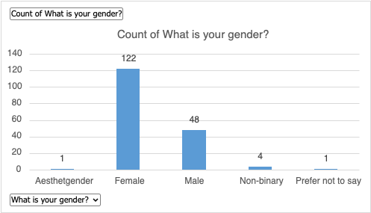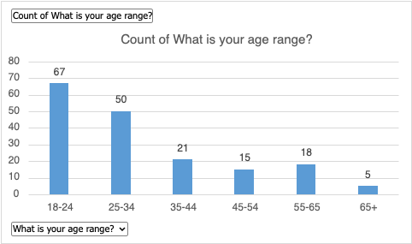
Figure Three: Ethnicity: Figure Four: Region:
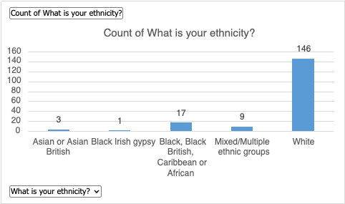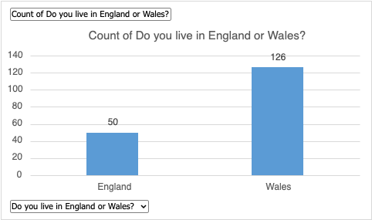

The respondent pool was predominantly female, aged 18–34, and based in Wales, suggesting that interest in police trust and diversity is especially strong among younger women and Welsh residents. Most participants identified as White, with low engagement from ethnic minorities, potentially reflecting mistrust in institutional processes or lack of outreach. While the survey offers valuable insights into public perceptions, the demographic skew may limit the broader generalisability of the findings.
These respondent patterns align with existing research showing that young people often express lower levels of trust in policing. The IOPC Youth Panel (2024) reported that 37% of young people felt less trust in the police over the past year, while just 11% felt more. Similarly, King’s College London found that only 44% of Generation Z trust the police (Duffy et al., 2024). Such figures highlight deeper concerns around fairness, accountability, and institutional reliability, suggesting that disengagement may be rooted in lived experiences rather than simple disinterest.

Figure Five: Overall trust: Figure Six: Community Representation:
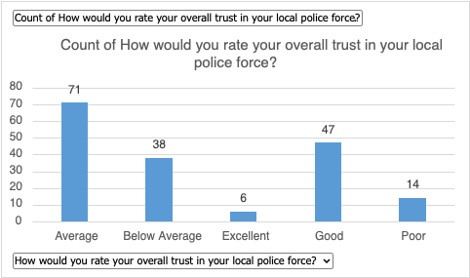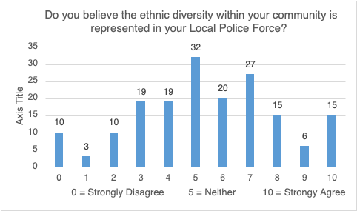
Figure Five shows that public confidence in local policing is cautious, with most respondents rating it as “Average” or “Good,” and very few selecting “Excellent.” This suggests that trust in policing is conditional rather than firmly established, aligning with procedural justice theory, which stresses that fairness and transparency are key to sustaining legitimacy (College of Policing, 2025). Lower positive ratings may reflect concerns about bias or past negative experiences that continue to shape public opinion.
Figure Six explores perceptions of ethnic diversity within local police forces, revealing mostly neutral to moderately positive responses. The concentration around mid-scale values suggests uncertainty about whether diversity is meaningfully visible in local policing. This ambiguity may stem from low levels of representation or poor communication about diversity initiatives.
Together, these datasets highlight a potential disconnect between perceived diversity and actual trust. When diversity lacks visibility or tangible community engagement, it may fail to influence public confidence. As Stauffer, Song, and Shoub (2022) argue, diversity must be both authentic and embedded within institutional practice to impact trust—representation without meaningful inclusion risks being seen as superficial.

Figure Seven: Perceptions of the effect of diversity on Police-community relations:
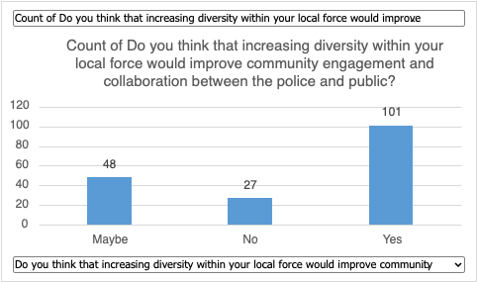
Figure Eight: Perceived impact on Police diversity on Community Engagement:
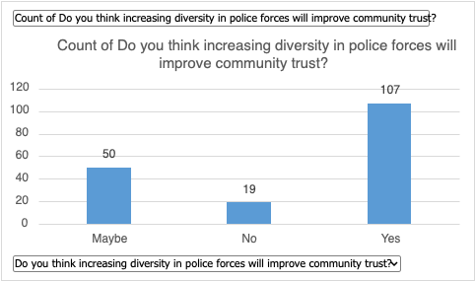
Figures assessing public perceptions of diversity in policing reveal strong support for the idea that a more representative police force enhances public trust and engagement. This finding aligns with procedural justice theory, which emphasises that institutional legitimacy improves when public services reflect the communities they serve (Hagan and Hans, 2017). Notably, respondents expressed slightly more confidence in diversity’s role in building trust than in improving engagement. This distinction suggests that while demographic representation may foster symbolic legitimacy, long-term public cooperation depends on fair and respectful interactions.
However, this support is accompanied by a degree of scepticism. Many respondents indicated uncertainty about whether increased diversity alone can bring about meaningful change. This mirrors critiques of “symbolic diversity,” where representation is increased without addressing underlying structural and cultural issues within policing (Bradford, Milani and Jackson, 2016). Diversity initiatives risk being perceived as tokenistic rather than transformative without changes in training, discipline, and community engagement.
This scepticism is particularly evident in responses concerning engagement, where more respondents rejected the idea that diversity alone improves police-community relations. This implies that while representation is important, broader structural factors—such as socioeconomic context and policing practices—play a greater role in shaping public perceptions. Supporting this, Ozer et al. (2024) argue that outcomes such as arrest rates are more strongly influenced by neighbourhood and institutional factors than by officer demographics. They emphasise that increasing workforce diversity must be paired with systemic reforms to reduce bias and enhance legitimacy.
Overall, while the data demonstrates public belief in the value of diversity, it also highlights the perception that representation must be accompanied by meaningful reform. To build and sustain trust, police forces must not only mirror their communities demographically but also uphold values of transparency, fairness, and accountability in practice.

Figure Nine: Perception of gender equality: Figure 10: Confidence in equal treatment:
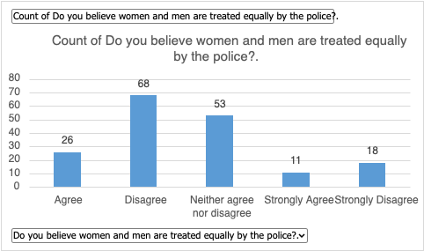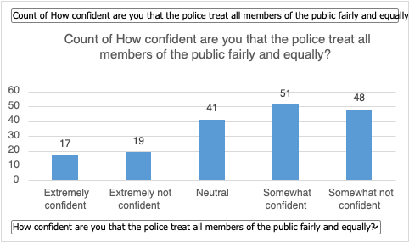

Figure Eleven: Perceptions of police fairness toward Ethnic minority communities:
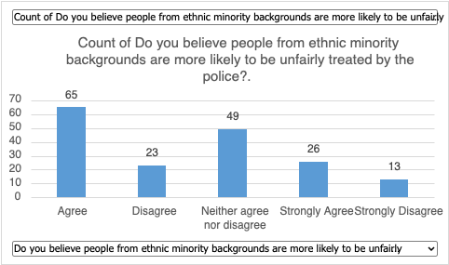
This study aims to examine the relationship between policing diversity and public trust across demographics. The graphs show public perceptions on police equity, focusing on ethnic minorities, gender, and overall fairness. These results address research objectives, specifically how diversity affects public trust and how perceptions of fairness influence confidence in policing in England and Wales.
Figure Nine illustrates a widespread public perception of gender inequality in policing, with numerous respondents doubting that men and women are treated equally. This raises concerns about gender bias in interactions with both victims and suspects. Supporting literature indicates patterns of victim-blaming in sexual violence cases and uneven enforcement practices that often result in secondary victimisation (Maier, 2024). Such results can skew victims' sense of justice and erode trust in law enforcement. Additionally, beliefs that women are either disbelieved or unfairly favoured contradict the principle of impartial policing. These insights underscore the pressing need for police agencies to implement gender-sensitive training and cultivate a more inclusive and culturally competent organisational culture. If these changes are not enacted, gender-based disparities in policing are likely to endure, further eroding public trust and perpetuating systemic bias.
Figure Ten reveals a divide in public confidence about police fairness. Some respondents expressed moderate trust, while many showed scepticism, which could indicate that public faith in policing's impartiality is not guaranteed. This ambivalence reflects concerns around procedural justice, where fairness seems inconsistent. As Yesberg et al. (2024) argue, trust in police is influenced not just by officers' identities but by how they wield their powers. The presence of high neutrality and low confidence responses underscores the limitations of diversity initiatives without structural reforms. Lacking accountability and equitable treatment, efforts to enhance representation may appear superficial, neglecting the deeper issues affecting public trust.
Figure eleven examines public beliefs on police treatment of ethnic minorities. A majority agreed that ethnic minorities are more likely to face unfair treatment, with only 39 disagreeing and 49 neutral. This is significant, as perceptions of racial bias—whether from direct experience or public narrative—can erode community trust. These results support the Commission on Race and Ethnic Disparities (2021), highlighting systemic racial disparities in the UK justice system. Regionally, areas with less diverse police forces or histories of racial tension may experience increased distrust if disparities persist. This relates to the research objective of understanding how police diversity affects trust and whether structural bias shapes public attitudes.
Figure three outlines the ethnic makeup of respondents, predominantly White, which may limit generalisability to more diverse populations. Still, many participants recognised ethnic disparities in policing (see Figure eleven), reflecting growing public awareness of systemic bias—even among those not directly affected. However, the lack of ethnic minority voices may obscure deeper mistrust found in other studies (IOPCB, 2024). Future research should target more inclusive samples, as the perspectives of underrepresented groups are vital to shaping effective diversity initiatives.
The datasets reveal widespread public concern about fairness in policing based on race, gender, and social status. These biases undermine police legitimacy and indicate that diversity initiatives must extend beyond representation for meaningful change. As Stauffer, Song and Shoub, (2022) notes, without genuine inclusion and accountability, mere representation is unlikely to build trust or improve outcomes. This scepticism appears in survey responses, where demands for transparency and fairness outweigh the perceived benefits of diversity. While representation is vital, respondents emphasised the need for procedural and structural reform to tackle deep-rooted inequalities.
These findings emphasise that trust in policing is not solely built through demographic change but through equitable practices and meaningful engagement. A holistic approach—integrating diversity with fairness, transparency, and sustained community dialogue—is required to rebuild confidence in law enforcement. Supporting this, the UK Home Office (2023) found that perceptions of fairness and accountability strongly influence public confidence. For policing to be seen as legitimate, reforms must extend beyond optics and address the underlying cultural and procedural issues that continue to undermine trust.
Figure twelve: Personal experiences of discrimination or bias:
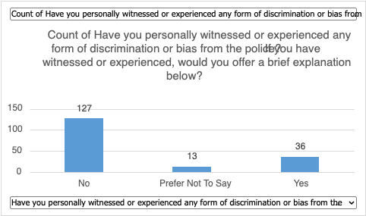

Findings from respondents who experienced discrimination reinforce the importance of police diversity in shaping community trust. These responses support the research objective by illustrating how diversity, or a lack thereof, affects public confidence. Personal accounts of racial profiling, gender bias, and age discrimination reveal that perceptions of inequality in policing are grounded in lived experience rather than abstract sentiment. This aligns with Peyton, Weiss and Vaughn’s (2022) argument that diversity is a functional component of institutional trust, but only when coupled with meaningful cultural reform.
Among the 36 respondents who reported discrimination, recurring themes pointed to systemic issues in police conduct. Common experiences included verbal mistreatment and procedural failure, such as officers swearing, shouting, or neglecting legal rights. These incidents reflect a breakdown in procedural justice, which is central to police legitimacy (Low and Owen-Evans, 2024).
Gender bias was another key theme, with some respondents describing victim-blaming in sexual assault cases, questioning of sobriety, and inconsistent treatment of women. These accounts point to gendered policing, where women are either disbelieved, infantilised, or treated with undue leniency, undermining perceptions of impartiality and reinforcing harmful stereotypes. The IOPC’s (2024a) updated guidance on victim-blaming language highlights how such behaviour deters victims from reporting and further erodes trust in law enforcement.
Racial profiling also emerged prominently. Several respondents reported Black individuals being unfairly stopped while White individuals in similar circumstances were ignored. This reflects national trends: Black individuals are 2.9 times more likely to be stopped and searched (HMICFRS, 2023a). The Institute of Race Relations (2024) argues that such disparities alienate minority communities, reinforcing a sense of targeted policing. The Lammy Review (2023) found that 51% of Black and Minority Ethnic individuals believe the justice system discriminates against them, compared to 35% of White respondents, highlighting the broader implications of biased policing.
Age discrimination was also noted, with younger respondents feeling targeted and stereotyped. IOPC data (2024b) supports this: young Black males aged 10–17 face a stop-and-search rate nearly four times higher than their White peers. The IOPC warns against the adultification of Black children, as this misperception undermines their rights and increases mistrust.
Taken together, these accounts reveal that experiences of discrimination are not isolated incidents but symptomatic of broader institutional issues. Without structural reforms—including accountability, cultural change, and equitable treatment—efforts to rebuild trust in policing will remain limited.
While this research highlights several personal accounts of discrimination, it is important to acknowledge that such experiences are likely underreported. Many individuals may choose not to disclose bias-related incidents due to fear of reprisal, mistrust in complaint systems, or internalised perceptions that reporting will not lead to meaningful change. Recent research from the Vulnerability & Policing Futures Research Centre (2024) underscores this issue, revealing that police forces across England and Wales are failing to meet the public’s basic expectations of fairness, transparency, and accountability. The report emphasises a systemic failure to recognise and respond adequately to vulnerable individuals and minority communities, leading to disengagement and the silencing of critical experiences. If discrimination is more prevalent than survey responses suggest, then trust deficits are likely even deeper than reported. This raises significant concerns for reform strategies: without addressing the internal cultures that inhibit transparency and self-scrutiny, efforts to diversify police forces risk appearing superficial. Symbolic inclusion cannot compensate for unaddressed structural failures, and without robust reporting frameworks, public confidence will continue to erode, especially among those communities most in need of institutional protection.

Figure thirteen: Public priorities for improving trust in the police:
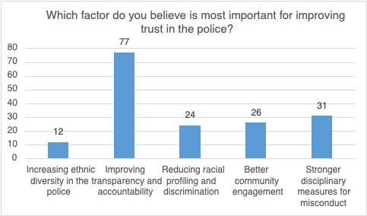
Findings from respondents who experienced discrimination reinforce the importance of police diversity in shaping community trust. Their accounts of racial profiling, gender bias, and age-based mistreatment suggest that inequality in policing is rooted in lived experience, not abstract perception. These insights support Peyton, Weiss and Vaughn’s (2022) argument that diversity builds institutional trust only when coupled with meaningful reform. Common themes—such as verbal abuse, procedural failings, and unfair treatment—highlight breakdowns in procedural justice, a core pillar of legitimacy (Low and Owen-Evans, 2024).
Gendered policing was particularly notable. Respondents reported victim-blaming in sexual assault cases and inconsistent treatment of women, aligning with IOPC (2024a) guidance that warns such behaviour deters victims and undermines trust. Racial profiling also emerged as a persistent issue, with Black individuals disproportionately targeted in stop-and-searches despite weaker grounds for suspicion (HMICFRS, 2023a; Institute of Race Relations, 2024). Age discrimination similarly surfaced, with young Black males disproportionately stopped and subject to ‘adultification’—a practice the IOPC (2024b) warns deepens mistrust.
Figure Thirteen illustrates how public priorities for improving trust centre on institutional reform rather than representation alone. While diversity is seen as valuable, most respondents emphasised transparency, stronger accountability, and effective discipline over demographic change. This aligns with critiques of symbolic diversity (Hebl, 2024), which warn that representation without structural change is perceived as superficial. The Criminal Justice Alliance (2019) also found that public confidence hinges more on independent oversight than on ethnic composition alone. Respondents made clear that trust must be earned through equitable conduct, not optics.
Taken together, these findings demonstrate that while a representative police force is important, trust is ultimately built through fairness, transparency, and cultural change. This reinforces the study’s core research aim—exploring how police diversity intersects with public trust. Objective 1 is supported by the clear perception that diversity must be accompanied by reform to be effective. Objective 2 is addressed through the varying experiences of trust across age, gender, and ethnicity. Objective 3 is reflected in the scepticism toward existing diversity efforts and the demand for deeper accountability.
In summary, this research shows that public trust in policing depends not just on who serves, but how they serve. A diverse force is not inherently legitimate—it must embody procedural justice and institutional integrity. Only then can diversity become a transformative force, rather than a symbolic gesture.

Chapter Five - Conclusion

This dissertation has explored the research question: “Reflecting communities – the impact of police diversity on public trust.” It has critically investigated whether greater demographic representation within police forces enhances community confidence or whether trust depends more fundamentally on systemic fairness, transparency, and accountability. The research was grounded in three key objectives: to assess the current state of police diversity and its relationship with trust, to explore regional variation in public confidence across England and Wales, and to evaluate the levels of representation within the police service itself.
The project adopted a logical and systematic approach, beginning with a review of the literature and policy landscape, followed by detailed secondary data analysis, and culminating in a primary research study using a quantitative survey. This structure allowed for a clear progression from theoretical context to practical insight and enabled the researcher to build a coherent argument that directly addresses the research question.
The study found that police diversity is broadly viewed as important by the public, but not sufficient to establish or rebuild trust. Many survey respondents supported the idea that representation enhances legitimacy and improves engagement, particularly among underrepresented groups. However, the research also uncovered considerable scepticism. A large proportion of participants expressed doubts about whether increasing diversity alone could lead to meaningful change without deeper structural reforms in accountability, training, and operational culture. These views were reinforced by existing literature, including critiques of symbolic diversity (Bradford et al., 2016) and calls for a shift toward cognitive and institutional change (Langston, 2017).
In addressing the first objective, the research provided a comprehensive overview of the current state of police diversity. The analysis of Home Office data and academic studies revealed a continuing underrepresentation of ethnic minorities, especially in senior ranks and certain regional forces. Although progress has been made, particularly in urban areas like London, the findings show that most forces still fall short of reflecting the communities they serve. Furthermore, the research highlighted the limitations of broad categorisations such as “BAME,” which obscure important distinctions between ethnic groups and risk misrepresenting the true extent of inequality.
The second objective—to examine the variation in community trust—uncovered marked regional differences. The Metropolitan Police, despite operating in one of the UK’s most diverse areas, received low public confidence ratings, particularly from young people, ethnic minorities, and women. In contrast, South Wales Police achieved comparatively higher levels of trust, which may reflect its more transparent approach to community engagement and its public acknowledgement of past failings. These findings suggest that local context, leadership, and organisational culture are just as important as demographic makeup in shaping public trust.
The third objective, which assessed representation within forces, confirmed that many respondents were unsure or unconvinced about whether their local police accurately reflect their communities. The survey data indicated that trust is often conditional and grounded in perceptions of fairness, not simply in shared identity. This reflects the broader literature on procedural justice, which argues that public confidence is more strongly influenced by how officers exercise their powers than by who they are (Yesberg et al., 2024).
The methodological approach adopted in this research was well suited to the aims of the study. The use of a structured online survey allowed the researcher to capture a broad range of perspectives efficiently, while the integration of secondary data offered crucial context and validation. Although challenges such as potential sampling bias and limitations in regional representation were encountered, the research was carefully designed, ethically sound, and effective in generating meaningful findings. The use of both quantitative data and qualitative insights from open responses enabled a rich, balanced analysis.
Through this critical investigation, the dissertation has contributed to a deeper understanding of the limits and potential of diversity initiatives in policing. It supports the view that while representation is symbolically important and can improve cultural awareness, it must be embedded within a broader strategy of reform. This includes visible disciplinary processes, leadership accountability, and community partnership, not merely demographic change.
The research also raised new questions that merit further exploration. For instance, how does diversity affect police behaviour internally—does it change decision-making or reduce bias in practice? What role does intersectionality play in shaping officers’ and community members’ experiences? Furthermore, how can forces ensure that diverse recruits are retained, supported, and promoted in a system historically shaped by exclusion?
Looking ahead, future research could benefit from longitudinal studies that track the impact of diversity over time, as well as more targeted qualitative interviews that explore the experiences of officers from minority backgrounds. In addition, further investigation into cognitive diversity, emotional intelligence, and police training practices could offer new insights into what truly builds community trust.
Ultimately, this dissertation confirms that diversity is a necessary but not sufficient condition for trust in modern policing. It is a starting point, not an end goal. At a time when police legitimacy is under unprecedented scrutiny, this research makes a timely contribution to the debate on how best to align police forces with the communities they serve. To truly reflect and serve those communities, police services must move beyond representational optics and commit to lasting institutional reform rooted in fairness, justice, and accountability.

References

Atlas (2024). Thematic Analysis in Surveys | Guide & Examples. ATLAS.ti. Available at: https://atlasti.com/guides/thematic-analysis/thematic-analysis-surveys? (Accessed 4 Feb. 2025).

Bergen, N. and Labonté, R. (2020). ‘Everything Is Perfect, and We Have No Problems’: Detecting and Limiting Social Desirability Bias in Qualitative Research. Qualitative Health Research, 30(5), pp.783–792. doi:https://doi.org/10.1177/1049732319889354.

Bhaskaran, V. (2023). Survey Research: Definition, Examples and Methods. QuestionPro. Available at: https://www.questionpro.com/blog/survey-research/.

Bhattacherjee, A. (2019). Chapter 9 Survey Research | Research Methods for the Social Sciences. Lumenlearning.com. Available at: https://courses.lumenlearning.com/suny-hccc-research-methods/chapter/chapter-9-survey-research/.

Blair, G., Weinstein, J.M., Christia, F., Arias, E., Badran, E., Blair, R.A., Cheema, A., Farooqui, A., Fetzer, T., Grossman, G., Haim, D., Hameed, Z., Hanson, R., Hasanain, A., Kronick, D., Morse, B.S., Muggah, R., Nadeem, F., Tsai, L.L. and Nanes, M. (2021). Community Policing Does Not Build Citizen Trust in Police or Reduce Crime in the Global South. Science, 374(6571). doi:https://doi.org/10.1126/science.abd3446.

Bouchrika, I. (2024). Primary Research Vs Secondary Research: Definitions, Differences, and Examples. Research.com. Available at: https://research.com/research/primary-research-vs-secondary-research.

Bradford, B., Milani, J. and Jackson, J. (2016). Identity, Legitimacy and Making Sense of Police Violence. SSRN Electronic Journal. Doi:https://doi.org/10.2139/ssrn.2793818.

Braun, V., Clarke, V., Boulton, E., Davey, L. and McEvoy, C. (2021). The Online Survey as a Qualitative Research Tool. International Journal of Social Research Methodology, 24(6), pp.641–654. doi:https://doi.org/10.1080/13645579.2020.1805550.

Brown, R. and Hobbs, A. (2023). POSTnote 693: Trust in the police: Overview. Available at: https://researchbriefings.files.parliament.uk/documents/POST-PN-0693/POST-PN-0693.pdf (Accessed 21 Oct. 2024).

Casey, B. (2023). Baroness Casey review: Final report. An Independent Review into the Standards of Behaviour and Internal Culture of the Metropolitan Police Service. pp.8–10.

Chopra, P. (2021). Race Report: Anger among Sikh and Black Communities of the UK — the Second Angle. The Second Angle. Available at: https://thesecondangle.com/race-report-anger-among-sikh-and-black-communities-of-uk/ (Accessed 29 Nov. 2024).

College Of Policing (2021). Diversity, Equality and Inclusion Strategy 2021-2024. Available at: https://assets.college.police.uk/s3fs-public/2021-10/Diversity-equality-and-inclusion-strategy.pdf? (Accessed 21 Jan. 2025).

College of Policing (2023a). Building trust and a fair culture. College of Policing. Available at: https://www.college.police.uk/about/corporate-strategy-2022-2026/building-trust-and-fair-culture.

College of Policing (2023b). Legal Basis. College of Policing. Available at:
https://www.college.police.uk/app/stop-and-search/legal/legal-basis (Accessed 21 Jan. 2025).

College Of Policing (2024). Diversity. College of Policing. Available at: https://profdev.college.police.uk/diversity/ (Accessed 21 Oct. 2024).
College Of Policing (2025). Improving Public Confidence in the Police: An Evidence-Based Guide. pp.15–18. Available at: Improving public confidence in the police: An evidence-based guide (Accessed 1 Apr. 2025).

Commission on Race and Ethnic Disparities (2021). The Report of the Commission on Race and Ethnic Disparities. GOV.UK. Available at: https://www.gov.uk/government/publications/the-report-of-the-commission-on-race-and-ethnic-disparities.

Cooper, S. (2022). Police Relational accountabilities: the Paralysis of Police accountability? Policing: A Journal of Policy and Practice, 17, pp.1–16. doi:https://doi.org/10.1093/police/paac081.

Crest (2022). Stop and Search: The Evidence. [online] Crest Site Official. Available at: https://www.crestadvisory.com/post/report-stop-and-search-the-evidence (Accessed 22 Oct. 2024).

Criminal Justice Alliance (2019). Stop & Scrutinise: How to Improve Community Scrutiny of Stop and Search. pp.4–7, 11–13. Available at: https://criminaljusticealliance.org/wp-content/uploads/CJA-Stop-and-Scrutinise-2019.pdf (Accessed 12 Apr. 2025).

Dacosta, C., Dixon-Smith, S. and Singh, G. (2021). Beyond BAME: Rethinking the politics, construction, application, and Efficacy of Ethnic Categorisation Stimulus Paper. Available at: https://pure.coventry.ac.uk/ws/portalfiles/portal/41898015/Beyond_BAME_final_report.pdf (Accessed 15 Jan. 2025).

Donohue, R.H. (2019). Shades of Blue: A review of the hiring, recruitment, and selection of female and minority police officers. The Social Science Journal, 58(4). doi:https://doi.org/10.1016/j.soscij.2019.05.011.

Duffy, B., Morini, P., Wright, J. and Hewlett, K. (2024). Perceptions of the Police: A Generational Crisis of Confidence? The Policy Institute, King’s College London.

Gill, S. (2024). Finding Sarah Everard: A Critical Discourse Analysis Exploring the First Two Weeks of News Media Coverage following Her Disappearance and Murder. International Journal of Communication, 18(0), p.20. Available at: https://ijoc.org/index.php/ijoc/article/view/21612.

Hagan, J. and Hans, V.P. (2017). Procedural Justice Theory and Public Policy: An Exchange. Annual Review of Law and Social Science, 13(1), pp.1–3. doi:https://doi.org/10.1146/annurev-lawsocsci-121416-011426.

Hanway, P. and Hambly, O. (2023). Public Perceptions of policing: a Review of Research and Literature. GOV.UK. Available at: https://www.gov.uk/government/publications/public-perceptions-of-policing-a-review-of-research-and-literature/public-perceptions-of-policing-a-review-of-research-and-literature.

Hebl, M. and King, E. (2024). Working Together. Oxford University Press eBooks. Oxford University Press. Doi:https://doi.org/10.1093/oso/9780197744383.001.0001.

Her Majesty’s Inspectorate of Constabulary and Fire & Rescue Services (2021). Disproportionate Use of Police Powers – a Spotlight on Stop and Search and the Use of Force. Available at: https://hmicfrs.justiceinspectorates.gov.uk/publications/disproportionate-use-of-police-powers-a-spotlight-on-stop-and-search-and-the-use-of-force/.

Hesketh, I. and Stubbs, G. (2023). Positive Action Paradox in UK Police recruitment: a Critical Perspective. Positive action paradox in UK police recruitment: A critical perspective, 97(2). doi:https://doi.org/10.1177/0032258x231172030.

Hills, J. (2021). The Macpherson Report: Twenty-two Years on - Home Affairs Committee - House of Commons. Publications.parliament.uk. Available at: https://publications.parliament.uk/pa/cm5802/cmselect/cmhaff/139/13907.htm (Accessed 29 Dec. 2024).

His Majesty’s Inspectorate of Constabulary and Fire & Rescue Services (2023a). Metropolitan PEEL Assessment 2023–2025 - His Majesty’s Inspectorate of Constabulary and Fire & Rescue Services. His Majesty’s Inspectorate of Constabulary and Fire & Rescue Services. Available at: https://hmicfrs.justiceinspectorates.gov.uk/peel-reports/metropolitan-2023-25/ (Accessed 29 Nov. 2024).

His Majesty’s Inspectorate of Constabulary and Fire & Rescue Services (2023b). Race and Policing: a Review of the Police Service’s Leadership and Governance Arrangements for race-related Matters. His Majesty’s Inspectorate of Constabulary and Fire & Rescue Services. Available at: https://hmicfrs.justiceinspectorates.gov.uk/publication-html/review-of-the-police-services-leadership-and-governance-arrangements-for-race-related-matters/.

His Majesty’s Inspectorate of Constabulary and Fire & Rescue Services (2023c). South Wales PEEL Assessment 2023–2025 - His Majesty’s Inspectorate of Constabulary and Fire & Rescue Services. His Majesty’s Inspectorate of Constabulary and Fire & Rescue Services. Available at: https://hmicfrs.justiceinspectorates.gov.uk/peel-reports/south-wales-2023-25/ (Accessed 29 Nov. 2024).

His Majesty’s Inspectorate of Constabulary and Fire & Rescue Services (2024). PEEL Assessments 2023–25. His Majesty’s Inspectorate of Constabulary and Fire & Rescue Services. Available at: https://hmicfrs.justiceinspectorates.gov.uk/peel-reports-year/2023-25/ (Accessed 29 Nov. 2024).

Hobbs, C. (2020). Black Police Officers: Selfless Heroes or Traitors. The London Economic. Available at: https://www.thelondoneconomic.com/opinion/black-police-officers-selfless-heroes-or-traitors-177217/ (Accessed 24 Nov. 2024).

Home Office (2021). Crime and Policing. GOV.UK. Available at: https://www.gov.uk/government/publications/the-report-of-the-commission-on-race-and-ethnic-disparities/crime-and-policing#how-to-achieve-a-more-diverse-police-service (Accessed 23 Oct. 2024).

Home Office (2022). Regional Ethnic Diversity. www.ethnicity-facts-figures.service.gov.uk. Available at: https://www.ethnicity-facts-figures.service.gov.uk/uk-population-by-ethnicity/national-and-regional-populations/regional-ethnic-diversity/latest/ (Accessed 10 Nov. 2024).

Home Office (2023). Public Perceptions of policing: a Review of Research and Literature. GOV.UK. Available at: https://www.gov.uk/government/publications/public-perceptions-of-policing-a-review-of-research-and-literature/public-perceptions-of-policing-a-review-of-research-and-literature?.

Home Office (2024). Home Secretary Announces Major Policing Reforms. GOV.UK. Available at: https://www.gov.uk/government/news/home-secretary-announces-major-policing-reforms.

Home Office (2023). Police Workforce. www.ethnicity-facts-figures.service.gov.uk. Available at: https://www.ethnicity-facts-figures.service.gov.uk/workforce-and-business/workforce-diversity/police-workforce/latest/ (Accessed 21 Oct. 2024).

Independent Office for Police Conduct (2024a). Ending Victim Blaming in the Context of Violence against Women and Girls. Why language, attitudes, and Behaviours matter. 2. Available at: https://www.policeconduct.gov.uk/sites/default/files/documents/IOPC-ending-victim-blaming-guidance-Feb-2024.pdf (Accessed 9 Apr. 2025).

Independent Office for Police Conduct (2024b). IOPC Race Discrimination Report. pp.11–14. Available at: https://www.policeconduct.gov.uk/race-discrimination-report (Accessed 12 Apr. 2025).

Independent Office for Police Conduct Youth Panel (2024). National Survey Report. Police Conduct. Available at: https://www.policeconduct.gov.uk/sites/default/files/documents/Youth-Panel-National-Survey-2024.pdf (Accessed 1 Mar. 2025).

Institute of Race Relations (2024). Criminal Justice System Statistics. Institute of Race Relations. Available at: https://irr.org.uk/research/statistics/criminal-justice/ (Accessed 9 Apr. 2025).

Lammy, D. (2017). The Lammy Review: an Independent Review into the Treatment of, and Outcomes for, Black, Asian and Minority Ethnic Individuals in the Criminal Justice System. Available at: https://assets.publishing.service.gov.uk/media/5a82009040f0b62305b91f49/lammy-review-final-report.pdf (Accessed 7 Apr. 2025).

Low, N. and Owen-Evans, R. (2024). Public Trust and Confidence in the Police. UK Parliament. Available at: https://post.parliament.uk/public-trust-and-confidence-in-the-police/ (Accessed 9 Apr. 2025).

Macpherson, W. (1999). The Stephen Lawrence Inquiry. [online] GOV.UK. Available at: https://assets.publishing.service.gov.uk/media/5a7c2af540f0b645ba3c7202/4262.pdf (Accessed 18 Nov. 2024).

Maier, S.L. (2024). Advocates’ Perception of the Secondary Victimization of Rape Survivors by Law Enforcement, the Legal System, and Hospital Professionals. Violence Against Women. Doi:https://doi.org/10.1177/10778012241292260.

Metropolitan Police (2024). London Race Action Plan. Metropolitan Police, pp.10–13. Available at: https://www.met.police.uk/SysSiteAssets/media/downloads/met/about-us/london-race-action-plan-2024.pdf.

Mwita, K. (2022). Strengths and Weaknesses of Qualitative Research in Social Science Studies. International Journal of Research in Business and Social Science (2147- 4478), 11(6), pp.618–625. doi:https://doi.org/10.20525/ijrbs.v11i6.1920.

National Police Autism Association (2017). The Futile Quest. [online] National Police Autism Association. Available at: https://www.npaa.org.uk/futile-quest/ (Accessed 28 Dec. 2024).

Nicholson-Crotty, J. and Li, D. (2023). When intragroup conflict is a good thing: Team diversity and use of force by police. International Public Management Journal, 27(1), pp.76–90. doi:https://doi.org/10.1080/10967494.2023.2174628.

Office for National Statistics (2024). Crime in England and Wales. Ons.gov.uk. Available at: https://www.ons.gov.uk/peoplepopulationandcommunity/crimeandjustice/bulletins/crimeinenglandandwales/yearendingjune2024.
Ozer, M., Akbas, H., Onat, I., Bastug, M., Akgul, A., ElSayed, N., ElSayed, Z., Koseli, M. and Ekici, N. (2024). Not as Simple as It Looked: Are We Concluding for Biased Arrest Practices?] arXiv.org. Available at: https://arxiv.org/abs/2406.11867 (Accessed 21 Mar. 2025).
Peyton, K., Weiss, C.M. and Vaughn, P.E. (2022). Beliefs about Minority Representation in

Policing and Support for Diversification. Proceedings of the National Academy of Sciences, 119(52). doi:https://doi.org/10.1073/pnas.2213986119.

Pica, E., Thompson, L.E., Pozzulo, J. and Sheahan, C.L. (2019). Perceptions of Police Conduct When Race and Gender Are Considered. Journal of Police and Criminal Psychology, 35. doi:https://doi.org/10.1007/s11896-019-09346-1.

Pickering, S., Dorussen, H., Martin Ejnar Hansen, Reifler, J., Scotto, T., Sunahara, Y. and Yen, D. (2024). London, You Have a Problem with women: Trust Towards the Police in England. Policing & society, 34(8), pp.747–762. doi:https://doi.org/10.1080/10439463.2024.2334009.

Richards, G. and Davies, N. (2023). Performance Tracker 2023: Police. Institute for Government. Available at: https://www.instituteforgovernment.org.uk/publication/performance-tracker-2023/police.

Ryan, G. (2018). Introduction to positivism, Interpretivism and Critical Theory. Nurse Researcher, 25(4), pp.41–49. Available at: https://oro.open.ac.uk/49591/17/49591ORO.pdf.

Shiner, M., Carre, Z., Delsol, R. and Eastwood, N. (2018). The Colour of Injustice: ‘Race’, Drugs and Law Enforcement in England and Wales. Available at: https://www.release.org.uk/sites/default/files/pdf/publications/The%20Colour%20of%20Injustice.pdf (Accessed 20 Jan. 2025).

Shipton, B. (2023). Signature Pedagogies in Police Education. SpringerBriefs in criminology (Print). Springer Nature. doi:https://doi.org/10.1007/978-3-031-42387-1.
Sopact University (2024). Integrating Secondary Data with Primary Data. [online] Sopact.com. Available at: https://university.sopact.com/article/secondary-data? (Accessed 4 Feb. 2025).

South Wales Police (2023). Chief Constable Jeremy Vaughan Addresses the National Black Police Association Conference. South Wales Police. Available at: https://www.south-wales.police.uk/news/south-wales/news/2023/hyd-oct/chief-constable-jeremy-vaughan-addresses-the-national-black-police-association-conference/.

Starkey, B.S. (2015). In Defense of Uncle Tom. Cambridge University Press. doi:https://doi.org/10.1017/cbo9781107707160.

Stauffer, K.E., Song, M. and Shoub, K. (2022). How Police Agency diversity, policies, and Outcomes Shape Citizen Trust and Willingness to Engage. Policy Studies Journal, 51(4). doi:https://doi.org/10.1111/psj.12479.
The Independent Office for Police Conduct (2024). IOPC Race Discrimination Report. IOPC, pp.33–45. Available at: https://www.policeconduct.gov.uk/race-discrimination-report?(Accessed 18 Jan. 2025).

The Lammy Review (2017). An Independent Review into the Treatment of, and Outcomes for, Black, Asian and Minority Ethnic Individuals in the Criminal Justice System. Home Office. Available at: https://assets.publishing.service.gov.uk/media/5a82009040f0b62305b91f49/lammy-review-final-report.pdf (Accessed 25 Feb. 2025).

Tura, F., Pickering, S., Martin Ejnar Hansen and Hunter, J. (2024). Intersectional Inequalities in Trust in the Police in England. CrimRxiv. doi:https://doi.org/10.21428/cb6ab371.52c402f8.

UK Parliament (2021). The Macpherson Report: Twenty-two years on - Home Affairs Committee - House of Commons. publications.parliament.uk. Available at: https://publications.parliament.uk/pa/cm5802/cmselect/cmhaff/139/13911.htm.

UK Research and Innovation (2022). Quantitative Research. www.ukri.org. Available at: https://www.ukri.org/who-we-are/esrc/what-is-social-science/quantitative-research/.

University of Law (2023). Diversity in policing 2023: Do constabularies truly represent the communities they serve? Law.ac.uk. Available at: https://www.law.ac.uk/resources/blog/diversity-in-policing/ (Accessed 21 Oct. 2024).

University of Nottingham (2025). Understanding Pragmatic Research. Nottingham.ac.uk. Available at: https://www.nottingham.ac.uk/helmopen/rlos/research-evidence-based-practice/designing-research/types-of-study/understanding-pragmatic-research/section03.html? (Accessed 4 Feb. 2025).

Vasko, H. (2024). The Importance of Gender Diversity on Police Culture the Importance of Gender Diversity on Police Culture. Available at: https://ideaexchange.uakron.edu/cgi/viewcontent.cgi?article=3334&context=honors_research_projects (Accessed 27 Nov. 2024).

Vunerability & Policing Futures Research Centre (2024). Police Are Failing to Meet the Public’s Minimum Standards of service, Researchers Find - Vulnerability & Policing Futures Research Centre. Vulnerability & Policing Futures Research Centre. Available at: https://vulnerabilitypolicing.org.uk/news/police-are-failing-to-meet-the-publics-minimum-standards-of-service-researchers-find/? (Accessed 19 Apr. 2025).

Wang, X. and Cheng, Z. (2020). Cross-sectional studies: Strengths, weaknesses, and Recommendations. Chest, 158(1), pp.65–71. doi:https://doi.org/10.1016/j.chest.2020.03.012.

Welsh Government (2024). Anti-racist Wales Action Plan: 2024 Update [HTML] |
GOV.WALES. GOV.WALES. Available at: https://www.gov.wales/anti-racist-wales-action-plan-2024-update-html [Accessed 20 Nov. 2024].

Wilopo, C. and Tino Plümecke (2024). Intersectionality of Racial Profiling: A Call for a Broader Understanding. Springer eBooks, pp.347–364. doi:https://doi.org/10.1007/978-3-031-52227-7_22.

Yesberg, J., Sargeant , E., Fenn, L., Murphy, K. and Madon, N. (2024). Fairness in policing: How Does Internal Procedural Justice Translate to External Procedural justice? Available at: https://academic.oup.com/policing/article/doi/10.1093/police/paae126/7913517 (Accessed 9 Apr. 2025).

Zhaksylyk, A., Zimba, O., Yessirkepov, M. and Koçyiğit, B.F. (2023). Research Integrity: Where We Are and Where We Are Heading. Journal of Korean Medical Science, 38(47). doi:https://doi.org/10.3346/jkms.2023.38.e405.

Appendix:

Appendix A: Questionnaire
Introduction:
Hello,
My names Kimberley Collins, I am 23 years old and in my final year of university. This survey is for my dissertation, and I appreciate all the responses.
Thank you for taking part in this survey. This study explores how diversity within the police force impacts public trust, particularly in the wake of recent high-profile cases of police misconduct in the UK. There has been growing public concern regarding issues of racism, sexism, and unprofessional conduct within police forces, as well as a lack of representation from minority communities. This survey seeks to understand how these factors influence public confidence in policing and whether greater diversity can help rebuild trust.
Diversity in this context refers to representing different ethnic groups, genders, and backgrounds within police forces, ensuring that they reflect the communities they serve. Trust relates to public confidence in the police to act reasonably, treat all individuals respectfully, and uphold justice without bias.
The findings of this survey will contribute to research examining whether a more representative police force leads to stronger community relations or whether more profound institutional changes are necessary to restore public faith in law enforcement.
The survey should take approximately 5 minutes to complete. All anonymous responses will be used solely for academic research as part of my dissertation. No personally identifiable information will be collected.
Your participation is entirely voluntary, and you may exit the survey at any time. If you have any questions or concerns, please contact me.
By continuing, you confirm that you are 18 or older and consent to participate in this study.

Section 1: Questions:
Q. 1 - Do you consent to taking part in this survey?
- Yes
- No

Q. 2- What is your gender?
- Male
- Female
- Non-binary
- Prefer not to say

Q. 3- What is your age range?
- 18-24
- 25-34
- 35-44
- 45-54
- 55-65
- 65+
- Prefer not to say

Q. 4- What is your ethnicity?
- White
- Black, Black British, Caribbean or African
- Mixed/Multiple ethnic groups
- Asian or Asian British
- Arab
- Prefer not to say

Q. 5 - Do you live in England or Wales?
- Wales
- England

Q. 6 – How would you rate your overall trust in your local police force?



Q. 7- How confident are you that the police treat all members of the public fairly and equally?
- Extremely confident
- Somewhat confident
- Neutral
- Somewhat not confident
- Extremely not confident

Q. 8 – Do you believe that ethnic diversity within your community is represented in your local police force?


Q. 9—Have you personally witnessed or experienced any form of discrimination or bias from the police? If so, would you offer a brief explanation below?
- Yes
- No
- Prefer not to say

Q. 10 – If you answered yes and are comfortable, please explain:
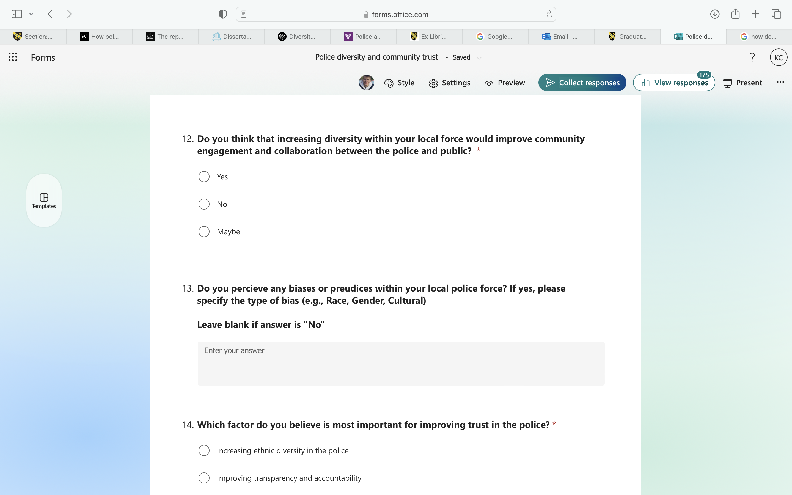

Q. 11 – Do you think increasing diversity in police forces will improve community trust?
- Yes
- No
- Maybe

Q. 12 – Do you think that increasing diversity within your local force would improve community engagement and collaboration between the police and public?
- Yes
- No
- Maybe

Q. 13 – Do you perceive any biases or prejudices within your local police force? If yes, please specify the type of bias (e.g., Race, Gender, Cultural)

Q. 14 – Which factor do you believe is the most important for improving trust in the police?
- Increasing ethnic diversity in the police
- Improving transparency and accountability
- Reducing racial profiling and discrimination
- Better community engagement
- Stronger disciplinary measures for misconduct

Q. 15 – Do you believe women and men are treated equally by the police?
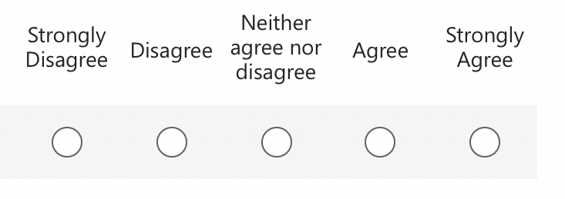

Q. 16- Do you believe people from ethnic minority backgrounds are more likely to be unfairly treated by the police?

Support offered:
If you have been affected by any of the topics discussed in this survey, support is available. The following resources offer advice, guidance, and confidential support:
📌 Victim Support – Free and confidential help for victims of crime, including police misconduct.
🔗 www.victimsupport.org.uk | Call 08 08 16 89 111
📌 Mind – Mental health support for those struggling with anxiety, trauma, or distress.
🔗 www.mind.org.uk | Call 0300 123 3393
📌 The Survivors Trust – Support for survivors of abuse and misconduct.
🔗 www.thesurvivorstrust.org | Call 08088 010818
📌 Samaritans – 24/7 emotional support for anyone in distress.
🔗 www.samaritans.org | Call 116 123
Please reach out if you need support. You are not alone. 💙

Appendix B- Responses:

Question 1: Do you consent to taking part in this survey?

Answer | Response
Yes | 175
No | 0

Question 2: What is your gender?

Answer | Response
Aesthetgender | 1
Female | 122
Male | 48
Non-Binary | 4
Prefer Not To Say | 1

Question 3: What is your age range?

Answer | Response
18-24 | 67
25-34 | 50
35-44 | 21
45-54 | 15
55-65 | 18
65+ | 5

Question 4: What is your ethnicity?

Answer | Response
Asian or Asian British | 3
Black Irish Gypsy | 1
Black, Black British, Caribbean or African | 17
Mixed/Multiple Ethic Groups | 9
White | 146

Question 5: Do you live in England or Wales?

Answer | Response
England | 50
Wales | 126

Question 6: How would you rate your overall trust in your local police force?

Answer | Response
Average | 71
Below Average | 38
Excellent | 6
Good | 47
Poor | 14

Question 7: How confident are you that the police treat all members of the public fairly and equally?

Answer | Response
Extremely Confident | 17
Extremely Not Confident | 19
Neutral | 41
Somewhat Confident | 51
Somewhat Not Confident | 48

Question 8: Do you believe the ethnic diversity within your community is represented in your Local Police Force?

Answer | Response
0 | 10
1 | 3
2 | 10
3 | 19
4 | 19
5 | 32
6 | 20
7 | 27
8 | 15
9 | 6
10 | 15

Question 9: Have you personally witnessed or experienced any form of discrimination or bias from the police? If you have witnessed or experienced, would you offer a brief explanation below?

Answer | Response
No | 127
Prefer Not To Say | 13
Yes | 36

Question 10: If You Answered Yes And Are Comfortable, Please Explain

ID | Response
1 | I was treated with no respect and was handled disturbingly, being young lady and having a male police officer beat you and then let you in van for hours while needing medication was a horrible experience for me and know I will never trust the police
2 | Assumptions because of race
3 | being let off for speeding as i’m “just a young girl”
4 | When out in oublic its diffficult sometimes being non-binry and the police didnt help a situation I was in
5 | Growing up my friends and I where stopped by the police multiple times for a stop and search and given no valid explanation or cause for it (a specific police officer in the local area targeted us) however one of my friends and I where rarely ever included within these searches if we where present; instead my friends who where black where searched instead. It was clear discrimination and the officer went out of their way to search them at any given point.
6 | Told I shouldn’t dress a certain way
7 | Because I’m a young black male
8 | I was told that bouncers had the right to break my finger while escorting me out of a bar because I had been drinking that night. "People like you" Need to be more careful
9 | Didn’t search my white girlfriend but stop and searched me
10 | Women get let off
11 | Not in relation to Q9, but for Q8 I chose 5 as a neutral response but in reality I would have preferred to leave this blank as I feel unable to answer the question, as I see so little of our local police force that I cannot reasonably answer.
12 | Women let off easier
13 | A police officer spoke to me like a piece of dirt on my shoe, he was swearing and screaming at me and also did not read the caution correctly or give me my rights.
14 | I worked with challenging young people for a number of years and have witnessed on a number of occasions discrimination towards young people who have not had the best start in life...however I can honestly say that it appears that attitudes have changed.
15 | I was told by a male police officer when I reported a sexual assault that I had too much to drink despite the fact I was stone cold sober
16 | Age discrimination like a group of young adults and teens

Question 11: Do you think increasing diversity in police forces will improve community trust?

Answer | Response
No | 19
Maybe | 50
Yes | 107

Question 12: Do you think that increasing diversity within your local force would improve community engagement and collaboration between the police and public?

Answer | Response
No | 27
Maybe | 48
Yes | 101

Question 13: Do you perceive any biases or prejudices within your local police force? If yes, please specify the type of bias (e.g., Race, Gender, Cultural)

ID | Response
1 | Race, religion, culture, age
2 | Race and gender
3 | Race
4 | Gender
5 | race
6 | Racial
7 | Age
8 | Yes, cultural differences and those below the poverty line suffer more from bias and prejudice
9 | Race
10 | Sexuality
11 | Race
12 | Race and culture
13 | Race and Cultural
14 | Gender and race
15 | Age
16 | Age and race
17 | Race
18 | Yes race
19 | Race Gender and Cultural
20 | Race and gender
21 | Race
22 | Gender
23 | Women
24 | Police misconduct
25 | The don’t treat disabled people equally
26 | I have a close friend who is homosexual and was assaulted in a police cell and called a “f****t, conveniently at a time when the cctv outside the cells wasn’t working. While this was many years ago, it has probably had massive impacts on my perceptions of police since. Also it’s impossible to ignore national reviews that explicitly state that the police is institutionally racist and misogynistic
27 | Gender
28 | Sexuality
29 | Gender- Women aren't treated as harshly
30 | Gender and cultural
31 | White male
32 | Gender
33 | Gender and the way people present themselves (unsure of how to explain the perception)
34 | Some male officers are quick to blame female assault victims for drinking too much
35 | Age.

Question 14: Which factor do you believe is most important for improving trust in the police?

Answer | Response
Increasing Ethnic Diversity in the Police | 12
Improving Transparency and Accountability | 77
Reducing Racial Profiling and Discrimination | 24
Better Community Engagement | 26
Stronger Disciplinary Measures for Misconduct | 31

Question 15: Do you believe women and men are treated equally by the police?

Answer | Response
Agree | 26
Disagree | 68
Neither Agree nor Disagree | 53
Strongly Agree | 11
Strongly Disagree | 18

Question 16: Do you believe people from ethnic minority backgrounds are more likely to be unfairly treated by the police?
Answer | Response
Agree | 65
Disagree | 23
Neither Agree nor Disagree | 49
Strongly Agree | 26
Strongly Disagree | 13

