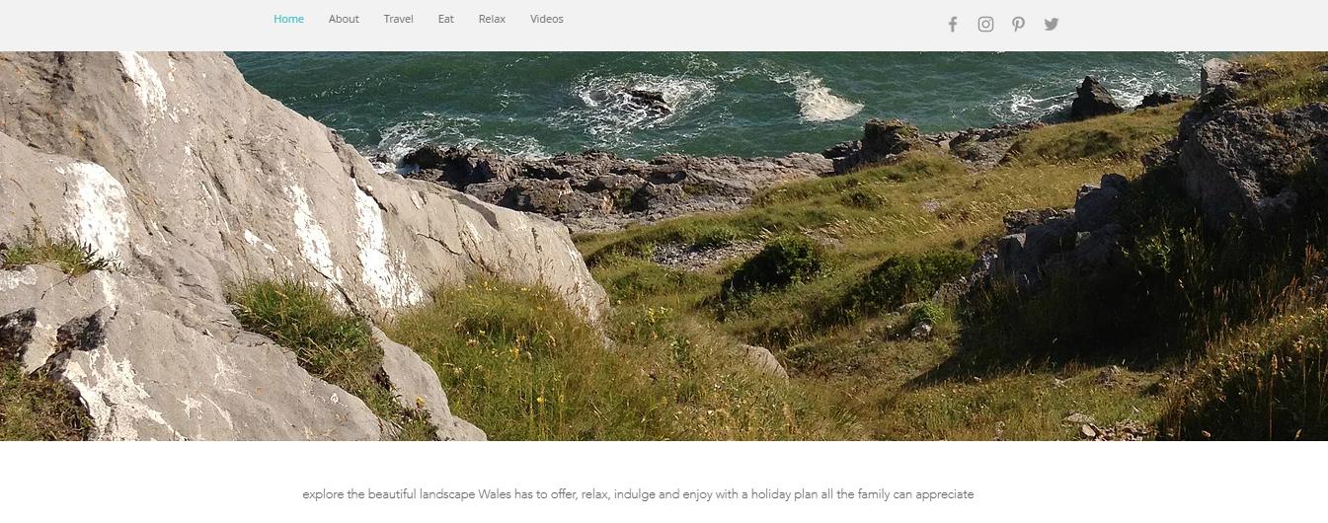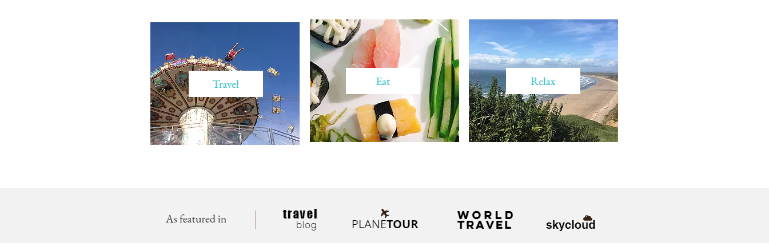
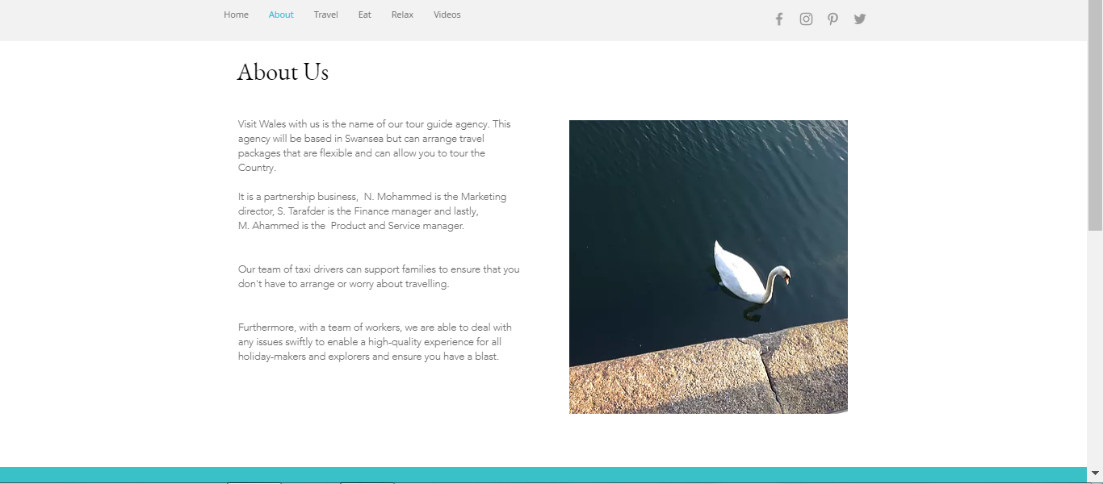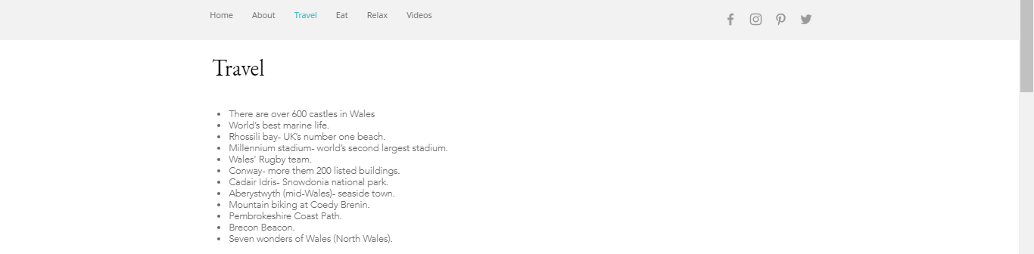
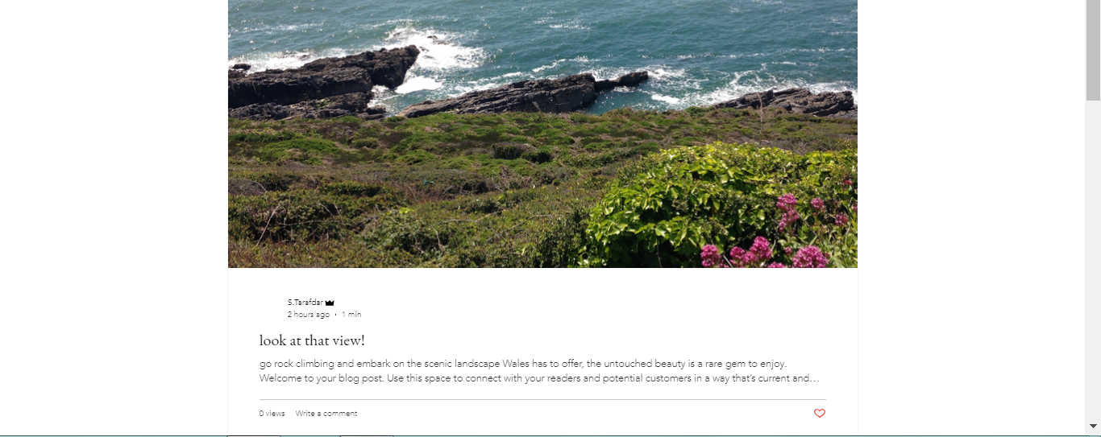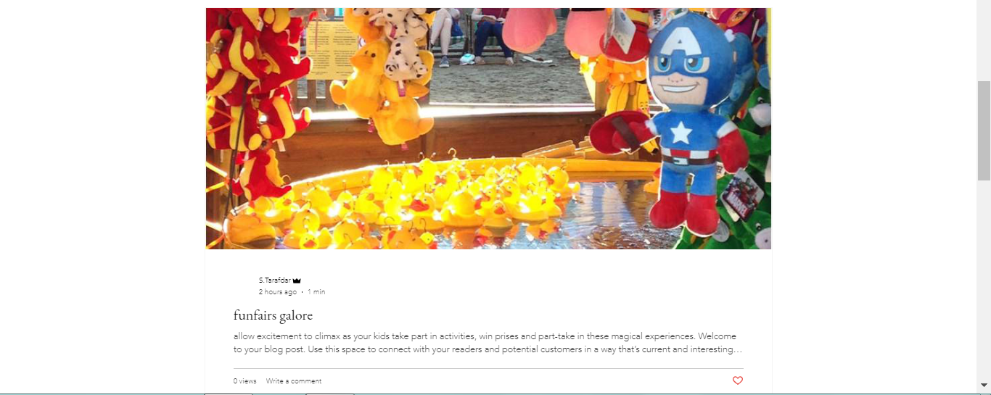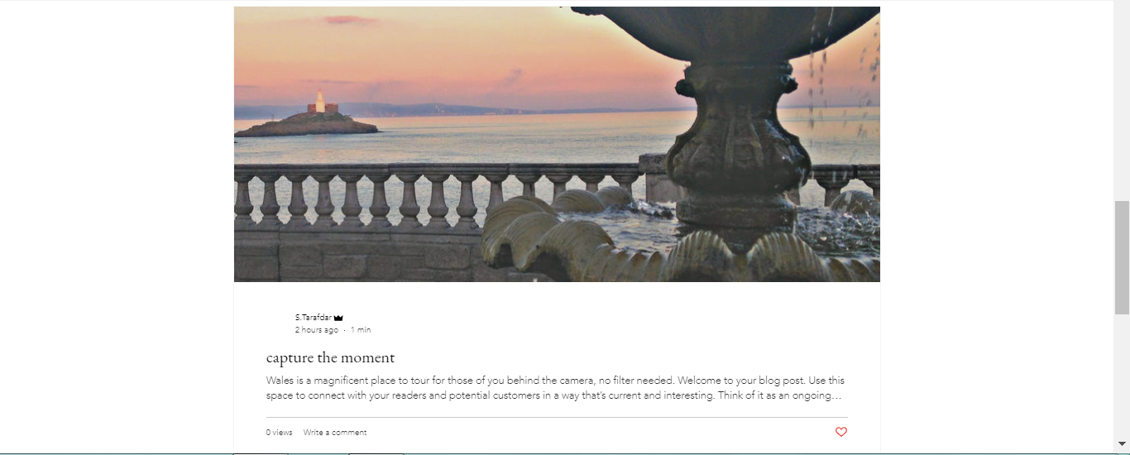
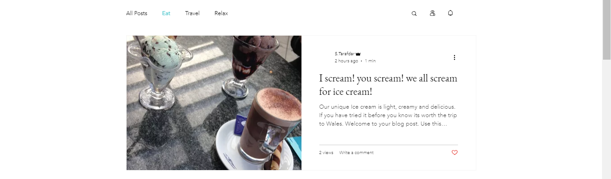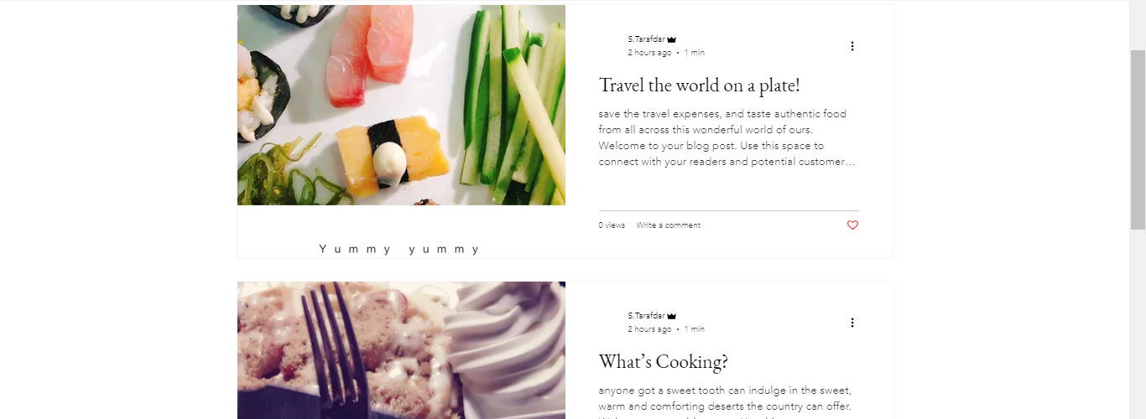
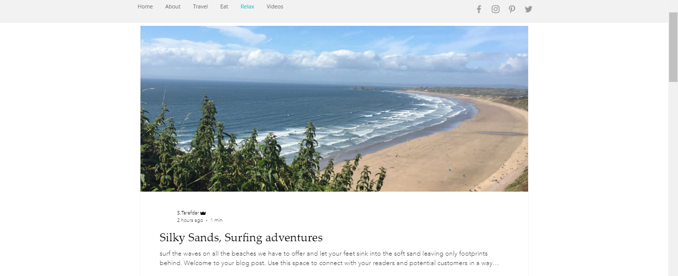
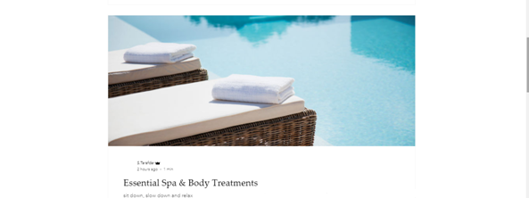
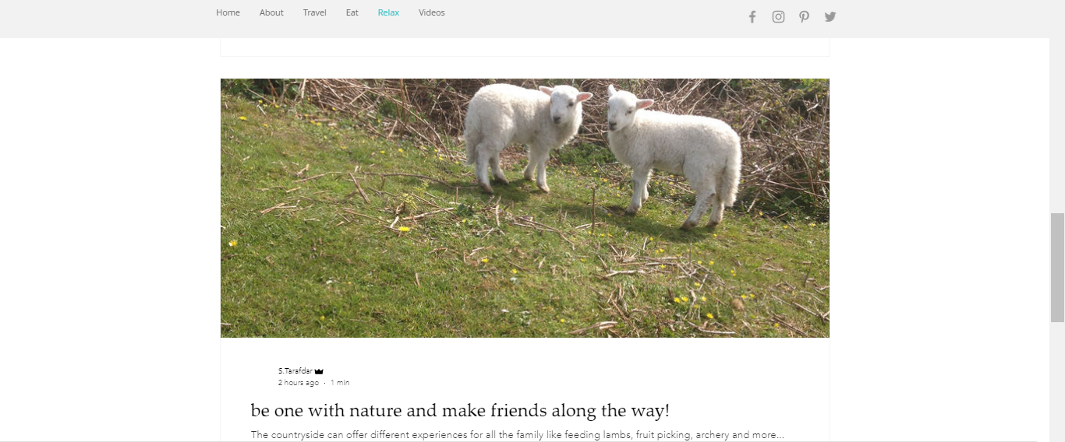
I used the Wix software to produce a website, as a tourist guide agency the aim is to promote Wales in order to persuade people to come and enjoy the beauty of Wales and allow local businesses to flourish. I first decided the name of the website ‘Visit Wales with us’ which immediately addresses what the website entails. I chose a simple layout and added my own photos that I have taken; these pictures give a visual view of what holiday makers can expect to find in Wales.
I chose a template that will enable me to easily adapt in order to fit the needs of my business plan. I have a home page which is the first Web page that is displayed and informs the user of the type of website they are using and the name of my agency. I included images of Wales and had links to different pages for tourists to explore before coming to Wales. On my tool bar after the home page I have an ‘about us’ page which explains a little bit about the business and what we do. Next I have a travel page that explores different options that people can go to depending on the type of holiday they want. This is followed by a food page which shows that Wales has a diverse palette for everyone to try. Next is the ‘Relax’ page which is targeted at holiday makers that want a relaxing break. I decided to present this with more images rather than reams of writing to entice the audience to search further, this will appeal to the younger travellers. Customers can also comment questions that can directly be answered by one of the members of our team.

