How to download the boundary data

We need to sign into the library and learning resources site. Press the search button first.

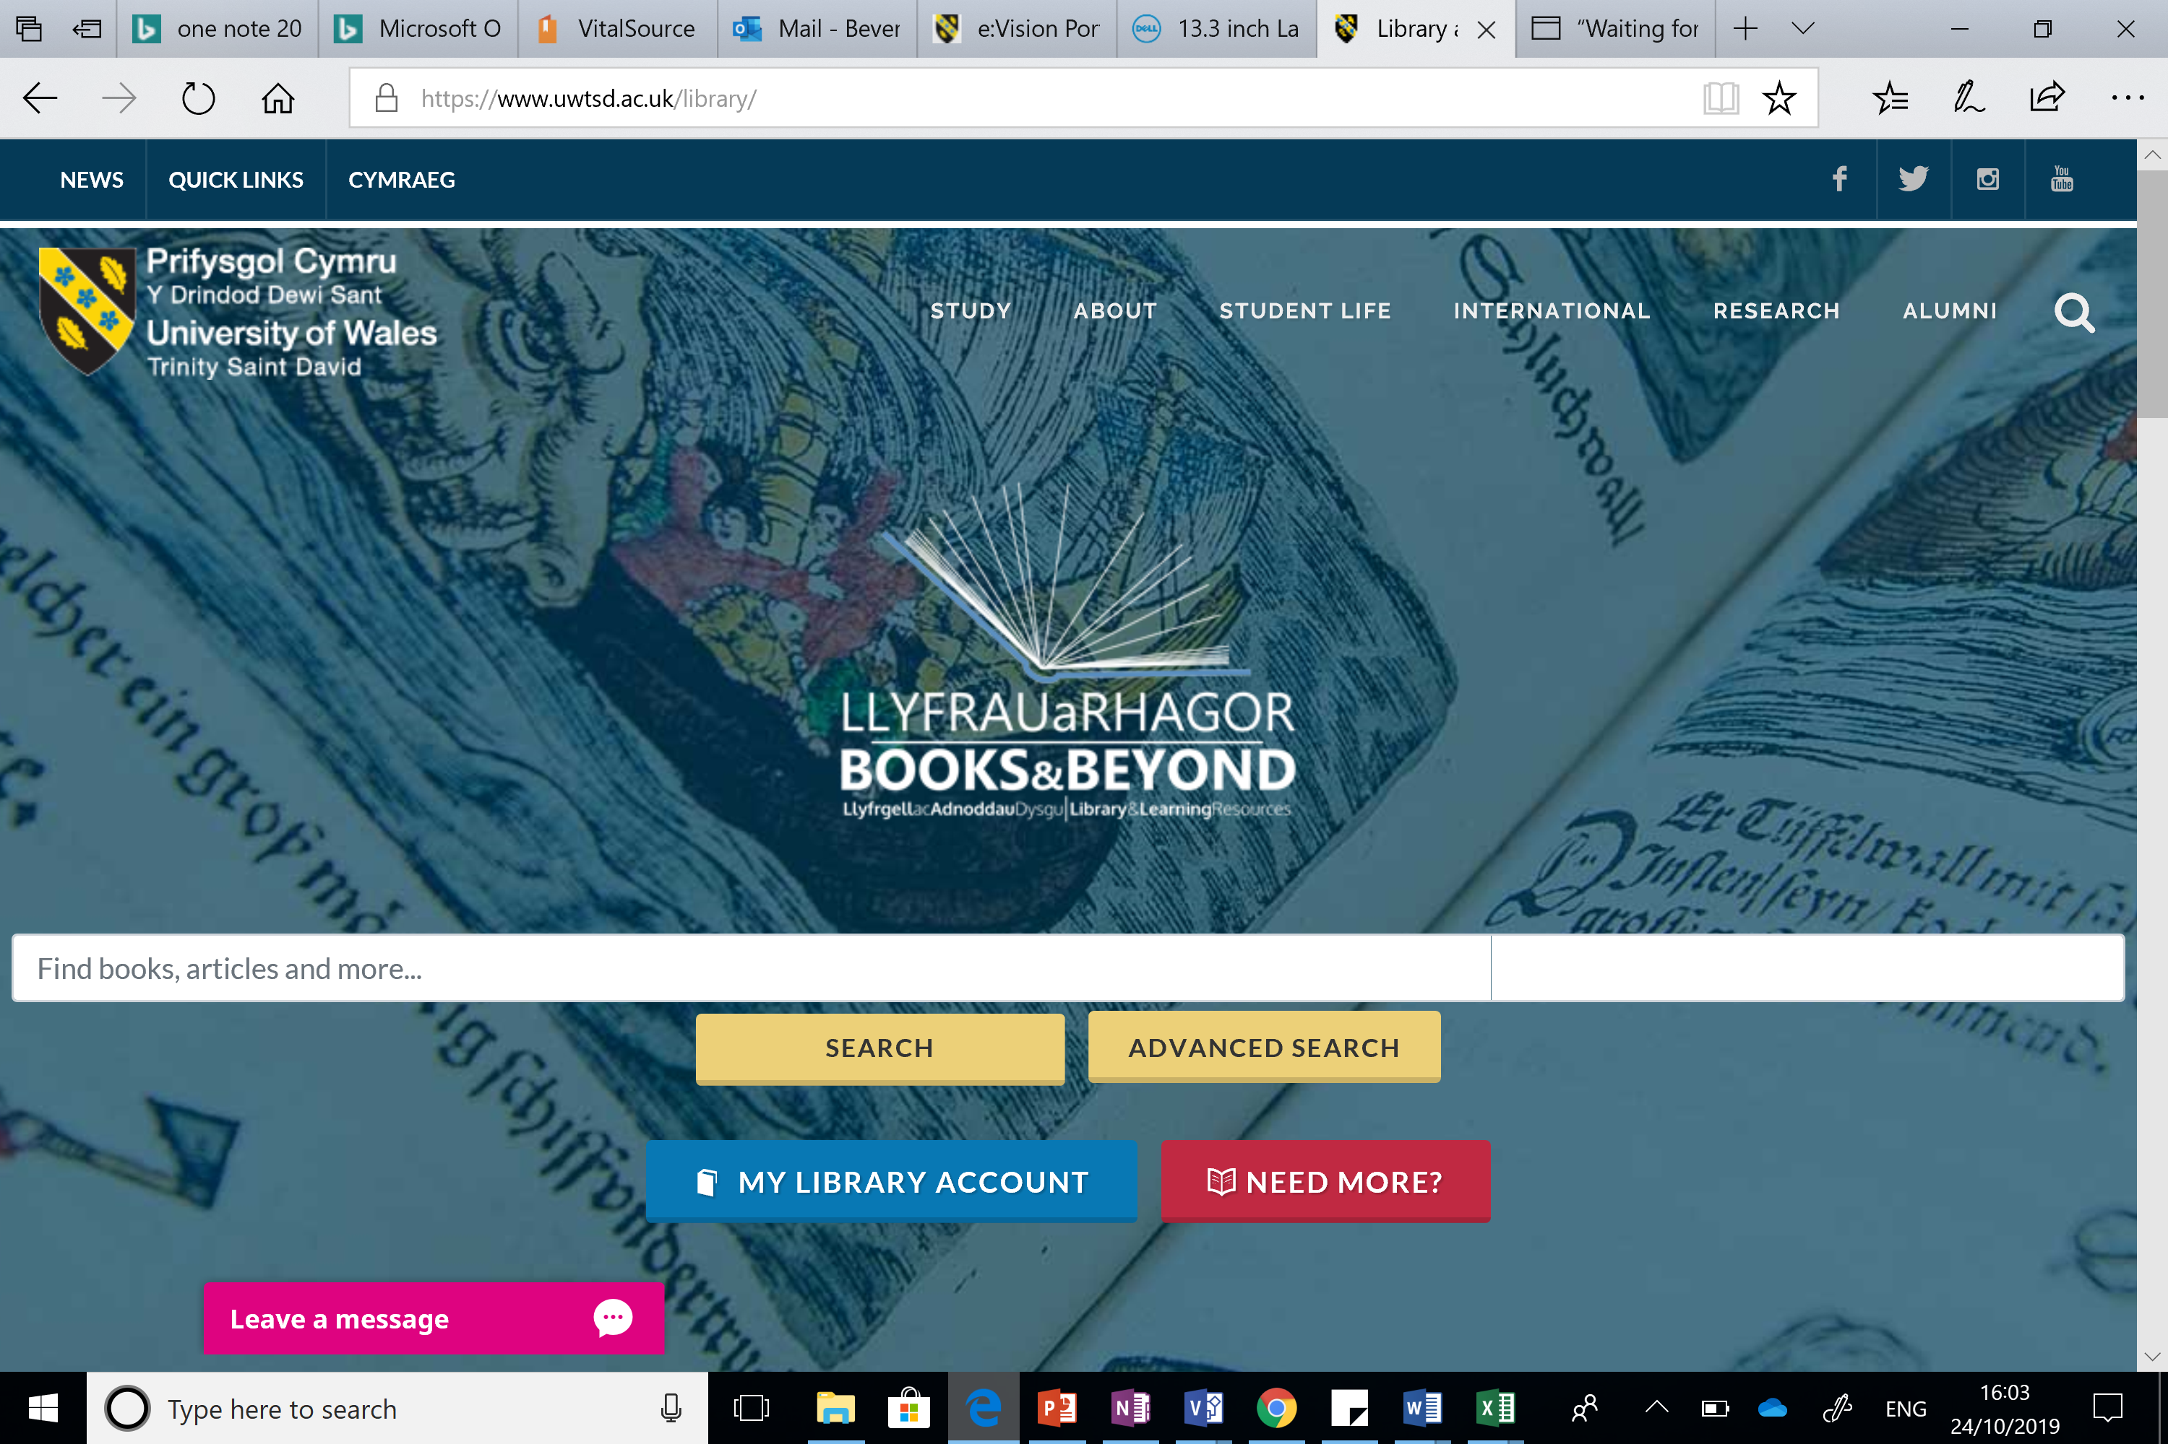

After pressing the search button we are now able to select the database by subject: Next choose A-Z resources and finally the UK data services.

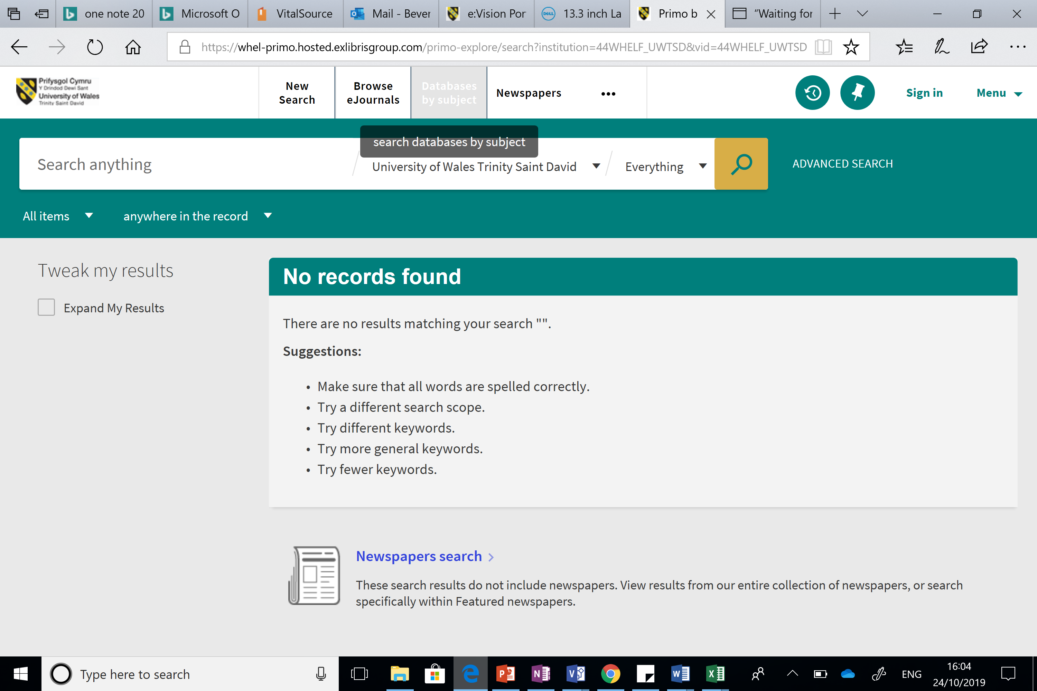

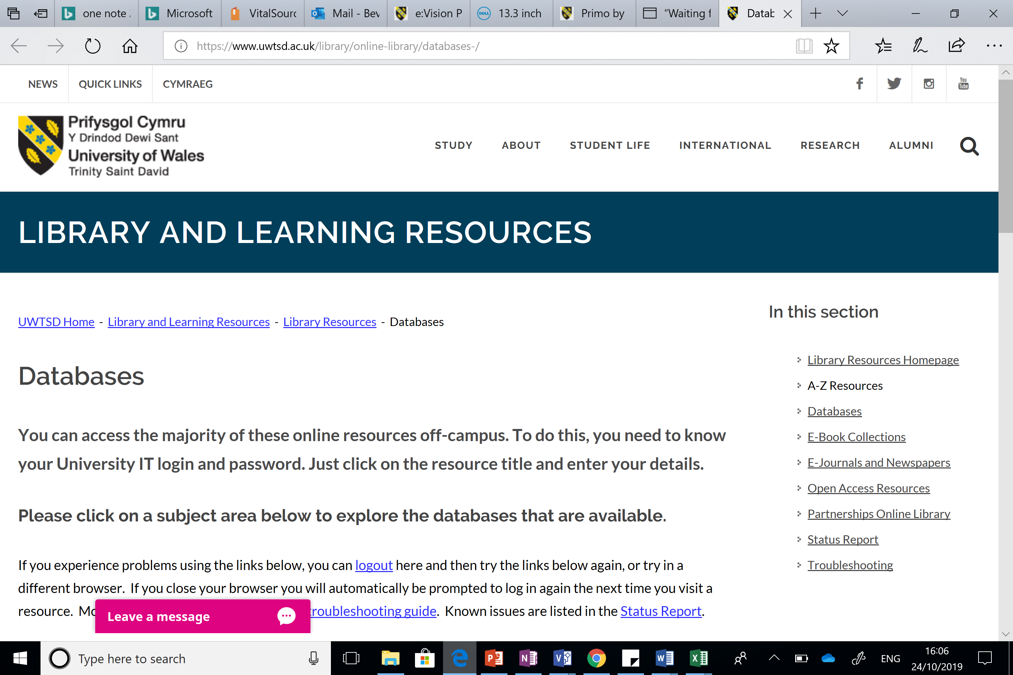
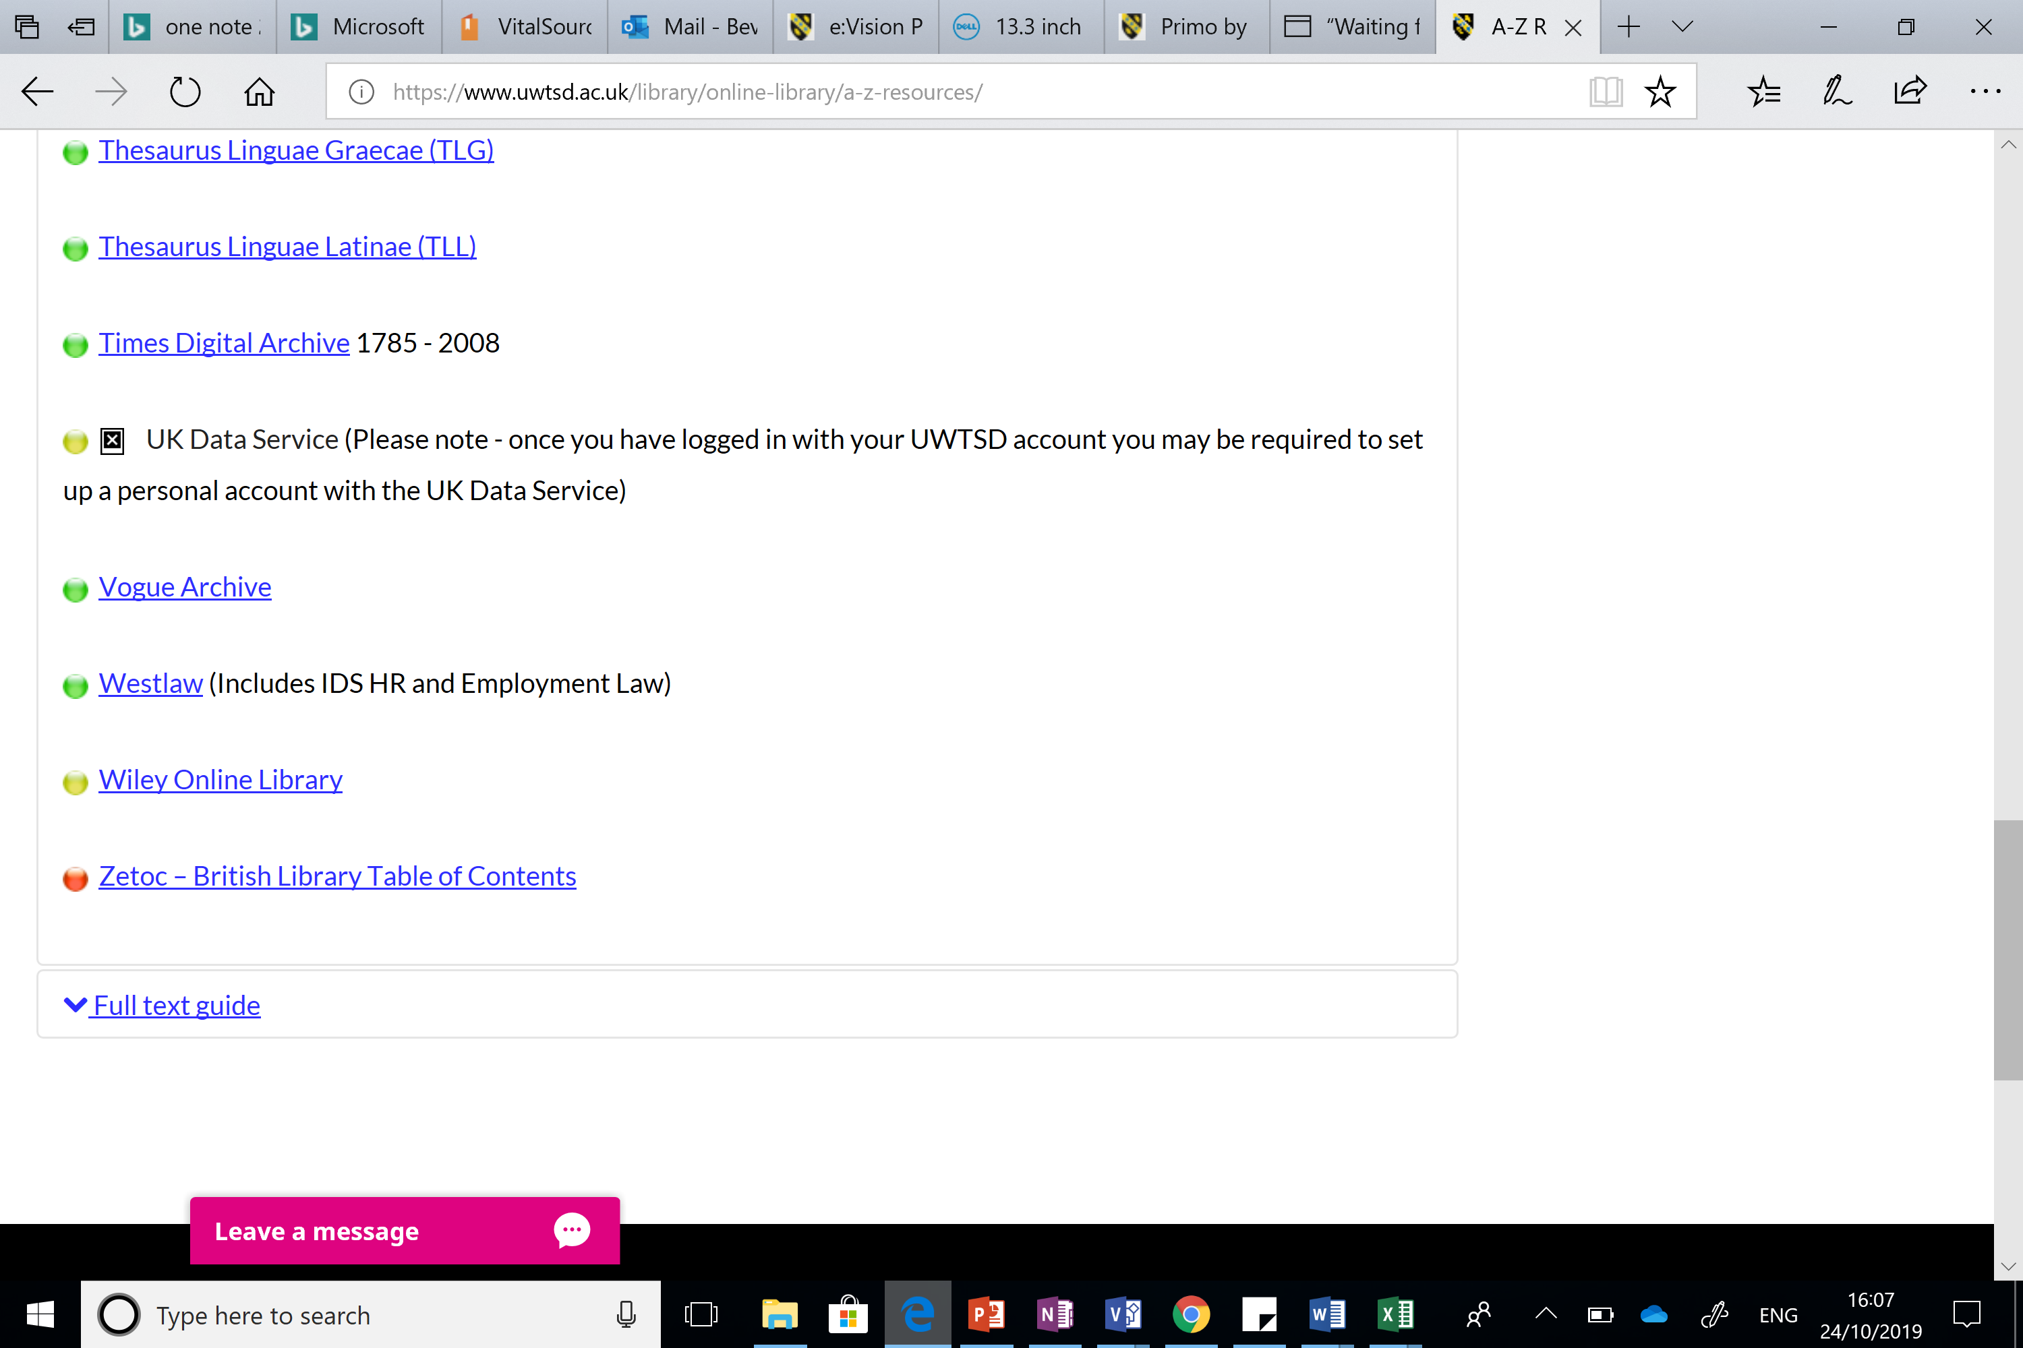

You should now be on the UKDS site. Remember you need to log onto the site but of you have gone on through moodle it should automatically log you in. Press the square on the left hand side.
Remember it is census data and then the boundary download that we need to select a map dataset. Then choose the boundary data selector not the easy download.

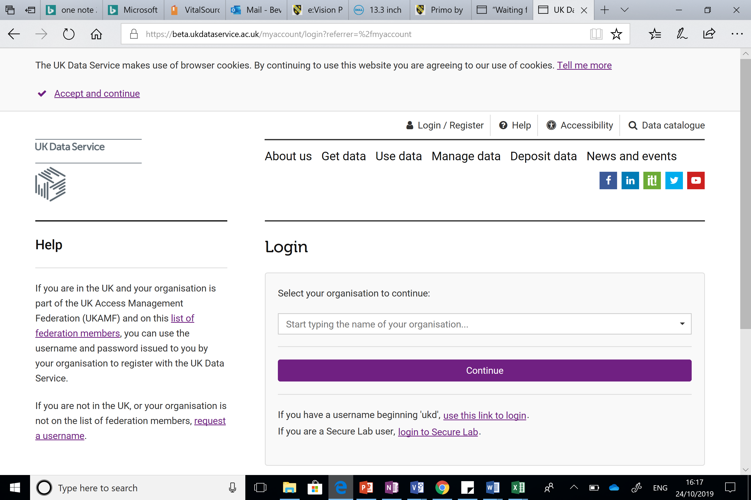

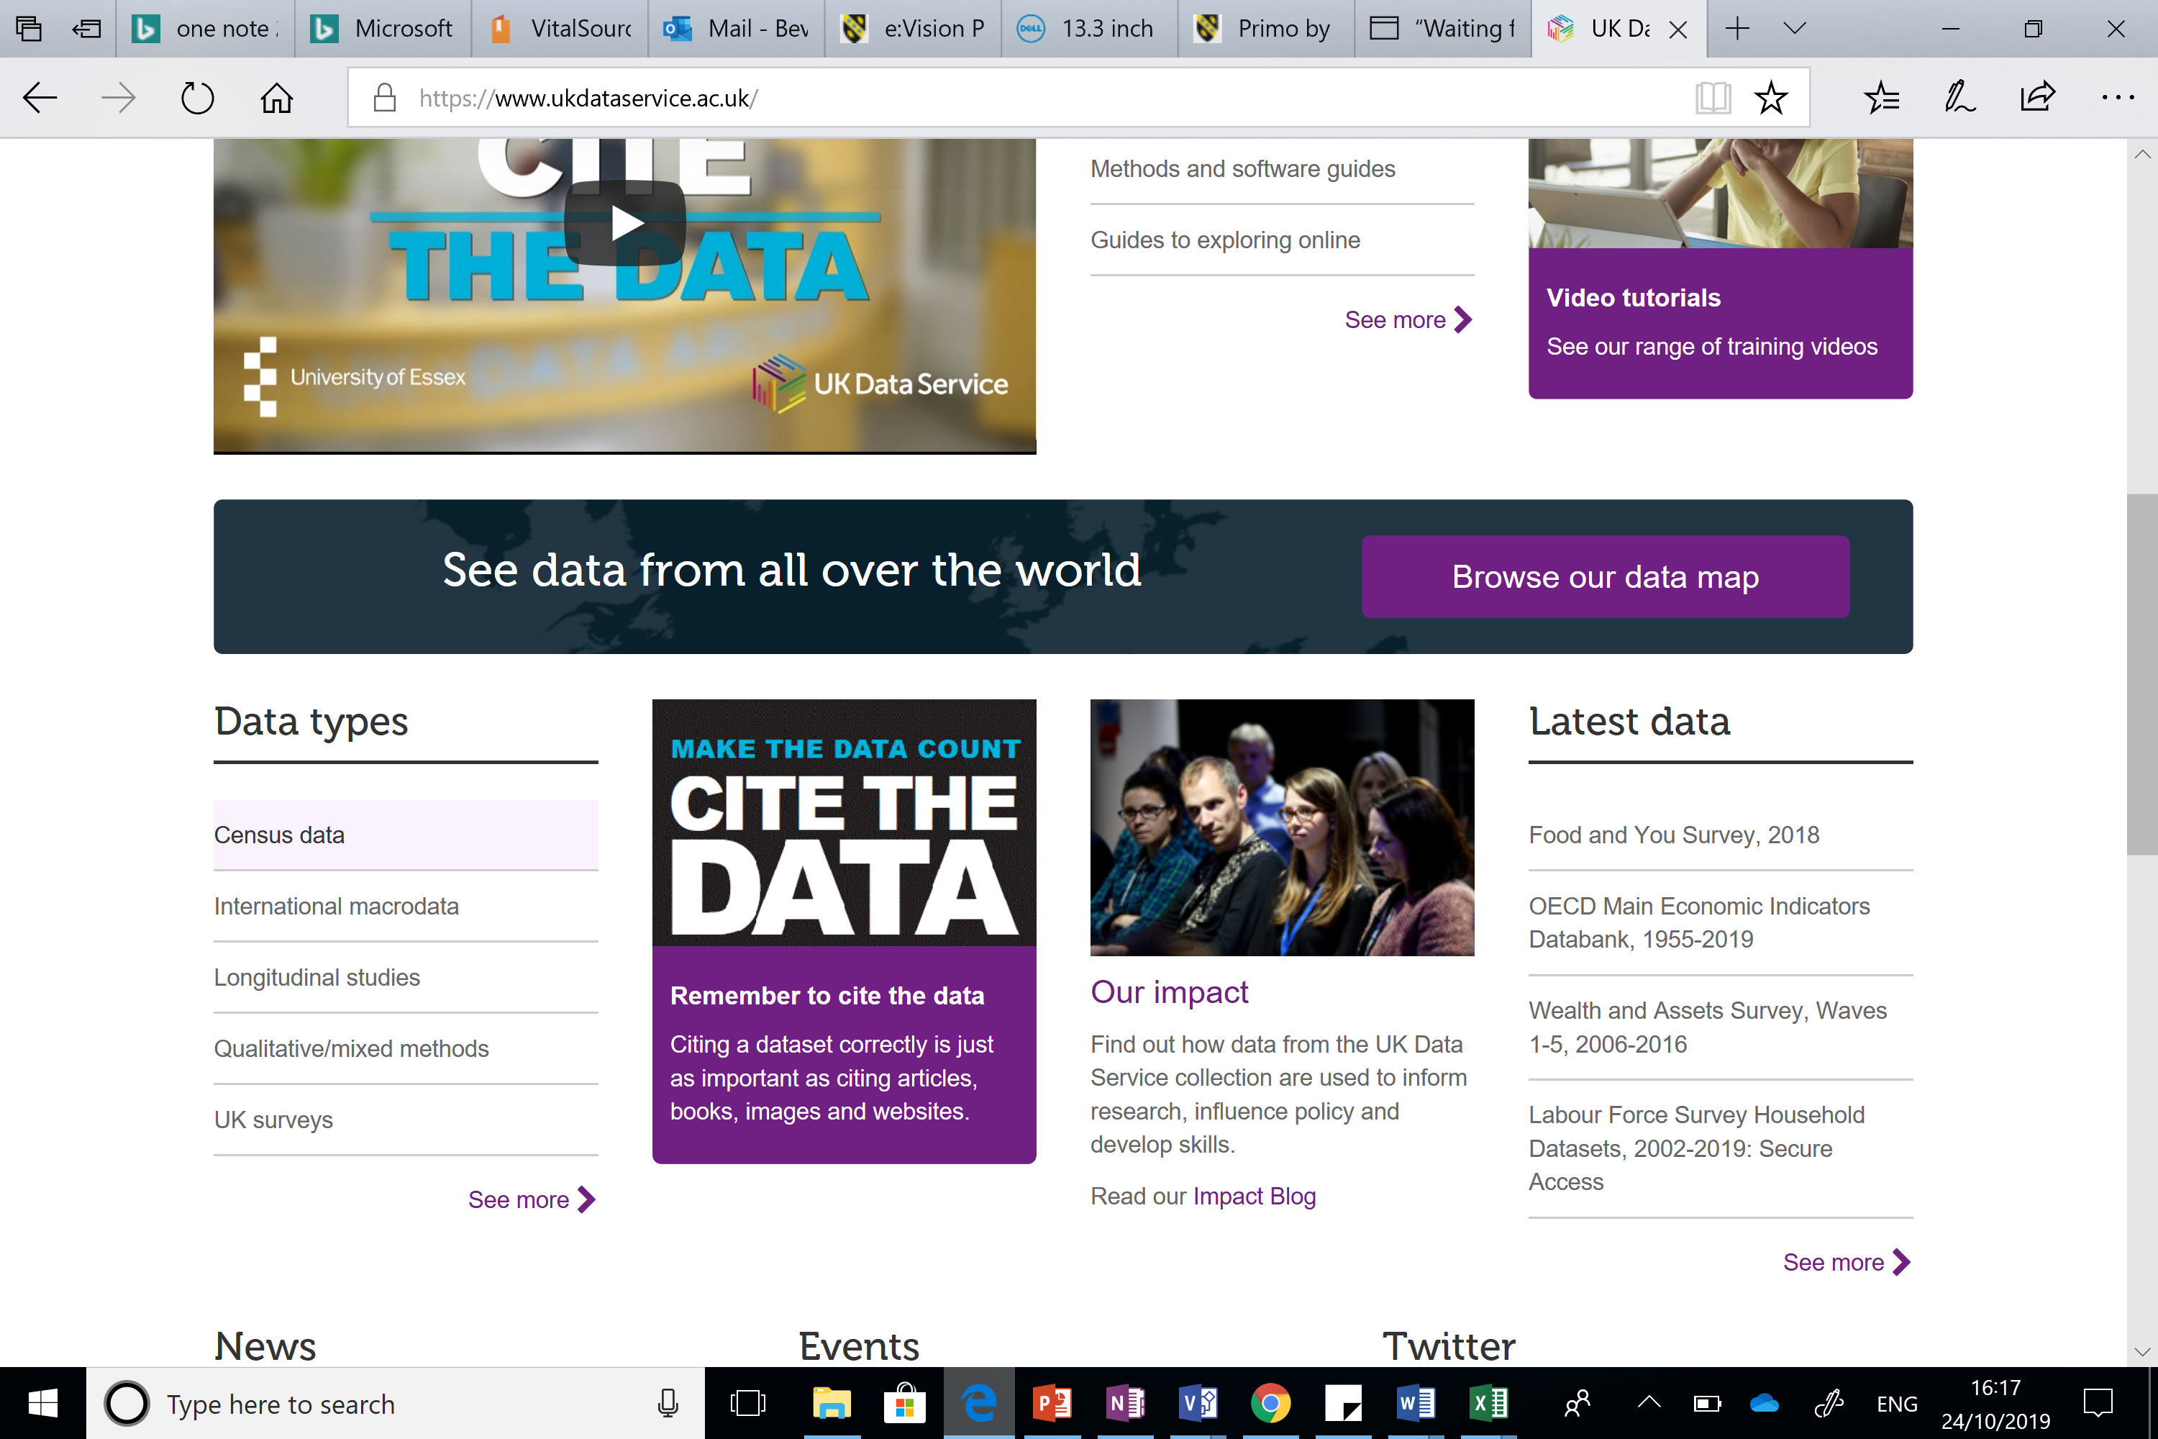

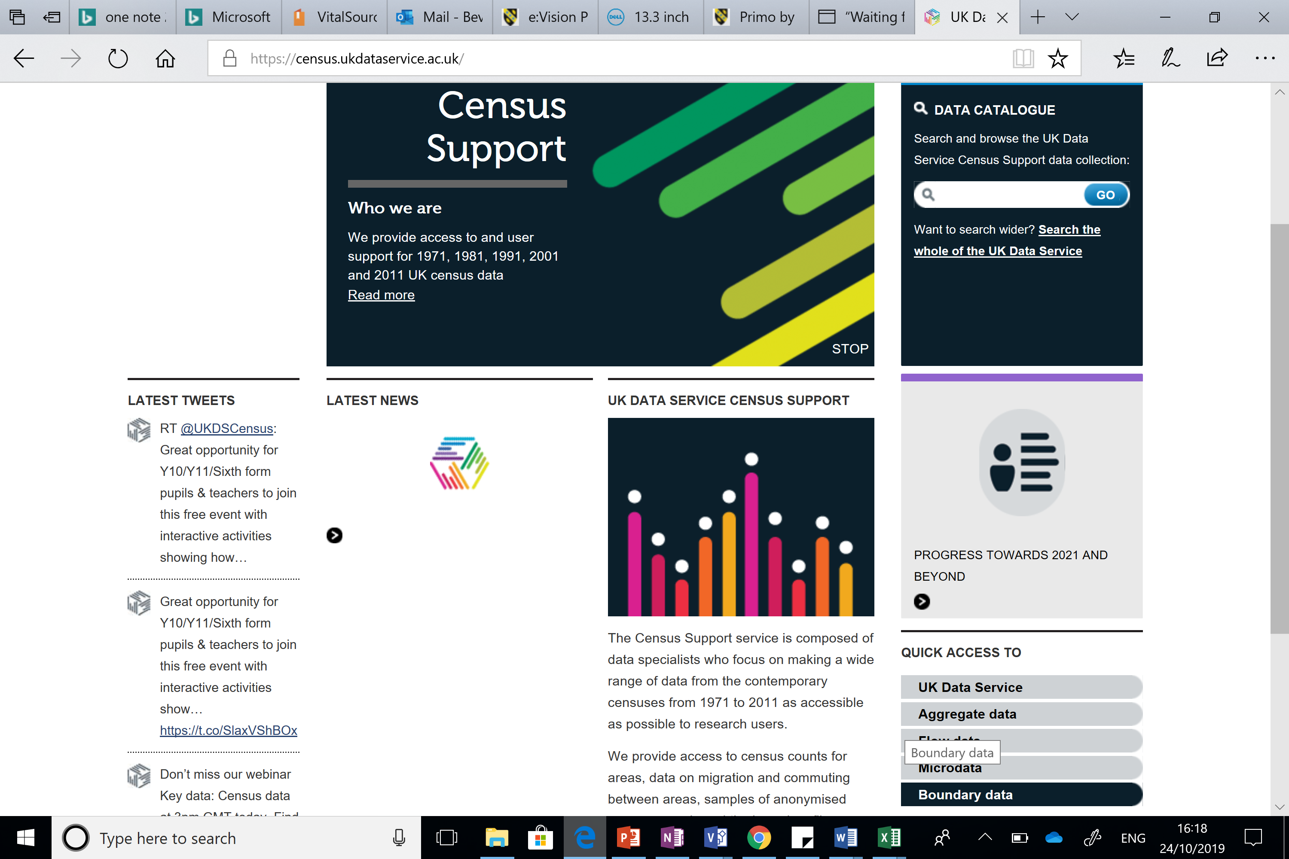

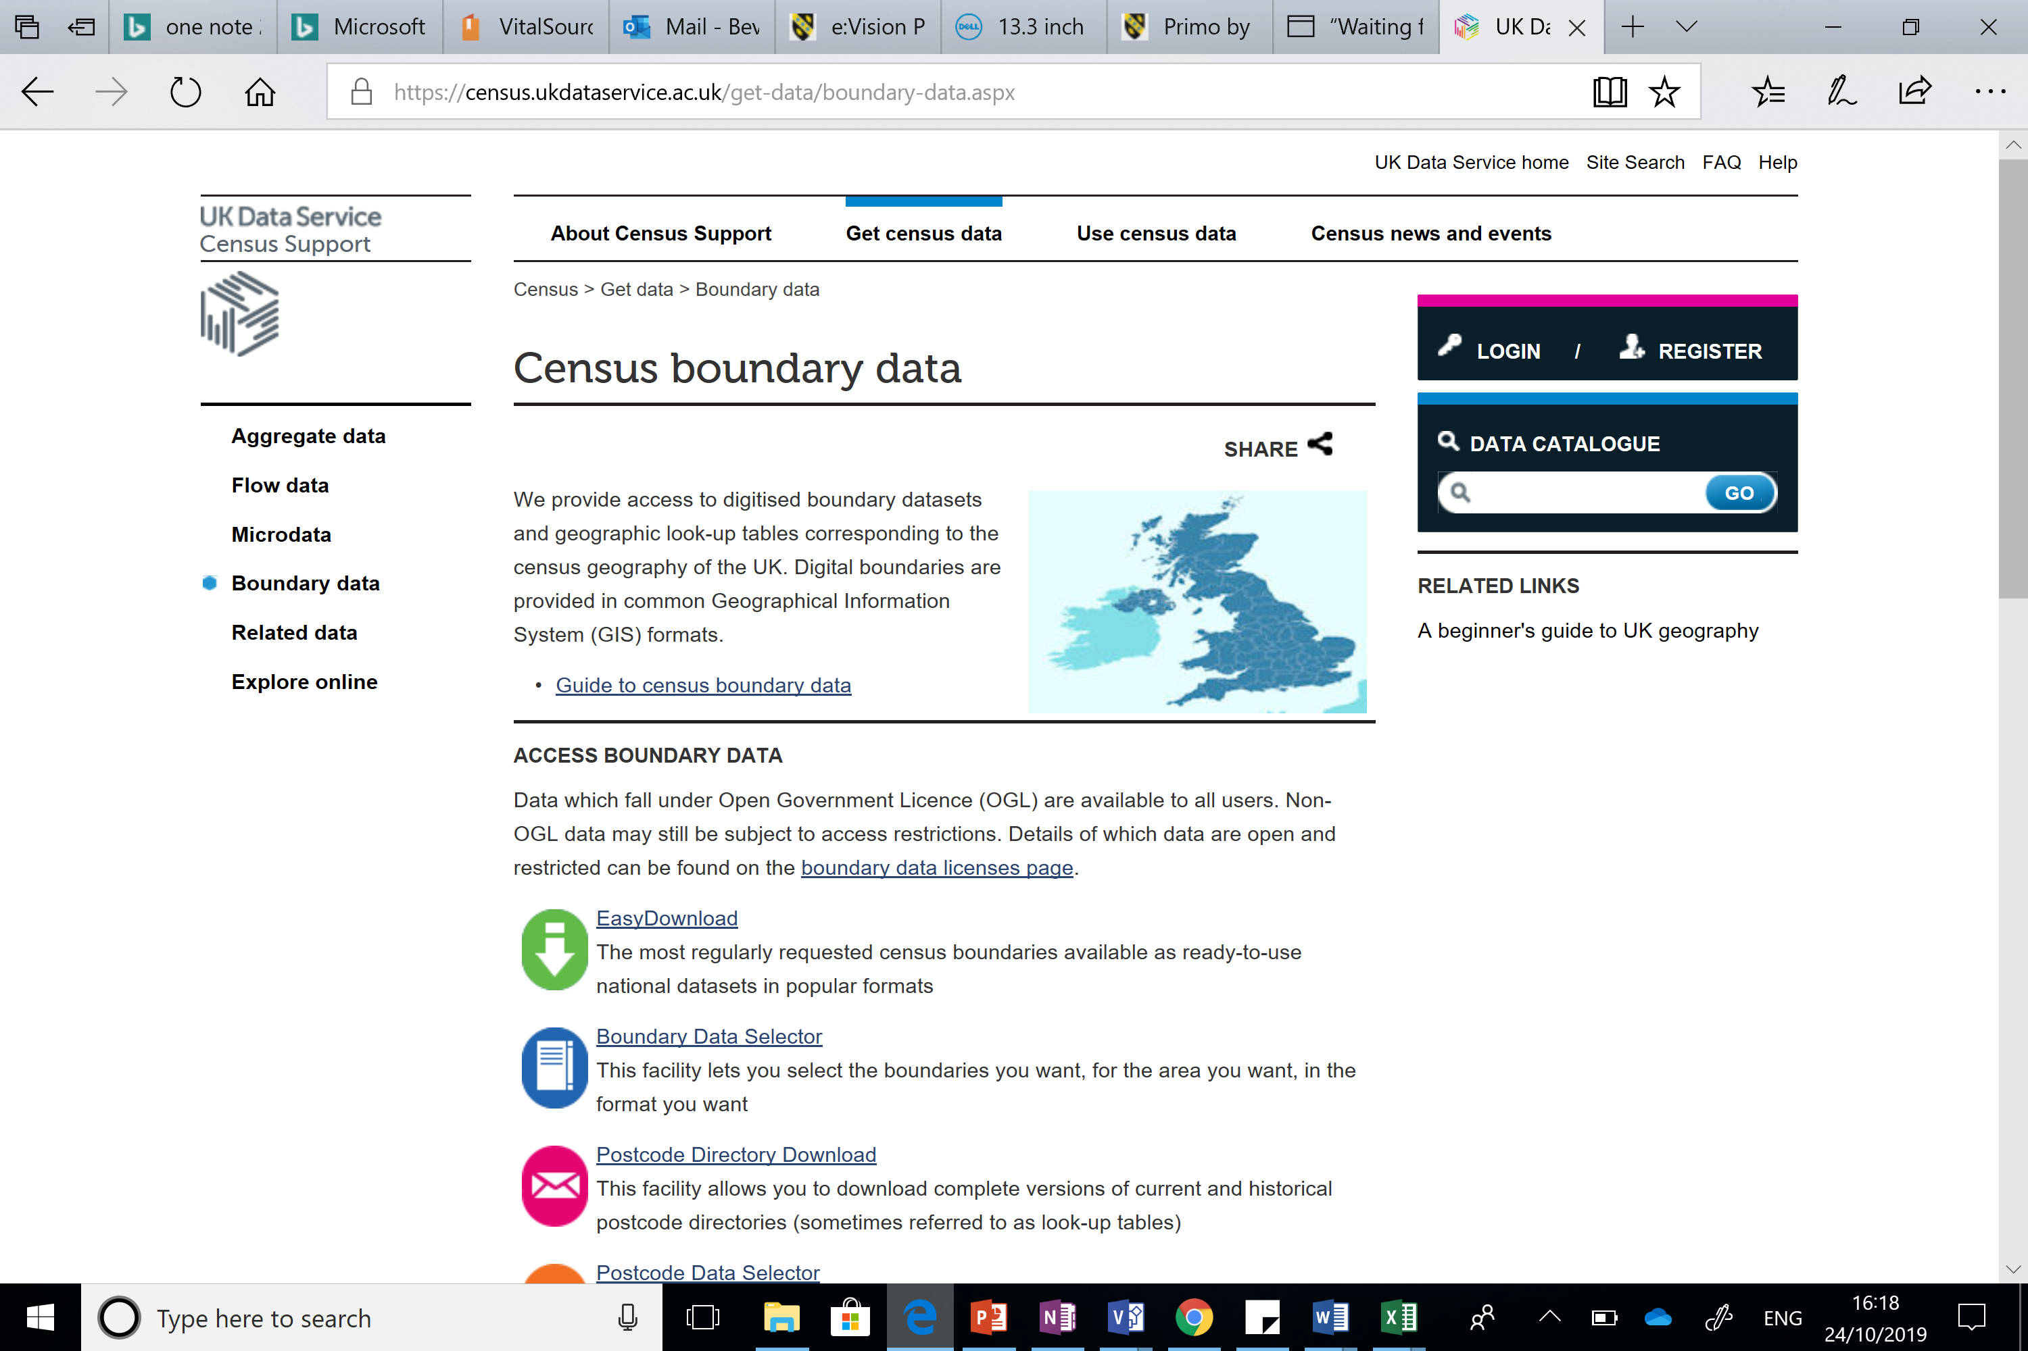
Once you are in the map select area you have several options to obtain the Swansea map make sure you have the following setup. Then remember to change the FORMAT to NATIVE MAPINFO before you select download / extract the data.



