Study 2: The Logistics Activities Used by Organisations

Topic 1: The Range of Logistics Activities Carried Out in Organisations

Storage and Distribution

Storage and distribution encompasses a number of activities in an organisation, carried out by the Logistics function which can be split into the following areas:

- Order processing

- Storage / warehousing and inventory control

- Transport or delivery of supplies or finished goods to the point of consumption

Order Processing

This area can be split into the following activities:

- Customer interface

- Order fulfilment

Customer Interface

This is a key activity within distribution which requires excellent customer service and relationship management skills. It involves close liaison and communication with the customer to ensure the organisation remains fully aware of customer requirements. In many cases, a direct link is maintained via Electronic Data Interchange (EDI) or a web portal which facilitates a continuous dialogue of order requirements and supply information. The use of barcode and RFID system allows for orders to be tracked by the customer at all steps of the order process.

Order Fulfilment

This involves internal liaison and communication to ensure the customer receives exactly what was ordered at the time and place specified on the order. Interpretation of the customer order is critical to ensure all internal stakeholders fully understand the customer requirements.

Storage / Warehousing and Inventory Control

The role of the warehouse should be to securely hold inventory, make inventory available for the point of consumption and maximise throughput of goods whilst minimising costs. Most organisations use a computerised Inventory Management System which makes this function significantly more efficient. The movement of goods can be broken down into four phases:

- Goods received - goods received from suppliers and recorded

- Goods transferred to stock – goods moved to secure storage area

- Goods selected for issue/use (picking) – locating, identifying and retrieving goods for despatch

- Goods moved to despatch and loaded – goods moved to despatch area to be checked and packed before despatch to the customer

The purpose of controlling inventory is to achieve an appropriate balance between holding enough inventory to satisfy customer orders and not holding so much inventory that it negatively impacts the financial performance of the organisation.
Transportation

The selection and management of appropriate transportation methods is a critical aspect of the Logistics function.

Transportation of people and goods is carried out under the following categories:
- Air
- Sea
- Road
- Rail
- Multimodal

Air Transportation

Air freight is a critical mode of transport. It serves markets and supply chains that demand speed but this achieved at a cost. To meet the demand for growth, world air cargo traffic is forecasted to growing on average by 4.2 percent per year. Industries such as the automotive and retail industries utilize air freight to achieve Just In Time’ (JIT) logistics.

The most important documentation relating to airfreight is the Air Waybill (AWB). An AWB provides the following details:

- A unique identifying number of which the first part is the IATA airline code number
- The name of the consignee who is the only party to whom the carrier can deliver

The AWB is the carrier’s receipt by air, providing evidence of the contract of carriage.

Figure 1 identifies the strengths and weaknesses of air transportation.

Figure 1: The Strengths and Weaknesses of Air Transportation

Strengths | Weaknesses
Speed | Expensive
Suitable for perishable goods | Inflexible relying on regular flight schedules
Increased level of security | Must be supported by other modes of transport to carry out transfers to and from airports
Reliable transit times and schedules | Environmental impact – carbon footprint
Less cargo handling

Sea Transportation

Sea freight accounts for around 90% of global trade. Ocean freight is a less expensive method of shipping goods, but the drawback is a longer transit time. Sea freight is used quite extensively for the movement of bulk commodities such as agricultural products (wheat, maize, soya, etc.), coal, iron ore or for wet bulk products such as crude oil and petroleum. Other goods are containerised for shipping by sea. Figure 2 identifies the strengths and weaknesses of sea transportation.

Figure 2: The Strengths and Weaknesses of Sea Transportation

Strengths | Weaknesses
Cost-effective | Long transit times
Suitable for large volumes | Must be supported by other modes of transport particularly if collection point or delivery point is land-locked
Environmentally friendly
Extensive coverage

There are three types of shipping companies servicing ports:

- Liner operators - vessels that carry containers sailing on fixed dates and to predetermined ports

- Charter operators - vessels that are utilised for a specific voyage

- Tanker and dry bulk operators - vessels that carry bulk cargo such as oil and grains

Road Transportation

Road transportation is used extensively in developed countries where there is an established road network. It consist of a range of vehicles from articulated lorries to small vans and cars or even bicycles.

Figure 3 identifies the strengths and weaknesses of road transportation

Figure 3: The Strengths and Weaknesses of Road Transportation

Strengths | Weaknesses
Cost-effective | Environmental impact
Capable of long and short distance journeys | Limited by size of vehicles
Can provide quick, scheduled deliveries | Can be affected by adverse weather conditions
Flexible with capability to support most collection and delivery points providing door-to-door service | Can be affected by and contributes towards road congestion
Easy to track
Minimal handling of goods – e.g. no need for packing into container
Easy to track and trace

The most common vehicles used to transport goods by road are Articulated Lorries (Artics). These consist of a tractor unit with a turn-table device which can be linked to a trailer. Artics have different types of trailers, including:

- Flatbed trailer- used for almost any type of freight, but goods need to be protected from the elements and theft

- Tilt trailer - like a flatbed trailer, but with a removable PVC canopy

- Curtain-sider - the mainstay of road haulage, this has a rigid roof and rear doors. The sides are PVC curtains that can be drawn back for easy loading

- Box trailer - an entirely rigid unit, with loading through back doors. A secure option for valuable goods

- Road train - a rigid vehicle at the front, which pulls a trailer behind it

- Swap-body system - built to accommodate standard cargo containers. Allows containers to be swiftly transferred during intermodal transport
- Low-loaders - often used for transporting heavy machinery and other outsize goods. Set low to the ground for easy loading

- Vans - frequently used to transport smaller cargoes shorter distances. Appropriate for “Last Mile Logistics”, transporting goods on the last leg of a journey to the point of consumption

The most common types of road transport are illustrated in Figure 4:

Figure 4:

All deliveries by road should include a Bill of Lading (BOL) with basic information about the shipment such as a description and estimated weight, provided by the shipper. The BOL is also used when the freight is transported over international borders and is presented to customs officials for inspection.

Rail Transportation

Rail transportation is considered to be an environmentally friendly option as trains burn less fuel per ton-mile than road vehicles. A train can have as many as 100 wagons but only needs one driver making it cost effective. However, at each end of rail transit, frequently a road delivery is required which adds additional time and cost.

Figure 5 identifies the strengths and weaknesses of rail transportation:

Figure 5: The Strengths and Weaknesses of Rail Transport

Strengths | Weaknesses
Faster average speeds | Must be supported by other modes of transport to carry out transfers to and from train stations
Links city centre to city centre | Inflexible in that trains can only run at certain times due to track availability
More environmentally friendly – less fuel per ton-mile than road | Not cost-effective for short journeys
Most efficient form of land transportation
Bulk handling capacity
Good safety record
Reliable transit times and schedules
Scope for automation (driverless trains)
Minimal disruption in poor weather conditions
Cost-effective over long distances
Alleviates road congestion and emissions

Movement of goods by rail is controlled through the use of rail waybill. The rail waybill is a document containing instructions to the railway company for handling, dispatching and delivering consignments.

The mode of transport used frequently depends on the type of freight and distance to be covered. Figure 6 identifies the most appropriate modes of transport for each situation.

Figure 6: Most Appropriate Modes of Transport

Multimodal Logistics

In reality, to take advantage of the strengths of certain transport modes and to avoid the weaknesses of other transport modes, it is often necessary to deploy multiple modes of transport. Multimodal logistics involves combination of different modes of transportation such as rail, road, and sea to cost-effectively manage shipments from start-to-end, ensuring optimum care and efficiency for each leg of the journey.

Figure 7 illustrates the use of multiple modes of transport

Figure 7: The Multimodal Transport Solution

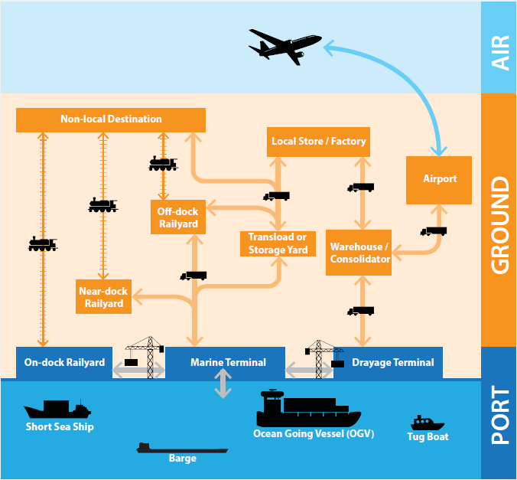

Intelligent Transport Systems (ITS)

ITS is widely used within transport systems with common techniques for logistics including Global Positioning System (GPS), Geographic Information Systems (GIS) and advanced information systems.

GPS shows a vehicle’s positioning and aids a control centre in monitoring and dispatching vehicles.

GIS provides basic geographic databases for the deliverers to organise their routes in an easier manner and in a faster way.

Advanced information systems provide real-time information for managers and deliverymen to adjust their paths as new demands occur.

The integration of GPS, GIS and advanced information systems provide high levels of manoeuvrability within transport systems.

Integration provides the following benefits:

- Improved service quality

- Reduced, unnecessary trips

- Increased loading rate

Topic 2: Performance Management in Logistics Activities

To ensure the Logistics function supports organisational objectives and continuously improves its service delivery, it is important to measure performance. The performance of the people, processes and systems that make up a Logistics function can be measured by using Key Performance Indicators (KPI’s). KPI’s measure the success of particular activities within a function which in turn evaluates the success being made towards the strategic goals of an organisation. KPI’s for Logistics function can be set within the following areas:

- Delivery
- Quality
- Cost

Figure 8 shows some typical KPI’s for a Logistics function

Figure 8: KPI’s in the Logistics Function

Area | KPI
Delivery | On time delivery to customers
Delivery | On time delivery from suppliers
Delivery | On time delivery to internal customers
Quality | Order information accuracy
Quality | Packaging accuracy
Quality | Consignment accuracy
Cost | Inventory costs
Cost | Transportation costs
Cost | Labour costs

Figure 9 provides an additional explanation of KPI’s and how they relate to the rest of an organisation:

Figure 9: KPI’s
https://www.youtube.com/watch?time_continue=3&v=9Co8slUvYj0

Self-Assessment Questions

- Which is the most economic form of transport for overseas shipments? Choose one answer:

  - Air freight

  - Road freight

  - Sea Freight

  - Rail freight

- GPS, GIS and Advanced Information Systems are all types of what? Choose one answer:

  - Intelligent Transport Systems

  - Inventory Management Systems

  - Warehouse Management Systems

  - Material Resource Planning Systems

- Which of the following are appropriate Key Performance Indicators for a Logistics function? Choose four answers

  - On time delivery from suppliers

  - Sales turnover

  - Packaging accuracy

  - Inventory costs

  - Supplier price reductions

  - New customers

  - Inventory costs

