Certfolio: Designing and Evaluating a Verifiable Professional Identity Platform for IT Professionals
Student Name: Marius-Catalin Bobitiu
Student ID: 1813436

Table of Contents
Abstract 4
1. Introduction 5
1.1. Project Background 5
1.2. Problem Statement 6
1.3. Aim 6
1.4. Objectives 6
1.5. Motivation 7
1.6. Expected Outcomes and Deliverables 7
1.7. Report Structure 7
2. Background Reading / Literature Review 8
2.1 Research on the Problem Domain 8
2.2 Skills-Based Hiring and Digital Credentials 8
2.3 Human Capital, Signalling Theory and Professional Trust 9
2.4 Digital Identity and Professional Branding 9
2.5 Evaluating Existing Examples 10
2.6 Analysis of Tools Required 10
2.7 Software Development Life Cycle 11
2.8 Summary of Literature Gap 12
3. Analysis 12
3.1 Requirement Analysis 12
3.2 Functional Requirements 13
3.3 Non-Functional Requirements 14
3.4 Use Case Analysis 15
3.5 System Requirements 15
3.6 Hardware Requirements 16
3.7 Software Requirements 16
3.8 Risk Analysis 17
3.9 Summary 18
4. Design 18
4.1 Introduction 18
4.2 System Architecture 19
4.3 User Interface Design 19
4.4 Storyboard and User Flow 20
4.5 Database Design 20
4.6 Credential and Trust Design 21
4.7 Public Profile Design 22
4.8 Security and Privacy Design 22
4.9 Design Summary 23
5. Implementation 23
5.1 Introduction 23
5.2 Implementation Overview 24
5.3 Profile Management Module 24
5.4 Skills Management Module 25
5.5 Credential Management Module 27
5.6 Portfolio Evidence Module 28
5.7 Public Profile Module 30
5.8 Public Project Page 31
5.9 Verification Status Implementation 32
5.10 Implementation Summary 32
6. Testing 33
6.1 Introduction 33
6.2 Test Cases 33
6.3 Testing Summary 34
7. Evaluation 34
7.1 System Evaluation 34
7.2 Evaluation Against Objectives 34
7.3 Personal Evaluation 35
7.4 Limitations 35
8. Further Enhancement 35
9. Conclusion 36
Bibliography 38

Abstract
The increasing adoption of skills-based hiring has changed how IT professionals demonstrate their knowledge and experience. However, certifications, technical skills and portfolio evidence are often distributed across multiple online platforms, creating fragmented professional identities and making it difficult for employers to assess candidates efficiently. This project addresses this problem through the design, development and evaluation of Certfolio, a cloud-based professional identity platform that brings together verified credentials, self-declared skills and project evidence within a single structured profile.
The project began with a review of literature relating to digital credentials, professional identity, personal branding and skills-based recruitment. Existing solutions, including credential platforms, portfolio repositories and profile aggregation tools, were analysed to identify limitations and opportunities for improvement. An iterative software development approach was adopted to design and implement a functional prototype consisting of profile management, skills management, credential management, portfolio evidence, public profile pages and project case-study pages. The system also incorporates a trust model that clearly distinguishes between externally supported credentials and self-declared information through verification status indicators.
The prototype was evaluated using functional and scenario-based testing against predefined functional and non-functional requirements. Results demonstrated that the system successfully supports the creation and presentation of a unified professional identity while improving clarity, transparency and trust in the representation of professional achievements. Although the prototype does not implement full standards-based credential verification, it establishes a practical foundation for future integration with digital credential standards and broader professional identity ecosystems. Overall, the project demonstrates the feasibility of combining verified credentials, portfolio evidence and professional storytelling within a single platform to better support modern IT professionals and skills-based recruitment.

Introduction

Project Background
This project is positioned within the fields of cloud computing, digital identity, employability systems, and professional technology platforms. It proposes the design and evaluation of Certfolio, a cloud-based platform intended to help IT professionals present verified certifications, self-declared skills, and portfolio evidence in one structured professional identity space. This research is worth undertaking because the IT labour market is increasingly influenced by skills-based hiring, rapid technological change, and the need for more trustworthy evidence of competence than a traditional CV can provide [1] [2].
The literature reviewed in the Certfolio source identifies a major shift from degree-based hiring towards skills-based hiring. In the technology sector especially, the value of static qualifications is being challenged by the short life cycle of technical skills and by employer demand for current, specialised knowledge in areas such as cloud, cybersecurity, DevOps, and AI [1] [2]. At the same time, employers face what the literature describes as a “verification headache”. Self-taught learning, online courses, and informal skill development are increasingly common, yet these achievements are often difficult for recruiters to assess confidently without recognised validation [3]. This creates a gap between what candidates can do and what employers can reliably trust.
Existing platforms only solve parts of this problem. Credential platforms such as Credly and Accredible are strong in institutional verification, but they remain largely issuer-centred and often give the individual limited control over presentation, branding, and long-term narrative ownership [4], [5]. In contrast, link-in-bio platforms such as Linktree are flexible and easy to personalise, but they provide no real verification and may weaken the user’s own professional web presence by depending on third-party domains [6], [7]. Technical portfolio platforms such as GitHub provide strong evidence of work, especially for developers, but they may be difficult for non-technical recruiters to interpret and can expose users to risks such as malicious code or recruitment scams [8], [9]. As a result, the professional identity of many IT workers becomes fragmented across multiple systems.
Theoretically, the proposed study is supported by Human Capital Theory and Signalling Theory. Human Capital Theory suggests that education and training improve productivity, while Signalling Theory argues that qualifications and credentials help reduce information asymmetry between candidates and employers [10]. In the context of IT, recent certifications can function both as evidence of current capability and as signals of adaptability and professional commitment [1], [11]. Literature on personal branding and online identity management also supports the project, showing that professionals increasingly need to manage multiple online identities while maintaining credibility, privacy, and coherence [12], [13]. Certfolio responds to this by aiming to combine trusted verification with stronger user ownership and more flexible professional storytelling.
The Certfolio source also highlights the importance of standards-based trust. Digital credential frameworks such as Open Badges 3.0, Comprehensive Learner Record, CASE, and LER-RS suggest that credentials can be machine-readable, portable, and verifiable rather than just visual images or PDF attachments [14], [15]. This strengthens the case for a cloud-based platform that is not simply another profile page, but a professional identity system built around interoperability, validation, and portability.
Overall, the gap in the existing market is the lack of a platform that combines three things at once: institutional verification, portfolio-style narrative presentation, and user control over identity. This makes the proposed study both topical and relevant to the Cloud Computing pathway, as it explores how a practical system can be designed to improve trust, usability, and professional visibility in a skills-driven market [1], [14].

Problem Statement
The problem addressed by this project is that IT professionals often present their certifications, skills, and portfolio evidence across separate digital platforms. This creates a fragmented professional identity and makes it harder for employers or recruiters to assess the reliability, relevance, and completeness of a candidate’s technical profile. While credential platforms, portfolio repositories, and profile aggregators each provide useful functions, they do not fully combine verification, professional storytelling, and user-controlled identity in one coherent system.
Certfolio therefore responds to this problem by exploring the design and development of a cloud-based professional identity platform that allows IT professionals to present verified credentials, self-declared skills, and project evidence in a unified and trustworthy format.

Aim
The aim of this project is to design, develop, and critically evaluate a prototype cloud-based professional identity platform that supports IT professionals in presenting verified certifications, self-declared skills, and portfolio evidence within a single structured environment. The project investigates how the integration of credential verification, professional narrative, and project-based evidence can contribute to a more coherent and trustworthy representation of technical competence in the context of skills-based recruitment and digital professional identity.

Objectives
- To critically analyse current literature and industry practice relating to digital credentials, skills-based hiring, personal branding and professional identity platforms.
- To evaluate the limitations of existing tools such as credential networks, link-in-bio platforms and portfolio repositories in supporting professional trust and identity ownership for IT users.
- To design and develop a prototype of Certfolio that supports verified credentials, self-declared skills, portfolio links and structured user profiles.
- To test and assess the prototype against usability, trust, clarity and relevance criteria using secondary research benchmarks and scenario-based evaluation.

Motivation
The motivation for this research is based on the growing mismatch between how IT professionals develop their skills and how those skills are verified and presented to employers. While certifications, self-directed learning, and project portfolios are increasingly important in the technology labour market, they are often displayed through separate and disconnected platforms. This creates a challenge for both candidates, who must manage fragmented professional identities, and employers, who need reliable evidence of skills. This project therefore investigates the design and development of Certfolio as a platform that brings together verified credentials, portfolio evidence, and professional narrative in one coherent digital profile.

Expected Outcomes and Deliverables
The final study is expected to produce a literature-informed analysis, a requirements specification, system design documentation, a working prototype, and an evaluation with recommendations for improvement and future deployment.

Report Structure
This report is organised into several sections. The introduction presents the project background, problem statement, aim, objectives, motivation, and expected deliverables. The literature review examines the problem domain, existing platforms, digital credentials, professional identity, and the tools required to develop the proposed artefact. The analysis section defines the functional, non-functional, system, hardware, and software requirements, as well as the risks that may affect the project. The design section presents the planned interface, system architecture, user flows, and database structure. The implementation section explains the main modules developed for the prototype and demonstrates the key functionality through screenshots and code snippets. The testing section presents test cases and results used to assess whether the system works as intended. The evaluation section reflects on the system, the achievement of objectives, project limitations, and personal learning. The final sections present further enhancements, the conclusion, references, and appendices.

2. Background Reading / Literature Review

2.1 Research on the Problem Domain
This project is positioned within cloud computing, digital identity, employability technology, digital credentials, and professional portfolio systems. The problem domain focuses on how IT professionals can present their skills, certifications, and project evidence in a way that is credible, structured, and easy for employers to interpret.
Professional identity in the technology sector is no longer represented only through a CV or degree certificate. It is increasingly shaped by certifications, online learning, GitHub repositories, digital badges, portfolio websites, and practical project evidence. This reflects the wider movement towards skills-based hiring, where employers focus more on current abilities and evidence of competence than formal job titles or degree history [1], [2]. This is especially relevant in IT because areas such as cloud computing, cybersecurity, DevOps, artificial intelligence, and data systems change quickly [2].
However, alternative learning routes also create a verification problem. Many professionals gain skills through online courses, self-directed learning, short certifications, bootcamps, and practical projects. These routes can be valuable, but they are not always easy for employers to verify. PR Newswire describes this as a “verification headache”, where informal skills are becoming more common but remain difficult for hiring managers to assess without reliable proof [3].
This creates fragmented professional identity. Certifications may be stored on credential platforms, code may be stored on GitHub, work history may appear on LinkedIn, and personal branding may be handled through a portfolio website or link-in-bio tool. Certfolio responds to this problem by exploring whether verified credentials, self-declared skills, and portfolio evidence can be brought together into one structured digital identity platform.

2.2 Skills-Based Hiring and Digital Credentials
Skills-based hiring focuses on the specific abilities a candidate can demonstrate rather than relying only on degree titles or previous job roles [1]. In IT, this is important because technical knowledge changes quickly, meaning that recent evidence of learning and practical experience may be as important as formal education history [2].
Digital credentials support this shift by providing a structured way of representing learning, certification, and professional achievement. Unlike a static certificate or a line on a CV, a digital credential can contain metadata such as the issuing organisation, date of issue, expiry date, learning outcomes, assessment criteria, and verification URL [14], [15]. Standards such as Open Badges 3.0, Comprehensive Learner Record, CASE, and LER-RS support portability, interoperability, and verification [14], [15].
However, digital credentials also have limitations. If credentials become too common, too easy to issue, or poorly connected to meaningful assessment, their value may decrease. Jobs for the Future argues that credentials only create value when they are meaningful, trusted, and connected to real labour market outcomes [16]. Certfolio therefore combines credential presentation with project evidence and professional narrative, so that formal achievement can be supported by practical examples of work.

2.3 Human Capital, Signalling Theory and Professional Trust
The academic foundation for this project can be linked to Human Capital Theory and Signalling Theory. Human Capital Theory suggests that education, training, and skill development increase an individual’s productive capability, while Signalling Theory argues that qualifications and credentials reduce uncertainty by signalling ability to employers [10].
In the IT sector, certifications can represent genuine learning while also acting as signals of competence [10], [11]. This is particularly relevant in cloud computing, cybersecurity, DevOps, and AI-related roles, where employers may need quick indicators of current technical knowledge [2]. However, signals only have value when they are credible. If a badge, certificate, or skill claim cannot be verified, the employer may still be uncertain about whether the candidate has the competence being claimed.
Certfolio therefore needs to support both evidence and interpretation. The platform should not only list skills and credentials, but also make the distinction between verified certifications, self-declared skills, and portfolio evidence clear to the viewer.

2.4 Digital Identity and Professional Branding
Professional identity has become increasingly digital. IT professionals are often expected to manage profiles across LinkedIn, GitHub, certification providers, portfolio websites, job boards, and personal domains. Each platform presents a different part of the individual’s professional identity, which can make the overall profile fragmented.
Personal branding literature supports the idea that professionals need to communicate a clear and consistent identity. Gorbatov, Khapova and Lysova describe personal branding as an interdisciplinary area connected to career development, identity, reputation, and employability [12]. Online identity management is also relevant because professionals must decide how much information to share, how to present themselves, and how to manage their reputation across digital spaces [13].
For IT professionals, this can be complex because evidence of skill may be technical, distributed, and difficult for non-technical recruiters to interpret. A GitHub repository may provide strong evidence for a developer, but it may not communicate the same value to a recruiter who cannot assess code quality directly [8]. Certfolio addresses this issue by bringing verified credentials, self-declared skills, and portfolio evidence into one coherent profile.

2.5 Evaluating Existing Examples
Existing platforms address parts of the problem, but no single category fully solves the issue Certfolio investigates. Credential platforms, link-in-bio tools, and technical portfolio platforms each provide value, but they also have limitations.
Credential platforms such as Credly and Accredible support verified digital badges and certificates. Their strength is institutional trust, as they allow issuing organisations to create, manage, and verify credentials [4], [5]. However, they are often issuer-centred rather than user-centred, meaning the individual may have limited control over presentation, layout, branding, and professional narrative [4], [5].
Link-in-bio platforms such as Linktree and Carrd provide a simple way to collect several links into one page. Their strength is accessibility, as they are easy to set up and publish [6]. However, they are not designed as trust-building platforms because they mainly redirect viewers to other pages rather than verifying the information being presented. Some sources also argue that third-party link pages can weaken ownership of the user’s own web presence because the platform benefits from the traffic rather than the individual’s own domain or professional website [6], [7].
GitHub is important for IT professionals because it can show practical evidence of code, documentation, version control activity, and collaboration [8]. However, it is not a complete professional identity platform. It can be difficult for non-technical recruiters to interpret, does not verify certifications, and can expose users to security risks linked to recruitment scams and malicious code shared through fake technical tasks [9].
This review shows that existing tools are useful but limited. Certfolio therefore takes elements from each category: the trust focus of credential platforms, the accessibility of profile aggregators, and the evidence-based value of portfolio platforms.

2.6 Analysis of Tools Required
The development of Certfolio requires tools that support web-based interface design, structured data storage, secure user interaction, and cloud accessibility. A front-end framework such as React or Next.js is suitable because Certfolio requires reusable components, dynamic profile pages, and interactive forms. A relational database such as PostgreSQL is suitable because the platform needs to store related data such as users, profiles, skills, credentials, projects, verification states, and links.
Interface design tools such as Figma are useful because Certfolio depends on clarity, trust, and visual hierarchy. The project also requires consideration of digital credential standards, as Open Badges and related standards provide a useful model for representing credentials with metadata, issuer information, and verification links [14], [15]. Security and privacy are also important because professional identity systems must avoid unnecessary data collection and clearly separate public and private information [17].

2.7 Software Development Life Cycle
An iterative prototyping approach was selected because Certfolio required both research-informed planning and practical prototype development. A fully linear waterfall approach would be less suitable because the interface, user flows, and feature priorities needed to be refined as the artefact developed.
Iterative prototyping allowed the project to begin with research and core requirements, move into design and implementation, test the prototype, and then identify improvements. This was suitable because the success of Certfolio depends not only on technical functionality, but also on clarity, usability, trust, and presentation.
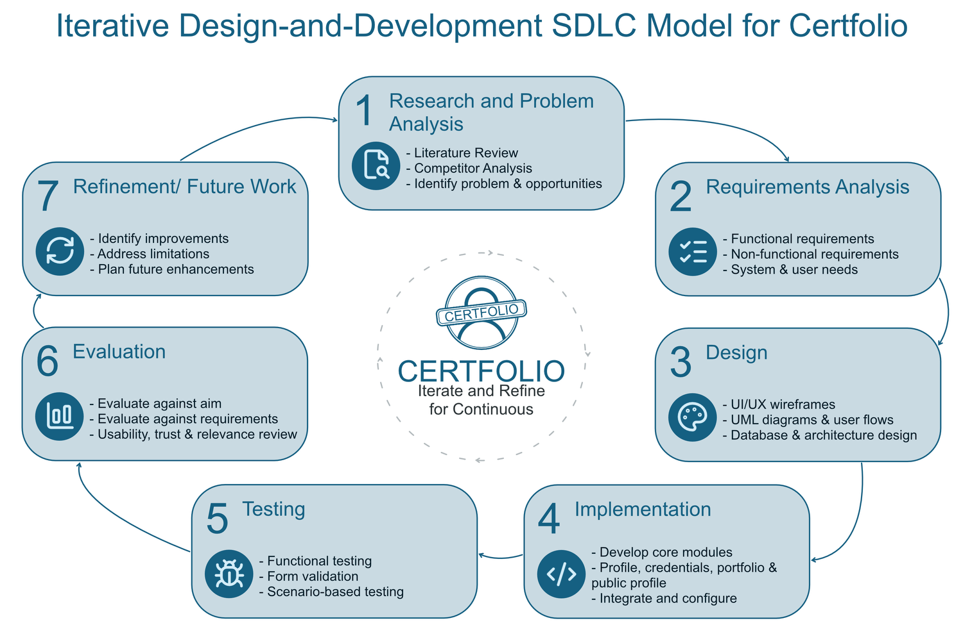
Figure 1 Iterative SDLC Model for Certfolio

The diagram shows the iterative SDLC model used for the Certfolio project. The process moves through research, requirements analysis, design, implementation, testing, evaluation and refinement.
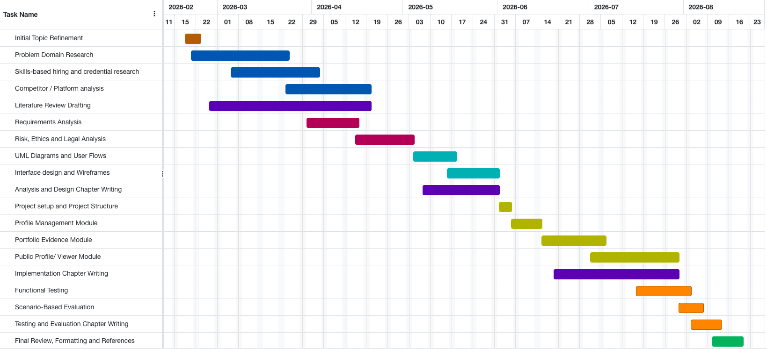
Figure 2 Certfolio Project Timeline
The project timeline covers February to July 2026. Research was carried out mainly between February and May, while documentation was completed throughout the project rather than left until the end.

2.8 Summary of Literature Gap
The literature and competitor review show a clear gap in how IT professionals present their professional identity. Credential platforms provide verification but are often rigid and issuer-centred [4], [5]. Link-in-bio platforms provide flexibility but do not provide verification or structured trust [6], [7]. GitHub provides evidence of technical work but is not a complete identity platform and can be difficult for non-technical viewers to interpret [8], [9].
At the same time, skills-based hiring increases the need for trusted evidence of capability [1], [2]. Self-taught learning increases the need for clearer verification [3]. Digital credential standards show that credentials can be portable, structured, and verifiable, but credential inflation and identity misuse remain risks [14], [15], [16], [17]. This gap supports the development of Certfolio as a prototype cloud-based professional identity platform that integrates verified certifications, self-declared skills, and portfolio evidence into a single structured profile.

3. Analysis

3.1 Requirement Analysis
The analysis stage defines what the Certfolio prototype needs to achieve and how the system should support its intended users. The main purpose of the platform is to allow IT professionals to present verified certifications, self-declared skills, and portfolio evidence in a single structured profile. This directly responds to the problem identified in the literature review, where professional evidence is often fragmented across separate platforms such as credential networks, GitHub, LinkedIn, and personal websites.
The primary user of the system is an IT professional who wants to build and manage a professional identity profile. This user needs to add personal profile information, certifications, skills, and project-based evidence. The secondary user is a recruiter, employer, or professional viewer who accesses the public profile to understand the user’s technical background and supporting evidence.
The system must therefore support two main areas: private management and public presentation. The private side allows the account holder to manage their own profile content, while the public side presents the information in a clear and trustworthy format. A key requirement is that the platform must clearly distinguish between verified credentials and self-declared claims, as this distinction is central to the project’s focus on trust.

3.2 Functional Requirements
Functional requirements describe the main actions that the system must allow users to perform. For Certfolio, these requirements focus on profile creation, credential management, project evidence, and public profile viewing.

Functional Requirement | Description
User registration and login | The system should allow users to create an account and securely access their profile dashboard.
Profile management | The system should allow users to create and update professional information such as name, role, biography, location, and links.
Skills management | The system should allow users to add and organise self-declared technical skills.
Credential management | The system should allow users to add certifications, including title, issuer, issue date, expiry date, and evidence link.
Verification status display | The system should show whether a credential is verified, pending, expired, or self-declared.
Portfolio project management | The system should allow users to add projects with descriptions, technologies used, links, and supporting evidence.
Public profile generation | The system should generate a public-facing profile that can be viewed by recruiters or employers.
Evidence linking | The system should allow users to attach or link evidence such as GitHub repositories, certificate URLs, case studies, or project documentation.
Edit and delete content | The system should allow users to update or remove profile items, credentials, skills, and projects.
Profile preview | The system should allow users to preview how their public profile appears before sharing it.

These functional requirements were selected because they support the core purpose of the platform. The prototype does not need to include every feature of a full professional network. Instead, it focuses on the essential functions needed to demonstrate the concept of a unified professional identity platform.

3.3 Non-Functional Requirements
Non-functional requirements describe how the system should perform rather than only what it should do. For Certfolio, these requirements are important because the platform handles professional identity information and must communicate trust clearly.
Non-Functional Requirement | Description
Usability | The interface should be clear and simple enough for users to manage their profile without technical difficulty.
Accessibility | The interface should use readable text, clear contrast, and logical navigation.
Responsiveness | The public profile should work across desktop, tablet, and mobile screen sizes.
Security | User accounts and profile management areas should be protected through secure authentication.
Privacy | The system should avoid collecting unnecessary personal data and should separate private account data from public profile data.
Trust clarity | Verified credentials and self-declared information should be visually and textually distinguished.
Performance | Public profile pages should load quickly and present information without unnecessary complexity.
Maintainability | The system should use reusable components and a clear project structure to make future development easier.
Scalability | The design should allow future features such as custom domains, recruiter views, and full credential verification.
Reliability | Profile information should be stored consistently and displayed accurately.

These non-functional requirements are particularly important because Certfolio is not only a technical artefact. It is also a trust-focused system. If the platform is unclear, slow, or visually confusing, it would weaken the purpose of presenting professional evidence in a credible way.

3.4 Use Case Analysis
The use case analysis identifies the main interactions between users and the Certfolio system. The two main actors are the IT Professional and the Public Viewer. The IT Professional manages the content of the profile, while the Public Viewer reads the profile and assesses the evidence presented.

Actor | Use Case | Description
IT Professional | Register / log in | Access the private dashboard securely.
IT Professional | Edit profile | Add or update professional identity information.
IT Professional | Add skills | Add self-declared technical skills.
IT Professional | Add credential | Add certification details and supporting evidence.
IT Professional | Add project | Add portfolio project information and evidence links.
IT Professional | Preview profile | View the profile before publishing or sharing it.
IT Professional | Publish profile | Make the profile available through a public link.
Public Viewer | View public profile | Access the user’s professional profile.
Public Viewer | Review credentials | See certifications and verification status.
Public Viewer | Review portfolio evidence | View projects, links, and evidence supporting the user’s skills.

The use case diagram should include the IT Professional on the left, the Certfolio system in the middle, and the Public Viewer on the right. The IT Professional should connect to actions such as managing the profile, adding credentials, adding skills, adding projects, previewing the profile, and publishing it. The Public Viewer should connect to viewing the profile, checking credentials, and reviewing project evidence.

3.5 System Requirements
The system requirements describe what is needed for the Certfolio prototype to operate successfully. As the project is a cloud-based web platform, the system requires a web application structure that supports account management, database storage, public profile display, and responsive user interfaces.
The system should include a private dashboard where the user can manage content and a public-facing profile that can be accessed through a shareable URL. The system should also support structured data storage so that credentials, skills, and portfolio projects can be stored separately but displayed together in one profile.
At prototype level, the system does not need to implement a full production-ready verification engine. However, it should model verification status clearly enough to demonstrate the design concept. For example, credentials can be marked as verified, self-declared, pending, or expired. This allows the prototype to show how trust information could be presented to a viewer.

3.6 Hardware Requirements
The hardware requirements for this project are relatively minimal because Certfolio is a web-based prototype. The development and testing process can be completed using a standard laptop or desktop computer.

Hardware | Purpose
Laptop or desktop computer | Used for development, testing, report writing, and design work.
Internet connection | Required for research, accessing online documentation, using cloud services, and testing public pages.
Web browser | Required for testing the interface and public profile pages.
Optional mobile device | Used to test responsiveness and mobile layout.

As the final artefact is a prototype rather than a large-scale production system, no specialist hardware is required. However, future deployment would require suitable cloud hosting or server infrastructure.

3.7 Software Requirements
The software requirements cover the tools needed to design, develop, test, and document the Certfolio prototype.
Software / Tool | Purpose
Laptop or desktop computer | Used for development, testing, report writing, and design work.
Internet connection | Required for research, accessing online documentation, using cloud services, and testing public pages.
Web browser | Required for testing the interface and public profile pages.
Optional mobile device | Used to test responsiveness and mobile layout.
Laptop or desktop computer | Used for development, testing, report writing, and design work.
Internet connection | Required for research, accessing online documentation, using cloud services, and testing public pages.
Web browser | Required for testing the interface and public profile pages.
Optional mobile device | Used to test responsiveness and mobile layout.
Laptop or desktop computer | Used for development, testing, report writing, and design work.

These tools are appropriate because they support a modern web development workflow. They also fit the cloud computing context of the project, as the artefact is designed as an online professional identity platform rather than a local-only application.

3.8 Risk Analysis
Risk analysis is important because several factors could affect the progress, quality, or reliability of the project. The main risks relate to scope, technical development, data privacy, evaluation limitations, and project management.

Risk | Probability | Impact | Mitigation
Scope expansion | High | High | Limit the prototype to core features: profile, credentials, skills, projects, and public profile.
Technical delays | Medium | Medium | Develop the system iteratively and prioritise the most important modules first.
Loss of project files | Low | High | Use GitHub, cloud storage, and regular backups.
Weak usability | Medium | Medium | Use wireframes, consistent layouts, and scenario-based testing.
Unclear distinction between verified and self-declared claims | Medium | High | Use clear labels, visual indicators, and explanation text on credentials.
Limited evaluation data | Medium | Medium | Use scenario-based evaluation and compare the prototype against requirements and literature findings.
Privacy issues | Medium | High | Avoid storing unnecessary personal data and separate private account data from public profile data.
Security issues | Medium | High | Use authentication, validation, and appropriate access control for profile management.
Time management problems | Medium | Medium | Follow the Gantt chart and write the report alongside development.
Incomplete prototype | Medium | High | Focus on completing the core user journey before adding optional features.

The most significant risk is scope expansion. Certfolio could easily become a large professional networking system, but this would not be realistic within the timeframe of the project. The project therefore focuses on a manageable prototype that demonstrates the core concept of a unified and trustworthy professional identity platform. Another important risk is the possibility of misleading claims. Since the platform deals with professional evidence, it must clearly separate verified credentials from self-declared skills. This is necessary to maintain trust and avoid presenting unsupported claims as verified achievements.

3.9 Summary
This chapter defined the main requirements and risks for the Certfolio prototype. The analysis identified the primary user as an IT professional and the secondary user as a recruiter, employer, or public viewer. The functional requirements focused on profile management, credential management, skills, portfolio evidence, and public profile generation. The non-functional requirements focused on usability, trust, privacy, security, responsiveness, and maintainability.
The chapter also outlined the system, hardware, and software requirements needed to develop the prototype. The risk analysis showed that scope control, privacy, trust clarity, and time management are important issues for the project. These analysis findings provide the basis for the next chapter, which presents the design of the Certfolio system.

4. Design

4.1 Introduction
This chapter presents the design of the Certfolio prototype. The design stage translated the requirements identified in Chapter 3 into a planned system structure, user interface, database model, and user flow. The aim of the design was to create a clear and trustworthy professional identity platform where IT professionals could manage certifications, self-declared skills, portfolio evidence, and a public-facing profile.
The design of Certfolio was guided by three main principles: clarity, trust, and usability. Clarity was important because the platform needed to present professional information in a way that recruiters or employers could understand quickly. Trust was important because the platform needed to distinguish verified credentials from self-declared claims. Usability was important because the user needed to manage their professional profile without unnecessary complexity.

4.2 System Architecture
Certfolio was designed as a cloud-based web application with separate areas for private profile management and public profile viewing. The private dashboard allows the user to manage their own information, while the public profile presents selected information to external viewers such as recruiters or employers.
The system architecture can be understood through three main layers:
Layer | Purpose
Presentation layer | Provides the user interface for the dashboard, forms, profile pages, and public profile view.
Application layer | Handles the main logic, including profile updates, credential management, project management, validation, and routing.
Data layer | Stores user profiles, skills, credentials, projects, evidence links, and verification status.

This layered structure was selected because it separates the visual interface from the application logic and database structure. This makes the prototype easier to maintain and extend. For example, future features such as recruiter dashboards, custom domains, analytics, or full Open Badges verification could be added without redesigning the entire system.
At prototype level, the system focuses on the core user journey rather than full-scale production deployment. The main journey is: the user logs in, manages their profile, adds credentials, adds project evidence, previews the profile, and publishes a public-facing version.

4.3 User Interface Design
The user interface was designed to support a professional and trust-focused experience. Since Certfolio is intended for IT professionals, the interface needed to look credible, structured, and modern without becoming too complex. The design avoids a social-media style layout and instead presents information in a portfolio/profile format.
The main screens planned for the prototype were:
Screen | Purpose
Dashboard | Gives the user an overview of their profile, credentials, projects, and completion status.
Profile settings | Allows the user to update personal and professional details.
Skills section | Allows the user to add and organise self-declared skills.
Credentials section | Allows the user to add certifications and supporting verification links.
Projects section | Allows the user to add portfolio projects and evidence links.
Public profile | Shows the user’s professional identity to recruiters, employers, or other viewers.
Public project page | Provides a more detailed view of an individual project or case study.

The interface design uses clear sectioning so that each type of professional evidence has its own area. Credentials, skills, and projects are not mixed together without explanation. This is important because each type of evidence has a different level of trust. A verified certification is different from a self-declared skill, and a portfolio project provides practical evidence rather than formal validation.

4.4 Storyboard and User Flow
The storyboard for Certfolio follows the typical journey of an IT professional creating and sharing a professional identity profile. The user begins by accessing the dashboard and completing their basic profile information. They then add certifications, skills, and portfolio projects. After this, the user previews their public profile and shares it with a recruiter or employer.
The main user flow is:
Log in → Open dashboard → Edit profile → Add skills → Add credentials → Add projects → Preview public profile → Publish/share profile
This flow was selected because it keeps the system focused on the main purpose of the project. The user is not required to complete unnecessary steps before creating a usable profile. At the same time, the flow encourages the user to build a profile that combines identity, credentials, and evidence.
The public viewer journey is simpler:
Open shared profile link → Review profile summary → Check credentials → View project evidence → Assess professional credibility
This second flow is important because Certfolio is not only designed for the account holder. It must also be understandable to the people viewing the profile. A recruiter or employer should be able to quickly understand what is verified, what is self-declared, and what evidence supports the user’s claims.

4.5 Database Design
The database design was planned around the main types of information required by Certfolio. The system needs to store users, profiles, skills, credentials, projects, and evidence links. These entities are connected because one user may have one profile, many skills, many credentials, and many projects.
A simplified database structure is shown below:
Entity | PK | Main fields | Purpose
User (users) | id | name, email, image, password_hash, email_verified_at, slug, created_at, updated_at, archived_at, deleted_at | Stores user accounts, authentication details, and core public identity information.
User Preferences (user_preferences) | id | user_id, accent_colour, headline, bio, public_profile, searchable, show_email, full_metadata, featured_credential_ids, featured_project_ids, created_at, updated_at | Stores profile appearance, privacy settings, and featured credentials and projects.
User Links (user_links) | id | user_id, platform, label, url, sort_order, created_at, updated_at | Stores website and social media links displayed on a user’s public profile.
Skills (skills) | id | user_id, name, category, sort_order, created_at, updated_at | Stores user-defined technical and professional skills together with their display order.
Issuers (issuers) | id | slug, display_name, normalized_name, aliases, kind, website_url, logo_url, theme_key, created_by_user_id, created_at, updated_at | Stores normalised certification provider information to avoid duplication and maintain consistency.
Credentials (credentials) | id | user_id, issuer_id, slug, title, source_type, verification_status, credential_code, verification_url, certificate_asset_key, issued_on, expires_on, summary, status, created_at, updated_at | Stores professional certifications, their verification details, supporting evidence, and publication status.

The database separates credentials from skills because they represent different types of professional claims. A skill can be self-declared, while a credential can have an issuer, date, and verification link. Projects are also stored separately because they provide practical evidence and may include multiple links or supporting materials.
The public_slug field allows the platform to generate a shareable profile URL. The status field in the credential table allows the system to show whether a credential is verified, self-declared, pending, or expired. This supports the trust-focused design of the project.

4.6 Credential and Trust Design
Trust is one of the most important parts of the Certfolio design. The platform should not present every claim as equal. A verified certification, a self-declared skill, and a portfolio project all provide value, but they do not carry the same type of evidence.
For this reason, Certfolio was designed to use clear trust labels. Examples include:
Label | Meaning
Verified | The credential includes a recognised external verification link (e.g., Credly). Certfolio validates the link format and recognised domain but does not independently verify the credential with the issuing platform.
Evidence Linked | The credential includes an external verification link from another provider. The link acts as supporting evidence but is not independently verified by Certfolio.
Self-declared | The credential was provided by the user without an external verification link. This includes manually entered credentials and uploaded certificates.
Expired | The credential has passed its expiry date. This is calculated automatically and is independent of the verification level.
Credential source (e.g., Credly, issuer link, uploaded certificate, or manual entry) is stored separately in the source_type field, while publication state (Draft, Published, or Archived) is managed independently through the status field. These fields are separate from the verification level.
This structure allows the platform to avoid misleading viewers. It also helps the user present their profile honestly. For example, a user may still include self-declared skills, but these should be clearly separated from verified achievements.
At prototype level, the verification system is modelled through status labels and evidence links rather than a full cryptographic verification engine. This is appropriate for the scope of the project because the aim is to demonstrate the concept and design of a trustworthy professional identity platform. Future development could extend this by integrating Open Badges 3.0 or other digital credential standards.

4.7 Public Profile Design
The public profile is the main output of the Certfolio system. It was designed to act as a structured professional identity page that can be shared with recruiters, employers, or professional contacts. The page needs to communicate the user’s identity, skills, certifications, and project evidence in a clear order.
The planned public profile structure is:
Profile header
→ Professional summary
→ Verified credentials
→ Self-declared skills
→ Portfolio projects
→ Evidence links
→ Contact / external links

The profile header introduces the user with their name, role, short summary, and professional links. The credentials section shows formal achievements and their verification status. The skills section shows self-declared areas of competence. The projects section provides practical examples of work and links to supporting evidence.
This structure supports the project’s aim because it brings together different parts of professional identity into one page. Instead of sending a recruiter to multiple disconnected links, Certfolio provides one profile that explains the relationship between credentials, skills, and projects.

4.8 Security and Privacy Design
Security and privacy were considered during the design stage because Certfolio handles professional identity information. The system should protect account management features so that only the profile owner can edit their information. Public viewers should only be able to access information that the user has chosen to publish.
The main security and privacy design considerations were:
Area | Design consideration
Authentication | Users should log in before editing profile content.
Access control | Private dashboard pages should not be accessible to public viewers.
Public/private separation | Account data should be separated from public profile data.
Data minimisation | The system should avoid collecting unnecessary personal information.
Evidence links | External links should be shown clearly so viewers understand where evidence comes from.
Trust labels | Verified and self-declared information should be clearly separated.

This design supports the ethical and legal concerns identified earlier in the project. Since the platform deals with professional identity, it must avoid encouraging misleading claims and should protect user data where possible.

4.9 Design Summary
The design chapter has explained how the Certfolio prototype was planned before implementation. The system was designed as a cloud-based web application with a private dashboard and a public profile. The interface focuses on clarity, usability, and trust. The database design separates users, profiles, skills, credentials, projects, and evidence links so that different types of professional information can be managed clearly.
The design also includes a trust model that distinguishes verified credentials from self-declared claims. This is central to the purpose of Certfolio because the platform aims to reduce professional identity fragmentation while improving the credibility of skill presentation. The next chapter explains how these design decisions were implemented in the working prototype.

5. Implementation

5.1 Introduction
This chapter explains how the Certfolio prototype was implemented. The implementation stage translated the requirements and design decisions from the previous chapters into a working web-based prototype. The focus was on the core user journey: managing a profile, adding skills, adding credentials, adding project evidence, and displaying this information through a public profile.

5.2 Implementation Overview
The prototype was implemented using the software tools and technologies identified in Chapter 3. The system was structured around two main areas: a private dashboard for managing profile content and a public-facing profile for external viewers. This separation was important because editing functionality should only be available to the profile owner, while selected professional information should be visible publicly.
The main implemented modules were profile management, skills management, credential management, portfolio evidence, public profile viewing, public project pages, and verification status display.

5.3 Profile Management Module
The profile management module allows users to create and update their professional identity information, including name, professional headline, biography, location, profile image, and external links. This information forms the foundation of the public Certfolio profile.
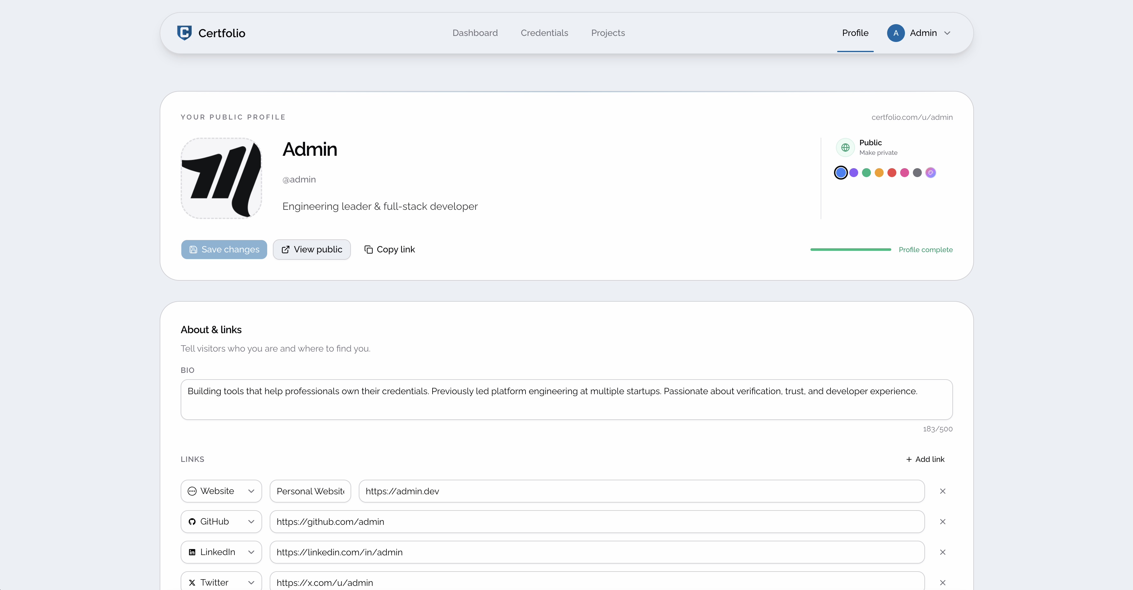
Figure 3 Profile Management Screen

Requirement | Implementation
Profile creation | The user can enter basic professional information.
Profile editing | Existing information can be updated from the dashboard.
Public profile support | Profile information is used to generate the public-facing page.
Professional narrative | The biography and headline explain the user’s professional focus.

const handleSave = useCallback(async () => {
setIsSaving(true)
try {
const formData = form.getValues()

let imageUrl: string | null = null
if (imageFile) {
const result = await uploadProfileImageAction(data.user.id, imageFile)
imageUrl = result.imageUrl
}

await saveProfile(data.user.id, {
...formData,
imageUrl: imageUrl ?? (data.user.image || null),
featuredCredentialIds: featuredCredIds,
featuredProjectIds: featuredProjIds,
})

form.reset(formData)
setImageFile(null)
setImagePreview(null)
setCommittedCredIds(featuredCredIds)
setCommittedProjIds(featuredProjIds)

toast.success("Profile saved")
} catch (error) {
console.error("Failed to save profile:", error)
toast.error("Failed to save profile. Please try again.")
} finally {
setIsSaving(false)
}
}, [
form,
imageFile,
featuredCredIds,
featuredProjIds,
data.user.id,
data.user.image,
])
Figure 4 Form handling snippet

5.4 Skills Management Module
The skills management module allows users to add and organise self-declared technical skills. These skills are displayed separately from verified credentials so that viewers can distinguish user-declared knowledge from externally supported evidence.
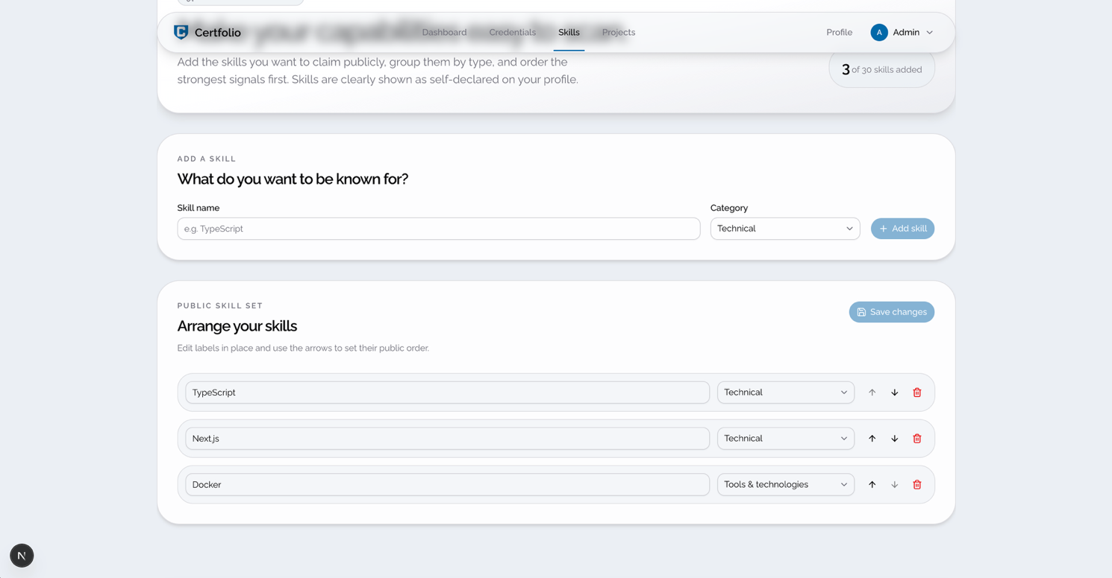
Figure 5 Skills Management Screen

Function | Description
Add skill | The user can add a technical skill to their profile.
Categorise skill | Skills can be grouped by area, such as cloud, frontend, backend, DevOps, or security.
Display skill | Skills are shown on the public profile as self-declared information.
Edit/delete skill | The user can update or remove skills when needed.
const addSkill = (nameValue: string, category: SkillCategory) => {
const name = nameValue.trim()
if (!name) return false
if (
skills.some((skill) => skill.name.toLowerCase() === name.toLowerCase())
) {
toast.error("That skill is already in your list.")
return false
}
if (skills.length >= 30) {
toast.error("You can add up to 30 skills.")
return false
}

draftId.current += 1
setSkills((current) => [
...current,
{ id: `new-${draftId.current}`, name, category },
])
return true
}
Figure 6 Add skill snippet

5.5 Credential Management Module
The credential management module allows users to add certifications and related evidence. Each credential can include title, issuer, issue date, expiry date, verification URL, and status. This module supports the trust-focused part of Certfolio by making credential evidence visible and clearly labelled.
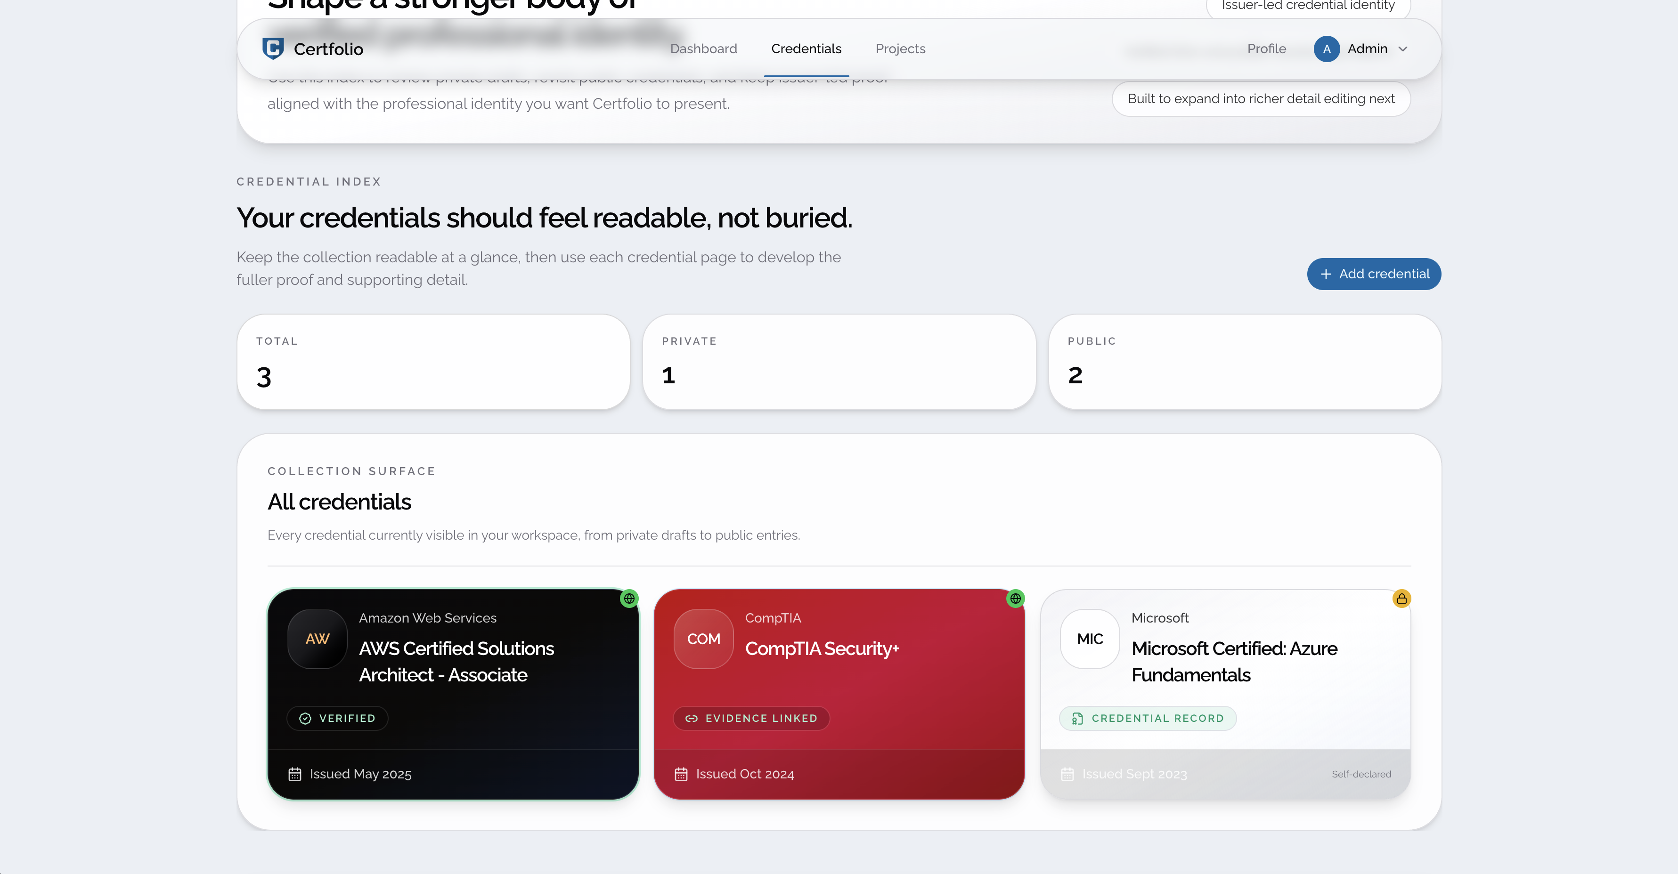
Figure 7 Credential Management Module

Field | Purpose
Credential title | Identifies the certification or badge.
Issuer | Shows the organisation that issued the credential.
Issue date | Shows when the credential was achieved.
Expiry date | Shows whether the credential is still current.
Verification URL | Provides a link to supporting evidence.
Status | Shows whether the credential is verified, pending, expired, or self-declared.
const credentials = session
? await db
.select({
id: CredentialsTable.id,
slug: CredentialsTable.slug,
title: CredentialsTable.title,
sourceType: CredentialsTable.source_type,
verificationStatus: CredentialsTable.verification_status,
issuedOn: CredentialsTable.issued_on,
summary: CredentialsTable.summary,
status: CredentialsTable.status,
issuerId: IssuersTable.id,
issuerDisplayName: IssuersTable.display_name,
issuerNormalizedName: IssuersTable.normalized_name,
issuerAliases: IssuersTable.aliases,
issuerKind: IssuersTable.kind,
issuerThemeKey: IssuersTable.theme_key,
issuerLogoUrl: IssuersTable.logo_url,
})
.from(CredentialsTable)
.innerJoin(IssuersTable, eq(CredentialsTable.issuer_id, IssuersTable.id))
.where(
and(
eq(CredentialsTable.user_id, session.user.id),
ne(CredentialsTable.status, "archived")
)
)
.orderBy(desc(CredentialsTable.issued_on), desc(CredentialsTable.created_at))
: []
Figure 8 User credentials fetching

5.6 Portfolio Evidence Module
The portfolio evidence module allows users to add projects that demonstrate practical experience. Each project can include a title, description, role, technologies used, outcome, and supporting links such as GitHub repositories, live websites, documentation, screenshots, or case studies.
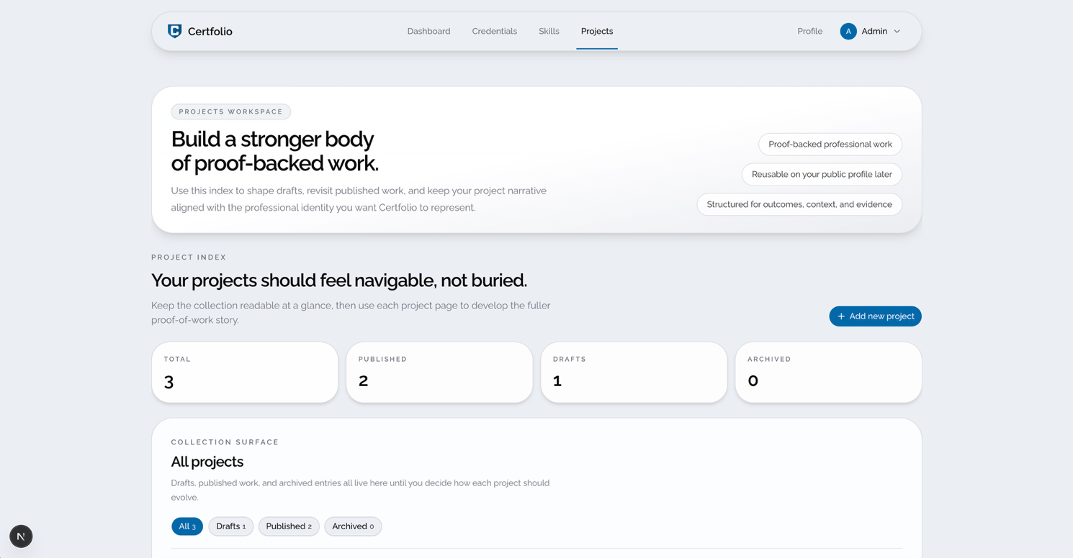
Figure 9 Projects Management Screen

Requirement | Implementation
Add project | The user can create a portfolio project entry.
Explain role | The user can describe their contribution to the project.
Add technologies | The user can list the technologies used.
Add evidence | The user can attach or link supporting evidence.
Display project publicly | Projects can appear on the public profile.

const { project, persistedEvidenceLinks } = await db.transaction(
async (tx) => {
const [project] = await tx
.insert(ProjectsTable)
.values({
user_id: session.user.id,
slug,
title,
cover_image_key: coverImageKey,
project_type: projectType,
role,
summary,
context,
outcome,
tools,
status: "draft",
updated_at: new Date(),
})
.returning()

if (evidenceLinks.length > 0) {
await tx.insert(ProjectEvidenceLinksTable).values(
evidenceLinks.map((evidenceLink, index) => ({
project_id: project.id,
label: evidenceLink.label,
url: evidenceLink.url,
kind: evidenceLink.kind,
sort_order: index,
}))
)
}

const persistedEvidenceLinks = await tx
.select()
.from(ProjectEvidenceLinksTable)
.where(eq(ProjectEvidenceLinksTable.project_id, project.id))
.orderBy(asc(ProjectEvidenceLinksTable.sort_order))

return { project, persistedEvidenceLinks }
}
)

return {
success: "Project created",
project,
evidenceLinks: persistedEvidenceLinks,
}
})
Figure 10 Project creation snippet

5.7 Public Profile Module
The public profile module presents the user’s professional identity to external viewers. It combines the user’s summary, credentials, self-declared skills, portfolio projects, and evidence links into one structured page.
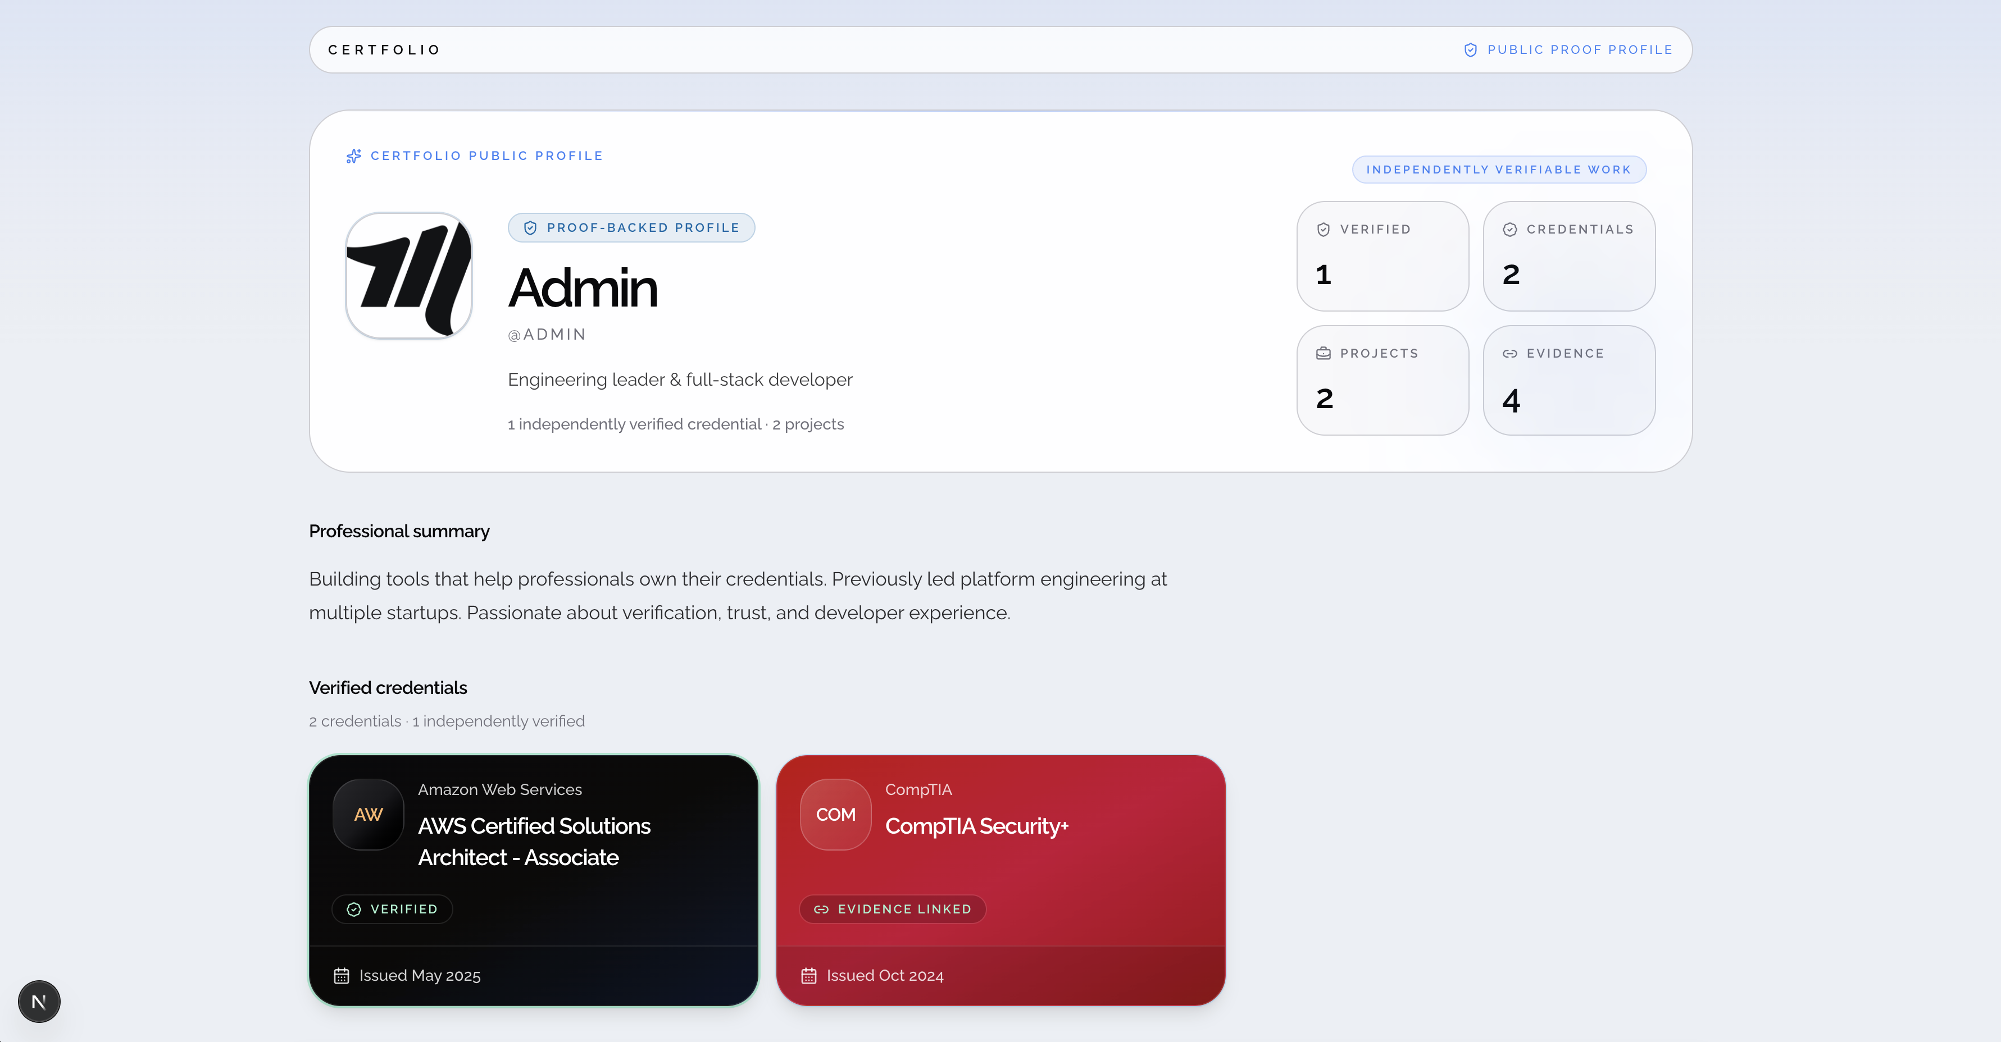
Figure 11 Public Profile Screen
Section | Purpose
Profile header | Introduces the user and their professional focus.
Summary | Provides a short professional overview.
Credentials | Shows certifications and verification status.
Skills | Shows self-declared technical skills.
Projects | Shows portfolio evidence and practical work.
External links | Provides links to supporting platforms or contact information.

This module demonstrates the main purpose of Certfolio by reducing the need for viewers to move between several disconnected platforms.

5.8 Public Project Page
The public project page provides a more detailed view of an individual portfolio project. It allows the user to explain the project, their role, the technologies used, supporting evidence, and the final outcome.
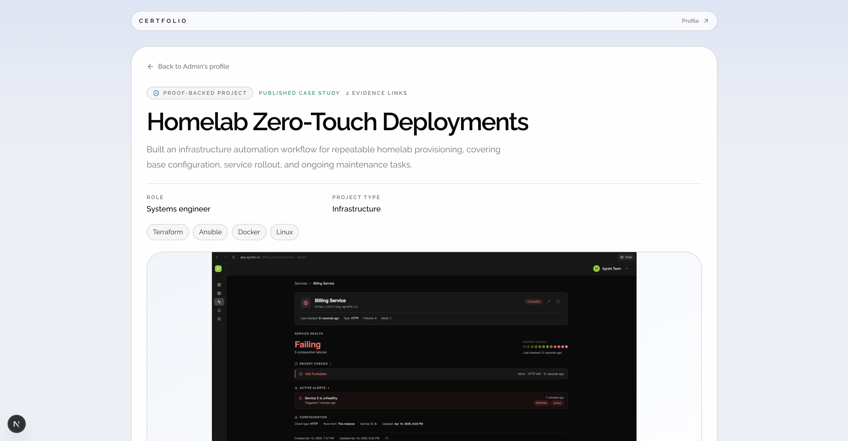
Figure 12 Public Project Screen

Section | Purpose
Project overview | Explains what the project is about.
Role and contribution | Shows what the user personally did.
Technologies used | Lists the tools, frameworks, or platforms involved.
Evidence links | Provides supporting proof such as repositories or screenshots.
Outcome | Explains what the project achieved.

5.9 Verification Status Implementation
The verification status system was implemented to visually separate different types of claims. At prototype level, this does not represent full cryptographic verification, but it demonstrates how trust information could be displayed clearly.
Status | Display meaning
Verified | The credential includes external evidence or a verification link.
Pending | The credential has been added but is not yet confirmed.
Expired | The credential has passed its expiry date.
Self-declared | The item was added by the user without external verification.
export function CredentialVerificationBadge({
status,
className,
}: {
status: CredentialVerificationStatus
className?: string
}) {
const badge = verificationBadgeMap[status]
const Icon = badge.Icon

return (
<div
className={cn(
"inline-flex items-center gap-2 rounded-full px-3 py-1 text-[11px] font-semibold tracking-[0.14em] uppercase",
badge.className,
className
)}
>
<Icon className="size-3.5" />
{badge.label}
</div>
)
}
Figure 13 Credential verification badge rendering

5.10 Implementation Summary
The implementation stage produced a working prototype with profile management, skills, credential management, portfolio evidence, public profile viewing, and public project pages. These modules demonstrate the core Certfolio concept: combining verified certifications, self-declared skills, and project evidence within one structured professional identity platform. The next chapter explains how the prototype was tested against its functional and non-functional requirements.

6. Testing

6.1 Introduction
Testing was carried out to check whether the Certfolio prototype met its main functional and non-functional requirements. The testing focused on the core user journey: managing a professional profile, adding skills, adding credentials, adding portfolio projects, viewing the public profile, and checking whether verified and self-declared information was displayed clearly.
The testing approach used functional test cases and scenario-based testing. Functional testing checked whether each feature worked as expected, while scenario-based testing considered whether the prototype supported the intended use case of an IT professional presenting evidence to a recruiter or employer.

6.2 Test Cases
Purpose | Input | Expected output | Result
Test profile creation | Name, role, bio, location | Profile information is saved and displayed | Pass
Test profile editing | Updated headline or biography | Updated information appears correctly | Pass
Test adding a skill | Skill name and category | Skill appears in the skills section | Pass
Test adding a credential | Credential title, issuer, date, status, URL | Credential appears with correct details | Pass
Test verification label | Credential status set to verified or self-declared | Correct trust label is displayed | Pass
Test expired credential display | Credential with expiry date in the past | Credential appears as expired | Pass
Test adding a project | Project title, description, technologies, evidence link | Project appears in the portfolio section | Pass
Test public profile page | Public profile URL | Profile loads without private edit controls | Pass
Test empty required fields | Blank required form fields | Validation message appears | Pass
Test responsive layout | Open profile on desktop and mobile screen sizes | Layout remains readable and usable | Pass

6.3 Testing Summary
The testing showed that the main prototype features worked as intended. The user was able to create and edit profile information, add skills, add credentials, add portfolio projects, and view the public profile. The most important testing outcome was that verified and self-declared information could be displayed separately, supporting the trust-focused aim of the project.
Some limitations remained. The prototype tested the concept of verification through status labels and evidence links, but it did not include full cryptographic credential verification. This is acceptable for the project scope, as the prototype was designed to demonstrate the professional identity concept rather than operate as a complete production platform.

7. Evaluation

7.1 System Evaluation
The Certfolio prototype was evaluated against its aim, objectives, and requirements. The system successfully demonstrated how IT professionals could present certifications, self-declared skills, and project evidence in one structured profile. The prototype also addressed the issue of fragmented professional identity by bringing different forms of evidence into a single public-facing page.
The strongest part of the system is its separation of evidence types. Verified credentials, self-declared skills, and portfolio projects are not presented as the same type of information. This supports trust because viewers can understand which claims are externally supported and which are user-declared. The public profile also improves clarity by placing professional information in a structured order rather than requiring viewers to visit several disconnected platforms.
However, the system remains a prototype. It does not include full Open Badges verification, automated credential checking, recruiter accounts, analytics, or custom domain support. These limitations reduce the completeness of the system but do not prevent it from meeting the project aim at prototype level.

7.2 Evaluation Against Objectives
Objective | Evaluation
To critically analyse literature and industry practice | Achieved through research into skills-based hiring, digital credentials, personal branding, and professional identity platforms.
To evaluate existing tools | Achieved through comparison of credential networks, link-in-bio platforms, and GitHub-style portfolio systems.
To design and develop a Certfolio prototype | Achieved through the implementation of profile, skills, credentials, projects, public profile, and project evidence features.
To test and assess the prototype | Achieved through functional test cases and scenario-based evaluation focused on usability, trust, clarity, and relevance.

7.3 Personal Evaluation
The project supported the development of both technical and research skills. From a technical perspective, the project required planning a full web-based prototype, structuring data, designing user flows, and implementing features that supported both private management and public presentation. From a research perspective, the project required connecting software design decisions to literature on digital credentials, employability, identity, and trust.
One of the main lessons from the project was the importance of scope control. Certfolio could easily expand into a much larger platform, including recruiter dashboards, automated verification, analytics, endorsements, and integrations. However, the project needed to remain realistic within the timeframe. Focusing on the core profile, credential, skill, and portfolio features made the prototype achievable while still demonstrating the main concept.

7.4 Limitations
The main limitation of the project is that the evaluation was based on scenario-based testing rather than primary user research. This means the prototype was not tested with a large group of IT professionals or recruiters. Another limitation is that credential verification was represented through status labels and evidence links rather than full standards-based verification. The prototype therefore demonstrates the design concept, but further work would be required before it could be deployed as a complete professional identity platform.

8. Further Enhancement
Several improvements could be made in future development. The most important enhancement would be full integration with digital credential standards such as Open Badges 3.0, allowing credentials to be verified more automatically. Certfolio could also be extended with custom domains, recruiter views, profile analytics, LinkedIn and GitHub integrations, PDF export, and stronger identity verification.
A future version could also include a more advanced evidence system where users connect each skill to specific credentials or projects. This would make the profile more transparent by showing exactly how each professional claim is supported. Primary user testing with IT professionals and recruiters would also improve the validity of the evaluation and provide stronger evidence for future design decisions.

9. Conclusion
This project designed, developed, and evaluated Certfolio, a prototype cloud-based professional identity platform for IT professionals. The project addressed the problem of fragmented professional identity by bringing together verified certifications, self-declared skills, and portfolio evidence into one structured profile.
The final prototype met the main aim of the project by demonstrating how professional evidence could be presented in a clearer and more trustworthy format. The literature review showed that skills-based hiring, digital credentials, and online professional identity are increasingly important within the IT sector. The analysis and design stages translated these findings into functional requirements, non-functional requirements, system architecture, interface design, and database planning.
The implementation produced a working prototype with profile management, skills, credentials, portfolio evidence, public profile viewing, and project case study features. Testing showed that the main system functions worked as expected, while the evaluation identified both strengths and limitations. Overall, Certfolio demonstrates a relevant and practical response to the need for more trustworthy digital professional identity systems. Although further development would be needed for full deployment, the prototype provides a strong foundation for future work in verifiable credentials, professional portfolios, and cloud-based identity platforms.

Table of Figures
Figure 1 Iterative SDLC Model for Certfolio 11
Figure 2 Certfolio Project Timeline 12
Figure 3 Profile Management Screen 25
Figure 4 Form handling snippet 26
Figure 5 Skills Management Screen 27
Figure 6 Add skill snippet 27
Figure 7 Credential Management Module 28
Figure 8 User credentials fetching 29
Figure 9 Projects Management Screen 30
Figure 10 Project creation snippet 31
Figure 11 Public Profile Screen 32
Figure 12 Public Project Screen 33
Figure 13 Credential verification badge rendering 34

Bibliography

[1] | Capital Analytics Associates, “Skills-Based Hiring Accelerates as Degree Value Erodes,” [Online]. Available: https://capitalanalyticsassociates.com/skills-based-hiring-accelerates-as-degree -value-erodes/. [Accessed 12 March 2026].
[2] | Cogent Info, “The 2025 IT Talent Forecast: Emerging Roles, Skills, and Certification Trends,” [Online]. Available: https://cogentinfo.com/resources/the-2025-it-talent-forecast-emerging-roles-sk ills-and-certification-trends. [Accessed 12 March 2026].
[3] | PR Newswire, “Gen Z Leads a 66% Surge in Self-Taught Job Skills, Creating a Verification Headache,” PR Newsire, [Online]. Available: https://www.prnewswire.com/news-releases/gen-z-leads-a-66-surge-in-self-taught-job-skills-creating-a-verification-headache-302694832.html. [Accessed 12 March 2026].
[4] | Certifier, “Accredible vs. Credly,” Certifier, [Online]. Available: https://certifier.io/blog/accredible-vs-credly. [Accessed 12 March 2026].
[5] | Virtualbadge.io, “Accredible vs. Credly: The Ultimate Feature Breakdown of 2025,” [Online]. Available: https://www.virtualbadge.io/blog-articles/accredible-vs-credly--the-ultimate-feature-breakdown-of-2025. [Accessed 12 March 2026].
[6] | SuperProfile, “Linktree vs Building Your Own Website with Links,” [Online]. Available: https://superprofile.bio/blog/linktree-vs-own-website-with-links. [Accessed 12 March 2026].
[7] | Vineyard Creative Co, “Linktree vs Website: Always Use Your Website for a Link in Bio,” [Online]. Available: https://vineyardcreativeco.com/blog/linktree-vs-website/. [Accessed 12 March 2026].
[8] | GitHub Community, “Using Github as a Portfolio When Applying for Jobs,” [Online]. Available: https://github.com/orgs/community/discussions/169760. [Accessed 12 March 2026].
[9] | Cybertex Security, “How Recruitment Scams Target Developers Through GitHub Test Tasks,” [Online]. Available: https://cybertex.io/how-recruitment-scams-target-developers-through-github-test-tasks/. [Accessed 12 March 2026].
[10] | SciSpace, “Human Capital or Signalling, Unpacking the Graduate Premium,” [Online]. Available: https://scispace.com/pdf/human-capital-or-signalling-unpacking-the-graduate-premium-4fid84muy2.pdf. [Accessed 12 March 2026].
[11] | IAPP, “The Impact of Credentials on Compensation,” [Online]. Available: https://iapp.org/news/a/the-impact-of-credentials-on-compensation. [Accessed 12 March 2026].
[12] | Frontiers, “Personal Branding: Interdisciplinary Systematic Review and Research Agenda,” Frontiers.
[13] | Akashie, “Online Identity Management and Professional Branding,” [Online]. Available: https://www.researchgate.net/publication/392927511_Online_Identity_Management_and_Professional_Branding. [Accessed 12 March 2026].
[14] | 1EdTech, “Connecting the Dots: Making Sense of Digital Credential Standards,” [Online]. Available: https://www.1edtech.org/blog/connecting-the-dots-making-sense-of-digital-credential-standards. [Accessed 12 March 2026].
[15] | 1EdTech, “Digital Credentials Procurement Considerations,” [Online]. Available: https://www.1edtech.org/sites/default/files/media/docs/2024/Digital%20Credentials%20Procurement%20Considerations.pdf. [Accessed 12 March 2026].
[16] | Virtualbadge.io, “Digital Badges Build Trust: Verifiable Credentials Explained,” [Online]. Available: https://www.virtualbadge.io/blog-articles/digital-badges-build-trust-verifiable-credentials-explained. [Accessed 12 March 2026].
[17] | Jobs for the Future (JFF), “Too Many Credentials, Not Enough Value. Let’s Change That,” JFF, [Online]. Available: https://www.jff.org/blog/too-many-credentials-not-enough-value-lets-change-that/. [Accessed 12 March 2026].
[18] | Forbes, “Trends in Digital Identity Verification: Insights From Tech Experts,” Forbes, [Online]. Available: https://www.forbes.com/councils/forbestechcouncil/2025/02/12/trends-in-digital-identity-verification-insights-from-tech-experts/. [Accessed 12 March 2026].

