BMIH6002

Management Assessment of Practical Tasks – Feedback from the hotel

Student Name: Andreea Gama
Student ID: 2219781
Date: 15/06/2025
Table of Contents
1. Introduction 3
2. Role Reflection 4
2.1 Description 4
2.2 Feelings 4
2.3 Evaluation 5
2.4 Analysis 5
2.5 Conclusion 5
2.6 Action Plan 5
3. Development Journey 6
3.1 Comparison with Level 4 Placement 6
3.2 Reflection on Previous Modules 6
4. Service Improvement Proposal 6
4.1 Key Area: Staff Communication During Busy Shifts 6
4.2 Justification 7
4.3 Improvement Plan 7
4.4 Academic Support 7
4.5 Performance Criteria Link 8
5. Conclusion 9
References 10

Table of Figures
Figure 1: Marriott 3
Figure 2: Gibbs Reflective Cycle 4

1. Introduction
Marriott Cardiff is a well-known 4-star hotel in the center of Cardiff. Because of its professional environment and top service, the hotel is popular with guests, whether they are on business or holiday (Fallon & Rutherford, 2010). Due to its location, Orlando is perfect for holding business conferences, weddings and welcoming tourists. The F&B (Food and Beverage) department contributes greatly to great experiences for guests. At Marriott Cardiff, The Admiral St David is a stylish restaurant combining Asian and European foods, along with a lounge bar, extensive room service and service for events like conferences and banquets.

Figure 1: Marriott
Source: (https://purepng.com/ 2025)
At this placement, I aimed to fulfil three main learning objectives.
- Learn to manage and lead with confidence in the busy world of the F&B industry.
- Increase teamwork and communication among your food and beverage team.
- Learn about and adhere to the international guest service standards of the hotel.

2. Role Reflection
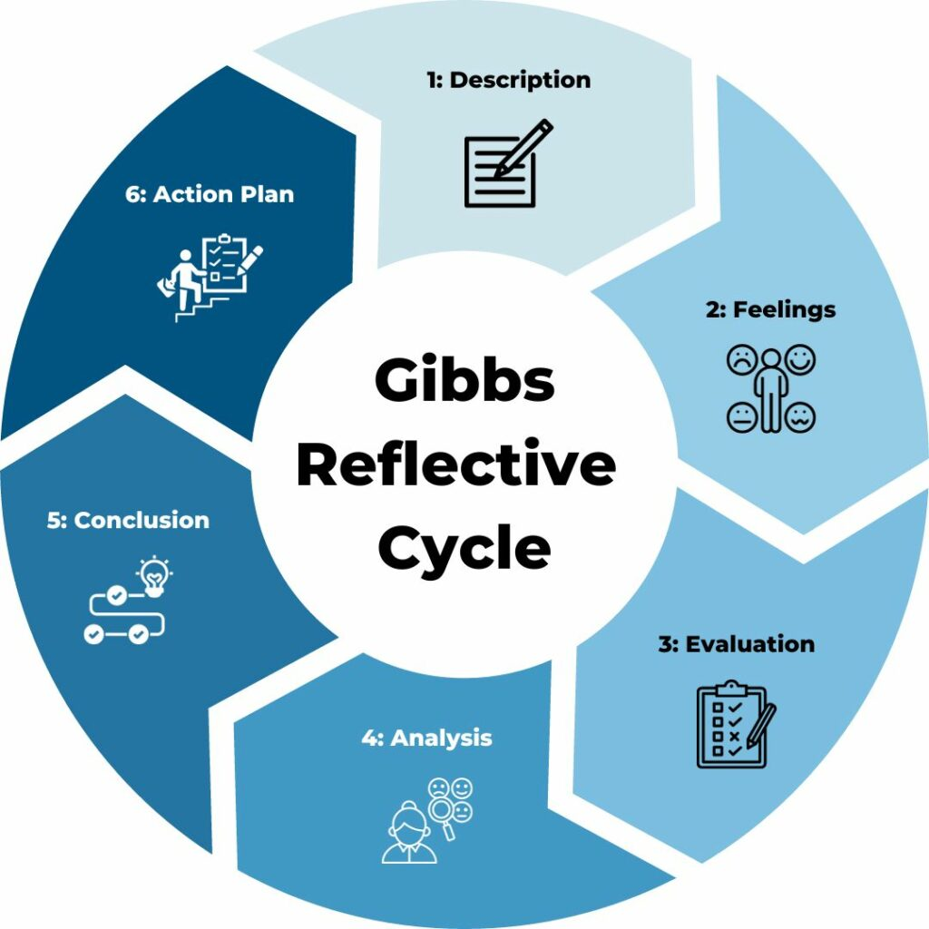
Figure 2: Gibbs Reflective Cycle
Source: (https://www.tsw.co.uk/ 2023)

2.1 Description
While on placement, I worked as a food and beverage associate in both the restaurants and events sections (Cousins et al., 2019). I was mostly responsible for taking orders, serving our guests, clearing tables, keeping the service areas stocked, and supporting the set-up and tear-down of event rooms. I spent time with members of the kitchen team and helped supervisors at times when there were a lot of guests.

2.2 Feelings
When I arrived, I was free from all my worries about Marriott’s big brand identity. I wasn’t sure if I could meet the expectations and serve customers well. After a while, knowing the routines and meeting the team helped me feel more capable in my work (Hagg, 2013). It was found that focusing on communication, time, and detail was vital to reaching success. For me, watching supervisors was exciting because I learned how they managed their teams, coped with surprises and delivered great guest services.

2.3 Evaluation
There were both ups and downs in my placement (ASET, 2017). Planning the banquet for over 150 attendees was a very rewarding experience. While experiencing tension, I maintained composure, did my duties and checked that everyone was served in time. By doing this, I honed how I work alone and with others. I found that guest complaints were harder to resolve if they came from the kitchen or if there were miscommunications during times when we were very busy.

2.4 Analysis
With the help of Gibbs’ model, I understood that two separate experiences helped me learn some key lessons (Markkanen et al., 2020). I noticed a senior supervisor handled an issue of overbooking clearly and patiently. Instead of getting stressed, she soothed her guests, supervised the kitchen staff and made a little waiting area with drinks where they could enjoy themselves. It revealed why it is important to solve challenges, care about others and lead effectively in stressful conditions.

2.5 Conclusion
By being placed in this position, I got to see the fast and changing nature of a branded international hotel at first hand. I realised that supervision, readiness and communication are essential for every consistent F&B service delivery. While I figured out that I am strong in teamwork and noticing detail, I was able to see that I must develop my leadership and stronger ways of communication.

2.6 Action Plan
I have set out the following actions to help me develop further in my profession:
- I take part in leadership workshops organised by the university to grow in my ability to manage and decide on things.
- Ask for extra responsibilities when things are quiet, such as running briefings for the team or teaching interns.
- Obtain regular support from my supervisors to guide me on how to be better with guests and handle issues.

3. Development Journey

3.1 Comparison with Level 4 Placement
My Level 4 position was found in a small, independent hotel where the menu wasn’t extensive and I’d get a lot of downtime, as there weren’t many guests each day. The atmosphere was much easiergoing, and the demands were more casual. I did basic duties related to F&B, such as setting tables, serving food and talking with some customers (Bergauer, 2024).
It was clear that the two systems differed in technology, top-down messaging and how much service was delivered. Marriott prioritised consistency, its well-known brand and being answerable for results, but the small hotel could be flexible and worked more informally. Exploring both kinds of settings gave me insight into what makes working in a brand chain harder or easier than in an independent business (Vallen & Vallen, Jerome, 2014).

3.2 Reflection on Previous Modules
I used the knowledge and skills developed in Level 4 while training in this placement. I quickly adjusted to Marriott since I understood how to plan a menu, interact with guests and provide service at a table. Analysing the design of a menu during my last project showed me the effort required to market Marriott’s seasonal à la carte meals.
I researched the use of CSR and sustainability in the hospitality sector at Level 5: Sustainable Hospitality and Tourism (Walker, 2021). The hotel takes sustainability into account through eco-friendly packaging, saving energy and paying attention to food waste. Still, the eco-friendly efforts happen more at the top of this company, while the previous study hotel proudly advertised its efforts to guests.

4. Service Improvement Proposal

4.1 Key Area: Staff Communication During Busy Shifts
I found that communicating among staff internally is challenging during both event setups and morning rush periods. Because there was a lot of work and it changed fast, the staff often became confused about guests’ preferences, seating and their needs.

4.2 Justification
I noticed more than once that team members forgot some table numbers, didn’t fully understand customers’ orders and served meals later than expected because of unclear instructions. These issues became more serious when the team didn’t have a briefing, or the supervisor was absent before the shift.

4.3 Improvement Plan
To enhance internal communication and service delivery, I propose the following three-step plan:
- Implement Pre-Shift Huddles:
Before each team, a brief meeting was held by the supervisor or team leader. For example, this means setting tables, listing any guest details, adding any updates about allergies and defining roles for team members (Wingate et al., 2021).
- Introducing Digital Handheld Devices:
Give your teams devices that let them check order details, who’s ordering and any food restrictions in moments. This approach decreases the chance of errors and makes you work more efficiently.
- Monthly Communication Workshops:
Regularly organise workshops within the company about good communication and how to work as a team. They can consist of acting out role-play situations, responding to complaints and reading other people’s body language.

4.4 Academic Support
Service operations heavily depend on well-organised internal communications, Johnston, Clark and Shulver (2012) note. Lack of clear communication results in service issues, which lower guests’ satisfaction and cause team members to feel down. In Gronroos’ model, service quality is increased by giving staff members proper internal service (Johnston, Clark, & Shulver, 2012).

4.5 Performance Criteria Link
More effective communication within the company helps the team meet goals like how quickly they serve, how few mistakes they make and guests’ contentment. This would also give staff improved knowledge, more confidence and the ability to work on their own or as part of a team.

5. Conclusion
Working at Marriott Cardiff enabled me to understand how the things I studied in class could be used in real life. I came to understand well how food and beverage operations are managed globally in a hotel chain and observed why strong leadership, clear communication and team cooperation matter. I reached 2 of my 3 goals and made substantial progress on the third, learning how to manage others.

References
ASET (2017) Good Practice Guide for Work-based and Placement Learning in Higher Education. Sheffield: ASET.
Bergauer, A., (2024). Run It Like a Business: Strategies for Arts Organizations to Increase Audiences, Remain Relevant, and Multiply Money--Without Losing the Art. BenBella Books.
Cousins, J., Hollier, A., Graham, D. and Foskett, D., (2019). Food and beverage management: for the hospitality, tourism and event industries.
Fallon, M. & Rutherford, D. (2010) Hotel Management and Operations. London: Wiley.
Hagg, E. (2013) Internship Guide: Work Placements Step by Step. 5th Ed. The Hague: Eleven International Publishing.
Johnston, R., Clark, G. & Shulver, M. (2012) Service Operations Management: Improving Service Delivery. 5th Ed. London: Pearson.
Markkanen, P., Välimäki, M., Anttila, M. and Kuuskorpi, M., (2020). A reflective cycle: Understanding challenging situations in a school setting. Educational Research, 62(1), pp.46-62.
Vallen, G.K. & Vallen, Jerome J. (2014) Check-In CheckOut: Managing Hotel Operations. 9th Ed. Harlow: Pearson Education Limited.
Walker, J.C. (2021) Introduction to Hospitality. 8 th Ed. Harlow: Pearson Education Limited.
Wingate, T.G., Jones, S.K., Khakhar, M.K. and Bourdage, J.S., (2021). Speaking of allergies: Communication challenges for restaurant staff and customers. International Journal of Hospitality Management, 96, p.102959.

