Rohan St Lawrence Dubrey (1905715)
Module Lead: Dr Gareth Hughes
Doctor Of Business Administration (UWTSD)
Critical Literature Review for doctoral Research
Module: LCDB7009
A Portfolio of Three Elements
Table of Contents
Chapter 1 2
1.1 Introduction 2
1.2 Purpose 2
1.3 Content 3
1.3.1 Information Selection Benchmarks 4
1.3.2 Methodological Evaluation of Sources 4
1.3.3 Identifying Themes, Patterns, and Gaps 4
1.3.3 Synthesis and Critical Discussion 5
1.4 Content Format 5
1.4.1 Title 5
1.4.2 Introduction 5
1.4.3 Main Body 6
1.4.3.1 Chronological 6
1.4.3.2 Thematic 6
1.4.3.3 Methodological 6
1.4.3.4 Theoretical 6
1.4.3.5 Conclusion 6
1.4.3.6 References 7
1.5 Conclusion 7
Chapter 2 Annotated Bibliography 7
Chapter 3 Literature Review 13
3.0 Introduction 13
3.1 Change Management 14
Figure 1.0 Change Management Timeline (Prosci.com, 2022) 15
Figure 1.2 Lewin’s Theory of Change (Richard, 2020) 16
3.2 Change Management in the NHS 16
Figure 1.3 Factors associated with hospital administrators' goals for organisational safety and employee well-being. (Grailey et al., 2022) Adapted. 18
3.3 Hospitality in Hospitals 19
3.4 Theories of Change 21
3.4.1 Lewin’s Change Theory 22
Figure 1.4 Kurt Lewin’s Theory Illustrated (Slideteam.net, 2021) 22
3.4.2 Kotter’s Change Theory 23
Figure 1.5 Kotter’s 8-step change model (Kotter,1996) 24
3.4.3 ADKAR Theory 24
Figure 1.6 ADKAR Theory of Change (Tapi, 2022) 24
3.5 Research Gap 25
3.6 Conclusion 26
References 27

Chapter 1

Introduction

A literature review is a primary concern for Doctoral Researchers. This report contains three sections. Firstly, Chapter One gives an over of a literature review. Secondly, Chapter Two is an annotated bibliography from reviewed literature. Thirdly, Chapter Three is a literature review on the relationship between change management and the planned patient flow methods, which presents several technical difficulties impacting stress on hospital workers. Notably, leadership attributes are critical to change management (Hsieh et al., 2023). Traditionally, literature reviews have been believed only to be an integral section in previous studies. However, recent evidence suggests that a literature review can be used as an independent publication (Lim et al., 2022).

A literature review enables Doctoral Researchers to apply the understanding of the work of scholars whose studies have made significant contributions to progress intellectually. This chapter aims to critically explore the purpose, content, and format of a critical literature review for Doctoral Research by critiquing the definitions of a literature review and highlighting the various types of reviews. Additionally, justifying the reason for the traditional (scoping) literature review chosen at this initial stage is outlined. Literature reviews are at the heart of understanding previous work conducted in the field of study; it offers a thorough survey of the literature on a subject, theory, or methodology. It synthesises earlier research to increase knowledge (Paul and Criado, 2020).

As explained later, the final thesis will undertake a systematic review to analyse evidence-based practices. However, the purpose below justifies a critical literature review to locate original work within the existing literature, signposting the way forward for further research. Furthermore, the focus and research topic will determine the literature review's content.

Purpose

Literature reviews are a desk or library-based procedure involving the secondary study of explicit knowledge; the purpose is to examine abstract ideas of explicit and tacit knowledge (Jesson, Matheson, and Lacey, 2013). Booth, Sutton, and Papaioannou (2016) argued that a literature review is a written assessment of what is currently known about a subject with no set methodology. The fact that literature reviews can appear as independent studies or as components of conceptual or empirical research is noteworthy. Nevertheless, despite its significance and appeal, health service research is still lacking in literature reviews, especially independent studies, due to its rarity (Lim et al., 2022). On the other hand, an extensive analysis of both recent and previous findings from studies, based on a search for relevant information, pointing to the current state of research, problems, and future directions, is what makes up a literature review; and, after that, cultivates a tightly organised collection encompassing relevant articles (Booth, Sutton and Papaioannou, 2016).
A considerable amount of literature has been published regarding literature reviews, with several scholars outlining similar contexts. Wisker (2009) professed that the real benefit of a literature review is to debate the relevant critical readings on the subject before contributing to new work in the conversation. Savin-Baden (2002) outlined that it is an opportunity to express personal opinions about the study that has been done, to recognise its contributions, and to criticise its flaws. Even so, the debate continues concerning the purpose of literature reviews and their place outside the completed research paper (Kraus et al., 2022). Whilst this may be true, the debate about literature reviews has gained new prominence, with many arguing that the literature review as an independent study worthy of publishing is valuable for several reasons within Doctoral Research (ibid).
There are numerous justifications for conducting a literature study; therefore, doctoral students should ensure that the research question is framed appropriately. For this reason, completing a literature review for an academic assignment as a doctoral researcher demonstrates understanding and comprehension of what is already known (Inouye and McAlpine, 2019). Simultaneously, it allows eventually identifying inconsistencies and gaps in the body of knowledge discovered (Cottrell, 2017). Additionally, Greetham (2021) concurs with Creswell (2018) that the goal of a literature review is to give the researcher a chance to identify the gap in the body of current knowledge and adds that it also gives the researcher a chance to make a unique addition to the issue. When conducting research, it is vital to be unique, making a new contribution to the body of knowledge. In the context of a literature review, this refers to adding a novel angle or viewpoint that significantly advances the discussion. As with any research project, justifying the review's significance, uniqueness, and knowledge-adding value is essential (Paul and Criado, 2020).
To further understand the purpose of literature reviews, this section explores the fact that there are several styles of literature reviews; therefore, it is essential to have a generic understanding of the different types of literature reviews to choose the appropriate content. Mainly, there are the traditional literature review and the systematic review. The focus will be on the traditional literature review for this study, having considered the styles of review, which entails (a) conceptual review, (b) scoping review, (c) state-of-the-art review, (d) and expert review (Jesson, Matheson, and Lacey, 2013).

Content

The traditional scoping review aims to systematically examine and provide an overview of the research environment, identify gaps, and guide future research and decision-making in a healthcare-related topic by systematically reviewing and summarising the available literature. A literature review's content will vary depending on the research question and the review's scope (Snyder, 2019). Additionally, it will often include a thorough examination of academic sources to pinpoint important ideas, disagreements, and knowledge gaps (ibid). However, as per the assignment brief, the contents of a critical literature review are outlined below.

Information Selection Benchmarks

This section outlines the selection and inclusion criteria for pertinent research in the review, including the kinds of sources, publication dates, geographic concentrations, and methodological methods. To begin with, writing a few initial research questions regarding the direction of the desired study is vital; however, these questions may not be the final research questions.
Afterwards, identifying the relevant databases is crucial. Although the University of Wales Trinity Saint David library's resources are excellent for searching articles and publications, some are unavoidably not available there. For this reason, considering other databases outside of the university is paramount. The databases considered were Web of Science, Scopus, Google Scholar, Elsevier Science Direct, Passport, Medline, and grey literature containing seminal reports. A vast amount of evidence-based healthcare literature relating to the discipline chosen were found on PubMed.
Next, Booth, Sutton and Papaioannou (2016) outlined that identifying keywords is essential to the process. Exploring a list of synonyms or related terms for each of the primary themes or variables of particular interest will enable finding the keywords in the desired field. Boolean operators are essential to combine terms and narrow search results.

Methodological Evaluation of Sources

When apt sources are available, a significant starting point is reviewing the publication's abstract and summary to assess whether it pertains to the research and needs to be included in the literature review. The purpose of the abstract is to inform the reader about the research being conducted in the paper, the methodologies employed, the locations where the study was conducted, and the key conclusions and findings (Paul and Criado, 2020). A critical literature review evaluates the quality and methodological rigour of the papers it includes. This assessment may involve examining the studies' sample size, data-gathering procedures, research design, and data analysis strategies (Leite et al., 2019).
Lim et al. (2022) noted that the evaluation rigorously assesses the data offered in the chosen studies. It analyses the research methodologies' advantages and disadvantages, the conclusions' accuracy and dependability, and the findings' generalisability or applicability.

Identifying Themes, Patterns, and Gaps

A critical literature study locates and dissects significant themes, trends, or debates in the work. It might classify and enumerate the results of several investigations to draw attention to patterns, discrepancies, and inconsistencies in the data. Strauss and Corbin (2008) opined that reaching data saturation indicates additional data collecting is no longer required, as it will not advance the researcher's grasp of the theory based on the present data collected and processed.
Nevertheless, in qualitative research, where the researcher claims to have achieved data saturation, transparency in data saturation reporting necessitates a more thorough description of the form, determination, and rationale of data saturation to permit reader judgement and additional confirmation (Hennink, Kaiser and Marconi, 2017; Malterud, Siersma and Guassora, 2016).
On the other hand, the review evaluates the restrictions and shortcomings in the existing body of knowledge. It highlights gaps in the literature, methodological issues, or inconsistent results. This gap aids in highlighting potential areas for further study.

Synthesis and Critical Discussion

This part offers a critical literature synthesis with the results from much research combined and their implications discussed. It might critically discuss contradictory evidence, explain observable patterns, and recommend lines of inquiry for additional research. Efron and Ravid (2018) opined that the trend is to summarise all the issues and solutions comprehensively. This can be in terms of methodology, considering approaches which would be more suited to address these issues or theoretical predictions, outlining what additional research should be conducted in the field of study.

Content Format

The format of a critical literature review commonly comprises the following sections: Title, introduction, main body, conclusion, and references.

Title

The phrases "Research Review" or "Literature Review" are typically placed after the title of the selected topic.

Introduction

The introduction of a critical literature review should provide a comprehensive summary of the subject, state the study's research question or goal, and discuss the significance of evaluating the literature critically (Snyder, 2019). Additionally, it acts as a roadmap outlining the subsequent sections of the review and how it is organised, highlighting the main sections or themes. This approach enables the reader to preview the structure and flow of the review.
Notably, if the critical literature review retains a particular methodological approach, such as a systematic review, meta-analysis, or critical discourse analysis, the approach and relevance should be succinctly described in the introduction.

Main Body

Booth, Sutton and Papaioannou (2016) explained that the literature review could have a chronological, thematic, methodological, or theoretical approach as follows:

Chronological

Following the subject's development over time is the easiest way to summarise the literature. In addition to identifying and summarising sources in chronological order, it is vital to analyse trends, turning points, and significant discussions that influenced the course of the area. This method provides a critical analysis of how and why specific events occurred. A chronological structure for a literature review organises and presents the examined literature according to the publication dates of the research and sources or their applicability to historical periods (Jesson, Matheson, and Lacey, 2013). This style provides insights into the growth of knowledge in the discipline and aids in tracing the evolution of concepts, theories, and approaches.

Thematic

Instead of presenting the evaluated literature chronologically, a thematic literature review organises and displays it according to themes or conceptual categories. This structure groups and discusses the studies and sources following recurring themes, subjects, or ideas that appear in the literature (Palmatier et al., 2017).

Methodological

A methodological literature review focuses on organising and presenting the reviewed literature per the various research procedures or approaches used in the studies (Sorescu et al. 2017). This style groups and discusses the literature under the specific research methodologies, data-gathering strategies, or analytical frameworks applied in the studies. This format encourages critical examination and comparison between diverse research and enables a thorough grasp of the strengths and drawbacks of different methodologies. For example, to compare the findings of qualitative and quantitative research.

Theoretical

A theoretically oriented literature review arranges and displays the examined literature according to theoretical frameworks, ideas, or viewpoints pertinent to the research issue. According to the theoretical frameworks used to analyse and interpret the findings, the literature is categorised and discussed in this manner (Denscombe, 2021). This approach encourages critical examination and comparison across many studies and theoretical perspectives, and enables a thorough knowledge of how various ideas contribute to understanding the study topic.

Conclusion

The conclusion of a literature review, which is the last part of the document, often summarises the key conclusions, themes, and recommendations drawn from the literature under examination (Snyder, 2019). Notably, it presents a succinct summary of the critical aspects drawn from the evaluated literature by arranging the literature review conclusion. Furthermore, the reader can then comprehend the main points of the literature review, in addition to its broader significance and prospective future paths.

References

A literature review references format denotes how the list of references or citations at the end of your literature review is formatted and presented (Patriotta, 2020). The structure and style chosen will change based on the citation style required by the academic institution or journal. RefWorks, Zotero, Mendeley, and EndNote, are just a few examples of reference management software that can organise and format references automatically in accordance with the selected citation style.

Conclusion

Altogether, the literature review’s primary goal is to critically evaluate the existing literature in a particular field, theme, or discipline, identifying pertinent theories, crucial concepts, empirical techniques, contexts, and unresolved research gaps to develop a research agenda for the future based on those gaps. The literature review provides a comprehensive collection and reading of pertinent research literature, selection, reading, classification, summarisation, collation, comparison, analysis, and synthesis.
Additionally, it provides a systemic and meticulous narrative examination of research findings, problems, and emerging patterns that have been reached in the issue under study over a particular time frame. A literature review, in short, serves as the foundation for any analytical study.

Chapter 2 Annotated Bibliography

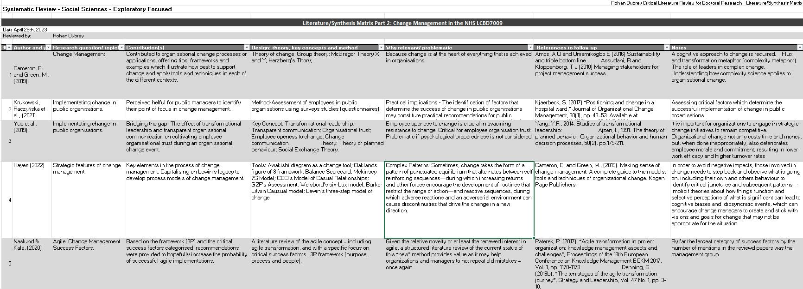

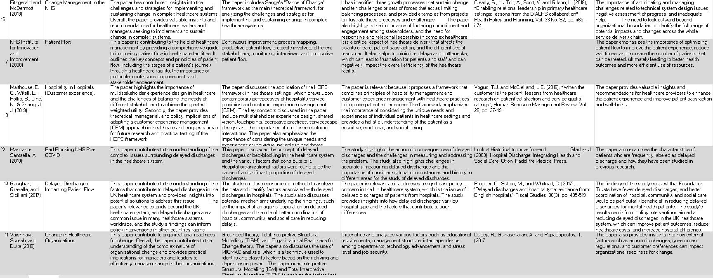

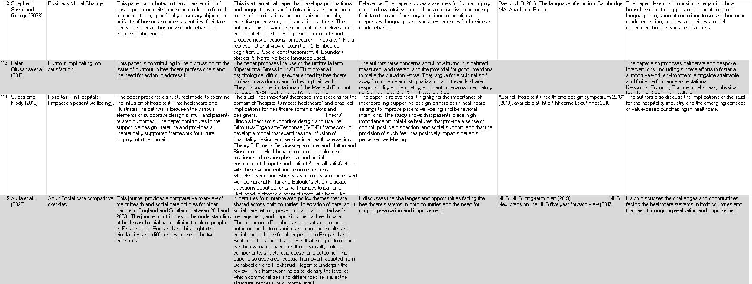

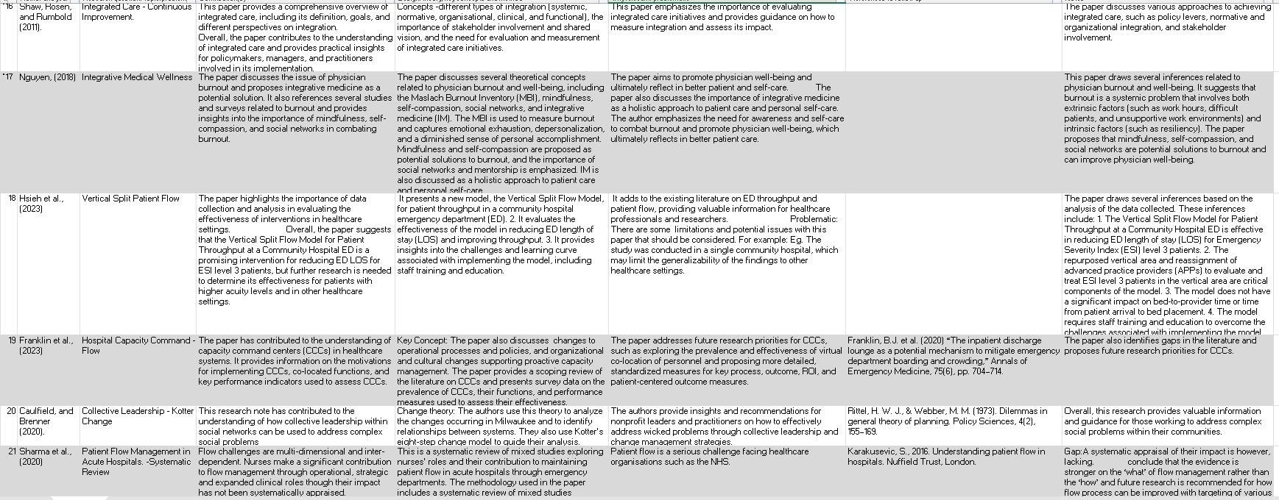

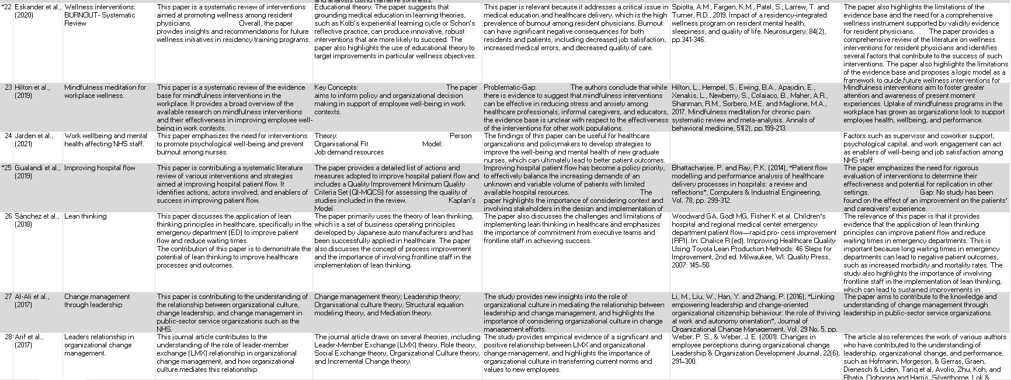

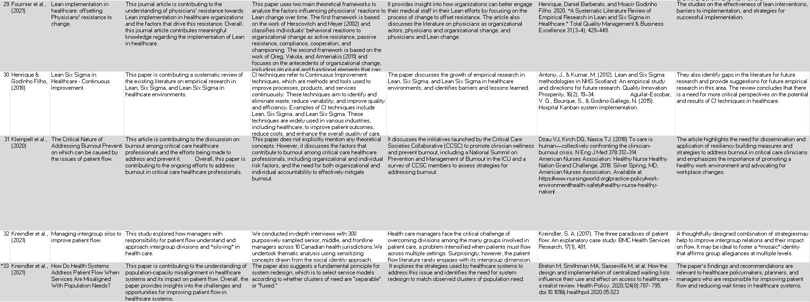

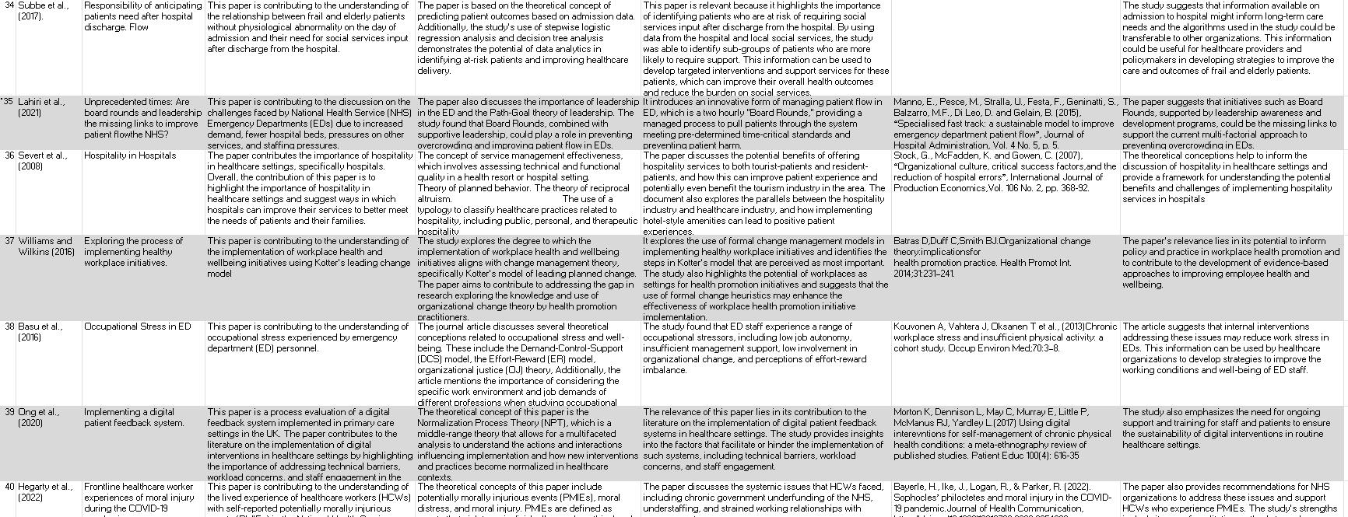

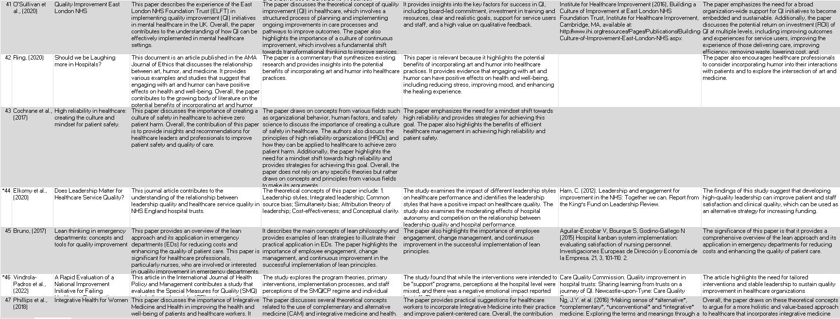

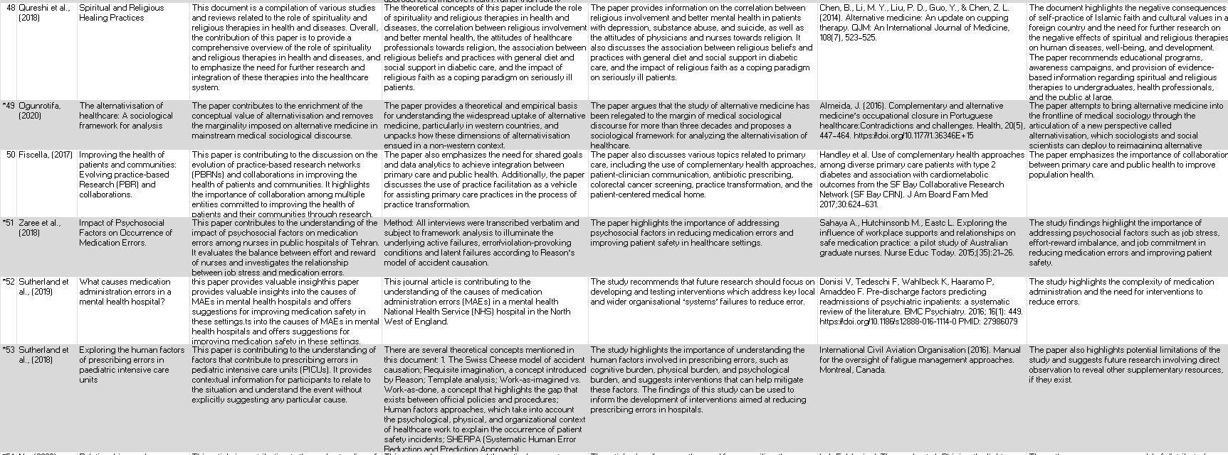

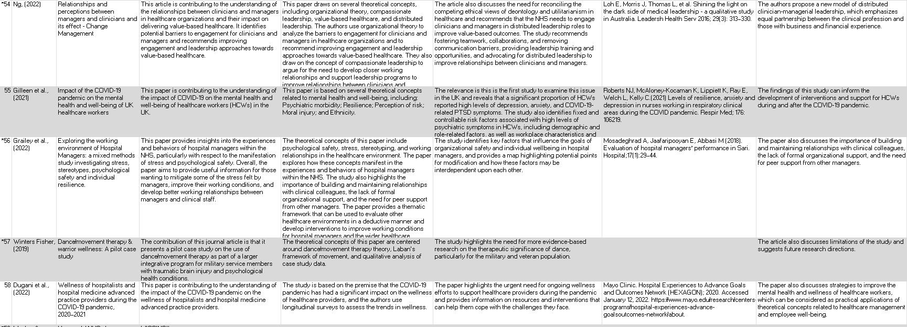
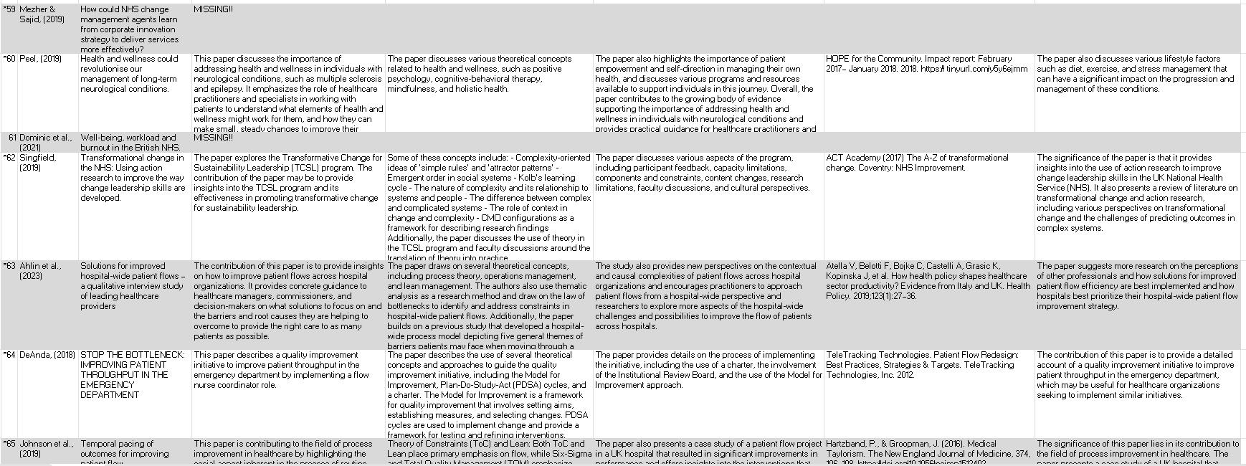
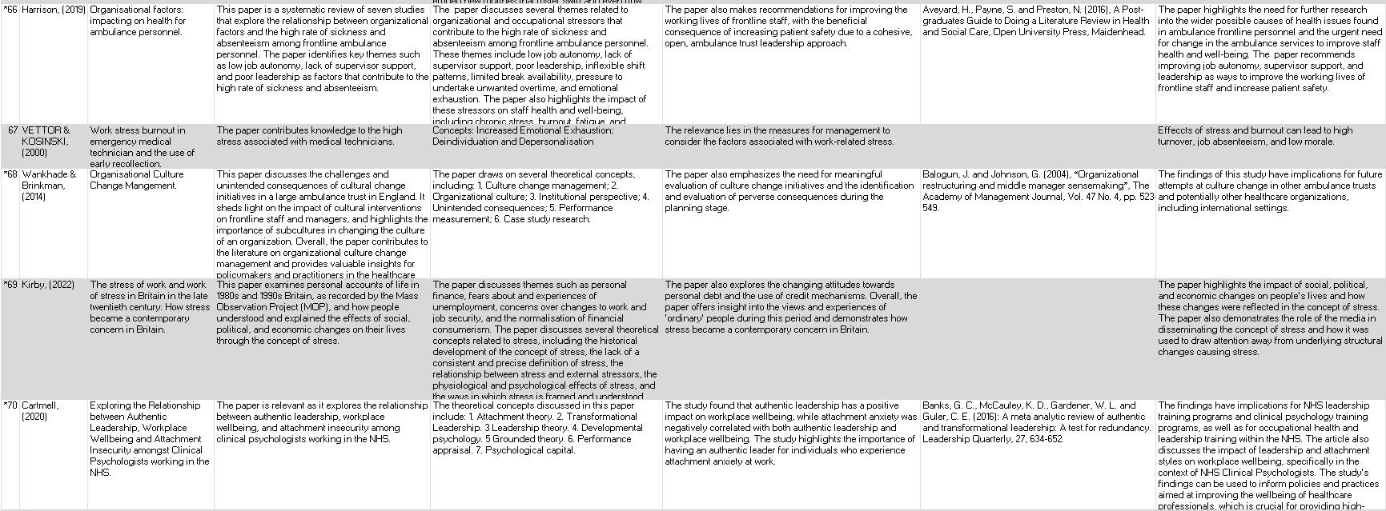
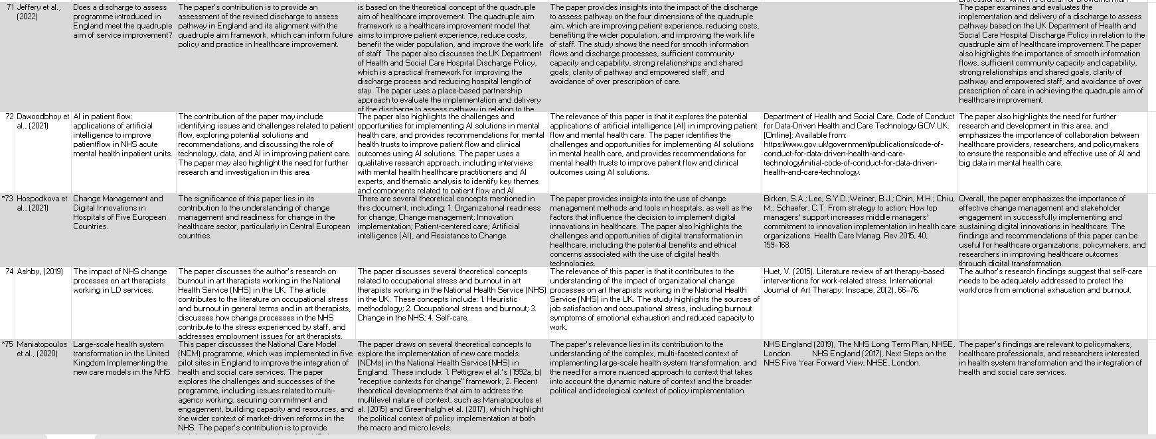
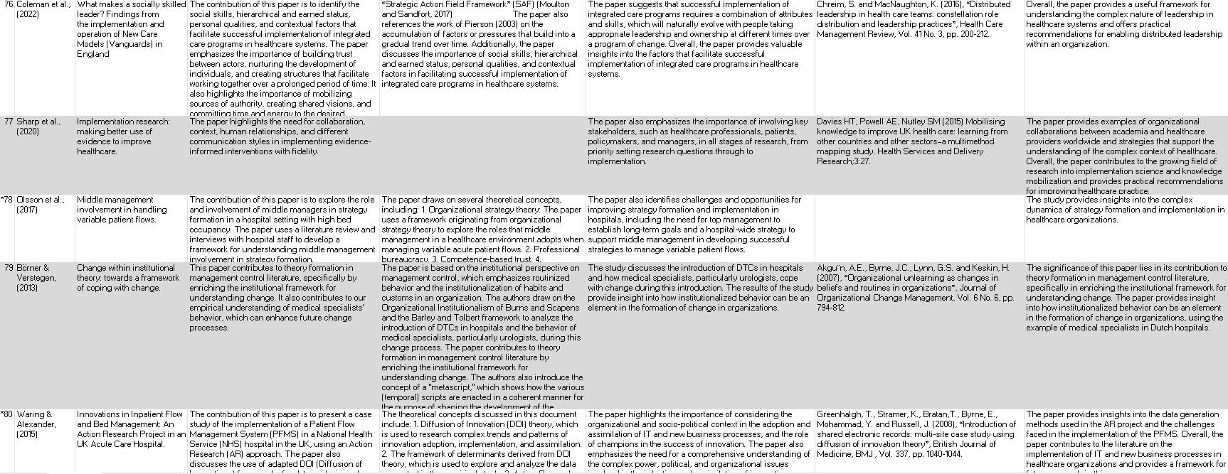

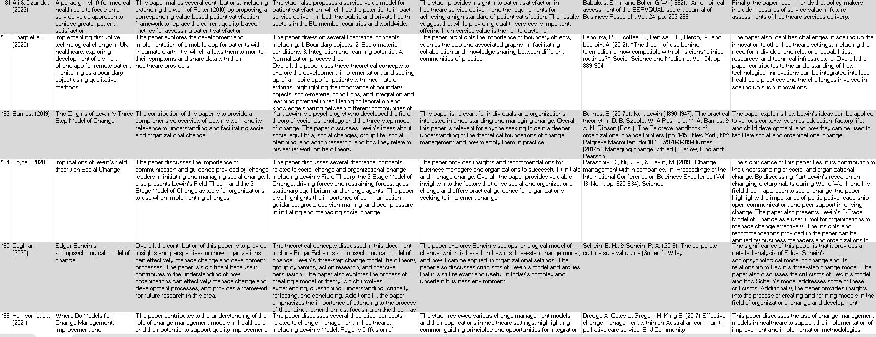
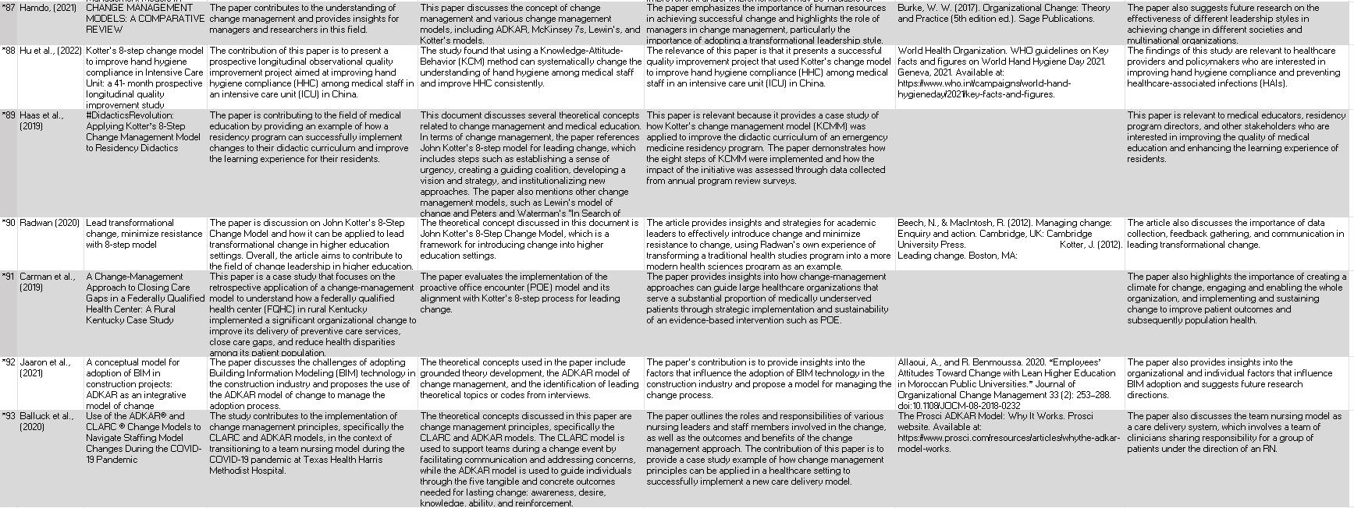
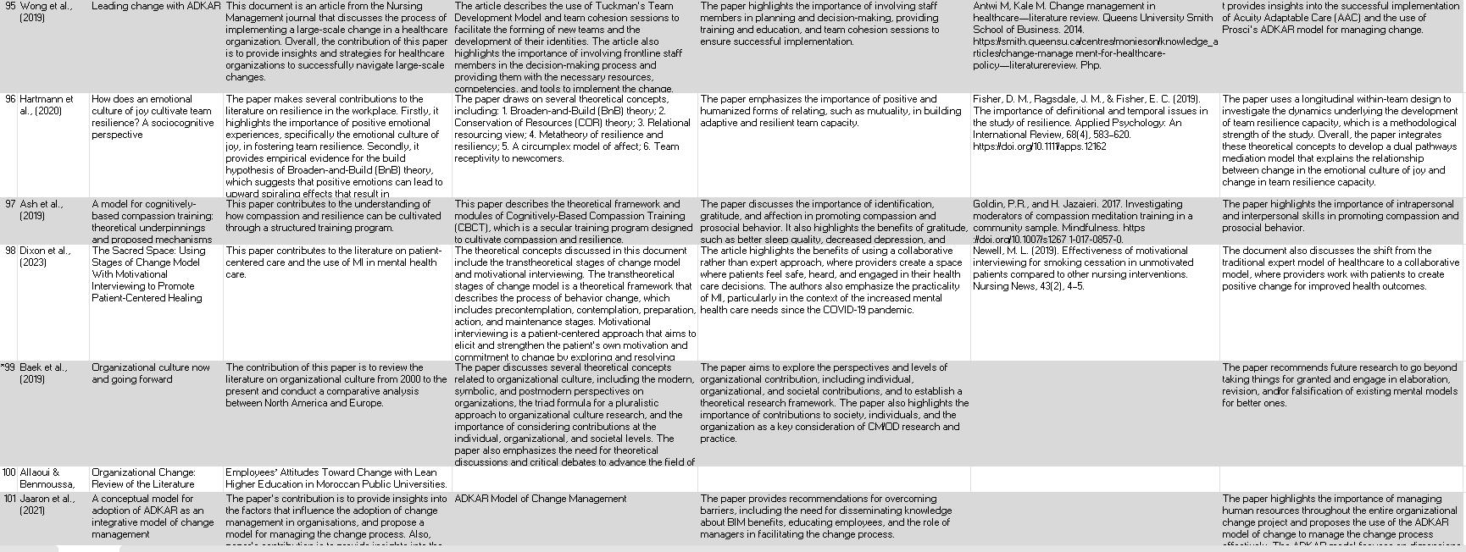

Chapter 3 Literature Review

3.0 Introduction

The correlation of change management to the designed strategies of patient flow provides several technical challenges to cause stress impacting hospital staff (Jarden et al., 2021; Basu et al., 2016; Hegarty et al., 2022). Multiple studies link the challenges of patient flow on leadership capabilities to the increased correlation of change management in public sector hospital organisations across several countries such as Europe, the United Kingdom, America, and Australia. Additionally, studies have shown the importance of leadership concerning managing stress, particularly in public sector health organisations or similar (Gaughan, Gravelle, and Siciliani, 2017; Hsieh et al., 2023; Sharma et al., 2020).

Patient flow is traditionally a process designed to create a series of care pathways to improve the flow of patients from the Emergency Department (ED) through various hospital settings, returning home or into social care (Gaughan, Gravelle, and Siciliani 2017). This process is a corroboration of the leadership capability to implement change management resulting in a seamless process of patients moving from one stage of their care to the next. The process requires a radical change in reducing staff stress (Ahlin et al., 2023; DeAnda, 2018). Appropriate change management fosters better well-being, reducing employee stress and enabling staff to look after patients more aptly. In return, staff whose well-being is positively impacted will sway the results in improved patient experience (Cartmell, 2020; Hilton et al., 2019; Al-Ali et al., 2017).

Hospitals are notoriously complex, which presents difficulties in managing and achieving the goals and objectives of assisting sick patients in recovering from their illnesses (Graley, 2017). Notably, change management is a crucial element in improving hospital services to attain the vision and mission of the organisation (Al-Ali et al., 2017). This preliminary traditional scoping literature review will focus primarily on change management, outlining key concepts and theories to evaluate the integration of hospitality in SDEC. The gaps discovered will be highlighted to form the basis of further research. Cameron, Esther, and Green (2019) outlined that the ideal target audience stems from anyone who wants to understand why change occurs ultimately and what needs to be done to make change a more welcoming concept for change management. The literature review will focus on Web of Science, Business Source Complete, Science Direct, PubMed, and Scopus databases. The important keywords are "change management", "patient flow", "employee well-being", "hospitality", and "integrative medical wellness". This literature review will aid in validating the final thesis at the end of the study.

3.1 Change Management

Change management is the process of planning, implementing, and managing adjustments to an organisation's procedures, technologies, or structure. It entails using a structured process to move people, teams, and organisations from their current state to a planned future state (Krukowski, Raczyńska et al., 2021; Hayes, 2022). Cameron, Esther, and Green (2019) outlined that change management can be executed excellently or poorly. Change management typically entails a series of actions (Williams and Wilkins, 2016) that guarantee adoption of a change project (Hayes, 2022). These activities could include determining the need for change, developing an implementation plan, informing stakeholders of the change, identifying, and mitigating risks, giving employees training and support, and tracking the change's results to ensure it achieves its objectives (Sharp et al., 2020). The main objective of change management is to ensure that the organisation accepts and embraces the change while minimising its adverse effects on employees (Hayes, 2022).

It is possible to date the beginnings of what is now known as change management before the 1990s (Doppelt, 2010). Levine (2016) asserts that change management has developed from fundamental beliefs through conceptual foundations to an established discipline. Prosci (2018) asserts that the development and expansion of the change management discipline may be categorised into four key areas, shown in Figure 1.0.

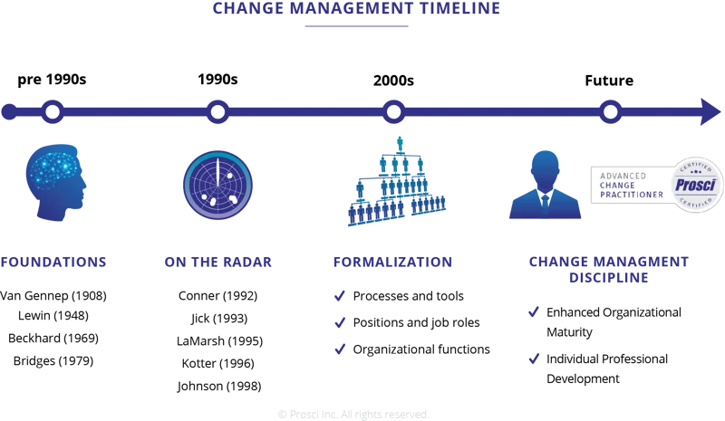

Figure 1.0 Change Management Timeline (Prosci.com, 2022)

Notably, the beginning of the 20th century saw the emergence of management ideas and practices as a separate subject of study, which is when the history of change management began (Keulen and Kroeze, 2014). Nevertheless, widespread acceptance of the formalised approach to change management did not occur until the second half of the 20th century. It can be argued that several scholars have emerged over the decades with salient literature to outline and justify the emergence of change management and its importance to organisations. Firstly, Management theorists such as Kurt Lewin created theories of change in the 1940s that emphasised the significance of comprehending and managing the psychological components of change (Caulfield and Brenner, 2020). Many organisations still use Lewin's three-stage change model (unfreezing, changing, and refreezing) below in Figure 1.2 as a framework for comprehending and implementing change.

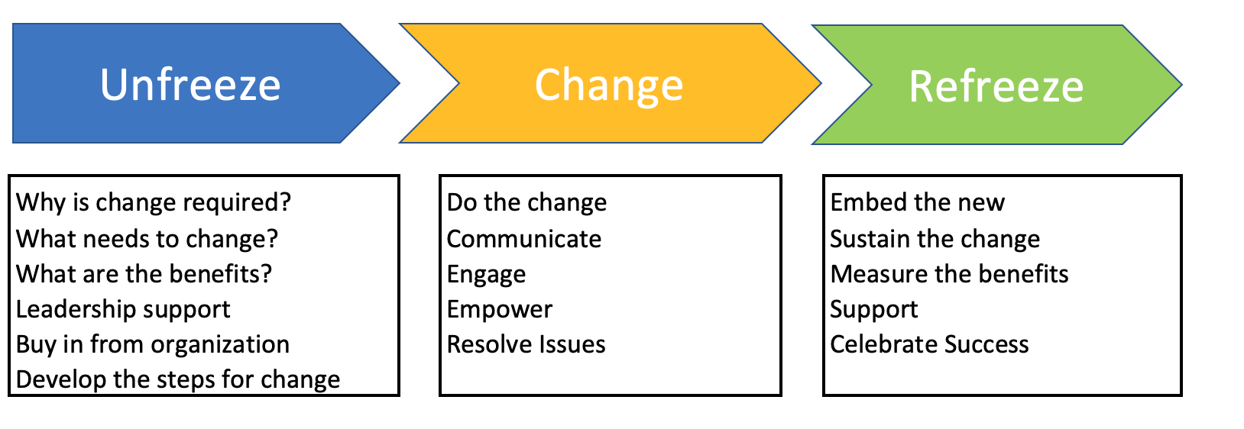

Figure 1.2 Lewin’s Theory of Change (Richard, 2020)

Secondly, Organisational development (OD) is a field of study that focuses on enhancing organisational efficiency through deliberate interventions (Cummings and Worley, 2014; Bushe and Markshak, 2009), which first came to prominence in the 1960s and 1970s. OD practitioners used various tools and approaches to enable change, such as team building, process consultation, and survey feedback. Bushe (2017) noted that the emphasis on change management changed towards a more strategic and business-oriented approach in the 1980s and 1990s. Furthermore, quality management systems such as Total Quality Management (TQM) and Six Sigma became popular as techniques to drive organisational progress (Pambreni et al., 2019). Several management consultants, such as Michael Porter and Gary Hamel, created frameworks for strategic change; however, these frameworks need revisiting to incorporate the well-being of staff in healthcare organisations.

Today, as organisations seek to manage complex and interrelated projects, change and project management have become increasingly interwoven (Naslund and Kale, 2020). Scholars have pinpointed that scrum and other agile processes have become prevalent methods for managing change in the software industry and other sectors (ibid). In contrast, Mueller and Jungwirth (2020) concluded that agile techniques strongly emphasise cooperation, which can become a bottleneck. A lack of participation from team members or stakeholders can cause communication breakdowns or delays, impeding progress and decision-making. Therefore, scrum and other agile processes are dependent on collaboration and communication.

Despite this, (Cameron and Green, 2019; Kjaerbeck, 2017) opined that change management continues to change as organisations encounter new opportunities and problems. Globalisation, sustainability, and digital transformation are just a few of the forces influencing the direction of change management in the health sector.

3.2 Change Management in the NHS

The NHS context has received widespread media attention as being in crisis and, more recently, with the Covid-19 pandemic's attack, as needing rehabilitation (Kleinpell et al., 2020). The National Health Service (NHS) has been labelled an organisation in crisis, requiring radical change to prevent failings (ibid). As a result, operational SDEC units and workforce initiatives (People Plan) have surfaced over the preceding two years (BMA, 2022). This new improvement gives effective patient care operations, NHS staff, and the preservation of their well-being much attention. This approach is a valuable chance for a developing strategic leader to determine whether and to what degree actions developed for efficient patient care operations through the SDEC model could be applied locally. In addition, under rules for employee well-being in people performance management.

The NHS uses change management to execute changes to the healthcare system while ensuring that daily operations run smoothly. The complexity and magnitude of the NHS can make change management extremely difficult (Ng, 2022; Beasley et al., 2020). Nevertheless, within the context of the NHS, Grailey et al. (2022) outlined that change management involves improving work conditions concerning stress some managers feel to improve their working conditions, and develop better working relationships between managers and clinical staff. In agreement, Hegarty et al. (2022) found that the theme of stress concerning NHS staff has been professed to evoke change management when mitigating stress felt by NHS staff.

The studies identified vital factors influencing hospital managers' organisational safety goals and individual well-being. The map below in Figure 1.3 highlights potential points for modification and how these factors may be interdependent upon each other during the change management process (Grailey et al., 2022). To assess what has been covered by both scholars, understanding the relationship between NHS staff and job satisfaction, high turnover, and stress is crucial to strategise in achieving the best outcome. Furthermore, previous studies highlighted that change management within the complexity of the NHS could be lacking in support due to the constraints in the application (Rajamohan et al., 2019). Figueroa et al. (2019) noted that health systems are complicated and constantly evolving across various contexts and health service levels. Therefore, it can be argued that it is still unclear what skills health managers and leaders need to respond to recent and upcoming problems. Nevertheless, Springfield (2019) provided insights into using action research to improve change leadership skills in the NHS. Various perspectives on transformational change and the challenges of predicting outcomes in complex systems are crucial (ibid).

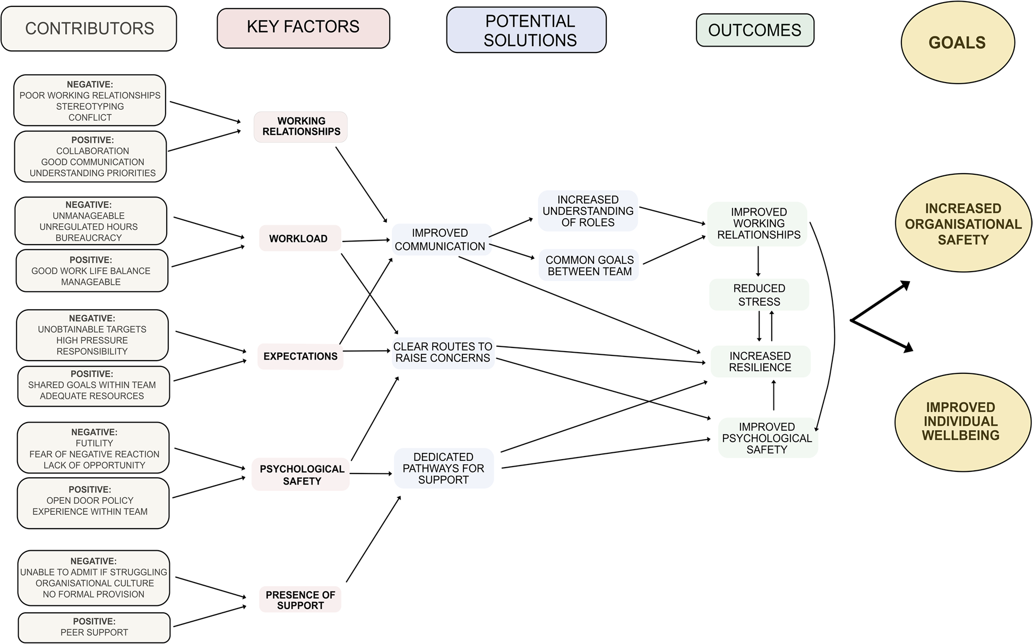

Figure 1.3 Factors associated with hospital administrators' goals for organisational safety and employee well-being. (Grailey et al., 2022) Adapted.

Change management in the NHS is vital for several reasons. First, it enables the organisation to navigate the complex healthcare system, enhance patient care, foster innovation, and encourage a culture of continuous improvement (Al-Ali et al., 2017). Secondly, change management in the NHS promotes fulfilling the mandate to provide the people it serves with high-quality, affordable, and sustainable healthcare services (O'Sullivan et al., 2020). It could be argued that change management promotes structure to reduce disruption and initiate new working methods. On the other hand, due to the rising shift in patient demands, the NHS must adjust to fulfil these demands whilst considering the impact on employees.

Several scholars have produced work promoting the position of change within the NHS. Figueroa et al. (2019) opined that to fulfil the demands of an ageing population, an extended lifespan, and complicated health issues, it is essential for modern health service delivery to adapt and develop. Harrison et al. (2021) applied Kotter’s (1995) model and Lewin's (1951) model to improve and support the position of change management approaches. In contrast, Regmi and Mudyarabikwa (2020) outlined barriers associated with implementing clinical commissioning policies to improve health and well-being. In view of this, navigating such barriers are crucial to delivering change.

On the other hand, often, individuals confuse the term ‘commissioning’ with contracting, hiring, and authorising, which creates resistance to change. Department of Health (2007) noted that there has been considerable debate about the definition and interpretation of this term. However, commissioning is converting needs and aspirations into services for users by identifying and acquiring services for the local population (ibid). Therefore, commissioning as a change management procedure produces the finest health and well-being results possible, emphasising equality, among other things.

Considering the literature on change management within the context of the NHS, it is necessary to consider the perspectives on the issues that further research will highlight. To begin with, the importance of leadership style must be considered to evoke change (Elsan Mansaray, 2019). Following this, provenance concerning the author's credentials was considered to ensure that the argument concerning the stress impact of patient flow on NHS staff was supported by evidence. The intended research shares similarity with the above argument considering the gap in the literature to reduce the impact of stress on NHS SDEC staff. The proposed method is looking at incorporating hospitality in hospitals.

3.3 Hospitality in Hospitals

The practice of welcoming and entertaining visitors, guests, or strangers amicably and generously is known as hospitality (Suess and Mody, 2018). Hospitality involves anticipating and meeting the needs and expectations of guests, ensuring their comfort, and making them feel valued and cared for (Hunter-Jones et al., 2020). Hospitality covers a wide range of businesses and industries, including hotels, dining, travel, event planning, and customer service. However, hospitality is not limited to providing accommodation and food services; it extends to creating a positive and welcoming experience for individuals or groups in various settings. Complimentary to this, hospital services include meeting the needs and expectations of patients and making them feel valued and cared for. Therefore, aspects of hospitality have been instilled into hospitals for centuries.

Subsequently, they are various aspects of hospitality involving the onus of the organisation to look after their staff, who in return looks after their guests to create the guest service journey (Nguyen et al., 2020). Upon concluding the study, Severt et al. (2008) professed the potential advantages of providing hospitality services to tourists and local patients, how this might enhance patient experience and perhaps even help the local tourism economy. Similarities between the hospitality and healthcare industries and how adding hotel-style facilities might improve patient satisfaction are contemporaneous. Suess and Mody (2018) study opined a well-structured model that shows the relationships between various supportive design stimuli and patient-related outcomes and examines the introduction of hospitality into healthcare. The paper adds to the body of knowledge on supportive design and offers a theoretically grounded foundation for further research.

Moving on, this section identifies the working definition of hospitality in this context, which does not resonate with the aesthetic definition of hospitality in hospitals that have already been researched; instead, the introduction of integrative medical wellness to support the well-being of SDEC staff resulting from the impact of stress caused by patient flow. Previous studies have concluded with several attributes of hospitality, including listening and community focus (Pope and Burns, 2013), trust, and servant leadership (Bavik, 2019). Notably, this approach will foster exploring a larger spectrum.

Outstandingly, leadership plays a significant role within the hospitality industry. Dierendonck (2011) emphasised that a challenging leadership method and burgeoning research area is servant leadership. Another prevalent perception is that it is a powerful employee-focused leadership style with the potential to produce fruitful organisational outcomes. Indeed, according to empirical research, servant leaders have a positive impact on outcomes at all organisational levels, including the individual, team, unit, and company levels, required for change management within hospitals (Bavik et al., 2017; Williams et al., 2017; Chon and Zoltan, 2019).

Several studies (Erickson and Rothberg, 2017; Suess and Mody, 2017; Majeed and Kim, 2022) noted that hospitality could significantly impact continuous improvement development within hospitals in the following ways. Firstly, from a patient context applying hospitality concepts to the healthcare industry can significantly improve the entire patient experience. Hospitals may create a comfortable and welcoming environment by implementing a customer-centric strategy and treating patients as guests (Klaus, 2018; Russell-Bennett et al., 2017). This approach comprises compassionate and attentive care, open lines of communication, welcoming surroundings, and customised services. Along with increasing happiness, a good patient experience promotes more remarkable health outcomes and patient loyalty. Secondly, from a staff well-being perspective, hospital worker engagement might follow the same rules as hospitality. This engagement fosters a culture of hospitality among healthcare employees, encourages continuous improvement programmes, and generates a healthy work atmosphere (Majeed and Kim, 2022). Healthcare personnel are more likely to be interested and motivated in their work when they feel respected, supported, and empowered. As a result, there is an increase in output, teamwork, and care quality.

From the literature gathered several studies have supported the position of hospitality in hospitals. However, Suess et al. (2017) concluded that the idea of a physical environment which affects patient outcomes is not new, though features of aesthetic design and hotel-like architecture are not the only factors that can influence patients' experience. Notably, staff well-being and behavioural intention, such as willingness to spend more on private healthcare, are crucial. Malthouse et al. (2019) provided a comprehensive picture of the patient as a cognitive, emotional, and social entity. The scholars emphasised the significance of taking individual patients' specific needs and experiences into account in healthcare settings. Therefore, effective leadership is essential in considering the well-being of staff, which is paramount.

In earlier studies on wellness and medical tourism, there is some evidence of debate regarding hotel-like services with healthcare treatments. For instance, while considering wellness travel, Majeed and Kim's (2022) study showed how Eastern and Western healthcare practices and healthcare hospitality work together to improve visitors' wellness experiences, health and well-being, and behavioural intentions. However, (ibid) work exhibits a rudimentary knowledge of hospitality in healthcare.

In addition, previous studies have attempted to emphasise the significance of hotel services in enhancing patient well-being and positive attitude by referencing the ideas of constructed design, aesthetic environment, appealing indoor aroma, and hospitable attitude in addition to caring and courteous guest reception and departure (Kim et al., 2021; Mody et al., 2020). These studies offer a springboard for further exploration of the dynamic function of hospitality in an acute hospital setting. In addition, it explores the vital function of healthcare and hospitality in hospitals to reduce the stress impact on employees. For example, SDEC departments could support Patient Staff Experience (PSE) and the health and well-being of staff. This research gap must be filled to promote PSE by applying theoretical models.

3.4 Theories of Change

Nowadays, many organisations must quickly adapt how they operate daily. In particular, it is crucial in the context of the NHS, where it is believed that ongoing change is necessary for health sectors to adjust to market demands and the state of the global economy. Change management is a never-ending cycle that calls for a clear vision, a well-thought-out plan, time, talent, inspiration, and financial and automatic efforts to carry out the change (Al-Ali et al., 2017). Additionally, it is an endeavour and contributor to a systematic turn of events, effective in change management. This chapter reviewed extant and relevant literature on the most well-known change management models. There are a few different change management models accessible, and selecting the most suitable model is crucial for leading or directing successful and seamless changes.

Theoretical discussions in qualitative research concern the epistemological paradigms, such as postpositivist and constructivist (Crotty, 1998). Theories relate to grounding the methodological approach. For example, phenomenology, ethnography, or storytelling underpinning a study. It is crucial to comprehend the ideas that affect choices made in the methodology and epistemology for a research project to explore the phenomenon. This study looked at several theories of change to extrapolate a suitable theoretical framework to cover the philosophical viewpoint. This method essentially links the author's epistemology to the theoretical framework.

3.4.1 Lewin’s Change Theory

Historically, Lewin’s (1940) theory of change consisted of three stages, analysing change as a process of transitioning from the present to the final phase and supported by field research, team dynamics, and academic studies (Rosenbaum et al., 2018). These three stages (see Figure 1.4) illustrate how people, communities, and organisations may successfully achieve long-lasting change. The concept is also known as the "Lewinian Change Model" or the "unfreeze-change-refreeze" model. However, Shiela and Rugami (2018) questioned the relevance of Lewin's theory in an ever-changing organisational setting, affirming limitations to addressing the human factor of transformation. Nevertheless, Hidayat et al. (2020) opined that although Lewin's theory offers a broad framework for comprehending the change process, the real-life execution of change can be complex and influenced by several elements, including organisational culture, leadership style, and the surrounding environment. The approach remains prominent in change management and offers a helpful framework for organising and leading change projects.
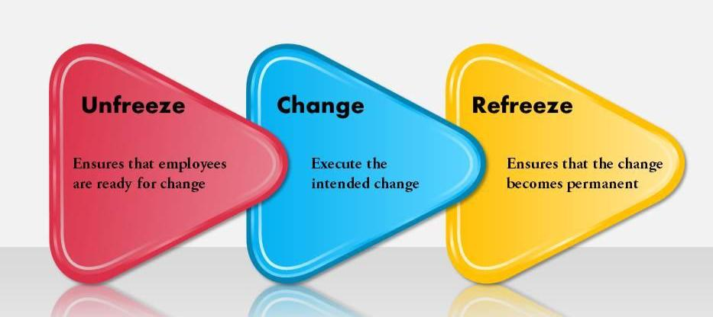

Figure 1.4 Kurt Lewin’s Theory Illustrated (Slideteam.net, 2021)

Teguh et al. (2019) outlined that Lewin's change model has several benefits that add to its acceptance and usefulness in managing change, such as the participation and involvement of others during the process. Participating in the change process as NHS staff can improve motivation, lessen opposition, and increase the possibility that the change will be effective. Lewin's methodology encourages a sense of ownership and commitment by involving key players and soliciting their input at various points along the process (ibid).

Nevertheless, while Lewin's change model includes several benefits, certain restrictions and potential downsides should be considered. For example, the limited emphasis on continuous change. Shiela and Rugami (2018) argued that according to Lewin's model, change happens in various phases and is finished and stable once it reaches the "refreeze" stage. However, Arif et al. (2017) outlined that change is frequently constant and continual in the quick-paced commercial climate of today’s healthcare sector. Due to the emphasis on stability, the model might not fully account for the need for ongoing adaptation and adaptability required in today’s NHS.

3.4.2 Kotter’s Change Theory

Kotter's theory of change outlines a methodical framework for guiding organisational transformation below in Figure 1.5. The model offers a plan for successfully implementing change, consisting of eight steps, also known as the "8-Step Process for Leading Change" (Odor, 2018). Kotter's theory intends to assist organisations in navigating the difficulties of change, overcoming opposition, and achieving successful and lasting transformation by using these processes. Communication is critical in implementing change. Ensuring everyone in the organisation has access to the transformation vision is crucial. This approach guarantees that everyone understands and supports the vision, which entails employing a variety of channels and tactics.

The benefit of this theory is that it coincides with the focus of the aforementioned leadership capabilities. In promoting and overseeing change, Kotter's philosophy emphasises the function of leadership. It emphasises the significance of effective leadership throughout the change process to energise, excite, and mentor staff, address opposition, and remove barriers (Bedoya, 2018). On the other hand, researchers must be cognisant of the reviewed literature outlining the lack of adaptability concerning the theory. Bedoya (2018) purported that Kotter's eight-step method might not be sufficiently adaptable for all organisational settings, centring on a top-down style. A one-size-fits-all strategy may not always be appropriate as different organisations have different cultures, structures, and requirements for change. It could be required to be flexible and adapt the change process to the organisation's unique requirements.

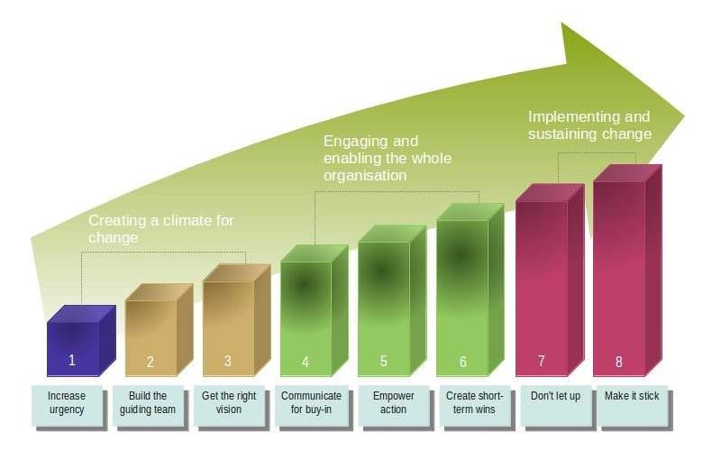

Figure 1.5 Kotter’s 8-step change model (Kotter,1996)

3.4.3 ADKAR Theory

A popular approach in change management procedures is the Prosci ADKAR theory of change below (see Figure 1.6). The acronym ADKAR stands for Awareness, Desire, Knowledge, Ability, and Reinforcement, the five essential components required for successful transformation at the individual level (Tusiime, 2019). As an organisation changes, it offers a framework for comprehending and managing individual transformations. From the literature gathered, Shiela and Rugami (2018) argued that the ADKAR model strongly emphasises dealing with each person's unique characteristics of change and acknowledges that successful organisational change depends on the smooth transitions of the participants. Therefore, organisations may successfully lead people through the change process and improve the likelihood of acceptance and implementation by concentrating on each model component.

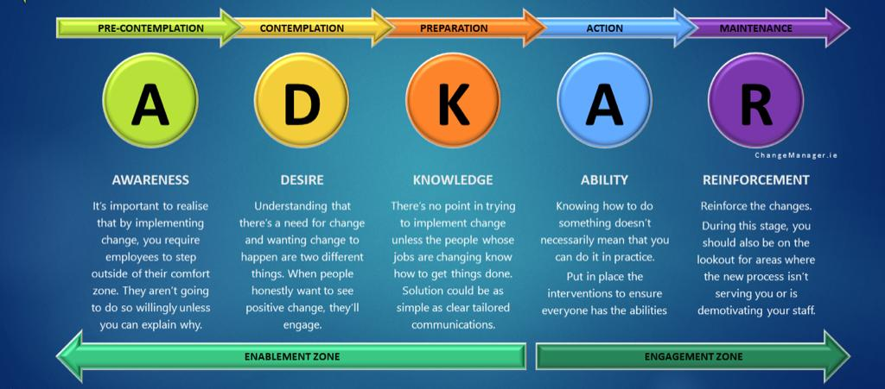

Figure 1.6 ADKAR Theory of Change (Tapi, 2022)

The model is advantageous in focusing on the context of individuals (ibid). The ADKAR paradigm acknowledges that individual-level transformation is necessary for success. The methodology helps establish a supportive atmosphere for change and raises the chances of successful adoption by addressing the needs and concerns of individuals. Hayes (2022) professed awareness and desire to enable the approach, which strongly emphasises the value of inspiring awareness and a desire for change. Organisations can boost employee engagement, dedication, and drive by clearly explaining the justifications for and advantages of the change.

Nevertheless, the model has limitations derived from the theme of individuality discovered in the literature. Although the ADKAR model offers a framework for comprehending individual transitions (Luke, 2021), it does not provide in-depth advice on change management techniques or targeted interventions to deal with the difficulties at each step (Jaaron et al., 2021). Additional change management frameworks or techniques might be required to supplement the ADKAR model for a more all-encompassing strategy.

Consequently, it is vital to remember that the abovementioned limitation does not render the ADKAR model incorrect but draws attention to some of its shortcomings, potential customisation, or support needs. When using the ADKAR model, organisations should consider these elements and, if necessary, supplement them with additional change management strategies. In short, it is crucial to understand that change management is a complicated and comprehensive process, and no one model can adequately represent all its facets. While Lewin's model is an excellent place to start, organisations may need to add other theories, techniques, or frameworks to handle the challenges and complexities of successfully managing change as per the gap discovered.

3.5 Research Gap

The current literature review on change management revealed complex problems arising from patient flow affecting patients' experience. The focus is on improving the experience of patients using change management as a process to interpolate seamless pathways. Nevertheless, the stress impact on employees resulting from the cyclical process, complexities, and patient flow challenges often results in staff burnout and high employee turnover.

The literature revealed that the skills health managers and leaders require to deal with the recent and upcoming problems within the NHS lack of support is unclear. Therefore, a gap has emerged in the literature reviewed for a radical change to implement and manage hospitality in the form of (integrative medical wellness) for staff to reduce stress caused by the complexities of patient flow. In return, the hypothesis is that this approach could reduce cost, high turnover, sickness, and burnout.

3.6 Conclusion

The literature reviewed concludes that change management is a strategic process involving complexities in the NHS. Importantly, understanding potential restrictions is essential to preventing study setbacks. However, it is evident from the literature that there is a chance to carry out research based on the gap identified in this sector. There is a lack of research on these SDEC high-pressure, quick-results units' effects on their staff. Nonetheless, the literature highlighted the importance of merging change management, leadership, stress, and patient flow to foster the opportunity of hospitality in the context of integrative medical wellness to improve staff well-being.

References

Ahlin, P., Almstrom, P. and Wanstrom, C. (2023) ‘Solutions for improved hospital-wide patient flows – a qualitative interview study of leading healthcare providers’, BMC Health Services Research, 23(1).
Al-Ali, A.A. et al. (2017) ‘Change management through leadership: The mediating role of organizational culture’, International Journal of Organizational Analysis, 25(4), pp. 723–739.
Ali, N. and Dzandu, M.D. (2023) ‘A paradigm shift for medical health care to focus on a service-value approach to achieve greater patient satisfaction’, Journal of Health Organization and Management, 37(2), pp. 133–157.
Allaoui, A. and Benmoussa, R. (2020) ‘Employees’ attitudes toward change with lean higher education in Moroccan public universities’, Journal of Organizational Change Management, 33(2), pp. 253–288.
Arif, M. et al. (2017) ‘Role of leader-member exchange relationship in Organizational Change Management: Mediating Role of Organizational culture’, International Journal of Organizational Leadership, 6(1), pp. 32–41.
Ash, M. et al. (2019) ‘A model for cognitively-based Compassion Training: Theoretical underpinnings and proposed mechanisms’, Social Theory & Health, 19(1), pp. 43–67.
Ashby, E. (2019) ‘The impact of NHS Change Processes on art therapists working in LD Services’, International Journal of Art Therapy, 25(1), pp. 19–29.
Aujla, N. et al. (2023) ‘A comparative overview of Health and social care policy for older people in England and Scotland, United Kingdom (UK)’, Health Policy, 132, p. 104814.
Baek, P., Chang, J. and Kim, T. (2019) ‘Organizational culture now and going forward’, Journal of Organizational Change Management, 32(6), pp. 650–668.
Balluck, J., Asturi, E. and Brockman, V. (2020) ‘Use of the ADKAR® and CLARC ® change models to navigate staffing model changes during the COVID-19 pandemic’, Nurse Leader, 18(6), pp. 539–546.
Basu, S., Yap, C. and Mason, S. (2016) ‘Examining the sources of occupational stress in an emergency department’, Occupational Medicine, 66(9), pp. 737–742.
Bavik, A. (2020) ‘A systematic review of the servant leadership literature in management and hospitality’, International Journal of Contemporary Hospitality Management, 32(1), pp. 347–382.
Bavik, A., Bavik, Y.L. and Tang, P.M. (2017) ‘Servant leadership, employee job crafting, and citizenship behaviours: A cross-level investigation’, Cornell Hospitality Quarterly, 58(4), pp. 364–373..
Beasley, L., Grace, S. and Horstmanshof, L. (2020) ‘Responding and adapting to change: An Allied Health Perspective’, Leadership in Health Services, 33(4), pp. 339–349.
Bedoya, E. 2018. Contributions of transformational management style to change management. Faculty of Business and Economics: 163-172. Available: https://www.researchgate.net/publication/345344646 (Accessed 9 May 2023).
Bruno, F. (2017) ‘Lean thinking in emergency departments: Concepts and tools for Quality Improvement’, Emergency Nurse, 25(6), pp. 38–41.
Burnes, B. (2019) ‘The origins of Lewin’s three-step model of change’, The Journal of Applied Behavioural Science, 56(1), pp. 32–59.
Bushe, G. R., & Marshak, R. J. (2009). Revisioning organisation development: Diagnostic and dialogic premises and patterns of practice. Journal of Applied Behavioural Science, 45(3), 112-127.

Bushe, G.R. (2017). Creating collaborative organisations that can persist: The partnership principle. OD Practitioner, 49(3), 23-29.
Borner, T. and Verstegen, B. (2013) ‘Change within institutional theory: Towards a framework of coping with change’, Journal of Accounting & Organizational Change, 9(3), pp. 304–321.
Cameron, E. and Green, M. (2020) Making sense of change management: A complete guide to the models, tools, and techniques of organizational change. 5th edn. London: Kogan Page.
Carman, A.L. et al. (2019) ‘A change-management approach to closing care gaps in a federally qualified Health Center: A rural Kentucky case study’, Preventing Chronic Disease, 16.
Chon, K.K.-S. and Zoltan, J. (2019) ‘Role of servant leadership in contemporary hospitality’, International Journal of Contemporary Hospitality Management, 31(8), pp. 3371–3394.
Cochrane, B.S. et al. (2017) ‘High reliability in healthcare: Creating the culture and mindset for patient safety’, Healthcare Management Forum, 30(2), pp. 61–68.
Coghlan, D. (2020) ‘Edgar Schein on change: Insights into the creation of a model’, The Journal of Applied Behavioural Science, 57(1), pp. 11–19.
Coleman, A. et al. (2022) ‘What makes a socially skilled leader? findings from the implementation and operation of new care models (Vanguards) in England’, Journal of Health Organization and Management, 36(7), pp. 965–980.
Dawoodbhoy, F.M. et al. (2021) ‘AI in patient flow: Applications of artificial intelligence to improve patient flow in NHS acute mental health inpatient units’, Heliyon, 7(5).
Denscombe, M. (2021) The good research guide: Research methods for small-scale social research projects. London: Open University Press McGraw Hill.
Dixon, L., Berger, C. and Smalley, B. (2023) ‘The sacred space: Using stages of change model with motivational interviewing to promote patient-centered healing’, Journal of the American Psychiatric Nurses Association, p. 107839032311546.
Dominic, C., Gopal, D.P. and Sidhu, A. (2021) ‘“it’s like juggling fire daily”: Well-being, workload, and burnout in the British NHS - A survey of 721 physicians’, Work, 70(2), pp. 395–403.
Dugani, S.B. et al. (2022) ‘Wellness of hospitalists and hospital medicine advanced practice providers during the COVID‐19 pandemic, 2020–2021’, Journal of Hospital Medicine, 17(4), pp. 259–267.
Easterby-Smith, M. et al. (2021) Management and business research. 7th edn. London: Sage.
Elkomy, S., Murad, Z. and Veleanu, V. (2020) ‘Does leadership matter for healthcare service quality? evidence from NHS England’, International Public Management Journal, 26(2), pp. 147–174.
Elsan Mansaray, H. (2019) ‘The role of leadership style in organisational change management: A literature review’, Journal of Human Resource Management, 7(1), p. 18.
Eskander, J., Rajaguru, P.P. and Greenberg, P.B. (2020) ‘Evaluating wellness interventions for resident physicians: A systematic review’, Journal of Graduate Medical Education, 13(1), pp. 58–69.
Figueroa, C.A. et al. (2019) ‘Priorities and challenges for Health Leadership and Workforce Management globally: A rapid review’, BMC Health Services Research, 19(1).
Fiscella, K. (2017) ‘Improving the health of patients and communities: Evolving practice-based Research (PBR) and collaborations’, The Journal of the American Board of Family Medicine, 30(5), pp. 562–566.
Fournier, P.-L. et al. (2021) ‘Lean implementation in healthcare: Offsetting physicians’ resistance to change’, Production Planning & Control, 34(6), pp. 493–505.
Franklin, B.J. et al. (2020) ‘The inpatient discharge lounge as a potential mechanism to mitigate emergency department boarding and crowding’, Annals of Emergency Medicine, 75(6), pp. 704–714.
Gilleen, J. et al. (2021) ‘Impact of the COVID-19 pandemic on the mental health and well-being of UK Healthcare Workers’, BJPsych Open, 7(3).
Grailey, K. et al. (2022) ‘Exploring the working environment of hospital managers: A mixed methods study investigating stress, stereotypes, psychological safety and individual resilience’, BMC Health Services Research, 22(1).
Gualandi, R., Masella, C. and Tartaglini, D. (2019) ‘Improving hospital patient flow: A systematic review’, Business Process Management Journal, 26(6), pp. 1541–1575.
Haas, M. et al. (2019) ‘#DIDACTICSREVOLUTION: Applying Kotter’s 8-step change management model to residency didactics’, Western Journal of Emergency Medicine, 21(1), pp. 65–70.
Harrison, J. (2019) ‘Organisational factors: Impacting on Health for Ambulance Personnel’, International Journal of Emergency Services, 8(2), pp. 134–146.
Harrison, R. et al. (2021) ‘Where do models for Change Management, improvement and implementation meet? A systematic review of the applications of Change Management Models in healthcare’, Journal of Healthcare Leadership, Volume 13, pp. 85–108.
Hartmann, S. et al. (2020) ‘How does an emotional culture of joy cultivate team resilience? A sociocognitive perspective’, Journal of Organizational Behaviour, 42(3), pp. 313–331.
Hayes, J. (2022) The theory and practice of Change Management. 6th edn. London: Bloomsbury Academic.
Hegarty, S. et al. (2022) ‘“it hurts your heart”: Frontline Healthcare Worker experiences of moral injury during the covid-19 pandemic’, European Journal of Psychotraumatology, 13(2).
Henrique, D.B. and Godinho Filho, M. (2018) ‘A systematic literature review of empirical research in lean and Six sigma in Healthcare’, Total Quality Management & Business Excellence, 31(3–4), pp. 429–449.
Hidayat, A.T., Hariyati, T.S. and Muhaeriwati, T. 2020. Applicability of Lewin’s Change Management Model for Optimization Management Function in Nursing Delegation between Head Nurse and Team Leader: A Mini Project in Jakarta Military Hospital. International Journal of Nursing and Health Services (IJNHS), 3(4): 471- 477. Available: http://ijnhs.net/index.php/ijnhs/home (Accessed 20 May 2023)
Hilton, L.G. et al. (2019) ‘Mindfulness meditation for Workplace Wellness: An evidence map’, Work, 63(2), pp. 205–218.
Hospodková, P. et al. (2021) ‘Change management and digital innovations in hospitals of five European countries’, Healthcare, 9(11), p. 1508.
Hsieh, Alex et al. (2023) ‘Implementation of vertical split flow model for patient throughput at a Community Hospital Emergency Department’, The Journal of Emergency Medicine, 64(1), pp. 77–82.
Hu, F. et al. (2022) ‘Kotter’s 8-step change model to improve hand hygiene compliance in Intensive Care Unit: A 41-month Prospective Longitudinal Quality Improvement Study’, Research Square [Preprint].
Hunter-Jones, P. et al. (2020) ‘Visioning a hospitality-oriented patient experience (HOPE) framework in Health Care’, Journal of Service Management, 31(5), pp. 869–888.
Inouye, K. and McAlpine, L. (2019) ‘Developing academic identity: A review of the literature on doctoral writing and feedback’, International Journal of Doctoral Studies, 14, pp. 001–031.
Jaaron, A.A.M., Hijazi, I.H. and Musleh, K.I. (2021) ‘A conceptual model for adoption of BIM in construction projects: ADKAR as an integrative model of Change Management’, Technology Analysis & Strategic Management, 34(6), pp. 655–667.
Jarden, R.J. et al. (2021) ‘New Graduate Nurse Wellbeing, work wellbeing and mental health: A quantitative systematic review’, International Journal of Nursing Studies, 121, p. 103997.
Jeffery, S. et al. (2022) ‘Does a discharge to assess programme introduced in England meet the quadruple aim of service improvement?’, Journal of Integrated Care, 31(1), pp. 16–25.
Johnson, M., Burgess, N. and Sethi, S. (2019) ‘Temporal pacing of outcomes for improving patient flow: Design Science Research in a National Health Service Hospital’, Journal of Operations Management, 66(1–2), pp. 35–53.
Keulen, S. and Kroeze, R. (2014) ‘Introduction: The era of management: A historical perspective on twentieth-century management’, Management & Organizational History, 9(4), pp. 321–335.
Khan, S.N., Rehman, H.M. and Ghayas, M.M. (2022) ‘Organizational change’, Leadership and Followership in an Organizational Change Context, pp. 197–218.
Kirby, J. (2022) ‘The stress of work and work of stress in Britain in the late twentieth century’, Contemporary British History, 36(4), pp. 622–645.
Kjaerbeck, S. (2017) ‘Positioning and change in a hospital ward’, Journal of Organizational Change Management, 30(1), pp. 43–53. doi:10.1108/jocm-05-2016-0094.
Kleinpell, R. et al. (2020) ‘The critical nature of addressing burnout prevention’, Critical Care Medicine, 48(2), pp. 249–253.
Kraus, S. et al. (2022) ‘Literature reviews as independent studies: Guidelines for academic practice’, Review of Managerial Science, 16(8), pp. 2577–2595.
Kreindler, S. et al. (2021) ‘How do health systems address patient flow when services are misaligned with population needs? A qualitative study’, International Journal of Health Policy and Management [Preprint].
Kreindler, S.A. et al. (2021) ‘Managing intergroup silos to improve patient flow’, Health Care Management Review, 47(2), pp. 125–132.
Krukowski, K., Raczynska, M. and Escher, I. (2021) ‘Change Management Success Factors in polish Public Administration’, EUROPEAN RESEARCH STUDIES JOURNAL, XXIV (Special Issue 3), pp. 1–16.
Lahiri, K., Indrasena, B.S. and Aylott, J. (2021) ‘Unprecedented times in the Emergency Department: Are “Board rounds” and leadership the missing links to improve patient flow?’, Leadership in Health Services, 35(1), pp. 74–90.
Leite, D.F.B., Padilha, M.A. and Cecatti, J.G. (2019) ‘Approaching literature review for academic purposes: The Literature Review Checklist’, Clinics, 74. doi:10.6061/clinics/2019/e1403.
Lim, W.M., Kumar, S. and Ali, F. (2022) ‘Advancing knowledge through literature reviews: “what”, “why”, and “how to contribute”’, The Service Industries Journal, 42(7–8), pp. 481–513.
Luke, K. (2021) ‘Twelve tips for managing change in medical education’, MedEdPublish, 10(1).
Majeed, S. and Kim, W.G. (2022) ‘Toward understanding healthcare hospitality and the antecedents and outcomes of patient-guest hospital-hotel choice decisions: A scoping review’, International Journal of Hospitality Management, p. 103383.
Maniatopoulos, G. et al. (2020) ‘Large-scale health system transformation in the United Kingdom’, Journal of Health Organization and Management, 34(3), pp. 325–344.
Mezher, S. and Sajid, M. (2019) ‘How could NHS Change Management Agents learn from corporate innovation strategy to deliver services more effectively?’, BMJ Leader, 3(2), pp. 52–58.
Mueller, E.F. and Jungwirth, C. (2020) ‘Are Cooperative firms more agile? A contingency perspective on small and medium-sized enterprises in agglomerations and peripheral areas’, Small Business Economics, 58(1), pp. 281–302.
Naslund, D. and Kale, R. (2020) ‘Is agile the latest management fad? A review of success factors of agile transformations’, International Journal of Quality and Service Sciences, 12(4), pp. 489–504.
Ng, J.Y. et al. (2016) ‘Making sense of “alternative”, “complementary”, “unconventional” and “integrative” medicine: Exploring the terms and meanings through a textual analysis’, BMC Complementary and Alternative Medicine, 16(1).
Ng, S.M. (2022) ‘A qualitative study on relationships and perceptions between managers and clinicians and its effect on value-based healthcare within the National Health Service in the UK’, Health Services Management Research, 35(4), pp. 251–258.
Nguyen, J., Ferraro, C. and Sands, S. (2020) ‘Similarity over difference: How congruency in Customer Characteristics Drives Service experiences’, Journal of Business Research, 121, pp. 592–603.
Odor, H.O. 2018. Organisational Change and Development. European Journal of Business and Management, 10(7): 58-64. (Accessed 13 May 2023).
Ogunrotifa, A.B. (2020) ‘The alternativisation of Healthcare: A sociological framework for analysis’, Cogent Social Sciences, 6(1).
Olsson, O.V., Aronsson, H. and Sandberg, E. (2017) ‘Middle management involvement in handling variable patient flows’, Management Research Review, 40(9), pp. 1007–1024.
Ong, B.N. et al. (2020) ‘Implementing a digital patient feedback system: An analysis using normalisation process theory’, BMC Health Services Research, 20(1).
O’Sullivan, O.P. et al. (2020) ‘Quality Improvement at East London NHS Foundation Trust: The pathway to embedding lasting change’, International Journal of Health Governance, 26(1), pp. 65–72.
Palmatier, R.W., Houston, M.B. and Hulland, J. (2017) ‘Review articles: Purpose, process, and Structure’, Journal of the Academy of Marketing Science, 46(1), pp. 1–5.
Pambreni, Y. et al. (2019) ‘The influence of Total Quality Management toward organization performance’, Management Science Letters, pp. 1397–1406.
Patriotta, G. (2020) ‘Writing impactful review articles’, Journal of Management Studies, 57(6), pp. 1272–1276.
Paul, J. and Criado, A.R. (2020a) ‘The Art of Writing Literature Review: What do we know and what do we need to know?’, International Business Review, 29(4), p. 101717.
Paul, J. and Criado, A.R. (2020b) ‘The Art of Writing Literature Review: What do we know and what do we need to know?’, International Business Review, 29(4), p. 101717.
Peel, C. (2019) ‘Health and wellness could revolutionise our management of long-term neurological conditions’, British Journal of Neuroscience Nursing, 15(4), pp. 194–199.
Phillips, J.K., Cockrell, S.A. and Parada, A.N. (2018) ‘Integrative health for women’, Primary Care: Clinics in Office Practice, 45(4), pp. 719–729.
Prestia, A.S. (2020) ‘Failure’:, Nurse Leader, 18(6), pp. 616–619.
Qureshi, N.A., Khalil, A.A. and Alsanad, S.M. (2018) ‘Spiritual and religious healing practices: Some reflections from Saudi National Center for Complementary and Alternative Medicine, Riyadh’, Journal of Religion and Health, 59(2), pp. 845–869.
Radwan, A. (2020) ‘Lead transformational change, minimize resistance with 8‐step model’, Dean and Provost, 21(7), pp. 1–5.
Rajamohan, S., Porock, D. and Chang, Y. (2019) ‘Understanding the relationship between staff and job satisfaction, stress, turnover, and staff outcomes in the person‐centered care nursing home arena’, Journal of Nursing Scholarship, 51(5), pp. 560–568.
Regmi, K. and Mudyarabikwa, O. (2020) ‘A systematic review of the factors - barriers and enablers - affecting the implementation of clinical commissioning policy to reduce health inequalities in the National Health Service (NHS), UK’, Public Health, 186, pp. 271–282.
Rosenbaum, D., More, E. and Steane, P. (2018) ‘Planned Organisational Change Management’, Journal of Organizational Change Management, 31(2), pp. 286–303.
Roşca, V.I. (2020) ‘Implications of Lewin’s field theory on Social Change’, Proceedings of the International Conference on Business Excellence, 14(1), pp. 617–625. doi:10.2478/picbe-2020-0058.
Severt, D. et al. (2008) ‘Hospitality in hospitals?’, International Journal of Contemporary Hospitality Management, 20(6), pp. 664–678.
Sharma, S., Rafferty, A.M. and Boiko, O. (2020) ‘The role and contribution of nurses to patient flow management in Acute Hospitals: A systematic review of Mixed Methods Studies’, International Journal of Nursing Studies, 110, p. 103709.
Sharp, Charlotte A et al. (2020) ‘Implementation research: Making better use of evidence to improve healthcare’, Rheumatology, 59(8), pp. 1799–1801.
Sharp, Charlotte A. et al. (2020) ‘Implementing disruptive technological change in UK Healthcare: Exploring Development of a smart phone app for remote patient monitoring as a boundary object using qualitative methods’, Journal of Health Organization and Management, 35(2), pp. 141–159.
Sheila, S.D. and Rugami, M. J. 2018. Influence of Change Strategies on Performance of Cement Manufacturing Companies in Kenya. International Journal of Contemporary Aspects in Strategic Management (IJCASM), 2(1): 187-199. Available: http://www.ijcab.org/wp-content/uploads/2018/07/IJCASM.2018.005.49.pdf (Accessed 19 May 2023).
Snyder, H. (2019) ‘Literature review as a research methodology: An overview and guidelines’, Journal of Business Research, 104, pp. 333–339.
Sorescu, A., Warren, N. L., & Ertekin, L. (2017). Event study methodology in the marketing literature: an overview. Journal of the Academy of Marketing Science, 45(2), 186–207.
Subbe, C.P. et al. (2017) ‘Anticipating care needs of patients after discharge from hospital: Frail and elderly patients without physiological abnormality on day of admission are more likely to require social services input’, European Journal of Internal Medicine, 45, pp. 74–77.
Suess, C. and Mody, M. (2017) ‘The influence of hospitable design and service on patient responses’, The Service Industries Journal, 38(1–2), pp. 127–147.
Sutherland, A., Ashcroft, D.M. and Phipps, D.L. (2019) ‘Exploring the human factors of prescribing errors in Paediatric Intensive Care Units’, Archives of Disease in Childhood, 104(6), pp. 588–595.
Sánchez, M. et al. (2018) ‘Improvement of emergency department patient flow using Lean Thinking’, International Journal for Quality in Health Care, 30(4), pp. 250–256.
Teguh, A., Sri Hariyati, R.T. and Muhaeriwati, T. (2019) ‘Applicability of Lewin’s change management model for optimization management function in nursing delegation between head nurse and team leader: A mini project in Jakarta military hospital’, International Journal of Nursing and Health Services (IJNHS), 2(2), pp. 66–74.
VETTOR, S.M. and KOSINSKI, F.A. (2000) ‘Work-stress burnout in emergency medical technicians and the use of early recollections’, Journal of Employment Counselling, 37(4), pp. 216–228.
Vindrola-Padros, C. et al. (2022) ‘The special measures for quality and challenged provider regimes in the English NHS: A rapid evaluation of a national improvement initiative for failing healthcare organisations’, International Journal of Health Policy, and Management [Preprint].
Wankhade, P. and Brinkman, J. (2014) ‘The negative consequences of Culture Change Management’, International Journal of Public Sector Management, 27(1), pp. 2–25.
Waring, T.S. and Alexander, M. (2015) ‘Innovations in inpatient flow and bed management’, International Journal of Operations & Production Management, 35(5), pp. 751–781.
Williams, W.A. et al. (2017) ‘Servant leadership and followership creativity’, Leadership & Organization Development Journal, 38(2), pp. 178–193.
Winters Fisher, A.F. (2019) ‘Dance/Movement Therapy & Warrior Wellness: A pilot case study’, The Arts in Psychotherapy, 62, pp. 52–60.
Wong, Q. et al. (2019) ‘Leading change with ADKAR’, Nursing Management, 50(4), pp. 28–35.
Yue, C.A., Men, L.R. and Ferguson, M.A. (2019) ‘Bridging transformational leadership, Transparent Communication, and employee openness to change: The mediating role of trust’, Public Relations Review, 45(3), p. 101779.
Zaree, T.Y. et al. (2018) ‘Impact of psychosocial factors on occurrence of medication errors among Tehran public hospitals nurses by evaluating the balance between effort and reward’, Safety and Health at Work, 9(4), pp. 447–453.

