AMPLIFIER DESIGN EXAMPLE ( Based on a real problem!)

Problem: Design a small signal amplifier that will amplify a microphone signal sufficiently to drive a low power integrated circuit amplifier.
Practical experimentation shows us that the IC power amplifier needs approximately 250mVpk-pk in order to produce an acceptable output volume on the speaker. This means that the small signal amplifier must be able to produce at least 250mVpk-pk at its output when connected to the 10k input resistance of the IC amp.
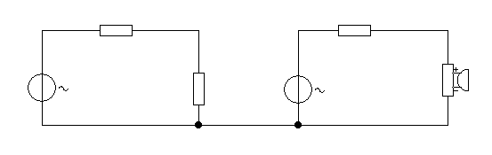
The microphone driving the small signal amplifier has an output voltage of approximately 20mVpk-pk for a reasonable volume input to the microphone. This is obviously too small to drive the power amp.
400Ω
10k

Low
8Ω
Mic
20mV
IC amp
Av = 4
This set-up will not work!
We therefore require a small signal amplifier to amplify the microphone input of say 20mVpk-pk to 250mVpk-pk.(on load).
The required gain of the small signal amplifier (ON LOAD) is therefore 250mV/20mV = 12.5
Note: the 10k input resistance of the power amp is acting as the load for the small signal amp (SSA)
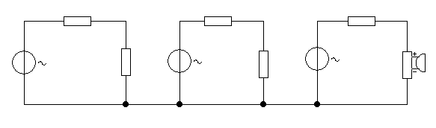

CE Amp (pre-amp) IC power amp
250mVpkpk on load
10k
Av =4
Av >12.5
400Ω
Mic

The SSA has been inserted between the Mic and the IC amp to provide voltage gain of the Mic signal.

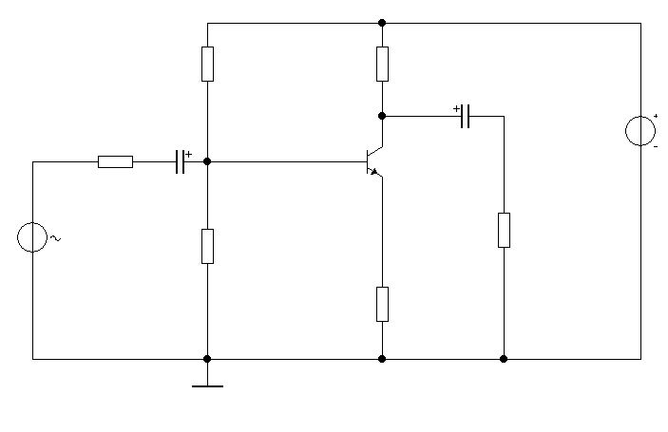
R_{A}
R_{B}
R_{C}
V_{c}
_{250mV}
10V
V_{in}
R_{E}
Rin of IC amp = 10k
400Ω
20mV
Mic
i/p

V_{E}
V_{B}
In practice, not all of the 20mV out of the small signal amp (pre-amp) will reach the base of the transistor, due to loading effects between pre-amp input resistance and the microphone output resistance, i.e. Vin < 20mV.

In addition, the loaded output of the pre-amp is 250mV, this means that the pre-amp unloaded output must be greater than 250mV in order to allow for the loading effect of the IC amp input resistance on the output resistance of the pre-amp amp.

In order for the pre-amp to cater for the two sets of losses, its gain (Av) must therefore, in practice, be greater than 12.5.
This increased gain is likely to be difficult to achieve, in practice, using a series feedback amplifier as there are too many conflicting “rule of thumb” requirements to satisfy the design and therefore a CE stage may be better.

If we use a CE stage we can easily achieve a relatively high gain since
Av = -39 x V^{CC}/2 this equates to approximately -40 x 10/2 = - 200.
This is much more than we will actually require therefore we can easily achieve a gain sufficient for our needs. I will ignore the negative sign from now on.

CAUTION: If we have too much gain we may get distortion of the output waveform.

Design procedure.
Let Vc = V^{CC}/2 = 10/2 = 5V
Make RC < 10k to reduce loading effects from the input resistance of the IC amp.
A typical value for I_{C} is 1mA. Therefore:
RC = (Vcc – Vc) / 1 mA = 5k

Therefore let RC = 4.7k (nearest preferred value)
This is < 10k as previously specified. If RC is actually 4.7k then
V_{RC} = I_{C} x RC = 1mA x 4.7k = 4.7V
Hence Vc actually = 10 - 4.7 = 5.3V

I_{E} approximately = I_{C} which therefore I_{E} = 1mA

Let V_{E} = 10% of V^{cc}, therefore let V_{E} = .1 x 10 = 1V

Therefore RE = V_{E} / I_{E} = 1/1mA = 1kΩ

Assuming V_{BE} = 0.7 V then V_{B} = 1.7V

I_{B} = I_{C} / h_{FE} = 1mA /100 = 10µA

Let I_{B1}= 10. I_{B} = 10 x 10 µA = 100 µA

Hence I_{B2} = I_{B1} - I_{B} = 100 µA - 10µA = 90µA

RA = (V^{CC} –V_{B}) / I_{B1} = (10 – 1.7) / 100 µA = 83k, use 82k

RB = V_{B} / I_{B2} = 1.7 / 90µA = 18.8k, use 18k

Obviously there will be a small knock-on effect on V_{B} but I will ignore it unless I perceive a problem in practice.

Determination of CB, CC and CE.

Let CB and CC ≥ 10 μF, i.e. let CB and CC = 10 μF

The emitter capacitor (CE can then be determined from:

CE = 1 / (2.π.fo.( re) = 1/(2. π.50. (26/1) = 122 µF Where fo is the low frequency cut-off.

Let CE = 122 µF, therefore use 220 µF

We now have an equivalent circuit for our design as follows:

Vy
Vx

CE Amp IC power amp
10k
Av =4
Av = 183
400Ω
2.24k
4.7k

Vx = (2.24k/ 2.64k )x 20mV = 17mV approx, Av = 39 x V_{RC} = 39 x 4.7 = 183 maximum. Note: Coupling capacitors are not shown.

In reality we will not achieve a gain of 183, possibly we will get say 160 or so.

Assuming we get a gain of 160 then Vy (off load) is given by:
160 x Vin = 160 x 17mV = 2.7 V pkpk approx.

Vy is then loaded by the 10k input resistor of the power amp and so the input voltage to the power amp will be given by:
Vy (loaded) = 10k / ( 10k + 4.7k ) x 2.7 = 1.8V approx.

This design now gives us too much gain, we only need 250mV at Vy when loaded, we’ve got 1.8V.

For the SF amp the unloaded gain could only be 4.7k/1k = 4.7 at best. The loaded gain would therefore be even smaller. So this is not suitable since we need an Av of greater than 12.5.
However, to achieve the gain we need we require an unloaded gain higher than the loaded gain of 12.5

The equivalent unloaded gain to achieve a loaded gain of 12.5 is achieved by calculating the collector a.c. voltage off load, let Vc represent this.

250mV= 10k x Vc , hence Vc = 350mVpkpk
( 10k + 4.7k )

Remember, the definition of Av for these types of amplifiers is for the unloaded gain.

The required unloaded gain for the CE stage above is therefore 350mv/17mV = 20 approx.

The required gain lies somewhere between what is achievable by the SF and CE stages, hence we can use a hybrid, circuit which gives us the best characteristics of both SF and CE stages.

By splitting the emitter resistor in two we can achieve gains that lie between the low gain of the SF stage and the high gain of the CE stage.

SPLIT EMITTER DESIGN

This technique requires splitting the emitter resistance into two parts and only decoupling one part of the emitter resistance such that the original emitter resistance RE is split so that RE = Re + Rx.

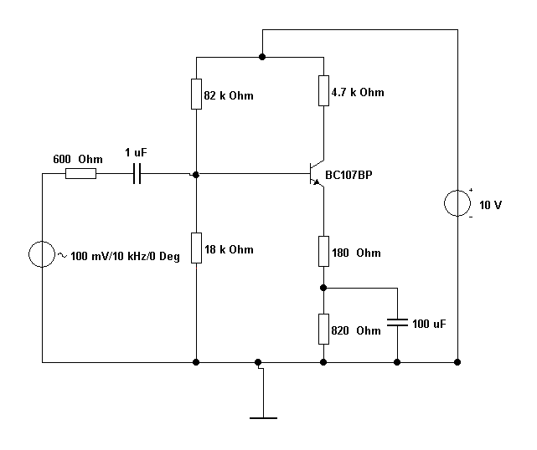
400Ω
2.2µ
20mVpkpk
220µ
RxE
Re
390nF

It can be shown that the new Av for the split emitter amplifier is given by:

Av = - RC = 4.7k = 24 approx.
- + Re ( 26 + 180 )
I_{c mA} 1

So the new split emitter gain Av = 24 and we need around 20. This is close enough for us to proceed. NOTE: The negative gain sign is not important, only its amplitude is important.

The gain of 24 is very close to what we want. We could get closer by inserting a variable resistor in place of Re.

We have now got a working circuit that will perform as required within an accuracy of 5-15 % say as a result of approximations made in analysis and component tolerances.

If we look more closely at the analysis of this circuit we will see that the input resistance is better than that of the CE stage and the low frequency cut-off will be lower, assuming we do not change the capacitor values.

Therefore it really is an all- round compromise between the best attributes of the SF and CE stages.

To achieve variable gain (within limits) we could make RE variable.

Note, we’ve not changed any of the d.c. bias conditions, we’ve only changed the a.c. parameters.

NB: In the above example Re was arbitrarily chosen for convenience, in practice we need to calculate Re from a pre-determined Av.

Therefore Re = Rc - 26
Av Ic(mA)

CE can remain the same (see note at end of handout) but CB now should be calculated as:

CB> 1 / /( 2 . π . fo. ( Rg + Rin )

Rin = 82k // 18k // hfe. 180 where hfe is assumed to be 100

Hence Rin = 8.1k approx.

Therefore CB > 1 / ( 2 . π . 50 . ( 400 + 8.1k) = 374 nF , Assuming low frequency cut-off is 50HZ.

Therefore let CB = 390nF

CC, if present can be set to 10μF.

Note: CE fully decouples Rx and so as far as an ac signal is concerned it only sees the 180Ω resistor and therefore the input looks like a series feedback type , hence we let CB define fo as if the circuit is a series feedback type.

NB: X_{CE} must be << Re at the lowest frequency of interest ( fo).

Hence we can calculate a suitable value for CE by making sure that X_{CE} < Re/10 so that it does an even better job of decoupling shorts out Rx at fo.

Therefore let CE ≥ 1 / ( 2.π.fo. X_{CE} ) THIS WILL MAKE CE EVEN BIGGER!

Hence let CE ≥ 1 / ( 2.π.50. 18 ) = 176 μF , NPV = 220μF.
Revised to make X_{CE} < Re / 10 NOT Rx/10. This makes for even better decoupling of Rx.

