
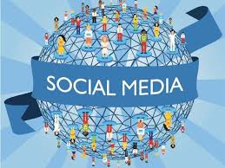
A report that describes human interconnection with the virtual world. From the creation to the development and evolution of the internet and social networks. Complementary applications for social interaction to recruitment.

Social Media, Marketing and Recruitment

Dalila De Fatima Sa Vieira (2336605)
Module Name: Digital Skills
Module Code: LCLM4002
Student’s Name: Dalila Sa Vieira
Student’s ID: 2336605
Lecturer’s Name: Hang Nguyen
Group:1

Table of Contents

Table of Contents………………………………………………………………………………………………………..Pag.1

Introduction…………………………………………………………………………………………………………………Pag.2

The history of internet and social media………………………………………………………………..……Pag.3

Social Media Platforms………………………………………………………………………………………………..Pag.3

Social and Digital Media to Reach the costumer………………………………………………………….Pag.4

Marketing Strategical in social media…………………………………………………………………………Pag.4

The Pyramid of Success……………………………………………………………………………………..….……Pag.5

Direct Marketing & Indirect Marketing……………………………………………………………………….Pag.6

Direct Marketing vs Indirect Marketing……………………………………………………………………….Pag.7

Social Media and Recruitment…………………………………………………………………………………..Pag.8

Statistics Chart…………………………………………………………………………………………………………..Pag.9

Acknowledgments…………………………………………………………………………………………………….Pag.10

References………………………………………………………………………………………………………………..Pag.11

Social Media, Marketing and Recruitment

Introduction

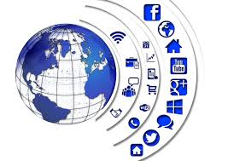
Though the research, analysis and “investigation” in the context and interconnectedness of platforms and the interactivity to the recourses to structures and applications disponible to the digital with intercoalition and development. The conjuncture of communication with several stereotypes with management and diversity of contents to the relation of the intended subject. From the creation of internet to the development of social media and the diversity of platforms and functionalities. In the context of referencing, it thematizes some of the corporate Marketing strategies, development structures between more traditional Marketing with differentiation from digital Marketing and cybernetical platforms with interconnection of recruitment platforms.

The history of internet and social media

Around the 1970s, the “appearance” of social platforms with chats and email began, starting a “revolution” in communicative media. According to (Britannica,2024), subsequently, in the 1979s, with consistency and evolutionary continuity, the USENT Network was “born”, the technology developed to
offer the implementation of a creation, posting and receiving messages in a way that is more recognized as Newsgroups.

The structure of deliberation forums (BBS) facilitated interaction for users, within the framework of a closure system. The establishment with Mosaic Pilot, the systematic fusion with the information exchange device with simple access, a breakthrough in virtual technology in the 1993 century. The Paradigm of evolution allowing easy navigation with wide ease of connectivity and accessibility to multimedia groupings, with long texts and news.

In the 21st century, social media has entered an “avalanche” of popularity with the social media platforms (sites) Friendster and My Space aimed at families and friends. Currently other sites control the popularity ranking, at the top of popularity and membership is Facebook with 3.07 billion users.

Social Media Platforms

Social media, according (University communications and marketing, no date) in the instruction of cybernetical platforms with virtual structures for the development of interaction and communicative action between members of the same platform community. Currently, social platforms are distinguished by their functionalities, used for various purposes, promotional and personalized diversities. Adapting various modalities, communicative action platforms with interconnections in conversations, blogs, micro blogs, video sharing, commercial promotions, advertising, recruitment and various information. The various cyber platforms with the development of digitality expand to commercial growth. With marketing strategies, promotional campaigns, interaction with new audiences and growth of a new database.

Social and Digital Media to Reach Costumer

The various cyber platforms with the development of digitality expand to commercial growth. According (Corporate Connections,2023) With marketing strategies, promotional campaigns, interaction with new audiences and management of compatibilities of database, new costumers lead.

The benefits of interacting with members of the platform community parallels the significance of the uniqueness of users promoting companies, products, services and recruiting, sharing the information between friends in the same community. In the strategic marketing panorama that covers all economic classes in the world.

Marketing Strategical in Social Media

Globalized and technified strategies used as marketing tools with ideologies in practice to cover all audiences and generate new opportunities for marketing products or services, In the supremacy of the development of resource tools, marketing strategies on social media, exemplifying some prisms for building the successful marketing pyramid in small, medium and large companies.

Identify Your Audience in Detail
In strategic Marketing management, the power of analysis is an essential tool for studying the market and the type of client or consumer. Power to analyse the competition (what they are doing, promotional campaigns and strategies) and evaluate the type of audience (what matters and what do not matter). In the cultural relevance of the business, always follow the key performance indicators (KPIs), in meeting your objectives and in paralleling commercial standards.

Create a Social Media Management Agenda
Develop a management engagement plan and professional oversight teams for social media platforms with customized advertising control administration. Interconnect with your customers, service providers and business partners. Share a schedule for regularly updating information and advertising campaigns.

Post Management at the Correct Time
When managing your social media calendar, it is extremely important to master audience activity times and deliver your advertising content at times with the highest audience interactivity.

Customize your Information for Social Media Search Engines
Personalize your content in the search engine, in a simplified, quick-access and easy-to-find, use keywords in post titles, differentiating advertising techniques with each update.

Inspect, Change and Reiterate
In creating the development of growth opportunities with innovative marketing strategies with the transcendence of modifying content according to the analysis of the quality of the information posted.

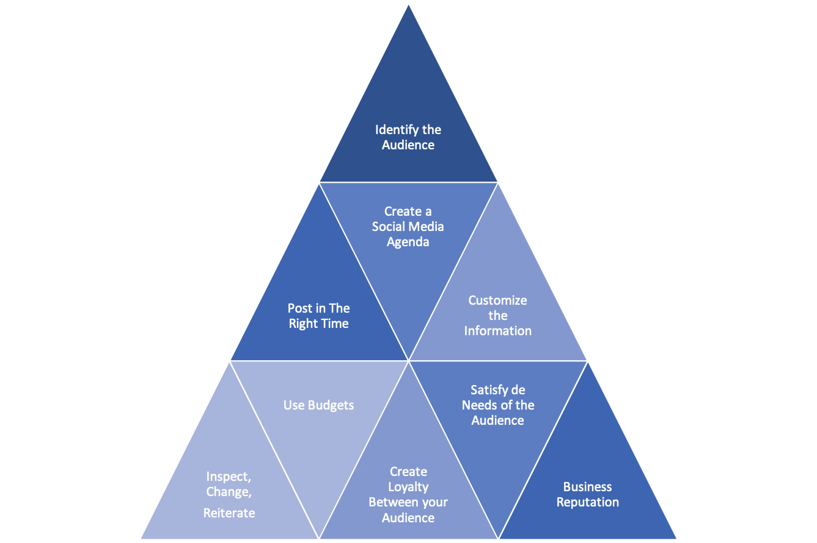
The nine principles of the Marketing strategy on social media
The Future of your Business in your Hands
The pyramid of success in social media

Direct Marketing & Indirect Marketing

It is important in business management to structure a Marketing plan that clarifies the verification of the benefits that can bring to the institution. According (Statler ,2024) Strategies created based on fixed budgets that more firmly stipulate the type of Marketing suitable for each company and public. In the diversity of organization of Marketing strategies developed by large institutions, the use of Direct Marketing tools appears within the scope of promotional action with the “fusion” of Indirect Marketing

Direct Marketing - when the customer will buy directly from you. For example, when a customer enters your establishment to buy directly from you or from a phone call, whenever there is the physical interaction of both characters. The advantageous methodology in the implementation of Direct Marketing, an essential tool for the development and personalization of service to meet the interpersonal needs of each member of the audience, a successful strategic fragmentation in production and marketing with short-term effects. The disadvantages of Direct Marketing are aimed at a failure of technical application and the product supplied.

Marketing Indirect - collecting data from the public that arrives through the channel’s advertisements, social media campaigns, recommendations and many others. It is the leads that arrive at your company without direct contact. The development of the strategic context of marketing incorporated into social networks, a structural "methodology" of adherence to a new audience for the creation of the constitutional growth of a database management, low cost, with controlled budgets. The disadvantages of indirect marketing are its interconnection with time management and satisfactory results in making profits. In consideration and the relevance of building an alliance of trust with your audience based on feedback and reviews.

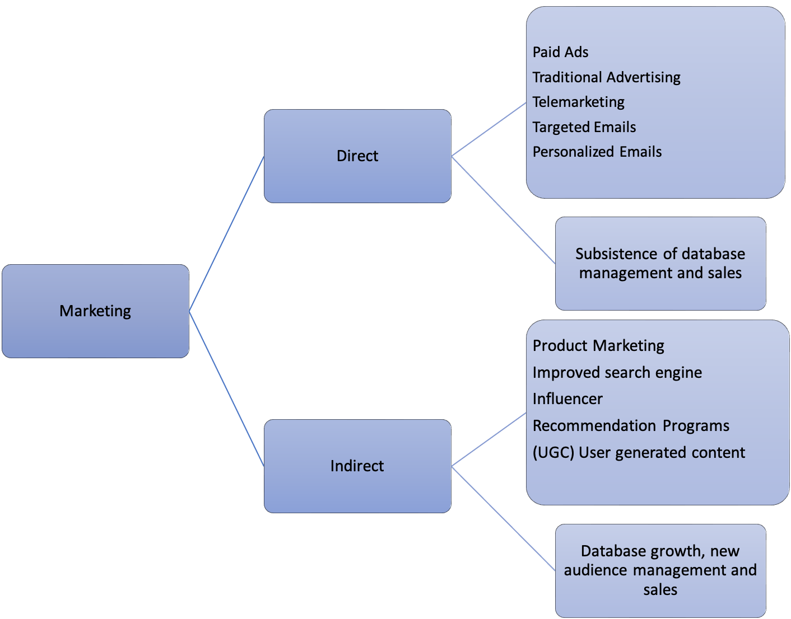
Marketing Direct VS Marketing Indirect

What type of Marketing will meet the expectations of your business?
Marketing Direct VS Marketing Indirect

In the Direct Marketing and Indirect Marketing guideline, an interconnection depending on the objectivity of each institution or business. In the successful development of the strategic Marketing plan, the power of analysis and the use of available tools are extremely important. When evaluating the needs and organization of your marketing plan and the characteristics of the target audience, it is important to check the resources available to adapt to the type of marketing available. In the prototype for developing advertising campaigns, the use of the unification of two, indirect/direct Marketing techniques, providing your business with stability and profits in the short term.

Social Media and Recruitment

LinkedIn

In 2002, in the living room, Reid Hoffman, a capitalist together with a team of 3 elements, Allen Blue, a Marketing professional, Eric Lay, Luc Vaillant, both engineers, "gave birth" to the development of the LikindIn project, which was launched in May 5, 2003. In 2005, with the development of cybernetical platform with a surprising structure for its users, providing access to job vacancy publications and connectivity with potential candidates. According (LinkendIn, 2024) In December 2016, LikindIn officially transitioned to the Mega company Microsoft under the leadership of Ryan Roslansky, offering a diversity of products and services.

On the LinkedIn platform you can create your professional profile based on your knowledge, experiences, skills and abilities, interconnecting with the business world. An essential platform for developing your professional career.

Facebook

Mark Zuckerberg and his roommates Eduardo Saverin, Andrew McCollum, Dustin Moskovitz and Chris Hudges, students at Harvard University, designed Thefacebook in 2003. A project limited to Harvard University students expanded in 2004 and was officially launched to the public, founded as Facebook. Currently, Facebook leads the ranking of social platforms, being at the top with a total of 3.07 billion users, with global community and business apps helping your business progress.

Facebook is the Cybernetic platform with the most interactivity between users and communities, in a statistical medium, every 60 seconds 293,000 status updates, 136,000 photos are exchanged and 5 new members sign up every five seconds.

LinkedIn, Facebook, Twitter and Glassdoor, the social platforms that lead the job market. Companies and users are increasingly joining cyber platforms for professional interaction.

Photo of pie chart with membership statistics on social networks with effects on recruitment
According (google,2024)

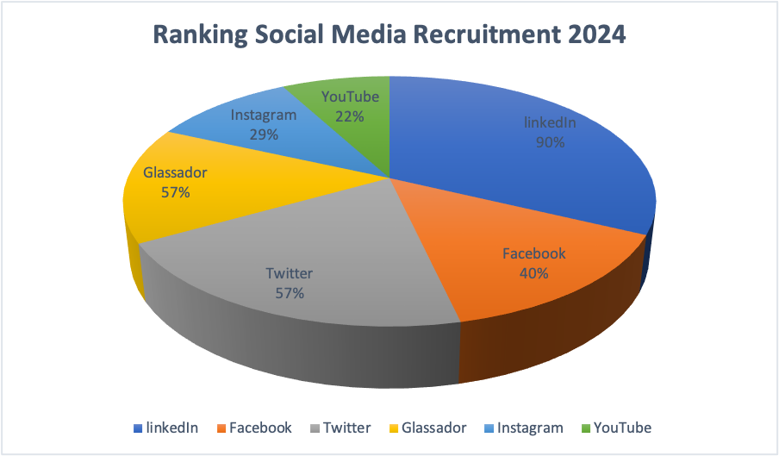

Every day, the business market invests in human resources and research with the aim of recruiting and approaching professionals, Social media platforms are a tool dedicated to finding jobs and professionals.

In conclusion and analysis in the modules described and the relevance of managing the information provided with reference to the cybernetic platforms of Social Media, Marketing and recruitment with interrelation to futuristic business development. In the methodologies of the strategic marketing system, Direct Marketing and Indirect Marketing are two necessary tools for developing accurate and successful marketing., In the designation of social media cyber platforms with recruitment instructions, they demonstrate consistency in connectivity and engagement, present solid platforms with futuristic prospects of evolution towards more effective and precise recruitment with the supremacy of total satisfaction between the hiring transition. From the etymologies of access to cybernetic social media platforms, an evolutionary future with great relativity to digitality and business implementation.

Acknowledgements

I am extremely grateful to my University of Wales, Trinity Saint David for the extremely refined space with a mix of elegance and modesty, to all the staff who work hard every day to provide an excellent service. A special thanks to my Lectures Sylvia (Academic Skills) and Hoang (Digital Skills) for their mastery and teaching methods, they are distinguished by their friendliness, patience and divine dedication. I will still be grateful for the opportunity for an academic future.
I describe it very worthily in small words, and one of the greatest privileges is attending classes at the University of Wales, Trinity Saint David.

References:

LinkedIn (2024) About LikendIn. Available at: https://about.linkedin.com/#:~:text=LinkedIn%20began%20in%20co%2Dfounder,the%20leadership%20of%20Ryan%20Roslansky. Accessed: (15 December 2024).

Statler.J (2024) Direct vs Indirect Marketing101: All You Need To Know. Available at: https://vipecloud.com/blog/direct-vs-indirect-marketing/#:~:text=Direct%20Marketing%20is%20when%20you,them%20to%20buy%20from%20you. Accessed: (15 December 2024).

Corporate Connections (2023) 5 Tips To Develop a Successful Social Media Marketing Strategy for your Business. Available at: https://www.corporateconnections.com/5-tips-to-develop-a-successful-social-media-marketing-strategy-for-your-business Accessed: (14 December 2024).

Britannica (2024) Social Media. Available at: https://www.britannica.com/topic/socialmedia ( Accessed: 13 December 2024).

University Communications and Marketing (no date) Social Media. Available at: // https://www.usf.edu/ucm/social-media/intro-social-media.aspx Accessed:13 December 2024)

University of Sheffield (no date) Social Media and LinkedIn. Available at: https://www.sheffield.ac.uk/careers/support/network/social-media Accessed: (13 December 2024).

