

THE IMPACT OF VIRTUAL LEARNING ENVIRONMENT

DIGITAL SKILLS AND RESEARCH METHODS: ASSIGNMENT 2 - RESEARCH REPORT

Marilena-Loredana Mihai (2129859)
Lecturer: Suneth Fernando
Moodle code: BMSW 4003_London _
VIRTUAL LEARNING ENVIRONMENT

TABLE OF CONTENTS

- Introduction…………………………………2
- Background…………………………………3
- Aims and Objects of this Research………4
- Methods…………………………………......5
- Survey Results……………………………..6
- Discussion………………………………….10
- Conclusion………………………………….11
- References…………………………………12
9. Appendix(Survey in) …….…………………..13

VIRTUAL LEARNING ENVIRONMENT

1.INTRODUCTION
This report will discuss about the importance of virtual learning environment with advantages, disadvantages, opportunities, positive or negative impact in educational institution and how to build information using the new technologies.
The Virtual Learning termen was made know to as, a decade ago which was growing step by step at today technology level and at the modern tools.
‘Brewer, De Jonge and Stout (2001 ) suggest that: “Ideally, technology plays a transparent supporting role in the learning process ... appropriate integration of learning technologies casts technology in the background ... gratuitous and/or awkwardly or inappropriately employed learning technologies can actually juxtapose the role and importance of technology allowing it to compete with the learning process”. ‘(Uhomoibhi, 2013)
Throughout this paper the term e-technology is used to describe a technology that supports e- learning. ‘Teachers and students in higher education are coming to realize that to become competent practitioners there is need to take advantage of up-to-date digital technologies and learning practices. Learning process requires measurement and evaluation of student’s behaviour. In the case of e-learning, evidence is sought for improvements resulting from the use of online tools and processes desired to achieve a given set of learning outcomes. In this 21st century, knowledge is fast becoming a powerful engine in life. The visions, innovations, and inventions are the building blocks of developing knowledgeable and sustainable society. E-learning has facilitated the use of a plethora of internet and web-based applications as the method of communication with a distributed audience. Therefore, institutions of higher learning are constantly venturing into new and innovative methods and are radically changing the educational practice making it competitive.’ (Paulo Alves,2013)
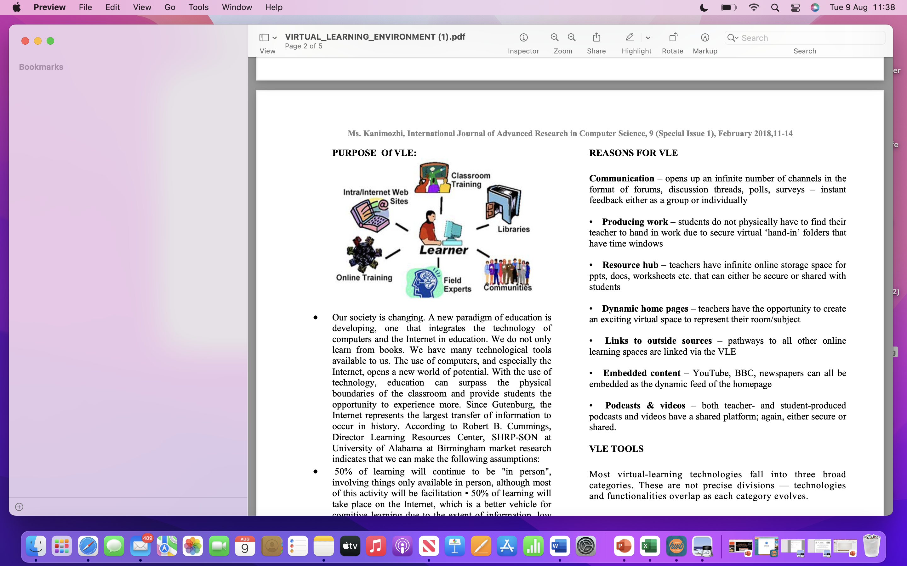

2.BACKGROUND

Pen and paper are still used today, therefore those who claim otherwise aren't entirely wrong. The traditional model of classroom instruction is gradually giving way to virtual learning as a more cutting-edge alternative as a result of the technological advancements we witness on a daily basis. The way individuals learn is being transformed by this type of education using EdTech. A US study also revealed that 81% of college students believed that digital learning technology had improved their academic performance.
I will provide an explanation of virtual learning to help comprehend what it is specifically. Along with that, we'll look at a few tools that will distinguish virtual learning environment.
Virtual Learning Methods
Virtual learning environments usually come in three different varieties. The primary distinction is whether or not there is interaction between the students and the teacher.
(Source: Smith, 2019 ex)
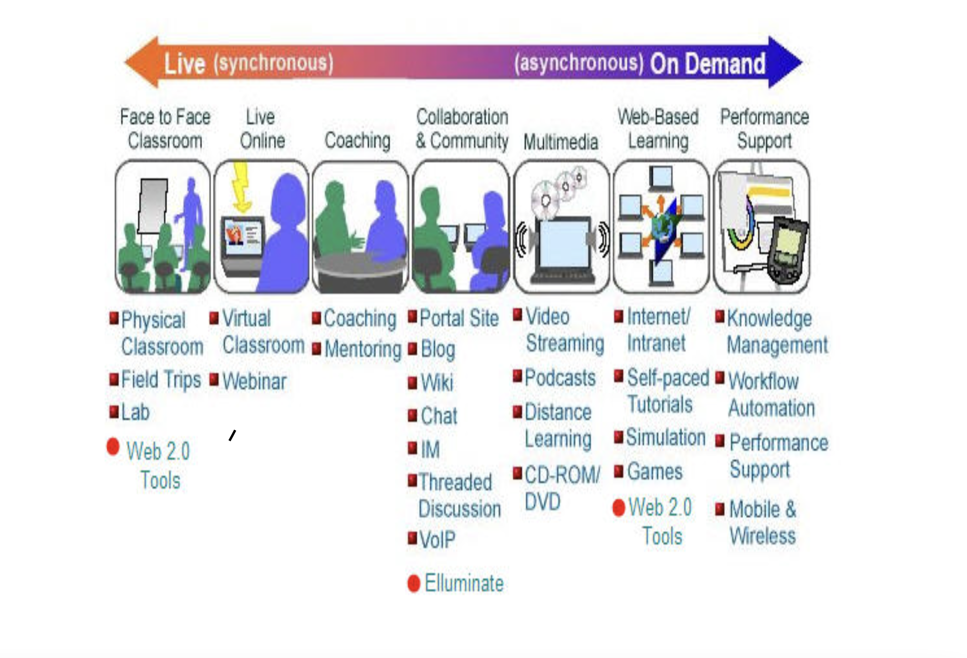
Synchronous learning, first real-time interaction between students and instructors occurs in this kind of virtual learning. Through video conferences or audio chats, this allows students to take part from a distance.
Synchronous Education
In nonparallel learning, there is no real-time interaction between the teachers and the students. Instead, there are certain readings and activities that the students must complete within a set amount of time. Here, communication takes place on message boards and forums. Those who struggle to stick to a strict schedule may benefit greatly from this type of online education.
Hybrid Instruction
In-person engagement and online learning are both necessary for hybrid learning. To improve and complete the in-person learning process, the online or virtual component is utilised.
A good virtual learning environment should be customizable to the learner's abilities and progress. One of the must-haves of virtual learning is video conferencing software that allows the instructor or teacher to interact with the learners. It's important to use some kind of digital whiteboard for diagrams and demonstrations. Being able to track the learners' data helps the educators in improving the learning material. It also helps the students in keeping track of their grades and adjusting accordingly. Another feature that is essential in virtual learning is assessment tools. Lecturers use them to be alerted when there's a student submission or message.
Virtual learning allows for the customization of the learning material to fit the learners progress and skills. This is done by using different multimedia tools and interactive software. No longer does the educator need to use pen and paper to manually grade the student’s assignments, instead, their work is graded automatically.
The main investment in the case of virtual learning is in the software and technology. Students get to use different software to research topics, complete projects, or finish assignments. Also, students save money on going back and forth to class or on textbooks.
Students work is graded automatically, and feedback is given quicker as their work is either graded automatically, or the teachers simply comments on the students works.
The students can access asynchronous classes whenever they have the time. This motivates more time-constrained individuals to pursue higher education or develop their abilities. The educational resources are available to students from the convenience of their homes. Since they have more time and space before participating in a virtual activity, it makes it simpler for them to participate.
Virtual learning tools are used to improve the interaction between learners and their instructor. This software should include features like instant messaging, video conferencing and streaming, digital whiteboard, file sharing, discussion platforms, and third-party integration. To prepare a list of the best software out there that will make virtual learning environment exceptional.
BigBlueButton was created by teachers, for teachers. Remote training, webinars, and online meetings may all be delivered with Adobe Connect. It makes it easier for them to alter the material to suit the preferences and intended audience. Users of this program may also download files and take part in surveys, simulations, and quizzes.
There are no issues using this Zoom video conferencing program on several platforms. Additionally, it provides a unique education plan that accommodates hybrid and online learning settings.
One of the factors behind how teaching and learning have changed is technology. Each day, both teachers and students can use networking media in both their personal and professional lives. They experiment with novel pedagogical approaches. Meanwhile, more tech-savvy generations of teachers and students have embraced and utilized teaching and learning management systems, like Blackboard and Moodle. It is no longer an innovation to use online communication for teaching and learning; rather, it has become the norm.
A further tendency in education is super-diversity and globalization. The majority of the issues brought on by excessive variety are linguistic and cultural. There are more regularly provided cross-campus activities and courses, and students from various cultural backgrounds stay in touch through a variety of networks.

3.AIMS AND OBJECTIVES OF THIS RESEARCH

Online classrooms are more flexible since they allow students to study whenever and wherever they choose without being tied to a class.
ADVANTAGES:
Timesaving - By studying online from there living room, no need for travel to and from college may save a lot of money and several hours.
Convenience - It also helps people to focus while working and to schedule exams and tests for when it is most convenient for them.
Develop digital skills - The student continues to develop their skills in using digital platforms in addition to learning the subjects and courses they are studying online. It aids in the growth of abilities and knowledge in the field of study.
Saving money - When teaching is done online, no need to spend money to setting up a classroom with the necessary. Students save money by not having to go to college to learn.
Feedback - Benefits of using a virtual learning is the quicker turnaround time for results following online examinations, students may see their performance results much sooner.
DISADVANTAGES:
Infrastructure Issues - The initial cost of setting up online courses is significant; the software must be updated to not create problems conducting online classrooms.
Training - Knowing about new technology is crucial because of lack of knowledgeable procedure and technical problems. Professors also find it difficult to produce electronic versions. Consequently, there is a constant requirement for IT assistance that regularly teaches instructors and students.
Lack of Social Competences - With the classes online missed face-to-face conversation and the student will lose social and emotional abilities.
Physical Affected - Online learning limits their movement and confines them to a desk and laptop where they can only stare at the screen and learn the material.
Vision Affected - Device’s blue light harms your eyes and can cause a lot of issues if use a laptop or phone screen frequently.
Lack of Communication - With the development of technology and online learning, a real classroom's is lost and are no longer Q&A questions and answers sessions professors- students.
The goal of the virtual learning is to provide students and faculty with the most up-to-date tools for dealing with crise like Pandemic lockdown we experienced.
To support the introduction and use of the latest technologies they are always ready to learn for new ensuring that are update in terms for their studies and knowledge.
The objective of this report is to do a primary and secondary research to observe the impact of virtual learning by collecting quantitative and qualitative data doing online survey and research from articles and blog.

4.METHOD

After doing my secondary research I collect qualitative
and quantitative data to help understand Virtual Learning Environment services with the benefits, disadvantages, challenges the students, teachers and admin faced using the new technology. I used web site, blog, journals, and books to collect data for this research.
For the primary research was conducted a survey to collected qualitative and quantitative data related to our university Moodle. The online software tools were used to do an online form which includes 10 questions with multiple choice of answers and send to colleagues, friend, and tutors for collect feedback from them via email. Data which was collected and stored in tables for analysis process. Screenshot of survey form is attached in the appendix.

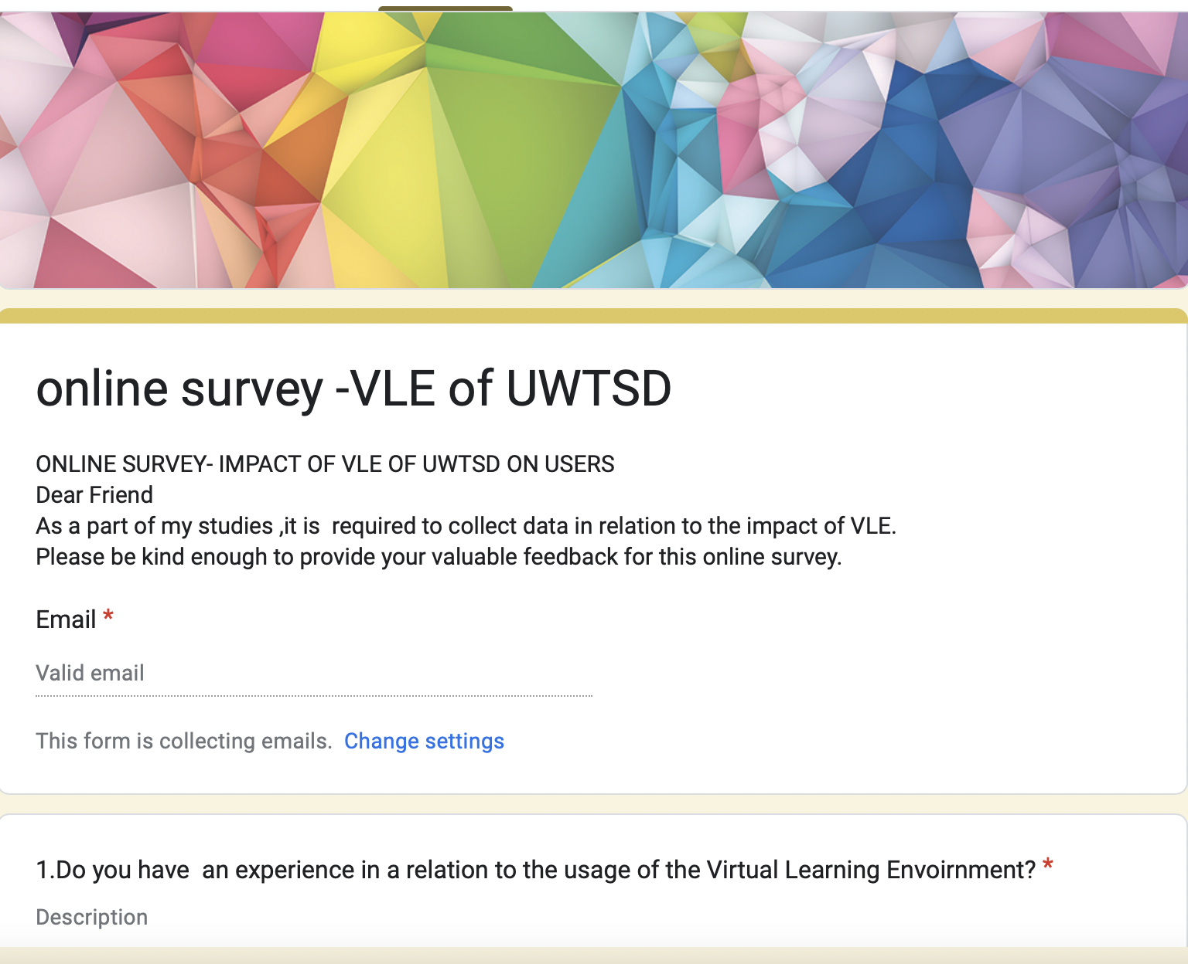

5.RESULTS SURVEY
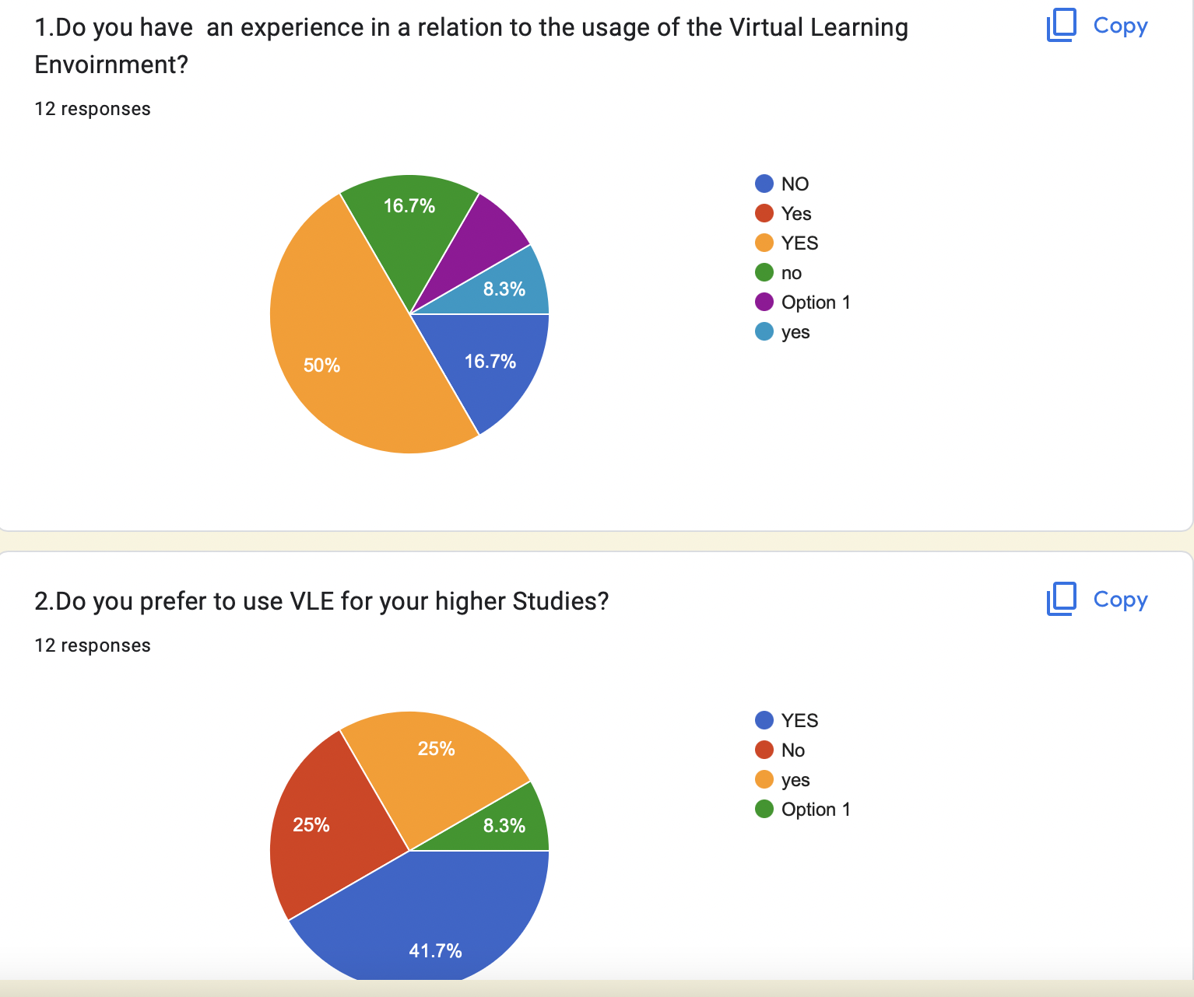
1. After my research 7 from 12 people have experience using Virtual Learning Environment and 4 doesn’t have.
2. According with my research more than half (8) will prefer to use VLE and a quarter (3) no with 1 hold back.

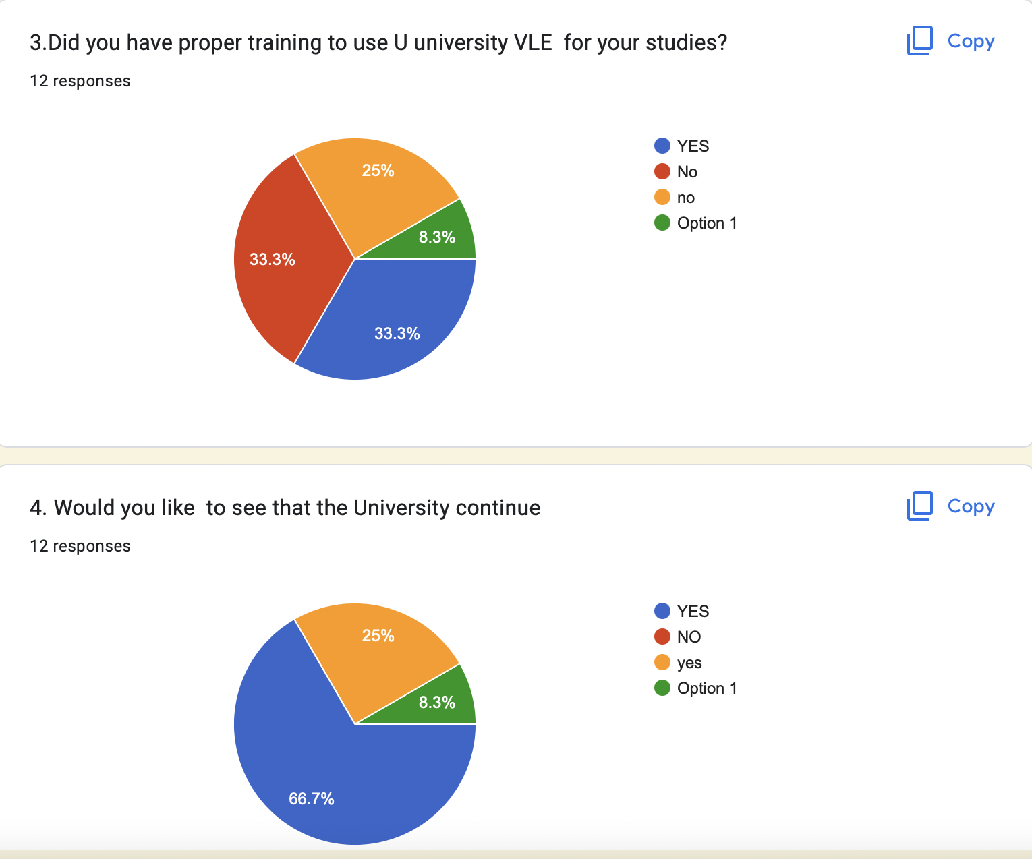

3.Likewise just 33% (4) have the training for using VLE, 58% (7) don’t and 1 abstain.
4.In accordance with my study nearly all (11) want to continue University use the VLE.

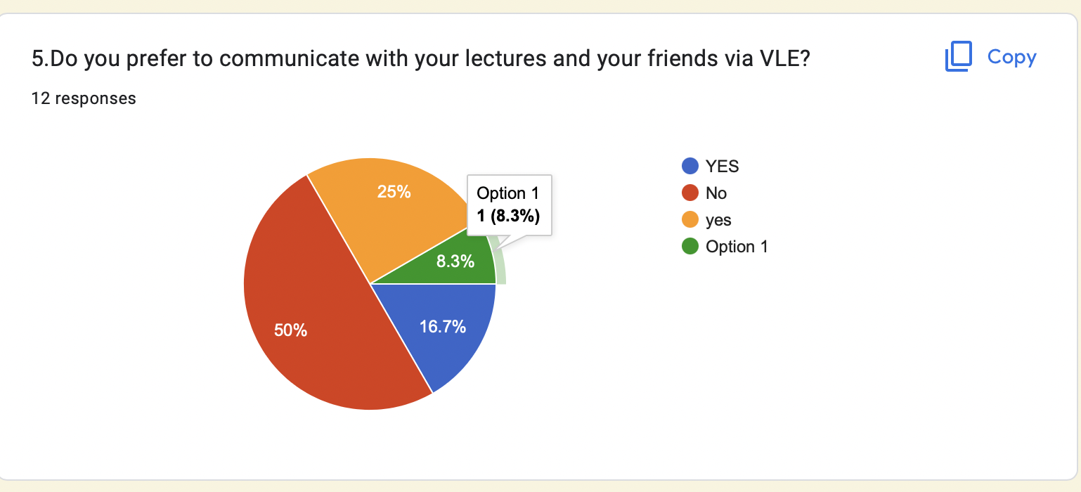
5.Coresponding my investigation from 12 people, half don’t want to communicate via VLE with 1 holding back and 5 like to communicate on VLE.

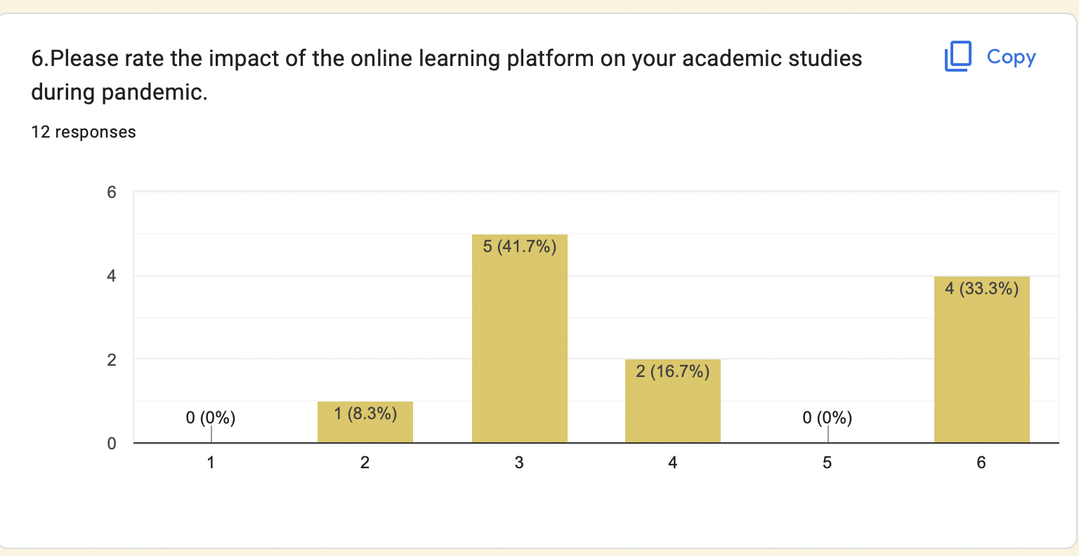

6.After my research for 4/12 people the impact was excellent and for the rest not to bad look satisfying to well.

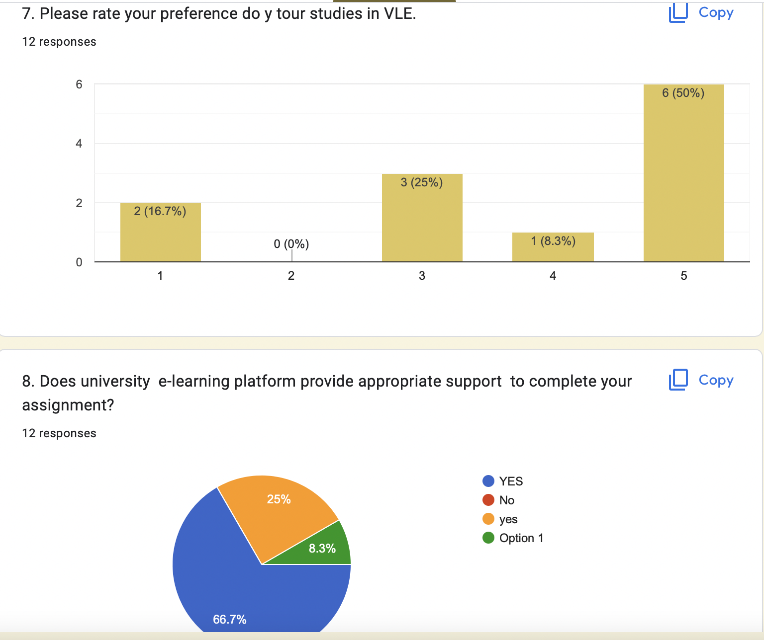
7.Corresponding my investigation half prefer to study online.
8.According with my study all the students have necessary support on e-learning platform to complete their work.

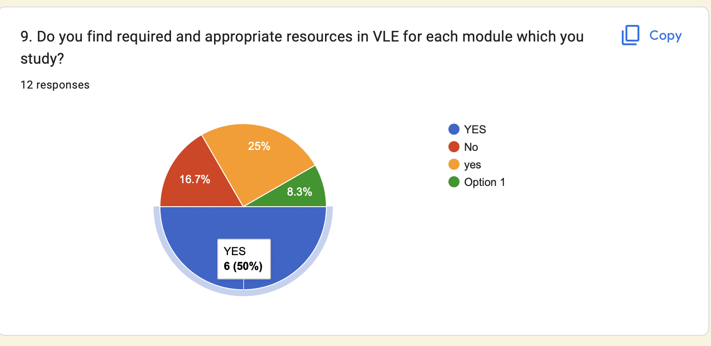9.Comparative with the answer of my study more than half (75%) have recourses for modules.

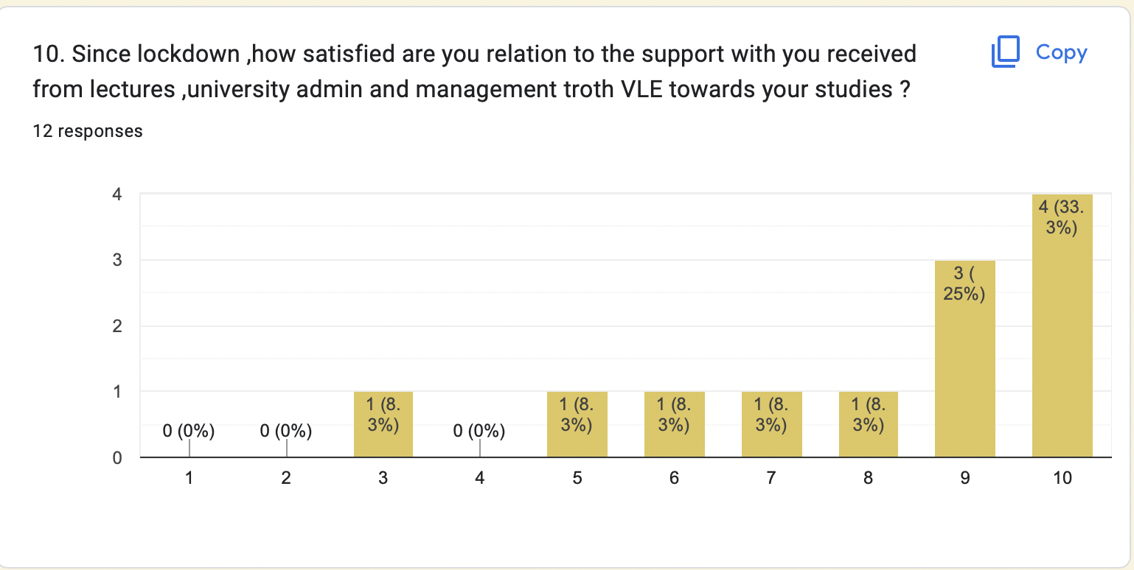
10.Equivalently with my enquiry the support received from university since lockdown was very satisfactory to excellent.

6. DISCUSSION

After my research I compered Virtual Learning Environment provide teachers, students, and admin with variety of services. E-Learning have both benefits and drawbacks, can be challenging giving the possibility to develop new skills, associated with the new technology are risks and opportunity.
The Virtual Learning need to have place in education making much easy the student’s life and help them to improve and be happy engaging in their study.
Using the new technology in my study I learn to do research online, survey form to collect data for my assessments by using google form, create documents in Word and preparing the presentations with Power Point to complete my assessments.

7. CONCLUSION

There is no longer a place for traditional education in the twenty-first century. The educational process is made more efficient and accessible by the switch from traditional classrooms to online learning. We can state with certainty that online learning is the future of education because to the incredible e-learning solutions that are developing every day.
Almost every industry in the world has adopted computers, and education is no different.

8. REFERENCES

ALSHEHRI ET AL.,(2019), Volume 8, Issue 3, 839 - 855. ‘’Assessing the Relative Importance of an E-learning system’s Usability Design Characteristics Based on Students' Preferences’’. https://files.eric.ed.gov/fulltext/EJ1222289.pdf,(Accessed: 28August2022) ,

Kotobee ,( 2022) in E learning ‘What Is Virtual Learning and How to Benefit from It?’[blog].13January.Available at: https://blog.kotobee.com/what-is-virtual-learning/(Accessed: 30August2022),
Uhomoibhi, J.O.et al (2013) E-Learning Development Tendencies in Higher Education and Future Directions. Available at: Academia Edu https://www.researchgate.net/publication/233725875(Accessed:30August2022)
https://www.researchgate.net/publication/230651664_Development_of_E-Learning_in_Higher_Education_and_Future_Directions

- APPENDIX





