KNOWLEDGE AND INFORMATION MANAGEMENT

CASE STUDY- JOHN DEERE

GABRIEL OBRET
1914293
LECTURER: SEYED NASIRPOUROSGOEI
MODULE CODE: BMSW5106

Executive summary
Making appropriate use of information system is an important task to influence the business positively. Making appropriate use of information technology can help in generating product of margins for the business. John Deere has been discussed in the report and detailed analysis has been made about the pros and cons of big data and internet of things. Some recommendations have been known to improve the performance of the company on an overall aspect. The report outlines the advantages and disadvantages of customer relationship management.
Table of Contents
Introduction 5
Identification of information system implemented in John Deere and its impact 5
Customer relationship management at John Deere 8
Advantages 9
Challenges in implementing customer relationship management 10
John Deer applying IT to counter each of Porter’s five force 11
Use of big data analytics and internet of things 12
Pros of big data analysis and IOT 13
Cons 13
Recommendation on strengthening the company related to knowledge management practices 14
Conclusion 14
References 16

Introduction
Information management is a constant cycle that comprises of different steps to formulate the learning activities to develop the information products and services. It comprises of distributing the information and using the available information to read the required data. Information management concentrates on storing the data safely and concentrating on appropriate disposal of the unnecessary data. The report has been discussing about the case study of John Deere where a multinational company is willing to increase the efficiency of crop production by making appropriate use of Big Data services.
Assignment will highlight an implementation of information system and range of typical data that has been collected to develop knowledge regarding the machineries. The assignment will be focusing on customer relationship management and its benefit for the company. Detailed analysis has been made about Big Data analytics and internet of things. Pros and cons of the technologies have been discussed in the assignment.

Identification of information system implemented in John Deere and its impact
Big data and information systems are used in smart farming activities that help in generating information about the technologies that can be used for development in agriculture. Big data is expected to have a huge impact on smart farming and it also concentrate on improving the supply chain. Smart farming comprises of implementation of different big data and information systems to which smart sensors and devices can be used to produce big amount of data through with unprecedented decision making capabilities can be focused. Big data is expected to develop major shift in rules and maintenance of power relationship between non-traditional players and traditional terrace in agriculture. The company has been using big data enabled services through which the farmers can be benefited. The company has been making a systematic use of crowd source and real time monitoring data that has been collected from different users to formulate the agricultural and farming activities accordingly (Osman, 2019).
Company has its online portal that will allow the farmers to have access to the data that has been collected from the sensors that are attached to the machineries. Online portal collect the information from the core machineries with the help of sensors through which aggregated data can be circulated. The machineries and the sensors are connected to the external data sets that comprises of financial information and weather forecast. The company makes appropriate use of different combinations to evaluate and monitor the productivity levels at the workplace. By evaluating the information and data from thousands of farms different information can be generated about the crops in different conditions. The system is developed to minimize the downtime by conducting prediction based on the crowd source data when the equipment is about to fail. The company is an example of an organization shifting from selling hardware to selling big data enabled services.
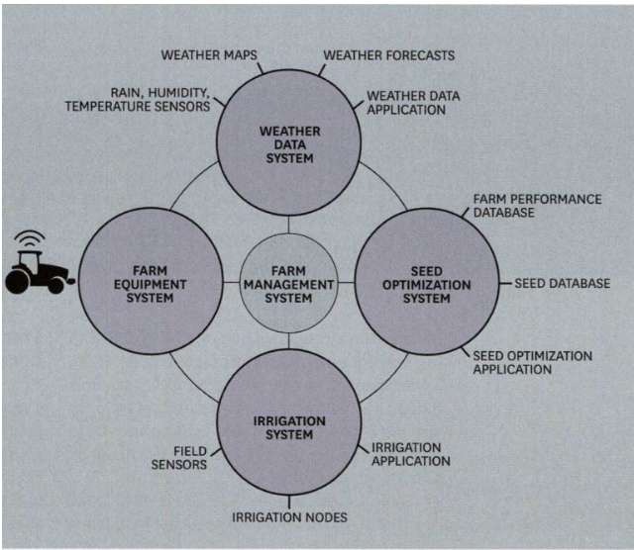
Figure 1: Information generated by John Deere
Source: Digital innovation and transformation, 2021
https://digital.hbs.edu/platform-digit/submission/farm-to-data-table-john-deere-and-data-in-precision-agriculture/
John Deere has been using artificial intelligence powered geographic information system with the help of data scientists and analysts to visualize different data points to generate patterns that could allow human beings to detect the product of margins. The company is in the new age of agriculture and they have improved their agricultural activities by making appropriate use of big data and artificial intelligence. Information system is being used to gain competitive advantage in different ways to survive in the industry successfully. The company is illustrating that different companies are making use of the data in most strategic and intelligent way to foster the forms by expanding their ability for sourcing external data. The company delivers location information to assess the potential market through which growth opportunities can be predicted and market assessment can be conducted with the help of science (Jiang, 2020).
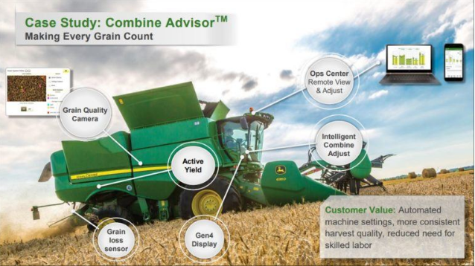
Figure 2: Information generated through sensors
Source: Digital innovation and transformation, 2021
It is an example of the data that has been collected regarding the green quality and the active wheeled to retrieve the data regarding the quality of the agricultural activities. It helps in evaluating and combining the information that retrieves data with the help of sensors and cameras. It helps in generating customer value with the help of photo printed machine settings and consistent harvest quality to reduce the efforts of skilled labor and using the skills of the labor to the right direction.
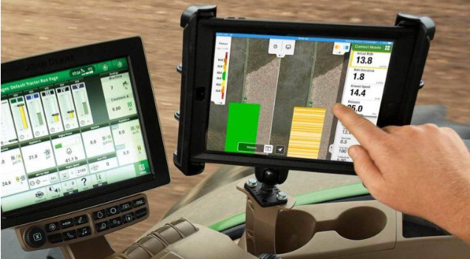
Figure 3: Collecting information through mobile sensors
Source: Digital innovation and transformation, 2021
John Deere connects the mobile to the monitor used to evaluate the job quality during the process of planting and spraying. It is an important process because it helps in evaluating the inside information of the machine field coverage and it also performs the predictive maintenance through machine data. Smart mining has been in the trend and a significant investment has been made for intelligent solution group that delivers consistent data and information about the advanced technology solutions. Data driven technology always helps the company to deliver value to the farmers and help them to evaluate and gather information to harness the improved farm management.

Customer relationship management at John Deere
Customer relationship management is a technology that is used for management of the relationship with the consumers and company. The company needs interaction with the consumers so that they can improve the business relationship and concentrate on staying connected to the consumers. It is important to streamline the process and improve the profitability so that customer relationship management system can be promoted. Customer relationship management is very important as it helps in contact management and enhancing the productivity of the unit. Customer relationship management solution works on building the relationship with individual people that comprises of consumers and service users. It is important for the company to include identification of new consumers and winning their business to generate support and additional services for their relationship management. John Deere is well known for its agricultural activities and it is a leading company in manufacturer of agricultural machinery industry. The company has been listed in fortune 500 ranking and the company delivers agricultural products that are generally sold in the name of JD. The company manufactures tractors, combine harvesters, planters and forestry equipment. The slogan of the company is “Nothing runs like Deere”. The company has been winning trust of the consumers by delivering best and high quality services (Hamidi and Jahanshaheefard, 2019).
Charles Deere concentrated on the distribution system of the company where they have introduced a wholesale branch to distribute the equipment manufacturer under the same brand name. Maintenance of the customer relationship management is very important because consumers of today have different requirements and unlimited wants. The company wants products at reasonable prices in best quality and there are numerous competitors in the industry. As a part of customer relationship management the company has kept its buying process simple and less complicated through which effective decision-making can be taken and behavior of the consumers can be influenced based on social and personal factors. The company has concentrated on importance of loyalty concept through which they have strengthened the loyalty and created a positive image of the products and services. Customer relationship management helps in developing strong relation between loyalty and profitability. Customer satisfaction is a part of customer loyalty and customer relationship management. The company has strong pre and post customer services through which high level of customer satisfaction can be observed. Customer relationship management helps in developing the information about the consumers through which customer data basis and information systems can be used systematically. It helps in formulating information about the consumers and relationship orientation through which the priority of the company can be managed and relationships can be organized.

Advantages
Customer relationship management helps in delivering better customer services and evaluating the responses of the consumers to improve the services. The company should constantly improve the level of service so that status of the consumers can be enhanced. Customer service efficiency is improved by comparing the time of the services that have been issued to the consumers. Customer relationship management is important to facilitate the discovery of new consumers and it helps in keeping the potential consumers retained. New customers can easily be identified with the help of customer relationship management and it is important for growing the business to encounter productive margins. It is important to increase the customer revenue through which coordination can be made between the company and consumer with the help of marketing campaigns. Customer relationship management helps in coordinating customer data through which conflict can be resolved easily. Customer relationship management helps in closing the deal is faster and convincing the consumers to purchase the products and services offered by the company. Customer relationship is very effective for the company as it helps in enhancing the effective cross and up-selling of the products. It helps in simplifying the process of sales and marketing process for the consumers with the help of effective communication channels (Singh and El-Kassar, 2019).

Challenges in implementing customer relationship management
Customer relationship management can be a challenging task because there are different businesses that require strong software and connectivity to manage the customer relationship. Customer relationship can be a challenging process because of lack of communication. Customer relationship requires decision making and it requires appropriate communication techniques. Lack of communication can take place and it can be implemented where Sales force cannot be updated. Customer relationship management software requires strong communication management otherwise the customers will be distracted and satisfactory level will be hindered. Lack of organization wide use can be seen. Latest communication is observed with the upcoming appointments and open consumer case. Lack of technology integration can be considered as a challenge and customer relationship management requires appropriate use of technical guidance. Cost can be a major constraint associated with customer relationship management because they are customer relationship management solutions that are very costly. It is important to set clear objectives and focus on deployment elements through which customer relationship management can be considered for resolving the inefficiencies rather than building it. Training it can be a difficult process to train the employees using the customer relationship management solutions (Almaiah, 2018).

John Deer applying IT to counter each of Porter’s five force
Porter five forces are known as holistic strategy framework that is used by the company at the time of taking the decision related to analyzing the present competition. It will also result in helping the company at the time of taking and building sustainable competitive advantage in farm and construction machinery industry. The five forces are given below:
Threats of new entrants (low)
In this type of company Threat of entrance of new company is very low as they have to come up with new and innovative things this will be having new ways of doing something by their lower pricing strategy which will also result in reducing the cost and will help the customer by providing a new value proportions (Meissner and Shmatko, 2019). The main aim of the company is to manage and challenge all the challenges that are related to the safeguard for their competitive edge.
Bargaining power of suppliers (low)
It has been identified that most of the company who have been situated in the field of farm and construction machinery industry always buy their raw material from the suppliers along with this for John Deere it can also result in reducing their Margins that are earn in the market.
Bargaining power of buyers (high)
Buyer is known as the main asset of the company as they want good deals and offering from the organization by paying minimum price. The company have is smaller than powerful customer base which can result in helping them to provide discounts and offers to their customers.
Threats of substitute product and services (high)
It has been identified that there are so many substitute of the company who are presented across the world who provide the same product but at very low cost which result in fulfilling all the customer needs. The threat of substitute is very high if it will result in offering a value proportion.
Rivalry among the existing competitors (high)
Therefore, in this type of industries they were rivalry among the existing competitors can result in decreasing the profitability of the companies. John he is known as the very competitive machinery industry. For example To be competitive in the market the company can shift from selling hardware to selling big data by using different services (Kahwati, et.al, 2017).
Thus, It has been identified that ID department of the company plays an important role at the time of countering each of the Porter 5 force for example IT department can result in helping the company at the time of Bringing new and innovative machinery in the market which will result in helping them at the time of rivalry among the existing competitors by giving them different types of challenges. The other example is that Information technology can also help the company bye experimenting different things that are related to product designs that are made by the different materials as the company can shift from one to another. In addition to this IT also result in giving information to the company related to their bargaining power of the buyers along with the suppliers as they are very important for the company it will also reduce the salt in helping them by reducing the defection related to existing customers (van Laar, et.al, 2019).

Use of big data analytics and internet of things
Big data analytics is a complicated process and it requires correlation to understand the market reigns and customer preferences. Big data analysis is very important to help the organization to generate informed and sound business decisions. Data analytics technologies are being used in a way to analyze the data sets to generate new information and use it in development of the business. Intelligence queries have to be developed and base equations have to be performed as a part of operations and performance. Big data analytics is a type of advanced analytics through which complex applications can be managed and predictive models can be used to perform identified and informed business. Big data analytics is a form of advanced analytics to which statistical algorithms can be managed and it can be powered by analytical system. Big data analytics is very important for performing the data driven decisions and it can help in improving the business related outcomes. The benefits include effective marketing and it also helps in leading to new revenue opportunities by customer personalization. Big data analytics can be used to focus on prediction and it can be managed by professionals (Kumar and Reenacts, 2018).
Internet of things is a system that is interrelated with the computing devices and it concentrates on digital machines to improve the performance on an overall aspect. Internet of things is a network that is associated with deploying and gathering the information to exchange real-world data across the internet and other networks. Highly important to concentrate on technology in operation through which data management can be seen. Internet of thing is used by the agricultural companies to focus on bringing the revolution during the harvesting process with the help of machine investigation and navigation. It is equally important to focus on identification of material handling with the help of drones as it is the most important element of internet of things. Agriculture is one of the most important industries to incorporate drones as it helps in equipping the sensors and cameras to image and map the farms. It helps in performing the activities associated with crop irrigation and evaluating the quality of the crops. Remote sensing is a part of internet of things that can be used during the process of agriculture and farming. It is used for internet of things through which remote sensing is being utilized with sensors and it is placed along the forms such as weather stations. It is equally important to focus on evaluating the soil quality so that the farming activities can be predicted and cultivation can be simplified. It also helps in identification of the irrigation process with the help of computer imaging that is conducted with the help of sensor cameras as a part of internet of things (Azmi and Sri, 2020).

Pros of big data analysis and IOT
Data analytics helps in improving the productivity of the operational unit in the company and internet of things is combined with the analytics through which work related parameters can be established and day-to-day business activities can be improved. It is very important to focus on adopting internet of things sensors two different machinery components to predict the future trends. It is important to streamline the day-to-day business operations through which energy of the employee can be utilized effectively and efficiently. Internet of things is used to estimate the future demand and expectations at the workplace. Big data analytics is generally used to facilitate the consumer understanding and engagement (Saggi and Jain, 2018).

Cons
Some challenges associated with big data management and internet of things. Big data is never 100% accurate and it might create difficulty for the business owner regarding the decision making process. The quality of the data can be e not identified easily and it can create a problem regarding data reliability. Problem associated with big data and information off of thing is which data to store and which data is not to be stored. The value of some data cannot be evaluated and identified due to which it can be space and storage consuming. Analysis death can be another problem and challenge that took place regarding the quick analysis and the analysis of the information. It can be a difficult process to evaluate the cybercriminals. Evaluation of the security factors can be a difficult process and it can be difficult to connect to traffic system and power plants.

Recommendation on strengthening the company related to knowledge management practices
It has been identified that John Deere is the multinational company that deals in manufacturing agriculture machinery (Lee and Lee, 2019). Knowledge management practices play an important role for the organization because it results in boosting the efficiency at the time of decision-making ability. It can be recommended that the company can use this for their strengthening no organization by making sure that all the workers who are working in the company have full access to overall expertise. by following the different challenges of COVID-19 the company can easily share prospective, information and ideas along with this they can also make the decision that is based upon protocol related to the pandemic that are made by the government of the country. The company can easily strengthen their knowledge management practice by following all the challenges that are related to COVID-19 pandemic as it will help company at the time of ensuring that if the company will exchange all the knowledge which will result in helping them at the time of overcoming challenging situation.
It can be recommended that it is the duty of the organization to fulfill all the challenges that is Related to COVID-19 pandemic it had direct impact on the customer engagement. The company can also conduct the survey that will result in helping them by knowing all the details and description related to the user experience at the time of creating, sharing and consuming knowledge and they will also come to know that whether the company is following all the challenges that are related to COVID-19 pandemic in proper manner. If the company will follow all the challenges that are related to COVID then they can also get different types of unique opportunities at the time of Food and Agriculture policies that are related to healthier population that are present across the world.

Conclusion
By winding up the above report it has been concluded that for the company it is very important to use different range of typical data which will help them to generate knowledge by using different scenarios in their machinery. With the assistance of the above report it has also given the information related to customer relationship management and how it will result in benefiting efficient operations of company. It has also evaluated about the How company can apply the IT to counter each of the porters 5 forces. It is also discussed about the big data analytics and the Internet of Things that can helped the company at the time of managing knowledge. Lastly it has also given the recommendation related to how the company can strengthen their knowledge management practices by considering all the current challenges related to COVID-19 pandemic.

References
Almaiah, M.A., 2018. Acceptance and usage of a mobile information system services in University of Jordan. Education and Information Technologies, 23(5), pp.1873-1895.
Azmi, F. and Sri, M., 2020. Factors that affect accounting information system success and its implication on accounting information quality. SIMILIARITY.
Digital innovation and transformation, 2021 Information generated through sensors [Online]Accessed through <https://digital.hbs.edu/platform-digit/submission/farm-to-data-table-john-deere-and-data-in-precision-agriculture/> [Accessed on 27th July 2021]
Digital innovation and transformation, 2021 Information generated through sensors [Online]Accessed through <https://digital.hbs.edu/platform-digit/submission/farm-to-data-table-john-deere-and-data-in-precision-agriculture/> [Accessed on 27th July 2021]
Digital innovation and transformation, 2021 Transformation through digital techniques [Online]Accessed through <https://digital.hbs.edu/platform-digit/submission/farm-to-data-table-john-deere-and-data-in-precision-agriculture/> [Accessed on 27th July 2021]
Ganyam, A.I. and Ivungu, J.A., 2019. Effect of accounting information system on financial performance of firms: A review of literature. Journal of Business and Management, 21(5), pp.39-49.
Hamidi, H. and Jahanshaheefard, M., 2019. Essential factors for the application of education information system using mobile learning: A case study of students of the university of technology. Telematics and Informatics, 38, pp.207-224.
Javed, F. and Cheema, S., 2017. Customer satisfaction and customer perceived value and its impact on customer loyalty: the mediational role of customer relationship management. Journal of Internet Banking and Commerce, 22(S8).
Jiang, D., 2020. The construction of smart city information system based on the Internet of Things and cloud computing. Computer Communications, 150, pp.158-166.
Kahwati, L., Carmody, D., Berkman, N., Sullivan, H.W., Aikin, K.J. and DeFrank, J., 2017. Prescribers’ knowledge and skills for interpreting research results: A systematic review. The Journal of continuing education in the health professions, 37(2), p.129.
Kumar, V. and Reinartz, W., 2018. Customer relationship management. Springer-Verlag GmbH Germany, part of Springer Nature 2006, 2012, 2018.
Lee, G.Y. and Lee, D.Y., 2019. Effects of a life skills-based sexuality education programme on the life-skills, sexuality knowledge, self-management skills for sexual health, and programme satisfaction of adolescents. Sex Education, 19(5), pp.519-533.
Meissner, D. and Shmatko, N., 2019. Integrating professional and academic knowledge: the link between researchers skills and innovation culture. The Journal of Technology Transfer, 44(4), pp.1273-1289.
Osman, A.M.S., 2019. A novel big data analytics framework for smart cities. Future Generation Computer Systems, 91, pp.620-633.
Saggi, M.K. and Jain, S., 2018. A survey towards an integration of big data analytics to big insights for value-creation. Information Processing & Management, 54(5), pp.758-790.
Singh, S.K. and El-Kassar, A.N., 2019. Role of big data analytics in developing sustainable capabilities. Journal of cleaner production, 213, pp.1264-1273.
Valmohammadi, C., 2017. Customer relationship management: Innovation and performance. International Journal of Innovation Science.
van Laar, E., van Deursen, A.J., Van Dijk, J.A. and de Haan, J., 2019. Twenty-first century digital skills for the creative industries workforce: Perspectives from industry experts. First monday.

