University of Wales Trinity Saint David
Wales Institute of Science & Art


Integrating Project
Integrating Project (ACHA4008)

Temitope Oshodi
05/2026

Contents
2 Introduction 3
3 Literature Review 4
3.1 Robotics and Autonomous Navigation 4
3.2 Tools and Techniques 5
3.3 Section I Led: Maze Navigation 8
4 Planning and Timeline 9
4.1 Step-by-Step-Plan 9
4.2 Pseudocode Example (Maze Navigation) 9
4.3 Timeline 10
5 Robot Design 11
5.1 Hardware Design 11
5.2 Components List 13
6 Implementation & Coding 15
6.1 Stage 1: Line Following 15
6.2 Stage 2: Maze Navigation 17
7 Testing and Evaluation 19
7.1 Stage-Wise Testing 19
7.2 Results 21
7.3 Reflection 22
8 Conclusion 23
9 References 24

Introduction
This project was about designing, building, and programming a LEGO Spike Prime robot to complete a two-stage navigation challenge. In the first stage, the robot had to follow a coloured line on the floor and avoid a 3D obstacle placed along the route. In the second stage, the robot needed to enter a wooden maze, detect dead-ends, choose the correct path, and stop at a red block at the end. The aim of the project was to combine hardware design, sensors, and programming to create a robot that could move and make decisions on its own.
Robotics is becoming more important in education because it helps students learn problem-solving, teamwork, and basic engineering skills. Using LEGO Spike Prime makes this easier because it allows beginners to build real robots and program them using simple block-based coding. It also helps students understand how sensors and motors work together in real-world situations.
I want to be honest about my role in the group. I was not able to do as much hands-on work as the others during the building and early coding stages. My tutor is aware of this and encouraged me to focus on understanding the components, explaining the parts used, and writing about the sections I could contribute to. Because of that, I took the lead on the maze navigation section, where I focused on how the distance sensor, gyro, and scanning mechanism worked. Even though I didn’t build everything myself, I made sure I understood how the robot functioned and how the code controlled its behaviour. This report reflects the parts I learned, researched, and contributed to.

Literature Review

Robotics and Autonomous Navigation
Autonomous navigation means a robot can sense its environment and make decisions without human control. Siegwart et al. (2011) explain that navigation usually involves sensing, localisation, and control. In educational robotics, these ideas are simplified using colour sensors, distance sensors, and basic logic.
Line-following robots normally use reflective sensors to detect contrast between a coloured line and the floor. Al-Shamayleh et al. (2018) explain that threshold-based line following is common for beginners because the robot only needs to check if the sensor sees the target colour.
Maze-solving robots often use wall-following or open-path selection. Kim and Kim (2019) show that scanning left and right with an ultrasonic sensor helps the robot choose the direction with more space.

Tools and Techniques
Hardware Components
The LEGO Spike Prime kit includes:
- A programmable hub
- Motors
- Sensors
- Technic building elements.
These allow students to build robots that can move and sense their surroundings.
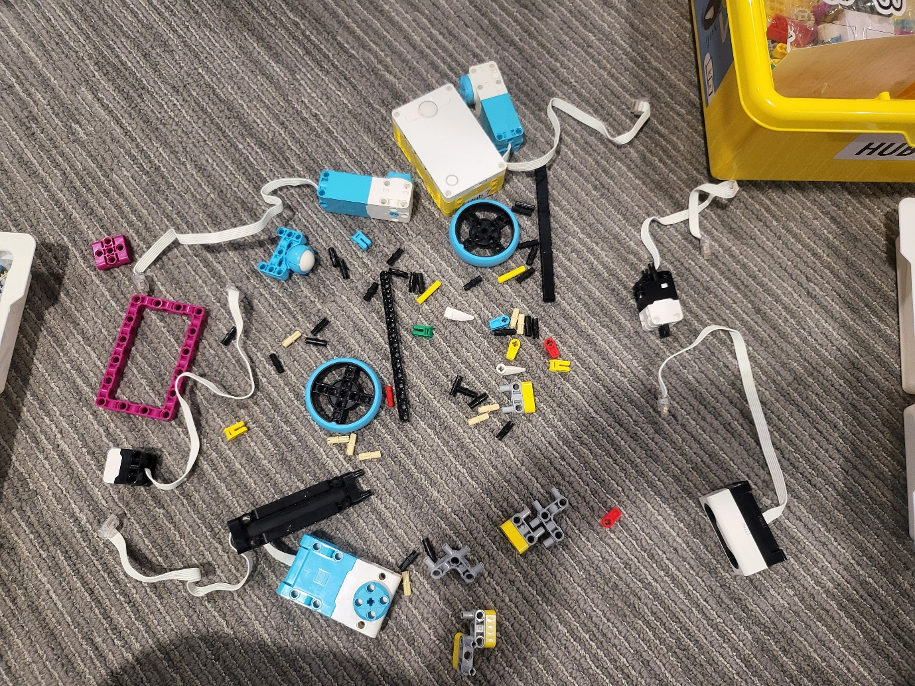
Figure 1. LEGO Spike Prime Components Used

Software and Programming Tools
We used LEGO Spike Word Blocks. This programming environment supports loops, conditionals, events, and custom functions. It is suitable for learners because it is visual and easy to understand.
Construction Techniques
To make the robot stable and reliable, we followed common construction principles:
- Keeping the centre of gravity low
- Rigid chassis
- Aligning sensors properly
- Balanced wheel placement
These ideas helped us design a robot that could move smoothly and read sensors accurately.

Section I Led: Maze Navigation
Since I led the maze navigation stage, I conducted additional research into:
- Gyro-based turning
- Distance-sensor scanning
- Dead-end detection
- Open-path selection algorithms
The decision to rotate the distance sensor using a motor was inspired by examples in educational robotics where a scanning head improves environmental awareness (Papert, 1993). This allowed the robot to compare left and right distances before choosing a direction.

Planning and Timeline

Step-by-Step-Plan
Stage1: Line Following
- Build chassis with front-mounted colour sensor
- Calibrate sensor to detect red line
- Implement threshold-based steering
- Add obstacle-avoidance function
- Test on curved line

Stage 2: Maze Navigation
- Mount distance sensor on rotating head
- Implement scanning function
- Implement gyro-based turning
- Test in small sections of maze
- Integrate with Stage 1 code

Pseudocode Example (Maze Navigation)
loop forever:
move forward
if obstacle detected:
run Target_Search
if colour sensor sees red:
stop and signal

Timeline
Week | Task
1 | Research + planning
2 | Robot Construction
3 | Line-following development
4 | Maze-navigation development
5 | Testing +debugging
6 | Report writing

Robot Design

Hardware Design
The robot was built using the LEGO Spike Prime kit. The chassis was reinforced using Technic beams to ensure stability. Two large motors powered the wheels, while a medium motor rotated the distance sensor for maze scanning.
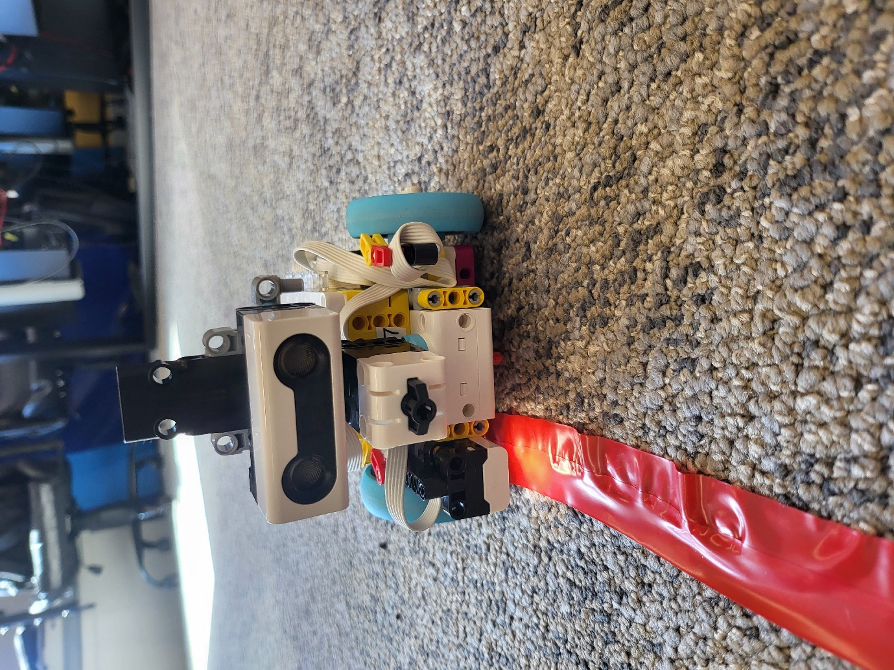
Figure 2. Front view of the Robot
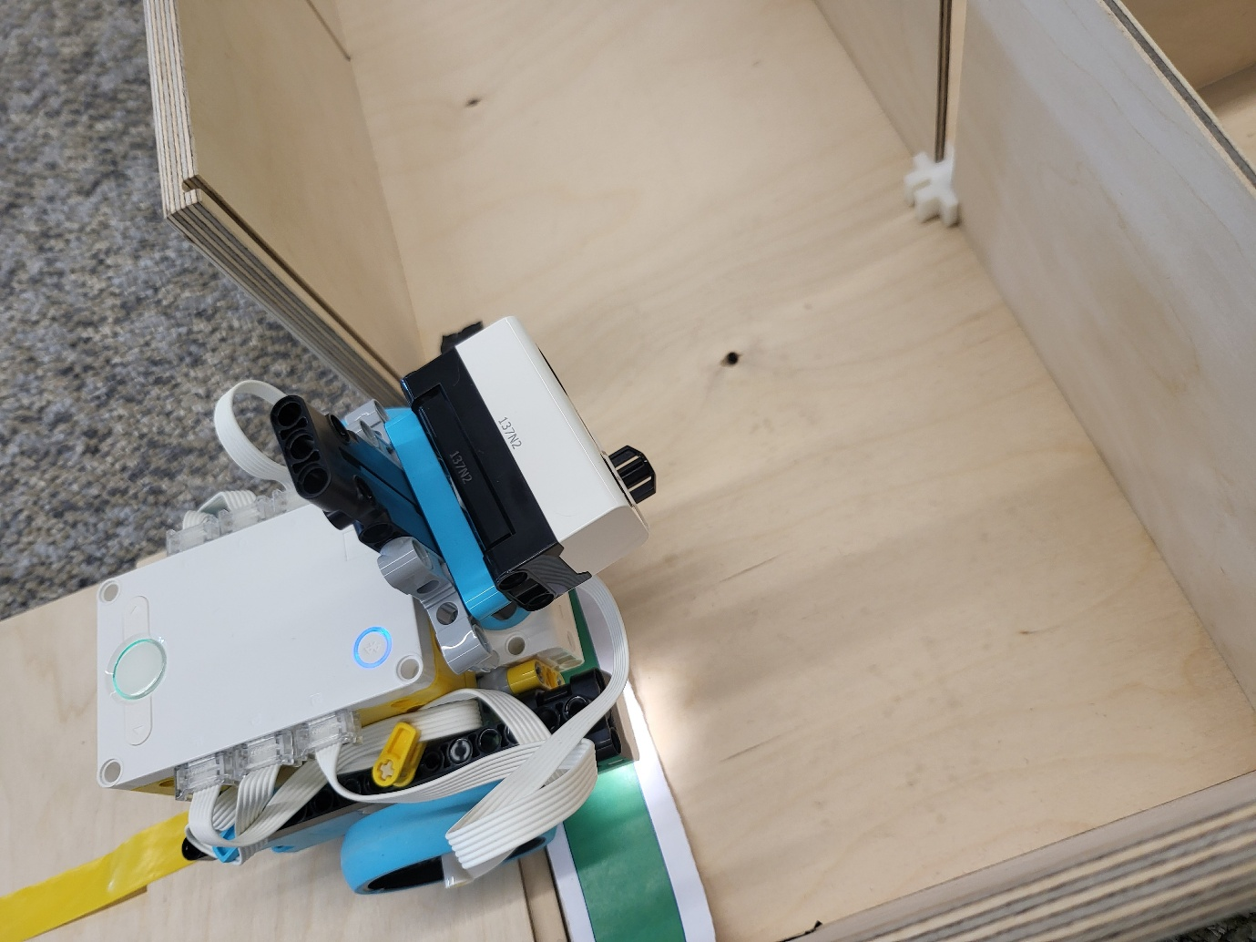
Figure 3. Robot entering the maze
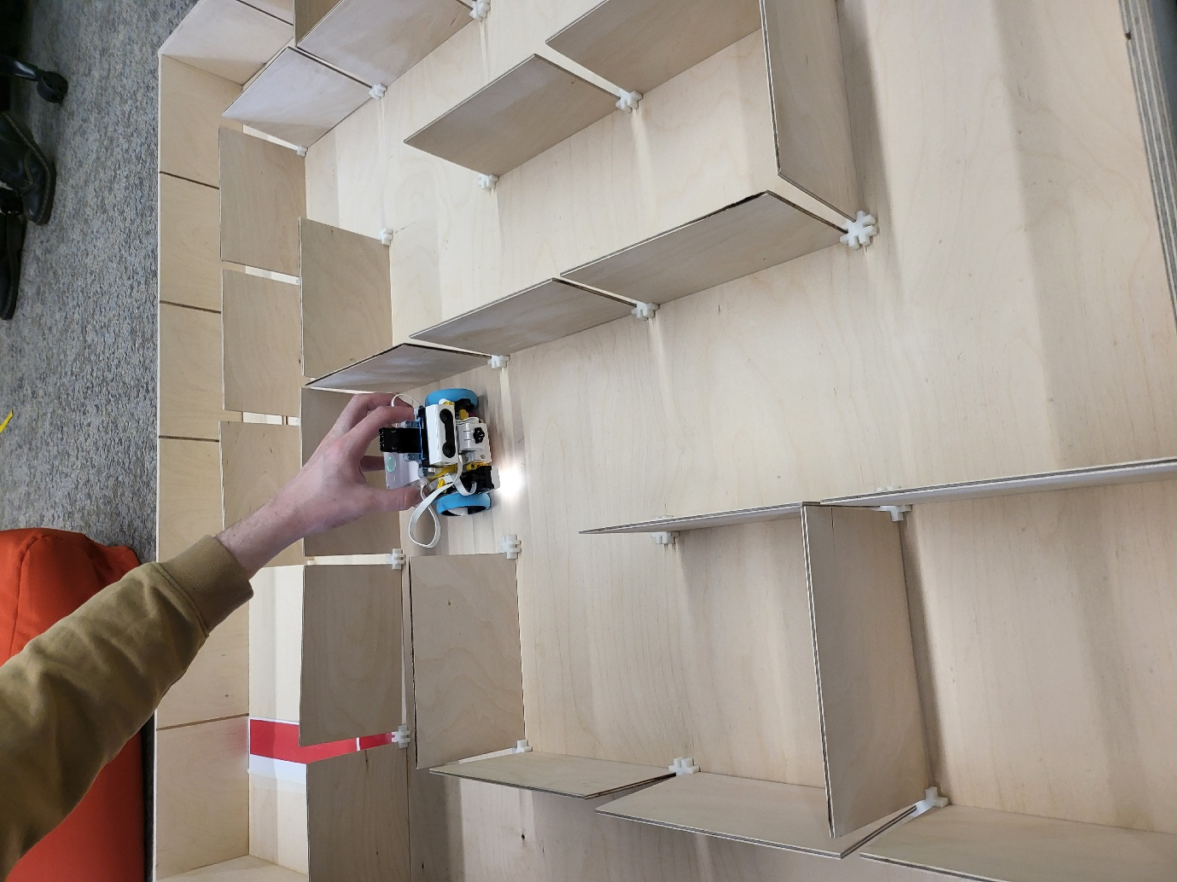
Figure 4. Robot inside the maze

Components List
- Spike Prime Hub
- Large Angular Motors (x2)
- Medium Angular Motor
- Colour Sensor
- Distance Sensor
- Technic beams (yellow, blue, black, pink)
- Connectors and axles
- Wheels and tyres
- White connector cables
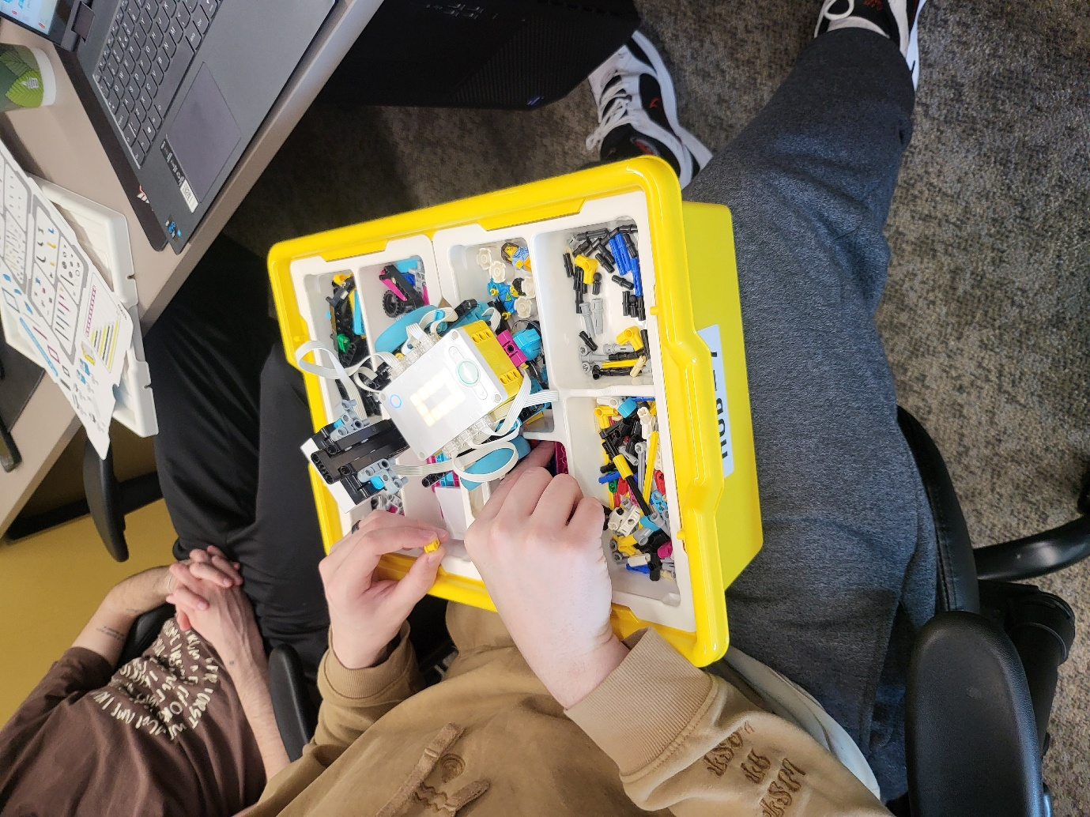
Figure 5. Spike box

Implementation & Coding

Stage 1: Line Following
The line-following algorithm uses the colour sensor to detect the red line. When the sensor sees red, the robot turns right, when it does not see red, it turns left. This creates a simple but effective correction loop.
Obstacle avoidance is triggered by Button A, which runs a sequence of backward and forward movements to bypass the wooden block.

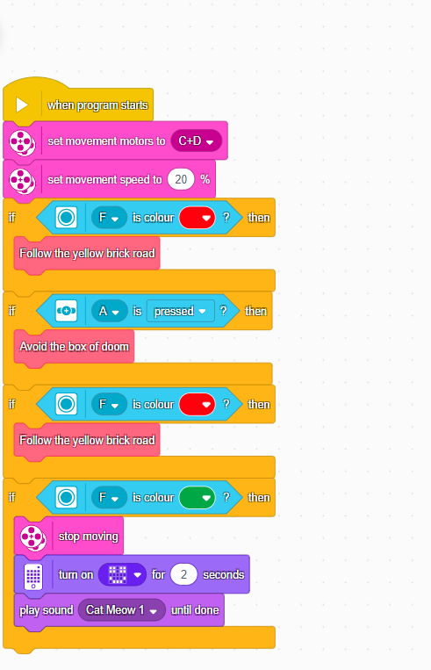
Figure 6. Line following Code

Figure 7. Robot following the line

Stage 2: Maze Navigation
The maze-navigation algorithm uses a scanning head to measure left and right distances. The robot compares these values and turns toward the more open path. Gyro-based turning helps the robot turn accurately at corners.
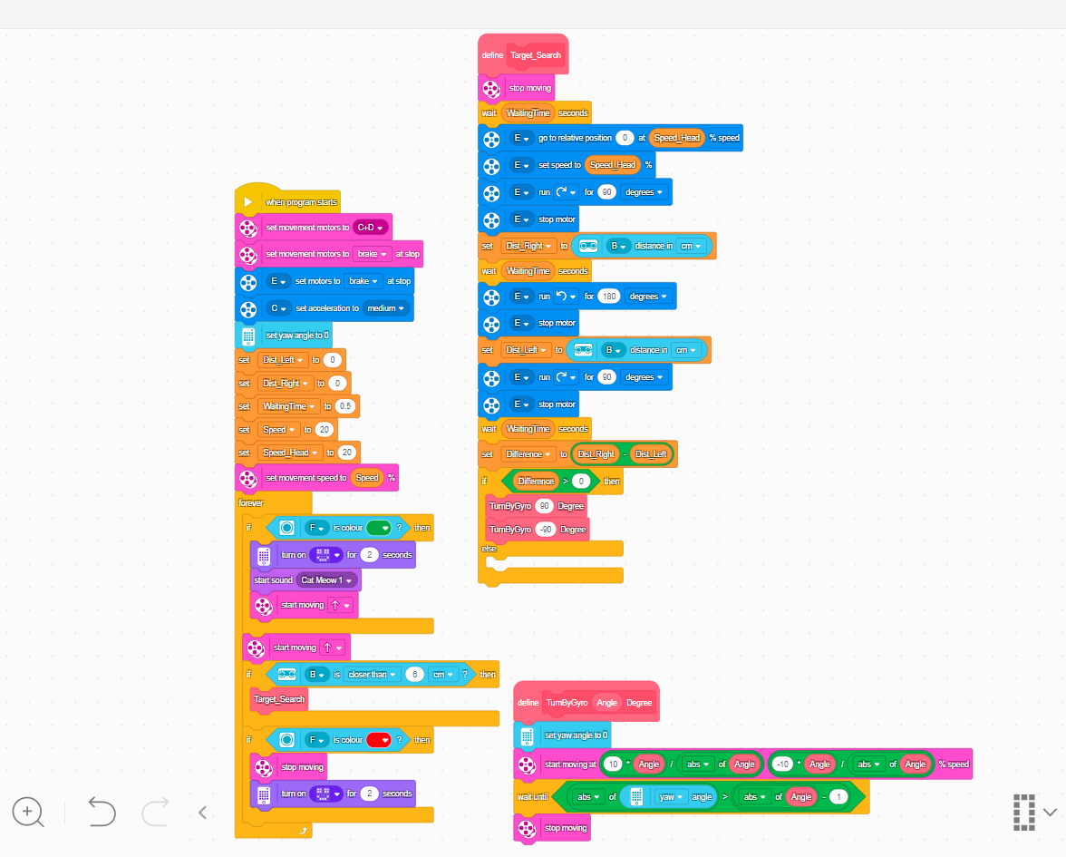
Figure 8. Maze Navigation Code

Testing and Evaluation

Stage-Wise Testing
Line Following
- Tested on straight and curved lines
- Checked colour sensor accuracy
- Adjusted speed for stability
Obstacle Avoidance
- Used a Spike Prime box as the obstacle
- Ensured the robot rejoined the line back
Maze Navigation
- Tested scanning function
- Verified left/right distance detection
- Adjusted gyro turning angles
Figure 9. Robot entering the maze

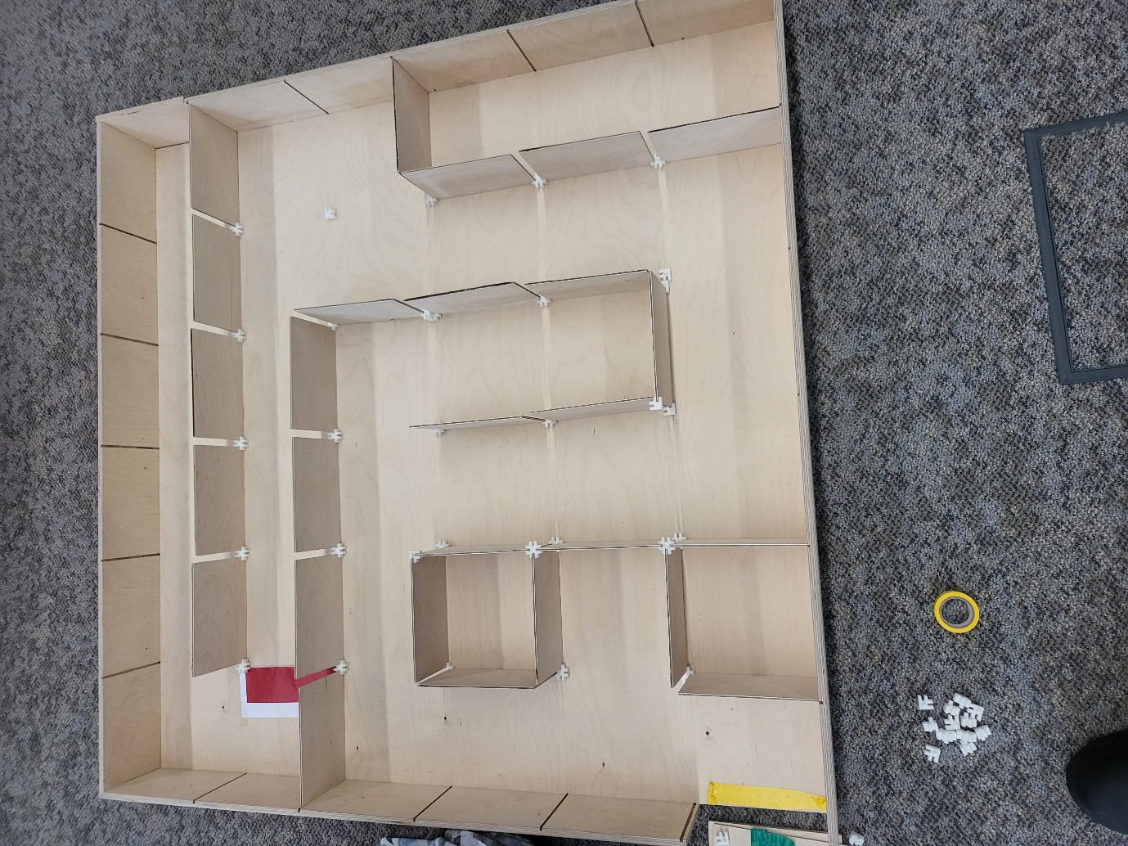
Figure 10. Maze layout picture

Results
- The robot successfully followed the line
- It avoided the obstacle reliably
- It navigated the maze and reached the red block
- The scanning head improved decision-making accuracy

Reflection
- Some challenges I faced included:
- Sensor misalignment
- Inconsistent turning angles
- Cable management inside the maze
- Understanding the right code to use
For future improvements, I would:
- Try proportional line following
- Improve teamwork communication
- Make the chassis more rigid

Conclusion
This project showed how LEGO Spike Prime can be used to create an autonomous robot. By combining line following, obstacle avoidance, and maze-solving algorithms, the robot completed both stages of the challenge. I learned a lot about sensors, coding, and teamwork, and I gained confidence in understanding how the robot works even when I wasn’t able to build every part myself.

References
Al-Shamayleh, A., et al. (2018). Line Following Robots: A Review.
Kim, J. & Kim, H. (2019). Ultrasonic-Based Maze Navigation.
Papert, S. (1993). Mindstorms: Children, Computers, and Powerful Ideas.
Siegwart, R., Nourbakhsh, I. & Scaramuzza, D. (2011). Introduction to Autonomous Mobile Robots. MIT Press.

