

Part 1 – Academic Report
Part 2: Reflective essay
Student Name: David Marian Beltic
Student ID: 2020289
Programme: BA Leadership and Management
Module: Emergent Leadership Skills in the Workplace
Module code: BMSW6101
Lecturer: Dr. Oluwaseun Adegbite

TABLE OF CONTENT
Part 1 – Academic Report 2
Introduction 2
Theory X, Y & Z Leadership 2
Introduction to Leadership Theories 2
Similarities and Differences 3
Key characteristics and principles of each theory 4
Advantages and Disadvantages 4
Role of Culture and Personal Differences 6
Personal Differences and Leadership Styles 7
Case Study Analysis 7
Situational Leadership 8
Introduction to Situational Leadership 8
The Situational Leadership Model 9
Organizational Example (Unilever) 9
Global Expansion (Theory X and Y) 10
Competitive Landscape (Theory Z) 10
Effectiveness of the Chosen Leadership Style 10
Conclusion 11
References 12
Appendices 16
Part 2: Reflective essay 19

Part 1 – Academic Report
Understanding Leadership Theories X, Y, and Z: A Comprehensive Analysis

Introduction
McGregor's Theory X and Theory Y represent contrasting management philosophies. Theory X leans towards an authoritarian approach, while Theory Y advocates for participative management. Effective leadership often requires a blend of both theories, tailored to individual and situational needs. Theory Z, introduced by William Ouchi, combines aspects of Theory Y and Japanese management principles, emphasizing trust, loyalty, and collaboration. This report investigates into three key leadership theories: Theory X, Theory Y, and Theory Z, exploring their relevance in contemporary organizational contexts. Theory X represents an authoritative management approach, while Theory Y emphasizes participative leadership. Theory Z combines the strengths of both. In today's dynamic workplaces, leaders face diverse challenges, demanding adaptability and flexibility. This report also examines how culture and personal differences influence leadership styles and delves into situational leadership. By analyzing these theories, discussing their similarities, differences, advantages, and disadvantages, and considering the impact of culture and personal traits, this report provides valuable insights for leaders navigating modern organizational complexities.

Theory X, Y & Z Leadership

Introduction to Leadership Theories
According to Channell (2021), McGregor's Theory X and Theory Y represent two contrasting management philosophies. Theory X adopts an authoritarian approach, assuming employees lack intrinsic motivation and need external rewards, punishments, and constant supervision to perform effectively. In contrast, Theory Y advocates for a participative management style, trusting that employees are self-motivated, capable of making decisions, and seek personal growth. While theory X suits high-pressure, output-driven environments, offering clear roles and goals but potentially stifling creativity and development. Theory Y, while more empowering and conducive to meaningful careers, may not be suitable for all employees, as it demands comfort with ambiguity. Effective management often requires a blend of both theories, adjusting to individual and situational needs. Striking this balance promotes employee motivation and wellbeing, fosters a positive work environment, and ultimately enhances organizational success (Sethuraman and Suresh, 2014). Theory Z, introduced by William Ouchi in 1981, distinguishes itself from Douglas McGregor's theories. Despite its misleading name, it stands as an independent management philosophy, often associated with the Japanese management style. Ouchi's Theory Z combines the favorable aspects of Theory Y and modern Japanese management principles. It places significant trust and freedom in employees, presuming their strong loyalty and commitment to teamwork and the organization (Cuofano, 2023).

Similarities and Differences
Similarities
According to Kurt (2022), the Theory X acknowledges that employees have innate potential, although it tends to view them as naturally lazy or unproductive (Figure 2). However, it does recognize that this potential can be influenced to improve work performance and organizational efficiency. While, the theory Y highlights the belief that employees possess potential and can be motivated when provided with suitable conditions and responsibilities. It suggests that people can become more productive when their potential is recognized and cultivated.
Theory X and Theory Z both place a significant emphasis on the style of management and its impact on employee efficiency and organizational success (Aithal & Kumar, 2016). Theory X leans towards strict supervision and authoritarian management, while Theory Z focuses on a distinct corporate culture and consensus decision-making. Moreover, both Theory X and Theory Z anticipate a degree of employee loyalty, although they differ in their approach to achieving it. Theory X expects employees to be efficient under strict supervision, while Theory Z aims to build loyalty by creating a supportive and culturally rich work environment (Aithal et al., 2016)
Differences
Theory X, as described by Render (2019), is characterized by a management perspective that assumes employees have a less favorable view of work. Managers adhering to Theory X tend to hold pessimistic beliefs about their employees' intentions. They perceive employees as inherently lazy, requiring strict control and micromanagement to motivate them. Managers in this category are typically authoritarian, preferring to exercise a high degree of control over their employees. They often view employees as unambitious and prioritize job security over autonomy. In summary, Theory X is marked by a top-down, directive management style with an emphasis on control and supervision. In contrast to Theory X, Theory Y presents a more optimistic view of employees and their motivations (Surbhi, 2017). According to the article by Render (2019), Theory Y managers believe that employees can be self-motivated and find fulfillment in their work. They do not view employees as inherently lazy or in need of constant supervision. Instead, they prefer to grant employees more autonomy and decision-making authority. Theory Y managers encourage employees to take responsibility for their tasks and believe that employees can work towards goals they believe in. This theory highlights a participative management approach, where employees are given more freedom and trust to carry out their roles (Vaidya & Wallstreetmojo, n.d.).
Theory Z, as described by Render (2019), represents a management philosophy that combines elements of both Japanese and American management practices. It focuses on creating a motivating work environment through long-term employment, respect for employees, individual responsibility, and group collaboration. Theory Z managers aim to build long-term relationships with employees and cultivate individual responsibility, rather than assuming it or not. They exercise more informal control over their subordinates and emphasize the importance of group collaboration. Theory Z acknowledges the existence of both Theory X and Theory Y employee personalities and adapts its approach to accommodate both types. It reflects a flexible, culturally sensitive management style that aims to create a harmonious and productive work environment.

Key characteristics and principles of each theory
Theory X assumes that people are naturally lazy, disliking work, and requiring strict control and external motivators like rewards and punishments (Surbhi, 2017). On the other hand, Theory Y contends that people are inherently self-motivated, enjoy their jobs, and can be trusted with responsibility and autonomy. Theory X is more authoritarian and lacks trust, while Theory Y promotes participative management, intrinsic motivation, and creativity in the workplace. Theory Z, also known as the "Japanese Management" or "Participative Management" theory, emphasizes long-term employment, job security, and a strong sense of community within the workplace. It suggests that workers are motivated by a sense of belonging, job satisfaction, and involvement in decision-making. Theory Z combines aspects of both Theory X and Theory Y by valuing stability and a strong work ethic while also emphasizing employee participation and commitment to the organization's goals (Russ, 2011). This theory is often associated with Japanese management practices and aims for a harmonious and cooperative work environment.

Advantages and Disadvantages
Advantages
An article by The Economic Times (2023) suggests that leadership under Theory X can bring certain advantages to an organization. This style provides clear structure and control, which can be beneficial in situations where tasks require precise execution and consistency. By closely supervising employees and enforcing strict rules, managers can reduce the likelihood of errors and maintain consistent quality in manufacturing processes. Additionally, Theory X's use of external motivators such as rewards and penalties can produce quick results and ensure employees meet specific goals and deadlines (Courtney et al., 2018).
Theory Y leadership offers several advantages to an organization. By emphasizing trust and autonomy, this style can significantly increase employee engagement and job satisfaction. Employees working in a Theory Y environment are more likely to feel valued and empowered, which often leads to higher productivity and creativity. Theory Y promotes workers' sense of accountability and motivation by encouraging them to take ownership of their work (Kurt, 2022). This approach also tends to result in lower turnover rates as employees are less likely to seek employment elsewhere.
Theory Z leadership emphasizes long-term employment, employee loyalty, and collaborative decision-making. In certain contexts, these principles can offer significant advantages. Employees in a Theory Z organization tend to have a strong sense of job security and belonging, which can foster a stable and cohesive work environment. The emphasis on teamwork and group decision-making often leads to better collaboration and problem-solving. In turn, this can contribute to a more efficient and harmonious workplace with lower turnover rates.
Disadvantages
The constant oversight and limited trust in employees can lead to demotivation and reduced job satisfaction among the workforces. Employees may feel micromanaged and undervalued, which can stifle their creativity and innovation. Moreover, the rigid nature of Theory X may hinder the growth and development of employees, as it does not encourage independent thinking or problem-solving. High turnover rates may also be a consequence, as employees seek more autonomy and job satisfaction elsewhere.
However, Theory Y may not be suitable for all situations. It requires skilled leadership capable of balancing autonomy with accountability. In some cases, employees might abuse their freedom, leading to decreased productivity and accountability issues. Additionally, not all roles within an organization may benefit from a Theory Y approach, particularly those that demand strict adherence to rules and regulations or require immediate results. Employees accustomed to a more authoritative style of management may also resist the shift towards Theory Y.
Furthermore, there are potential disadvantages associated with Theory Z leadership. The consensus-building process, which is integral to this style, can result in slow decision-making, making it challenging to adapt to rapidly changing circumstances. Furthermore, some employees may resist a shift to Theory Z, particularly those accustomed to different management styles. In some cases, the focus on consensus may lead to a reluctance to take risks or make bold decisions, potentially resulting in mediocrity or missed opportunities for innovation.
For example, in fast-food restaurants like McDonald's and Burger King in the UK, Theory X management may be evident. Managers closely supervise employees, enforce strict procedures for food preparation and customer service, and use incentives like bonuses for meeting sales targets. While this ensures consistent service quality, it can lead to high turnover due to the demanding work environment and limited autonomy for employees. The advantages and disadvantages of these leadership styles are context-dependent, and effective leaders often adapt their approach to the specific needs of their organization and team.

Role of Culture and Personal Differences
The way that leadership styles are applied and how effective they are inside organisations is greatly influenced by personal differences and organisational culture. Understanding and navigating these factors is crucial for leaders seeking to create inclusive and effective leadership approaches. In this discussion, we will delve into the impact of culture and personal differences on leadership styles and explore how leaders can adapt to these factors.
Culture heavily influences communication norms. In high-context cultures, such as Japan or many Middle Eastern countries, indirect and subtle communication is preferred. In contrast, low-context cultures, like the United States or Germany, tend to value direct and explicit communication. Leaders must adapt their communication styles to align with the cultural preferences of their team members to ensure effective communication.
As Hai et al. (2019) stated some cultures have a strong hierarchical structure, where authority figures are highly respected and decision-making is centralized (e.g., South Korea). In contrast, other cultures value more egalitarian relationships and participative decision-making (e.g., Scandinavia). Leaders need to adapt their leadership style to align with these cultural expectations. In hierarchical cultures, a more directive approach may be accepted, while in egalitarian cultures, a participative style may be more effective.
Cultures vary in their emphasis on collectivism (group harmony and cohesion) or individualism (personal goals and autonomy). In collectivist cultures, such as many Asian societies, leaders may need to prioritize team goals and build strong relationships. In individualist cultures, like the United States, leaders may focus more on individual recognition and empowerment.

Personal Differences and Leadership Styles
Threlfall (2019) stated that individuals have diverse personality traits, such as introversion or extroversion, which can influence their leadership styles. An extroverted leader may excel in team building and communication, while an introverted leader might thrive in analytical decision-making. Effective leaders recognize these differences and adapt their approach to leverage the strengths of their team members. Leaders from different cultural backgrounds may have inherent biases or preferences for certain leadership styles based on their upbringing. Being aware of these biases is essential for leaders to avoid unintentional favoritism and to create an inclusive work environment.
However, generations, such as Baby Boomers, Generation X, Millennials, and Generation Z, may have distinct values and expectations from leaders (Janzer, 2021). While older generations might favour a more conventional, hierarchical style of leadership, younger generations frequently value more collaborative and adaptable leadership approaches. Leaders need to be adaptable and bridge these generational gaps effectively.
Moreover, Garamvölgyi & Rudnák (2023), stated that leaders must adapt by developing Cultural Intelligence (CQ), embracing diversity and inclusion, being flexible in leadership styles, participating in cross-cultural training, and fostering open feedback and communication to navigate cultural and individual factors effectively.
Culture and personal differences have a profound impact on leadership styles' application and effectiveness. Effective leaders recognize these influences, adapt their leadership styles accordingly, and actively promote diversity and inclusion within their teams. Leaders may build a more inclusive and effective leadership strategy that benefits individuals and the organisation as a whole by accepting cultural and personal differences.

Case Study Analysis
Errida & Lotfi (2021) presents a case study that focuses on a Moroccan construction company that underwent organizational changes and explores how a leader successfully applied change management principles, particularly the Theory Y approach, within this context. The study aims to identify factors influencing change management success and how they were leveraged effectively. In this case, the leader demonstrated a Theory Y approach by recognizing the importance of empowering and involving employees in the change process. This approach aligns with the belief that individuals are motivated, creative, and capable of taking ownership of their work. The leader emphasized open communication, employee involvement, and a supportive work culture.
The Theory Y leadership approach led to increased employee engagement as employees felt valued and included in the change process. They were encouraged to provide input and contribute to decision-making, enhancing their commitment to the changes (Errida & Lotfi, 2021). However, the company successfully implemented multiple organizational changes, such as adopting lean construction, increasing digitalization, and integrating supply chains. The Theory Y approach encouraged employees to embrace these changes and actively participate in their implementation.
The successful application of Theory Y leadership principles within a Moroccan construction company led to improved employee engagement, successful change implementation, enhanced performance, and sustained change. This case study highlights the importance of trust, empowerment, and collaboration in achieving change management success and offers valuable lessons for leaders across different sectors (Errida & Lotfi, 2021)
Lessons learned from this case study include the significance of empowering and involving employees in the change process to boost engagement and trust, the critical role of effective communication and collaboration in fostering a culture of inclusion, the need for continuous leadership support to maintain enthusiasm, the sustainability of change through intrinsic motivation, and the applicability of Theory Y principles to diverse industries with a focus on adaptable leadership approaches tailored to organizational needs.
The outcomes of applying Theory Y leadership in the Moroccan construction company included improved employee engagement, successful implementation of organizational changes, enhanced performance, and sustained change, highlighting the effectiveness of this leadership approach in achieving successful change management.

Situational Leadership

Introduction to Situational Leadership
Situational Leadership is a leadership theory and model developed by Paul Hersey and Kenneth Blanchard in the late 1960s and early 1970s ( Cherry & Morin, 2023). This leadership approach focuses on adapting leadership styles to match the developmental readiness or maturity level of individual team members or groups within an organization. Situational Leadership recognizes that different situations and individuals require different leadership approaches to be effective.
In modern organizations, the relevance of Situational Leadership lies in its adaptability and responsiveness to the diverse and ever-changing challenges faced by leaders (Joshi, 2023). It acknowledges that one leadership style may not fit all scenarios and individuals, emphasizing the importance of flexibility and the ability to assess and adjust leadership behaviors based on the specific needs of the situation and the people involved. This approach is particularly suited for today's dynamic and complex work environments, where leaders must navigate varying levels of competence and commitment among their team members to achieve optimal results.

The Situational Leadership Model
The Situational Leadership Model underscores the significance of leadership flexibility, emphasizing that effective leaders must possess the adaptability to tailor their leadership styles to the specific needs of different situations and the individuals they lead (Yukl, 2008). In essence, leaders are expected to be versatile in their approach, recognizing that varying circumstances and team compositions may necessitate diverse leadership behaviors (Figure 1).
This model introduces the concept of "developmental readiness," which evaluates a team member's preparedness based on their competence and commitment within a given role or task (Riggio et al., 2009). This readiness assessment categorizes individuals into four distinct stages. In the first stage, characterized by low competence but high commitment, a directive leadership style is recommended, involving clear instructions and guidance from the leader. For those with some competence but low commitment, the coaching leadership style is more appropriate, with leaders providing support, feedback, and encouragement to build commitment. The third stage, where individuals demonstrate moderate to high competence with variable commitment, benefits from a supportive leadership style, where the leader actively facilitates and participates in decision-making processes to foster commitment. Lastly, individuals with high competence and high commitment thrive under a delegating leadership style, where leaders provide autonomy and minimal supervision.
Crucially, the Situational Leadership Model emphasizes dynamic adaptation, acknowledging that leadership is not a static concept but an ever-evolving process. Leaders are expected to continuously assess the developmental readiness of their team members and adjust their leadership behaviors to align with the evolving demands of the situation (Riggio et al., 2009). This dynamic responsiveness enables leaders to optimize team effectiveness, enhance job satisfaction, and drive overall performance (Kozlowski & Ilgen, 2006).
Ultimately, the model encourages leaders to aim for an optimal leadership style that corresponds with the current developmental readiness of each team member. This alignment ensures that leadership practices are finely tuned to the unique characteristics and requirements of the individuals being led, fostering a harmonious and productive working environment.

Organizational Example (Unilever)
Unilever, a multinational consumer goods company headquartered in the UK, provides a compelling organizational example where leadership style was adeptly adjusted to meet evolving challenges and opportunities. Unilever's leaders recognized the growing global emphasis on sustainability and responsible corporate practices (Unilever, 2022). According to a report by GlobeScan (2023), Unilever`s consumers increasingly demanded environmentally friendly products and ethical business conduct, leaders understood the need to align the company with these values which brings them on the second place on the graphs with 29% of experts (Figure 3).

Global Expansion (Theory X and Y)
Unilever was expanding its presence in emerging markets, each with unique cultural, economic, and regulatory contexts (Unilever, 2022). Leaders acknowledged the necessity of adjusting leadership styles to effectively navigate these diverse markets. They combined elements of Theory X (providing structure and clear guidelines when needed) and Theory Y (empowering local leaders and teams to adapt strategies to local contexts) to successfully manage this expansion.

Competitive Landscape (Theory Z)
The FMCG sector was highly competitive, with both traditional rivals and newer, more agile competitors (Bokkerink et al., 2017). Leaders recognized the need for a collaborative approach (Theory Z), fostering teamwork and shared decision-making. This approach allowed Unilever to stay competitive and responsive in a rapidly changing industry.

Effectiveness of the Chosen Leadership Style
According to GBR (2022), Unilever's leaders adeptly blended elements of Theory X, Y, and Z within a transformational leadership style, successfully addressing various challenges. Their visionary approach fostered a compelling vision of sustainability and ethical practices, aligning the company with global environmental and social goals while inspiring employee motivation. This leadership style encouraged empowerment and collaboration among employees, mirroring the spirit of Theory Z. Additionally, leaders recognized the need for adaptive leadership in diverse global markets, providing clear guidance when necessary (Theory X) and encouraging local adaptation to meet regional needs (Theory Y).
This leadership approach generated notable results, evident in Unilever's achievement of significant sustainability milestones, enhanced brand reputation due to its commitment to sustainability, successful market growth in emerging economies driven by innovation in sustainable products, and the cultivation of high levels of employee engagement and retention (Unilever, 2021). Team members felt a deep alignment with the company's values and vision, contributing to the overall effectiveness of this leadership style.

Conclusion
In conclusion, leadership is a multifaceted concept, and various theories offer distinct insights into effective leadership styles. Theory X, Theory Y, and Theory Z provide valuable frameworks for understanding and adapting leadership approaches in contemporary organizations. While each theory has its unique strengths and weaknesses, successful leaders often find a balance between these theories, adjusting their strategies to suit individual and situational needs.
Furthermore, the role of culture and personal differences cannot be underestimated. Leaders must recognize and navigate these factors to create inclusive and effective leadership approaches. Cultural awareness, adaptability, and a commitment to diversity and inclusion are essential in today's globalized and diverse workplaces.
Furthermore, situational leadership emphasises how crucial it is for leaders to be adaptable and responsive (Cherry & Morin, 2023. To maximise output and job happiness, leaders must determine whether their team members are ready for the next step in their growth and modify their approaches accordingly.
Drawing from our analysis and the Unilever case study, it's evident that effective leadership involves a dynamic blend of Theory X, Y, and Z principles. Unilever's success in aligning its leadership style with the evolving challenges of sustainability and global expansion serves as a compelling example of how these theories can be applied in a real-world context.
However, contemporary leadership requires a nuanced approach that integrates various theories, acknowledges cultural and personal differences, and remains adaptable to changing circumstances. By embracing these principles, leaders can foster engaged, motivated, and high-performing teams, ultimately contributing to organizational success in today's dynamic business landscape.

References
Aithal, S. and Kumar, S.P.M. (2016) Comparative Analysis of Theory X, Theory Y, Theory Z, and Theory A for Managing People and Performance. Available at: DOI:10.5281/zenodo.154600 (Accessed: 02 October 2023).
Aithal, Sreeramana and Suresh, K. (2016) Comparative Analysis of Theory X, Theory Y, Theory Z, and Theory A for Managing People and Performance. Available at: https://mpra.ub.uni-muenchen.de/72974/1/MPRA_paper_72974.pdf (Accessed: 02 October 2023).
Bokkerink, M. et al. (2017) How Big Consumer Companies Can Fight Back, BCG Global. Available at: https://www.bcg.com/publications/2017/strategy-products-how-big-consumer-companies-can-fight-back (Accessed: 02 October 2023).
Brabrand, H. (no date) Leading others: Situational leadership, Albright. Available at: https://www.albrightglobal.com/post/leading-others-situational-leadership (Accessed: 02 October 2023).
Channell, M. (2021) McGregor’s theory X vs theory Y: How to increase performance in your team, TSW Training. Available at: https://www.tsw.co.uk/blog/leadership-and-management/mcgregors-theory-x-vs-theory-y/ (Accessed: 02 October 2023).
Cherry, K. and Morin, A. (2023) Situational Leadership Theory, Verywell Mind. Available at: https://www.verywellmind.com/what-is-the-situational-theory-of-leadership-2795321 (Accessed: 02 October 2023).
Courtney , M.A., Ackerman, E. and Neuhaus , M. (2018) Self Determination Theory and How It Explains Motivation, PositivePsychology.com. Available at: https://positivepsychology.com/self-determination-theory/ (Accessed: 03 October 2023).
Cuofano, G. (2023) What Is Theory Z? Theory Z In A Nutshell, FourWeekMBA. Available at: https://fourweekmba.com/theory-z/ (Accessed: 02 October 2023).
Ebrary (n.d.) Comparison of theories X and Y, Ebrary. Available at: https://ebrary.net/2841/management/comparison_theories (Accessed: 02 October 2023).
Errida, A. and Lotfi, B. (2021) The determinants of organizational change management success: Literature review and case study, Saga. Available at: https://journals.sagepub.com/doi/full/10.1177/18479790211016273 (Accessed: 02 October 2023).
Garamvölgyi, J. and Rudnák, I. (2023) Exploring the Relationship between Cultural Intelligence (CQ) and Management Competencies (MC). Available at: https://doi.org/10.3390/su15075735 (Accessed: 02 October 2023).
GBR (2022) Leadership Management of Unilever, George Business Review. Available at: https://www.george-business-review.com/leadership-management-and-their-contribution-to-unilevers-success/ (Accessed: 02 October 2023).
GlobalScan (2023) Sustainability Leaders, GlobalScan. Available at: https://globescan.com/wp-content/uploads/2023/06/2023SustInsti-Globescan-Leaders-survey_Highlights.pdf (Accessed: 02 October 2023).
Hai , K.K., Kibok, B. and Najung, K. (2019) How Korean Leadership Style Cultivates Employees’ Creativity and Voice in Hierarchical Organizations. Available at: https://doi.org/10.1177/21582440198762 (Accessed: 02 October 2023).
IvyPanda (2023) Theory X and theory Y examples & use in management: Term paper example, IvyPanda. Available at: https://ivypanda.com/essays/theory-x-and-theory-y-in-management-term-paper/ (Accessed: 02 October 2023).
Janzer, C. (2021) Generational Differences in the Workplace: Boomers, Gen X, Gen Y, and Gen Z Explained, Workest. Available at: https://www.zenefits.com/workest/generations-in-the-workplace-boomers-gen-x-gen-y-and-gen-z-explained/#:~:text=Baby%20boomers%20are%20the%20eldest,born%20between%201995%20and%202009. (Accessed: 03 October 2023).
Joshi, K. (2023) Comprehensive overview of situational leadership: How to use it, Emeritus Online Courses. Available at: https://emeritus.org/blog/leadership-situational-leadership/#:~:text=Situational%20leadership%20has%20become%20essential,current%20ever%2Dchanging%20work%20environment. (Accessed: 02 October 2023).
Kozlowski, S.W.J. and Ilgen, D.R. (2006) Enhancing the Effectiveness of Work Groups and Teams. Psychological Science in the Public Interest, 7(3), 77-124. Available at: tps://doi.org/10.1111/j.1529-1006.2006.0003 (Accessed: 03 October 2023).
Kurt, S. (2022) Theory X And Theory Y, Douglas McGregor, Education Library. Available at: https://educationlibrary.org/theory-x-and-theory-y-douglas-mcgregor/ (Accessed: 02 October 2023).
Render, J. (2019) Macgregor’s XY theory and Ouchi’s theory Z, Agile. Available at: https://agile-mercurial.com/2019/06/28/macgregors-xy-theory-and-ouchis-theory-z/ (Accessed: 02 October 2023).
Riggio, R.E., Hrivnak, G. and Reichard, R. (2009) Leadership Development, ResearchGate. Available at: https://www.researchgate.net/publication/282612144_Leadership_Development (Accessed: 02 October 2023).
Russ, T.L. (2011) Theory X/Y assumptions as predictors of managers’ propensity for participative decision making. Available at: DOI:10.1108/00251741111130887 (Accessed: 03 October 2023).
Sethuraman, K. and Suresh, J. (2014) Effective leadership styles, International Business Research. Available at: https://doi.org/10.5539/ibr.v7n9p165 (Accessed: 02 October 2023).
Surbhi, S. (2017) Difference between theory X and theory Y (with comparison chart), Key Differences. Available at: https://keydifferences.com/difference-between-theory-x-and-theory-y.html (Accessed: 02 October 2023).
The Economic Times (2023) What is ‘Theory X & theory Y’, The Economic Times. Available at: https://economictimes.indiatimes.com/definition/theory-x-theory-y (Accessed: 03 October 2023).
Threlfall, D. (2021) Are the Best Managers Introverts, Extroverts, or Somewhere In-between?, RSS. Available at: https://www.teamgantt.com/blog/are-the-best-managers-introverts-extroverts-or-somewhere-in-between (Accessed: 03 October 2023).
Unilever (2021) Unilever Sustainable Living Plan 2010 to 2020 Summary of 10 years’ progress, Unilever. Available at: https://www.unilever.com/files/92ui5egz/production/16cb778e4d31b81509dc5937001559f1f5c863ab.pdf (Accessed: 02 October 2023).
Unilever (2022) Unilever International celebrates decade of consistent growth serving the underserved, Unilever. Available at: https://www.unilever.com/news/news-search/2022/unilever-international-celebrates-decade-of-consistent-growth-serving-the-underserved/ (Accessed: 02 October 2023).
Vaidya, D. and Wallstreetmojo (no date) Theory X and theory Y (mcgregor) - what are they, examples - wallstreetmojo, Wallstreetmojo . Available at: https://www.wallstreetmojo.com/theory-x-and-theory-y/ (Accessed: 02 October 2023).
Yukl, G. (2008) The Importance of Flexible Leadership, ResearchGate. Available at: https://www.researchgate.net/publication/254848271_The_Importance_of_Flexible_Leadership (Accessed: 02 October 2023).

Appendices

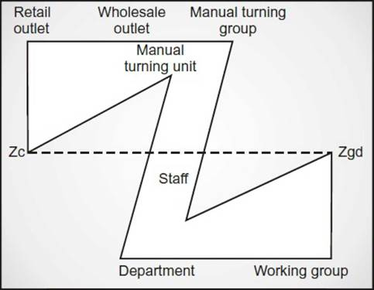
Figure 1 Theory Z Model (Adopted from Urwick).
(Source: Ebrary, n.d.)


Figure 2 A person refusing to work (“X”) and a person cheering the opportunity to work (“Y”)
(Source: Kurt, 2022)

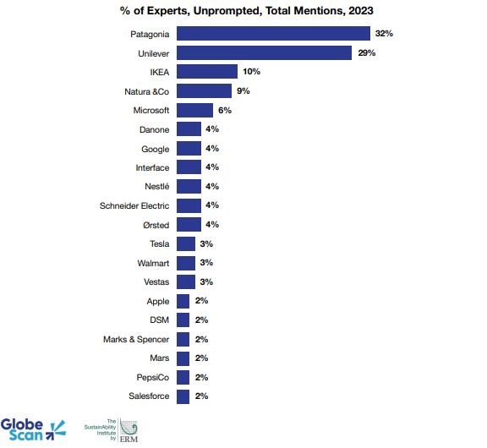
Figure 3 Companies most recognized for their sustaiability leaderhip
(Source: GlobeScan, 2023)

Part 2: Reflective essay

Reflection in the context of learning in higher education, involves a thoughtful examination and analysis of the historical and ideological dimensions of higher education. It goes beyond a mere intellectual understanding of knowledge and truth to encompass a more holistic perspective that includes the individual learner's context in the world (Brockbank and McGill, 1998).
The leadership snapshot featuring Indra Nooyi, CEO of PepsiCo, offered a real-world example of a leader breaking conventional boundaries and creating positive change. The ensuing discussion on the difference between leadership and management, citing Frederick Taylor and Barnard's conceptualization of authority, added nuance to my understanding of these distinct yet interconnected roles.
Acknowledging the dark side of leadership, characterized by toxicity and the misuse of influence for personal ends, illuminated the complexity and ethical dimensions of leadership. The session's summary encapsulated the multifaceted nature of leadership, emphasizing its demanding yet rewarding essence. As I reflect on this session, I am mindful that how I think about leadership will significantly influence my approach and practice of leadership in diverse contexts.
Session 6 on Leadership in Uncertain Times has been exceptionally captivating and enlightening, providing valuable insights that I believe will significantly contribute to my future career development. The session underlined the pivotal role of leadership in ensuring organizational success, particularly in the context of evolving structures and constant change. During this session I have also understood that flatter organizations require a different approach to leadership resonated with me, challenging traditional notions of hierarchical authority. The assertion that effective control is best achieved through strong values embodied in leadership aligns with my belief in the power of ethical leadership to navigate complex landscapes.
More than that, the delineation of strategic leadership roles for both top and middle management shed light on the multifaceted nature of leadership responsibilities. Recognizing middle managers as not merely implementers but as crucial contributors to change, particularly in sense-making and local leadership, broadened my perception of leadership within organizational hierarchies.
Moreover, the discussion on leadership as a function of the organization highlighted the contextual factors that shape leadership effectiveness. The acknowledgment of organizational age, size, structure, stability, crisis situations, and cultural variations underscored the need for leaders to adapt their approaches based on the unique characteristics of their organizational context.

Leadership as an Art and Science: A Balancing Act
Session 1 introduced the idea of thinking about leadership as both an approach and a theory. This duality resonated deeply with me. Leadership, I realized, is both an art and a science—an amalgamation of intuitive understanding and systematic knowledge. The 7 A's of practical leadership—Attitude, Attention, Added Value, Agenda, Available, Action, and Agility—served as practical guideposts. Engaging in teamwork and presentations around these elements not only enhanced my collaborative skills but also reinforced the idea that effective leadership is a holistic endeavor encompassing various dimensions.

The breakdown of leadership into trait, behavior, situational, relational, and emerging approaches provided a roadmap for comprehending the complexity of leadership. I found myself resonating with the idea that leadership is not a static concept but an ever-evolving phenomenon. The session compelled me to introspect, asking myself, "What sort of leadership roles am I called on to play in my life?" This self-inquiry triggered a realization that leadership is not confined to organizational settings; it permeates various facets of life, urging me to be a leader in different contexts

Session 6: Navigating Uncertainty with Leadership
Fast-forwarding to Session 6, the focus on leadership in uncertain times struck a chord with the contemporary challenges organizations face. The assertion that leadership is key to organizational success in the face of flatter structures and constant change resonated with my understanding of the contemporary business landscape. The recognition that employees are more demanding and require strong leadership highlighted the evolving dynamics in the employer-employee relationship.
The delineation of strategic leadership roles for top and middle management provided a nuanced understanding of the diverse responsibilities leader’s shoulder. This session was not just about theoretical frameworks; it was a practical guide to understanding the intricacies of leadership in the real world. The exposure to various theories of leadership—traits and skills, behavioral and style-based, situational and contingency models, and transactional-transformational approaches—underscored the importance of adaptability in leadership.
The practitioner's perspective on leading in uncertain times added a real-world dimension to the session. The recognition that agility is the new currency of business and the need for organizations to be comfortable disrupting their business models in the face of complexity and uncertainty resonated deeply. The insights from the Global CEO Outlook survey by KPMG further emphasized the critical importance of agility in navigating the challenges of today's global economy (KPMG, 2019).

Transformational Leadership: A Personal Epiphany
The exploration of Transformational Leadership left an indelible mark on my perspective. The idea that leaders can transform and motivate followers by generating awareness, inducing them to transcend self-interests, and activating higher-level needs struck me as a profound paradigm shift (Pastor and Mayo, 2008). As I explored into the characteristics of a transformational leader—encouraging motivation, exemplifying moral standards fostering an ethical work environment, and building company culture (Solinger et al., 2020). I planned a leadership style that goes beyond tasks, transcending into a realm of inspiration and positive impact toward my career’s goals.
The process of transformational leadership, with its focus on recognizing the need for change, using charisma to appeal to ideals and emotions, inspiring employees to think differently, and addressing emotional needs, resonated deeply. I found myself contemplating not just how I could be a better leader but how I could inspire positive change and growth in those around me.
Exploring the evolution of leadership theories, from the Great Man Theory to contemporary Transactional and Transformational Leadership, offered a comprehensive historical perspective. This journey through leadership theories helped me appreciate the dynamic nature of leadership concepts and the ongoing quest to understand and apply effective leadership principles (Pastor and Mayo, 2008).
The in-depth exploration of Transformational Leadership left a lasting impression. The emphasis on generating awareness, transcending self-interest, and activating higher-level needs aligns with my belief in the transformative potential of inspirational leadership. The elements of transformational leadership—idealized influence, motivating inspiration, intellectual stimulation, and personalized attention—offered a sophisticated perspective on the attributes that make for successful leadership in unpredictable times.

Linking Knowledge to Aspirations: Career and Higher Education
As I reflect on these learnings, the connection to my career aspirations and higher education becomes evident. The newfound insights into leadership will undoubtedly serve as a compass guiding me through the intricacies of professional life.
In my envisioned career path, which involves navigating through the complexities of a dynamic business environment, the understanding gained in Session 6 on leading in uncertain times is invaluable. The realization that agility is the new currency of business aligns seamlessly with my belief in the need for adaptability and resilience in the face of change. The practitioner's perspective on disruptions in business models resonates deeply, challenging me to be comfortable with discomfort and fostering a mindset that sees growth opportunities in every challenge.
The exploration of leadership theories, from the historical Great Man Theory to contemporary transactional-transformational models, provides me with a robust foundation. Armed with this knowledge (Khan and Nawz, 2016) I feel equipped to critically analyse and adapt my leadership style based on the unique demands of different situations. The understanding that leadership is not a static concept, but a constantly evolving phenomenon fuels my commitment to continuous learning and growth.
The emphasis on transformational leadership has left an enduring impact on my vision for the future. I aspire not only to lead but to inspire positive transformations within the organizational contexts I find myself in. The focus on ethical work environments, clear values, and fostering a company culture aligned with collective values resonates deeply with my commitment to ethical leadership (Yang and Wei, 2018). These principles will serve as the guiding light in my leadership journey, ensuring that my actions contribute not only to organizational success but also to the well-being and growth of those I lead.
In terms of higher education, these learnings have sparked a curiosity to delve deeper into leadership studies. The realization that leadership is not just a skill but a dynamic interplay of various elements—traits, behaviors, relationships, and influence processes—fuels my desire to pursue advanced studies in leadership. I am eager to explore how these concepts are evolving in the contemporary landscape and how they can be applied to drive positive change in organizations.

Gibbs' Reflective Cycle
A well-structured model for reflection, Gibbs' Reflective Cycle promotes a detailed account of an experience, an examination of the emotions involved, an assessment of the experience, an interpretation of the experience to make sense of it, and a conclusion about what you learned and what you could have done differently.
Description
Throughout this learning journey, I delved into various facets of leadership, drawing inspiration from real-world examples like Indra Nooyi and Amazon's leadership practices (see Appendix 1). The appendices, showcasing Amazon's certifications and job proposals (Appendix 1 and Appendix 2), served as practical touchpoints for my exploration.
Feelings
I found myself intrigued and engaged, especially during the session on leadership in uncertain times. The complexities of contemporary business landscapes, the nuances of leadership roles, and the transformative potential of leadership left me feeling both challenged and inspire.
Evaluation
Reflecting on these experiences, I recognized the dynamic nature of leadership, the ethical dimensions involved, and the pivotal role of adaptability (see Appendix 1). The evaluation led me to appreciate not only the practical aspects of leadership but also its profound impact on organizational success and individual growth.
Analysis
Analyzing the implications, I connected these learnings to my career aspirations. The need for agility in a dynamic business environment resonated deeply, aligning with my belief in adaptability and resilience. The emphasis on transformational leadership sparked a personal epiphany, pushing me to aspire not only to lead but to inspire positive transformations within organizations.
Action Plan
To actively apply these learnings, I plan to seek opportunities for practical leadership experience. Taking on roles or projects that challenge me will be instrumental in refining my skills. Additionally, exploring advanced studies in leadership will deepen my understanding of evolving concepts, aligning with my commitment to continuous growth.

Conclusion
In conclusion, the exploration of leadership in Session 1 and Session 6 has been a transformative journey. It has kindled a fire within me—a passion for leadership that extends beyond the confines of a job title. The multifaceted nature of leadership, from its historical evolution to its application in uncertain times, has provided me with a holistic understanding that I am eager to apply in my career and higher education.
As I navigate the intricate web of leadership theories and practical insights, I am confident that these learnings will not only propel me towards my career goals but also contribute to the broader landscape of organizational leadership. My commitment to leadership excellence, grounded in ethical principles and a transformative mindset, is not just a professional aspiration but a personal philosophy that I carry forward with a sense of purpose and enthusiasm. This journey of exploration and reflection has not only expanded my knowledge but has set the stage for a continuous pursuit of leadership excellence, both in my career and higher education endeavours.

References
Brockbank, A. and McGill, I. 1998. Facilitating Reflective Learningin Higher Education. 423 743. Buckingham, England: SRHE and Open University Press.
Carlos Pastor, J. and Mayo, M., 2008. Transformational leadership among Spanish upper echelons: the role of managerial values and goal orientation. Leadership & Organization Development Journal, 29(4), pp.340- 358
Dobbs, C. 2012. Leadership Lessons from John Wooden, Leadership Lessons from John Wooden | Access Athletes®. Available at: https://accessathletes.com/blog/blogdisplay.cfm?%2FLeadership-Lessons-from-John-Wooden-834 (Accessed: 14 November 2023).
Khan, U.I., and Nawaz A., 2016. A comparative analysis of leadership theories. A review. ResearchGate, Available at: https://www.researchgate.net/publication/322917350_A_COMPARATIVE_ANALYSIS_OF_LEADERSHIP_THEORIES_A_REVIEW (Accessed: 14 November 2023).
KPMG 2019 Agile or irrelevant. Available at: https://assets.kpmg.com/content/dam/kpmg/xx/pdf/2019/05/kpmg-global-ceo-outlook-2019.pdf (Accessed: 14 November 2023).
Solinger, O.N., Jansen, P.G. and Cornelissen, J.P., 2020. The emergence of moral leadership. Academy of Management Review, 45(3), pp.504-527.
Yang, Q.I. and Wei, H., 2018. The impact of ethical leadership on organizational citizenship behavior: The moderating role of workplace ostracism. Leadership & Organization Development Journal, 39(1), pp.100-113.

Appendices
Appendix 1 Leadership certificates at workplace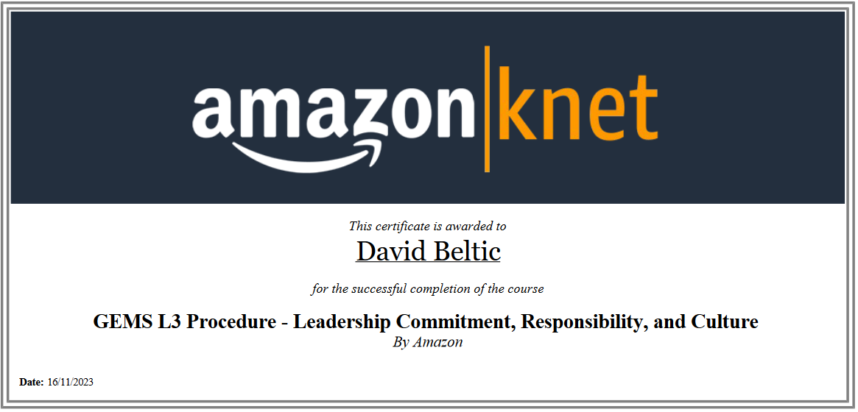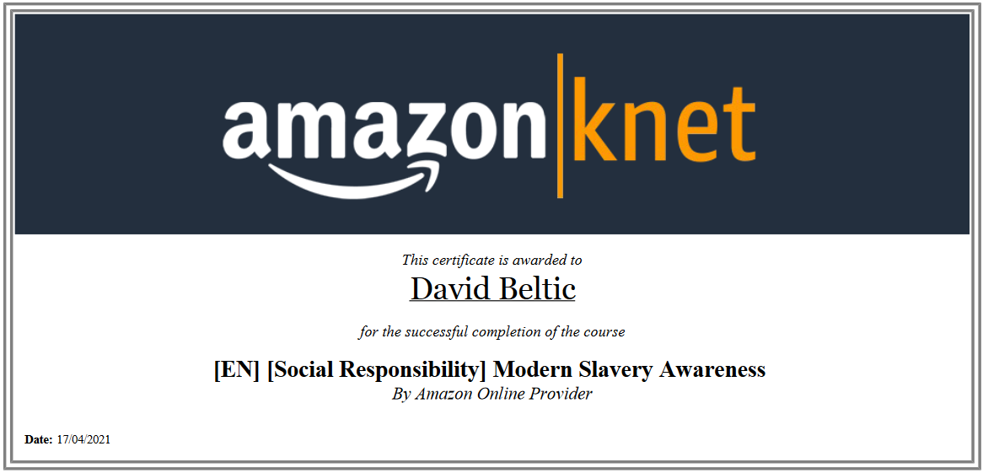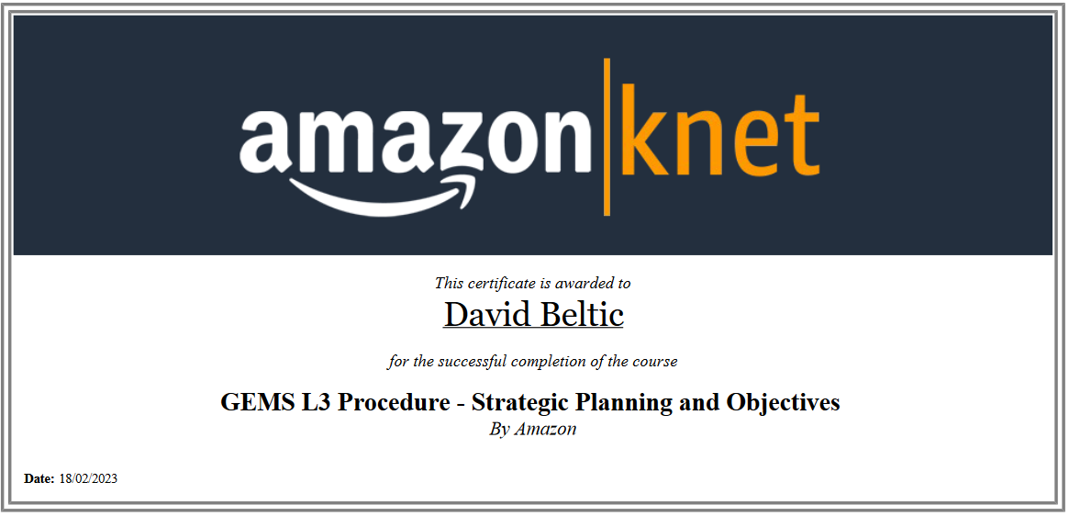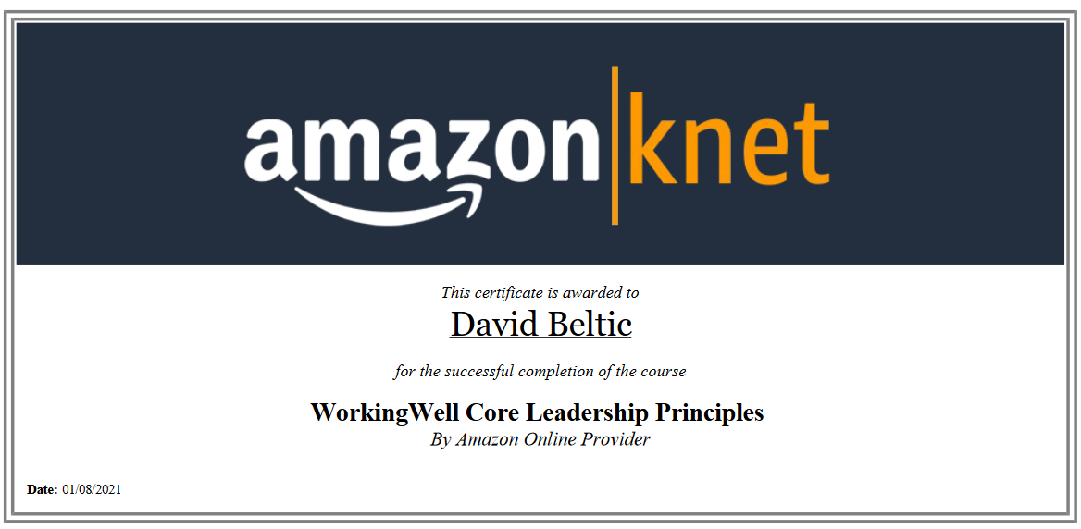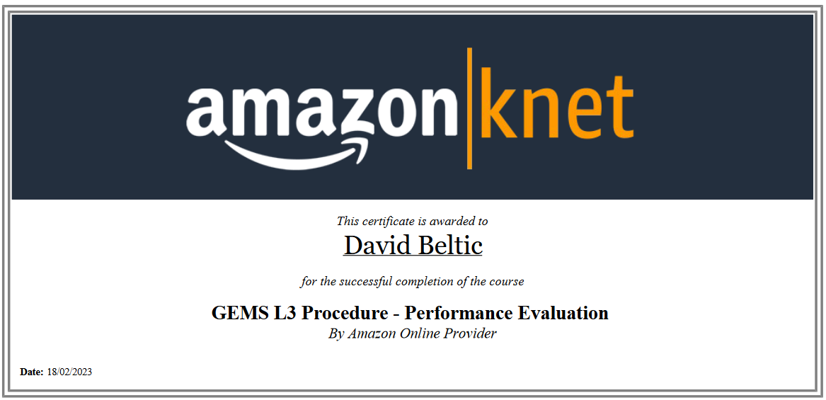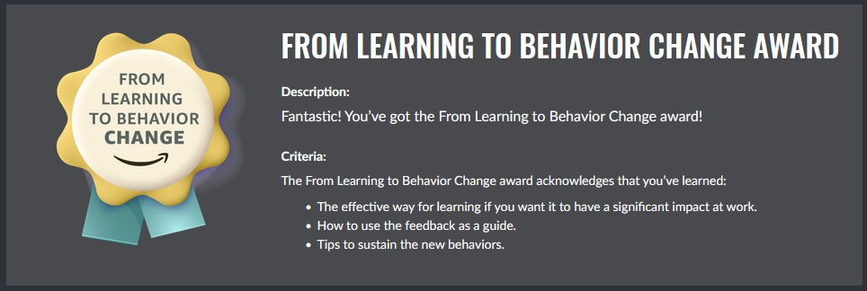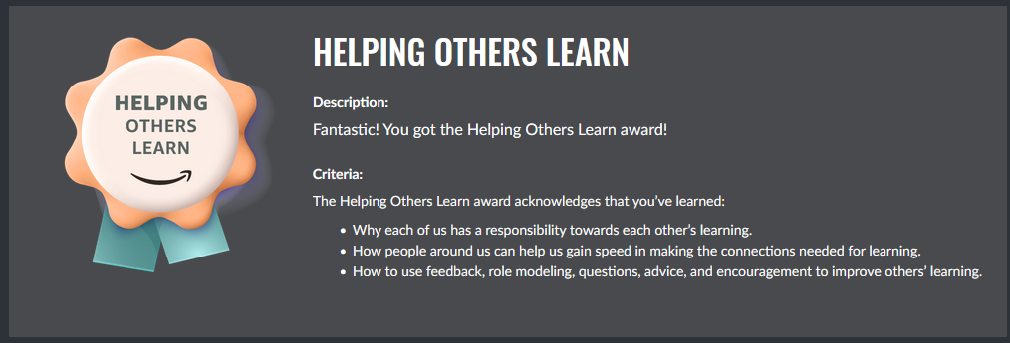
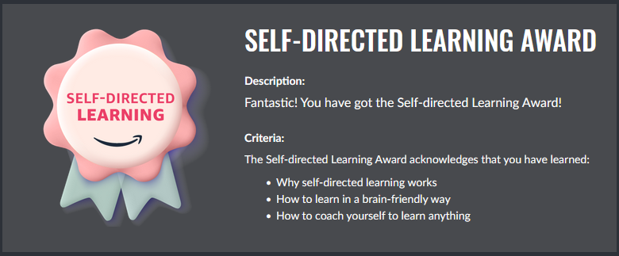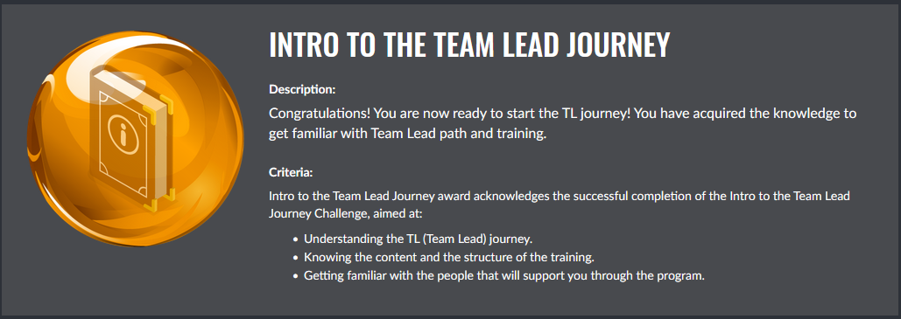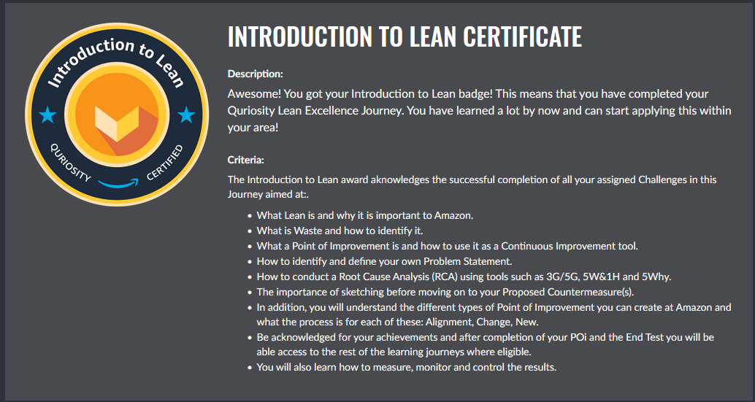

Appendix 2 – HR Job Proposal from Amazon
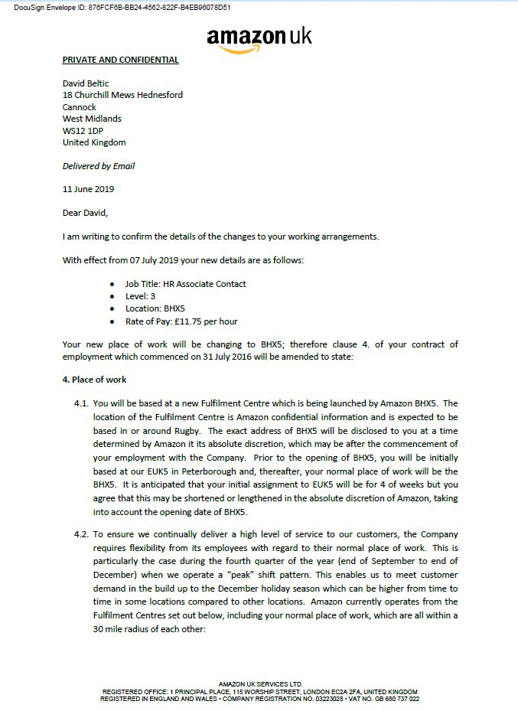
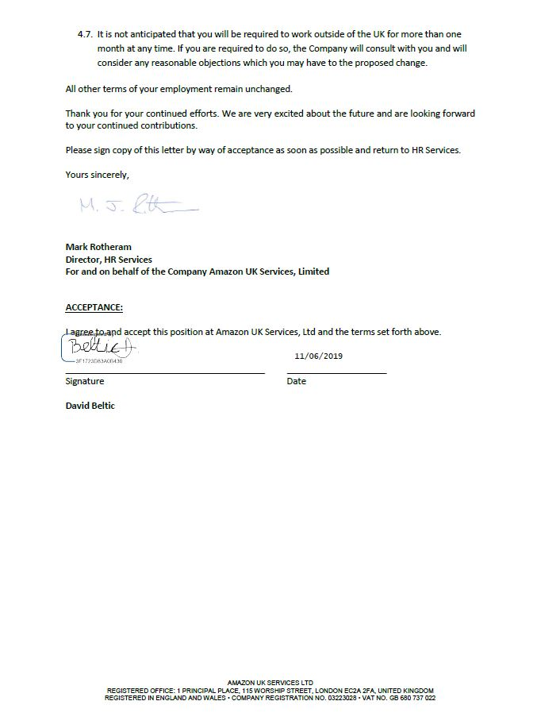

Appendix 3 – Temporary Area Manager Job Proposal from Amazon




