A Critical Evaluation of the Role of Digital Innovation in Professional Practice

Author: Kalee Thomas
Student Number: 2107886
Submission Deadline: 7th March 2022

- Introduction

This paper, as the title suggests critically evaluates the use digital innovation in the modern education. This is looked at through the lens of a literature review and practical application i.e. the description, use and evaluation of a digital innovation tool within a classroom setting. The literature review will aim to examine the learner in the context of the digital world, the organisation of Higher Education and in addition how technology and digital innovation can be embedded and adopted through the review of a variety of models.
Also examined are the challenges to ensure that use of digital innovation is appropriate, fit for purpose and more importantly enhances the learner/educator experience. The latter point of enhancement of experience encapsulates my interpretation of what digital innovation in professional practice actually is.
The last two sections of this paper will describe the digital innovation that I have used in a University (Higher Education) setting. The use of this tool will be evaluated and reflected upon and my experience discussed along with feedback from the students on its use. The appendices section of this document will contain screen shots of the tool being used to provide context to the descriptions and also evidence of its use.

- The Role of Creativity and Digital Innovation

Throughout the course of this literature review I will be analysing the impact of use of digital innovation on the learner and the educator. This will be done using various models and frameworks that are commonly associated in the embedding and adoption of technology. This will be contextualised with articles and books around these themes and have this has also been considered in line with the current digital climate and societal considerations.
The introduction section of this literature review discusses the Fourth Industrial Revolution and whilst this is not directly related to education and pedagogy it is vital in considering our current society and the role post-16 education. Klaus Schwab describes the concept of the Fourth Industrial Revolution and how the use of emerging technology has increased and is changing and connecting industries such as ‘government, business, civil society’ (Shwab, 2016, p8) and also the world of academia. The global pandemic saw an accelerated adoption on technology in many industries, including academia. Increased use of technology and digital innovation to allow education to continue during government lockdown saw use of online delivery, digital tools deployed both in the physical and virtual classrooms and an increased use of Virtual Learning Environments (VLE).
Beetham and Sharpe (2020, p.1) describe, albeit in a generalised manner that ‘learner’s lives are unimaginable with without digital devices, skills and connectivity’. This comment encapsulates both societal culture in terms of use of data, but also skillset of the future workforce. In particular, the digital skill is something that is intrinsically linked to the Fourth Industrial Revolution, and coming back to the original point around the role of post-16 education this is paramount as the role is not just in educating a subject but more an holistic view where practices must ensure that learners can function in a digital world. This latter point is noted by Beetham and Sharpe and discuss technology in terms of ‘context, content, and educational method’. When considering the role of creativity and digital innovation we must incorporate these three elements as they are intrinsically linked. I believe that ‘context’ is reflected in the wider consideration of ensuring students can function effectively in a digital world. Gleason (2018, p.5) supports the assertion when discussing the role of Higher Education in supporting the Fourth Industrial Revolution. She states that Higher Education establishments must prepare students for a ‘productive life’. Therefore when considering the wider role of Higher Education in the context of a digital world in the midst of a Fourth Industrial Revolution, use of digital technology and innovation must be used as a means of education.
In addition to the cultural and industrial links to use of technology in education we must consider the practical elements of adoption and what this means for modern pedagogy and for the educational organisations. There are various models for the implementation of technology in delivery of education. The SECTIONS (Students, Ease of Use, Costs, Teaching functions, Interaction, Organisational Issues, Networking and Security) Framework developed by Bates and Poole in 2003 (Beetham and Sharpe 2020, p.167) is holistic and considers the students, the organisation and the educators in the use of technology. Each element of this framework will be considered throughout this review.
We can group the Costs, Security and to an extent Organisational issues together. This can be considered in the context of the learning establishment. The use of technology and digital innovation cannot be done in isolation by a single educator. This needs to form part of the strategic direction of an organisation and will often have a department dedicated to the maintenance of Information Technology (IT). Not only do many organisations deploy use of IT as part of its pedagogy but also in how the organisation is managed, communicated with and marketed. We see this in practice in Higher Education with examples such as the use of emails to communicate with students, the requirement of digital documents in replacement of the traditional hard copy assignment and the use of Virtual Learning Environments. Beetham and Sharpe discuss how learning organisations have changed to become digital and this has changed the student experience. This includes finding information about learning programmes via websites to the application and the student enrolment process. This brings us full circle to the Fourth Industrial Revolution as academic establishments as entities are also embracing technology as a means of management. This can provide challenges for use of digital innovation. Aside from the pedagogical implications cost, cybersecurity arrangements as well as hardware and software management must also be factored in.
When utilising technology in education a number of factors must be considered in relation to the ‘Student’. For example, does the student have access to technical devices, the Internet and are do they possess the necessary digital literacy skills? It was mentioned in a previous section Beetham and Sharpe’s assertion that learner’s lives are unimaginable with without digital devices, skills and connectivity’. In March 2021 a Digital Strategy for Wales was published. Within this strategy there are specific mission statements for Digital Inclusion and Digital Connectivity (p.8). The need for a strategy tells us that there are individuals who may not have access to technology, stable infrastructure or, may not have the digital literacy required to undertake learning that is digitally based. These could be for a variety of reasons including socioeconomic status. The response of Higher Education to deliver online education in response to the Covid-19 pandemic has forced many of these issues to the surface. Cohen et al (2021) discusses these themes and impact on equitable provision to students for online learning. The move to online was a replacement of the classroom and if we consider the Substitution, Augmentation, Modification, Redefinition (SAMR) model developed by Dr Ruben Puentedura, (Aprinaldi, Widiaty and Abdullah, 2018, p.1), this is aligned to the Substitution and Augmentation stages where online lectures replaced classroom and resources accessed via the Internet, and virtual libraries.
Gillett-Swan (2017, p.2) discusses the feeling of isolation that students may feel when studying online and also the need for strategies to ensure group work is facilitated appropriately and discusses the Graham and Misanchuk’s (2004) assertion that there is ‘less focus on delivery and more attention to the task/content’. The emphasis here is on how linked the learner experience is to the outcome and considering the learner background and relationship with technology can enhance or inhibit their success. This described isolation students describe is arguably a contradiction to the ‘Interaction’ component of the SECTIONS model. Bates and Poole (2003) describe three types of interaction; learner-teacher and learner-learner. In contrast to Graham and Misanchuk’s they discuss strategies to ensure that learners engage or interact during the learning process to reduce the risk of isolation and also to ensure successful outcomes on completion of study. This leads us to consider ‘Teaching Functions’, course design and pedagogy in more detail.
The TPACK model developed by Mishra and Koehler in 2006 (Brauer, Decker & Van der Pol, 2013, p. 8) is very applicable when considering the detail of course design and pedagogy linked to digital innovation and use. This model is based on 3 sources of knowledge – CK Content Knowledge, PK Pedagogical Knowledge and TK Technical Knowledge. In essence this model takes into account the technology available and the educators familiarity with it, the way in which the learner will best achieve educational outcomes and content knowledge. If there is insufficient knowledge in either of these domains, there is a risk to the learner. Following this model ensures that digital innovation is fit for purpose, does not detract from the content and also ensures that the way in which the learner understands and applied content is enhanced, not diminished.
The 7 C’s of Learning Design Framework developed by Conole in 2016 (Betham and Sharpe, 2020, p.169) is a useful tool to assist the educator when designing a course or a lesson plan to consider where digital innovation could be optimised as pat of delivery. This comprises Conceptualise, Create, Communicate, Collaborate, Consider, Combine and Consolidate. The first C – Conceptualise, allows the educator to consider information about the students and likely audiences. This allows considerations such as access to technology, likelihood of digital literacy etc to be part of the design process. The educator can then think about where technology is best used. For example social media platforms, or software in the VLE can be used to facilitate Communication and support Collaboration. Earlier on in this paper the issue of isolation of students was discussed. Using technology effectively in examples such as these can actually combat this and ensure learners are engaged and form a learning community.
Revisiting the TPACK model, Digital Knowledge of educators is vitally important, therefore ease of use and digital literacy must be considered as skillsets in the digital era. Beetham and Sharpe discuss the need for a Digital Capability Checklist (p.264); however this refers to the learner and not the educators and there is very little information about digital literacy of educators and how they can effectively contextualise use of digital innovation to enhance the learning experience of students. Breen (2018) conducted research with colleagues from higher education and their ability to interact with technology in the context of the TPACK model. They describe an interesting point made by a colleague who queried how it is possible for educators to maintain technical knowledge given the fact paced world of technology. This is an interesting point, particularly when there doesn’t seem to be a baseline standard aside from the ability to maintain a Virtual Learning Environment.
Literature around the topic of the role of digital innovation in professional practice is vast. Different countries and cultures have adopted different methods that are driven by governmental directives, organisational culture and financial considerations. At an operational level there is the added complexity of socioeconomic factors that potentially affect the learners coupled with a range of digital literacy capabilities with learners and staff alike. Common themes that come through form the literature is that it is the responsibility of the educator to ensure that digital innovation enhances the learner experience and these tolls are built in appropriately.

- Selection and Use of a Digital Tool

3.1 Background
The class that I have been working with are Level 4 students Under Graduate students in a Higher Education (University) setting. The class is comprised of approximately 30 students and they are studying to work in the Health and Care setting either as part of their continuous professional development or have aspirations to work in this sector. The module they are studying is around Industry Engagement and ensuring the students are have fundamental skills such as reflective practice, interview skills.

3.2 Introduction
The tool that I have chosen to use is Microsoft Teams and this will be used as part of their assignment. The first part of their assessment the students have been asked to undertake is to consider a Job Description and to assess their suitability to the role and where they match the essential criteria on the job specification to answer 5 questions that will be asked of them during a mock interview. This interview will be conducted via Microsoft Teams and will be recorded. There is a time limit of no more than 10 minutes. Following this interview students were given access to a feedback sheet from myself and were given access to the recording of their interview. The second part of their assessment is to use the feedback and the recording to complete a SWOT (Strengths, Weakness, Opportunities, Threats) Analysis on their performance.

3.3 Justification of Use
I have chosen to use the SECTIONS framework developed by Bates in 2015 (Beetham and Sharpe, 2020, p.167) to demonstrate my decision to use this technology. I feel this demonstrates a holistic approach to my decision. This also allows recording of a practical assessment, this is something that is often difficult to do in a live environment and ensures the students can review their performance at a later stage and that the content of the second part of their assessment is accurate.
3.31 Students
As mentioned the students are a combination of individuals who work in the health and care field or school leavers who are aspiring to work in this sector. There is not a high level of digital literacy amongst the students aside from use of mobile phones and social media. They have been using Microsoft Teams as part of online delivery of lectures and have access to this as part of their student IT accounts. This software is familiar to them and ensures that digital literacy or added anxieties around use of unfamiliar technology is reduced.
3.32 Ease of Use
Microsoft Teams is a standard video conferencing software used throughout the university. It is intuitive and is familiar to staff and students. A Microsoft Teams meeting was set up with each student separately and was recorded by myself. The recording, once stopped is automatically transported into the ‘chat’ functionality of the meeting for both lecturer and student to access. Aside from the length of time it takes to set up each meeting individually, this is very easy to use.
3.33 Costs
As the University have a licensing arrangement with Microsoft there were no additional costs incurred for use of this software. Charges to students would arguably be use of home internet and electricity charges. These would be very low considering the session assessment was 10 minutes in length.

3.34 Teaching Functions
This will be discussed in terms of assessment functions. Use of camera and sound enabled the mock interview to take place between the lecturer and student. The recording functionality allows students to rewatch their assessment, thereby reducing the risk of memory bias when reflecting on their performance for the second part of their assignment. There is also the ability to provide feedback the written feedback document directly to the student instantly through the chat facility that is generated when the meeting is arranged. The recording also ensures that any the recordings can be made available to Internal Verifiers and can act as a record of the assessment should the need arise.

3.35 Organisational Issues
As mentioned previously this software is used regularly by staff throughout the organisation and so there is no licensing issue or conflict. As this is part of the university IT system, any functionality issues can be reported and resolved by the University IT technical support team thereby reducing risks of technical issues using unsupported 3rd party software

3.36 Networking
Whilst there was no specific networking requirements for students as this was an individual assessment, this did allow dialogue pertinent to this assessment to be possible between the lecturer and the student.

3.37 Security & Privacy
As Microsoft Teams is part of the university Network this sits behind a secure cyber security infrastructure. There is also an individual login for each student and staff member. Separate meetings were set up with each individual student. This means that no student can access another students work, feedback, recording or meeting. This ensures complete confidentiality of student work

A lesson plan for use of this technology and screenshots demonstrating its use can be found in the Appendices section of this document.

- Evaluation and Reflection of Use

I have chosen to use Gibb’s Reflective Model to reflect and evaluate use of my chosen digital tool.

4.1 Description
The digital tool I chose to use the Microsoft Teams. This was used for a practical mock interview assessment for a group of level 4 students. Each student was interviewed separately and the session recorded. All student were asked to keep their cameras on during the session and were told when recording had started and stopped. This recording had numerous functions. Firstly, it allowed the student to watch and evaluate their own performance, it allowed me to rewatch to ensure my feedback was as detailed as possible and it also acted as a record of the interaction for Internal Verification purposes. Each session lasted 10 minutes and students were asked a series of interview questions that they had prepared for.

4.2 Feelings
As with any use technology my initial worries are around what happens if technical issues arise. This is out of my control and this can be very difficult to overcome and I was conscious that I did not want anything to unduly effect the performance of the student. In addition, whilst I am comfortable in using Microsoft Teams, I have never used it for the purposes of assessment; which made me feel slightly anxious.

4.3 Evaluation
This evaluation comprises my experiences with using this tool and feedback that I have received from the students.
In terms of ease of use, I found the tool familiar and intuitive, therefore I did not encounter any technical difficulties with it’s use. The students were all able to successfully enter into the meeting and using my verbal guidance were able to access their recordings and feedback following their practical assessment.
I felt the recording facility was particularly useful. As I had a large number of students to assess in one day and in quick succession, there is a risk that making quick notes during the interview not only means that I could miss information but that I may experience memory bias when recalling events. I felt that the ability to rewatch their mock interview gave me the ability to give clear and accurate feedback and spend sufficient time doing this following the interviews. From the students perspective, they articulated that they found the ability to watch their interviews useful; however some did state they felt it was a daunting and found it uncomfortable to watch themselves on camera.
There was an issue with one of the students who did not wish to turn her camera on. For identity reasons and also, in order to ensure I can assess her non-verbal cues I explained that she needed to ensure her camera was turned on. I did not factor in that individuals may feel anxious about talking with the camera on and this was an unexpected encounter.
The intended outcome was to provide a mock interview for the students to assess their interview skills and how well they can articulate a specific set of skills required to do a particular role. Online interviews have become more and more widely used and so is a realistic enactment of a real world scenario; however I found that on the whole, the students performed very poorly. This could be for a variety of reasons but I could postulate that because students have associated Microsoft Teams with Online lectures and is very informal in terms of behaviour, this affected the seriousness and professionalism I would expect from someone undertaking an interview, or indeed an assessment. Answers given were very informal, unclear and unprofessional. This could be to do with the skills of the group and therefore forms part of their SWOT analysis as an area to work on, however I feel that this is an area that needs consideration if this was to be used as a method of assessment in the future.
Student feedback was very positive on use of MS Teams as a method of assessment, as mentioned they found the recordings useful and stated that they liked that the assessment was over quickly. One student stated that they would have felt more nervous having to come onto campus and ‘wait to be called in’. There was no negative feedback from the students with regards to this which is very positive.
From my perspective, I found the tool in itself very easy to use. As a student ‘lecturer’, I felt the recording was a layer of protection as I could very easily evidence every practical session an so I could justify any feedback I gave very easily. On reflection I think the students may have gotten more out of a face to face interview. The students on the whole were very relaxed; however I feel this could have affected their performance.

4.4 Conclusion
On the whole use of the tool was successful. It was used successfully by both myself and the learners and its use did not interfere with the outcome from a digital literacy or comfortability perspective. I do feel that if I were ot use this tool in this manner again, I would ensure that expectations around behaviours are set. For example, this is an interview, it must be treated as such. I would also explain the need for camera in advance to allow anyone with specific difficulties to approach me to allow us to look at compensatory measures if appropriate. I feel the functionality allowed students to perform their tasks securely and the recording aspect was a particular positive for both myself and the students.
On a personal note and reflecting back I stand by my chosen digital tool as this had not been used by myself for assessment and had previously been used simply as a video conferencing mechanism. I do think that in my professional practice I need to embrace new technology and be willing to trial new products as part of my content delivery. I feel that given the digital age that we are in, keeping up to date with my digital skills and competencies will be just as important and keeping abreast of content specific developments and research.

4.5 Action Plan
This action plan was formulated from items identified throughout this reflection and from reading conducted as part of the literature review. All objectives are SMART (Specific, Measurable, Achievable, Realistic, Time-bound).
Objective | Tasks (what you need to do to achieve goal) | Success Criteria | Timeframe
To test the efficacy of using an online platform for a practical assessment | - To speak to colleagues who have undergone both online and face to face practical assessments  - To change the assessment method to allow the student to chose an online mock interview or a face to face | - All students perform to the best of their abilities regardless of the technology used | 4 weeks
To ensure students are made aware of behaviours expected of them when undertaking online assessment | - Ensure this is covered in the assignment description  - Ensure this is discussed in lectures | - Students behave in a professional, appropriate manner whilst undertaking the assessment | 4 weeks
Use a digital tool that I have not used before in a classroom (virtual and face to face) | - Research different tools  - Ensure there are no licensing or cost implications  - Practice it’s use  - Produce a lesson plan highlighting its use  - Ensure the tool will enhance the learner experience  - Gain feedback from students and colleagues where appropriate | - The tool us used  - The students respond positively to the use of the digital tool | 8 weeks

References

Aprinaldi, A., Widiaty, I., Abdullah, A.G., (2018) ‘Integrating SAMR Learning Model in Vocational Education’. IOP Conference Series. Materials, Science and Engineering 434(1) DOI:10.1088/1757-899X/434/1/012309
Beetham, H., Sharpe, R., (2020), Rethinking Pedagogy for a Digital Age. Principles and Practices of Design. 3rd edition. Oxon: Routledge
Breen, P., (2018) Developing Educators for the Digital Age – A Framework for Capturing Knowledge in Action. 1st edition. London: University of Westminster Press
Brauwer, N., Dekker, P., Van der Pol, J. (2013) e-Learning Cookbook. TPACK in Professional Development in Higher Education. 1st edition. Amsterdam: Creative Commons Attribution 3.0 Netherlands license
Ezra, O., Cohen, A., Bronstein, A., Gabbay, H., Baruth, O. (2021),‘Equity Factors During the Covid-19 Pandemic: Difficulties in emergency remote teaching (ert) through online learning’, Education and Information Technologies, 25(6), p7657-7681. https://doi.org/10.1007/s10639-021-10632-x
Frodeman, R. (2017) The Oxford Handbook for Interdisciplinarity. 2nd edition. Oxford: Oxford University Press
Gillett-Swan, J. (2017) ‘The Challenges of Online Learning. Supporting and Engaging the Isolated Learner’, Journal of Learning Design, 10(1) p20-30. DOI:http://dx.doi.org/10.5204/jld.v9i3.293
Gleason, N. (2018) Higher Education in the Era of the Fourth Industrial Revolution. 1st edition. Singapore: Palgrave Macmillan
Hamilton, E., Rosenburg, J., Akcaoglu, M., (2016) ‘The Substitution Augmentation Modification Redefinition (SAMR) Model : A Critical Review and Suggestions for Its Use’ Techtrends, 60(5), p433-441, DOI 10.1007/s11528-016-0091-y
Morley, D., Jamil, Md., (2021) Applied Pedagogies for Higher Education – Real World Learning and Innovation across the Curriculum. 1st edition. Open Access: Palgrave Macmillan https://doi.org/10.1007/978-3-030-46951-1
Pickford, R., Race, P. (2007) Making Teaching Work. 1st edition. London: SAGE Publications Ltd
Schwab, K. (2016) The Fourth Industrial Revolution. 1st edition. Geneva: World Economic Forum.
Welsh Government (2021) Digtal Strategy for Wales. How we will use digital, data, and technology to improve the lives of people in Wales, Digital strategy for Wales | GOV.WALES (accessed 6th March 2021)
Chapter 8: Choosing and using media in education: the SECTIONS model – Teaching in a Digital Age (opentextbc.ca) (accessed 07/03/2022)
Gibbs' Reflective Cycle - Helping People Learn From Experience (mindtools.com) (accessed 06/03/2021)

Appendix A – Lesson/Assessment Plan

Lesson Plan

Topic: Mock Interview |  | Class: Industry Engagement for Professionalism
Date:  8th February 2021 | Length of lesson:  10 minutes per student |  | Number of students:  11
Resources required:
Laptop
Webcam
Speakers
Access to Microsoft Teams
Pen
Paper

Aim of Assessment

The aim of the assessment is to conduct a mock job interview with the student. They will be asked 5 questions related to their suitability to the role. They will be required to articulate where and how they meet this criteria with examples taken from a working, home or education environment.

Learning Outcomes – The Learners Should Be Able To:

Articulate where they meet the criteria in the job specification
Answer questions clearly
Behave professionally
Maintain good eye contact
The learner will use the written feedback and recording to undertake a SWOT analysis on their own performance

Previous student knowledge required for the session:

Learner will have:

- Had access to and read the job description and person specification
- Be provided with the interview questions
- Will have pre-booked an appropriate time slot for the mock interview

Anticipated difficulties (if applicable):

Technical difficulties such as:
Poor internet connection
Fault with a camera
Fault with the sound

Assessment Detail:

Stage | Focus | Strategy | Time
Introduction  Development  Plenary/conclusion | The student will understand what this ten minutes will entail and this is a welcome  Recording starts and the questions are asked with answers given  Ensure the student understand next steps | To ensure the student is comfortable and calm. The student understands the time limit and that the session will be recorded  Questions are asked and where possible supplementary questions asked if the student has not been clear or given insufficient information  Ensure student is congratulated on completing the task. Explain where the student will find the recording and that the feedback will be typed and provided into the chat facility of the meeting by the end of the day. Re-iterate they will need to utilise both the recording and the feedback in order to complete their SWOT analysis. Invite any further questions. Avoid giving feedback at this stage | 30 seconds  10 minutes  2 minutes

Assessment Strategies: when and how are they included within the lesson?

N/A

Informal reflection (to be completed after the session)

The session went well, however as the assessments were back to back it is difficult to process feedback. The recordings will need to be used in order to ensure feedback is individual accurate and detailed for each learner.

No technical issues encountered

Appendix B – Use of the Tool
All student images and identifiers have been removed to ensure confidentiality is maintained
Diagram 1
This shows the calendar appointment for the meeting with link that would appear in my and the students respective diaries
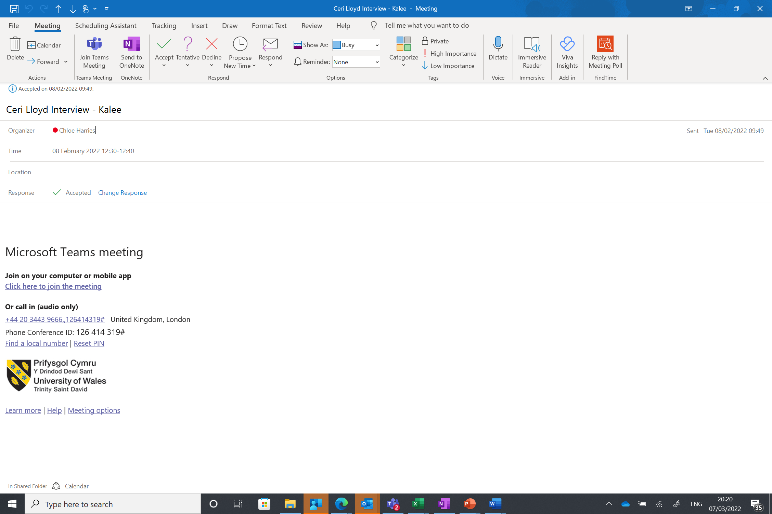

Diagram 2
This shows the video of the interview. On the left hand side you can see the ‘chat’ function relating to the meeting highlighted in yellow
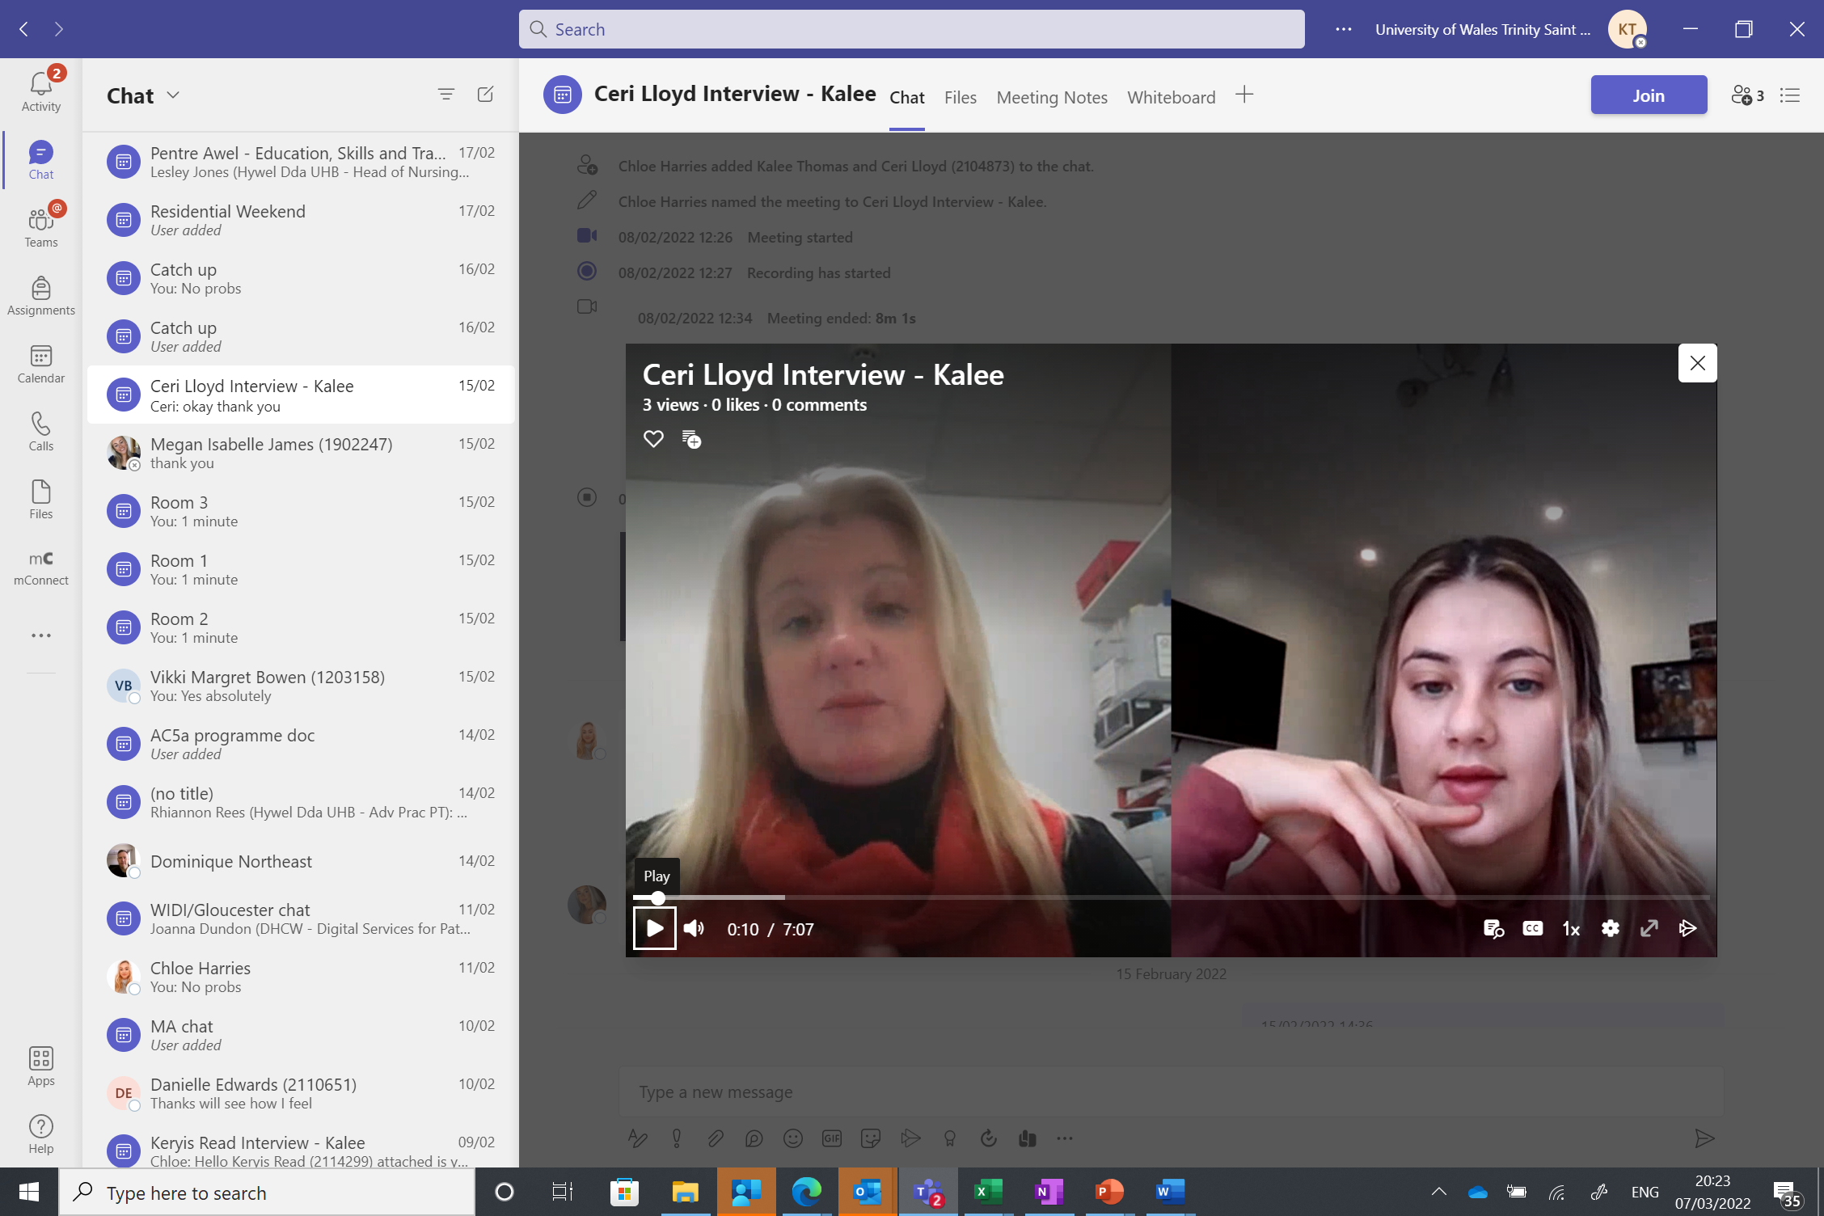

Diagram 3
This depicts the chat thread. This is where the student can locate the recording and also access their feedback form (highlighted in yellow)



