University of Wales
Trinity Saint David

High Skills for the Workplace. Level4
DIGITAL SKILLS AND RESEARCH METHODS

Student Name: Shemshat Nazarova
Student number: 1706500
Lecturer Name: Ze Zook

Executive Summary
This report illustrates the use of technology that makes the growth of an organization and increases the productivity. The Austin Fraser Limited focus on the social media to makes the service more unique among the candidates or clients. The recruitment service can be completed through creating of the profile in LinkedIn, Twitter and Facebook.

Table of Contents
Introduction 4
Effectiveness in the use of modern technology 4
Social Media as the tool used in marketing 6
Information gathering and communication 8
Own professional online presence 11
Conclusion 12
References 13

Introduction
The modern working of the organization depends on the digital skills that make high value among the staff members. It helps to expand the areas through the digital skills, which makes the growth of the entire organization using advanced technology. In this case, Austin Fraser Limited organization has been chosen, in which there is a necessity to implement the use of modern technology to make more specialist regarding the recruitment process. Being the employee of the Austin Fraser Limited the company provides the services in the outstanding form of recruitment for all the candidates or clients. The main aim of this report is to illustrate the effective use of modern technology in the Austin Fraser Limited and use the social media to carry out the marketing process. Communication and information gathering are obtained within the workplace and creating opinion regarding the use of online presence in the professional field to demonstrate a better form of research (Armstrong et al. 2015).

Effectiveness in the use of modern technology
Technology provides the techniques at the time of applying scientific knowledge, engineering and devices. The technology has been widely used in every organization to mitigate the chances of errors and indulge less number of staff members. All sorts of research and development can be carried out using modern technology. In order to know the demand of the consumers, there lies with various companies’ website on the Internet technology. Technology has been used in the education, medical, training, communication and marketing. The organization can able to carry out the marketing, communication and consumer service growth through the effective use of technology. The main importance of technology is to improve the communication, human capital, efficiency and mobility that help in the expansion of the entire business (Boyd, 2014).
The usage of modern technology allows for the faster processing of the data that makes the easier form of retrieval in achieving of important data and replaces the effort of the staff members. Effective use of technology eliminates the chances of errors and takes the appropriate time to complete the entire task properly. The quickest form of process is been carried out through the technology and keeps the entire information up to date as per required within the workplace. This helps the organization Austin Fraser Limited to search out the candidates and make a proper recruitment on the other successful company. Effective use of technology helps the Austin Fraser Limited Company to develop the business more efficiently with the appropriate solutions to enhance the better productivity. Being the employee of Austin Fraser Limited needs to implement the modern technology such as tablets, data base systems to store the information of the clients as well as the candidates (Davenport et al. 2014).
Austin Fraser Limited use cloud files storage and tablets or smart phone as the modern technology that makes the recruitment process complete for the clients. In order to store the information of the clients, the Austin Fraser Limited uses cloud file storage and to make the communication the staff members use possible smart phone or tablet. The main comparison between cloud file storage and smart phone is that the cloud file stores ample of information regarding the database of the clients whereas the smart phone makes the possibility to get connected among the clients for the recruitment process. From the practical examples, cloud file storage has helped to get the important data of the candidate that is required after two years before for the being appointed to the company. Smart phone or tablet has helped to get connected with the client at any moment to enhance better services (Palmer, 2016).
The employability can be easily increased using other modern technology that lies with the option of web-based email, web conferencing and office applications installed in the computer systems. Austin Fraser Limited needs to focus on the increasing more employees to deliver better services to the candidates as well as clients. The proper research can be carried out through the effective use of technology within the workplace that delivers proper techniques regarding the used devices. There are certain technologies that the organization lacks as gained from the practical experiences. Use of the web conferencing, office applications and web-based email might develop a better platform for the growth of the Austin Fraser Limited in the market of U.K gaining a place of better recruitment service for the clients or candidates (Van Dijck, 2013).

Social Media as the tool used in marketing
Social Media provides the collective areas required in the online form of communications carried out in the particular channel that makes the dedication through the community-based input at the time of sharing of the content. The social media provides the platform for the organization that helps to enable the users to participate in the social networking. It delivers the collective form of online communications channels among various users. The main examples of the social media include with the Facebook, Twitter, Google+, Wikipedia, LinkedIn, Reddit and Pinterest. Social media changes the way, which makes the individual, and a company makes the possibility of the company. The entire process is carried out through the computer-mediated way in technology that makes the sharing of interest (Perrin, 2015).
The LinkedIn social network provides the better platform that helps the person to search for the better job. An employee, as well as business-oriented social networking services, can be operated through mobile applications and websites. These websites are used by the professional at the searching for the better job by posting the resume for the company. In this case, Austin Fraser Limited needs to focus on using the LinkedIn services to deliver an outstanding recruitment service among the clients or candidates. As the organization Austin Fraser Limited is based upon the recruitment the exact candidates for the other companies, hence, the firm needs to use the LinkedIn social networking service more effectively. It allows the candidates or clients to create profiles and connect on the each other in the online areas through the development of a professional relationship (Quinton and Wilson, 2016).
The Facebook is another online social networking site that allows the users to develop a personal profile, sharing of videos and photos that make the better form of communication. The Austin Fraser Limited Company has focused on the development of profiles of the staff members so that the clients can able to see the information. The organization can able to use the Facebook account to be connected to several clients or candidates staying in the far areas. The Twitter can be used in the Austin Fraser Limited firm by allowing the clients to tweet for the company's members and implements a proper form of update in the real-time. Twitter provides a better Internet service for the candidate to get the information of the required position in the company. The staff members in the company of Austin Fraser Limited have properly used the LinkedIn service to get the actual candidates or clients that can be provided in the other companies (Rauniar et al. 2014).
Advantage of social media
i. The social media has been used in business to develop the market products, promotion of brands, connection to the current consumers, foster of new business, implements various offers and develop personal interactions with the consumers.
ii. It provides the connectivity with the other person by learning and sharing of actual thoughts required in the business.
iii. It implements benefits among the teacher and students through the enhancement of education without paying for it.
iv. Social media provides the platform to make the promotion and marketing of the particular products or service required in the business (Ruths and Pfeffer, 2014).
The disadvantage of social media
i. Cyber bullying is the major disadvantage of social media by creating of the fake account on the social networking sites.
ii. The identity of theft is another problem that makes a financial loss with the hacking from the created personal accounts.
iii. The security problem is another disadvantage that might arise from the development of personal accounts.
The implications of social media use in the professional settings and personal areas provide the exact area in the investigation with the networking used in the workplace. It provides the main highlighting areas in the emergent research and psychological impacts. This makes the publication regarding the indispensable sources of references for researchers and professional interest regarding the use of social media. It makes the positive form of impacts and detrimental effects on the use of technology. The LinkedIn profile has been chosen the most because it provides the professional areas to enhance the recruitment service among the candidates (Scott, 2015).

Information gathering and communication
The gathering of the important information is the vital things that need to be focused by the Austin Fraser Limited Company. The information and communication are gathered in such a manner that helps to provide a better service to the candidates or clients through the recruitment drive. The entire process can be completed through the advanced technology that makes the
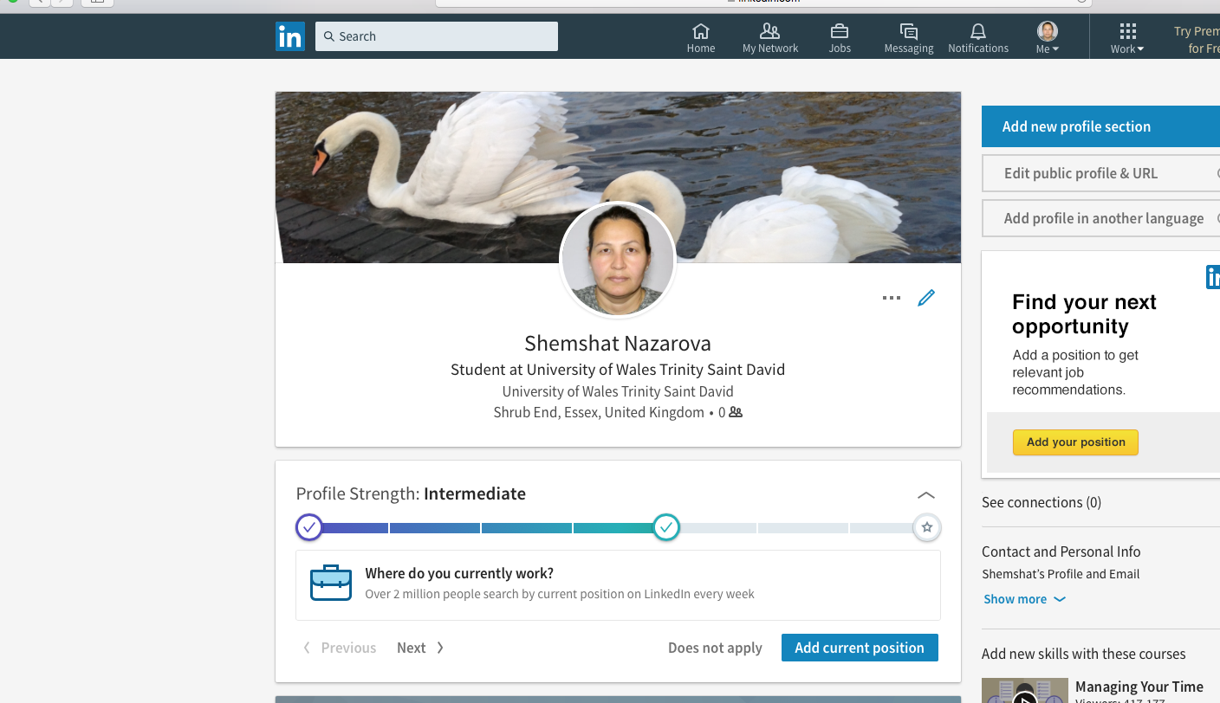

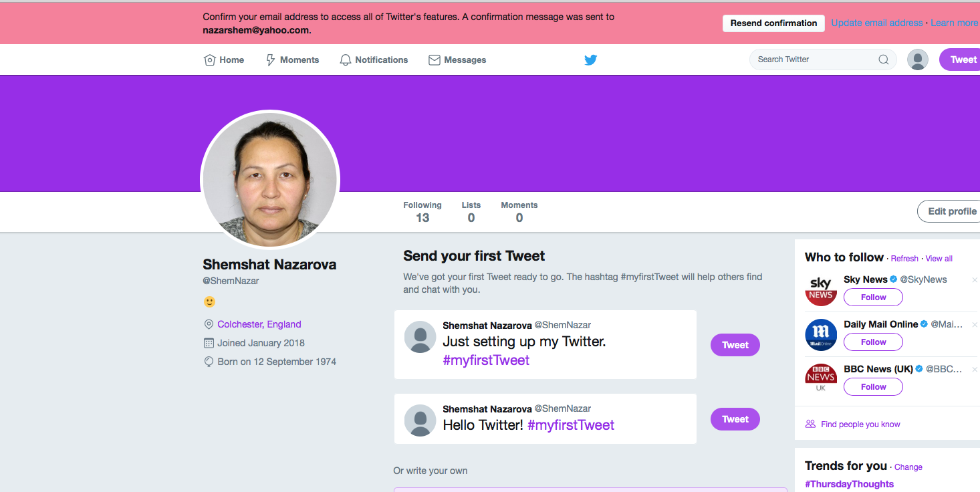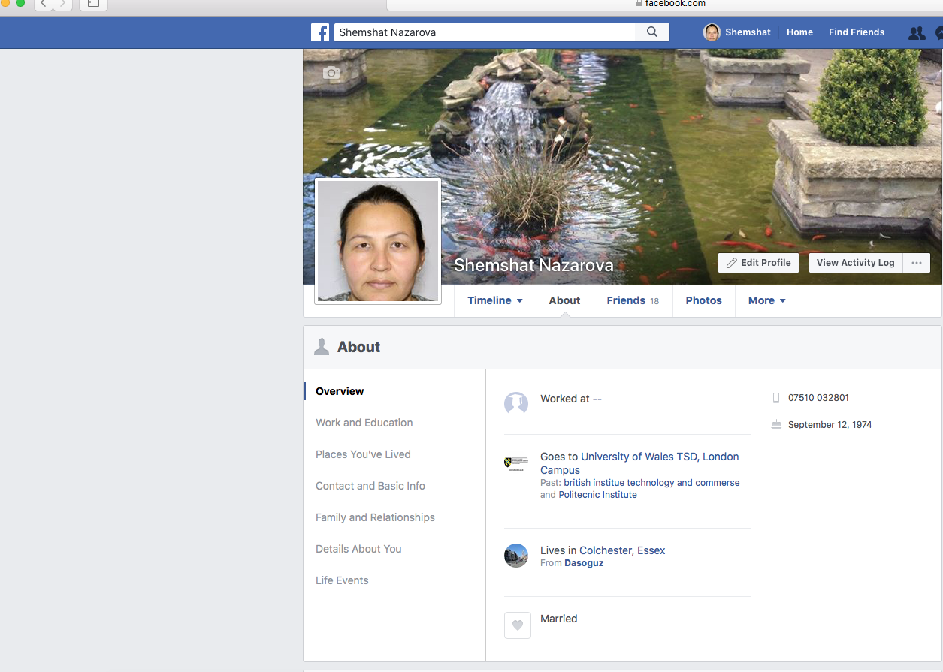

Entire data used by the organization for the future aspects. This gathered information need to be monitored properly through the enhancement of better performance. The effective communication provides the information sharing process among the staff members of the Austin Fraser Limited company and the candidates or clients. This information assists the better process used within the organization to achieve the success in the present and future aspects (Tiago and Veríssimo, 2014).
However, the social networking sites implement the important account required among the individuals that make the better form interest to make the possibility of the communication. This communication process can be carried out using modern technology situated in the social media. It lies with the Facebook, Twitter and LinkedIn that makes the possibility of the communication and gather important data regarding the recruitment process. This includes the skills, knowledge and experiences as the vital information of the candidate that helps the staff members Austin Fraser Limited to know it properly. The information and communication can be collected through another latest technology that includes the tablets or smart phone. Successful communication can be carried out using the modern technology that helps to gather appropriate data regarding the services enhanced by the organization Austin Fraser Limited (Trainor et al. 2014).

Own professional online presence
The creating the own professional online presence provides the better way of demonstration required in the growth of career and makes the suitable evidence regarding the research. It is important to have a better online presence that helps in the showcase of experience and skills of the candidates or clients. The person needs to be consistent regarding all the social media sites through the creation of strong professional areas by developing of profiles that can be recognized by the other companies at the time of providing of a job. LinkedIn provides the exact areas to showcase the ideas for building the professional presence on social media (Utz, 2016).
The recruiters try to focus on the candidates that implement the sources in managing and building network in the career. Clients or candidate needs to update the account, which is based on the skills, education and experiences of a job. The personal website provides the features for the individual's credentials. The person can able to provide information on the offering of the employer by linking the profiles in the online areas. The Facebook is another process that makes the differentiation professional from the personal individual. Twitter implements the process that makes the establishment regarding he/she experts existing in the same company. Pinterest is the platform that makes the online area, which makes the highlight of candidate resume (Tuten and Solomon, 2017).

Conclusion
It is concluded that the digital skills need to implement by all the staff members at the time of working in the company. Being the employee Austin Fraser Limited it is necessary to carry out the entire working through the modern technology. The latest technology helps the organization to reduce the chances of error and implement better recruitment service among the candidates or clients. The organization has used the social media as the main platform to gather information and communication.

References
Armstrong, G., Kotler, P., Harker, M. and Brennan, R., 2015. Marketing: an introduction. Pearson Education.
Boyd, D., 2014. It's complicated: The social lives of networked teens. Yale University Press.
Davenport, S.W., Bergman, S.M., Bergman, J.Z. and Fearrington, M.E., 2014. Twitter versus Facebook: Exploring the role of narcissism in the motives and usage of different social media platforms. Computers in Human Behavior, 32, pp.212-220.
Palmer, S., 2016, January. The representation of engineering education as a social media topic on Twitter. In PAEE/ALE 2016: Proceedings of the 8th International Symposium on Project Approaches in Engineering Education and 14th Active Learning in Engineering Education Combined Conference and Workshop (pp. 37-44). Project Approaches in Engineering Education Association.
Perrin, A., 2015. Social media usage. Pew Research Center.
Quinton, S. and Wilson, D., 2016. Tensions and ties in social media networks: Towards a model of understanding business relationship development and business performance enhancement through the use of LinkedIn. Industrial Marketing Management, 54, pp.15-24.
Rauniar, R., Rawski, G., Yang, J. and Johnson, B., 2014. Technology acceptance model (TAM) and social media usage: an empirical study on Facebook. Journal of Enterprise Information Management, 27(1), pp.6-30.
Ruths, D. and Pfeffer, J., 2014. Social media for large studies of behavior. Science, 346(6213), pp.1063-1064.
Scott, D.M., 2015. The new rules of marketing and PR: How to use social media, online video, mobile applications, blogs, news releases, and viral marketing to reach buyers directly. John Wiley & Sons.
Tiago, M.T.P.M.B. and Veríssimo, J.M.C., 2014. Digital marketing and social media: Why bother?. Business Horizons, 57(6), pp.703-708.
Trainor, K.J., Andzulis, J.M., Rapp, A. and Agnihotri, R., 2014. Social media technology usage and customer relationship performance: A capabilities-based examination of social CRM. Journal of Business Research, 67(6), pp.1201-1208.
Tuten, T.L. and Solomon, M.R., 2017. Social media marketing. Sage.
Utz, S., 2016. Is LinkedIn making you more successful? The informational benefits derived from public social media. new media & society, 18(11), pp.2685-2702.
Van Dijck, J., 2013. The culture of connectivity: A critical history of social media. Oxford University Press.

