

Business Intelligence – future of our life? 5 popular trends

Module Name: Data Handling and Business Intelligence
Module Code: LCBB5000
Student Name: Alina Mutoi
Student Number: 2028702

Lecturer: Dr. Anupam Mazumdar
Submitted date: 31st of December 2022

Table of content

- Introduction……………………………………………………………….........3
2. Business Intelligence current and future trends ............……...............................................................................................................4
2.1 Artificial Intelligence…………………………………..……………….........4
2.2 Natural Language Processing (NLP)………………………....................................................................................4
  - Data Security..............................................................................................5
  - Data Visualisation…………………………………..................................5
  - Data Discovery……………………………...............................................6
3. Conclusion……………………………………………………..........................7
- Reference list……………………………………………..................................8

- Introduction
Business Intelligence (BI) represents a wide range of applications, systems and technologies created in order to help businesses to make better decisions and “improve performance, discover opportunities and operate efficiently”. (Phocas, 2022). It consists by accessing, gathering and analysing data for giving information about different aspects of an organisation, such as sales, expenses, warehouse capacity, budgeting etc. (Howson, 2007).
The term of “Business Intelligence” was first promoted by the former analyst Howard Dresner in 1989. It helps companies and organisations to improve sales and customer service based on needs, to provide a better quality of products and services, to save on inefficient promotions or expenses.
The following report presents 5 current and future trends of Business Intelligence used nowadays around the world, as Artificial Intelligence (AI), Natural Language Processing (NLP), Data Security, Data Visualisation and Data Discovery tools, with a description of the area these can be applied.

- Business Intelligence current and future trends

2.1 Artificial Intelligence
Artificial Intelligence (AI) is the simulation of human intelligence processes by machines, especially computer systems. AI systems predicts future states in patterns, by using and processing a large amounts of labeled data. It is operated in order to performs jobs and tasks better and quicker than human beings, with less errors, especially when it is about repetitive, detail-oriented tasks. (Burns, 2022)
It is expected that AI systems will replace a lot of day-by-day activities, becoming a part of normal life. EctoLife is one of the example of the future of AI. It is the first artificial womb facility, built on the base of the natural women’s womb. The facility is projected to allow the conception of a baby for infertile couples after a genetically engineering an embryo before implanting it into the artificial womb. The system will give parents the possibility to choose the features of the future baby: hair and eyes colour, level of intelligence, height, weight etc. (Metro, 2022)
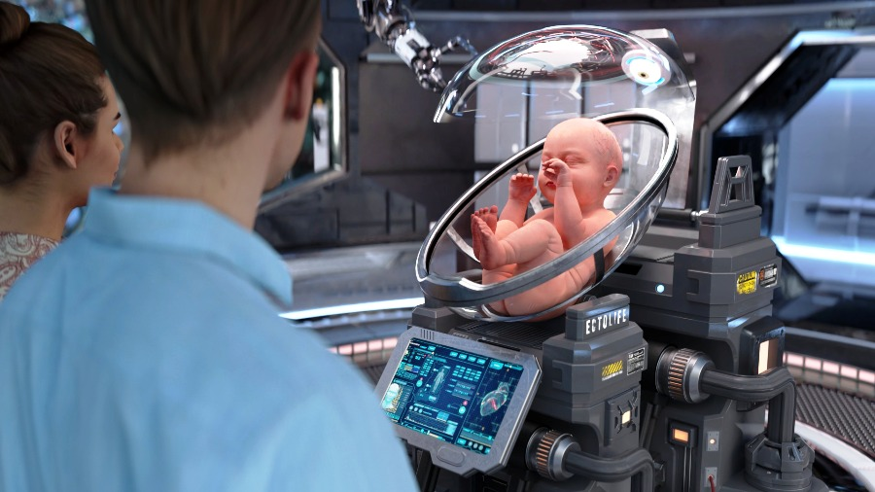

2.2 Natural Language Processing (NLP)
Natural Language Processing (NLP) is a data system that allows users to interact with data by asking questions in a conversational format. It is a voice-based system that integrate the capability of a voice-digital assistant to generate easy to understand answers on a device. (Kaur, R., 2022)
People with disabilities can efficiently be advantaged of this kind of systems. Devices and gadgets that can type, turn on/off different things in the house, clean, do laundry and washing up, open and close the door can serve as a good help when it is needed for people who move around harder.
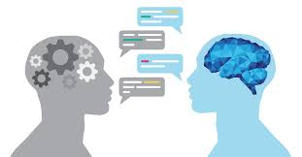

2.3 Data Security
Data Security is a system that allows protection of sensitive digital information from unauthorized access. The tools are cybersecurity practices like encryption, access restriction (physical and digital), data masking etc. that secure data from misuses. Nowadays, when practically everything is technologized, Data Security is a very important system preventing important information from Internet hackers cyberattacks.
The card reader used by an UK bank is an useful tool to prevent card’s scam attacks and to extra secure the bank account. It is required when the holder of the card wants to make a money transfer, asking for some holder information, such as sort code, account number etc. After getting it, the card reader generates a unique code that can be used to make payments. (Make use of, 2022)
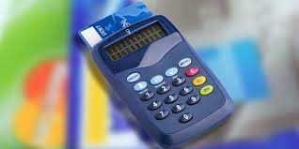

2.4 Data Visualisation
Data Visualisation uses analytics and visualizations for presenting the collected data from internal and external sources in a clear and easy to use way. It represents a flexible communication, where high volume and variety of information can be handled with less time and effort.
For example, a company can represent its sale for the current year through a KPI dashboard – a Data Visualisation tool that provides a centralized, birds-eye view of various data (sales, customers, revenue, expenses, products etc.), allowing an easy and quick performance tracking. The KPI graphics can have different designs and styles of representing, based on the company skills and preferences. (Yellow Fin, 2022)
YTD company sales activity for a specific year (not mentioned), represented in a KPI dashboard bellow
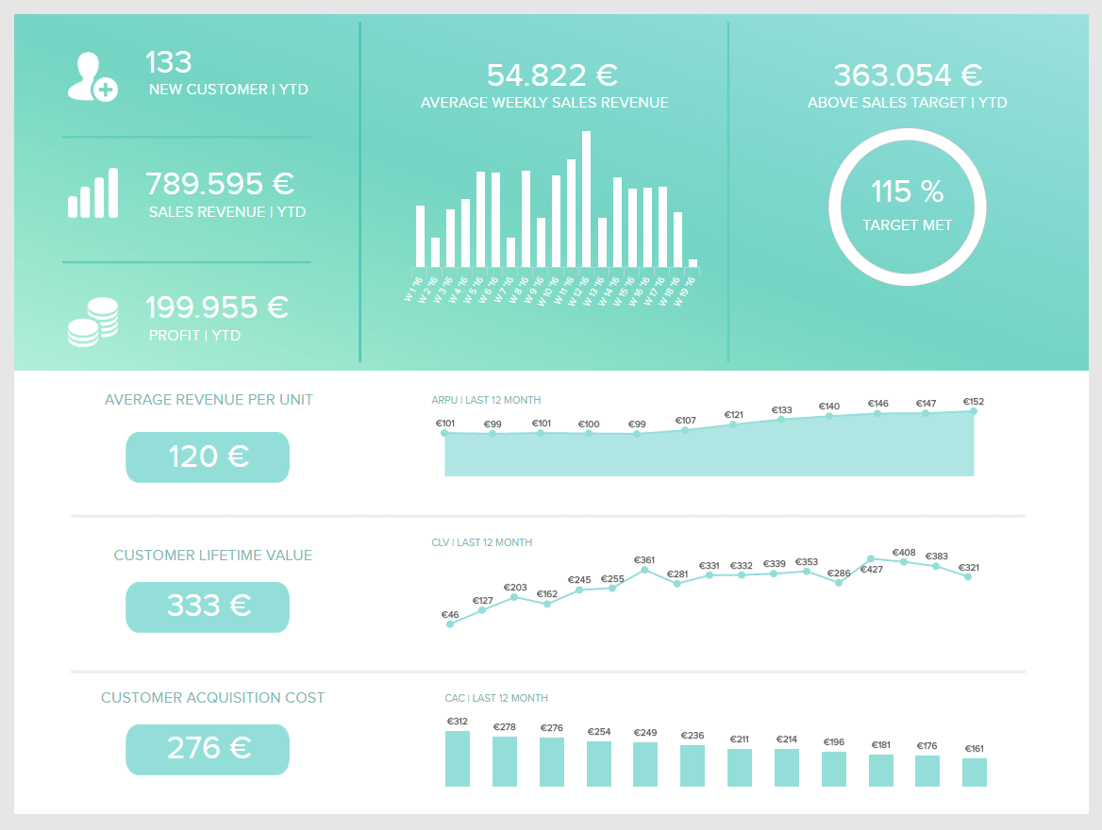

2.5 Data Discovery
BI Data Discovery process is used for collection and evaluation of data from different sources in order to identify information trends and patterns. It connects multiple data, clean, analyse and prepare it, after sharing the easy understandable and clear information throughout the organisation. (Tibco, 2022)
For example, it can refer to customers purchases preferences. Companies and shops can put together all shopping preferences for a period of time and discover what kind of products are bought more often, depending also on the age and gender category. This information will help businesses to know what products to supply, thus making more profit and less losses on offering products that are not so popular.

- Conclusion

Business Intelligence becomes an important and popular area of global modernisation and progress. A lot of BI trends and applications were created and promoted in the last decades and, over time, more and more will be put in action in order to make people’s life easier and more efficient. The next generation enters an era of democratisation and self-service, electronic communication and interaction. Will it also change the life values?

- Reference list

- Azevedo A., Santos M., (2015). “Integration of data mining in business intelligence system”. Business Science Reference, pp. 14-15
- Autho Blog, 2022. What is Data Security? Top threats and and best practices https://auth0.com/blog/what-is-data-security/ (Accessed on 24th of December, 2022)
- Burns, E., 2022. “What is Artificial Intelligence (AI)?” https://www.techtarget.com/searchenterpriseai/definition/AI-Artificial-Intelligence (Accessed on 23th of December 2022)
- Calzon, B. 2021. “Top 10 analytics and Business Intelligence trends for 2022” https://www.datapine.com/blog/business-intelligence-trends/ (Accessed on 20th of December 2022)
- Fallon, N. 2022. “Predictive or prescriptive analytics? Your business needs both” https://www.businessnewsdaily.com/8655-predictive-vs-prescriptive-analytics.html (Accessed on 27th of December 2022)
- Howson, C., (2008). “Successful Business Intelligence: secrets to making BI a killer app”. McGraw-Hill, pp. 13-17
- Indeed, 2022. “A definitive guide to email: Importance, uses and advantages” https://www.indeed.com/career-advice/career-development/importance-of-email (Accessed on 24th of December 2022)
- Make use of, 2022. Online banking card readers: How do they work and how secure are they? https://www.makeuseof.com/tag/online-banking-card-readers-work-secure/ (Accessed on 30th of December, 2022)
- Metro, 2022. World’s first artificial womb facility is creepy glimpse of pregnancy in the future https://metro.co.uk/2022/12/13/artificial-womb-facility-is-a-glimpse-of-pregnancy-in-the-future-17926466/ (Accessed on 26th of December, 2022)
- Phocas, 2022. “The history of Business Intelligence (the Past)”. https://www.phocassoftware.com/business-intelligence-blog/the-history-of-business-intelligence-the-past (Accessed on 24th of December 2022)
- Kaur, R., 2022. “Business Intelligence trends in 2022: Future of BI”. Select Hub https://www.selecthub.com/business-intelligence/business-intelligence-trends/ (Accessed on 19th of December 2022)
- Tibco, 2022. What is Data Discovery? https://www.tibco.com/reference-center/what-is-data-discovery#:~:text=Data%20discovery%20involves%20the%20collection,framework%20to%20understand%20their%20data. (Accessed on 30th of December, 2022)

