
TITLE: MARKETING MANAGEMENT
ASSESSMENT-2


STUDENT NAME: GURVINDER KAUR
STUDENT ID: 2238951
PROGRAMME: MBA – MASTER OF BUSINESS ADMINISTRATION
MODULE CODE: LCMB7001
LECTURER NAME: TUSHARA BALENDRAN
DATE OF SUBMISSION: 01/09/2023
TABLE OF CONTENTS
- Introduction………………………………………………….3
- PESTLE Factors……………………………………………..3
- Porters 5 Forces Model…………………………………7
  - Advantages…………………………………………..11
  - Disadvantages………………………………………11
- SWOT Analysis……………………………………….......12
- Segmentation, Targeting and Positioning……14
- Marketing Mix Strategies…………………………….16
- Recommendations for future………………………17
- Conclusion…………………………………………………..19
- Reference……………………………………………………20

- INTRODUCTION
In today’s competitive and dynamic business environment, organizations have to face many difficulties and challenges to manage and maintain their position. Sony, a leading multinational corporation known for innovative consumer gaming products, electronics, and entertainment, is the subject of this case. Between globalization, digital transformation, intensifying brand competition, reputation management, data-driven decision-making, and increasing customer expectations, Sony faces many challenges. This study conducted an environmental marketing analysis to examine the external drivers affecting Sony’s performance and examine all the internal strategies. Finally, the goal is to provide Sony with insightful recommendations that enable it to chart a path to sustainable competitive advantage in an ever-evolving market.
- PESTLE FACTORS
A PESTLE (Political, Economic, Sociological, Technological, Legal, and Environmental) study examines the significant external factors that influence an organization. It may be used in a range of contexts and aid senior managers and human resource experts in making strategic choices.
PESTLE analyses are management frameworks and diagnostic tools. The results of the analysis provide insight into external factors that can influence strategy and business decisions. (CIPD, 2023)
The PESTLE tool: PESTLE is an acronym for:
P = Political
E = Economic
S = Social
T = Technology
L = Legal
E = Environmental
POLITICAL: Political factors include countries government policies and political stability, tax implications, industry regulations and global trade agreements and restrictions. The political factors are unfavourable for sony due to the following reasons:
- International trade policies affect Sony’s global operations and supply chain efficiency.
- Government regulations affect product specifications, safety standards, and intellectual property rights
ECONOMIC: The economic environment will be influenced by the exchange rate, the rate of economic expansion or contraction, the effects of globalisation, the rate of inflation, the level of interest rates, the price of living, the cost of labour and consumer expenditure. The economic factors can be favourable or unfavourable for Sony due to the following reasons:
- Fluctuations in currency exchange rates can affect Sony’s profits in various areas.
- An economic downturn can affect the purchasing power of consumers and the demand for consumer goods such as electronics.
SOCIAL: Social factors are a broad term that encompasses a wide range of topics, including lifestyle trends, cultural conventions and expectations, career attitudes, work-life balance, consumer preferences and purchasing patterns, and population demographics.
- Different cultural preferences influence product design, features, and marketing c campaigns.
- Sony needs to provide cultural sensitivity to resonate with customers in different markets.
Social factors are favourable in nature as variations are done in the products considering the culture.
TECHNOLOGY: Technology has grown exponentially. Other technological developments that will have an effect on data storage include disruptive technologies like smartphones, social networks, automation robotics, and the growing trend towards artificial intelligence (AI) artificial intelligence. Rapid technological progress requires continuous innovation to remain competitive.
- Sony products are influenced by global technology trends, creating opportunities and challenges.
Technological factors are favourable as sony keeps on adapting the changes.

LEGAL: The legal landscape is ever-evolving, particularly in the United Kingdom, where Employment Labour Law and Employment Tribunal decisions have a lasting impact on working practices. It is essential to remain informed of any alterations to legislation and, of course, Health and Safety Regulations.
- Intellectual property laws protect Sony’s innovations from unauthorized reproduction.
- If Sony gathers and uses consumer data, it is important to comply with data privacy guidelines.

ENVIRONMENTAL: Environment: This area focuses on Corporate Social Responsibility (CSR) and ethical sourcing of products and services, which has a direct effect on procurement and supply chain management of your business.
- Growing environmental concerns require Sony to adopt environmentally friendly practices in manufacturing and packaging.
- Sustainability initiatives are on the same line with changing consumer values and regulatory factors.

The success story of Sony depends on its product and marketing proposals to suit local cultural needs. Adapting to different economic conditions helps Sony survive market fluctuations and maintain profitability. Digitization is changing the way content is consumed, leading Sony to expand into digital entertainment platforms. Sony is investing in streaming services, digital content distribution, and online markets to reach a wider audience (S]ony and Naik 2019). Sony uses digital platforms for targeted marketing to attract customers through social media and online advertising. Interactive content, such as augmented reality experiences, drives engagement and builds brand loyalty. Sony has emphasized its heritage of innovation, technological expertise, and quality. Companies use strategic branding and differentiation to stand out in a competitive market.
In the digital age, negative reviews and social media can backfire and affect your reputation. Open communication, active customer involvement, and effective crisis management are essential. Sony collects consumer data to adjust marketing settings and understand preferences (Contreras-Cruz et al. 2023). Data analysis informs product development, marketing strategies, and decision-making processes. Sony invests in a superior customer experience through customer service and hassle-free interactions. Continuous product innovation, quality, and responsiveness to customer feedback help exceed expectations.
3.PORTERS 5 FORCES MODEL
In his seminal work, Michael Porter identified five forces that had a major influence on a company's profitability in its sector. This analysis, now known as Porter Five Forces Analysis, is still widely used in the business world today. The Porter Five Forces are:
- Threat of New Entry
- Bargaining Power of Suppliers
- Bargaining Power of Buyers
- Threat from Substitute Products
- Competitive Rivalry

The long-term success of Sony depends on the ability of the company to resolve business challenges, such as those highlighted in the Five Forces analysis below. Michael Porter's Five Forces analysis is used as a management tool to identify the intensity or strength of the forces affecting the business based on the external forces in the industry. In the case of Sony, these external forces are based on several industries, given that the company operates in the electronics market, gaming market, entertainment market, and financial services market.
The analysis of the Five Forces of Competition and the Bargaining Power of Buyers in the Industry has revealed that Competition and Bargaining Power have the highest intensity among the five Forces in the Industry. The external factors that have a significant impact on the business must be addressed through strategic solutions. Such strategic solutions will enable the business to achieve its objectives and satisfy the satisfaction of the Mission Statement and Vision Statement of Sony, despite the competitive difficulties discussed in the Five Forces analysis.
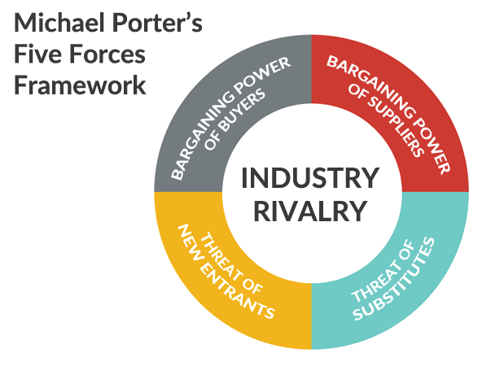

- Threat of New Entry (Strong Force): The entry of new companies into the Electronic Equipment market brings with it new innovations, new methods of operation, and puts pressure on Sony Corporation's pricing strategy, cost reduction, and new value propositions. Sony Corporation must address all of these challenges and construct effective barriers to maintain its competitive advantage.

Sony Corporation can address the challenges posed by new market entrants.
- By introducing new products, not only does it attract new customers, but it also provides an opportunity for existing customers to purchase Sony Corporation's products.

- By creating economies of scale, it is possible to reduce the overall fixed cost per unit.

- Bargaining power of suppliers (Moderate Force): The majority of companies in the electronic equipment sector purchase their raw materials from a variety of suppliers. Those with a dominant position can reduce the profit margins that Sony Corporation can generate in the marketplace. The dominant suppliers in the consumer goods sector use their bargaining power to command higher prices than those in the electronic equipment industry. The overall effect of this higher bargaining power is a decrease in the profitability of the electronic equipment sector.

Sony Corporation can address the challenges posed by Bargaining Power of the Suppliers
  - By experimenting with several product designs and materials, the company may switch to another if the price of one raw material increases.
  - By creating an efficient supply chain with a variety of vendors.

Bargaining Power of Buyers (Strong Force): Consumers are often a demanding group of customers. They seek to purchase the highest quality products by paying the lowest possible price. This has resulted in a decrease in the long-term profitability of Sony Corporation. The larger and more influential the customer base of Sony Corporation is, the greater the ability of customers to negotiate for increased discounts and offers.

Sony Corporation can handle the challenges Bargaining Power of the Buyers

By establishing a broad consumer base. This is beneficial in two ways It will lessen the negotiation power of buyers and provide the company the ability to streamline its sales and production procedures.

By developing new items quickly. Customers frequently seek discounts and offers on known items, therefore if Sony Corporation continues to develop new products, it may reduce customers' negotiating power.

Threats of Substitute Products or Services (Moderate Force): When a new offering satisfies a similar customer need in a variety of ways, the profitability of the industry suffers. For instance, storage hardware drives are replaced by services such as Dropbox and Google Drive. The risk of a substitute offering arises if the product or service offers a unique value proposition that stands out from the current offerings of the industry.

Sony Corporation can handle the challenges posed by Threat of Substitute Products / Services

By emphasizing services over products.

By recognizing the fundamental need of the consumer rather than what they are buying.

By increasing switching costs for customers.

Rivalry among the Existing Competitors (Weak Force): Sony Corporation operates in a highly competitive Electronic Equipment industry, where competition between the existing players in the industry can lead to a decrease in prices and a decrease in the profitability of the industry as a whole. This competition has a negative impact on the long-term profitability of the organization.

Sony Corporation can handle the challenges posed by Intense Rivalry among the Existing Competitors in Electronic Equipment industry

By establishing long-term differentiation

By increasing size, it will be able to compete more effectively.

By examining all five competitive forces, strategists at Sony Corporation can gain a comprehensive understanding of the determinants of the organization's profitability in the electronic equipment industry. This allows them to recognize potential game-changing trends in advance and act quickly to capitalize on the opportunity that arises. By gaining a thorough understanding of the five Porter Five Forces, managers at Sony Corporation are able to shape those forces to their advantage.
3.1 Advantages of Porter’s 5 Forces Model
- It shifts the emphasis of a firm's attention away from the typical SWOT analysis and onto its reaction to a change in the external environment. The five forces framework is also highly interconnected with other models, such as the PEST forces [Political, Economic, Social, and Technological], to aid in understanding and capitalizing on dynamism.
- It also emphasized the need of looking for imperfect markets that provide greater chances, because flawed markets provide potential for supernormal earnings, which do not exist in perfect competition.
3.2 Disadvantages of Porter’s 5 Forces Model
- At first, Porter completely ignored complements in the context of the industry, while recognising substitutes. For example, the market for digital games is significantly affected by the introduction of new gaming consoles such as a 'Microsoft Xbox' or a 'Sony Playstation'. Porter mentions complements in the revised edition but states that they can be seen through the lens of five forces, whereas many management theorists view them as a sixth force.
- Porter also makes a bold claim that industry structure does not determine competition and profitability, nor does it determine whether an industry is new or old, hi-tech or low-tech, regulated or non-regulated. In many cases, the industry structure is not the only factor that influences the profitability of the firm. Governments and legal actions can also have a significant impact on the firm’s profitability.

- SWOT ANALYSIS
This Strategic Worldwide Operational Overview (SWOT) analysis of Sony has identified a number of key issues that could impede the company's global growth and development. Sony's position in the global consumer electronics market serves as a foundation for strategies for expansion and strategic fit, which are based on the SWOT factors (Strengths, Weaknesses, Opportunities, and Threats) identified. To maximize business performance, strategies such as Sony's general competitive strategy and robust growth strategies must address the issues identified in the SWOT analysis.
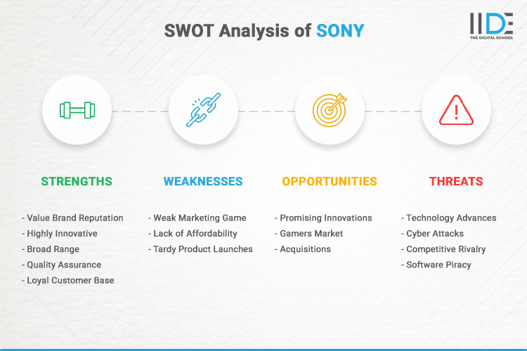
SONY’S STRENGTHS
This element of the SWOT analysis highlights the business strengths of the technology and entertainment organization. Internal strategic variables that assist firm growth and profitability are referred to as strengths. Sony's advantages include the following:
- Strong brand
- Diversified business operations
- Popular profitable products
The strengths of the company are evident in the strong brands of the company, such as the PlayStation brand and the Sony Music brand, which are among the most influential in the global market. These strong brands allow the company to easily draw customers to its new and existing products. Furthermore, the company operates as a conglomerate with a diversified range of business activities. For instance, the company offers electronics, gaming, and entertainment products. The SWOT analysis demonstrates that this diversification reduces market-related risks and enhances the stability of the company's operations. Conversely, the company profits from its popular and profitable products, including the PlayStation video game console. This intrinsic factor is considered to be one of the strengths of the company, as it ensures profits in the face of competition in the consumer electronic and entertainment market. Despite this, Sony must continue to improve its strengths in order to remain competitive.
SONY’S WEAKNESSES
This part of the SWOT analysis highlights the vulnerabilities or internal strategic variables that limit or lower the performance of the information technology and entertainment organization.
One of the major drawbacks of Sony's business is the absence of dominant mobile devices. The company's smartphones and tablets have not been performing well in comparison to other leading global consumer electronics firms, including Apple and Samsung. As the company's reliance on online services increases, it must address the potential vulnerabilities of its IT assets, including servers, databases and networks. This is a weakness as it raises data security concerns for the company and its customers. Another of the company's weaknesses is the similarity of some of its consumer electronics. For instance, competitors can replicate the features of the company's cameras and home theatre equipment. In this analysis, weaknesses present significant impediments to growth, which can be addressed to improve the company's competitiveness and profitability.
SONY’S OPPORTUNITIES
According to this component of the SWOT analysis, Sony has chances to expand its business. In the information technology, consumer electronics, gaming, and entertainment businesses, opportunities are external strategic elements that might increase firm growth and revenues.
Sony's growth may be accelerated by more company diversification. For instance, the business might look at prospects in similar industries by expanding on its present skills. Sony also has the chance to develop new items to generate new revenue sources. Rapid product and service innovation may also strengthen a company's competitive edge, particularly in light of the intense industry competition. The organization has potential to increase its profitability in its existing industries and maybe in other sectors, according to this component of the SWOT analysis.
SONY’S THREATS
Threats to Sony's consumer electronics, gaming, and entertainment sectors must be conquered and resolved.
The threat of cyber-attacks is a major concern for Sony, particularly as the company is increasingly dependent on online platforms and networks. Furthermore, this SWOT analysis indicates that competition is a threat to the business due to the presence of other large firms operating aggressively in global markets, as outlined in Sony's Five Forces analysis. The company's IT services, online services and artificial intelligence, films, video streaming and consumer electronics are in direct competition with the offerings of Samsung Electronics, Apple Electronics, Alphabet-based Google (Google), Microsoft Corporation, LG Electronics and Huawei, and Disney, Netflix and Universal Pictures, among others. Software and content piracy pose challenges to the company's ability to sustain profitability. For instance, piracy can reduce revenues associated with Sony's gaming products and films, thus necessitating the need for solutions to protect the company's software and entertainment offerings. As highlighted in this section, strategic actions must be taken to mitigate or prevent the effects of identified threats on the business.
- SEGMENTATION, TARGETING AND POSITIONING
SEGMENTATION
The requirements, wants, and expectations of consumers in the audio and video equipment sector vary, as do their resources, geographies, access to technology, cultural preferences, attitudes toward purchases, and how they intend to utilize the goods and services. Sony divides the market into smaller segments and groups that have similar characteristics, purchasing patterns, socioeconomic backgrounds, etc. through a process known as market segmentation.
TARGETING
Sony needs to focus on a certain market after identifying different customer segments within the market.
Existence of the right partners to effectively market to the target market
- Existence of the necessary infrastructure to target a certain client group. For instance, everyone is aware that there is a part of the auto industry that is environmentally sensitive and willing to pay a premium for electric vehicles, but none of the big auto manufacturers were able to successfully target that market due to the lack of a collaborative ecosystem. Tesla created that ecosystem and got profitable.
- The segment's structural allure - The presence of the essential infrastructure needed to successfully sell to the intended audience.
- The market's potential for financial gain: Sony must determine if the market segment it intends to target has the potential for financial gain.
- The organization's comparative advantages and disadvantages in successfully marketing to the target market.
POSITIONING
In today's cutthroat market, brand positioning and value proposition positioning are essential for commercial success. Sony must position its products so that they give customers a clear mental picture of the company's goods and services as well as a distinctive identity and reference point. Because production costs in the audio and video equipment market are being driven down and because of direct consumer access provided by e-commerce and other online retailing tactics, brand positioning and product differentiation are becoming more and more important.

- MARKETING MIX STRATEGIES
The combination of the firm's tactical marketing instruments, including product, pricing, venue, and promotion, to elicit the desired response in the target market.
Product, pricing, place, and promotion make up the four Ps of the marketing mix. The marketing mix refers to the process through which a company designs and implements a combination of product strategies, price strategies, distribution channel possibilities, and promotion vehicles.
Sony needs to place the consumer at the center of its decision-making process and then base those decisions on the demands and wishes of the customer as well as the firm's financial and technological resources to manufacture products at a certain price. Finally, it must decide on both distribution and promotion methods to reach those clients in an effective and efficient manner.
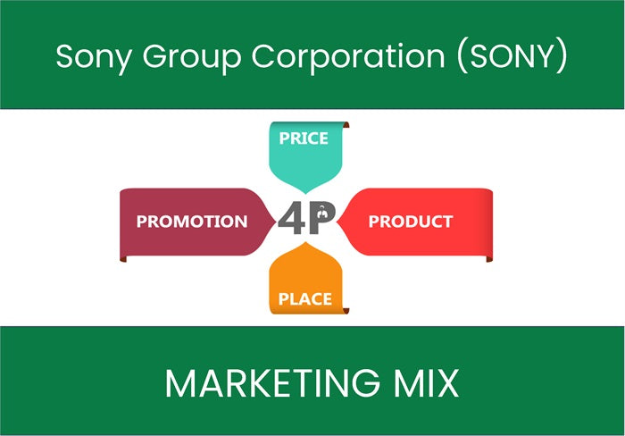

RECOMMENDATIONS FOR THE FUTURE
- Embrace technological Progress: Being a multi-national corporation, Sony must continue to integrate technology with cutting-edge procedures into its marketing and products or R&D. marketing efforts to handle through maintain its positioning to be an innovator in the industry business landscape. Virtual reality or VR, AI-driven experience, and Augmented Reality or AR are substantial (Priyanto et al. 2023). In addition, AI-driven personalization can drive customer loyalty and deliver personalized offers and experiences. Incorporating these technologies not only sets Sony apart but also demonstrates its commitment to providing customers with futuristic and relevant solutions.
- Strengthen Customer Relations: Increasing the engagement of customer interactivity must be a priority for Sony. Different companies must utilize social media platforms, develop online communities, and encourage content that makes of user generated across their products and services (Azzari and Pelissari 2021). By contributing a platform to the customer and sharing experiences, recommendations, and insights this company or brand Sony could able to create a sense of ownership to develop and improve on the basis of loyalty of the customer. Moreover, engaging ability of customers or consumers through webinars, live chat, and online events could deepen the process of engagement and increase the awareness of the brand.
- Competitive and Adaptive marketing: In the face of rapidly changing market dynamics, Sony needs to adopt an agile marketing approach. This involves quickly adapting marketing strategies to respond to emerging trends and consumer preferences. Competitive marketing allows Sony to take advantage of immediate opportunities, stay ahead of competitors, and stay relevant (Periyasami and Periyasamy 2022). The advantages of flexibility and quick decision-making allow us to quickly implement the company's strategy, effectively target new segments, and adjust the campaign to meet the needs of growing customers. Marketing approaches in an agile way help Sony to alter the market dynamics and the landscape. This strategy of marketing is also capable of resizing the crucial points of the brand.
- Sustainable Initiatives: By incorporating sustainability and ethical considerations into the marketing strategy, consumers become more aware of the environment. Sony can demonstrate its commitment to sustainability by promoting environmentally friendly packaging, renewable energy consumption, and recycling. Integrating sustainability into marketing can resonate with environmentally conscious consumers, aligning Sony with growing trends and making a positive contribution to the planet (MARCA 2019). Sony could focus the commitment it creates in a sustainable way by taking many initiatives such as energy usage with renewable powers, packaging with eco-friendly products, and also promoting their product through recycling. Integrating through sustainability could resonate and align with developing itself through the help of trends for conscious consumers in an environmentally and sustainable way.

CONCLUSION
In summary, the analysis of Sony's environmental marketing shows the influence of external influence drivers on their strategy. Digitization, globalization, and rising customer expectations have shaped Sony's marketing landscape. Adapting differences and diversified cultural conditions with economic conditions, integrating the technology with cutting edge, fostering the engagement of customers, and emerging as per the strategy in an imperative way. Many different proportions of value, successful campaigning of the brand, and establishment through the success of marketing provide its competitive edge. Being a crucial tool, marketing is not only managing and handling all difficulties and challenges but steers toward of the brand through competitive advantage in a sustainable way. Through positioning the brand to continue the success ladder through innovation in the perspective of the global marketplace.
REFERENCE

- (PDF) A Critical Analysis of Porter's 5 Forces Model of Competitive Advantage. Available from: https://www.researchgate.net/publication/348550277_A_Critical_Analysis_of_Porter's_5_Forces_Model_of_Competitive_Advantage
- (PDF) Strategic Analysis of SONY inc.. Available from: https://www.researchgate.net/publication/345985664_Strategic_Analysis_of_SONY_inc.
- A Critical Examination of Porter's Five Forces Model of Competitive Advantage (PDF). Accessible at https://www.researchgate.net/publication/348550277_A_Critical_Analysis_of_Porter's_5_Forces_Model_of_Competitive_Advantage.
- Azzari, V. and Pelissari, A., 2021. Does brand awareness influences purchase intention? The mediation role of brand equity dimensions. BBR. Brazilian Business Review, 17, pp.669-685.
- Chavadi, C.A., Sirothiya, M., Menon, S.R. and MR, V., 2023. Modelling the Effects of Social Media–based Brand Communities on Brand Trust, Brand Equity and Consumer Response. Vikalpa, p.02560909231172010.
- Chen, Y. and Wang, L., 2019. Commentary: Marketing and the sharing economy: Digital economy and emerging market challenges. Journal of Marketing, 83(5), pp.28-31.
- Contreras-Cruz, A., Kirbac, A., Dennett, C. and Daim, T.U., 2023. Human-centered design as a tool to improve employee experience: The case of a US plant-based food manufacturer. Technology in society, 73, p.102248.
- Euromonitor (2020), "Consumer Cyclical Sector Analysis ", Published in 2020.
- H. Igor Ansoff (1957), Strategies for Diversification, Harvard Business Review, September–October 1957, pp. 113–124
- MARCA, D.D.L.A.U., 2019 LOYALTY DETERMINANTS TO A TECHNOLOGY BRAND: THE SONY PLAYSTATION.
- Maslow (1987), Motivation and Personality, 3rd ed. (New York: Harper Collins Publishers, 1987)
- Michael R. Solomon (2014), Consumer Behavior, 11th ed. (Upper Saddle River, NJ: Prentice Hall, 2014), pp. 132–134
- Molly Soat (2016), More Companies Require Revenue-Focused Marketing ROI Measures, Study Finds, Marketing News Weekly, 2016
- Nancy Lee and Philip Kotler (2015), Social Marketing: Changing Behaviors for Good, 5th ed. (Thousand Oaks, CA: SAGE Publications, 2015)
- Periyasami, S. and Periyasamy, A.P., 2022. Metaverse as future promising platform business model: Case study on fashion value chain. Businesses, 2(4), pp.527-545.
- Priyanto, P., Murwaningsari, E. and Augustine, Y., 2023. Exploring the Relationship between Robotic Process Automation, Digital Business Strategy and Competitive Advantage in Banking Industry. Journal of System and Management Sciences, 13(3), pp.290-305.
- References Books on Sony Marketing Segmentation, Targeting, Differentiation, Positioning Analysis
- Sforcina, K. (2023). Digitalizing Sustainability: The Five Forces of Digital Transformation. Taylor & Francis.
- Sony (2021), "Sony Annual Report", Published in 2021.
- Sony Businesses & Products.
- Sony Group Corporation – Form 20-F.
- Sony History.
- Sony, M. and Naik, S., 2019. Six Sigma with CK theory for innovations in operational excellence: a case study. Benchmarking: An International Journal, 26(7), pp.2105-2121.
- Van Nguyen, T., Pham, H.T., Ha, H.M. and Tran, T.T.T., 2022. An integrated model of supply chain quality management, Industry 3.5 and innovation to improve manufacturers' performance–a case study of Vietnam. International Journal of Logistics Research and Applications, pp.1-23.
- Wang, J., 2023. The Brand Communication Strategy under the Experience Economy--Takes the Pop-up Store as an Example. Journal of Education, Humanities and Social Sciences, 8, pp.2506-2513.

