Module code: LCBB4005
Module name: The Global Business Environment

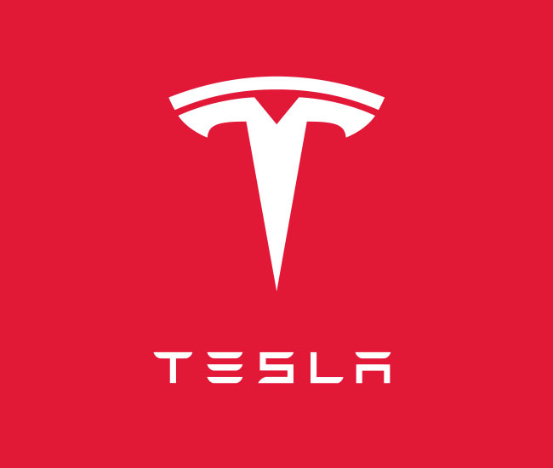

Environmental Analysis of Automobile Industry
  - Tesla
Assigment-2
Student’s Name: Valentina Pituscanu
Student’s ID: 2124861

Lecturer: Nadeem Mirza

Acknowledgement
This work would not have been possible to come to the present shape without the wonderful guidance, supervision and help to me by a number of people. I would firstly like to express my sincere gratitude and indebtedness to my guide Professor Name and our HOD for their kind support, guidance and encouragement throughout my project work.
I would also like to expand our appreciation to all those who have directly or indirectly guided me in making our flawless journey throughout the course.
In addition, we also expand our gratitude to University name for introducing us to this methodology of work, and their passion for the “underlying structures” had lasting effect. We thank all the authors and national organizations for their help either directly or indirectly for helping us in this course.

Introduction
In task-1 of the report, a critical analysis of Tesla as a global business was done. Brief SWOT and PESTEL Analysis was done using Porters five forces. After evaluating the challenges faced by the company, factors were studied which have Tesla a competitive edge and helped them in increasing their profitability.
The next task is aimed at analyzing the effect of COVID on the automobile industry as a whole, and then on TESLA. The critical analysis will study the megatrends in the industry to develop survival and success factors for the industry.

Impact of Pandemic
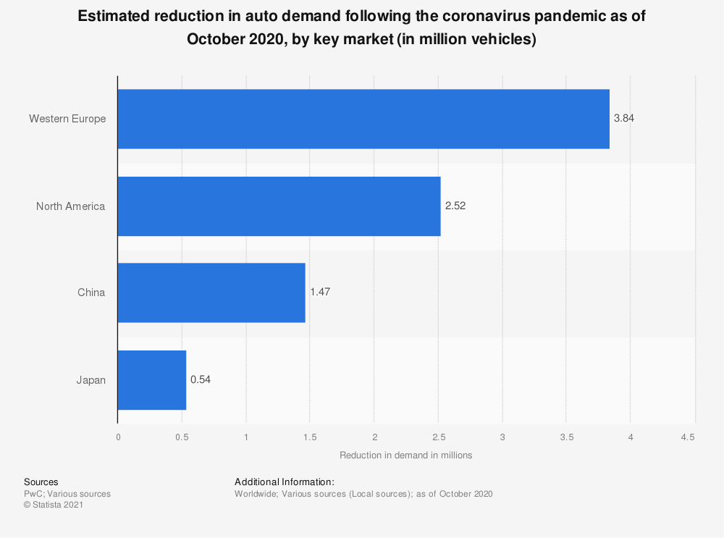
The pandemic has disrupted nations, not only in terms of health but also in terms of economic activities. The list of suffering sections includes the automobile industry. Imposed lockdowns affected the supply chains and hence the value chains of the industry. Factories remained closed for over 2 months with profits declining at a sharp rate. Dealers and suppliers were bearing losses as there was a reduction in sales. Employees were dismissed for short spans. In China, sales went down by a sharp 92% in Feb 2020. In the European region, there was a decrease of 7.4% in sales as compared to the previous year (Nayak, 2022). Every business wanted to adopt agile strategies to come out of the losses suffered in the pandemic by taking the time to explore market requirements and then filling in that void (Hoeft, 2021).
With restricted space to reduce fixed expenditures, certain Original equipment manufacturers have low funds to survive this tenure of loss revenues (Accenture-Impact on the automotive industry, 2020). The overall sales across the world fell to 63.8 Million in 2020. Though the industry is in recovering stages, reaching the pre-pandemic levels is still a long journey (UK new car sales 29% below the pre-pandemic level in 2021 - SMMT - ET Auto, 2022).
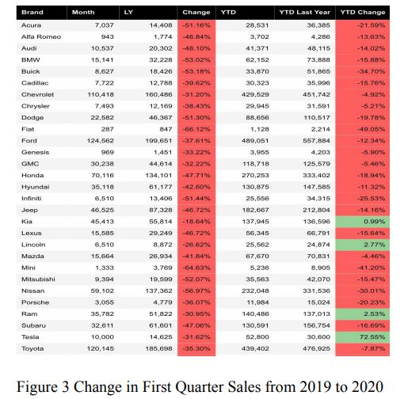
Even in the pandemic, Tesla emerged as strong as ever. When other automotive industries were fighting for their survival, sales of Tesla was sky rocketing. Due to the breaking of supply chains in COVID, deliveries were hit, But Tesla was already offering cars through their websites to maintain that aspect of continuity. Improvements in the climate of the world during the pandemic increased seriousness among the folks on climate change which led to more people choosing an electric vehicle, hence making Tesla a preferred product. It continued to stay profitable during the pandemic and reported a 54% rise in deliveries (Tesla shrugs off pandemic as sales hit a new record, 2022)
One such instance of Tesla's success is before the shutdown of the Fremont Facility, Musk provided incentives and pushed production to meet targets (Tesla almost hits the 500,000-car delivery target for 2020 despite the pandemic, 2022).
One key credit for this can be given to the proactive nature of the company. The pandemic had hit China badly, long before it spread across the World. This led them to pre-plan before things could get worse. Then comes their basic innovative idea of Electric Vehicles at a time like this, with climate change being the focus of every world leader, Tesla sales are no doubt showing an upward trend even in the pandemic (BELLON, RANA, 2022).
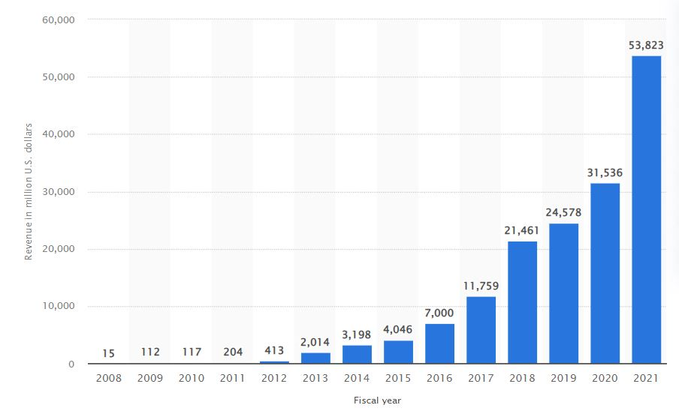
Tesla had also pre-planned on handling the virus spread to its employees by implementing a track and trace system, launching prevention training and opting for vaccines as soon as possible (Tesla Impact Report, 2020)

The pandemic might have boosted the sales for the company, but it also affected its rate of growth for the company. The company was slowed down in production outputs and this was also creating the founder, Elon Musk to make some irrational decisions. He also made some remarks on overplaying the pandemic effects of the government. The closing of the California facility created a lot of unrest for the employees. The company was threatening to penalize the employees if they weren't visiting the plant. This insensitivity of the automobile giant did affect the brand image of Tesla and its founder, Mr. Musk (Chokshi, 2022). Over 400 employees tested positive after the reopening of the plant (Plain site Data). The company then raised pay cuts and temporary firing of the workforce until production from the closed factories were suspended (Bellon, 2022)
There also have been several allegations regarding the receivables of Tesla mismatching with the revenue generation and the company has offered no explanation for this. All of these factors might influence the brand image of Tesla. According to me, these controversies might become a ticking bomb for the company when something goes wrong on a larger scale.
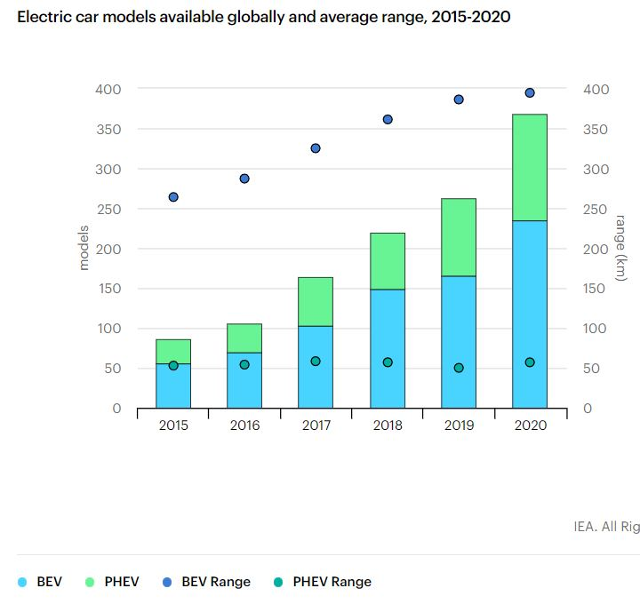

Megatrends of the Industry
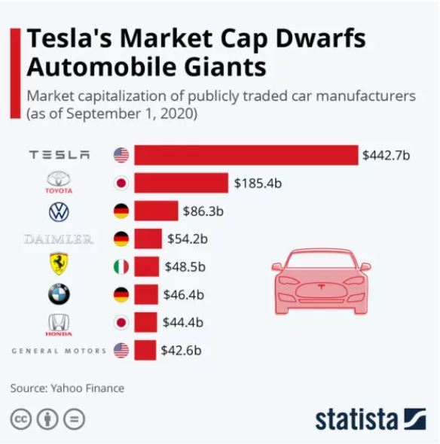
The automobile industry holds a large fraction in terms of revenue generation, 7% of European GDP as of 2020. Around 20 million people are directly or indirectly employed in the sector. German-based manufacturers like Volkswagen are among the leading industries followed by Toyota, Ford, Honda, and General Motors. With sustainability being the limelight and defining the majority of recent trends in the market, every industry has a target to reduce carbon emissions and is coming up with innovative ways to achieve those. Digitalization is the next biggest trend affecting ideas, followed by increased connectivity and globalization. Changes in the social structures have also resulted in variations in customer demands over countries.

- Sustainability: It has become one of the hottest topics of discussion. With the gradually increasing stringency in environmental regulations by the government, carmakers all over the world are bringing in new innovations and investing more and more in R&D to make more fuel-efficient vehicles. Industry dominants like General Motors have made statements about switching completely to renewable sources of energy and achieving carbon neutrality by 2040. Electric vehicles are one such practical solution to achieve these highly ambitious targets. To reduce carbon emissions, countries are providing subsidies for the purchase of electric vehicles, hence the increase in sales and popularity (Wang, 2021). With the rapidly rising fuel prices because of the Russia-Ukraine war, electric vehicles present an overall cheaper choice. Even though the sales were during the pandemic, the sales of electric vehicles exhibited a sharp increase of 70% (Global EV Outlook 2021 – Analysis - IEA, 2022). Tesla is a pioneer in the production of high-end electric cars. With ballooning sales, Model-3 has become the world’s bestselling plug-in EV, crossing sales of over a million in 2021 (Statista Tesla, 2022).
Apart from electric cars, the company is also harnessing solar energy through solar roofs and panels. With the aim of making their production more efficient, Tesla is trying to standardize low energy and water consumption per car in the new factories. Tesla has taken a lead in the key sustainability practices like life cycle assessment of their vehicles in comparison to the exits fuel-based motors. From raw material supply to the end-use, electric vehicles have proved to have marginally lower emissions than internal combustion engines. Other such initiatives include localization of supply chains, distribution of factories as per demands, in-house cells manufacturing units and the famous recycling of batteries both in-house and through third parties. All of these technical solutions to environmental problems have also served Tesla’s brand image and have been its marketing strategy. (Tesla Impact Report, 2022)

- Digitalization: Every industry is in a race to keep up with the current digitalization and the move towards artificial intelligence. The automobile industry was facing a slow momentum in the market which has led companies to invest more in R&D and find new operating methodologies to either maintain or increase their competitive edge. Moving to digital supply chains for cost-cutting, autonomous driving and data pools for continuous improvement in customer experience are some techniques (Digital Transformation IBM, 2022). And it is not just happening in the cliché desk works but also in production, quality management, retailing, and in each and every factor of the value chain. Tesla took the first rank in ARC's inaugural Industrial Digital Transformation Top 25 special report. Tesla is equipped with over-the-air software aimed at giving continuous updates to improve the safety and other performance of their cars. This helps in improving customer satisfaction and increasing return rates. The company is also into data-driven improvements and innovations. (Braunfels, 2021). With the mindset of data, driven technologies from on-field vehicles operating costs are determined, carbon emissions are measured, battery recycling is monitored, etc. Tesla is into continuous development the self-driving systems with vision-based artificial intelligence to develop inference level driving. It also has improved advanced safety features like Automatic Emergency Braking, Lane Departure Warning, Forward and Side Collision Warning, Obstacle-Aware Acceleration, blind spot warnings and continuous improvements through its software (Tesla Impact Report, 2020) With 5G coming in the next few years, Tesla has also moved into connectivity.

- Connectivity: With digitalization smashing the markets, connected car systems might prove to be the best thing. A future with automatic driving cars and no traffic jams can be the next disruption. Vehicle-to-Vehicle and Vehicle-to-Infrastructure technology for communication between two cars, sensors to detect and stop at traffic lights, speed adjustment, voice recognition, and a completely personalized experience(Yarali, 2022). Tesla has already stepped into the market with offerings such as live traffic visualization, live cameras, video and music streaming and many more.

- Globalization: Improved connectivity and open markets have helped every industry to increase their profits and economies to generate revenue while creating employment. It helped them in minimizing manufacturing costs and improving the supply chain hence decreasing logistics and transportation costs (Grodzicki, 2020). Tesla has production units in the United States and Germany. To serve the Asian market, Tesla has a facility in Shanghai, China and the CEO, Elon Musk has huge plans for the China Unit. The company has partnered with Panasonic for Photovoltaic battery cells (Mangram, 2012). The company also has minor linkages with hotels to provide charging stations at specified locations. Tesla has always been targeting to enhance its customer base by localizing production and reducing the wait time. As a CSR responsibility the company has taken the target of expanding supercharge facilities to promote long-distance travels (Tesla Impact Report, 2020)

Analysis of Trends: Success & Survival Factors

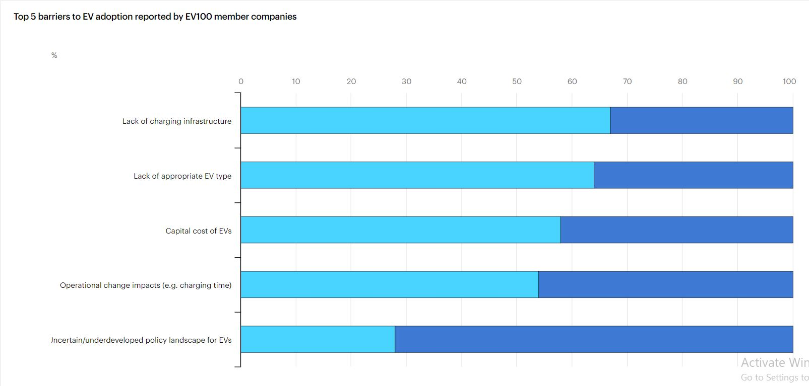

Although Tesla had a slow start, the company has grown massively in the last few years, reporting continuous profitable quarters even in the pandemic. The company presents a bright future as it has emerged in the era to climate change and sustainable development. The mission statement of the company clearly states that it is aiming to become carrier for the world towards sustainability and cleaner vehicles. With its ambitious targets of reducing carbon footprint, developing a whole ecosystem of production, from using solar energy in production to its in-house cell manufacturing sections, the survival rate of the company increases multi-fold. With its initiative of large scale battery recycling and material recovery, the brand value of the company takes a high jump.
A major risk that Tesla faces is a new entrance into the market with better technology and lower prices. Tesla’s customer base is still mostly upper-middle class and wealthy people. Although the company is working on their cheapest car, a new entrant might cause a disruptive market and reduce Tesla’s monopoly. Another risk I think Tesla has is the CEO Elon Musk. Musk has no doubt contributed to the organization enormously but his flickering nature and his ego wars with the government might hinder the expansion targets and the brand image on the company. His dealings with local county during the pandemic and similar such dealings can hinder the process of Tesla’s unparalled growth.
The company should invest in developing low cost vehicles with markets like India and other similar developing economies. The more consumer base they cover, the safer their tenure will become. There has been several controversies about the liquidity and payables of Tesla. The company should as soon as possible provide clarifications for the same as it might affect their image. The company is already focusing on auto insurance as an opportunity. There has also been articles mentioning the over spending on R&D which according to me is helping them in the present but might not prove to be sustained.
Concluding, Tesla definitely needs to take certain drastic steps to increase its survival rates and ensure a long term market share.

References

Nayak, J., Mishra, M., Naik, B., Swapnarekha, H., Cengiz, K. and Shanmuganathan, V., 2022. An impact study of COVID‐19 on six different industries: Automobile, energy and power, agriculture, education, travel and tourism and consumer electronics. Expert systems, 39(3), p.e12677.
Hoeft, F., 2021. The case of sales in the automotive industry during the COVID‐19 pandemic. Strategic Change, 30(2), pp.117-125.
Accenture.com. 2022. [] Available at: <https://www.accenture.com/_acnmedia/PDF-121/Accenture-Covid-19-Impact-Automotive-Industry.pdf>
ETAuto.com. 2022. UK new car sales 29% below pre-pandemic level in 2021 - SMMT - ET Auto.
Available at: <https://auto.economictimes.indiatimes.com/news/passenger-vehicle/cars/uk-new-car-sales-29-below-pre-pandemic-level-in-2021-smmt/88725611>
BBC News. 2022. Tesla shrugs off pandemic as sales hit new record.
Available at: <https://www.bbc.com/news/business-54636005>
The Guardian. 2022. Tesla almost hits 500,000-car delivery target for 2020 despite pandemic. Available at: <https://www.theguardian.com/technology/2021/jan/03/tesla-almost-hits-500000-car-delivery-target-for-2020-despite-pandemic>
BELLON, RANA, T., 2022. Tesla sets revenue record, makes profit thanks to pollution credit sales to rivals. Available at: <https://www.reuters.com/article/uk-tesla-results-idUKKBN27631G>
Tesla.com. 2022.
Available at: <https://www.tesla.com/ns_videos/2020-tesla-impact-report.pdf>
Chokshi, N., 2022. Coronavirus Wrecked Tesla’s Momentum and Elon Musk Is Furious (Published 2020). Nytimes.com.
Available at: <https://www.nytimes.com/2020/05/13/business/Elon-Musk-tesla-factory-coronavirus.html>
Bellon, T., 2022.
Available at: <https://www.reuters.com/article/us-health-coronavirus-tesla-idUSKBN21Q0CO>
Wang, L., Qin, Z., Slangen, T., Bauer, P. and Van Wijk, T., 2021. Grid impact of electric vehicle fast charging stations: Trends, standards, issues and mitigation measures-an overview. IEEE Open Journal of Power Electronics.
IEA. 2022. Global EV Outlook 2021 – Analysis - IEA. [] Available at: <https://www.iea.org/reports/global-ev-outlook-2021>
Statista. 2022. Topic: Tesla. Available at: <https://www.statista.com/topics/2086/tesla/>
Tesla.com. 2022. Available at: <https://www.tesla.com/ns_videos/2020-tesla-impact-report.pdf>
Ibm.com. 2022. Available at: https://www.ibm.com/downloads/cas/LVDZDXOA
(Braunfels, N.S.J., 2021. Tesla motors: disrupting the automotive industry).
Yarali, A., 2022. Digital Transformation Trends in the Automotive Industry.
Grodzicki, M.J. and Skrzypek, J., 2020. Cost-competitiveness and structural change in value chains–vertically-integrated analysis of the European automotive sector. Structural Change and Economic Dynamics, 55, pp.276-287.
Mangram, M., 2012. The globalization of Tesla Motors: a strategic marketing plan analysis. Journal of Strategic Marketing, 20(4), pp.289-312.

