Postgraduate Research Methods: ACFA7004
Joseph Julian Blackmore (1702858)
UWTSD SA1 1NE

Index
(Inc42, 2020)
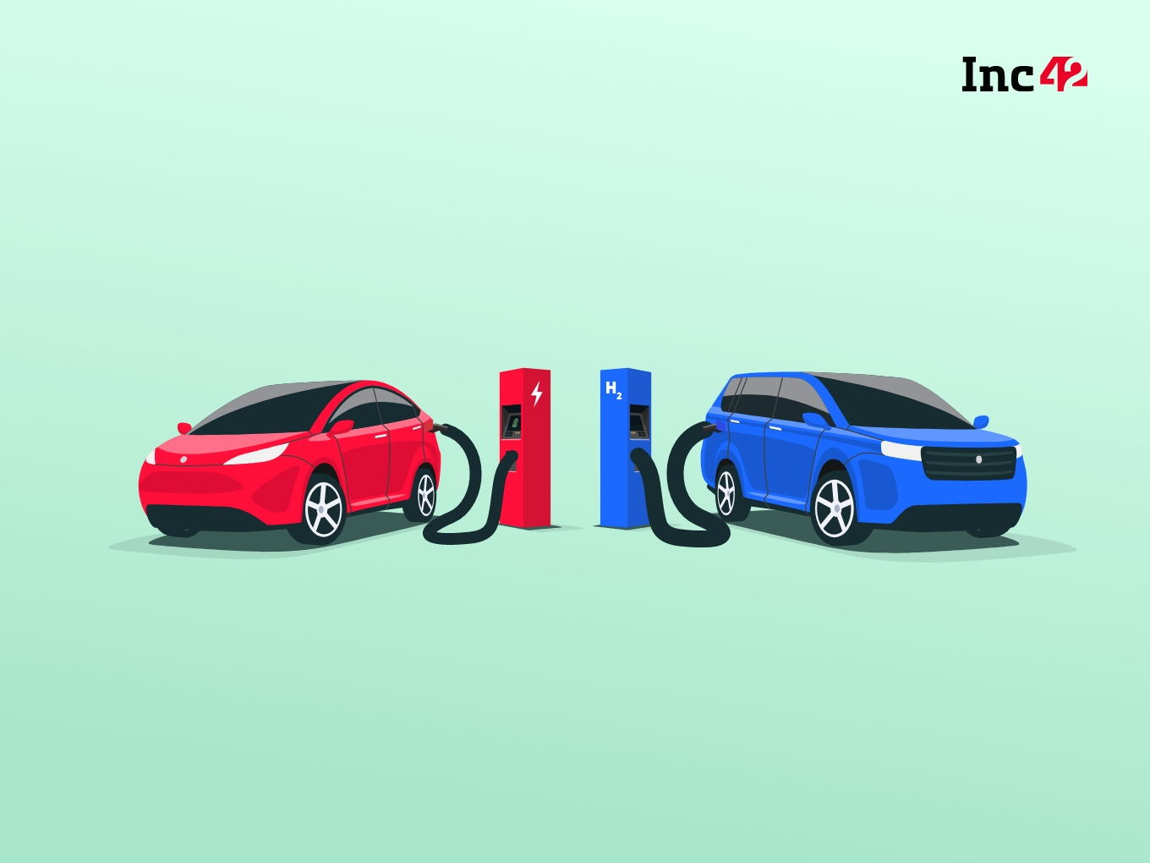

How can Wales Implement Low Emission Vehicles into National Policy More Effectively?

- Introduction

  - Intent & Scope of the Research

- Literature Review

2.1. International Policy That Has Influenced Adoption of Electric & Hydrogen Vehicles

2.2. Infrastructure of Electric & Hydrogen Vehicles

2.3. Some Key Differences Between Plug-in Electric, Hydrogen & E-fuels

- Research Methodology & Results Analysis

3.1. Archival Research

3.2. Structure Surveys & Semi-structured Interviews

3.3. Timescale

4. Evaluation

Introduction

The role of transportation, both public and private, in greenhouse gas and carcinogenic emissions is a topic that is increasingly gaining attention from both a media and legislative perspective. As the first major economy to pass a net zero emissions law with a target set for 2050, it is apparent that development in terms of clean transportation will become increasingly necessary in the UK from a long term perspective. Further ambitious targets to reduce greenhouse gas emissions to below 68% of 1990 levels by the end of the decade will also necessitate immediate action from Westminster and the devolved governments in order to bring transportation policy in line with the vision of a ‘low carbon economy’ (UK Government, 2020). Transportation plays a critical role in the function of a developed economy, we rely on transportation in the form of logistical services, emergency services, exploration, local and international travel in addition to the personal mobility and convenience that both public transport and privately owned vehicles provide us. Considering the importance of transport in Wales as a nation of varied landscape and quality of access to transportation infrastructure, it is imperative that policy relating to transport moving forwards must work as effectively and proactively as possible in order to meet the demands of Wales’ population whilst meeting the commitments made to reduce emissions and improve air quality. On the 18th November 2020 the UK government published the plans of their “10 point plan for a green industrial revolution” in which the announcement that the sale of all new purely fossil fuel powered vehicles will be outlawed by 2030, with plug-in hybrid vehicles being on sale until 2035. According to the current government plans, by 2035 in the UK all new cars and vans will be “zero tailpipe emission vehicles”. Within this plan the UK government also stated that “We will invest £120 million next year to begin the introduction of at least 4,000 more British built zero emission buses”. In addition to this the plan states that a date will be consulted for the phasing out of new diesel heavy goods vehicles (HGV’s), with a £20 million investment in 2021 towards zero emission freight trials to aid in the development of hydrogen and other zero emissions trucks. (Johnson & Sharma, 2020)
This is set to pose a significant challenge for Wales as surface transport is Wales’ third-largest source of emissions. Between 2016 and 2018, emissions from surface transport fell by 2%, however, emissions in 2018 were still 3% higher than the 1990 baseline. Surface transport emissions have not altered significantly since 1990, despite ongoing improvements in vehicle efficiency. This is as a result of the total distance driven by cars in Wales increasing by 13% since 2008 to 31.6 billion vehicle-km in 2018, this has largely outweighed improvements in petrol and diesel vehicle efficiency, at least from a greenhouse gas emissions perspective (Gummer, et al., 2020). Industry sectors, such as manufacturing, have successfully reduced their contribution to greenhouse gas emissions in this period, however surface transport has failed to achieve the same success.

1.1 The Intent & Scope of the Research

Technology surrounding low emissions vehicles is evolving rapidly and different technologies have unique strengths and limitations from both a perspective of consumer convenience and potential for environmental benefit. Currently, battery electric vehicles (BEV’s) are set to be the primary alternative to petrol and diesel fuelled internal combustion engine (ICE) vehicles, however, other alternatives such as hydrogen fuel cell vehicles (HFCV’s) and carbon neutral synthetic fuels may also have a role in achieving a net zero carbon emission economy by 2050. The success of low emission vehicles and the manner in which they are supported in policy will be dependent on a variety of groups, each with distinct areas of knowledge and responsibility. Groups such as automotive engineers, environmental scientists, policy makers, urban planners, developers in infrastructure and construction and conservationists will all have a role in the future of vehicle technology in Wales. If transportation policy in Wales empowers these individuals to contribute their unique skills and knowledge as effectively as possibly in overcoming the challenge of reducing vehicle emissions, Wales stands a greater chance of being successful in this area. The intent of this research project is to construct a guide for Welsh policy makers that will allow for a well informed decision making process involving the implementation of electric, hydrogen fuel cell, and other future fuel technologies in Wales’ roadmap to a carbon neutral economy by 2050. If Wales is successful in utilising low emission vehicles in a manner that not only allows the nation to meet its legally binding targets, but also has a positive impact on air quality and its global environmental footprint, this could have a far reaching positive impact on both current and future generations. There are risks involved from both an economic and environmental perspective in reacting to the announcements made by Westminster surrounding the gradual phasing out of petrol and diesel fuelled vehicles. Relying heavily on the precautionary principle risks being too slow to react to shifts in technology, resulting in a lack of infrastructure to support innovative technologies and falling behind on targets to reduce emissions. Investing hastily risks supporting technology and infrastructure that will quickly become outdated or replaced entirely, leading to an inefficient use of resources and public funds. (Science Communication Unit, University of the West of England (UWE) Bristol, 2017). Due to the complexities surrounding this issue, it is vital that those responsible for constructing policy surrounding this matter are as well-informed as possible in order to have as positive an impact as possible for Wales and the wider community.
The hypothesis of this proposal is that individuals will have a difference in opinion and level of knowledge surrounding alternatively powered vehicles depending on their field of study or employment. By considering the role that these individuals will play in the future of low emissions vehicles in Wales, this will be a useful tool in constructing more effective policy for low emission vehicles in Wales. There are currently no academic papers that have proposed a roadmap for how policy in Wales should react to the prohibition of the sale of new petrol and diesel fuelled vehicles in 2030, by considering the impacts of a contemporary environmental and technological issue in the specific context of Welsh policy, this can be a relevant contribution to knowledge. The research will not involve the generation of a mathematical model to determine the strengths and limitations of BEV’s and HFCV’s, however existing models from scientific, engineering and economic publications will be studied in order to inform the recommendations for Welsh policy.

Literature Review

There are a number of topics relevant to the proposed research proposal with a diverse selection of academic studies and government documents that can be reviewed in order to enhance the understanding of low emission vehicles from both a technical and legislative perspective. The following literature review is separated into relevant subsections from a topical perspective.

International Policy That Has Influenced Adoption of Electric & Hydrogen Vehicles

In recent history the UK’s policy surrounding electric vehicles has largely been influenced by its membership to the European Union.
One of the seven flagship projects of the Europe 2020 strategy devised in 2010 for smart, sustainable, and inclusive growth was entitled ‘’Resource Efficient Europe.’’ The purpose of this project was to encourage changes towards a resource-efficient economy with significantly reduced green-house gas emissions by decoupling economic growth from the use of resources and energy. In 2011 the White Paper titled ‘’Roadmap to a single European transport area – towards a competitive and resource-efficient transport system’’ highlighted the need to reduce the oil dependence of the transportation sector in European countries. This document presented plans, including the development of alternative fuels, and incentivisation for low emissions vehicles. In a 2013 document titled ‘’Clean Power for Transport: A European alternative fuels strategy’’ the European Commission proposed a set of actions and targets for the construction of infrastructure for the distribution of alternative fuels (electricity, natural gas, and hydrogen), based on technical standards that would be identical for all member states. Despite the common goals of reducing emissions in the transportation sector across the 28 members of the EU during the release of these documents, the rate of adoption of electric vehicles and their respective energy mix varies greatly between countries within the EU. (Burchart-Korol, et al., 2020). This could suggest the need for individual countries to approach applying policy and legislation towards encouraging the development of low emissions transportation as a more integral part of their respective environmental strategies. (Blackmore, 2020)

2.2 Infrastructure of Electric and Hydrogen Vehicles

According to the Department of Transport, as of 2020 only 0.105% of vehicles registered in Wales are electric. This figure is expected to rise rapidly approaching 2030 due to Westminster’s announcement in November 2020. This presents a significant challenge as infrastructure for zero tailpipe emission vehicles is lacking within the country. There are only 21 charge points per 100,000 members of Wales’ population, compared to 278:100,000 in Norway, the world leader in terms of adoption of electric vehicles (Hall, et al., 2020). The unique geography of Wales itself also provides distinct challenges in offering an effective charging infrastructure, there are also inequalities present in the quality and availability of electric vehicle charging infrastructure as rural and economically disadvantaged areas are underserved in this regard. It is also worth considering that there are only 2 hydrogen refueling stations in Wales in the following locations:

- University of South Wales, Glyntaff, Pontypridd, Wales (CF37 4BD)
- University of South Wales, Baglan, Port Talbot, Wales (SA12 7AX)

According to a Welsh government consultation document, the number of fast chargers needed across Wales increases to 30,000 to 50,000 over the next ten years. Wales currently has less than 1% of this total installed. (Welsh Government , 2020)
Increasing the quality and availability of infrastructure to support the increasing number of plug-in hybrid electric vehicles (PHEV’s) and battery electric vehicles (BEV’s) in Wales will require investment from both energy companies and the government. Even with an extensive increase in the number of public charging points across the country, there remains concerns regarding the ability for infrastructure to meet the demands of electric vehicle owners due to the time taken for electric vehicles to charge. Through the ‘Electric Vehicle Home Charge Scheme’, the UK government currently offers a grant towards buying and installing a wall-box. The grant covers 75% of the cost, up to a maximum cost of £500. As of the 1st of July 2019, this grant is only eligible for smart charge points, therefore allowing the charge point to react to information received, by adjusting the rate of charging or discharging so that grid demand can be more effectively balanced. The benefit of incentivising home charging is that it has the potential to significantly reduce the pressure on public charging facilities. (Office For Low Emission Vehicles; Office For Zero Emission Vehicles, 2021).

A technology that has potential to allow the National Grid to manage the strain imposed on electricity supply from the widespread adoption of EV’s is ‘Vehicle-to-Grid’ or ‘V2G’. This refers to the ability of EV batteries to deliver power back to the grid, such technology used in conjunction with smart charge points can allow vehicles to be utilised as energy storage units. (Lund & Kempton, 2008) There are consumer benefits for this system as electricity can be sold back to the grid during peak demand times, whilst this also acts as a benefit for the National Grid as this acts as regulation for power demand. the National Grid predicts that smart charging and V2G technology could considerably reduce the national demand for electricity to power EV’s in a number of possible future scenarios, as illustrated in the graph below;
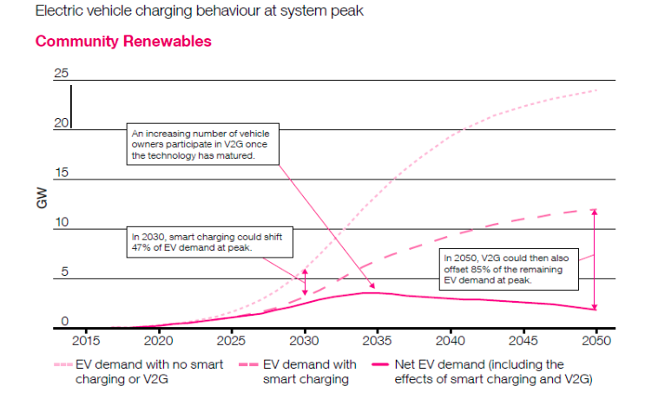

Figure 1: National Grid prediction for the potential of V2G to reduce the demand of EV’s on the grid based on the ‘Community Renewables’ scenario. (National Grid ESO, 2019)

Whilst V2G has been highlighted as having encouraging potential in its ability to reduce grid demand, there exists conflict in whether such an energy control architecture should be left as consumer controlled (de-centralised) or involve an aggregator in the control of the systems (centralised).
Table 1: A comparison between the advantages and disadvantages of a centralised and de-centralised V2G infrastructure control architecture.
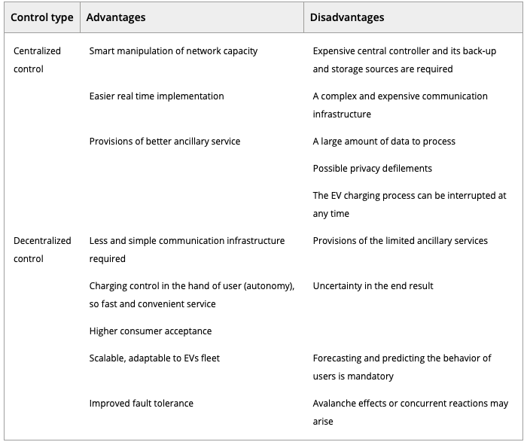

(Arfeen, et al., 2019)

A bi-directional charging infrastructure based on V2G can have multiple practical benefits from the perspective of a Distribution System Operator (DSO), as it enables active power regulation, peak shaving and valley filling in the load curve. The potential of this technology to alleviate concerns from a grid management perspective will be dependent on the rate of adoption amongst EV owners in their home charging setup in addition to a public electric vehicle charging station (EVCS) infrastructure that utilises the technology effectively. (Hadian, et al., 2020). When planning a strategy to locate EVCS in a manner that meets user demands appropriately there are a number of variables to consider. There exists uncertainties in how individuals will use charging infrastructure particularly in a widespread V2G infrastructure scenario, however, some simulation informed models have attempted to generate optimal allocations considering a variety of factors. Some of these variables include the probability of EVs owners’ behaviour and their presence in the EVCS, uncertainties of State Of Charge (SOC), appropriate charging/discharging schedule, load profile of the system and how demand response programs can consider EV battery capacity, state of charge (SOC) of battery, driving habits of an EV owner and their required usable range by the end of the charging process. (Ul-Haq, et al., 2018)
A Monte Carlo simulation is a broad class of computational algorithm that is used to predict the probability of different outcomes considering the influence of random variables. When constructed appropriately, Monte Carlo simulations can be an effective tool in understanding the impact of risk and uncertainty in a broad selection of applications. (Bonate, 2001) Monte Carlo simulations have been applied to solving problems involving the optimal locating of EVCS. The following flow chart is an example of a proposed methodology that considers a potential application for a Monte Carlo simulation in the planning of EVCS infrastructure planning;
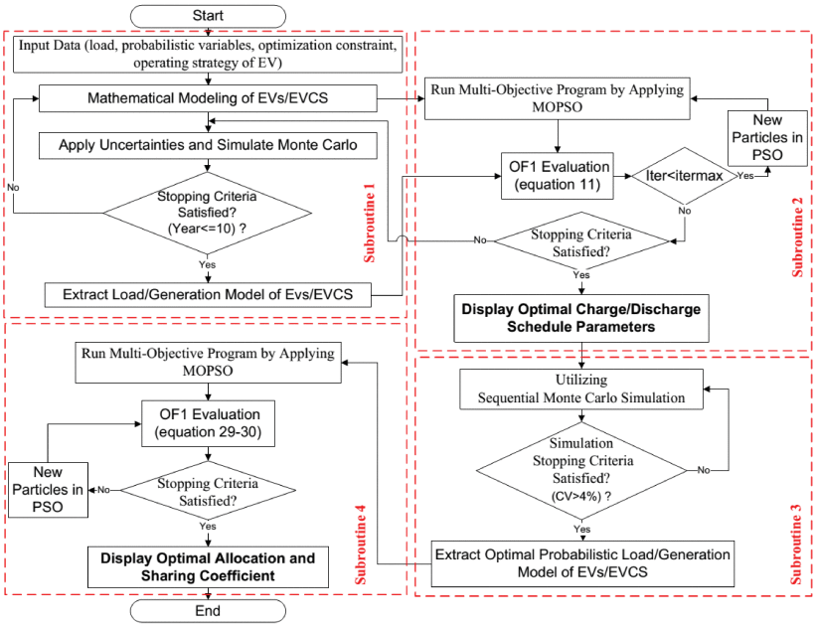

Figure 2: A methodology for how Monte Carlo simulations can be utilised for the application of planning optimal electric vehicle charging station locations. (Ul-Haq, et al., 2018)

Some Key Differences Between Hydrogen, Plug-in Electric & E-fuels

From an infrastructure perspective, there are some complex factors to consider in implementing a charging network that will support the widespread adoption of EV’s effectively. Despite the legitimacy of concerns surrounding the ability of infrastructure to meet the demands of widespread EV ownership in Wales, it is worth considering that the fundamental architecture of BEV technology has the ability to facilitate technological developments that can work positively in managing potential challenges relating to grid demand.
Hydrogen fuel cell vehicles have some distinct differences in this regard compared to plug-in electric vehicles. Despite a very limited existing infrastructure within Wales supporting hydrogen fuel cell vehicles (HFCV’s), there are signs that HFCV’s could have in important role to play in supporting a carbon neutral economy by 2050. Westminster has shown interest in the capability of this technology through funding schemes, such as the £23 million fund to accelerate the take-up of hydrogen vehicles, and roll out more cutting-edge hydrogen refuelling infrastructure in 2017. The UK Transport Minister at the time, John Hayes, also stated ‘Hydrogen fuel cell electric vehicles can play a vital role alongside battery electric vehicles to help us cut harmful emissions’.
(Fuel cells bulletin, 2017)

The fundamental infrastructure challenge that HFCV’s face has been described as the classic ‘chicken and egg’ conundrum. In order for consumers to be convinced to invest in HFCV’s in significant numbers, they will expect an economically viable, easy to use and widely available fuelling infrastructure. However, for energy companies and governments to be willing to risk investing in hydrogen fuelling infrastructure they require a larger consumer base of HFCV owners in order to reduce the risk of investment. (Shamsi, et al., 2021)
In comparison to electric vehicle charging stations, hydrogen fuelling stations can be considered a more practical compromise as a means of powering zero tailpipe emission vehicles due to the significantly reduced time needed to fill a vehicle with compressed hydrogen compared to charging a vehicle that has constraints in charge rate either by the limitations of the vehicle or the charger itself. Hydrogen refuelling stations also present a future alternative fuel that does not require behavioural changes from an end user perspective, as hydrogen filling stations function similarly to a petrol or diesel pump. Another fundamental aspect of utilising compressed hydrogen as a fuel that should be considered is the pathway for hydrogen delivery and storage from hydrogen production plants to refuelling stations. Unlike plug-in electric vehicles, hydrogen fuel cell vehicles require their fuel to be transported to stations in a similar vein to tradition fossil fuels.

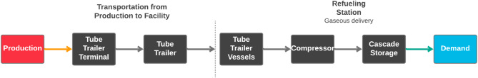

Figure 3: Schematic of hydrogen delivery, storage, and dispensing to consumers
(Shamsi, et al., 2021)

Another aspect to consider with planning infrastructure for hydrogen fuel cell vehicles is how to optimise allocation and location of production plants and refuelling stations. The requirement of transporting the fuel by truck can be perceived as a key disadvantage compared to plug in electric vehicles from an environmental perspective. Whilst HFCV’s and vehicles powered by carbon neutral e-fuels offer a low carbon alternative to traditional petrol and diesel powered vehicles that do not require significant behavioural change from a consumer perspective, currently BEV’s are considered to be the more energy efficient technology;
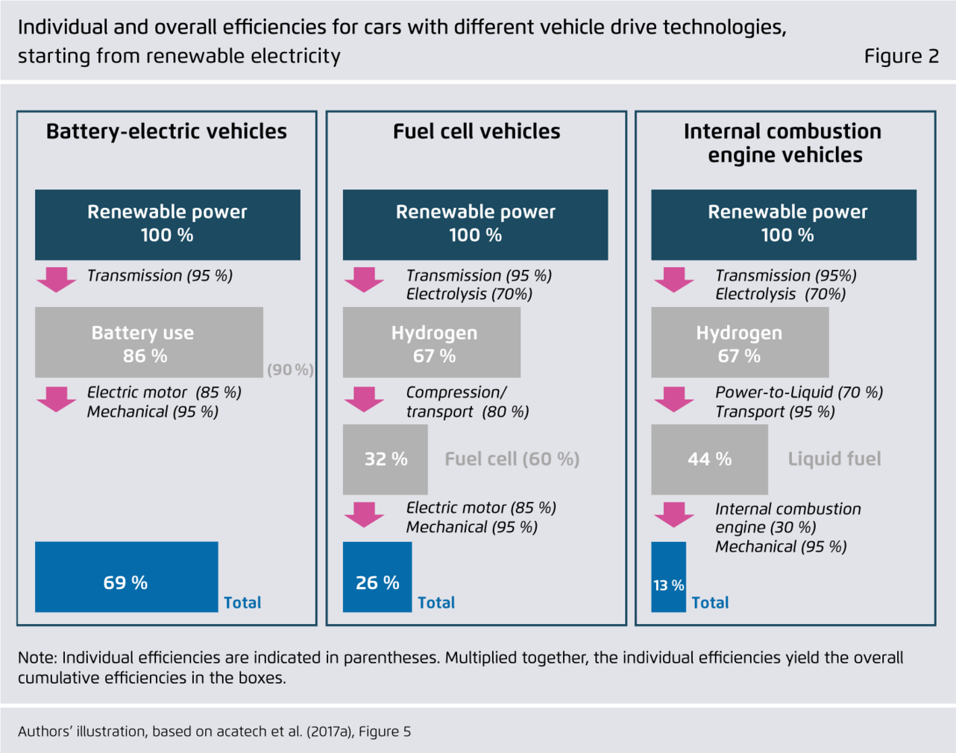

Figure 4: An infographic comparing the estimated energy transfer efficiencies of electricity consumption required for propulsion between BEV’s HFCV’s and electro fuel powered ICE’s (Perner, et al., 2018)

Additionally, whilst e-fuels may be carbon neutral as CO2 is captured from the atmosphere in the synthesis of the fuel, combustion of this fuel will continue to emit toxins and carcinogenic pollution, limiting the ability of this technology to improve air quality in urban environments. Currently, only HFCV’s and BEV’s can be considered as ‘zero tailpipe emissions vehicles’. (Ehsani, et al., 2018) However, infrastructure transformation to support HFCV’ or BEV’s will inevitable take time and owners of existing ICE vehicles will continue to be a source of consumer demand for fuel, car enthusiasts and classic car owners being a more obvious example of this. Baring this in mind, the potential role of e-fuels in Wales’ future of transportation should not be ignored. (Ausfelder & Wagemann, 2020)

Research Methodology & Results Analysis

In order to tackle the research question there are 3 distinct aims that will each require specific research methods and data analysis. The three main aims for this proposal are to determine the following;
- Gain a research informed understanding and knowledge surrounding the differences between different low emission vehicle technologies and the key challenges that Welsh policy must consider in relation to this.
- Test the hypothesis that the opinion and level of understanding surrounding low emission vehicles will vary between groups with relevant expertise, influence or area of study.
- Ultimately, develop a clear guide for how Wales can utilise low emission vehicle technologies in policy effectively so that Wales can become a world leader in reducing the environmental impact of vehicles.

The proposed methodology includes the use of both quantitative and qualitative viewpoints, data collection, analysis, and inference techniques for the broad purposes of breadth and depth of understanding and corroboration. This can be considered as a mixed methods or ‘MM’ research design (Schoonenboom & Johnson, 2017). A classification of the purposes of MM research was published in 1989 by Greene, Caracelli, and Graham. Their analysis led to the following categorisation of purposes for MM research;

- Triangulation seeks convergence, corroboration, correspondence of results from different methods;

- Complementarity seeks elaboration, enhancement, illustration, clarification of the results from one method with the results from the other method;

- Development seeks to use the results from one method to help develop or inform the other method, where development is broadly construed to include sampling and implementation, as well as measurement decisions;

- Initiation seeks the discovery of paradox and contradiction, new perspectives of frameworks, the recasting of questions or results from one method with questions or results from the other method;

- Expansion seeks to extend the breadth and range of inquiry by using different methods for different inquiry components.

(Greene, et al., 1989)

This form of methodology is suited to the proposed research as the study aims to use existing academic studies and data in parallel to the collection of primary data that can function to test the hypothesis in order to inform the construction of the policy guide.

. Archival Research

To accomplish the first aim, an archival research method can be used so that the fundamental characteristics of low emission vehicle technologies can be presented. By presenting the findings from existing academic studies, this can be used to inform the presentation of the challenges relating to the topic so that they can be considered in the context of Welsh policy. The archival research is intended to be separated into distinct categories so that the fundamental challenges and questions surrounding low emissions vehicles can be more clearly presented. At the end of each section the fundamental issues to address can be summarised and considered in the context of Welsh policy.

The proposed research areas for the archival research are as following;
- What the environmental benefits/disadvantages of low emission vehicles are, comparing the concerns surrounding the different technologies and resource use.
- Infrastructure and energy management, including comparisons in energy efficiency.
- Potential future developments.
- The unique strengths and limitations of low emission vehicle technologies.

These topics can be studied using existing quantitative and qualitative studies, such as mathematical models and computer simulations, empirical experimentations and case studies.
This part of the methodology is closely linked to the literature review, however the analysis of the data gathered in the context of Welsh policy will be used to inform the guide.

Structured Surveys & Semi-structured Interviews

The intention of collecting data from structured surveys is to test the hypothesis that opinions relating to low emission vehicles will vary between groups with relevant expertise, influence or area of study. Structured surveys will enable a direct comparison between the answers given by people within the distinct groups such as engineers, conservationists etc. The intention is to request students and lecturers within the institution to complete the surveys in addition to utilising contacts within car enthusiast circles to gain a data sample. The aim is to achieve at least 30 responses in order to gain a useful set of data to analyse based on suggestions made by academics, for example, for ethnography and grounded theory, Morse suggested approximately 30 – 50 participants (Morse, 1994), while Creswell suggested only 20 – 30. (Creswell, 1998)
In addition to collecting survey responses, the intention is to arrange interviews with people in a position of authority within a relevant field, such as someone involved with Welsh politics and a senior automotive or energy engineer etc, subject to availability of willing respondents. The role of the semi structured interviews will be to determine whether there is clarity in the roadmap of Wales future in terms of low emission vehicle policy and whether the unique insights and skills of those that will be involved in reducing vehicle emissions in Wales are being utilised effectively.

Timescale

- Draft introduction, then complete literature review, begin in May, finish by mid June. Analyse secondary data and develop understanding of low emissions vehicle technologies.
- Develop questionnaires and interview plans by May, aim to collect relevant primary data by July
- July to August the results of primary data can be analysed, this can be used to inform the model for how policy in Wales can be improved
- August to September, make any relevant modifications to introduction, complete guide and relevant model before writing the conclusion

Evaluation

Wales has been described as a world leader in regards to environmental policy, a good example being the developments achieved through the ‘Towards Zero Waste’ strategy, (Welsh Assembly Government, 2010) leading into the ‘Beyond Recycling’ plan to encourage circular economy practices in Wales. Wales has met its legal obligations in regards to reducing waste and increasing rates of recycling and is the most successful of the 4 nations within the United kingdom in this regard. Such has been the level of success of Welsh policy in this area, it is now recognised as the 3rd best nation in the world in regards to recycling. The rate of adoption of low emissions vehicles and reduction in surface transport emissions cannot be regarded as favourably as Wales’ performance in other areas of sustainable development. If Wales as a nation is going to follow the legally binding commitments made by the 2015 Wellbeing of Future Generations Act in regards to fostering a more sustainable transportation infrastructure and improving air quality, policy supporting low emission vehicles must aim to be as effective as possible in order to meet the demands of the significant challenges that lay ahead. By presenting practical solutions that can increase the probability of successfully utilising contemporary technological developments that have the potential to contribute to reducing Wales’ environmental impact, this presents a worthwhile contribution to knowledge. However there are some potential limitations to the research proposal. Analysing secondary data in order to achieve the first aim of the proposal will require careful consideration of the merit of the sources being analysed. In order to legitimise any conclusions made in this section of the research there must be clear evidence that complimentary and contradictory sources for each topic have been studied. Additionally, the validity of conclusions drawn from the data analysis of survey results will be dependent on the collection of a representative volume of responses. The structure of surveys must also omit any leading or biased questions and allow for the opinions of those being surveyed to be clearly understood and compared.

