Graphics & Games Programming

ACCA6021

By

Daniel O’Dwyer 1801164

Table of Contents

Design

Pages 3 – 13

User guide

Page 13

Testing

Pages 13 – 17

Bibliography

Page 18

1.4 Appendix

Pages 18 - 44

1.0 Design
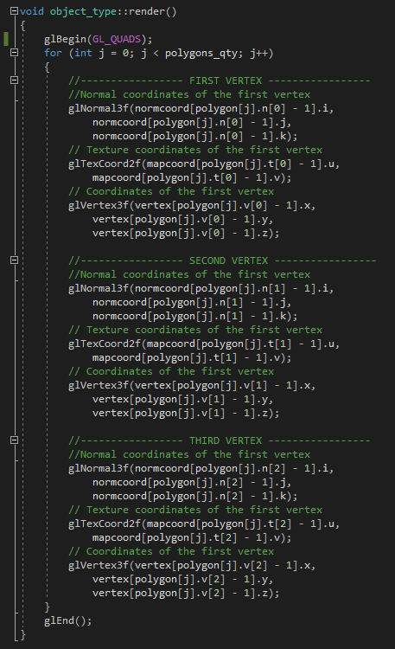
The first part of our program is the render class. This takes the data from out imported object and draws it. It will search through the necessary information in the obj file and render it in the display window. If all goes well the users object will be there to see in the display.

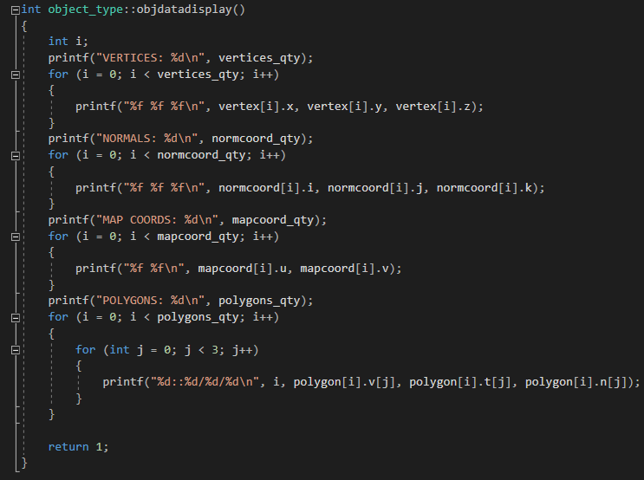
Next we have our data display function. This simply reads the number of vertices, normals, map coordinates, and polygons. Once it has read them it displays them in the console.
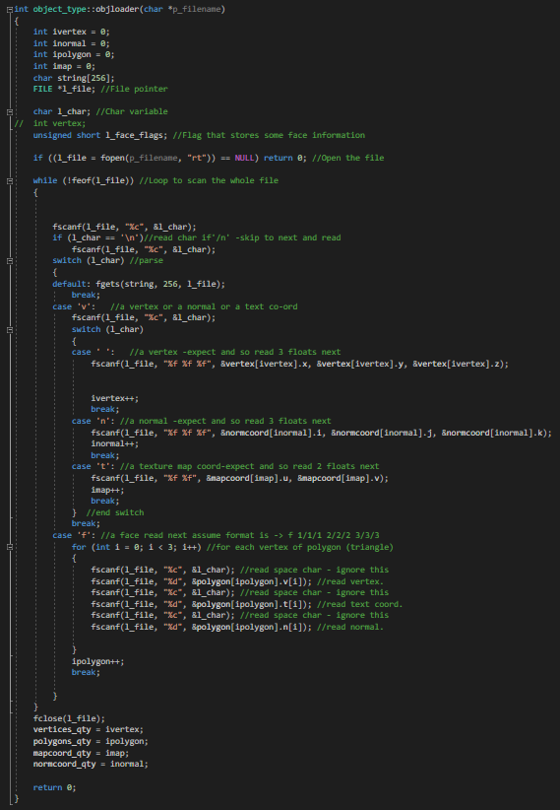
The heart of the program is the obj file loader. Without this we would not be able to import object to use. This reads any obj file the user specifies. It scans the file looking for specific lines and data about the object. When it finds this information, it can determine the objects size, shape, and depth. When the file is called it will load the object so it’s ready to use when needed.
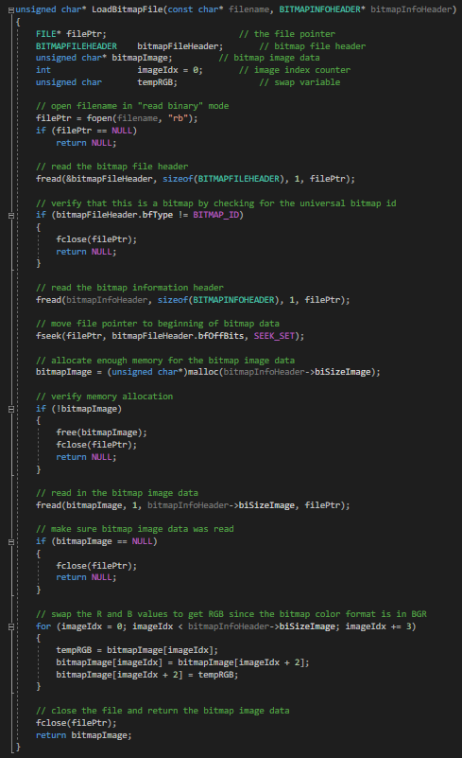
Another crucial part of the program is the bitmap file loader. This functions similarly to the object loader. It reads the bitmap file and loads it ready for use.
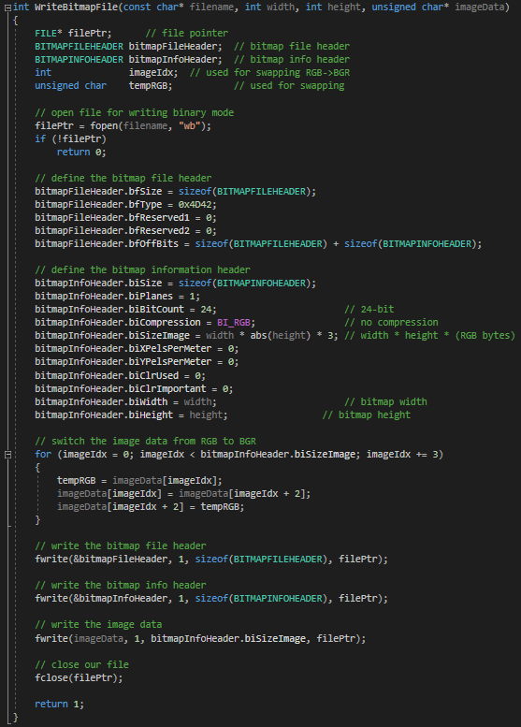
We also have the bit map writer. Again, this is similar to the object loader. It converts certain data in the bit map file to make it useable in our programme. With these two functions working together, any bit map file can be loaded and used. After it is finished with the file it closes it.

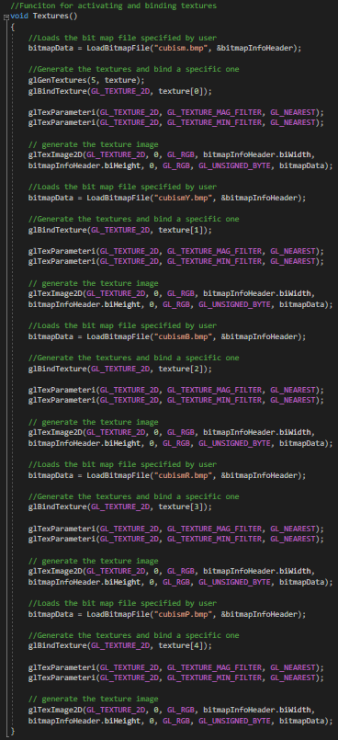
The next part is the texture binding function. This generates an array to store the textures in. We can access that array and bind the textures to individual objects. In this way we can make object that look the same look unique. This is helpful to us as the author is using an object that resembles a card. Using this object without textures would make it difficult to distinguish between each individual object.
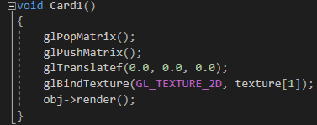
This function uses a matrix to position the cards. By using push and pop we can load different positions. It also binds a particular texture to the card and calls it to be rendered. We do this for all ten cards.
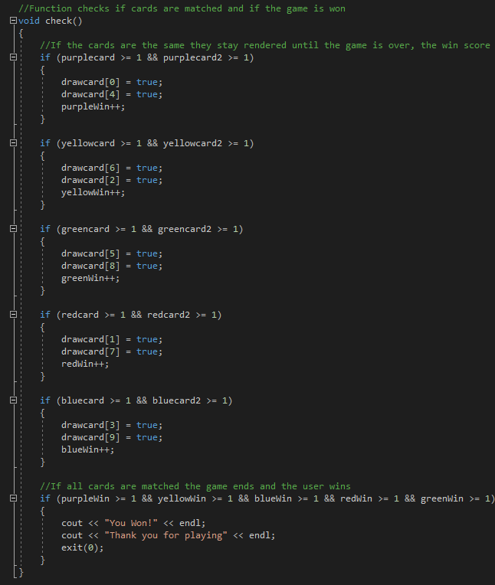
This function checks multiple things. It provides most of the core functionality to the game mechanics. It checks if two of the same cards have been selected. Each card has its own unique variable so it’s easier to check them against each other. If they’re matched they stay rendered until the game is over. When all five pairs are matched the game ends.

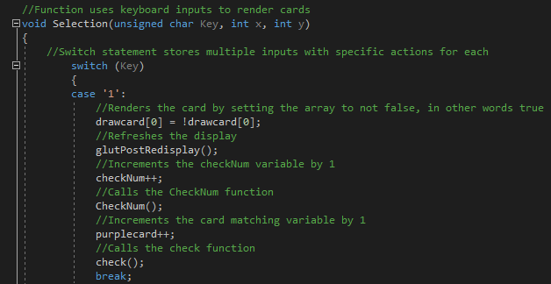
This function uses key inputs to check specific things. Ultimately, it renders the card. However, there are thing happening in the background. Several check occur to make sure the game progresses as it should. The function we mentioned earlier is use here.
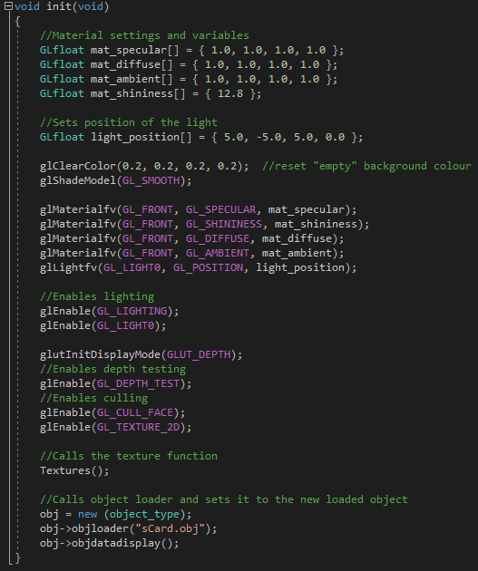
This function is used to initialise many things for our programme. We have material values like diffuse, ambient light, and shininess. We set the position of out lighting in this function along with enabling it to work. Depth testing and culling are enabled here. The texture function is called here as well as the object loader, which uses the file name to load the object specified.
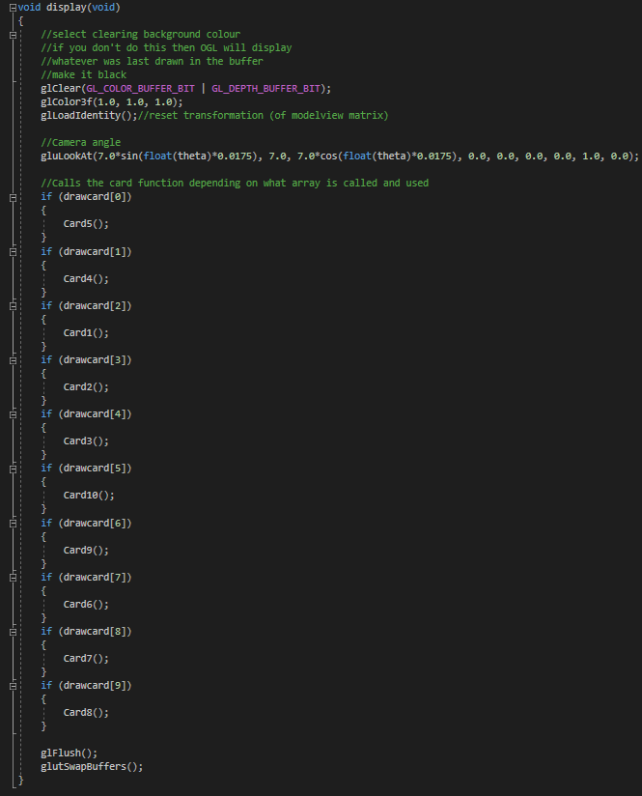

Next is our display function. We use this to define our camera and its angle. We also have several if statements that call different card functions. These card function render the cards among other things.
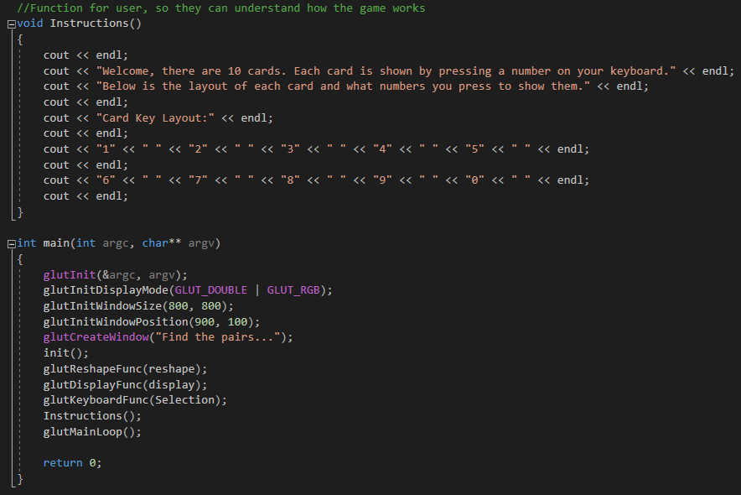
Lastly, we have our instruction function and our main function. The instruction function simply provides the user with information on how to use the game. The main function where we call all our functions so that they are running when we debug the programme. The author would like to state that not all code shown is his own, code used in this project will be referenced below in the bibliography.
1.1 User Guide
The user will enter debugging mode and will be greeted with two screens. One screen is the console which contains information about the game and how to play it. The other is the display window where the game itself is played. The user will press the number keys on their keyboard (numbers 0 – 9). When a number is pressed a card will show. If two cards are shown and the user tries to reveal a third, they will disappear. When a pair is found they will stay displayed for the whole game. The game is won when the user has matched all ten cards.
1.2 Testing
Test 1
Description: In this first test we will test if the game finishes when all cards are matched.
Expected outcome: The game will finish when all cards are matched.
Actual Outcome: The game finished when all cards were matched.
Result: Pass
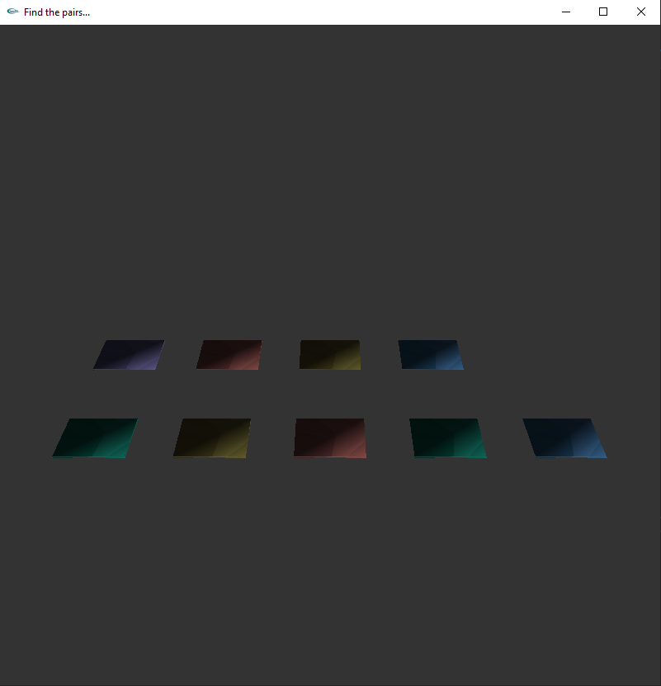
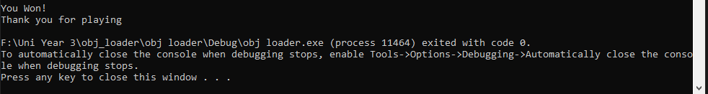

Test 2
Description: In this second test we will see if the more than 2 cards can be shown at the same time. In matching games showing more than two cards is considered rule breaking, usually.
Expected outcome: Only two cards will show at any given time.
Actual Outcome: Only two cards showed at any given time.
Result: Pass
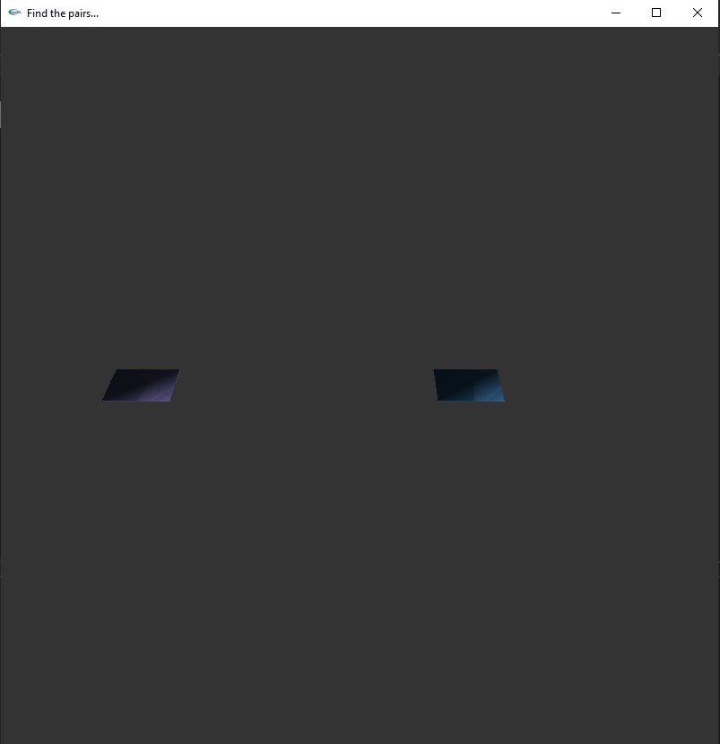

Test 3
Description: In the third and final test we will see if matched cards stay shown until the game is over.
Expected outcome: The matched cards will stay shown until the game is over.
Actual Outcome: The matched cards stayed shown until the game was over.
Result: Pass

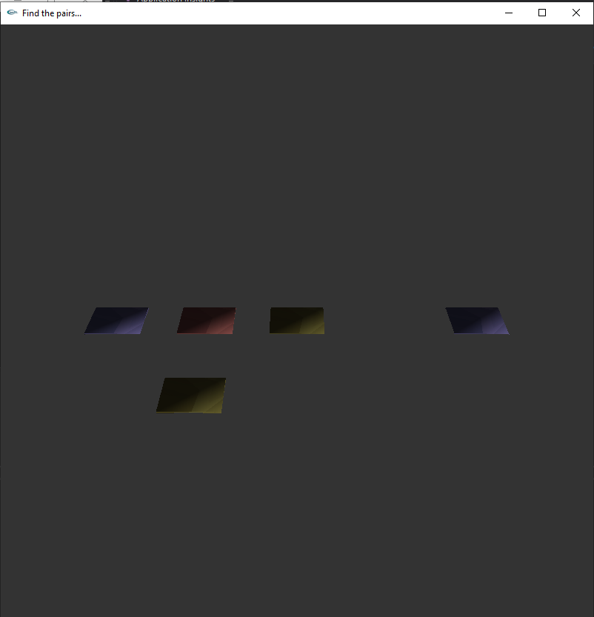
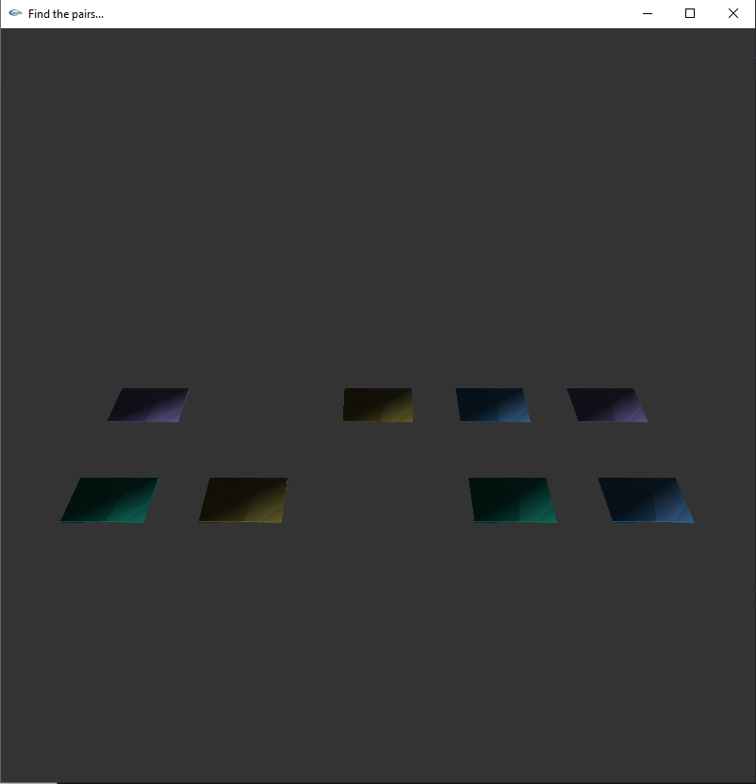

1.3 Bibliography
[1] Bitmap Loader Code: UWTSD Moodle 2020/21: Graphics and Games Programming [Online]. Available: https://moodle.uwtsd.ac.uk/. [Accessed: 08-Jan-2021].
[2] Object Loader Code: UWTSD Moodle 2020/21: Games Architecture and Mechanics [Online]. Available: https://moodle.uwtsd.ac.uk/. [Accessed: 11-Jan-2021].
[3] Object Loader Header Code: UWTSD Moodle 2020/21: Games Architecture and Mechanics [Online]. Available: https://moodle.uwtsd.ac.uk/. [Accessed: 12-Jan-2021].
1.4 Appendix
OBJLoader.h
#pragma once
#ifndef OBJLOAD
#define OBJLOAD
/*****************************************************************************************
*Loads obj file - limited to vertices, faces, normals, texture maps
*loads to object structure as defined in .h file
******************************************************************************************/

#define MAX_VERTICES 8000 // Max number of vertices (for each object)
#define MAX_POLYGONS 8000 // Max number of polygons (for each object)
#define MAX_NORMALS 8000 // Max number of polygons (for each object)

// Our vertex type
typedef struct {
float x, y, z;
}vertex_type;

// Our normal type
typedef struct {
float i, j, k;
}normcoord_type;

// The polygon (triangle), 3 numbers that aim 3 vertices
typedef struct {
int v[3], t[3], n[3];
}polygon_type;

// The mapcoord type, 2 texture coordinates for each vertex
typedef struct {
float u, v;
}mapcoord_type;

// The object type
class object_type {
public:
int id_texture;
object_type() {}
~object_type() {}
int objloader(char *p_filename);
int objdatadisplay();
void render();
private:
char name[20];
int vertices_qty;
int polygons_qty;
int mapcoord_qty;
int normcoord_qty;

vertex_type vertex[MAX_VERTICES];
mapcoord_type mapcoord[MAX_VERTICES];
normcoord_type normcoord[MAX_NORMALS];
polygon_type polygon[MAX_POLYGONS];

};
#endif
BitmapLoader.cpp
#include <stdlib.h>
#include "glut.h"
#include <math.h>
#include <iostream>
#include <stdio.h>
#include <windows.h>
#include <io.h>

#define BITMAP_ID 0x4D42
#define _CRT_SECURE_NO_WARNINGS

unsigned char* LoadBitmapFile(const char* filename, BITMAPINFOHEADER* bitmapInfoHeader)
{
FILE* filePtr; // the file pointer
BITMAPFILEHEADER bitmapFileHeader; // bitmap file header
unsigned char* bitmapImage; // bitmap image data
int imageIdx = 0; // image index counter
unsigned char tempRGB; // swap variable

// open filename in "read binary" mode
filePtr = fopen(filename, "rb");
if (filePtr == NULL)
return NULL;

// read the bitmap file header
fread(&bitmapFileHeader, sizeof(BITMAPFILEHEADER), 1, filePtr);

// verify that this is a bitmap by checking for the universal bitmap id
if (bitmapFileHeader.bfType != BITMAP_ID)
{
fclose(filePtr);
return NULL;
}

// read the bitmap information header
fread(bitmapInfoHeader, sizeof(BITMAPINFOHEADER), 1, filePtr);

// move file pointer to beginning of bitmap data
fseek(filePtr, bitmapFileHeader.bfOffBits, SEEK_SET);

// allocate enough memory for the bitmap image data
bitmapImage = (unsigned char*)malloc(bitmapInfoHeader->biSizeImage);

// verify memory allocation
if (!bitmapImage)
{
free(bitmapImage);
fclose(filePtr);
return NULL;
}

// read in the bitmap image data
fread(bitmapImage, 1, bitmapInfoHeader->biSizeImage, filePtr);

// make sure bitmap image data was read
if (bitmapImage == NULL)
{
fclose(filePtr);
return NULL;
}

// swap the R and B values to get RGB since the bitmap color format is in BGR
for (imageIdx = 0; imageIdx < bitmapInfoHeader->biSizeImage; imageIdx += 3)
{
tempRGB = bitmapImage[imageIdx];
bitmapImage[imageIdx] = bitmapImage[imageIdx + 2];
bitmapImage[imageIdx + 2] = tempRGB;
}

// close the file and return the bitmap image data
fclose(filePtr);
return bitmapImage;
}

int WriteBitmapFile(const char* filename, int width, int height, unsigned char* imageData)
{
FILE* filePtr; // file pointer
BITMAPFILEHEADER bitmapFileHeader; // bitmap file header
BITMAPINFOHEADER bitmapInfoHeader; // bitmap info header
int imageIdx; // used for swapping RGB->BGR
unsigned char tempRGB; // used for swapping

// open file for writing binary mode
filePtr = fopen(filename, "wb");
if (!filePtr)
return 0;

// define the bitmap file header
bitmapFileHeader.bfSize = sizeof(BITMAPFILEHEADER);
bitmapFileHeader.bfType = 0x4D42;
bitmapFileHeader.bfReserved1 = 0;
bitmapFileHeader.bfReserved2 = 0;
bitmapFileHeader.bfOffBits = sizeof(BITMAPFILEHEADER) + sizeof(BITMAPINFOHEADER);

// define the bitmap information header
bitmapInfoHeader.biSize = sizeof(BITMAPINFOHEADER);
bitmapInfoHeader.biPlanes = 1;
bitmapInfoHeader.biBitCount = 24; // 24-bit
bitmapInfoHeader.biCompression = BI_RGB; // no compression
bitmapInfoHeader.biSizeImage = width * abs(height) * 3; // width * height * (RGB bytes)
bitmapInfoHeader.biXPelsPerMeter = 0;
bitmapInfoHeader.biYPelsPerMeter = 0;
bitmapInfoHeader.biClrUsed = 0;
bitmapInfoHeader.biClrImportant = 0;
bitmapInfoHeader.biWidth = width; // bitmap width
bitmapInfoHeader.biHeight = height; // bitmap height

// switch the image data from RGB to BGR
for (imageIdx = 0; imageIdx < bitmapInfoHeader.biSizeImage; imageIdx += 3)
{
tempRGB = imageData[imageIdx];
imageData[imageIdx] = imageData[imageIdx + 2];
imageData[imageIdx + 2] = tempRGB;
}

// write the bitmap file header
fwrite(&bitmapFileHeader, 1, sizeof(BITMAPFILEHEADER), filePtr);

// write the bitmap info header
fwrite(&bitmapInfoHeader, 1, sizeof(BITMAPINFOHEADER), filePtr);

// write the image data
fwrite(imageData, 1, bitmapInfoHeader.biSizeImage, filePtr);

// close our file
fclose(filePtr);

return 1;
}
Main.cpp
#define BITMAP_ID 0x4D42
#define _CRT_SECURE_NO_WARNINGS

#include <stdlib.h>
#include "glut.h"
#include "objloader.h"
#include <math.h>
#include <iostream>
#include <stdio.h>
#include <windows.h>
#include <io.h>

using namespace std;

//Bit map reader variables
BITMAPINFOHEADER bitmapInfoHeader;
unsigned char* bitmapData;
//Array for storing textures
static GLuint texture[5];

unsigned char* LoadBitmapFile(const char* filename, BITMAPINFOHEADER* bitmapInfoHeader);
int WriteBitmapFile(const char* filename, int width, int height, unsigned char* imageData);
void init();
void display();
static int theta = 0;

int winview[2]; //contains window view width [0] and height [1]
object_type *obj; //Initailising object class

//Funciton for activating and binding textures
void Textures()
{
//Loads the bit map file specified by user
bitmapData = LoadBitmapFile("cubism.bmp", &bitmapInfoHeader);

//Generate the textures and bind a specific one
glGenTextures(5, texture);
glBindTexture(GL_TEXTURE_2D, texture[0]);

glTexParameteri(GL_TEXTURE_2D, GL_TEXTURE_MAG_FILTER, GL_NEAREST);
glTexParameteri(GL_TEXTURE_2D, GL_TEXTURE_MIN_FILTER, GL_NEAREST);

// generate the texture image
glTexImage2D(GL_TEXTURE_2D, 0, GL_RGB, bitmapInfoHeader.biWidth,
bitmapInfoHeader.biHeight, 0, GL_RGB, GL_UNSIGNED_BYTE, bitmapData);

//Loads the bit map file specified by user
bitmapData = LoadBitmapFile("cubismY.bmp", &bitmapInfoHeader);

//Generate the textures and bind a specific one
glBindTexture(GL_TEXTURE_2D, texture[1]);

glTexParameteri(GL_TEXTURE_2D, GL_TEXTURE_MAG_FILTER, GL_NEAREST);
glTexParameteri(GL_TEXTURE_2D, GL_TEXTURE_MIN_FILTER, GL_NEAREST);

// generate the texture image
glTexImage2D(GL_TEXTURE_2D, 0, GL_RGB, bitmapInfoHeader.biWidth,
bitmapInfoHeader.biHeight, 0, GL_RGB, GL_UNSIGNED_BYTE, bitmapData);

//Loads the bit map file specified by user
bitmapData = LoadBitmapFile("cubismB.bmp", &bitmapInfoHeader);

//Generate the textures and bind a specific one
glBindTexture(GL_TEXTURE_2D, texture[2]);

glTexParameteri(GL_TEXTURE_2D, GL_TEXTURE_MAG_FILTER, GL_NEAREST);
glTexParameteri(GL_TEXTURE_2D, GL_TEXTURE_MIN_FILTER, GL_NEAREST);

// generate the texture image
glTexImage2D(GL_TEXTURE_2D, 0, GL_RGB, bitmapInfoHeader.biWidth,
bitmapInfoHeader.biHeight, 0, GL_RGB, GL_UNSIGNED_BYTE, bitmapData);

//Loads the bit map file specified by user
bitmapData = LoadBitmapFile("cubismR.bmp", &bitmapInfoHeader);

//Generate the textures and bind a specific one
glBindTexture(GL_TEXTURE_2D, texture[3]);

glTexParameteri(GL_TEXTURE_2D, GL_TEXTURE_MAG_FILTER, GL_NEAREST);
glTexParameteri(GL_TEXTURE_2D, GL_TEXTURE_MIN_FILTER, GL_NEAREST);

// generate the texture image
glTexImage2D(GL_TEXTURE_2D, 0, GL_RGB, bitmapInfoHeader.biWidth,
bitmapInfoHeader.biHeight, 0, GL_RGB, GL_UNSIGNED_BYTE, bitmapData);

//Loads the bit map file specified by user
bitmapData = LoadBitmapFile("cubismP.bmp", &bitmapInfoHeader);

//Generate the textures and bind a specific one
glBindTexture(GL_TEXTURE_2D, texture[4]);

glTexParameteri(GL_TEXTURE_2D, GL_TEXTURE_MAG_FILTER, GL_NEAREST);
glTexParameteri(GL_TEXTURE_2D, GL_TEXTURE_MIN_FILTER, GL_NEAREST);

// generate the texture image
glTexImage2D(GL_TEXTURE_2D, 0, GL_RGB, bitmapInfoHeader.biWidth,
bitmapInfoHeader.biHeight, 0, GL_RGB, GL_UNSIGNED_BYTE, bitmapData);
}

//Function uses a matrix to place the card and store its co-ords, also binds a specific texture and renders the card
void Card1()
{
glPopMatrix();
glPushMatrix();
glTranslatef(0.0, 0.0, 0.0);
glBindTexture(GL_TEXTURE_2D, texture[1]);
obj->render();
}
//Function uses a matrix to place the card and store its co-ords, also binds a specific texture and renders the card
void Card2()
{
glPopMatrix();
glPushMatrix();
glTranslatef(2.0, 0.0, 0.0);
glBindTexture(GL_TEXTURE_2D, texture[2]);
obj->render();
}
//Function uses a matrix to place the card and store its co-ords, also binds a specific texture and renders the card
void Card3()
{
glPopMatrix();
glPushMatrix();
glTranslatef(4.0, 0.0, 0.0);
glBindTexture(GL_TEXTURE_2D, texture[4]);
obj->render();
}
//Function uses a matrix to place the card and store its co-ords, also binds a specific texture and renders the card
void Card4()
{
glPopMatrix();
glPushMatrix();
glTranslatef(-2.0, 0.0, 0.0);
glBindTexture(GL_TEXTURE_2D, texture[3]);
obj->render();

}
//Function uses a matrix to place the card and store its co-ords, also binds a specific texture and renders the card
void Card5()
{
glPopMatrix();
glPushMatrix();
glTranslatef(-4.0, 0.0, 0.0);
glBindTexture(GL_TEXTURE_2D, texture[4]);
obj->render();
}
//Function uses a matrix to place the card and store its co-ords, also binds a specific texture and renders the card
void Card6()
{
glPopMatrix();
glPushMatrix();
glTranslatef(0.0, 0.0, 2.0);
glBindTexture(GL_TEXTURE_2D, texture[3]);
obj->render();
}
//Function uses a matrix to place the card and store its co-ords, also binds a specific texture and renders the card
void Card7()
{
glPopMatrix();
glPushMatrix();
glTranslatef(2.0, 0.0, 2.0);
glBindTexture(GL_TEXTURE_2D, texture[0]);
obj->render();
}
//Function uses a matrix to place the card and store its co-ords, also binds a specific texture and renders the card
void Card8()
{
glPopMatrix();
glPushMatrix();
glTranslatef(4.0, 0.0, 2.0);
glBindTexture(GL_TEXTURE_2D, texture[2]);
obj->render();
}
//Function uses a matrix to place the card and store its co-ords, also binds a specific texture and renders the card
void Card9()
{
glPopMatrix();
glPushMatrix();
glTranslatef(-2.0, 0.0, 2.0);
glBindTexture(GL_TEXTURE_2D, texture[1]);
obj->render();
}
//Function uses a matrix to place the card and store its co-ords, also binds a specific texture and renders the card
void Card10()
{
glPopMatrix();
glPushMatrix();
glTranslatef(-4.0, 0.0, 2.0);
glBindTexture(GL_TEXTURE_2D, texture[0]);
obj->render();
glPopMatrix();
}

//Bool variable for rendering cards, set to false so they dont render
bool drawcard[10] = { false,false,false,false,false,false,false,false,false,false };

//Variables used for matching the cards
int purplecard = 0;
int yellowcard = 0;
int greencard = 0;
int redcard = 0;
int bluecard = 0;
int purplecard2 = 0;
int yellowcard2 = 0;
int greencard2 = 0;
int redcard2 = 0;
int bluecard2 = 0;

//Variables for decideing whether the user has won the game or not
int purpleWin = 0;
int yellowWin = 0;
int greenWin = 0;
int blueWin = 0;
int redWin = 0;

//Function checks if cards are matched and if the game is won
void check()
{
//If the cards are the same they stay rendered until the game is over, the win score also goes up by 1 for each pair
if (purplecard >= 1 && purplecard2 >= 1)
{
drawcard[0] = true;
drawcard[4] = true;
purpleWin++;
}

if (yellowcard >= 1 && yellowcard2 >= 1)
{
drawcard[6] = true;
drawcard[2] = true;
yellowWin++;
}

if (greencard >= 1 && greencard2 >= 1)
{
drawcard[5] = true;
drawcard[8] = true;
greenWin++;
}

if (redcard >= 1 && redcard2 >= 1)
{
drawcard[1] = true;
drawcard[7] = true;
redWin++;
}

if (bluecard >= 1 && bluecard2 >= 1)
{
drawcard[3] = true;
drawcard[9] = true;
blueWin++;
}

//If all cards are matched the game ends and the user wins
if (purpleWin >= 1 && yellowWin >= 1 && blueWin >= 1 && redWin >= 1 && greenWin >= 1)
{
cout << "You Won!" << endl;
cout << "Thank you for playing" << endl;
exit(0);
}
}

//Variable for checking how many cards are rendered
int checkNum = 0;

//Function for checking how many cards are rendered and un-rendering them if its more than 2
void CheckNum()
{
//If more than 2 cards are shown, does not apply to pairs
if (checkNum == 3)
{
drawcard[0] = false;
drawcard[1] = false;
drawcard[2] = false;
drawcard[3] = false;
drawcard[4] = false;
drawcard[5] = false;
drawcard[6] = false;
drawcard[7] = false;
drawcard[8] = false;
drawcard[9] = false;
drawcard[0] = false;
//Resets the variable back to 0 so 2 more cards can be rendered
checkNum = 0;
}
}

//Function uses keyboard inputs to render cards
void Selection(unsigned char Key, int x, int y)
{
//Switch statement stores multiple inputs with specific actions for each
switch (Key)
{
case '1':
//Renders the card by setting the array to not false, in other words true
drawcard[0] = !drawcard[0];
//Refreshes the display
glutPostRedisplay();
//Increments the checkNum variable by 1
checkNum++;
//Calls the CheckNum function
CheckNum();
//Increments the card matching variable by 1
purplecard++;
//Calls the check function
check();
break;
case '2':
drawcard[1] = !drawcard[1];
glutPostRedisplay();
checkNum++;
CheckNum();
redcard++;
check();
break;
case '3':
drawcard[2] = !drawcard[2];
glutPostRedisplay();
checkNum++;
CheckNum();
yellowcard++;
check();
break;
case '4':
drawcard[3] = !drawcard[3];
glutPostRedisplay();
checkNum++;
CheckNum();
bluecard++;
check();
break;
case '5':
drawcard[4] = !drawcard[4];
glutPostRedisplay();
checkNum++;
CheckNum();
purplecard2++;
check();
break;
case '6':
drawcard[5] = !drawcard[5];
glutPostRedisplay();
checkNum++;
CheckNum();
greencard++;
check();
break;
case '7':
drawcard[6] = !drawcard[6];
glutPostRedisplay();
checkNum++;
CheckNum();
yellowcard2++;
check();
break;
case '8':
drawcard[7] = !drawcard[7];
glutPostRedisplay();
checkNum++;
CheckNum();
redcard2++;
check();
break;
case '9':
drawcard[8] = !drawcard[8];
glutPostRedisplay();
checkNum++;
CheckNum();
greencard2++;
check();
break;
case '0':
drawcard[9] = !drawcard[9];
glutPostRedisplay();
checkNum++;
CheckNum();
bluecard2++;
check();
break;
case 'e':
exit(0);
break;
};
}

void init(void)
{
//Material settings and variables
GLfloat mat_specular[] = { 1.0, 1.0, 1.0, 1.0 };
GLfloat mat_diffuse[] = { 1.0, 1.0, 1.0, 1.0 };
GLfloat mat_ambient[] = { 1.0, 1.0, 1.0, 1.0 };
GLfloat mat_shininess[] = { 12.8 };

//Sets position of the light
GLfloat light_position[] = { 5.0, -5.0, 5.0, 0.0 };

glClearColor(0.2, 0.2, 0.2, 0.2); //reset "empty" background colour
glShadeModel(GL_SMOOTH);

glMaterialfv(GL_FRONT, GL_SPECULAR, mat_specular);
glMaterialfv(GL_FRONT, GL_SHININESS, mat_shininess);
glMaterialfv(GL_FRONT, GL_DIFFUSE, mat_diffuse);
glMaterialfv(GL_FRONT, GL_AMBIENT, mat_ambient);
glLightfv(GL_LIGHT0, GL_POSITION, light_position);

//Enables lighting
glEnable(GL_LIGHTING);
glEnable(GL_LIGHT0);

glutInitDisplayMode(GLUT_DEPTH);
//Enables depth testing
glEnable(GL_DEPTH_TEST);
//Enables culling
glEnable(GL_CULL_FACE);
glEnable(GL_TEXTURE_2D);

//Calls the texture function
Textures();

//Calls object loader and sets it to the new loaded object
obj = new (object_type);
obj->objloader("sCard.obj");
obj->objdatadisplay();
}

void display(void)
{
//select clearing background colour
//if you don't do this then OGL will display
//whatever was last drawn in the buffer
//make it black
glClear(GL_COLOR_BUFFER_BIT | GL_DEPTH_BUFFER_BIT);
glColor3f(1.0, 1.0, 1.0);
glLoadIdentity();//reset transformation (of modelview matrix)

//Camera angle
gluLookAt(7.0*sin(float(theta)*0.0175), 7.0, 7.0*cos(float(theta)*0.0175), 0.0, 0.0, 0.0, 0.0, 1.0, 0.0);

//Calls the card function depending on what array is called and used
if (drawcard[0])
{
Card5();
}
if (drawcard[1])
{
Card4();
}
if (drawcard[2])
{
Card1();
}
if (drawcard[3])
{
Card2();
}
if (drawcard[4])
{
Card3();
}
if (drawcard[5])
{
Card10();
}
if (drawcard[6])
{
Card9();
}
if (drawcard[7])
{
Card6();
}
if (drawcard[8])
{
Card7();
}
if (drawcard[9])
{
Card8();
}

glFlush();
glutSwapBuffers();
}

void reshape(int w, int h)
{
glViewport(0, 0, w, h);
glMatrixMode(GL_PROJECTION);
glLoadIdentity();
glFrustum(-1.0, 1.0, -1.0, 1.0, 1.5, 20.0);

glMatrixMode(GL_MODELVIEW);
winview[0] = w; winview[1] = h;
}

//Function for user, so they can understand how the game works
void Instructions()
{
cout << endl;
cout << "Welcome, there are 10 cards. Each card is shown by pressing a number on your keyboard." << endl;
cout << "Below is the layout of each card and what numbers you press to show them." << endl;
cout << endl;
cout << "Card Key Layout:" << endl;
cout << endl;
cout << "1" << " " << "2" << " " << "3" << " " << "4" << " " << "5" << " " << endl;
cout << endl;
cout << "6" << " " << "7" << " " << "8" << " " << "9" << " " << "0" << " " << endl;
cout << endl;
}

int main(int argc, char** argv)
{
glutInit(&argc, argv);
glutInitDisplayMode(GLUT_DOUBLE | GLUT_RGB);
glutInitWindowSize(800, 800);
glutInitWindowPosition(900, 100);
glutCreateWindow("Find the pairs...");
init();
glutReshapeFunc(reshape);
glutDisplayFunc(display);
glutKeyboardFunc(Selection);
Instructions();
glutMainLoop();

return 0;
}

OBJLoader.cpp
#include <stdio.h>
#include <iostream>
#include <io.h>
#include <stdlib.h>
#include "glut.h"
#include "objloader.h"

void object_type::render()
{
glBegin(GL_QUADS);
for (int j = 0; j < polygons_qty; j++)
{
//----------------- FIRST VERTEX -----------------
//Normal coordinates of the first vertex
glNormal3f(normcoord[polygon[j].n[0] - 1].i,
normcoord[polygon[j].n[0] - 1].j,
normcoord[polygon[j].n[0] - 1].k);
// Texture coordinates of the first vertex
glTexCoord2f(mapcoord[polygon[j].t[0] - 1].u,
mapcoord[polygon[j].t[0] - 1].v);
// Coordinates of the first vertex
glVertex3f(vertex[polygon[j].v[0] - 1].x,
vertex[polygon[j].v[0] - 1].y,
vertex[polygon[j].v[0] - 1].z);

//----------------- SECOND VERTEX -----------------
//Normal coordinates of the first vertex
glNormal3f(normcoord[polygon[j].n[1] - 1].i,
normcoord[polygon[j].n[1] - 1].j,
normcoord[polygon[j].n[1] - 1].k);
// Texture coordinates of the first vertex
glTexCoord2f(mapcoord[polygon[j].t[1] - 1].u,
mapcoord[polygon[j].t[1] - 1].v);
// Coordinates of the first vertex
glVertex3f(vertex[polygon[j].v[1] - 1].x,
vertex[polygon[j].v[1] - 1].y,
vertex[polygon[j].v[1] - 1].z);

//----------------- THIRD VERTEX -----------------
//Normal coordinates of the first vertex
glNormal3f(normcoord[polygon[j].n[2] - 1].i,
normcoord[polygon[j].n[2] - 1].j,
normcoord[polygon[j].n[2] - 1].k);
// Texture coordinates of the first vertex
glTexCoord2f(mapcoord[polygon[j].t[2] - 1].u,
mapcoord[polygon[j].t[2] - 1].v);
// Coordinates of the first vertex
glVertex3f(vertex[polygon[j].v[2] - 1].x,
vertex[polygon[j].v[2] - 1].y,
vertex[polygon[j].v[2] - 1].z);
}
glEnd();
}

int object_type::objdatadisplay()
{
int i;
printf("VERTICES: %d\n", vertices_qty);
for (i = 0; i < vertices_qty; i++)
{
printf("%f %f %f\n", vertex[i].x, vertex[i].y, vertex[i].z);
}
printf("NORMALS: %d\n", normcoord_qty);
for (i = 0; i < normcoord_qty; i++)
{
printf("%f %f %f\n", normcoord[i].i, normcoord[i].j, normcoord[i].k);
}
printf("MAP COORDS: %d\n", mapcoord_qty);
for (i = 0; i < mapcoord_qty; i++)
{
printf("%f %f\n", mapcoord[i].u, mapcoord[i].v);
}
printf("POLYGONS: %d\n", polygons_qty);
for (i = 0; i < polygons_qty; i++)
{
for (int j = 0; j < 3; j++)
{
printf("%d::%d/%d/%d\n", i, polygon[i].v[j], polygon[i].t[j], polygon[i].n[j]);
}
}

return 1;
}

int object_type::objloader(char *p_filename)
{
int ivertex = 0;
int inormal = 0;
int ipolygon = 0;
int imap = 0;
char string[256];
FILE *l_file; //File pointer

char l_char; //Char variable
// int vertex;
unsigned short l_face_flags; //Flag that stores some face information

if ((l_file = fopen(p_filename, "rt")) == NULL) return 0; //Open the file

while (!feof(l_file)) //Loop to scan the whole file
{

fscanf(l_file, "%c", &l_char);
if (l_char == '\n')//read char if'/n' -skip to next and read
fscanf(l_file, "%c", &l_char);
switch (l_char) //parse
{
default: fgets(string, 256, l_file);
break;
case 'v': //a vertex or a normal or a text co-ord
fscanf(l_file, "%c", &l_char);
switch (l_char)
{
case ' ': //a vertex -expect and so read 3 floats next
fscanf(l_file, "%f %f %f", &vertex[ivertex].x, &vertex[ivertex].y, &vertex[ivertex].z);

ivertex++;
break;
case 'n': //a normal -expect and so read 3 floats next
fscanf(l_file, "%f %f %f", &normcoord[inormal].i, &normcoord[inormal].j, &normcoord[inormal].k);
inormal++;
break;
case 't': //a texture map coord-expect and so read 2 floats next
fscanf(l_file, "%f %f", &mapcoord[imap].u, &mapcoord[imap].v);
imap++;
break;
} //end switch
break;
case 'f': //a face read next assume format is -> f 1/1/1 2/2/2 3/3/3
for (int i = 0; i < 3; i++) //for each vertex of polygon (triangle)
{
fscanf(l_file, "%c", &l_char); //read space char - ignore this
fscanf(l_file, "%d", &polygon[ipolygon].v[i]); //read vertex.
fscanf(l_file, "%c", &l_char); //read space char - ignore this
fscanf(l_file, "%d", &polygon[ipolygon].t[i]); //read text coord.
fscanf(l_file, "%c", &l_char); //read space char - ignore this
fscanf(l_file, "%d", &polygon[ipolygon].n[i]); //read normal.

}
ipolygon++;
break;

}
}
fclose(l_file);
vertices_qty = ivertex;
polygons_qty = ipolygon;
mapcoord_qty = imap;
normcoord_qty = inormal;

return 0;
}

