Joshua J Port 2114468

BEng Embedded Electronic Systems

University of Wales Trinity St David’s

Electronics 1

(ACDB5002)

Table of Contents
Task and Design 4
Background Research 4
Pedestrian Crossing regulations 4
Traffic Light Regulations 4
Information and Analysis on Other Similar Products 4
Circuit Design Steps and Software Used 7
A flowchart/pseudocode showing the system operation. 9
A Parts List and Estimate of Costing 11
Details of Testing Simulated Outputs and Results. 11
Conclusion, Recommendations on Future Work etc. Additional Files Such 12
References 13

Figure 1 - Real Life Pedestrian Crossing [4] 5
Figure 2 - T Junction Top 6
Figure 4 - T Junction Right 6
Figure 3 - T Junction Left 6
Figure 5 - T Junction Bottom 6
Figure 6 - Components Used 8
Figure 7 - PIC18F452 Chip Used 8
Figure 8 - Traffic Light and Button Activation Sequence 9
Figure 9 - Traffic Light Combined Sequence 10
Figure 10 - Virtual Terminal Pot Testing 11

Task and Design

The task that was set out for this assignment was to make a real-life representation of a traffic light controlled crossroads in a built-up urban environment with high densities of pedestrians. To add to this, a pedestrian crossing light, a crossing countdown timer and ultrasonic sensors or variable resistor values to determine car distances to activate the light changes would be implemented into the design. The four streets on the crossroads would be traffic light controlled set out in pairs and alternate between left and right or up and down. To set the pedestrian timers to work, I would need to use sets of timing delays in co-ordnance with the density delay aspect of the sensors. The design I have made using proteus 8 is an accurate representation of a crossroads using real life components.

Background Research

Pedestrian Crossing regulations
Currently in the UK there are regulations for the minimum time allocated for pedestrians to cross the road. According to the legislations set out by the government in West Sussex the minimum time for the light to be on green on regular traffic lights is 7 seconds [1]. When running the simulation, the delays have been dropped to show the functionality of the design. Around the UK the traffic light guidance of 7 seconds on green is a standard that must be adhered to as a minimum. The maximum for a timer countdown shown on the streets with seven segment displays is set to 15 seconds to allow ample time for any pedestrian needing to cross.

Traffic Light Regulations
There is no hard law set for the maximum or minimum height of a traffic light pole however the average around the UK for these poles are around 18 feet off the ground [2]. The reason why there is no hard law with height restrictions is because on some road there must be lights which hang high for long congested traffic to see. As for the size of the traffic lights, shown below is a diagram of the size of the traffic light box and the recommended guidelines for the height and width.
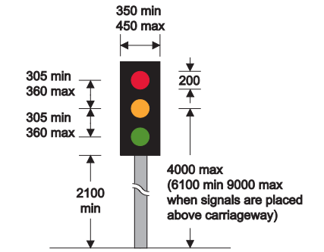 [3]

Information and Analysis on Other Similar Products

The simulation is mainly based off some key components / similar products in real life. The first one is a pedestrian traffic light crossing. Shown below is the in real life design for a pedestrian crossing with two sets of traffic lights. This type of design is less commonly used as there is no pedestrian button and or timer like the one used in this proteus simulation. Although this method of a pedestrian crossing is used in real life it is extremely dangerous. This is due to the pedestrians not having lights of their own. With a crossroads traffic can go down any lane from the other three roads, meaning there would have to be some red or green light controls to stop the traffic hitting the pedestrians. This method of a crossing is near the looks of a pelican or zebra crossing.
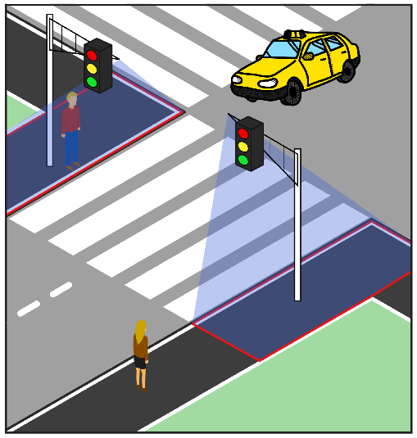
Figure 1 - Real Life Pedestrian Crossing [4]
The second similar product is a T junction. A T junction (instead of using traffic lights generally speaking) uses a main street and a side street with a give way line. The reason why this is a near model is because if we break down a crossroads it can be described as 4 T junctions connected.

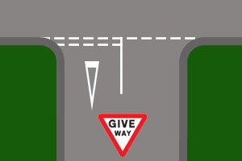

Figure 2 - T Junction Top
Figure 4 - T Junction Right

Figure 3 - T Junction Left
Figure 5 - T Junction Bottom

[5]

As shown in the above 4 figures 2 through 5, the t Junctions can be set out in a way that resembles the crossroads being simulated. Using this model but with traffic lights instead of give way signs, an understanding can be made that the traffic can either go left or right. Factoring this into the design with traffic also moving forward, we can deduce that all the pedestrian lights would need to be red at the point of crossing to eliminate the risk of a pedestrian being hit by an oncoming car.
The Potentiometer values shown in the design are a representation of a sensor working to activate the lights depending on the distances of the cars. A close model to this would be an automatic opening door. The door has a sensor on both sides which uses a density based control to see how far the object (in this case a person) is to the sensor. This then sends a pulse to the door allowing it to automatically open for the person to have a safe passage through.

Circuit Design Steps and Software Used

The software needed to create, run, and test my design included CCS Project wizard for programable integrated chips and Proteus 8 design simulation software. Both pieces of software were vital to the success of the task.
To start the design process, a chip with many I/O ports and analogue ports would be required. The chip would have to be large enough (have the right number of ports) to run all my inputs and outputs needed to make the complete crossroad simulation. From previous work with PIC16 and PIC18 the realisation was that a PIC 18 would have to be used for all the processes to happen all at once as and when needed.
To start off the PIC18F452 chip dataset would have to be checked [6]. This is because just picking a random PIC 18 would not guarantee that there would be enough analogue ports available to run the 4 analogue signals through. I then opened ccs project wizard and brought the code from the set up into my main C file. The start of the project was about getting all the component that would be required for the simulation of the crossroads. These components included,8 green LEDs for the pedestrians, 8 red LEDs for the pedestrian crossings, 8 common cathodes dual seven segment displays, 8 Single throw single pole switches connected to 8 resistors acting as pull down resistors pulling the voltage low, 4 potentiometers to act as the ultrasonic sensors and 4 sets of red, orange and green traffic light sets. The components are shown down below in figure 2.

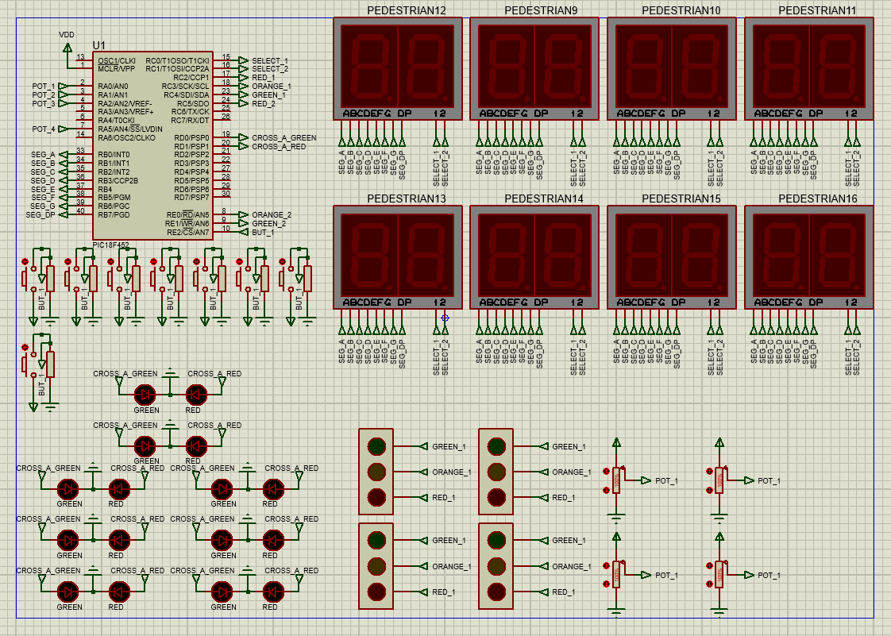
Figure 6 - Components Used
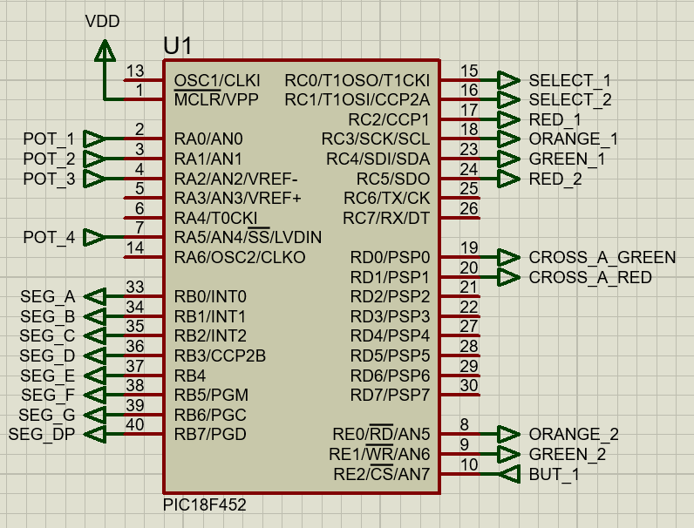
Figure 7 - PIC18F452 Chip Used
Once all the components had been collected, they needed to be set up so that they would run the specific function designed and then had to be placed in a design format that resembles a fully functioning crossroads. This took a lot of re arranging as trying to get all the components to be in a small enough size to fit into the design was a challenge. Each part of the circuit is designed so there are no wires tracing across the design. To do this I used the input and output components and labelled them as shown in figure 3.

There are two based controls used within this design and simulation. The first of those two controls are time based controlling. Time based controls are used within the traffic light system and the pedestrian crossings. The way that time based controls work is that they are set to a specific time as to when or when not to activate. This is shown by the traffic light signals between red, orange, and green as well as the second set of lights all being changed on set delay timings.
Another example of the time based controls within this design is the pedestrian timers. Although the button is not a time based control the actual timers are. Each timer is set to count down from 15 to 0 and then shut off. This timer is to allow an allocated time for the pedestrians to cross the road safely. It is a time control because it is on a set run time and is not activated or run due to an increase in density of any way.
The second based control used in the simulation is density based controlling. Examples of this in the simulation are the potentiometer values. Density based controls uses the density (in this case the value given) to produce an output signal. The simulation uses this output signal whether it is high or low to tell the chip to change the lights from either green to red or vis versa. The value of the pot being high determines the cars are further away from the lights and the smaller the number the closer they are. The smallest values will take priority.

A flowchart/pseudocode showing the system operation.

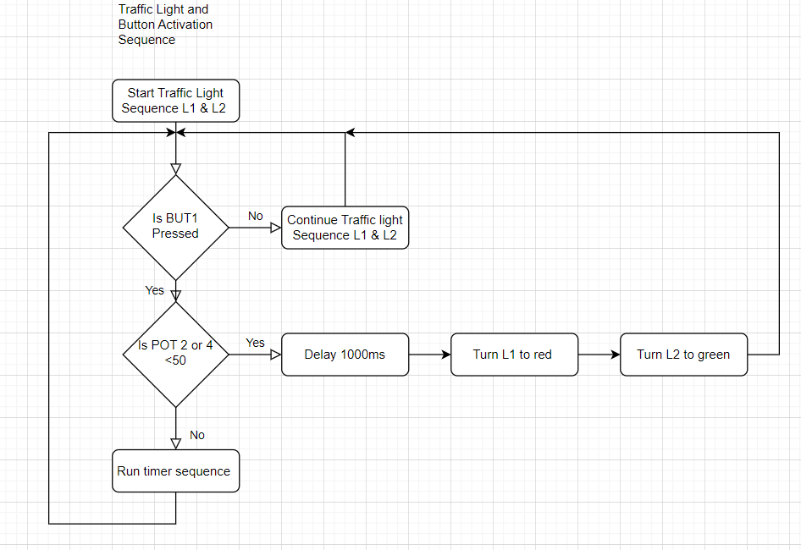
Figure 8 - Traffic Light and Button Activation Sequence
Figure 8 displayed above shows the flowchart for the activation of the pedestrian crossing button to stop the flow of traffic. It starts off by setting the two traffic light systems to run in an order of turning 1 to red whilst 2 is green, then changing them to have 1 display green and 2 to display red. It then goes into a question which is controlled by the value of the integer “change”. Change is originally set to 0. When the button (BUT1) is pressed the change value then changes to the value of 1. When this happens, it lets the main void program check if the pot value is equal to 50 or less on pot 2 or 4. If either of the pot values is less than or equal to 50 then the traffic lights will turn to allow that traffic through after the completion of the previous sequence. There is another sequence to reciprocate this with pot 1 and 3. If the button is pressed and the pot is more than 50 the timer will start for the Pedestrians. This timer sequence is a subroutine interrupt for the main code and will activate when the traffic has both turned to red.

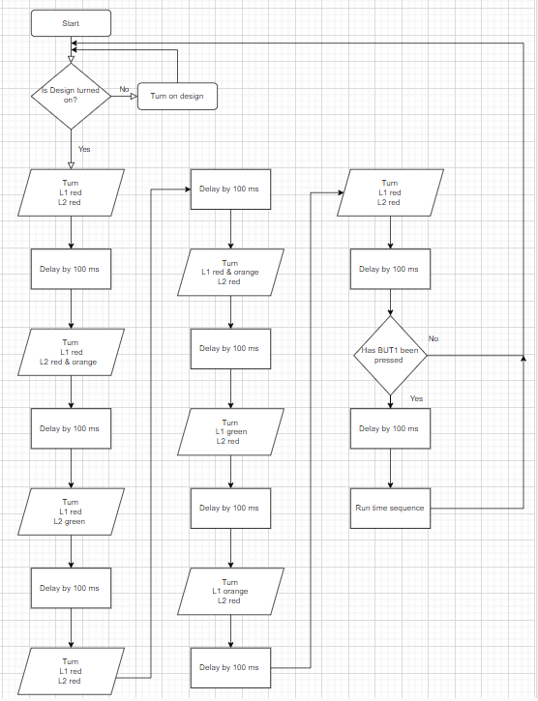
Figure 9 - Traffic Light Combined Sequence
The start of the flow chart checks if the devices are turned on / the simulation is running as without them being turned on there would be no way of running the program. If the device is turned on, then it runs through a normal traffic light system as stated earlier in the background information. This system runs red through green then back to red in a constant pattern switching from set 1 to set 2 and back again.

A Parts List and Estimate of Costing

Component | Price (GBP) | Units | Site
Pic18F452 | £10.63 | 1 | [7]
Dual Seven Segment Display | £3.60 | 8 | [8]
Red LED | £0.29 | 12 | [9]
Orange/Yellow LED | £0.29 | 12 | [10]
Green LED | £0.29 | 12 | [11]
SPST Switch | £0.99 | 8 | [12]
Resistor Set | £5.99 | 1 | [13]
Variable Resistor | £3.99 | 4 | [14]

Taking into account the unit (volume) of components needed the total price of the simulated design would be £79.74.

Details of Testing Simulated Outputs and Results.

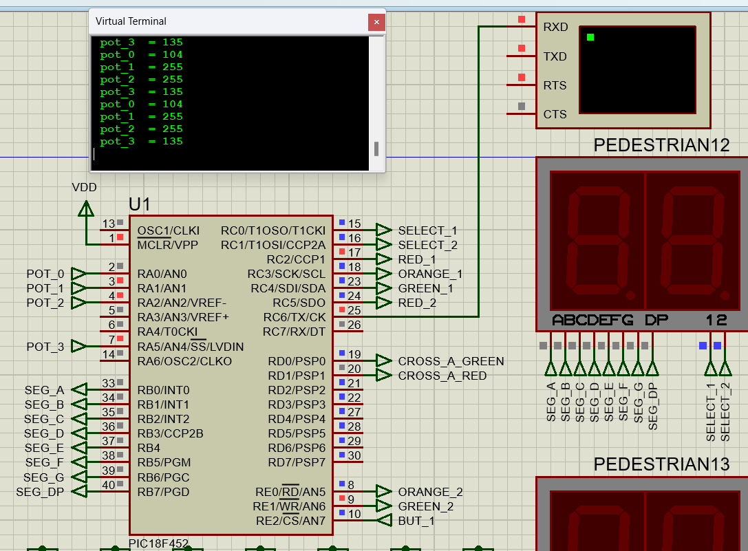
Figure 10 - Virtual Terminal Pot Testing
There were 3 key tests that must be carried put on the design to ensure it ran smoothly an effectively. One was the timing delay and countdown setup, two was the traffic light order sequence and the third one was setting the potentiometers.
Countdown timers: To be able to test all the B port connections, it was useful to start on a single seven segment display. Once a single seven segment display was wired up to the output pins of port B, the segment test could be started. To do the segment test, all B ports would be put high. If this is successful, all the segments should light up. After placing the values 9 to 0 in an array, the second check could be carried out to see if the clock would countdown from 9 to 0 and then turn off. Once these tests have been conducted, a dual cathode segment display could be put to replace the single displays with only the change of flicking between select 1 and 2 to create the numbers 15 to 0.
The second test of the traffic light sequence is easy. Three LED lights were set out and connected from the chip to ground. The pin then went high to check for the LED lighting up. Once it had lit up then three pins could then be connected to the traffic light box used in the final design.
The last test was the potentiometer test. Once again this was a simple test which involved having a virtual terminal. The pots would be set to different values and then the pin would be set high. The readings would then be displayed on a virtual terminal so show the design was reading the values correctly before integrating it into the model.

Conclusion, Recommendations on Future Work etc. Additional Files Such

Overall, the process of designing, setting up and simulating the crossroad was effective and covered all the aspects set out in the task. Although there were problems with obtaining how the potentiometers worked with the traffic light signals, in the end I decided to go with making them activate when the lowest value was shown. This was a change to the original plan of having them activate when they were lower than the value of 50% being 127 in binary shown in my flowcharts. This ultimately incorporated a sensing device into my simulation which was of effective nature. This simulation could be compatible with in real life crossroad use.
Having the traffic light as set pairs was the best way to increase the performance of the overall task and made the design much more accurate for hardware use. Across the whole of the United Kingdom, crossroad lights do not work in pairs. I believed that having pairs of traffic lights can be more beneficial to allow a constant traffic flow and less queues. However, if I was to reproduce this task, I would set out the traffic lights to all act individually.

References

[1] | B Edmunds, “Traffic Signal Design Standards: Requirements for Design of Permanent Traffic Signal in West Sussex (Issue 9),” West Sussex County Council, 2020.
[2] | M. Cahill, “How tall are traffic lights?,” Jerry, 2022.
[3] | Legislation Government, “The Traffic Signs Regulations and General Directions 2016,” Legislation, 2016.
[4] | A. K. B. B. A. G. Peter Nimac, “Pedestrian Traffic Light Control with Crosswalk FMCW Radar and Group Tracking Algorithm,” MDPI, Switzerland, 23 February 2022.
[5] | R. Jenkins, “T-Junctions Tutorials,” Driving-Test_Success.com.
[6] | ALLDATASHEETS, “PIC18F452 Datasheet (PDF) - Microchip Technology,” ALLDATASHEETS.com.
[7] | Future Electronics, Microchip l PIC18F452-I/PT, Future Electronics, 2023.
[8] | Sparkfun, Dual 7-Segment Display - LED (RGB), SparkFun Electronics.
[9] | Hobby Components, 5mm Red LED, PrestaShop, 2023.
[10] | Hobby Components, 5mm Yellow LED, PrestaShop, 2023.
[11] | Hobby Components, 5mm Green LED, PrestaShop, 2023.
[12] | Hobby Components, Momentary OnOff Push Button Micro Switch (Red), Ecommerce software by PrestaShop, 2023.
[13] | Hobby Components , Pack Of 600 Resistors - 1/4W 1% – 30 Values, Ecommerce software by PrestaShop, 2023.
[14] | Hobby components, Linear Sliding 10K Potentiometer, PrestaShop, 2023.

