

Cover Page

Gilbert Atalor
Student No-2420110
BSc Health and Social Care
Moodle Code – BMHP5015_BIRM
Lecturer’s Name — Wafa Nasir
Assignment Title -- Component 1.

Task 1 – Personal Brand
Write about your own person brand and how you could develop this to enable you to reach your employment goals.
Introduction:
Personal branding is the intentional communication of your individuality and values to build confidence and help the target audience identify with you. It is what builds trust and the profound passionate service that drives clients’ empowerment (Harvard Business School, 2026).
The importance:
My personal branding is what sets me apart, strengthens my reputation, and brings the right fit job opportunities. It establishes my professional credibility and keeps my online profile true to my professional standards, moving me from frontline worker to management role. It secures my employment without any gaps or loss of professional status.
My personal brand as a support worker:
My personal brand isn’t about being seen, but about my professional ethos, the hallmark traits that defines the quality and professional credibility and my specialized skills, excellent communication, empathy and compassion, active listening, teamwork and organizational abilities. They validate my heartfelt connection, which is fundamental to effective service delivery (National Health Career Association, 2019).
Areas of improvement:
Areas of improvement include limited training, and IT skills, time management, inadequate work experience, and communication skills.
Strategies to improve my personal brand:
Enhancing my personal brand requires continuous learning, developing those values that make me uniquely valuable, such as empathy, confidentiality, reliability, dependable character, consistency in performance, punctuality, and identifying my core strengths and goal setting (NHS England, 2026).
Attaining professional success demands projecting my brand identity, values, and expertise both online and offline. I will purposefully position myself for professional growth, broadening my professional circle to stay updated on sectors best practices, and consistently broadcasting my professional value to my network Gorbatov, et al; (2019).
Task 2 - Network Map and Rationale
Create a map of your own network considering career, support, social and community dimensions. Additionally, you should provide a supporting rationale explaining and critically assessing this.
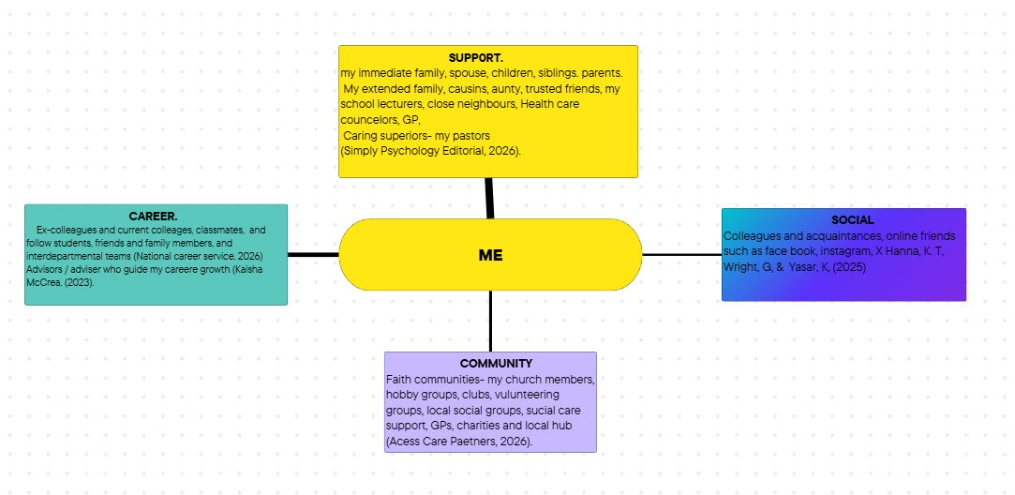

Map explained:
Supportive circle: Very strong ties), my core circle. My spouse and children who surround me know my daily routines.
My parents nurtured and provided me with the right foundation and guided my behavioral standards during my upbringing. and siblings, my life peer models and lifelong social partners.
Layer 2 (Strong ties), my extended family members, my school lecturer, and ‘Go - to neighbors’, and GPs offering immediate support. Layer 3: (Weak ties). Those devoted to my wellbeing - my pastors, providing spiritual guidance and bosses monitoring my performance.
Career circles: serve as problem-solvers.
Social circle: (Dormant ties), engage in sharing information, experience, activities, promoting social awareness.
Community circle: Foster high- accessibility, providing sense of belonging. and low- intensity community ties.
Supporting rationale:
Human capacity longevity relies upon a broad collaborative network. Social safety nets sustain adaptability, community ties and specialized expertise. Rushed multi-channel network gets shallow, but targeting influencers restore quality. Dunbar stratification limits social circle, separating professionals from personal spaces Christen, A. G, (1986).
Conclusion: Clearly, interpersonal networks are essential for mental well-being throughout personal development, facilitating crucial transition towards emotional stability and adaptive coping mechanism,

Task 3- Blog
Write a blog exploring a current topic or issue of your choice within the health and social care sector in the UK. The purpose of this is to inform a specific target audience of your choosing.

TITLE: The impact of understaffing on Healthcare workforce in the UK.
Workforce scarcity remains the most critical challenge in healthcare, worsened by the COVID-19 pandemic pressure and a rising wave of voluntary staff resignations (Care Quality Commission (CQC) 2025). UNISON data reveal that workforce deficit in the UK healthcare system stands approximately 96,000 daily, profoundly compromising care quality while compromising the well-being of the workforce. 45% of frontline staff surveyed raised concern that inadequate staffing has left them unable to provide safe, dignified and passionate care (UNISON, 2019, 2025).
Though minor progress is recorded in social care recruitment, the vacancy disparity is double the national average, driven by systemic low wages and adverse working conditions, leaving 20% of the workforce in poverty (The Health Foundation note, 2025).
This current pressure on healthcare system is organizational crisis rather than a deficit of healthcare workers’ performance. This has created severe operational overload and resource gaps, directly impacting caregivers who already face widespread understaffing, resulting in reliance on inconsistent agencies or temporary staff who may lack firsthand experience with care pathways, internal IT framework, and how to escalate concerns.
Official NHS data confirms that a continuous labor deficit has created significant disparities in the distribution of clinical skills. In the health and social care sector, systemic workforce deficit acts as a critical stressor that exacerbates staff burnout, which can lead to a severe state of physical, emotional, and mental exhaustion, ultimately eroding the mental and emotional stability of caregivers. Unstable shift work disrupts sleep quality, while frequent roster adjustment hinders optimal recovery and insufficient rest compounds systemic collapse (Royal Open College, 2025)
This statistical data outlines a chronic workforce crisis.
Mental Health strain: Roughly 65.1% of staff say job stress is making them sick, and there is an unprecedented surge in anxiety symptoms like panic attacks and nightmares.
Presenteeism: 66% of employees work several times a year while indisposed, a sharp rise from 49% from 2017 (Royal College of Nursing Press Release, 2025).
Overtime burden: 70.4% of health care and nursing workers work overtime every week, with 52.1% of that extra time completely unpaid (Royal College of Nursing, news and Events, 2025).
Zero hours: Nearly 21% of social care workers, up to 35% domiciliary care workers are on zero-hours contracts, affecting shifts predictability and financial insecurity (Skills for Health, 2025).
Conclusion:
Health care work in the UK depends on accessibility, quality, and delivery speed of care services, shaped by staff well-being, workforce pressure, burnout, overwhelming operational pressure. Urgent attention is essential to maintain the system’s capacity for high-quality care.

Task 4- NHS Equality, Diversity and Inclusion
What is the primary goal of the NHS Equality, Diversity, and Inclusion Improvement Plan?
Aims to purge institutional and personal discrimination in the workplace, driving workplace equity, inclusion and career growth for all employees.

2 How does the NHS EDI Improvement Plan propose to tackle the gender pay gap?
The Mend the Gap recommendation aims to fix gender pay by 2024, promoting flexible placement options across non-clinical personnel roles to widen recruitment in staff campaigns. It also aims to assess pay gap across protected characteristics, with board-guided, phased delivery in stages by race and sex (2024), disability (2025), and others (2026).

3.What is meant by the term ‘intersectionality’ as used in the NHS EDI Improvement Plan?
Intersectionality means recognizing that a person’s identity like race, gender, overlap. Because people hold multiple identities at once, they can face complex combined forms of discrimination rather than just one.
4.Why is it important for the NHS to create a psychologically safe work environment?
It is important because it prioritizes patients’ safety and provides high-quality care for everyone. It drives ongoing risk awareness, mutual support, and open communication.
5.How does the NHS EDI Improvement Plan suggest improving the experience of internationally recruited staff?
The implementation of High impact action 5, mandates the NHS to provide holistic information, formal onboarding, and employee integration, ensuring fair access to professional development.
6.What role does leadership play in advancing EDI objectives according to the NHS Improvement Plan?
Leadership must ensure accountability that drives systemic equity and elevate patients care through mentorship, benchmarking, demonstrating anti-racist behaviors, inclusive actions, evaluating workers data, diversifying leadership to foster inclusive workplace.
7.Identify one way the NHS EDI Improvement Plan aims to reduce health inequalities within the workforce.
The high impact action 5 fosters a safe and respectful work environment, embracing a culture of inclusion and belonging.
8.Why does the NHS EDI Improvement Plan emphasize the importance of collecting and analyzing data on protected characteristics?
Transparent data reveal systemic bias and hold leaders to account, creating an equitable environment that retains staff and improve care.

9.Explain how flexible working policies can contribute to equality and inclusion in the NHS workforce.
This policy fosters work-life integration that elevates employee satisfaction. It aims to enable instant approval for employee time-off requests, except there is undeniable business reason for refusal.

10.What is one strategy mentioned in the NHS EDI Improvement Plan to combat bullying and harassment in the workplace?
The high impact action six strategy.

Task 5- A Letter to Yourself
Think of a time in the past when you may have been experiencing issues or difficulties, and after considering what you have learned in this module about emotional intelligence and resilience write a letter to your younger self explaining how these attributes were important at that time and perhaps how developing these areas could have been useful.

A letter to myself:

One Monday morning, I was contacted by my manager to cover the shift for my colleague who could not resume his shift because of a family medical emergency regarding his daughter that was rushed to the hospital. Being a team leader, I saw this as a supportive gesture for both my stressed colleague and my management team, and I accepted the urgent request.
While engaged in providing emergency care assistance to a resident during an epileptic episode, an anxious family member visiting a different service user expressed aggressive frustration over a ten-minutes medication delay caused by the epilepsy incident. Other residents became distressed due to the tone of voice resulting in a serious challenge which requires the attributes of emotional intelligence and resilience to resolve.
Emotional intelligence is the capacity to guide, regulate one’s emotions, understand and manage the emotions of others (Harvard Division of Continuing Education, 2025). Resilience is the capacity needed to successfully cope with difficult life events without becoming overwhelmed (Cambridge University Press & Assessment, 2018). With the attributes of emotional intelligence and resilience, I was able to intervene and handle the challenge peacefully, completely calming the situation, ensuring a safe setting, and maintaining the peace of mind of other residents. Understanding the visitor’s emotions, I comforted him by listening attentively in a peaceful space and kingly informed him why there was delay, promising him it would never happen again. The visitor was visibly relieved and thanked me sincerely for keeping him informed and for the calm communication during the crisis.

Importance of emotional intelligence and resilience. Applying the four main components of Daniel Goleman’s framework of self-awareness, self-regulation, social awareness and social skills, I depersonalized the visitor’s anger, remained objective in calming down the crisis. The attributes of resilience enabled me to mitigate the challenging high-stressed setting, and I instantly realigned my focus towards patients’ needs, maintaining my productivity despite any disruption.
.
Task 6- GANTT Chart (200 words equivalent)
Compile a Gantt chart which illustrates the tasks you must complete to achieve your future employment goals
Introduction:
Becoming a manager in adult social care requires credentialed healthcare executive managing strict compliance scheduling. Below is a 24 – months roadmap structured around UK CATE standards.
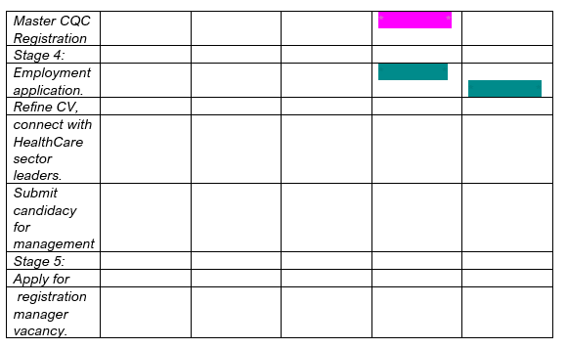
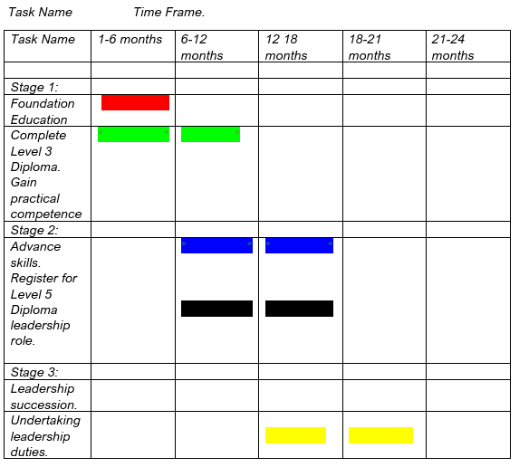
1: Foundation Education (Months,1 -6)
Prioritizing experiential and cultivating practical insights to understand daily routines.
Stage 2: Advancing in leadership skills (Months, 6 – 12).
Registe for Level 5 Diploma for skills in leadership stewardship, regulatory alignment, and partnership collaboration.
Stage 3: Leadership transition (Months,12 – 18). Leveling up to senior carer / Team Leader role to master practical experience in a hands-on task. Care Level Quality Commission (CQC) Registration compliance and audit partnering with active managers to appraise operational approaches.
Stage 4: Job Hunting (Months,18 – 24). Refine resume.
Attain the CQC assessment and secure service approval by hiring and inducting the Registered Manager.
Finally, apply for a registration Manager vacancy post-successfully fit and proper interview ahead of appointment (APM Women in Project Management Conference, 2026. Canva Team, 2026).

Task 7- Making Changes- Report
You are the manager of a care home and want to make changes to your workplace. Identify one specific change that you want to implement and write a brief report on how this is going to be achieved considering the necessary skills needed and addressing possible barriers to success. Relevant change models can be highlighted.

Introduction:
Social care constantly evolves to meet new welfare crisis. Digital tools transformed social interaction, how groups blend and highlight pressing concerns. Consequently, social services must modernize to align with digital driven world. Oye. B, (2025).
Keeping up with this rapid transformation, as the care home manager, I propose upgrading our record documentation into a unified digital client-management platform, moving away from paper-based daily notes and MAR sheets, as current audit reveal delayed inter-shift handovers, compromised record retention, poor legibility of handwriting entries, and substandard adherence to Care Quality Commission Regulation (CQC) Regulation 17.
This initiative seeks to optimize residents’ safety, foster person-centered care, immediate information flow and uphold CQC compliance. To drive this change, I will apply Lewin’s three-stage framework (1951), backed by Kotter’s (1966) eight-steps model. (The change model). 1. The unfreezing stage: Preparing the organization, I will immediately prioritize addressing late medical errors, delayed entries and CQC feedback by conveying staff meetings and relative forum to explain why paper recording falls short of GDPR and CQC standards. 2. Transformation stage: I will establish a project team of myself as Lead, a senior carer Digital champion, our IT provider and a nurse. All paper plans care plans will be uploaded and transferred online, staff will employ handheld devices to note point- of -care services, ABC charts, fluids, and medication administration with refusal codes, and all staff are to upskill in basic IT and person-centered digital documentation
3.Refreeze: The change established, digital documentation strictly enforced and monthly benchmark compliance will be checked. In keeping with Kotter’s model for anchoring success means timely care notes, fewer medication errors, confident staff, and positive CQC feedback (Harvard Business School, 2017).
Skills needed
Strategic thinking ability.
Good communication skills.
Respecting other’s views.
Organizational skills.
Conflict resolution skills. Digital proficiency skills
Clinical and legislative knowledge (NHS Health Careers, 2026).
Addressing the barriers.
Technological barriers can be addressed through partnering with IT provider to upskill staff. Data security and confidentiality breach or data loss can be addressed through auto-lock devices, mandatory information governance training, and compliance with GDPR. Cost can be addressed through upgrading WI- FI before go-live and have offline mode.
Conclusion: As shown above, transitioning sustainably to digital tools optimizes safety and person-centred care.

References
Access Care Partners (2026) How to build a strong support network. Available at: https://accesscarepartners.org/how-to-build-a-strong-support-network (Accessed: 18 October 2026).
APM Women in Project Management Conference, (2026). Pp.18-21. What is Gantt Chart? UK. Available at: https://www.apm.org.uk/resources/find-a-resource/gantt-chart (Accessed: 7 October 2026). Available at: https://pubmed.ncb.nlh.nih.gov (Accessed: 17 October 2026).
Christen, A. G. (1986) Developing a social support network. Journal of the American College of Dentists. Volume 53, Issue 1. Available at: https://pubmed.ncbi.nlm.nih.gov (Accessed: 21 October 2026).
Care Quality Commission (CQC) (2025) Monitoring the Health Act in 2021-2022. England. Available at: https://www.cqc.org.uk/publications/monitiring-mental-health-act/2021-2022/staff-shortage (Accessed:14 October 2026).
Canva Team (2026) Creating a Gantt chart: How- toss, templates, and tips. Available at: https://www.canva.com/online-whiteboard/gantt-chart/ (Accessed: 05 October 2026).
Care Quality Commission (2025) Regulation17: Good Governance – Care quality: Regulations for service providers and managers. England. Available at: https://www.cqc.org.uk/guidance-regulations-services-and-managers/health-social-care-act/regulation-17 (Accessed: October 2026).
Harvard Business School (2017) A 3 – Step Change Management Framework for Businesses. Online. Available at: https://online.hbs.edu/blog/post/a-3-step-framework-for-managing-organisational-change (Accessed:12 October 2026).
Harvard Business School (2026) Personal Branding: What it is & why it matters. Available at: https://online.hbs.edu (Accessed: 14 September 2026).
McCrea, K. (2023) Who is in my career network? Chesterfield. https://www.linkedin.com (Accessed: 17 October 2026).
National Institute of Health (2023) The importance of parenting in child health. Available at: https://pmc.ncbi.nih.gov (Accessed: 18 October 2026).
New Castle University (2016) Intersectionality/ Our research. New Castle upon Tyne. Available at: https://www.nil.ac.uk/research/culture/edi-toolkit/intersectionality/ (Accessed: 17 September 2026).
National Career Service (2026). Networking: tips to help your career. England. Available at: https://nationalcareers (Accessed :17 October 2026).
NHS England (2026) Support worker learning and development roadmap. Available at: https://hee.nhs.uk (Accessed: 07 October 2026).
NHS Health Careers, (2026) Strategic Management: entry requirements, skills and interests. England. Available at: https://healthcareers.nhs.uk (Accessed:13 October 2026).
Royal Open College (2026) Challenges facing Healthcare workers in UK. England. Available at: (https://royalopencollege.org/blog/healthcare/top-challenges-facing-healthcare-workers-in-theuk (Accessed: (09 October 2026).
Royal College of Nursing Press Release (2025) Working in understaffed services is making nurses sick, as new research shows staff suffering nightmares and panic attack. London. Available at: https://www.rcn.org.uk (Accessed: 14 October 2026).
Skills for Health (2025) The state of the adult social care sector and workforce in England. Available at: https://skillsforcare.org.uk (Accessed: 14 October 2026).
Gorbatov, S., Khapova, S.N. and Lysova, E.I. (2019) Get Noticed to Get Ahead: The Impact of Personal Branding on Career Success. Vol 10-2019. Amsterdam Netherlands. Available at: https://doi.org/10.3389/fpsyg.2019.02662 (Accessed: 18 October 2026).
Simply Psychology Editorial (2026) Building a social support Network: A practical Guide. United Kingdom. Available at: https://www.simplypsychology.com/article-support-networks-building (Accessed: 18 October 2026).
Skills for Health (2025) The growing gap in UK healthcare. Available at: https://www.skillsforhealth.org.uk/article/the-growing-gap-in-uk-healthcare/ (Accessed: 21 September 2026).
The King’s Fund (2025) Care workforce crisis. Available at: https://www.kingsfund.org.uk (Accessed: 14 October 2026).
The Health Foundation note (2025) New report highlights fragile progress for the adult social care workforce. England. https://www.health.org.uk (Accessed: 14 October 2026).
The Health Foundation (2023) Nine major challenges facing health and care in England. Available at: https://www.org.uk/report-and-analysis/briefings/nine-major-challenged-facing-health-care-in-england (Accessed: 21September 2026).
UNISON (2025) Too few nurses staff on duty to provide safe NHS care. England. Available at: https://www.unison.org.uk (Accessed: 14 October 2026).
UNISON (2026) Immigration changes are worsening the care crisis. England. Available at: https://unison.org.uk/news/2026/08/immigration-changes-are-worsening-care-crisis (Accessed: 15 October 2026).
UNISON (2019) Health service is compromising patients’ health, says UNISON. England. Available at: https://www.unison.org.uk (Accessed: 14 October 2026).

