Genine Martin
1915749
BMHP5014_BIRM
Changemakers: Creativity and Value Creation
Dr Azora Hurd
E-Portfolio Evidence of Learning
Task 3 Pitch and Supporting Flyer
Task 4 Conference Poster

Task 3 Pitch and Supporting Flyer:
Pitch:
Good afternoon everyone, thank you for coming today to hear more about Mediband with a difference. You may have a general idea of what Mediband is if you have read our flyer if you have not seen our flyer, I will give you a brief introduction of how Mediband with a difference began. I bet that you are wondering what is Mediband and what is its purpose? Mediband came an idea when I wanted to go out for my daily exercise according to COVID-19 restrictions and being a Type 1 diabetic, I had to take my blood glucose levels before leaving the house to ensure they were in range. Once out taking a walk I would notice that my levels would sometimes fall and that I did not have my glucose tablets with me because I had nothing to put them in. I would look foolish walking in my exercise clothes with a handbag on my side which could hold my glucose tablets, so I needed to think of a solution to my problem which I had.
Online there were armbands for diabetics to cover their sensors or to hold a mobile phone when a person was exercising but nothing to hold anything else. So, I thought why not modify an armband which would be suitable for my medical needs and then Mediband with a difference was born. If a diabetic goes out to exercise and experience a hypoglycaemia their symptoms can be sweating, feeling dizzy, collapsing, or passing out (Yale, Paty and Senior, 2018). To treat this, they will need carbohydrates in the form of glucose tablets, biscuits, or a sugary drink. By having the Mediband on your arm will give direct and easy access to your carbohydrates. The Mediband is made from recyclable substitutions which will lead to less resource use in turn can help save our planet (Fletcher and Tham, 2019).

Supporting Flyer:
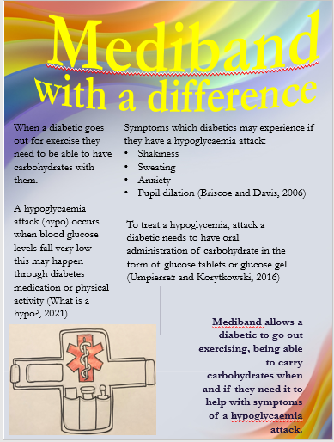 Front page
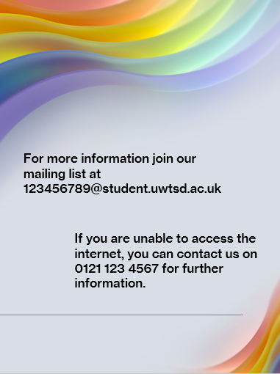 Back page

Task 4: Conference Poster
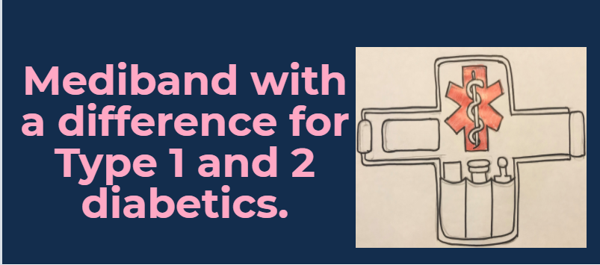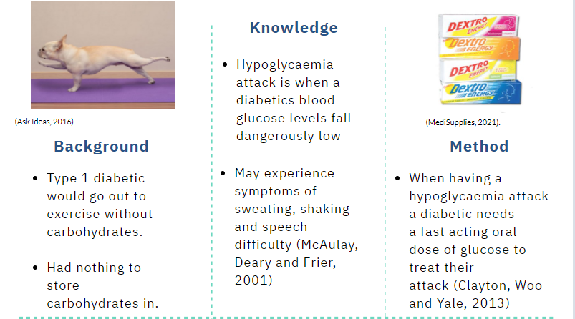
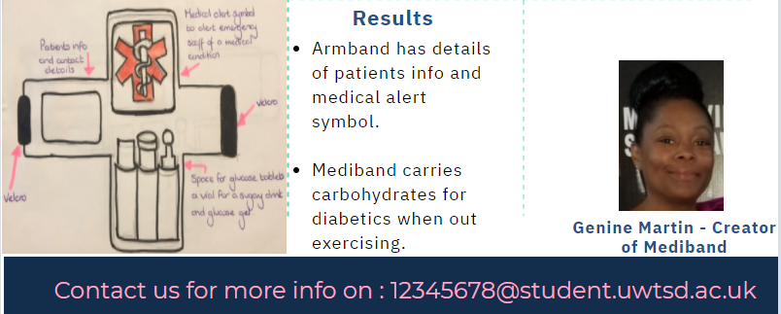

References

Ask Ideas, (2016). Dog Doing Push Up Funny Exercise. [image] Available at: <https://www.askideas.com/25-most-funniest-exercise-animal-pictures-that-will-make-you-laugh/> [Accessed 23 March 2021].
Briscoe, V. and Davis, S., (2006). Hypoglycemia in Type 1 and Type 2 Diabetes: Physiology, Pathophysiology, and Management. Clinical Diabetes, 24(3), pp.115-121. DOI: 10.2337/diaclin.24.3.115
Clayton, D., Woo, V. and Yale, J., (2013). Hypoglycemia. Canadian Journal of Diabetes, 37, pp. S69-S71.DOI: 10.1016/j.jcjd.2013.01.022.
Diabetes UK. (2021). What is a hypo? [online] Available at: <https://www.diabetes.org.uk/guide-to-diabetes/complications/hypos> [Accessed 24 March 2021].
Fletcher, K. and Tham, M., (2019). Earth Logic Fashion Action Research Plan. [pdf] London: The J J Charitable Trust, pp.45. Available at: <https://earthlogic.info/wp-content/uploads/2019/12/Earth-Logic-eversion.pdf> [Accessed 23 March 2021].
McAulay, V, Deary, I. J & Frier, B. M, (2001). Symptoms of hypoglycaemia in people with diabetes. Diabetic medicine, 18(9), pp.690–705. DOI: 10.1046/j.1464-5491.2001. 00620.x
MediSupplies, (2021). Different flavours of dextrose tablets. [image] Available at: <https://www.medisupplies.co.uk/Pharmaceuticals/Diabetic-Emergency/Dextro-Energy-Glucose-Tablets> [Accessed 23 March 2021].
Umpierrez, G. and Korytkowski, M., (2016). Diabetic emergencies — ketoacidosis, hyperglycaemic hyperosmolar state and hypoglycaemia. Nature Reviews Endocrinology, 12(4), pp.222-232. DOI 10.1038/nrendo.2016.15
Yale, J., Paty, B. and Senior, P., (2018). Hypoglycemia. Canadian Journal of Diabetes, [online] 42, pp. S104-S108. DOI.org/10.1016/j.jcjd.2017.10.010

