DS 1 Template

My Screenshots/Photos
- Please add 4–6 screenshots or photos of your digital life.
- You can use your phone or laptop.
- For each screenshot, write one or two sentences explaining what it shows.

Screenshot/Photo
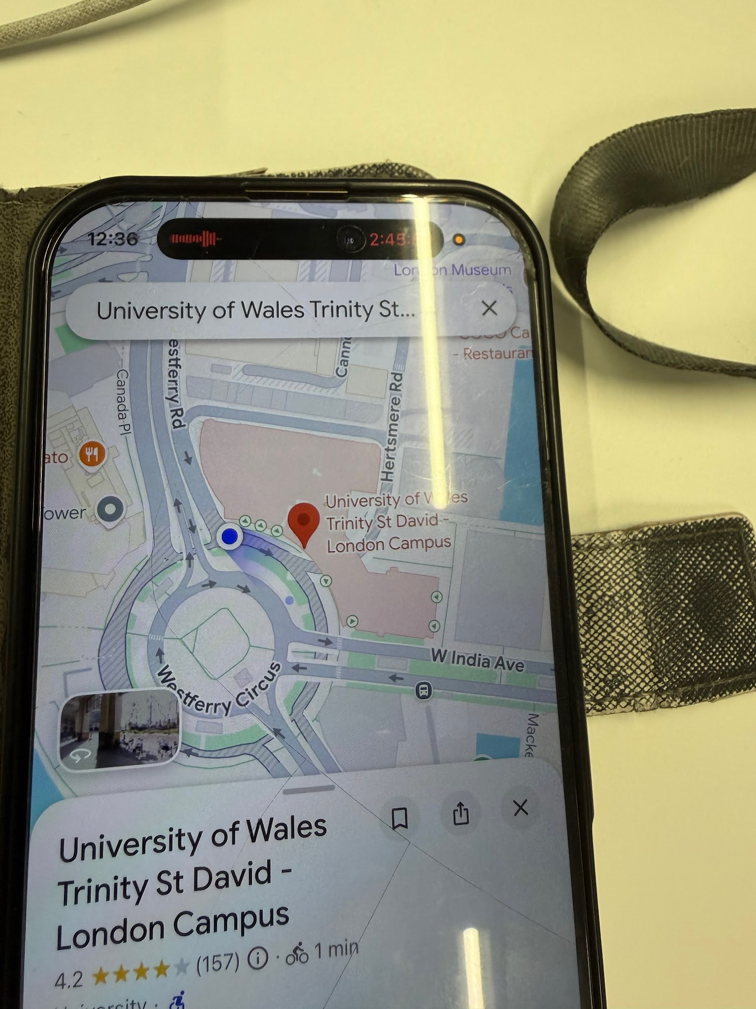I use Google Maps on my phone to get to my
I use Google Maps on my phone to get to my university

Screenshot/Photo 2
- 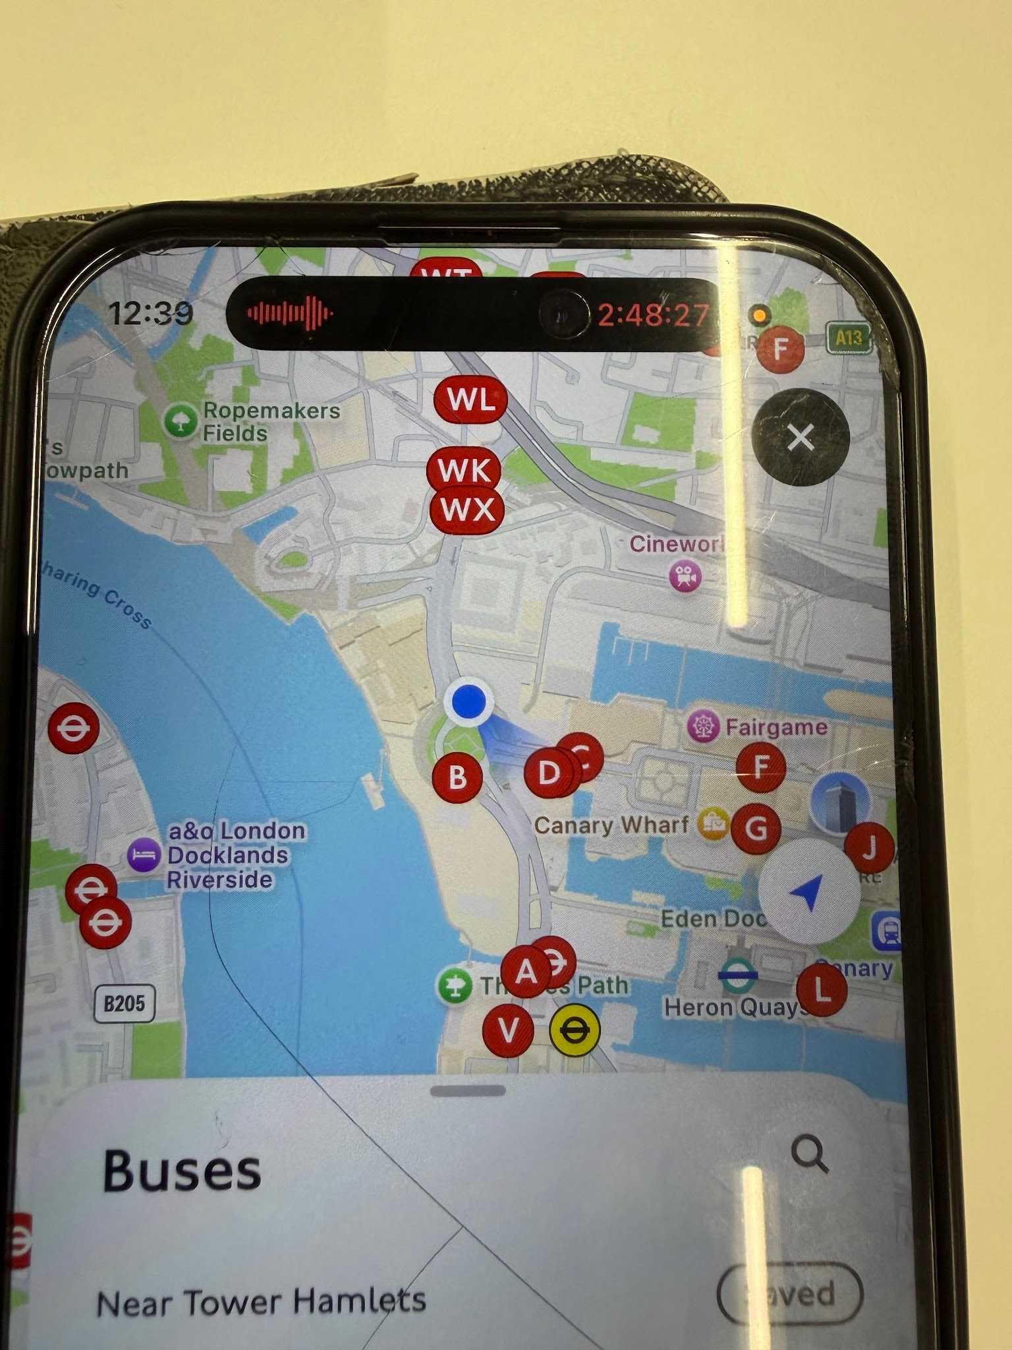
- I use the bus timetable on my phone to check the bus times.

Screenshot/Photo 3Screenshot/Photo 4
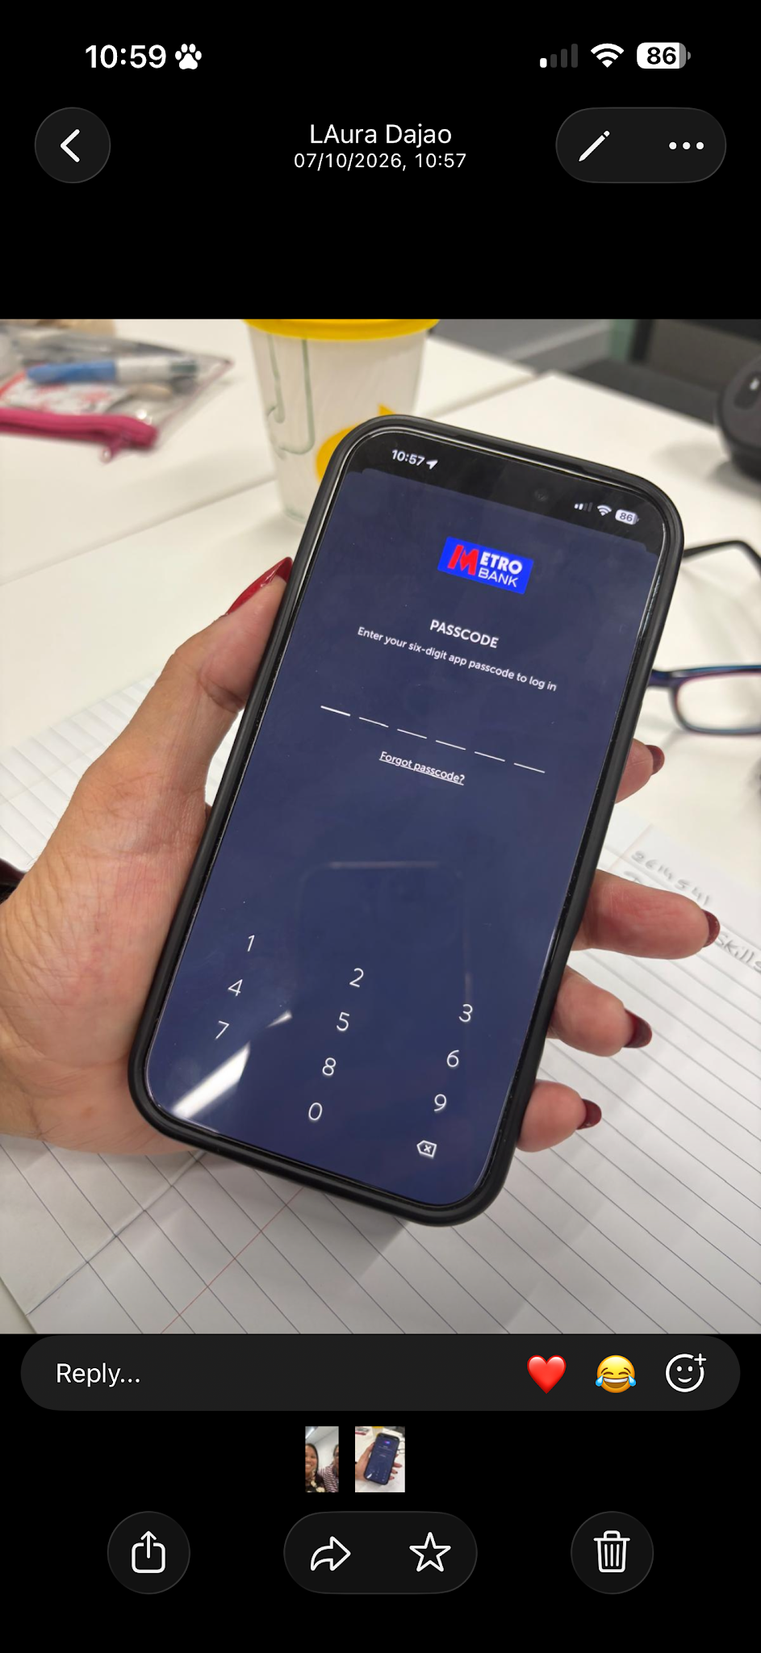
I use my phone Bank app to pay my fear to go university

Screenshot/Photo 5
[Insert Photo/Screenshot below]

[Write what this shows of your digital life]

Screenshot/Photo 6
[Insert Photo/Screenshot below]
[Write what this shows of your digital life]

My Short Reflection
- Write 5–8 simple sentences about your digital life.
- You can use the sentence starters below if helpful.
- I use my phone to see map to come my university
- I use my phone to see my timetable on bus to reach station
- I use my phone Bank app to use my pay my fair to train

Sentence starters
- I use digital tools to …
- I feel confident when I …
- I want to improve …
- I often use these tools: …
- I sometimes feel nervous about …
- I hope this module will help me …
- Digital skills are important for me because …
You can write more if you want.

Submission Checklist
Before you submit, please check:
​​​ ✅I added 4–6 screenshots
✅I wrote short sentences for each screenshot
✅ I wrote my short reflection
✅My work is my own
✅My file opens correctly
​​✅ My file opens correctly

