What helps me learn language and mathematics? : An analysis of a child’s learning in mathematics and language with recommendations for ensuring progress.
Donaldson (2015, p.18) describes how literacy and numeracy are the ‘essential foundations of education’, and recommends that these ‘foundations’, along with digital competence, should be developed as cross-curricular skills throughout Wales’ new curriculum. Cochran, DeRuiter and King (1993) describe how teachers’ pedagogical knowledge, their knowledge of how to teach, is equally important as their subject knowledge, their knowledge of what they are teaching. Donaldson (2015) and Cochran, DeRuiter and King (1993) highlight the importance of developing essential skills, such as language and mathematics, through teachers’ effective knowledge of the subject content and pedagogical approaches to ensure that the learners are continuously progressing. Therefore, this assignment will include an analysation of a pupils learning in language and mathematics along with recommendations of ways to progress their learning. The ASK model will be utilised within the assignment to effectively analyse the pupil’s learning with regards to their attitude, skills and knowledge of language and mathematics. The Mosaic approach was used to collect data that shows the learning and understanding of language and mathematics from the child’s perspective (Clark and Moss, 2011). The following data collected, via the Mosaic approach, will be used for the analysis: samples of work, learning mind maps, interviews with pupil, observation notes, and pupil emotion table. When collecting the previously mentioned data, it was ensured that the pupil provided consent to each aspect of the data, their involvement was not detrimental to their well-being or education, and that the pupil felt comfortable at all times. All data collected adhered to the British Educational Research Association (BERA) (2018) guidelines. It was also ensured that the school provided its consent for the data to be collected, as shown in appendix 16. The pupil in question is female, 9 years old and taught within a combined year five and six class, located in the authority of the City and County of Swansea.

Mathematics
The pupil has a very positive outlook on learning mathematics and understands the benefits of developing her mathematical skills. Appendix 1, a learning mind map created by the pupil, evidences how the pupil believes that learning mathematics will make her smarter, and how the more methods and topics she learns will enhance her learning. During the interview conducted with the pupil, shown in Appendix 2, she stated that mathematics was important to learn because it will aid her during her future education. Ming-tak and Wai-shing (2008) describe how a positive learning environment can have a positive impact on pupils’ learning, motivation, and their sense of achievement. Furthermore, Dart (2000) informs how there is a relation between students’ views on learning and their educational outcomes. Ming-tak and Wai-shing (2008) and Dart (2000) show how the learner having a positive outlook on mathematics may have a positive impact on her learning. Donaldson (2015, p.29) describes how one purpose of education is for pupils to be ‘ready to play a full part in life and work’. This implies that education should prepare learners for the world of work and ensure they understand why education is essential. It is evident, as previously highlighted in appendix 2, that the pupil has this understanding. Within some aspects of the pupils work she shows resilience and determination to improve and develop her understanding of mathematics. Appendix 3 shows an example of the pupil making corrections to her work based on her self-assessment and partner peer-assessment of her work. The Department for Children, Education, Lifelong Learning Skills (DCELLS) (2008a, p.11) highlights the importance of developing pupils’ self-assessment skills as it ‘fosters reflective learning’. Alike the Welsh Government, Black and William (1998) believe that self-assessment is essential as it allows the learner to understand which elements of their work are good and which elements could be improved, however they state that learners must have an understanding of how to self-assess their work and what good aspects of work look like. DCELLS (2008a) and Black and William (1998) show that self-assessing is highly important and suggests that the pupil’s example of work, seen in appendix 3, shows her understanding of addition as she is able to reflect on her work and make improvements.

Within the learning mind map, shown in appendix 1, the pupil states that she enjoys playing mathematical games. Therefore, during the interview, shown in appendix 2, the pupil was asked to declare why she enjoyed playing said games, to which her response suggests that the pupil has the ability to apply her knowledge of mathematics in different contexts and real-life situations. Ebbinghaus (1885) believed that in order for the brain to effectively memorised information, said information must be repeated and recalled in different contexts. Furthermore, DCELLS (2008b, p.33) states that the brain must make connections between cells through ‘repeated use’ to allow memorable learning to occur. Both Ebbinghaus (1885) and DCELLS (2008b) show how playing mathematical games is likely to enhance the pupil’s memory of the mathematics she has learned. However, I feel that there is insufficient data to state whether the mathematical games the pupil has engaged with have developed her knowledge or memory of her mathematical skills. Squire (2003, p.58) states that video games used within education may develop some skills, such as mathematics, however they have been criticised as they take away children’s ‘opportunities to develop their creativity’. Furthermore, Palmer (2015) is of the belief that children are negatively affected when using too much technology and should not be surrounded by it throughout the day. Both Squire (2003) and Palmer (2015) imply that the pupil may be developing some mathematical skills when playing games, but it may be detrimental to their other skills, such as creativity. During mathematics sessions, the pupil would frequently engage in group discussion about different topics, for example the pupil would discuss the correct and incorrect elements of work, shown in appendix 4, to which the pupil in question was very confident when doing so and on a number of occasions shared her discussion with the class. Appendix 5 provides data of an observation of the pupil during a discussion, to which it suggests the pupil has the ability to effectively communicate with group members, share her knowledge of column addition, and recall the addition step by step approach. Vygotsky (1987, cited in Kozulin, 2003, p.40) theorised that people learn for interaction and ‘collaboration with more capable peers’ which results in them gaining a greater understanding of the topic, compared to working independently. This suggests that by the pupil discussing the correct and incorrect elements of work, shown in appendix 4, they are recalling prior knowledge, to which Ebbinghaus (1885) and DCELL (2008b) previously stated is an effective way of memorising information, along with developing their knowledge and understanding of the topic as she is ‘collaborating with more capable peers’ (Vygotsky, 1987, cited in Kozulin, 2003, p.40).

When learning to use the column method for addition the pupil seemed to benefit from the step-by-step approach that was introduced and modelled by the practitioner, shown in appendix 6. Within the pupil’s learning mind map, shown in appendix 1, the pupil states that she believes that step by step methods aid her learning. Appendix 7, an example of the pupil’s column method work, evidences that the pupil has used the step-by-step approach to aid her addition. Bates (2016, p.46) describes how scaffolding can be used to support the learner’s development by breaking a ‘given task into smaller sub-tasks’. Furthermore, Stuyf (2002) states that the aim of scaffolding pupil’s learning is that the learners eventually become independent with the task and no longer require the support of the scaffolding. Both Bates (2016) and Stuyf (2002) show how providing the pupil with a step-by-step approach may have supported the pupil’s knowledge and development of the column method and will eventually allow her to become independent. However, when the teacher implemented a step-by-step approach to support the pupil using the column method for subtraction, as seen in appendix 14, it is evident within a sample of her work shown in appendix 13, that the pupil did not benefit from the scaffolding. In question 3 of the sample of work, the pupil has incorrectly subtracted two one-digit numbers, 9 from 6. It could be suggested that the pupil has insufficient knowledge of number and negative numbers. Psarianos (2017) describes how number is ‘a solid foundation’ for the development of mathematical skills and fluency. Donaldson (2015) states that learning should be an inclusive continuum where pupils, at an individual pace, build upon their prior knowledge and work towards progression steps. Both Psarianos (2017) and Donaldson (2015) imply that, in order for pupil to progress to higher level skills, they must develop and build upon their basic skills.

Language
Within the pupil’s language learning map and the interview conducted with the pupil, shown in appendixes 15 and 8 respectively, the pupil describes how she enjoys learning and using language as it builds her confidence. Ferris (1998, quoted in Arango, 2015) informs how students often show inhibition during lessons due to their lack of confidence which can have a negative impact on their learning. Furthermore, Norman and Hyland (2003, p.12) describes how group activities and interactions with other people develop and enhance ‘confidence and achievement at all levels of learning’. Therefore, Ferris (1998, quoted in Arango, 2015) and Norman and Hyland (2003) imply that developing and enhancing confidence is likely to increase the pupil’s learning of language. Additionally, Donaldson (2015, p.30) states that one purpose of Wales’ new curriculum is to allow children to be ‘confident individuals’ who ‘are building their mental and emotional well-being by developing confidence’. This implies that confidence and pupil well-being is important to develop within the education system in Wales and has an impact on children’s learning. Within the pupil emotion table, shown in appendix 9, the pupil expresses her enjoyment of reading and writing stories, to which she states in the pupil interview, shown in appendix 8, she does in her spare time. Cimmiyotti (2013) informs that, within their research, there is a correlation between reading skills and academic performance. Cimmiyotti (2013) continues to describe how high reading ability, attained from reading regularly, can benefit the learner’s following skills: writing ability, as they have a wider range of vocabulary; and mathematic performance, as they have greater comprehension skills which aid their problem-solving skills. Additionally, The Children’s Book Review (2010) state that learners increase their vocabulary and develop their writing skills when reading, however they highlight the fact that books must be of a high quality to benefit the learner. Both Cimmiyotti (2013) and The Children’s Book Review (2010) highlight that reading can enhance and develop the learner’s reading ability, along with vocabulary, writing skills and mathematics.

An activity within the classroom required the pupil to use information, that she had previously researched, to teach her partner about the life of her chosen artist. The task required her to recall information she had previously researched and use said information to provide another learner with an understanding of the life of the artist. Appendix 10 shows an observation of the pupil during the lesson. Thinking Classroom (2018) describes how there are two categories of thinking skills: cognitive thinking skills and reflective thinking skills. Cognitive thinking skills include learners gathering information, organising information and forming a basic understanding, and applying the information and understanding (Thinking Classroom, 2018). Additionally, Bloom’s taxonomy included the following three levels of thinking: knowledge, the act of recalling information; comprehension, the act of understanding the information; and application, the act of using and applying the information (Bates, 2016). Both sources show that the pupil has the reading ability to derive meaning from new information and apply it in a different context. As previously stated within the assignment, Ebbinghaus (1885) theorised that, for memorable learning to occur, information must be repeated and recalled in different contexts. This reinforces the fact that the pupil’s thinking skills has an impact on their learning and understanding of language.

Appendix 11, a vocabulary table created by the pupil to support the description of her artwork and therefore her written speech, shows that the pupil has a good level of vocabulary and illustrates her understanding of adjectives. As previously stated, Cimmiyotti (2013) and The Children’s Book Review (2010) described that there may be a correlation between reading regularly and having a wide range of vocabulary. The sample of the pupil’s written speech, shown in appendix 12, exemplifies that the pupil’s regular reading has developed her range of vocabulary and has benefitted her understanding of language as she is able to apply her knowledge of vocabulary in her written work. DCELLS (2016a, p.29) describe how learners attaining a level four in writing use ‘adventurous’ vocabulary intentionally. This is evident in her work when vocabulary such as ‘wonky’ and ‘swirly’ are used, shown in appendix 12. This sample of work also shows that the pupil has the ability to adapt her writing style to conform to the expectations of a written speech. DCELLS (2008c, p.24) inform that learners should have a growing awareness of the ‘style’ of different types of writing and should ‘adjust their language’ to suit the style in which they are writing in. When using the vocabulary to describe her artwork, it is evident that the pupil has insufficient knowledge of listing, and therefore using punctuation effectively. DCELLS (2016a, p.12) state that pupils in year five should be able to ‘use a full range of punctuation’ including listing correctly. Additionally, DCELLS (2008c, p.24) describe how learners should become ‘competent writers’ who display the ability to write ‘clearly and coherently’. These statements evidence the importance of developing the pupil’s knowledge of using punctuation correctly to write clear description. Furthermore, Donaldson (2015, p.49) believes that Wales’ new curriculum should develop competence in language to a high level to allow pupils to develop as ‘ambitious, capable learners’. The sample of work, shown in appendix 12, identifies that the pupil can confidently structure her written speech using sub-headings, to which, when attaining level 4, learners should organise their work appropriately (DCELLS, 2016a). Additionally, Smith and Dawes (2014) state that learners towards the end of Key Stage 2 should use paragraphs to organise their writing effectively. Within the learner’s work, shown in appendix 12, it is apparent that the pupil can use sub-headings to organise their work, however the learner requires more opportunities to develop her knowledge of how to correctly paragraph in order to progress her writing.

Future progress
Within the pupil’s column subtraction work, a sample shown in appendix 13, it is evident that the pupil has insufficient knowledge of number, particularly subtracting two numbers that will result in a negative outcome. To progress the pupil’s learning, the teacher could use the connections model to support her understanding of number. Haylock and Thangata (2007, p.108) describes how the connections model allows learners to ‘construct understanding of mathematical ideas’ through the use of the following: concrete experiences, language, pictures and mathematical symbols. Additionally, DCELLS (2008b, p.35) state that learners must make connections between ‘existing skills, knowledge and understanding, and new learning’. Haylock and Thangata (2007) and DCELLS (2008) imply that supporting the pupil in making connections between different sources of information will develop her knowledge and understanding of mathematics. With regards to subtraction, it would be beneficial for the learner to be provided with multi-link when conducting column subtraction, to understand that it is not possible to subtract seven from five and have a positive outcome, providing her with a concrete experience. It would also be very beneficial for the learner to use a number line, which includes positive and negative numbers, as it will support the pupil’s understanding of the order of negative numbers, providing the pupil with understanding through pictures. As previously stated, a step-by-step approach was used to support the learner with her column addition and subtraction. Stuyf (2002) informs how the aim of scaffolding is for learner to become independent and no longer require the support. However, the pupil required the use of the step-by-step scaffolding during all lessons. Therefore, the scaffolding must be gradually released in order to develop the independence of the learner (Stuyf, 2002). Graves and Fitzgerald (2003, quoted in Fisher and Frey, 2016, p.2) state the gradual release of responsibility model entails teachers gradually doing ‘less of the work’ and the learners gradually assuming ‘increased responsibility for their own learning’, which encourages independence within learners. Therefore, Stuyf (2002) and Graves and Fitzgerald (2003, quoted in Fisher and Frey, 2016) show that gradually removing the support from the step-by-step instructions will allow the learner to develop her mathematical independence. Additionally, Donaldson (2015, p.28) describes how independence should be ‘fostered’ within all teaching and learning. DCELLS (2016b) describe how learners, attaining a level four within mathematics, should be able to problem solve using their own strategies. Therefore, it would be beneficial to progress the learner’s knowledge and apply her column addition and subtraction skills when solving mathematical problems. The pupil suggested in her learning map, shown in appendix 1, that playing mathematical games supported and developed her learning. Ebbinghaus (1885) and DCELLS (2008b) agreed with the use of mathematical games as they encourage the memorisation of information through repeated use in different contexts. Furthermore, DCELLS (2016b) state that learners should be given opportunities to ‘transfer mathematical skills should to a variety of context’ to which playing mathematical games develops. However, it was previously noted that there was insufficient data to conclude whether the mathematical games had an impact on the child’s learning. Therefore, to progress the pupil’s learning and understanding of mathematics, the teacher could provide the pupil with specific mathematical games that develop skills that have been and are currently being developed within mathematical sessions. This will allow the teacher to monitor what games the learner is playing and ensure that they are developing her understanding of mathematics. A game that would be beneficial to the pupil’s understanding of mathematics is ‘Times Tables Rock stars’ which develops learner’s knowledge of times tables through daily practice (Times Tables Rock stars, 2019). DCELLS (2016b) states that learners in year 5 should be able to identify multiples of from 2 to 10, which shows the importance of developing the pupil’s times tables.

Within the pupil’s written speech, shown in appendix 12, it was evident that the pupil had insufficient knowledge of how to structure her work into paragraphs correctly. In order for the pupil’s writing to be progressed, the teacher should model to the learner how to structure work into paragraphs correctly, ensuring that they emphasise the main aspects of paragraphing. Eggen and Kauchak (2001) state that instructional strategy, modelling, allows learners to observe skills being conducted by the teacher. Furthermore, DCELLS (2008d) describe that teachers in Wales may use modelling to allow pupils to observe the language and learning skills they require. Eggen and Kauchak (2001) and DCELLS (2008d) reinforce the suggestion that the teacher must model how to use paragraphs to the learner as it will allow them to observe and apply the skill within their work. On the contrary, Haston (2007) states that modelling can inhibit students’ learning if it is not used in appropriate situations. Additionally, Abraham Maslow theorised that comfort is a lower-order need that learners must have in order to learn (Bates, 2016). Therefore, it is recommended that the teacher ensures that the learner is in a comfortable learning environment to ensure they are able to engage with the teacher when modelling and gain an understanding. Another element of the pupil’s language that could be progressed is her knowledge of using punctuation to list correctly. In order for the learner’s skills to be progressed it is recommended that the teacher conducts a miscue analysis for the pupil’s writing. Driscoll, Lambirth and Roden (2015) describe how a miscue analysis allows the teacher to observe the pupil writing and provides the teacher with the following opportunities: discussing the work the pupil is writing and suggesting alterations they must make and why. Driscoll, Lambirth and Roden (2015) show that conducting a miscue analysis will allow the teacher to provide the learner with specific, personalised targets based on their writing and provide one-to-one support to develop her knowledge of listing correctly. Donaldson (2015, p.26) describes how ever learner ‘benefits from personalised learning’ and encourages them to take more responsibility of their own learning. Dean (2006) states that personalised learning focuses on the child’s specific learning developments and may increase their learning. Donaldson (2015) and Dean (2006) furthermore show how conducting a miscue analysis and providing the pupil with personalised targets will encourage the pupil to develop her knowledge of punctuation and may increase her understanding. Within the pupil’s language learning map, shown in appendix 15, the pupil suggests that using language, for example discussing ideas with a group, supports the development of her confidence. A way that the learner’s skills could be progressed is by providing her with more opportunities, inside and outside of the classroom, to develop her oracy skills. For example, the pupil could be involved in increasing opportunities where she must listen to other members of the classroom sharing their viewpoints, consider them, then respond to what they have discussed (DCELLS, 2008e). Donaldson (2015, p.48) comments that developing oracy ‘is of central importance to both thinking and learning’ and suggests that oracy has an impact on the development of essential skills. Millard and Gaunt (2018) agrees with this idea and describe how developing oracy can result in ‘cognitive gains’ in which additional subjects, such as mathematics and science, are supported and developed as oracy can transfers reasoning skills. Donaldson (2015) and Millard and Gaunt (2018) reinforce the progression of the learner’s oracy skills as it provides support and development to additional essential skills. However, Oradee (2012, p.534) research suggests that the most effective way to develop oracy is by using a combination of the ‘three communicative activities’: discussion, problem-solving and role-playing.

Reference list
Allen, L. et al. (2014) ‘L2 writing practice: Game enjoyment as a key to engagement’, Language Learning &Technology, 18(2), pp. 124-150.
Arango, H. (2015) Student’s self-confidence as a way to improve English oral production in tenth grade students at Ricaurte school. Bogotá: Universidad Libre. Available at: https://repository.unilibre.edu.co/bitstream/handle/10901/7878/PradaHernando2015.pdf?sequence=1&isAllowed=y (Accessed: 16th March 2019).
Bates, B. (2016) Learning theories simplified. London: SAGE Publications Ltd.
Black, P. and William, D. (1998) Inside the black box: Raising standards through classroom assessment. London: GL Assessment.
British Educational Research Association. (2018) Ethical Guidelines for Educational Research. 4th edn. London: British Educational Research Association. Available at: https://www.bera.ac.uk/wp-content/uploads/2018/06/BERA-Ethical-Guidelines-for-Educational-Research_4thEdn_2018.pdf?noredirect=1 (Accessed: 24th March 2019).
Cimmiyotti, C. (2013) Impact of Reading Ability on Academic Performance at the Primary Level. Unpublished Graduate Master’s thesis. Dominican University of California. Available at: https://scholar.dominican.edu/cgi/viewcontent.cgi?referer=https://scholar.google.co.uk/scholar?hl=en&as_sdt=0%2C5&q=impact+of+reading+on+academic+performance&btnG=&oq=impact+of+reading&httpsredir=1&article=1126&context=masters-theses (Accessed: 16th March 2019).
Clark, A. and Moss, P. (2011) Listening to Young Children: The Mosaic approach. 2nd edn. London: NCB.
Cochran, K. DeRuiter, J. and King, R. (1993) ‘Pedagogical Content Knowing: An Integrative Model for Teacher Preparation’, Journal of Teacher Education, 44(4), pp. 263-272.
Dart, B. et al. (2000) ‘Students’ conceptions of learning, the classroom environment, and approaches to learning’, The Journal of Educational Research, 93(4), pp. 262-270. Available at: https://search.proquest.com/docview/204211000?pq-origsite=gscholar (Accessed: 12th March 2019).
Dean, J. (2006) Meeting the Learning Needs of All Children: Personalised learning in the primary school. London: Routledge.
Department for Children, Education, Lifelong Learning Skills. (2008a) Why develop thinking and assessment for learning in the classroom? Cardiff: Welsh Assembly Government.
Department for Children, Education, Lifelong Learning Skills. (2008b) Learning and Teaching Pedagogy. Cardiff: Welsh Assembly Government.
Department for Children, Education, Lifelong Learning Skills. (2008c) English: Guidance for Key stages 2 and 3. Cardiff: Welsh Assembly Government.
Department for Children, Education, Lifelong Learning Skills. (2008d) Learning and Teaching Pedagogy. Cardiff: Welsh Assembly Government.
Department for Children, Education, Lifelong Learning Skills. (2008e) Skills framework for 3 to 19-year-olds in Wales. Cardiff: Welsh Assembly Government.
Department for Children, Education, Lifelong Learning Skills. (2016a) Curriculum for Wales: Program of Study for English, Key Stages 2-4. Cardiff: Welsh Government.
Department for Children, Education, Lifelong Learning Skills. (2016b) Curriculum for Wales: Program of Study for Mathematics, Key Stages 2-4. Cardiff: Welsh Government.
Donaldson, G. (2015) Successful Futures. Crown copyright. Available at: http://gov.wales/docs/dcells/publications/150317-successful-futures-en.pdf (Accessed: 10th March 2019).
Driscoll, P. Lambirth, A and Roden, J. (2015) The Primary Curriculum: A Creative Approach. 2nd edn. London: SAGE Publications Ltd.
Ebbinghaus, H. (1885) Memory: A Contribution to Experimental Psychology. Translated from x by Ruger, H. & Bussenius, C. New York: Teachers College, Columbia University. Available at: https://pdfs.semanticscholar.org/8501/b17d47d1b365fc75c0acb949a04e2d1aae88.pdf (Accessed: 20th February 2019).
Eggen, P. and Kauchak, D. (2001) Educational Psychology: Classroom Connections. 5th ed. New York: Macmillan.
Fisher, D. and Frey, N. (2014) Better Learning Through Structured Teaching: A Framework for the Gradual Release of Responsibility. 2nd edn. Alexandria: ASCD.
Haston, W. (2007) ‘Teaching Modeling as an Effective Teaching Strategy’, Music Educators Journal, 93(4), pp. 26-30.
Haylock, D. and Thangata, F. (2007) Key Concepts in Teaching Primary Mathematics. London: SAGE Publications Ltd.
Kozulin, A. et al. (2003) Vygotsky’s Educational Theory in Cultural Context. New York: Cambridge University Press.
Millard, W. and Gaunt, A. (2018) Speaking up: The importance of oracy in teaching and learning. Available at: https://impact.chartered.college/article/millard-importance-of-oracy-in-teaching-learning/ (Accessed: 22nd March 2019).
Ming-tak, H. and Wai-shing, L. (2008) Classroom Management: Creating a positive learning environment. Hong Kong: Hong Kong University Press.
Norman, M. and Hyland, T. (2003) ‘The role of confidence in lifelong learning’, Education: Journal Articles, 7, pp. 1-16. Available at: http://sprite.bolton.ac.uk/201/1/ed_journals-7.pdf (Accessed: 16th March 2019).
Oradee, T. (2012) ‘International Journal of Social Science and Humanity’, Developing Speaking Skills Using Three Communicative Activities (Discussion, Problem-solving, and Role-playing), 2(6), pp. 533-535. Available at: http://www.ijssh.org/papers/164-A10036.pdf (Accessed: 22nd March 2019).
Palmer, S. (2015) Toxic Childhood: How the modern world is damaging our children and what we can do about it. London: Orion Publishing Group Ltd.
Psarianos, A. (2017) 3 Ways Number Bonds Leas to Maths Mastery. Available at: https://mathsnoproblem.com/3-ways-number-bonds-lead-to-maths-mastery/ (Accessed: 15th March 2019).
Smith, P. and Dawes, L. (2014) Subject Teaching in Primary Education. London: SAGE Publications Ltd.
Squire, K. (2003) ‘Video Games in Education’, International Journal of Intelligent Simulations and Gaming, 2(1), pp. 49-62.
Stuyf, R. (2002) Scaffolding as a Teaching Strategy. Available at: http://www.workplacesafety.pbworks.com/f/Scaffold%20Learning.doc (Accessed: 15th March 2019).
The Children’s Book Review (2010) How Reading Improves Child Literacy. Available at: https://www.thechildrensbookreview.com/weblog/2010/11/how-reading-improves-child-literacy.html (Accessed: 16th March 2019).
Thinking Classroom (2018) Thinking Skills. Available at: https://www.thinkingclassroom.co.uk/ThinkingClassroom/ThinkingSkills (Accessed: 17th March 2019).
Times Tables Rock Stars. (2019) What is Times Tables Rock Stars? Available at: https://ttrockstars.com (Accessed: 24th March 2019).

Appendix 1 – Learning map: mathematics
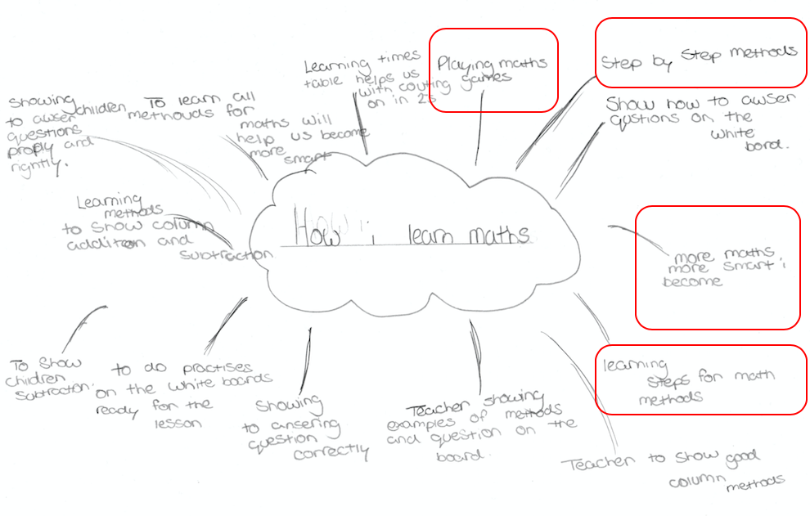

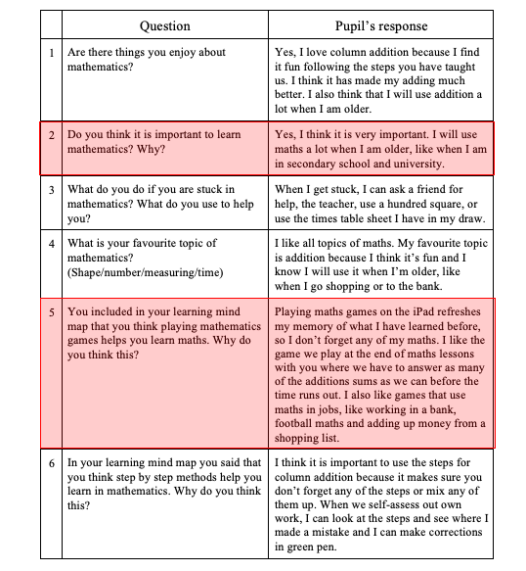
Appendix 2 – Interview: mathematics

Appendix 3 –Sample of work: corrections
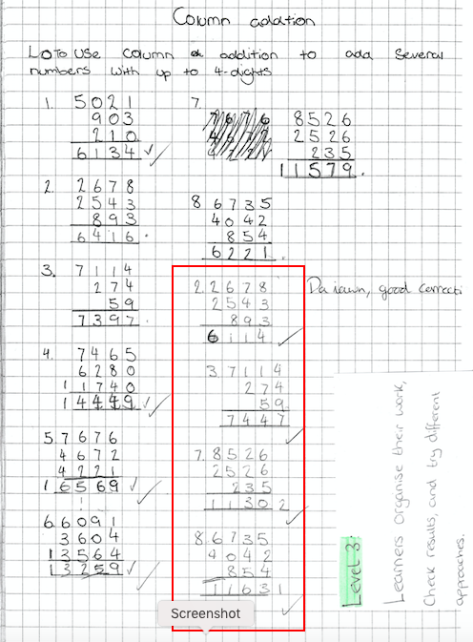

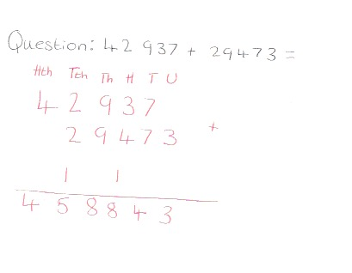
Appendix 4 – Discussion question

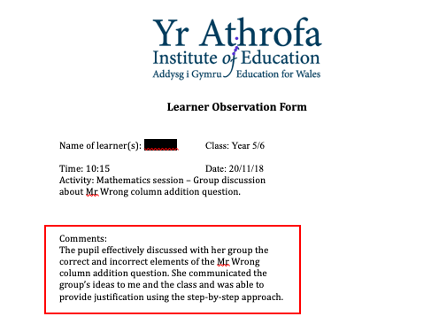
Appendix 5 – Observation: group work

Appendix 6 – Step-by-step column addition

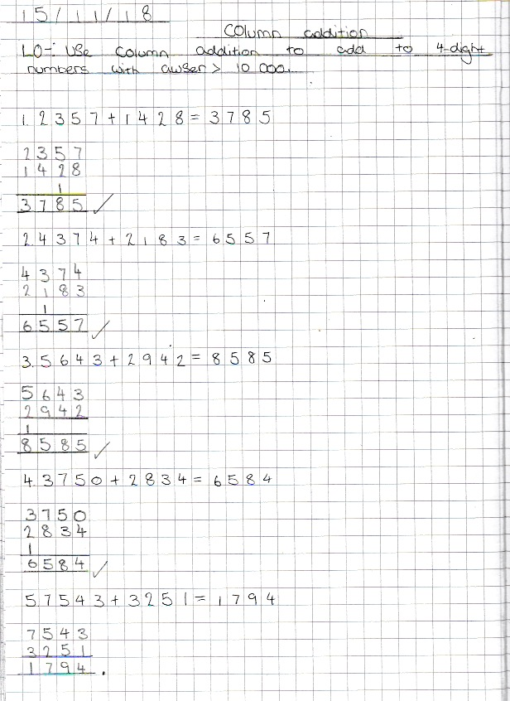
Appendix 7 – Sample of work: column addition

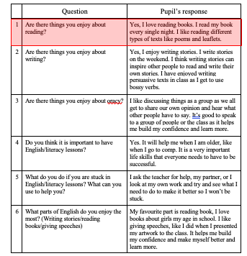
Appendix 8 – Interview: Language

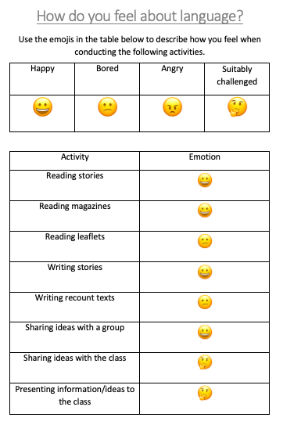
Appendix 9 – Pupil emotion table: Language

Appendix 10 – Observation: thinking skills
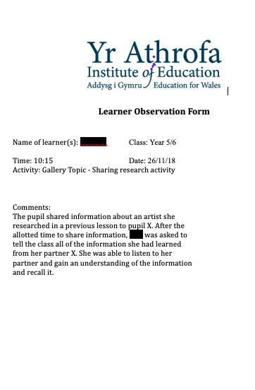

Appendix 11 – Sample of work: Vocabulary table
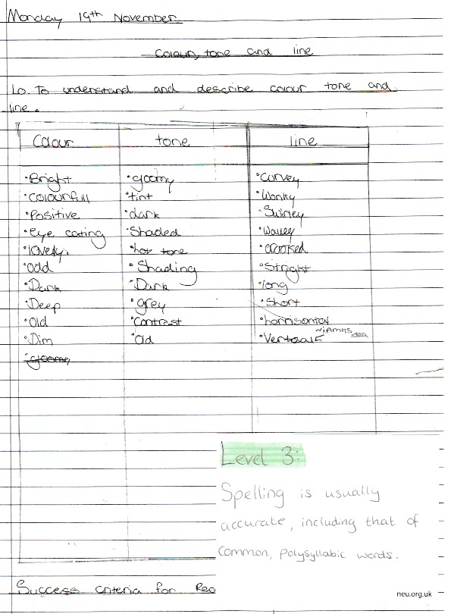

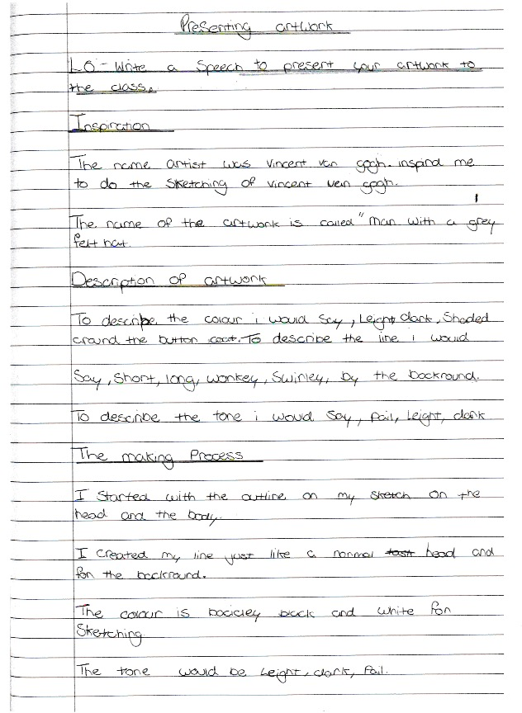
Appendix 12 – Sample of work: Speech

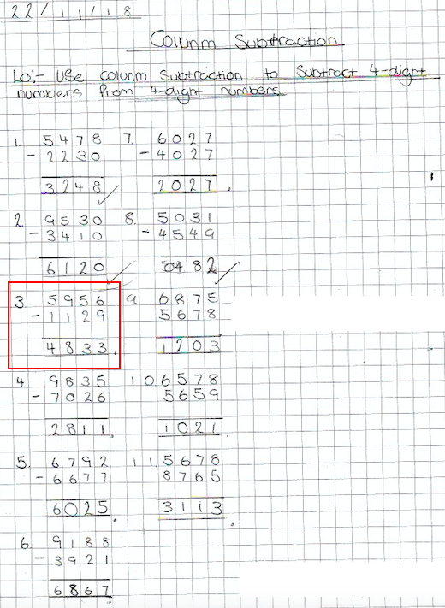
Appendix 13 – Sample of work: column subtraction

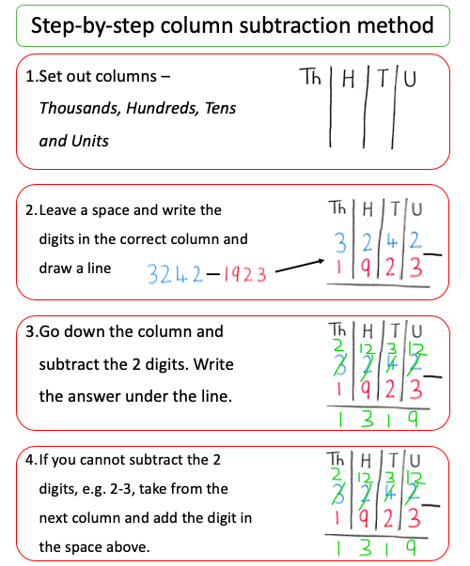
Appendix 14 – Step-by-step column subtraction

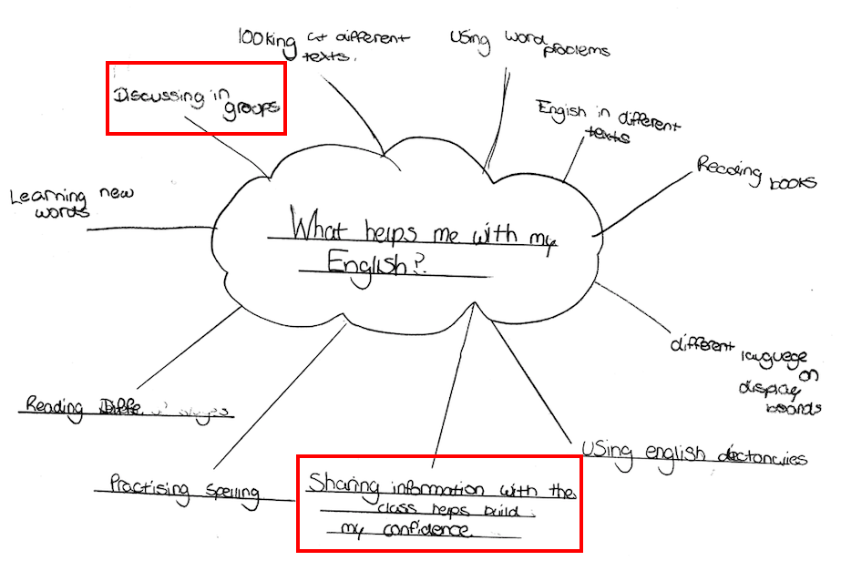
Appendix 15 – Learning map: language

Appendix 16 – Consent form

