Contents
Chapter One - Introduction 6
1. Aim 6
2. Objectives 6
3. Structure of the project 6
Chapter Two - Literature Review 7
1. Introduction 7
2. The Impact of E-commerce Websites on Information Technology 8
2.1 Introduction 8
2.2 Definition of E-commerce Websites 8
2.3 Benefits of E-commerce Websites 8
2.4 Challenges of E-commerce Websites 8
2.5 Future Perspectives of E-commerce Websites 8
3. Accessibility within E-commerce 10
3.1 Introduction 10
Importance of Accessibility in E-commerce 10
3.2 Accessibility Guidelines and Standards 10
3.3 Assistive Technologies for E-commerce Accessibility 10
3.4 Design Considerations for Accessible E-commerce 10
3.5 Legal Requirements and Compliance 10
3.6 Case Studies on Accessible E-commerce 11
4. Security within E-commerce Websites 12
4.1 Introduction 12
4.2 Authentication and Access Control 12
4.3 Secure Socket Layer (SSL) and Transport Layer Security (TLS) 12
4.4 Secure Payment Gateways 12
4.5 Regular Security Audits and Updates 12
4.6 Data Encryption and Storage 12
4.7 Security Awareness and Training 13
5. Regulations within E-commerce Websites 14
5.1 Introduction 14
5.2 Consumer Protection Regulations 14
5.3 Intellectual Property Rights 14
5.4 Payment and Security Regulations 14
5.5 International Regulations 15
6. Statistics about E-commerce in the UK 16
6.1 Introduction 16
6.2 E-commerce Growth 16
6.3 Consumer Behaviour 16
6.4 Sector-wise Distribution 16
6.5 Challenges and Opportunities 16
Chapter Three – Research Methodology 17
1. Introduction 17
Philosophy 17
Approach 17
Strategies 17
Literature Review 18
Case Study 18
Software Development 18
Risks & Limitations 18
Ethical Issues 18
Validity, Reliability & Generalisability 18
Validity 18
Reliability 19
Generalizability 19
Data Evaluation Methods 19
Data Collection 19
Data Evaluation 19
Development Methodology 20
Software Development Methodology 20
Other Relevant Subsidiary Methodologies 20
Chapter Four – Case Studies 21
1. Case Study One 21
2. Case Study Two 21
3. Case study Three 22
Chapter Five - Design & Implementation 24
1. Introduction 24
2. Design 24
3. Implementation 24
3.1 Requirements 24
3.2 Interfaces 25
3.3 problems or successes you had in coding the software 26
4. Some screenshot of both websites 27
Chapter Six - Limitations 28
1. Wix feedback 28
2. PHP Feedback 30
3. Clients feedback 31
4. Wix Analysis 32
4.1 Sessions by device 32
Chapter Seven – Evaluation 33
1. What did I learn? 33
2. Did I meet my objectives? 33
3. Did I meet my overall aim? 34
Chapter Eight – Conclusion and Recommendations 35
1. Recommendations 35
References 36
Chapter Nine - Appendix 39
1. Gantt Chart 39
2. Wireframes 39
3. Colour schemes Ideas 48
4. Error message 50
5. Self developed PHP Site 52

Figure 1 - Research onion 17
Figure 2 - Screenshot of the website looks like on the jewellery page 27
Figure 3 - Screenshot of the code for the jewellery page 27
Figure 4 - screenshot of gantt chart 39
Figure 5 - wireframe of the layout of the home page 39
Figure 6 - wireframe of the layout of the about us page 40
Figure 7 - wireframe of the layout of the staff page 40
Figure 8 - wireframe of the layout of the events calendar page 41
Figure 9 - wireframe of the layout of the gallery shop/all products page 41
Figure 10 - wireframe of the layout of the paintings & prints products page 42
Figure 11 - wireframe of the layout of the photography products page 42
Figure 12 - wireframe of the layout of the ceramics & sculpture products page 43
Figure 13 - wireframe of the layout of the Jewellery products page 43
Figure 14 - wireframe of the layout of the Hand Made Crafts products page 44
Figure 15 - wireframe of the layout of the photography books page 44
Figure 16 - wireframe of the layout of the greeting cards products page 45
Figure 17 - wireframe of the layout of the original music page 45
Figure 18 - wireframe of the layout of the private hire page 46
Figure 19 - wireframe of the layout of the private hire page 46
Figure 20 - Wireframe of the log-in/my account page 47
Figure 21 - wireframe of the register page 47
Figure 22 - colour scheme one 48
Figure 23 - Colour scheme Two 48
Figure 24 - Colour Scheme Three 49
Figure 25 - Colour Sceme Five 49
Figure 26 - Error message on XAMPP 50
Figure 27 - Error message from phpmyadmin 50
Figure 28 - Error message from all product page on my website 51
Figure 29 - Screenshot of the website looks like on the jewellery page 52
Figure 30 - Screenshot of the code for the jewellery page 52
Figure 31 - Screenshot of the submit php form 53
Figure 32 - Screenshot of the about us code 53
Figure 33 - Screenshot of book.php code 54
Figure 34 - screenshot of calandar.html code 54
Figure 35 - overview of database 55

Declaration of Originality
I, Benjamin Gaylard (2003557) declare that I am the sole author of this project; that all references cited have been consulted; that I have conducted all work of which this is a record, and that the finished work lies within the prescribed word limits.

This work has not previously been accepted as part of any other degree submission.

Signed : Benjamin Gaylard

Date : 01 May 2024

Chapter One - Introduction

Aim
This project aims to investigate and develop an e-commerce website tailored for Hybrid Arts Café.

Objectives
- Conduct a literature review on books, online resources, journals, and related articles.
- Design and develop a user-friendly e-commerce website for Hybrid Arts Café
- Conduct user testing to assess the effectiveness of the e-commerce platform, gather user feedback, and make necessary improvements to enhance user satisfaction.
- Recommend further enhancements and strategies to ensure Hybrid Arts Café's successful online presence and future growth.

Structure of the project
Chapter One outlines the project's goals and objectives.
Chapter Two delves into the existing literature.
Chapter Three details the research methodology employed.
Chapter Four examines various website case studies.
Chapter Five covers Design & Implementation.
Chapter Six addresses Limitations.
Chapter Seven discusses the project's evaluation.
Chapter Eight presents the Conclusion and Recommendations.
Chapter Nine comprises the appendix.

Chapter Two - Literature Review

Introduction

The Impact of E-commerce Websites on Information Technology

Introduction
In today's digital age, the rapid advancements in Information Technology (IT) have revolutionised various aspects of our lives. One such significant transformation is the emergence of e-commerce websites which have transformed the way businesses operate and consumers engage in online transactions. [1] This part of the literature review aims to explore the concept of e-commerce websites and their impact on Information Technology.

Definition of E-commerce Websites
E-commerce websites refer to online platforms that facilitate the buying and selling of products or services through electronic means [2]. These websites act as virtual marketplaces where businesses and consumers can interact initiate transactions and exchange goods or services. E-commerce websites utilize various technologies and tools to ensure secure and efficient online transactions including secure payment gateways encryption protocols and delivery tracking systems [3].

Benefits of E-commerce Websites
E-commerce websites have brought about numerous advantages for both businesses and consumers. Firstly these platforms have significantly expanded the market reach for businesses allowing them to transcend geographical limitations and target a global customer base. By eliminating the need for physical storefronts businesses can reduce operational costs and offer products or services at competitive prices [4].
Moreover, e-commerce websites provide consumers with convenience and accessibility. Customers can browse through a wide range of products or services from the comfort of their homes or on the go. The availability of detailed product descriptions customer reviews and comparison tools enables consumers to make informed purchase decisions. Additionally, e-commerce websites often offer personalised recommendations based on user preferences enhancing the overall shopping experience [5].

Challenges of E-commerce Websites
While e-commerce websites have revolutionised the retail industry they are not without challenges. One of the primary concerns is the issue of security and privacy. As e-commerce websites involve the exchange of sensitive personal and financial information the risk of data breaches and cyberattacks is a significant threat. Businesses must invest in robust security measures to protect customer data and maintain their trust [6].
Another challenge is the lack of physical interaction between businesses and consumers. In traditional brick-and-mortar stores, customers can touch feel and try products before making a purchase decision. E-commerce websites need to compensate for this limitation by providing detailed product descriptions high-quality images and customer reviews to bridge the gap [6].

Future Perspectives of E-commerce Websites
The future of e-commerce websites looks promising with continuous advancements in Information Technology. One of the emerging trends is the integration of Artificial Intelligence (AI) and machine learning algorithms within e-commerce platforms. AI algorithms can analyse user behaviour preferences and purchase history to offer highly personalised shopping experiences and recommendations [7].
Additionally, the rise of mobile devices has led to the growth of mobile commerce (m-commerce). E-commerce websites are adapting to this trend by optimising their platforms for mobile devices and developing dedicated mobile applications. This allows consumers to shop on the go further enhancing accessibility and convenience [8].

Accessibility within E-commerce

Introduction
In our internet-driven world, the rise of e-commerce has made it an essential part of everyday life. The proliferation of smartphones and internet access has fuelled a surge in online shopping. However, for this convenience to be truly inclusive, e-commerce platforms must prioritise accessibility [9]. This ensures that everyone, regardless of ability, can participate in the online shopping experience.

Importance of Accessibility in E-commerce
Accessibility refers to the design and implementation of digital platforms in a way that allows people with disabilities to access and navigate them effectively. In the context of e-commerce, accessibility is of utmost importance to ensure that individuals with disabilities can independently browse and make transactions on online platforms. By making e-commerce accessible businesses can tap into a larger customer base and provide equal opportunities for all users [10].

Accessibility Guidelines and Standards
To ensure accessibility within e-commerce various guidelines and standards have been established. The Web Content Accessibility Guidelines (WCAG) developed by the World Wide Web Consortium (W3C) provide a comprehensive set of recommendations for making web content more accessible. These guidelines cover aspects such as perceivability operability understandability and robustness which are crucial for creating an inclusive online shopping experience [10].

Assistive Technologies for E-commerce Accessibility
Assistive technologies play a vital role in enabling individuals with disabilities to access and interact with e-commerce platforms. Screen readers for example convert text into synthesised speech allowing visually impaired users to navigate websites. Similarly, alternative input devices such as voice recognition software and switch access can assist individuals with mobility impairments in interacting with e-commerce interfaces. By incorporating support for these assistive technologies e-commerce platforms can enhance accessibility and cater to a wider range of users [11].

Design Considerations for Accessible E-commerce
Designing an accessible e-commerce platform involves considering various factors to meet the needs of users with disabilities. Some key considerations include providing alternative text for images ensuring proper colour contrast for visually impaired users and structuring content with proper headings and navigation. Additionally implementing responsive design principles and optimizing website performance are crucial for delivering a seamless experience across different devices and internet connections [12].

Legal Requirements and Compliance
In many countries, there are legal requirements and regulations in place to ensure accessibility within e-commerce. For instance, the Americans with Disabilities Act (ADA) in the United States mandates equal access to goods and services including online platforms. Non-compliance with accessibility guidelines can result in legal consequences and damage to a company's reputation. Therefore businesses must prioritize accessibility and comply with relevant regulations [13].

Case Studies on Accessible E-commerce
Several companies have taken proactive measures to enhance accessibility within their e-commerce platforms. For example, Amazon has implemented various accessibility features such as screen reader compatibility and keyboard navigation to cater to users with disabilities [14]. Target another prominent e-commerce retailer has made significant efforts to improve accessibility by providing alternative text for images and ensuring proper colour contrast. These case studies highlight the positive impact of accessibility initiatives on user experience and customer satisfaction [15].

Security within E-commerce Websites

Introduction
In today's digital age, the growth of e-commerce has revolutionized the way businesses operate and consumers shop. However, along with the convenience and accessibility that e-commerce brings there are also significant security concerns.

Authentication and Access Control
One of the fundamental aspects of security in e-commerce websites is authentication and access control. It is crucial to verify the identity of users and control their access to sensitive information. This can be achieved through various techniques such as password biometrics two-factor authentication and encryption. By implementing strong authentication mechanisms e-commerce websites can prevent unauthorized access and protect user accounts and personal information [16].

Secure Socket Layer (SSL) and Transport Layer Security (TLS)
Another significant security measure in e-commerce websites is the use of SSL and TLS protocols. These protocols ensure secure communication between the user's browser and the website's server. SSL and TLS encrypt the data transmitted making it unreadable to anyone intercepting it. This is particularly important when transmitting sensitive information such as credit card details or personal information during online transactions [17].

Secure Payment Gateways
The security of payment transactions is of utmost importance in e-commerce websites. Payment gateways play a vital role in ensuring secure online transactions. These gateways act as intermediaries between the e-commerce website and the financial institutions securely transmitting payment information. Integration with reputable and secure payment gateways is crucial to protect customers' financial data from unauthorized access and fraudulent activities [18].

Regular Security Audits and Updates
To ensure the continuous security of e-commerce websites regular security audits and updates are necessary. Vulnerability assessments and penetration testing help identify weaknesses in the system and address them promptly. Additionally keeping the website's software and plugins up to date is crucial to address any known security vulnerabilities. Regular security audits and updates help mitigate potential risks and ensure a robust security posture [19].

Data Encryption and Storage
The protection of customer data is a primary concern for e-commerce websites. Data encryption plays a significant role in safeguarding sensitive information. Encrypting data ensures that even if it is intercepted it remains unreadable without the decryption key. E-commerce websites should also employ secure storage methods such as encryption at rest to protect customer data from unauthorized access in case of data breaches [20].

Security Awareness and Training
Human factors can often be a weak link in the security chain. Therefore it is essential to raise security awareness among employees and provide regular training sessions. Employees should be educated about best practices for handling customer data recognizing phishing attempts and understanding the importance of strong passwords. By instilling a security-conscious culture within the organization e-commerce websites can reduce the risk of insider threats and human errors [21].

Regulations within E-commerce Websites

Introduction
E-commerce has revolutionised the way businesses operate allowing them to reach a wider audience and conduct transactions online. However with the rise of e-commerce there has also been an increased need for regulations to ensure fair and secure transactions. This article explores the regulations that govern e-commerce websites and their significance in the IT and Computer Science field.

Consumer Protection Regulations
Consumer protection regulations play a crucial role in ensuring the trust and confidence of online shoppers. These regulations aim to safeguard consumers from fraudulent activities misleading information and unfair business practices. One important regulation is the requirement for e-commerce websites to provide clear and accurate product descriptions pricing information and terms of sale. This helps consumers make informed decisions and minimizes the risk of fraud or deception [22].
Furthermore e-commerce websites must adhere to regulations that protect consumers' personal information. Data privacy regulations such as the General Data Protection Regulation (GDPR) require businesses to obtain explicit consent from consumers before collecting and using their data. This ensures that consumers have control over their information and protects them from potential privacy breaches [23].

Intellectual Property Rights
Intellectual property rights (IPR) are essential in the e-commerce industry as they protect the originality and creativity of content creators. E-commerce websites must respect copyright laws and ensure that they do not infringe upon the intellectual property rights of others. This includes using copyrighted images videos or written content without permission [24].
To comply with IPR regulations e-commerce websites can implement measures such as filtering systems to detect and prevent the sale of counterfeit or pirated products. Additionally they can provide a mechanism for content creators to report any copyright infringements allowing prompt action to be taken [25].

Payment and Security Regulations
One of the critical aspects of e-commerce regulations is ensuring secure online transactions. E-commerce websites must comply with payment card industry (PCI) regulations which set standards for securely processing and storing customers' payment card information. This includes encrypting sensitive data regularly updating security measures and conducting vulnerability assessments [26].
Moreover e-commerce websites must comply with regulations that protect consumers' financial information such as the Payment Card Industry Data Security Standard (PCI DSS). These regulations help prevent data breaches identity theft and unauthorized access to sensitive information [27].

International Regulations
As e-commerce transcends geographical boundaries it is essential to consider international regulations. International regulations such as the European Union's e-commerce directive ensure a ,harmonized legal framework for online businesses. These regulations cover various aspects including electronic contracts online dispute resolution and liability of intermediaries [28].
E-commerce websites operating globally must also comply with local regulations in different countries. This includes complying with taxation laws customs regulations and consumer protection laws specific to each jurisdiction [28].

Statistics about E-commerce in the UK

Introduction
E-commerce has revolutionized the way business is conducted worldwide and the United Kingdom is no exception. This research paper aims to provide an overview of the, current statistics related to e-commerce in the UK. By examining key indicators and trends we can gain insights into the growth impact and future prospects of e-commerce in this country.

E-commerce Growth
According to the Office for National Statistics (ONS) the UK has witnessed a significant surge in e-commerce activities in recent years. In 2020 the value of e-commerce sales reached £698 billion representing a 46% increase compared to the previous year. This growth can be attributed to various factors such as increased internet penetration convenience and the COVID-19 pandemic which accelerated the adoption of online shopping.

Consumer Behaviour
Consumer Behaviour E-commerce’s grip on the UK retail scene only tightens, with a staggering 94% of adults now shopping online. Mobile reigns supreme, especially among the young, with 62% of 16-24 year olds using their devices to click and buy. Beyond convenience, platforms are winning hearts with speedy deliveries, easy returns, and personalized experiences, blurring the lines between browsing and buying with the help of social media. In this evolving landscape, understanding changing consumer preferences, from sustainability to personalized recommendations, is key to success.

Sector-wise Distribution
The mos,t popular online shopping categories in the UK are fashion, electronics and media, and food and personal care. These three sectors account for more than 70% of the online retail market share in 2022. Other sectors, such as furniture and appliances, toys and hobbies, and digital services, have smaller but growing shares of the e-commerce market.

Challenges and Opportunities
Some of the challenges faced by e-commerce businesses in the UK include competition from global players, such as Amazon, regulatory issues, such as Brexit ,and data protection laws, cyber security threats, such as hacking and fraud, and customer satisfaction and retention, such as delivery and returns policies, product quality and reviews, and loyalty programs.
Some of the opportunities for e-commerce businesses in the UK include expanding to new markets, such as cross-border e-commerce, which is expected to grow by 25% annually in the next five years, adopting new technologies, such as artificial intelligence, blockchain, and augmented reality, to enhance customer experience and efficiency, and embracing social and environmental responsibility, such as reducing carbon footprint, supporting local communities, and promoting ethical and sustainable practices.

Tool analysis
What Is an Ecommerce Website Builder?
An ecommerce website builder refers to the software that enables entrepreneurs to establish and oversee a website specializing in the online sale of goods or services. To accomplish this, a unique array of functionalities is necessary that surpasses what a conventional website builder typically provides. These functionalities encompass a shopping cart, a checkout procedure, diverse payment methods, and analytical capabilities. Furthermore, more sophisticated functionalities may encompass intricate product filtering and the inclusion of gift cards or loyalty programs as options [29].
Wix:
Wix is an influential website builder that operates without the need for code. It is equipped with various business tools that have the capability to assist in the creation of a diverse range of websites, spanning from a simple personal blog to a complex hub for an enterprise-level online business. The platform includes built-in features that cater to eCommerce, marketing, scheduling, branding, and more. As a prominent presence in the website industry, Wix has established itself as a frontrunner in web design and has been an early adopter of emerging technologies such as AI website creation .
Wix stands out as a user-friendly platform, offering a hassle-free website-building experience without the need for coding skills. Its intuitive interface caters to individuals unfamiliar with web design, empowering them to craft visually appealing and unique websites through a diverse range of templates and customization options. Wix further enhances the user experience by providing tools for ecommerce integration, and SEO optimization [3].
Nonetheless, Wix does have some limitations. Unlike some other website builders, it lacks the flexibility for users to customize code or modify the underlying structure of their sites. This constraint may pose challenges for those seeking to create intricate or highly tailored websites. Additionally, Wix can be comparatively pricier than alternative website-building options, and some users have reported concerns about the level of customer service provided by the platform [3].
WordPress:
WordPress is a free and open-source content management system (CMS) that allows you to create a website or blog without any coding experience. It is the most popular CMS in the world, powering over 60% of all websites [4].
WordPress is a great choice for beginners because it is easy to use and has a large community of users and developers [5]. There are also thousands of free and premium plugins and themes available for WordPress, which can be used to extend the functionality of your website [6].

Here are some of the benefits of using WordPress:
- Ease of use: WordPress is very easy to use, even if you have no coding experience. There are a variety of plugins and themes available that can make it even easier to create a professional-looking website [7].
- Flexibility: WordPress is a very flexible CMS that can be used to create a wide variety of websites, including blogs, e-commerce stores, and business websites [8].
- Scalability: WordPress can be scaled to support any size website. There are a variety of hosting options available that can accommodate your website's traffic and growth [9].
- Community: WordPress has a large and active community of users and developers. This means that there is a wealth of resources available to help you get started and troubleshoot any problems you may encounter [10].

Squarespace:
In the realm of website development platforms, Squarespace stands out for its user-friendly interface, characterized by an intuitive drag-and-drop functionality that empowers users to create visually appealing websites without the need for coding expertise [11]. The platform's diverse range of professionally designed templates, known for their responsiveness across devices, further facilitates the seamless customization of websites [12]. Squarespace offers an all-in-one solution, encompassing web hosting, security, domain registration, and robust e-commerce features, streamlining the website creation process for individuals and businesses. The platform's commitment to excellent customer support through live chat, email, and phone contributes to a positive user experience [13].
However, Squarespace does have its limitations. Customization options are somewhat constrained compared to other platforms, potentially requiring additional effort for users with specific design requirements. The pricing plans, while offering a compelling value proposition, may be perceived as slightly higher than some competitors, particularly for small businesses or individuals on a tight budget [14]. Additionally, the app marketplace's limited range of third-party integrations may pose challenges for users seeking to incorporate specialized tools [15].
Shopify:
Pros (Advantages) of Shopify:
- User-Friendly Interface: Shopify's intuitive design makes it easy for users to set up and manage their online stores without a steep learning curve [16].
- Diverse Template Options: The platform offers a wide range of templates, allowing users to create visually appealing and professional-looking websites [17].
- SEO Benefits: The platform includes features that contribute to better search engine rankings, helping businesses attract more visitors to their websites [16].
Cons (Disadvantages) of Shopify:
- Limited Customization: Some users find that the level of customization available on Shopify may be limiting for highly unique or specialized design preferences [18].
- Transaction Fees: Shopify charges transaction fees for using third-party payment gateways, which can add to the overall cost of running an online store for some businesses [18].

Chapter Three – Research Methodology

Introduction
A research methodology that was applied in the writing of this report. There are various kinds of research methods. Most of the research methodologies used a variety of methods. The project's methodology and research are covered in this chapter. The rationale for this project will be clarified by the research technique.
The research onion has six layers. The research onion represents the different decisions you will need to make when developing a research technique. Figure 1 shows the layers of the study onion. These levels make it easier to follow a study plan. It outlines the goals and procedures of the gathered research.

Figure 1 - Research onion

Philosophy
The project will take a positivist stance, prioritizing an unbiased and factual evaluation of the needs and efficacy of the e-commerce website. This method makes it easier to measure consumer needs and evaluate the effectiveness of websites using quantifiable standards. Following a Positivist framework, the study seeks to offer concrete and understandable insights into the process of growth.

Approach
A deductive approach will be employed, initiating the project with a meticulous review of existing e-commerce websites. This review will serve as the foundation for concluding best practices, which will then be applied to Hybrid Arts Cafe as a comprehensive case study. The deductive approach ensures a structured and logical progression from theory to application.

Strategies
The project will employ a combination of Literature Review, Case Study, and Software Development strategies to achieve a holistic understanding and successful implementation.

Literature Review
A critical aspect of the research involves conducting an in-depth literature review of previous research on e-commerce websites. This will involve an exploration of design principles, features, and best practices in the field. By synthesizing existing knowledge, the project aims to leverage proven concepts and methodologies in the development of the e-commerce platform.

Case Study
The case study strategy will involve a detailed examination of Hybrid Arts Cafe's current online presence on social media platforms such as Facebook and Instagram. This analysis will identify specific areas where the implementation of an e-commerce website can enhance business operations and improve the overall customer experience. By grounding the project in a real-world scenario, the case study strategy ensures practical relevance.

Software Development
The core of the project involves the design and development of the e-commerce website based on the research findings and insights gained from the literature review and case study analysis. This hands-on approach ensures that the theoretical knowledge acquired is translated into a functional and effective solution for Hybrid Arts Cafe.

Risks & Limitations
An essential component of the research methodology is the identification and mitigation of potential risks and limitations. Possible challenges, such as insufficient budget and technical difficulties during development, have been recognized. To address these concerns, the researcher will implement mitigation plans, including the allocation of appropriate resources and the utilization of experienced knowledge and practices.

Ethical Issues
The project acknowledges and addresses various ethical considerations associated with developing an e-commerce website. Privacy and data security are paramount, and the project commits to complying with data protection laws such as GDPR and CCPA. Additionally, the importance of informed consent is emphasized, ensuring that participants are fully aware of how their data will be used and have the option to opt out without facing negative consequences.

Validity, Reliability & Generalisability
To establish the credibility of the research, the project emphasizes validity, reliability, and generalizability.

Validity
Validity is ensured by relying on data-driven decisions and best practices. The project aims to demonstrate that the e-commerce website is an appropriate solution for Hybrid Arts Cafe's specific needs.

Reliability
The reliability of the research is highlighted by asserting that a different researcher, following the same methodology, would likely draw similar conclusions. This ensures the replicability and consistency of the study.

Generalizability
The results of the project are not confined to Hybrid Arts Cafe alone. They are designed to be applicable to other similar companies seeking to develop e-commerce websites, demonstrating a broader relevance.

Data Evaluation Methods
The data collection and evaluation methods are crucial components of the research methodology.

Data Collection
Data will be collected through a combination of stakeholder interviews, customer focus groups, and the analysis of website analytics and sales metrics. This multifaceted approach ensures a comprehensive understanding of various perspectives and aspects related to the e-commerce platform.

Data Evaluation
The collected data will be evaluated using various statistical methods and tools. This evaluation process aims to measure the effectiveness of the e-commerce website in terms of customer satisfaction, usability, and its impact on increased sales for Hybrid Arts Cafe.

Development Methodology
In the subsequent sections, the researcher will outline the approach, methodologies, and development strategies tailored to meet the needs and expectations of the project.

Software Development Methodology
Given the nature and scale of the project, Feature Driven Development (FDD) has been chosen as the primary software development methodology. FDD, being an agile approach, is deemed ideal for small single-programmer projects like this one. This methodology ensures a rapid yet effective development process, with the flexibility to incorporate adjustments as needed. Through FDD, the researcher aims to efficiently develop a feature-rich e-commerce platform that specifically addresses the unique requirements of Hybrid Arts Cafe.

Other Relevant Subsidiary Methodologies
In addition to the primary software development methodology, the researcher will incorporate other relevant subsidiary methodologies tailored to specific components within the project.
For instance, the User Experience (UX) Design methodology will be implemented to optimize site usability. This approach integrates user research, wireframing, prototyping, and usability testing to deliver an engaging user experience, ultimately converting visitors into customers. Additionally, Search Engine Optimization (SEO) best practices will be applied during the website design phase to ensure the e-commerce platform's discoverability by potential customers through search engines.
Furthermore, specific considerations relevant to cafes and art-related businesses will be integrated into the development process. For example, the visual appeal of the website will be given special attention to showcase the unique atmosphere and artistic offerings of Hybrid Arts Cafe. This will involve the integration of high-quality images, videos, and interactive elements to create an immersive online experience that mirrors the ambiance of the physical cafe.
Moreover, ensuring secure online transactions and protecting customer data will be prioritized. Robust security measures will be implemented, adhering to industry standards to build trust with customers and safeguard their sensitive information.

Chapter Four – Case Studies

Case Study One
The first website that the researcher looked into as part the case studies was; Llantarnam Grange Arts Centre.
Llantarnam Grange Arts Centre's website serves as a vibrant hub for exploring contemporary art and craft in Cwmbran, Wales, showcasing exhibitions, workshops, events, and an onsite cafe, aiming to inspire and engage a diverse audience. The centre, housed in a Grade II listed building with a rich history, was transformed into an arts centre in 1979, fostering artistic creation, education, and appreciation.
The website targets a broad audience, including art enthusiasts interested in viewing contemporary art and craft, local residents seeking engaging cultural experiences, families looking for educational activities for children, tourists exploring Cwmbran and Wales's cultural offerings, and artists and creatives seeking opportunities to showcase their work and network with others.
Its design features a contemporary and vibrant aesthetic, reflecting the centre’s artistic spirit, with high-quality photographs and videos showcasing the venue, artworks, and events. The layout is organized and user-friendly, with clear navigation menus and prominent calls to action. However, readability could be improved, especially for older users, by adjusting certain sections where black text is used on a dark background.
The website functions well on various devices and offers smooth responsiveness, with online booking for events and workshops working seamlessly. Adding functionalities like online ticket purchases for exhibitions and cafe reservations could further enhance convenience.
Content is informative and engaging, providing detailed descriptions of exhibitions, workshops, events, and the cafe menu. However, adding artist interviews, curator's notes, or related blog posts could add depth and intellectual stimulation for art enthusiasts.
SEO efforts seem targeted, with meta tags and headers utilizing relevant keywords like "Cwmbran art," "contemporary craft," and "workshops." Further analysis of keyword rankings and competition could identify optimization opportunities, especially for local searches.
While social media icons are readily available for sharing content, their integration could be strengthened by embedding social media feeds, showcasing user-generated content, and utilising interactive features like polls or Q&A sessions to activate audience engagement.
While the website appears to use secure connections and protocols, explicitly highlighting data security measures, especially if online booking or payments are implemented, would inspire trust in users.

Case Study Two
The second case which the researcher looked into was; The Art Shop & Chapel Website
The Art Shop & Chapel website serves as a comprehensive online platform for the Abergavenny-based art establishment, blending information about its two physical locations—a restored townhouse and a 19th-century chapel—while showcasing exhibitions, events, workshops, and their art supplies shop. This analysis delves into the website's design, functionality, engagement with its target audience, and areas for potential improvement.
The Art Shop & Chapel is a community-oriented centre for visual arts, music, and literature, with two distinct locations catering to aspiring and established artists, art enthusiasts, and local residents.
Its website targets a diverse audience, including art enthusiasts interested in exhibitions, workshops, and events, artists seeking materials and professional development opportunities, the local community exploring cultural activities, and foodies drawn to the Chapel Kitchen's seasonal menu and local sourcing.
With a clean and contemporary design, the website features high-quality visuals of gallery spaces, artwork, and food, complemented by straightforward navigation menus and prominent calls to action. However, optimizing white space could soften the layout's starkness and potentially enhance content hierarchy.
Functionality-wise, the website performs well across devices, with smooth interactions such as event booking forms and online shop functions. However, clearer differentiation between "The Art Shop" and "The Chapel" sections in the navigation could reduce initial confusion.
Content ranges from informative exhibition descriptions and artist profiles to event details and blog posts, though occasionally concise descriptions, particularly for artwork, could benefit from additional context or interpretations. Highlighting upcoming events and blog posts more prominently could further engage visitors.
While meta tags and headers suggest a targeted SEO strategy, further analysis of keyword rankings and optimization opportunities could be beneficial. Similarly, while website loading speed is acceptable, optimizing image sizes and implementing caching mechanisms could improve page load times.
Basic accessibility features like image alt text are present, but employing a website accessibility checker and conducting user testing with diverse abilities could identify and address potential barriers for users with disabilities.
Social media icons are readily available, but their integration could be enhanced with features like embedding social media feeds or showcasing user-generated content to further activate audience engagement.

Case study Three
The final website for this case study is; The Terrace Arts Cafe Website.
The Terrace Arts Cafe website offers a virtual glimpse into the picturesque coastal cafe nestled in Seaton Devon, showcasing its enticing menu, breathtaking ocean views, vibrant local art scene, and inviting atmosphere. This analysis dives into the website's design, functionality, engagement with its target audience, and areas for potential improvement.
Situated by the Seaton seafront, the family-run Terrace Arts Cafe combines delicious food and beverages with stunning ocean views, featuring art from local creatives adorning its walls.
The website targets a diverse audience, including beachgoers, local residents, tourists, day trippers, art enthusiasts, and families seeking a welcoming cafe experience with scenic views and good food.
With a warm and inviting aesthetic, the website features high-quality photographs capturing the cafe's interior, terrace, and ocean vistas, alongside straightforward navigation and prominent calls to action. However, enhancing the font size for improved readability on mobile devices could be beneficial.
Functionality-wise, the website performs smoothly across various devices, with interactive elements such as the contact form and email link functioning flawlessly. Introducing an online booking form for reservations, particularly during peak seasons, could enhance user convenience.
Content primarily focuses on providing informative details like menu descriptions, opening hours, location information, and gallery insights. Incorporating short stories about the featured artists could deepen the artistic appeal and foster visitor engagement.
While meta tags and headers suggest a targeted SEO approach with relevant keywords, further analysis of keyword rankings and competition could uncover optimization opportunities.
Website loading speed is acceptable on desktops but could be slightly improved on mobile devices through image size optimization and caching mechanisms, especially for users with slower internet connections.
In terms of accessibility, basic features like image alt text and keyboard navigation appear to be lacking, necessitating the implementation of an accessibility checker and user testing to ensure inclusivity for users with disabilities.
While social media icons are present for content sharing, enhancing integration through features like embedding social media feeds and showcasing user-generated content could further boost audience engagement.
Regarding security, the website seems to employ secure connections and protocols, yet explicit mention of an SSL certificate and highlighting data security measures, particularly with potential future online ordering implementation, would instil trust in users.

Chapter Five - Design & Implementation

Introduction

Design

Implementation

Requirements
Upon meeting with the owner of Hybrid Arts Café, we engaged in a comprehensive discussion to outline the precise needs and objectives of the website. From this discussion, we distilled the requirements into two distinct categories: non-functional and functional.
Non-functional requirements, as we delineated, encapsulate the overarching qualities and characteristics that define how effectively the system operates. Each of these aspects plays a critical role in ensuring the website's success in meeting user needs and stakeholder expectations [29].
User Experience: This encompasses a wide array of considerations aimed at creating an engaging and intuitive interface for visitors. To achieve this, the website must boast a visually captivating design that not only reflects the artistic essence of Hybrid Arts Café but also prioritizes ease of navigation. Furthermore, it should offer seamless compatibility across various devices, ensuring a consistent and enjoyable experience for users accessing the site from desktops, laptops, tablets, or smartphones.
Security: Paramount in today's digital landscape, security measures must be robustly implemented to safeguard user data and protect against cyber threats. This entails employing industry-standard encryption protocols, implementing secure authentication mechanisms, and regularly updating security patches to mitigate potential vulnerabilities.
Performance: The website's performance is crucial in determining user satisfaction and retention. It must be optimized for swift loading times, minimizing latency, and ensuring smooth navigation throughout the site. This involves efficient resource management, leveraging caching techniques, and employing content delivery networks (CDNs) to deliver content swiftly to users across the globe.
Maintenance: Ongoing maintenance is essential to ensure the website remains functional, secure, and up-to-date. This includes regular backups of data, software updates, and proactive monitoring to identify and rectify any issues promptly. Additionally, clear documentation and user guides should be provided to facilitate seamless maintenance procedures.
Scalability: As Hybrid Arts Café grows and evolves, the website must be capable of scaling alongside it. This necessitates a scalable infrastructure that can accommodate increased traffic, content expansion, and new features without sacrificing performance or user experience.
On the other hand, functional requirements delineate the specific features and functionalities that the website must offer to fulfil its intended purpose effectively. Each of these components contributes to the overall utility and appeal of the site, catering to the diverse needs of its users [29].
E-Commerce System: A robust e-commerce platform is imperative for facilitating online transactions, enabling customers to browse and purchase artwork, merchandise, and other offerings seamlessly. This entails implementing secure payment gateways, inventory management systems, and order processing functionalities.
Online Store: The online store should serve as a central hub for showcasing and selling Hybrid Arts Café's diverse range of products. It must feature intuitive product categorization, detailed product descriptions, high-quality imagery, and user-friendly checkout processes to streamline the purchasing experience for customers.
Blog: A blog section provides an avenue for sharing news, updates, stories, and insights relevant to the Hybrid Arts community. It serves as a platform for engaging with customers, fostering a sense of community, and showcasing the cafe's artistic endeavours, events, and initiatives.
Event Calendar: An interactive event calendar is essential for keeping patrons informed about upcoming events, performances, workshops, and exhibitions hosted by Hybrid Arts Café. It should allow for easy browsing, filtering, and RSVP functionality, empowering users to plan their visits and participate in scheduled activities.
Monthly Subscription Plan: Offering a monthly subscription plan provides customers with exclusive benefits, discounts, and perks, incentivizing loyalty and recurring patronage. The website should support subscription management functionalities, allowing users to sign up, manage their subscriptions, and access member-only content or events.
Integration with Square POS: Integration with Square Point of Sale (POS) system streamlines transaction processing and inventory management, synchronizing online and offline sales channels seamlessly. This ensures real-time inventory updates, centralized sales reporting, and enhanced operational efficiency for Hybrid Arts Café.
See summary of the requirements in the appendix.

Interfaces
At the initial meeting with the owner, there was a discussion about colour preferences for the website, encompassing a range from blue, black, white, grey, brown and orange. These colours were envisioned to set the tone and vibe of the website, reflecting the brand's identity and values. However, as the project progressed, there was a shift in the researcher vision.
Following the meeting, the researcher diligently compiled several colour palettes, drawing inspiration from the owner's initial preferences. These palettes were thoughtfully crafted to resonate with the brand and its target audience, each offering a unique blend of hues and shades. However, despite the careful selection and after completing an module researcher in usability they decided to change the colour scheme to the main three colours. The colour scheme change to black, white and orange.
The developer embarked on establishing the information hierarchy through low-fidelity, black-and-white wireframes. These wireframes served as the skeletal framework for each page of the website, focusing on layout and structure without the distraction of colour-detailed design elements. This approach allowed the client to assess the fundamental layout and flow of the website, providing valuable insights for further refinement.
By starting with low-fidelity wireframes, the developer fostered collaboration and transparency in the design process, enabling the client to actively participate in shaping the user experience. This iterative approach not only ensured that the website met the client's expectations but also facilitated efficient development by addressing potential design challenges early on.

problems or successes you had in coding the software
One error that the developer encountered is that the address table will not enter the data through the shipping form during the checkout stage. This will cause an issue for the owner as she wouldn’t know where the order would need to be posted too. To resolve this issue, the developer should first thoroughly review the code for any bugs or inconsistencies. They should ensure that the shipping form is properly linked to the address table and that all necessary data fields are correctly mapped. Additionally, testing the functionality across different scenarios can help identify any specific conditions causing the issue. If needed, consulting with online tools such as Stack overflow, an AI tool or referring to documentation for the programming language or framework being used may provide insights into potential solutions. Once the root cause is identified, implementing the necessary fixes and conducting thorough testing to verify the functionality is essential before deploying the updated code to the production environment.
Another issue in the development and testing phase of the website, the developer encountered a challenge with XAMPP, a popular free PHP development environment used on Windows, macOS, or Linux systems. Specifically, an error occurred where MySQL shut down unexpectedly. To address this issue, the developer needed to restore the database backup from the c drive. However, although the database itself was backed up, the tables within it were not included. Fortunately, the developer was able to resolve this setback by importing an older version of the tables into phpMyAdmin, a web-based administration tool for managing MySQL databases. By doing so, the necessary table structures and data were restored, allowing the developer to continue their work on the website without further interruption. See the appendix for the error which was encountered.

Some screenshot of both websites
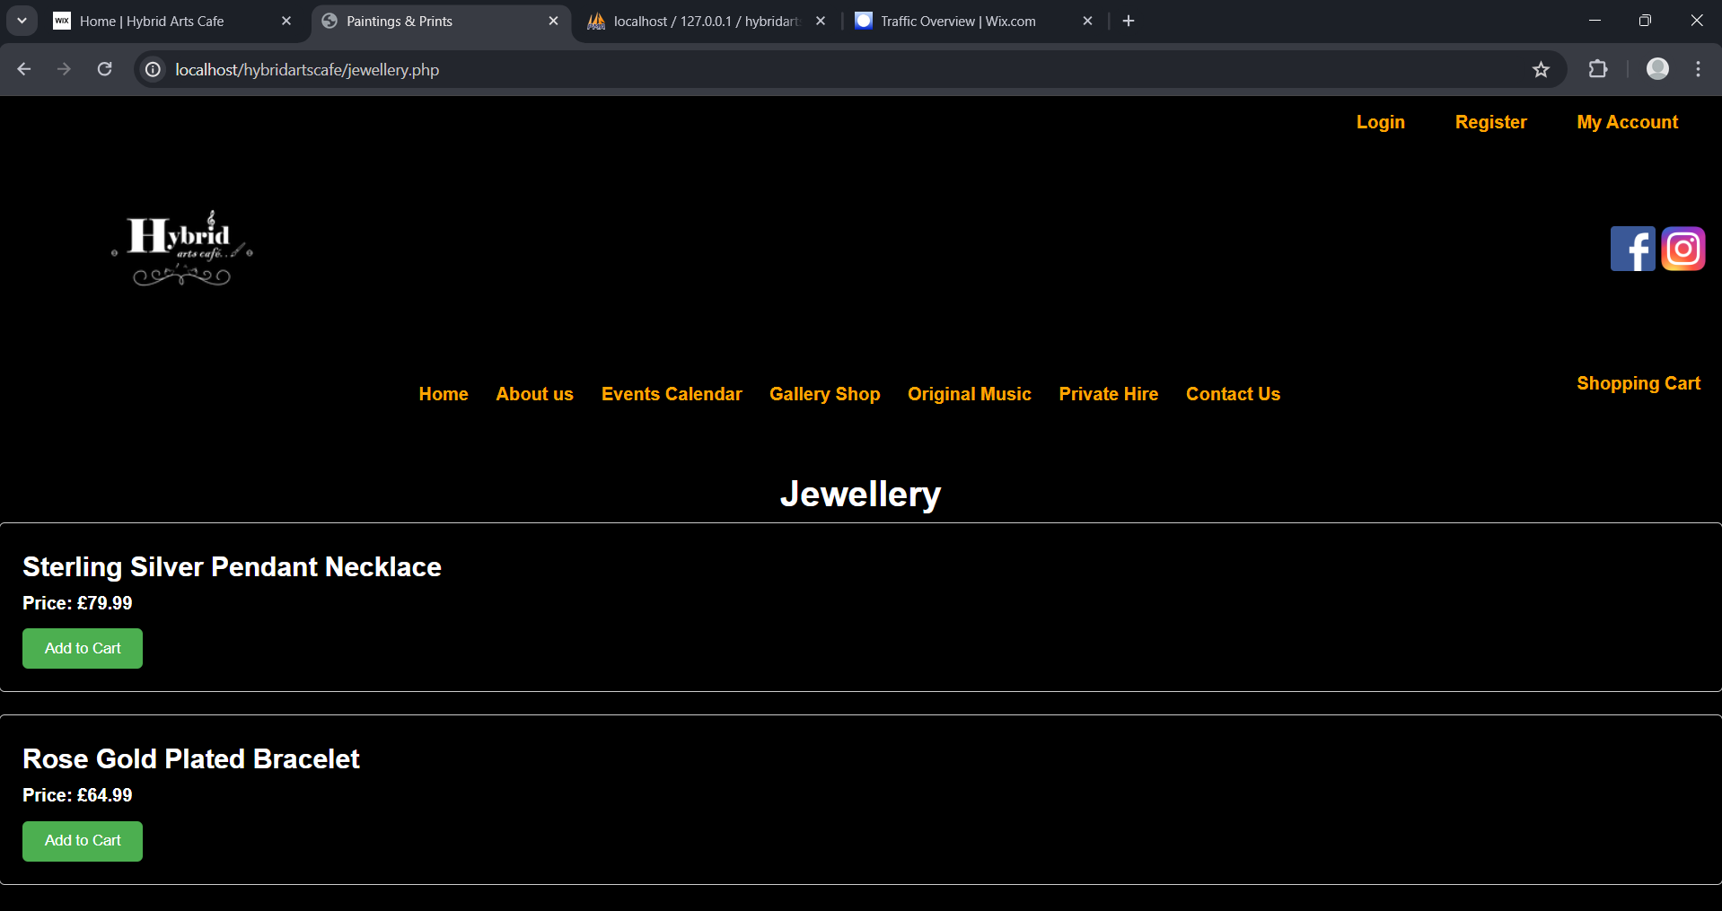
Figure 2 - Screenshot of the website looks like on the jewellery page
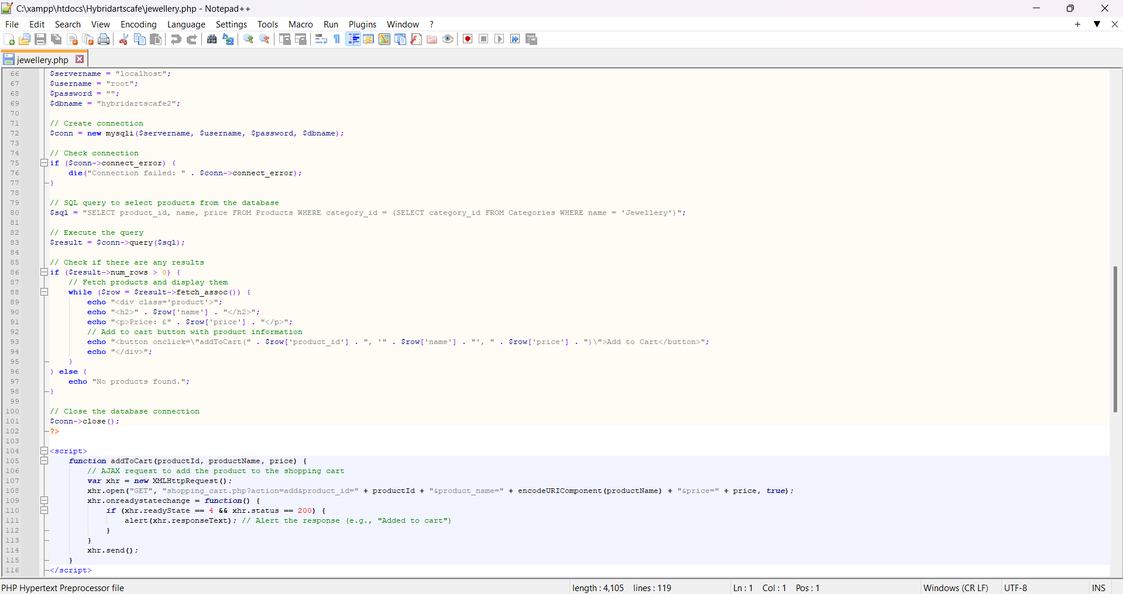
Figure 3 - Screenshot of the code for the jewellery page
Figure 3 shows the code which was used to create the jewellery page for the website.

Chapter Six - Limitations

Wix feedback
Understanding User Feedback to Enhance Your Wix Website
Building a website involves constant creation, evaluation, and improvement. User feedback is vital in this process, offering valuable insights from various perspectives. By embracing constructive criticism, website owners can refine the user experience (UX) and ensure their online presence resonates with their target audience. This analysis explores the feedback provided by five individuals regarding a Wix website, pinpointing areas for improvement alongside noteworthy strengths.
Person One
The first critique highlights the website's structure as a key concern. Person One finds the distinction between header text, navigation menu, and content unclear, potentially confusing users. Text overlapping images, an odd square within the navigation menu, and a cluttered homepage are also identified. While acknowledging functional website links and social media integration, suggestions are made to streamline navigation and establish a consistent colour scheme across all pages.
To address Person One's concerns, a website audit is recommended. This process meticulously evaluates the site's information architecture, ensuring a clear hierarchy that guides users intuitively. This might involve implementing clear visual separation between headers, menus, and content sections. Effective use of white space can also enhance readability and reduce clutter. Additionally, revisiting the design of the navigation menu to eliminate the "random square" and streamline its overall layout is crucial. A/B testing different colour schemes can lead to the selection of a palette that is both aesthetically pleasing and promotes user engagement.
Person Two:
The second perspective focuses on the website's colour scheme, suggesting that the current one might be overwhelming for visitors. Despite this critique, Person Two acknowledges positive aspects like social media buttons that enable seamless connection and a map feature that enhances user convenience. Recommendations include consolidating login options for a more streamlined user experience. Displaying opening hours prominently on the Contact Us page will ensure users can easily access crucial information. The layout of the private hire section also warrants refinement, ensuring clarity and intuitive navigation. Particular focus should be directed towards improving text visibility on buttons and calendars to prevent user frustration.
Addressing Person Two's feedback necessitates a data-driven approach. Heatmaps, a website analytics tool, can reveal areas of user focus, informing the decision-making process regarding colour palette optimisation. Striking a balance between visual appeal and user comfort is paramount. Streamlining login options by implementing single sign-on or social media logins can expedite user access. Integrating opening hours seamlessly within the Contact Us page ensures users are well-informed. Additionally, restructuring the private hire section to enhance its intuitiveness and conducting usability testing will bolster user confidence when navigating this specific feature. Text size and colour contrast on buttons and calendars require careful consideration to guarantee optimal readability across devices.
Person Three
The third perspective underscores the importance of design coherence and simplicity. Person Three proposes linking the website logo directly to the homepage, a fundamental user expectation. Implementing a limited colour palette restricted to three shades fosters a more unified visual experience. Integrating subscription options organically within the website's existing text flow can also enhance user engagement. Notably, Person Three suggests incorporating opening hours, alternative payment methods (if applicable), and a visually appealing logo in place of text-based branding.
Addressing Person Three's feedback necessitates revisiting the website's design principles. Implementing a style guide that outlines colour palettes, font choices, and logo usage will establish design consistency across all pages. A prominent "Home" button linked to the homepage should be readily accessible from all website sections. Integrating subscription options seamlessly within the content can incentivise users to engage further. Implementing a visually striking logo that aligns with the overall design aesthetic will enhance brand recognition. Additionally, ensuring opening hours are readily accessible and incorporating alternative payment options (if applicable) will bolster user experience.
Person Four
Person Four's feedback sheds light on potential issues with mobile device compatibility. Formatting inconsistencies observed on Android phones necessitate immediate attention. Positive remarks regarding login functionality and link accessibility offer reassurance. However, critiques encompass ambiguous features like a clickable wheel and undisclosed additional photo galleries. Person Four emphasises the importance of consistent font size and colour palette across all pages, particularly in sections like "About Us" and "Private Hire."
Heeding Person Four's feedback necessitates employing responsive web design (RWD) principles. RWD ensures that website layout adapts automatically based on the device being used, guaranteeing an optimal user experience across desktop computers, tablets, and mobile phones. Investigating the purpose and functionality of the "clickable wheel" element is crucial for determining whether it requires refinement.
Person Five
Person Five reiterates the importance of user experience across various devices. They point out readability challenges encountered on smaller screens, highlighting the necessity for adjustments. While acknowledging the website's initial positive impression, their suggestions focus on enhancing clarity through font size adjustments and colour scheme refinements. Specific areas for improvement include decluttering content, standardizing font sizes, and improving text visibility on various backgrounds.
Addressing Person Five's feedback necessitates a focus on accessibility. Implementing larger font sizes and ensuring sufficient contrast between text and background colours will enhance readability on mobile devices. Utilising responsive web design principles (as mentioned with Person Four) will guarantee the website adjusts automatically to different screen sizes, preserving readability across all devices. Decluttering content by prioritising essential information and strategically utilising white space can further improve user experience on smaller screens. Standardizing font sizes across all pages will create a more cohesive and user-friendly experience.
Person Six
Person six emphasises the importance of accessibility and user experience across various functionalities of the website. They note the ease of navigation with Voiceover but suggest additional features like alternative buttons for size adjustment and colour inversion for improved visibility. Moreover, they highlight areas such as the calendar on the event page and the lack of alt text for images in the online shop that hinder accessibility.
Person Five praises the well-structured layout of the about us page and the ease of navigation on the event page, but they propose simplifying the calendar function for better compatibility with Voiceover. Additionally, they commend the usability of the online shop but suggest adding alt text to images for accessibility.
On the contact page, Person six suggests including a telephone number for the café alongside email contact options. They also recommend making the forgotten password and sign-up buttons clearer for Voiceover users on the login page and adding alternative login methods like Google or Facebook authentication.
Overall, Person six finds the website well-organized and accessible with voiceover but suggests enhancements for better usability and accessibility, particularly regarding alternative button options, calendar functionality, image alt text, and contact options. They also advocate for future content like videos to include audio descriptions or subtitles for improved accessibility to visually and hearing impaired individuals.

PHP Feedback
Positive Impressions on Layout and Navigation
All three testers agreed that the calendar layout was superior to the Wix design. They found the website easy to navigate, highlighting a successful layout implementation. This suggests the website's underlying structure is user-friendly and provides a smooth user experience.
Colour Scheme and Readability
While Person Two appreciated the overall colour scheme, they found the orange text colour on a white background to be straining on the eyes. This calls for adjusting the text colour, particularly for improved readability of text against the white background. Person Three also suggested tweaking the sub-menu text colour to create a more cohesive aesthetic experience.
Enhancing Login and Registration
Both Person One and Person Two highlighted the absence of crucial features for user login and account management:
Social Login: Integrating login options through Google and Facebook would provide convenience for users who already have accounts on those platforms. This would streamline the login process and potentially attract new users familiar with those platforms.
Forgotten Password: This is a standard functionality that allows users to retrieve their password if forgotten. Its absence can be frustrating for users who encounter login difficulties. Implementing a forgotten password feature would improve user experience and reduce potential frustration.
Reset Password: Adding a "reset password" option during login would streamline password recovery. This would allow users to easily reset their passwords without needing to contact customer support.
"My Account" Page Customisation
Person Two suggested a change to the heading colour on the "My Account" page, implying it clashes with the overall theme. Addressing this would ensure a more visually consistent and aesthetically pleasing experience for users navigating their account page.
Success with Social Media Integration
Person Three applauded the inclusion of social media links, highlighting the website's potential for user connection and community building. This suggests the website is on the right track in terms of fostering social interaction and engagement.
Expanding Calendar Sharing Capabilities
Person Three appreciated the ability to share calendar events on social media platforms, emphasizing the website's social and collaborative features. This suggests the website is already leveraging social media integration, but there might be further opportunities to explore enhancing calendar-sharing functionalities.
Expanding Payment Options
Person Three suggested adding PayPal as a payment option alongside any existing methods. This would cater to users who prefer alternative payment gateways and potentially increase the website's appeal to a wider audience with diverse payment preferences.
Recommendations for Logo Improvement
Person Three recommended enlarging the logo for better brand recognition. Additionally, implementing a link on the logo that redirects users back to the homepage would create a smoother website flow. A larger and more prominent logo would strengthen brand identity, while a clickable logo directing users back to the homepage would improve user experience and website navigation.

Clients feedback
The website design hasn't hit the mark with the client. They feel it relies too heavily on templates, suggesting they find it unoriginal and lacking a unique feel for their brand. They believe they could create a similar website themselves quite quickly.
There are also functionality issues. The website apparently isn't fully working, particularly when it comes to taking payments. The absence of payment methods on the checkout page is a critical flaw, as it would prevent customers from completing purchases. Without a working checkout process, the website can't serve its core purpose.
Content seems to be entirely missing as well. The client points out there's no relevant information or even their products listed on the website. Without this essential content, the website offers no value to visitors and simply won't achieve its goals.
Beyond the design itself, the client is unhappy with how the project was managed. They feel they weren't involved in the development process, even though they were told it was an independent project. This lack of collaboration has left them feeling excluded and unimportant.
Overall, the client feels the website is incomplete and unprofessional. They're disappointed that the final product doesn't reflect the level of customisation and functionality they were expecting.

Wix Analysis

Sessions by device
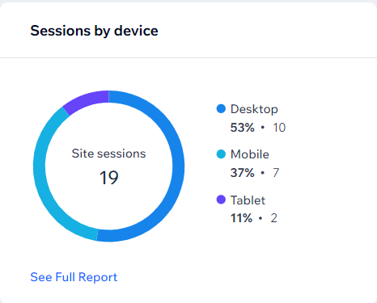
This bar graph illustrates the distribution of website sessions across different device types. As evident from the graph, desktop devices account for the highest proportion of sessions at 53%. Mobile devices follow closely at 37% while tablets contribute to 11% of overall sessions.
This data suggests that a significant portion of users access the website via desktops. However, there is a considerable mobile user base as well. This highlights the importance of ensuring a responsive website design that adapts seamlessly across various devices.

Chapter Seven – Evaluation

What did I learn?
This project has proven to be an exceptional educational endeavour, providing valuable insights into website development. My primary focus was on coding different sections of the website using Java, which afforded me a comprehensive introduction to the intricacies of web development.
Initially, my exploration delved into Java for interactivity, requiring a deep understanding of Java syntax and logic to craft dynamic website elements.
Subsequently, I delved into the synergy between Java, PHP, and CSS. Java facilitated interactivity, while PHP managed server-side tasks and database interactions. CSS played a pivotal role in visually enhancing the website's presentation.
Importantly, this project underscored the significance of client requirements. It demanded a keen understanding of the client's vision and adept translation of those needs into executable code.

Did I meet my objectives?
During this project, I did meet the objectives which I set out the complete.
The project's success began with a comprehensive literature review. This involved a deep dive into relevant resources from the UWTSD library, including books and journals. Additionally, I explored scholarly articles on the IEEE website and examined journals from the field of e-commerce. This research phase was crucial as it provided a strong understanding of best practices in e-commerce and the importance of user experience (UX) considerations. These insights directly informed the design and development of the Hybrid Arts Café website, ensuring it adhered to current best practices and prioritized user needs.
Leveraging the knowledge gained from the literature review, I designed and developed a fully functional e-commerce website specifically for Hybrid Arts Café. The user interface (UI) was meticulously crafted to prioritise user-friendliness. This involved incorporating well-chosen colour schemes that not only enhance the website's aesthetics but also contribute to a positive user experience.
To ensure the website's effectiveness in achieving its goals, I conducted user testing sessions. This involved recruiting users to interact with the website and provide valuable feedback. This feedback proved to be instrumental in identifying areas for improvement. By carefully considering user insights, I was able to make necessary adjustments and optimize the website for maximum user satisfaction.
Building upon the successes of this project, I have formulated additional recommendations and strategies. These are designed to further strengthen Hybrid Arts Café's online presence and pave the way for continued growth in the future. By implementing these recommendations, the cafe can solidify its position in the online marketplace and reach a wider audience.

Chapter Eight – Conclusion and Recommendations

Recommendations
The foremost recommendation for enhancing the Hybrid Arts Café website is to integrate their point of sale system. By seamlessly incorporating this system, the café can streamline inventory management processes and gain valuable insights into the most popular items sold over the past year. This integration would not only improve operational efficiency but also enable the café to make data-driven decisions regarding stocking and marketing strategies.
Secondly, the implementation of a monthly subscription plan could significantly benefit the café in various ways. Such a plan would provide a consistent revenue stream, foster customer loyalty through exclusive perks and discounts, and offer a more personalized experience tailored to individual preferences. Additionally, it would yield valuable data insights for marketing and product development, necessitating careful consideration of pricing, benefits, and marketing strategies to ensure its success. User-friendly subscription management features on the website would enhance convenience and customer satisfaction.
Furthermore, enhancing security features at crucial stages like checkout, login, and registration is imperative. Utilising HTTPS encryption during checkout, partnering with secure payment processors, and implementing strong password requirements with multi-factor authentication are essential steps to safeguard customer data and build trust. Additionally, measures such as email verification for user legitimacy can enhance security and protect against potential threats.
In conclusion, these recommendations collectively present a comprehensive strategy to improve the Hybrid Arts Café website. Each initiative offers opportunities for growth, customer satisfaction, and operational efficiency, making them ideal projects for an undergraduate student to undertake.

References

[1] | “A Study on Impact of E-Commerce on Consumer Buying Behaviour (With Special Reference to Grocery Products, Consumer of Coimbatore District),” vol. 9, no. 8, pp. 28-31, 2023.
[2] | D. Chaffey, Digital business and e-commerce management, Pearson UK, 2020.
[3] | P. Kotler, H. Kartajaya and I. Setiawan, Marketing 4.0: Moving from traditional to digital., John Wiley & Sons, 2020.
[4] | E. Turban and J. Outland, Electronic commerce 2018: A managerial and social networks perspective., Springer, 2019.
[5] | K. C. Laudon and C. G. Traver, E-commerce 2020: Business, technology, society, Pearson, 2020.
[6] | M. A. Hossain and A. S. Patrick, “E-commerce security and privacy: Challenges and strategies.,” Journal of Management Information and Decision Sciences, vol. 23, no. 2, pp. 14-25, 2020.
[7] | S.-C. Necula and V.-D. Păvăloaia, “AI-Driven Recommendations: A Systematic Review of the State,” pp. AI-Driven Recommendations: A Systematic Review of the State of the Art in E-Commerce, 2023.
[8] | A. Kompaniets, “Why Mobile Commerce Is Growing So Fast,” Uptech, 27 June 2023. [Online]. Available: https://www.uptech.team/blog/m-commerce-overview. [Accessed 29 December 2023].
[9] | WebAim, “Webaim,” n.d.. [Online]. Available: https://webaim.org/. [Accessed 29 December 2023].
[10] | W3C, “WCAG 2 Overview,” n.d.. [Online]. Available: https://www.w3.org/WAI/standards-guidelines/wcag/. [Accessed 28 December 2023].
[11] | W3C Web Accessability Initiative(WAI), , “Making the Web Accessible,” n.d.. [Online]. Available: https://w3.org/WAI/. [Accessed 01 January 2024].
[12] | “E-Commerce Website for Visually Impaired,” International Journal For Science Technology And Engineering, vol. 11, no. 5, pp. 6033-6038, 2023.
[13] | Americans with Disabilities Act (ADA), “Accessibility,” n.d.. [Online]. Available: https://www.ada.gov/. [Accessed 01 Feburary 2024].
[14] | Amazon, “accessibility,” n.d.. [Online]. Available: https://www.amazon.com/accessibility.. [Accessed 01 Janauary 2024].
[15] | Target, “Accessibility,” n.d.. [Online]. Available: https://help.target.com/help/subcategoryarticle?parentcat=Compliance&childcat=Accessibility&lnk=fnav_t_spc_1_21. [Accessed 02 January 2024].
[16] | H. Nahari, Web Commerce Security: Design and Development, Wiley, 2011.
[17] | W. Stallings, Network Security Essentials: Applications and Standards., Pearson, 2017.
[18] | K. C. Laudon, and C. G. Traver, E-commerce 2019, Pearson, 2019.
[19] | R. J. Anderson, Security Engineering: A Guide to Building Dependable Distributed Systems., Wiley, 2020.
[20] | J. Ashdown and E. Eryurek, Data Governance: The Definitive Guide, O'Reilliey, 2021.
[21] | TechWyse, “Cyber Security Human Factors & Vulnerabilities,” 23 March 2023. [Online]. Available: https://techwyse.co.uk/cyber-security/human-aspects/. [Accessed 01 March 2024].
[22] | legislation.gov.uk, “Consumer Rights Act 2015,” n.d.. [Online]. Available: https://www.legislation.gov.uk/ukpga/2015/15/section/2.. [Accessed 01 March 2024].
[23] | Intersoft Consulting , “General Data Protection Regulation GDPR,” n.d.. [Online]. Available: https://gdpr-info.eu/. [Accessed 30 Decemeber 2023].
[24] | European Union Intellectual Property Office (EUIPO), “Protecting your IP rights on e-commerce marketplaces,” n.d.. [Online]. Available: https://www.euipo.europa.eu/en/observatory/enforcement/tools/protecting-ip-rights-e-commerce-marketplaces. [Accessed 30 December 2023].
[25] | World Intellectual Property Organization (WIPO), “E-commerce and Intellectual Property Rights: A Guide for Policy Makers,” n.d.. [Online]. Available: https://www.wipo.int/edocs/mdocs/sme/en/wipo_wasme_ipr_ge_03/wipo_wasme_ipr_ge_03_13-main1.pdf. [Accessed 30 December 2023].
[26] | National Institute of Standards and Technology (NIST), “Volume I: Guide for Mapping Types of Information and Information Systems to Security Categories,” August 2008. [Online]. Available: https://nvlpubs.nist.gov/nistpubs/legacy/sp/nistspecialpublication800-60v1r1.pdf. [Accessed 30 December 2023].
[27] | Payment Card Industry Security Standards Council (PCI SSC), “PCI Data Security Standard (DSS) v4.0.,” March 2023. [Online]. Available: pcisecuritystandards.org. [Accessed 30 December 2023].
[28] | European Commission, “e-Commerce Directive | Shaping Europe's digital future,” n.d.. [Online]. Available: digital-strategy.ec.europa.eu. [Accessed 03 February 2024].
[29] | R. S. Pressman and B. E. Maxim, Software engineering: A practitioner's approach, McGraw-Hill Education, 2015.
[30] | P. L. A. T. MARK N.K SAUNDERS, RESEARCH METHODS FOR BUSINESS STUDENTS, New York:: Pearson Education, 1997.
[31] | “Project Guide for steps of the scientific method,” [Online]. Available: Source: https://www.sciencebuddies.org/science-fair-projects/science-fair/steps-of-the-scientific-method). [Accessed 2022 3 3].

Reference list for tool analysis didn’t have time to include with the main reference list
[2] | E. Shwake, “What is Wix, you ask? Let us show you,” 08 September 2023. [Online]. Available: https://www.wix.com/blog/what-is-wix#viewer-7q3jb. [Accessed 24 November 2023].
[3] | P. Harris, “Pros and Cons of Using Wix - 13 Factors to Consider,” 20 July 2023. [Online]. Available: https://www.enzuzo.com/blog/pros-and-cons-of-using-wix. [Accessed 20 November 2023].
[4] | Wordpress.org, “Meet WordPress,” n.d.. [Online]. Available: https://twd.wordpress.org/. [Accessed 20 November 2023].
[5] | WordPress.com., “WordPress.com vs. WordPress.org,” n.d.. [Online]. Available: https://wordpress.com/support/com-vs-org/. [Accessed 20 November 2023].
[6] | B. Jovanovic, “35+ Best ThemeForest WordPress Themes for Any Business,” 30 October 2023. [Online]. Available: https://wpklik.com/wordpress-themes/best-themeforest-wordpress-themes/. [Accessed 21 November 2023].
[7] | Wordpress.com, “Plugins,” n.d.. [Online]. Available: https://wordpress.org/plugins/. [Accessed 20 November 2023].
[8] | J. Creatives, “How to Create a WordPress Website,” 27 February 2018. [Online]. Available: https://www.youtube.com/watch?v=GxH3nyKR7wA. [Accessed 24 November 2023].
[9] | kinsta.com, “Powerful Managed WordPress Hosting,” n.d.. [Online]. Available: https://kinsta.com/wordpress-hosting/. [Accessed 20 November 2023].
[10] | Wordpress.org, “Support Forums.,” n.d.. [Online]. Available: https://wordpress.org/support/forums/. [Accessed 21 November 2023].
[11] | L. Akseli, “Squarespace pros and cons: an in-depth analysis based on 200 reviews,” 06 September 2022. [Online]. Available: https://www.twicecommerce.com/blog/ecommerce/squarespace-pros-and-cons. [Accessed 20 November 2023].
[12] | M. Bahic, “Squarespace website builder review (2023): Pros and cons, features tested by our experts,” 14 November 2023. [Online]. Available: https://www.techradar.com/reviews/squarespace. [Accessed 20 November 2023].
[13] | R. Brandl and I. Wibowo, “Squarespace Review 2023 Does It Live Up to the Hype?,” October 16 2023. [Online]. Available: https://www.tooltester.com/en/reviews/squarespace-review/#pros-cons. [Accessed 20 November 2023].
[14] | Ravi, “Disadvantages Of Squarespace: Read This Before Buying!,” 17 January 2023. [Online]. Available: https://www.rockstarmarketing.co.uk/disadvantages-of-squarespace/#What_is_Squarespace. [Accessed 21 November 2023].
[15] | J. WARNIMONT, “Squarespace Review: Great for Some People, but Not for Everyone,” 03 May 2023. [Online]. Available: https://themeisle.com/blog/squarespace-review/#pros-cons. [Accessed 21 November 2023].
[16] | Waredock, “9 Shopify Benefits You Should Know,” n.d.. [Online]. Available: https://www.waredock.com/magazine/advantages-of-shopify/. [Accessed 24 November 2023].
[17] | ReConvert, “The Pros & Cons of Shopify - Is it Right for You?,” 20 September 2022. [Online]. Available: https://www.reconvert.io/blog/shopify-pros-and-cons. [Accessed 25 November 2023].
[18] | BOAST DIGITAL, “Advantages and Disadvantages of Shopify,” 11 March 2022. [Online]. Available: https://www.boastdigital.com.au/advantages-and-disadvantages-of-shopify/#Disadvantages_of_Shopify. [Accessed 25 November 2023].
[19] | Squarespace, “Frequently asked questions,” n.d.. [Online]. Available: https://www.squarespace.com/. [Accessed 20 November 2023].
Reference list for statistics didn’t have time to include with the main reference list
[1] | Statista Research Department, “E-commerce in the United Kingdom (UK) - statistics & facts,” 19 December 2023. [Online]. Available: https://www.statista.com/topics/2333/e-commerce-in-the-united-kingdom/#topicOverview. [Accessed 05 January 2024].
[2] | Mordor Intelligence, “UK Ecommerce Market Size & Share Analysis - Growth Trends & Forecasts Source,” n.d.. [Online]. Available: https://www.mordorintelligence.com/industry-reports/united-kingdom-ecommerce-market. [Accessed 20 January 2024].
[3] | L. Castillo, “Must-Know Uk Ecommerce Statistics [Latest Report],” 16 December 2023. [Online]. Available: https://gitnux.org/uk-ecommerce-statistics/. [Accessed 01 Janaury 2024].
[4] | A. Adebisi, “UK Retail Report, E-Commerce Trends, and Online Shopping Statistics 2023,” 12 July 2023. [Online]. Available: https://investingstrategy.co.uk/financial-news/uk-retail-report-e-commerce-trends-and-online-shopping-statistics-2023/. [Accessed 03 January 2024].
[5] | Mordor Intelligence, “UK Ecommerce Market Size & Share Analysis - Growth Trends & Forecasts (2024 - 2029),” n.d.. [Online]. Available: https://www.mordorintelligence.com/industry-reports/united-kingdom-ecommerce-market. [Accessed 19 January 2024].
[6] | Statista Research Department, “E-commerce in the United Kingdom (UK) - statistics & facts,” 19 december 2023. [Online]. Available: https://www.statista.com/topics/2333/e-commerce-in-the-united-kingdom/#topicOverview. [Accessed 19 Janaury 2024].

Chapter Nine - Appendix

Gantt Chart
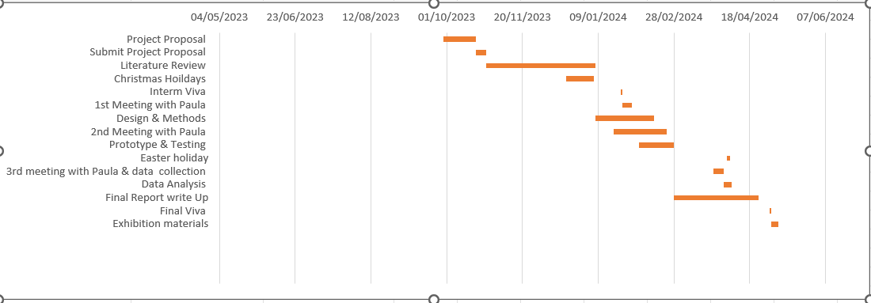
Figure 4 - screenshot of gantt chart

Wireframes
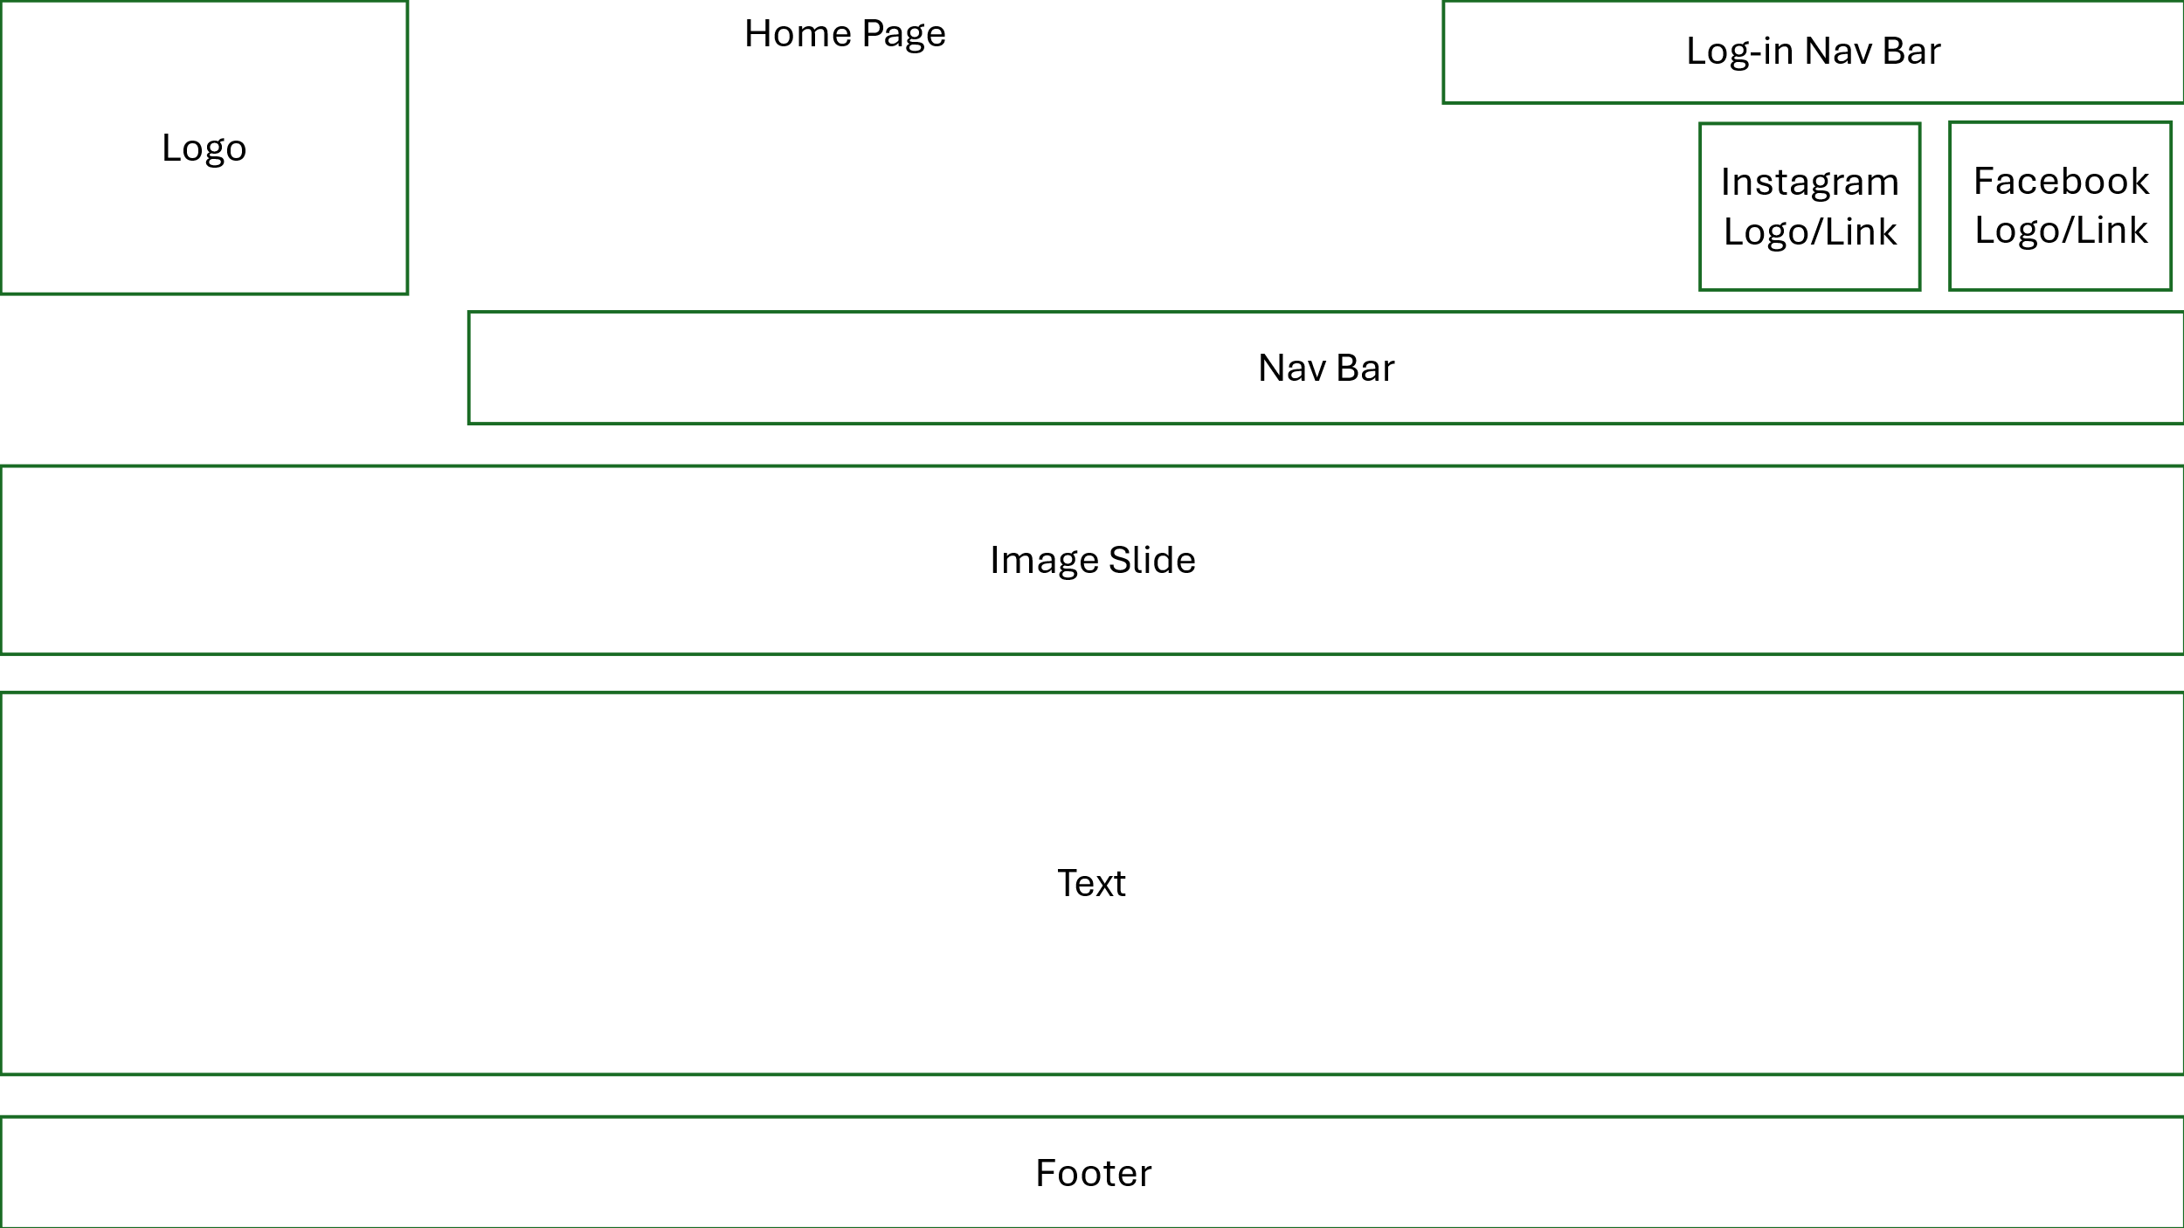
Figure 5 - wireframe of the layout of the home page
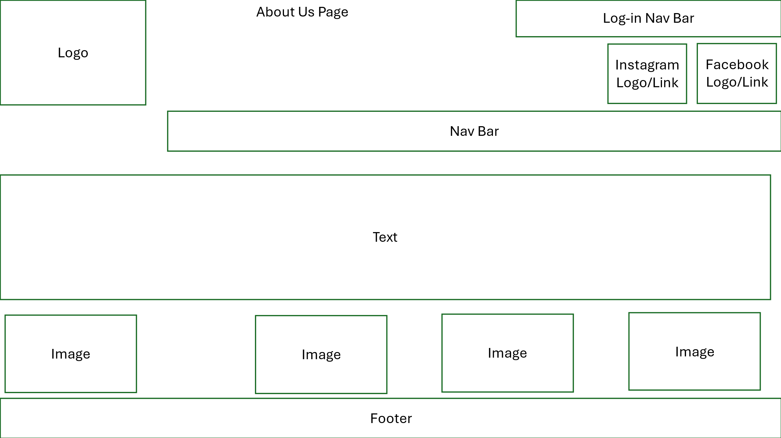
Figure 6 - wireframe of the layout of the about us page
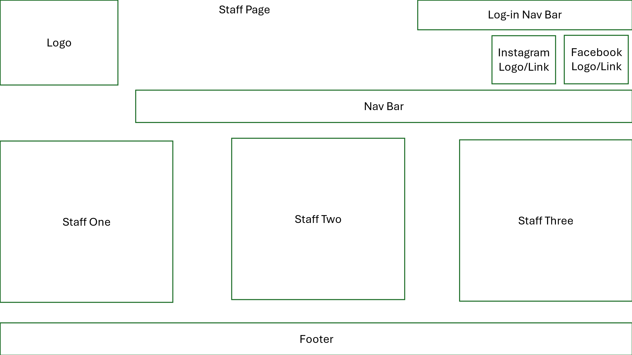
Figure 7 - wireframe of the layout of the staff page
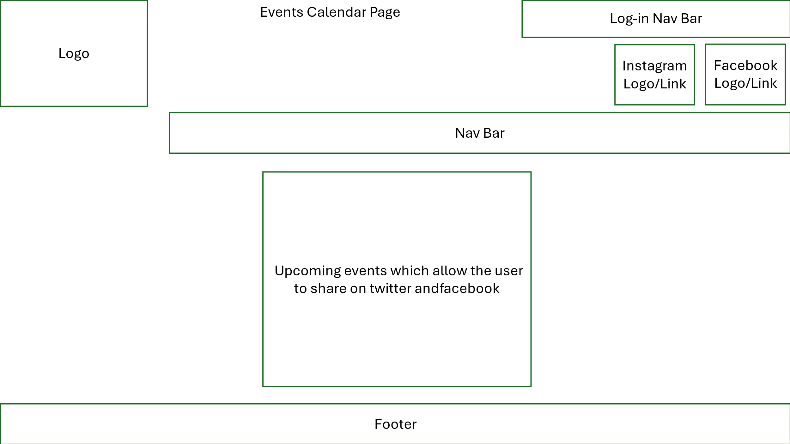
Figure 8 - wireframe of the layout of the events calendar page
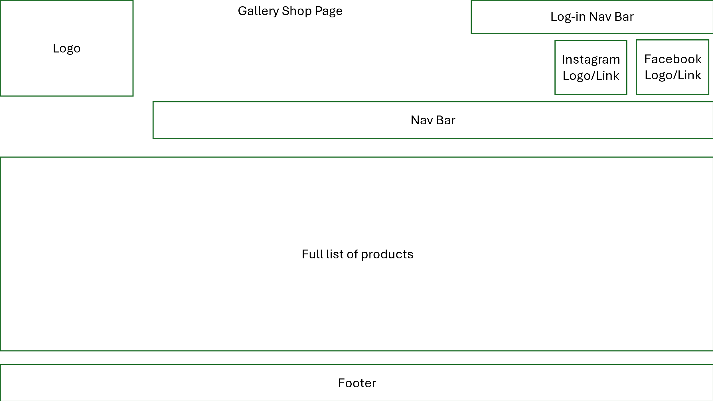
Figure 9 - wireframe of the layout of the gallery shop/all products page
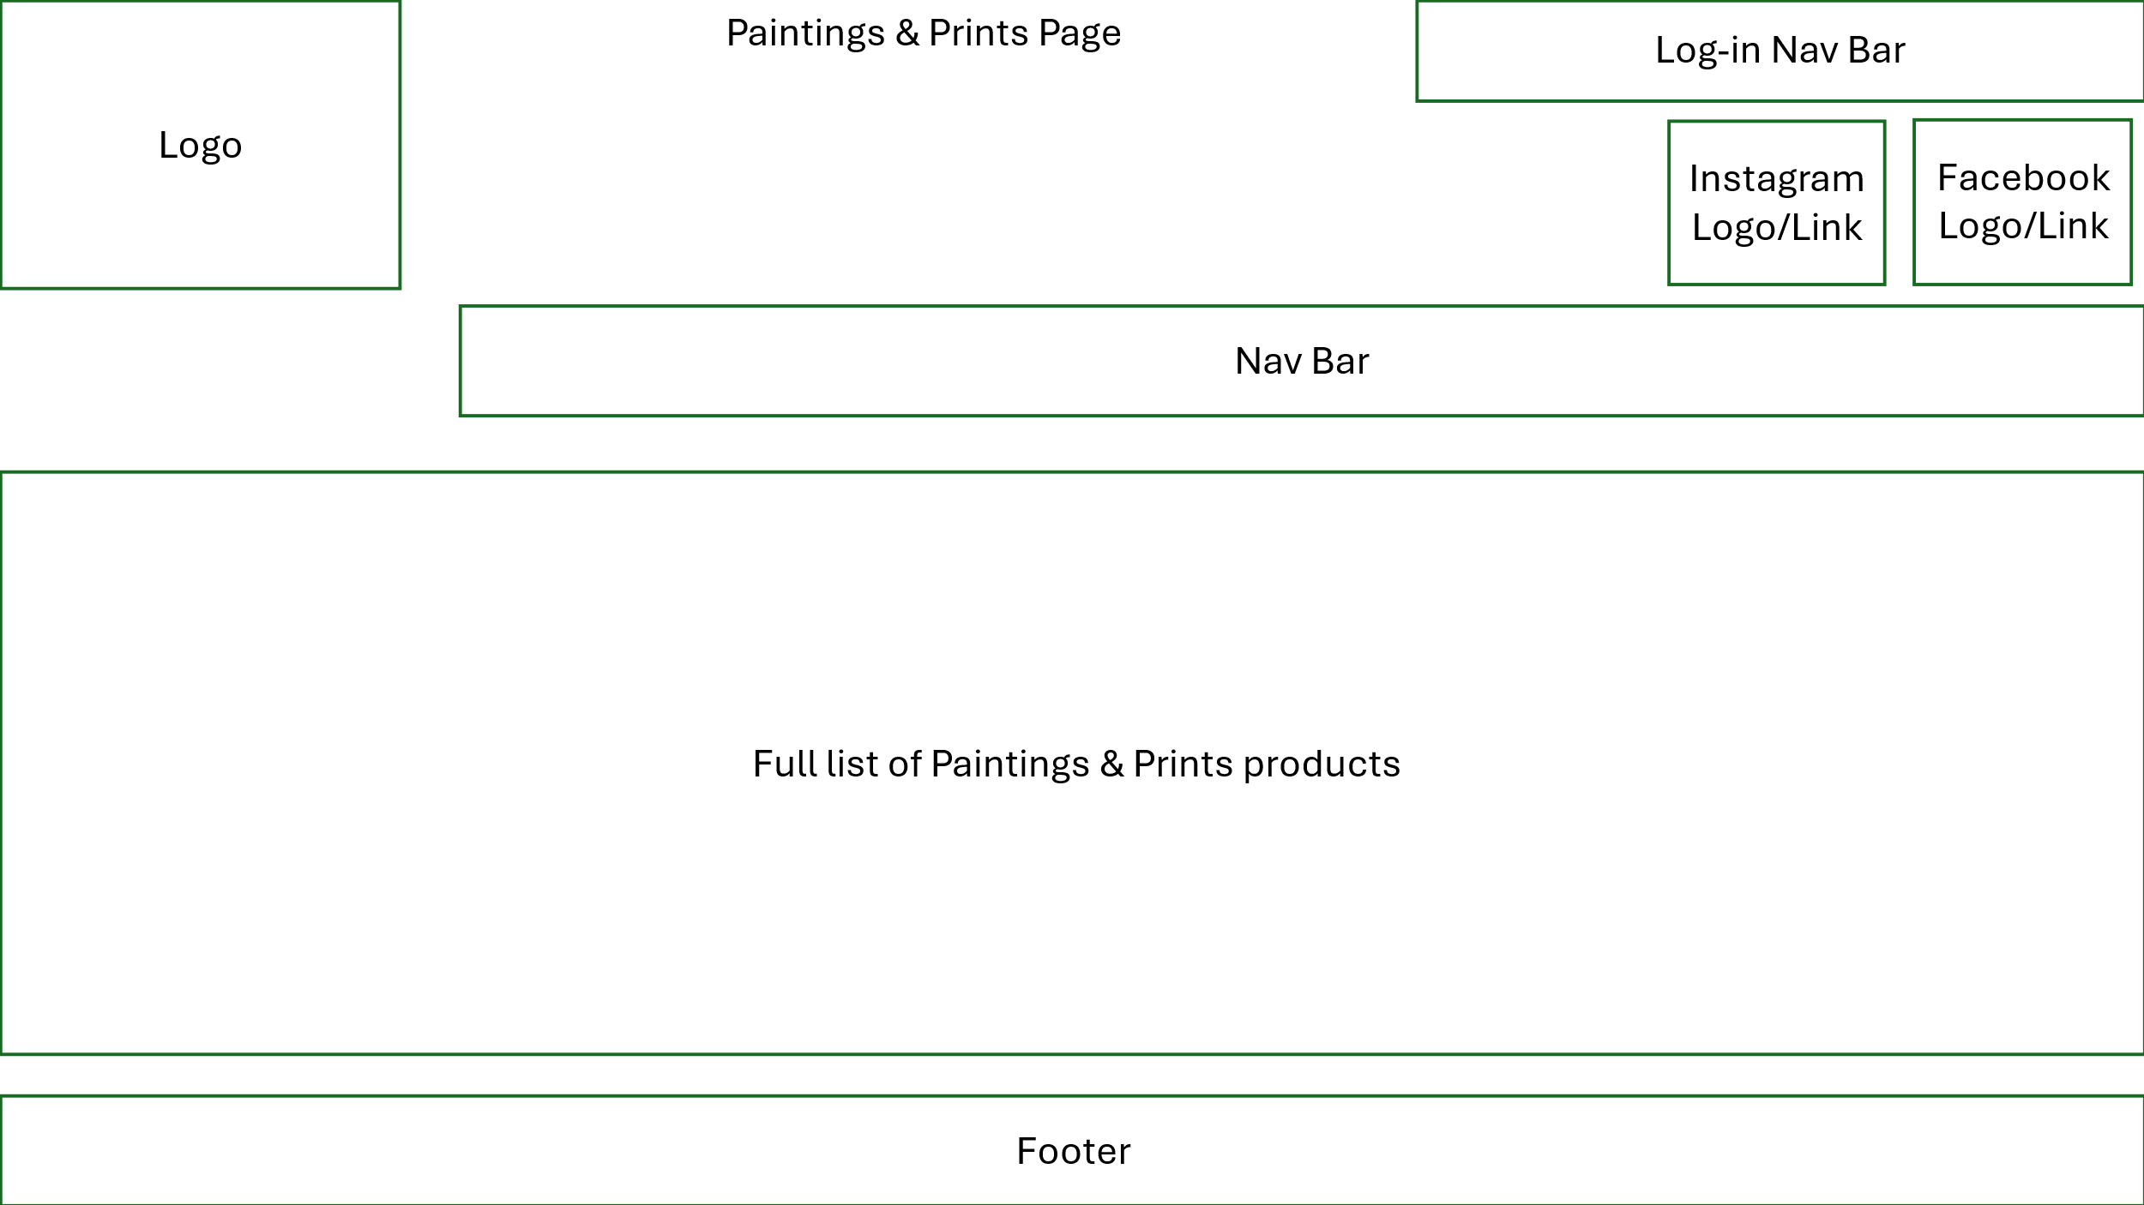
Figure 10 - wireframe of the layout of the paintings & prints products page
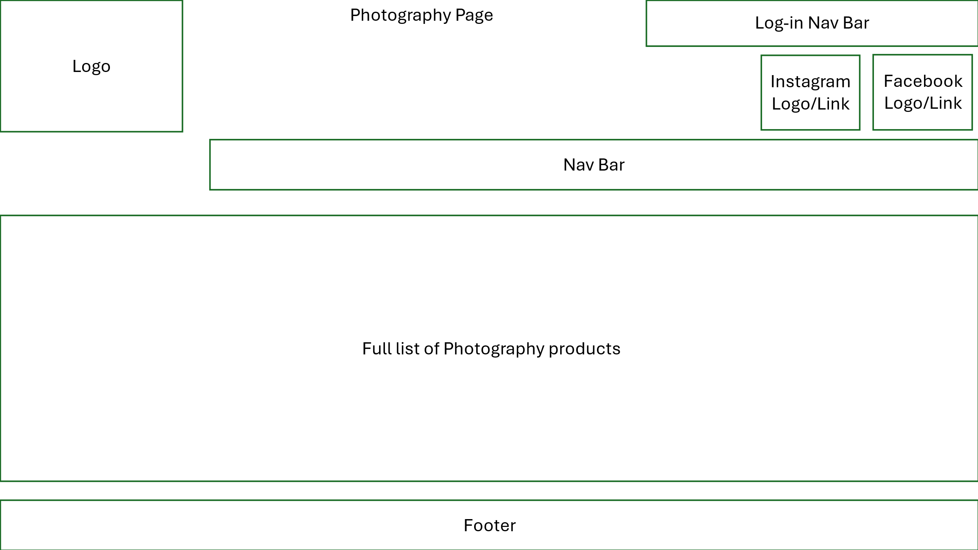
Figure 11 - wireframe of the layout of the photography products page
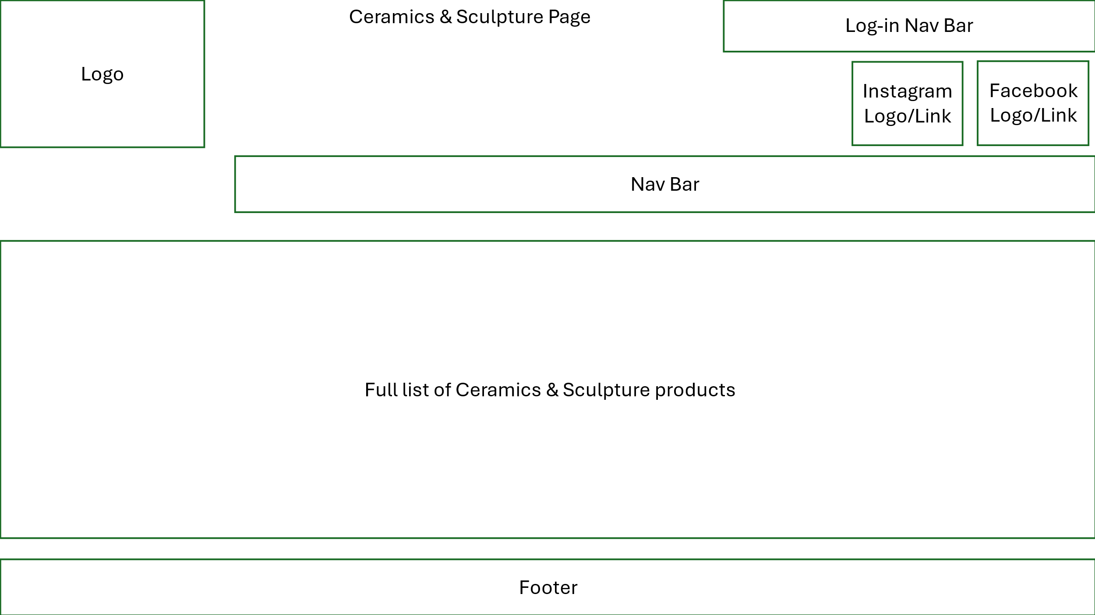
Figure 12 - wireframe of the layout of the ceramics & sculpture products page
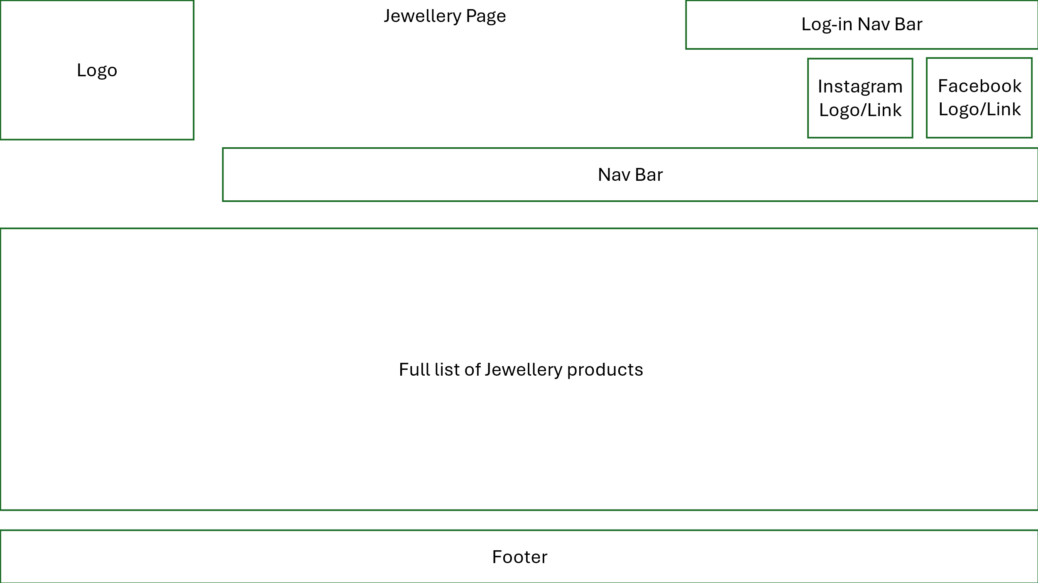
Figure 13 - wireframe of the layout of the Jewellery products page
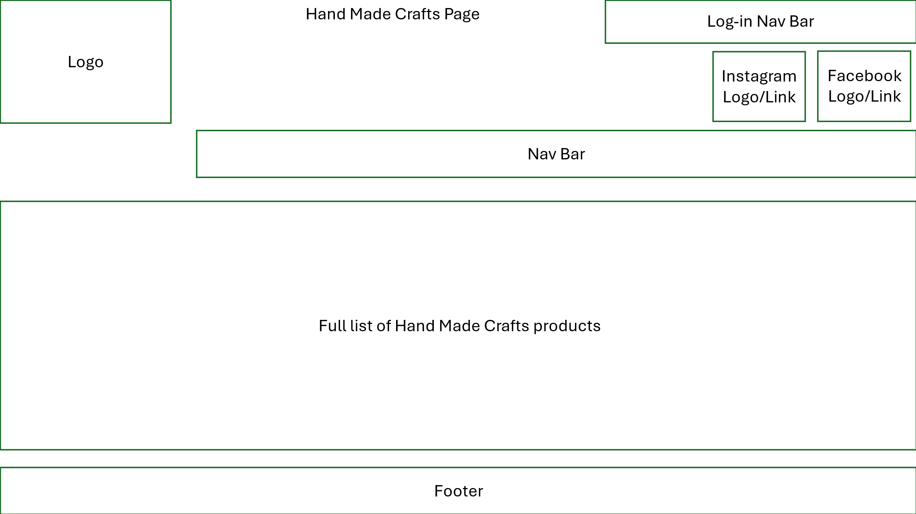
Figure 14 - wireframe of the layout of the Hand Made Crafts products page
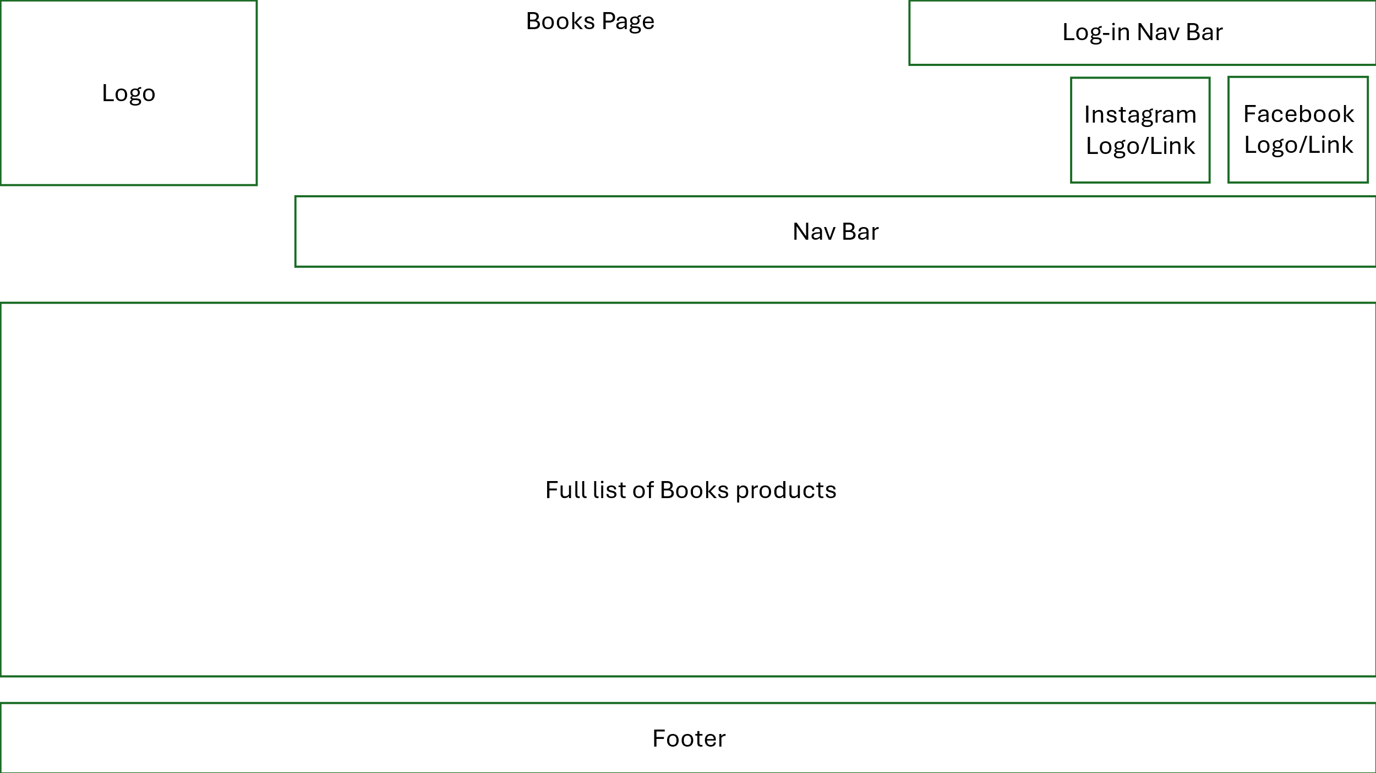
Figure 15 - wireframe of the layout of the photography books page
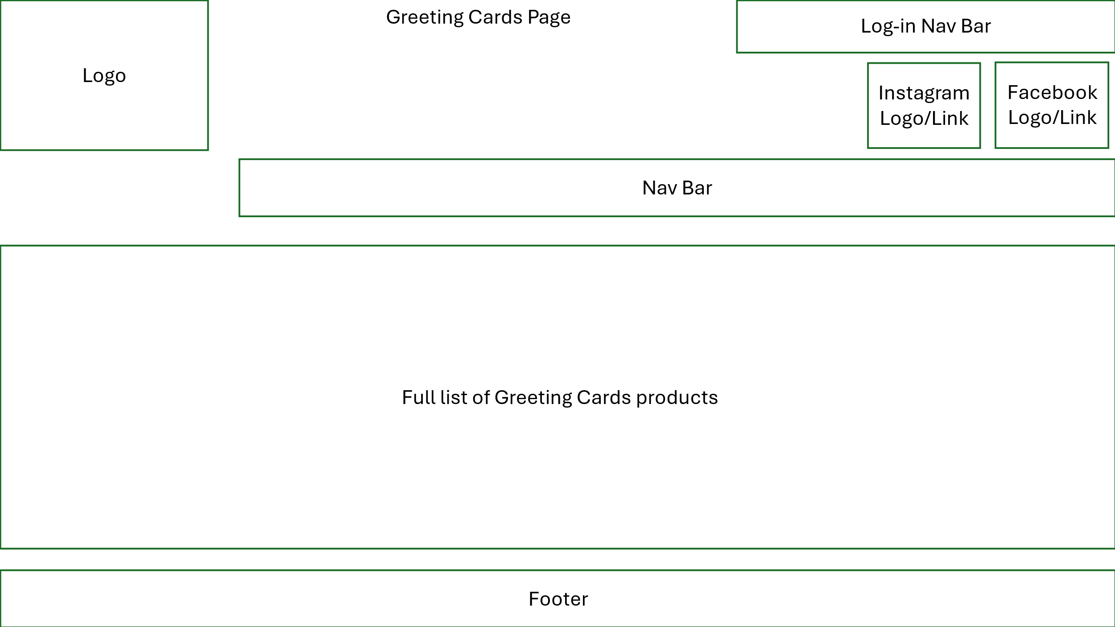
Figure 16 - wireframe of the layout of the greeting cards products page
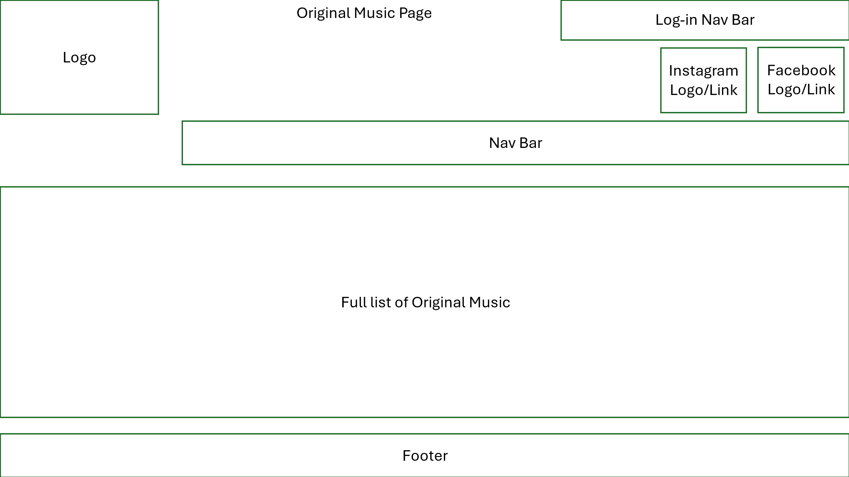
Figure 17 - wireframe of the layout of the original music page
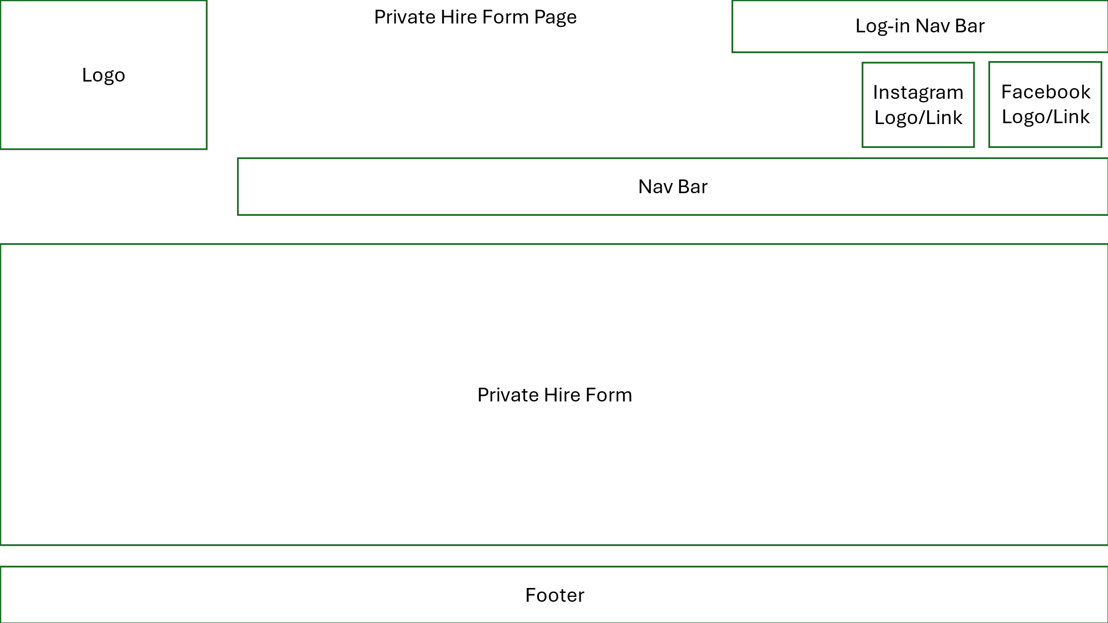
Figure 18 - wireframe of the layout of the private hire page
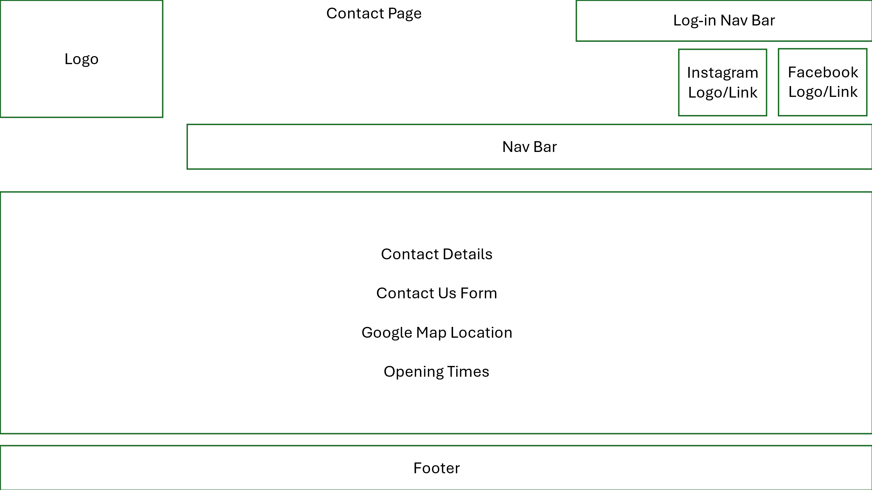
Figure 19 - wireframe of the layout of the private hire page
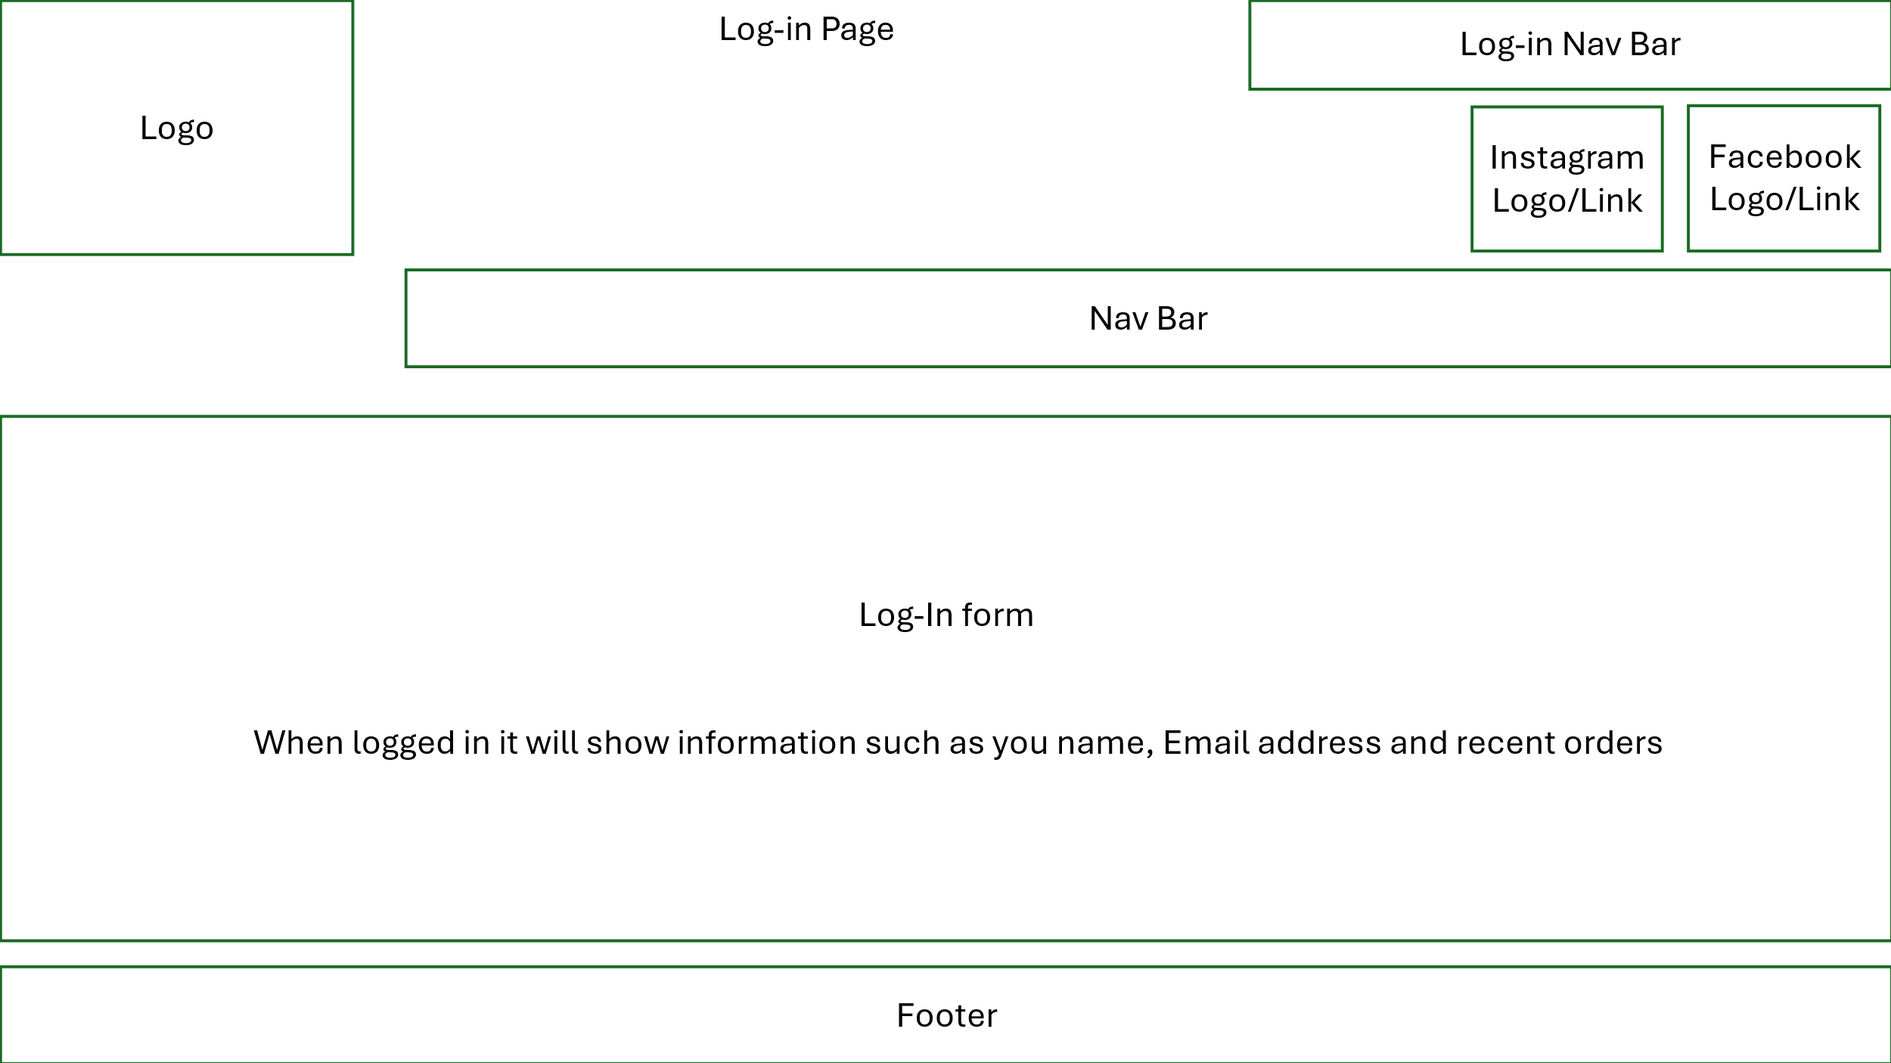
Figure 20 - Wireframe of the log-in/my account page
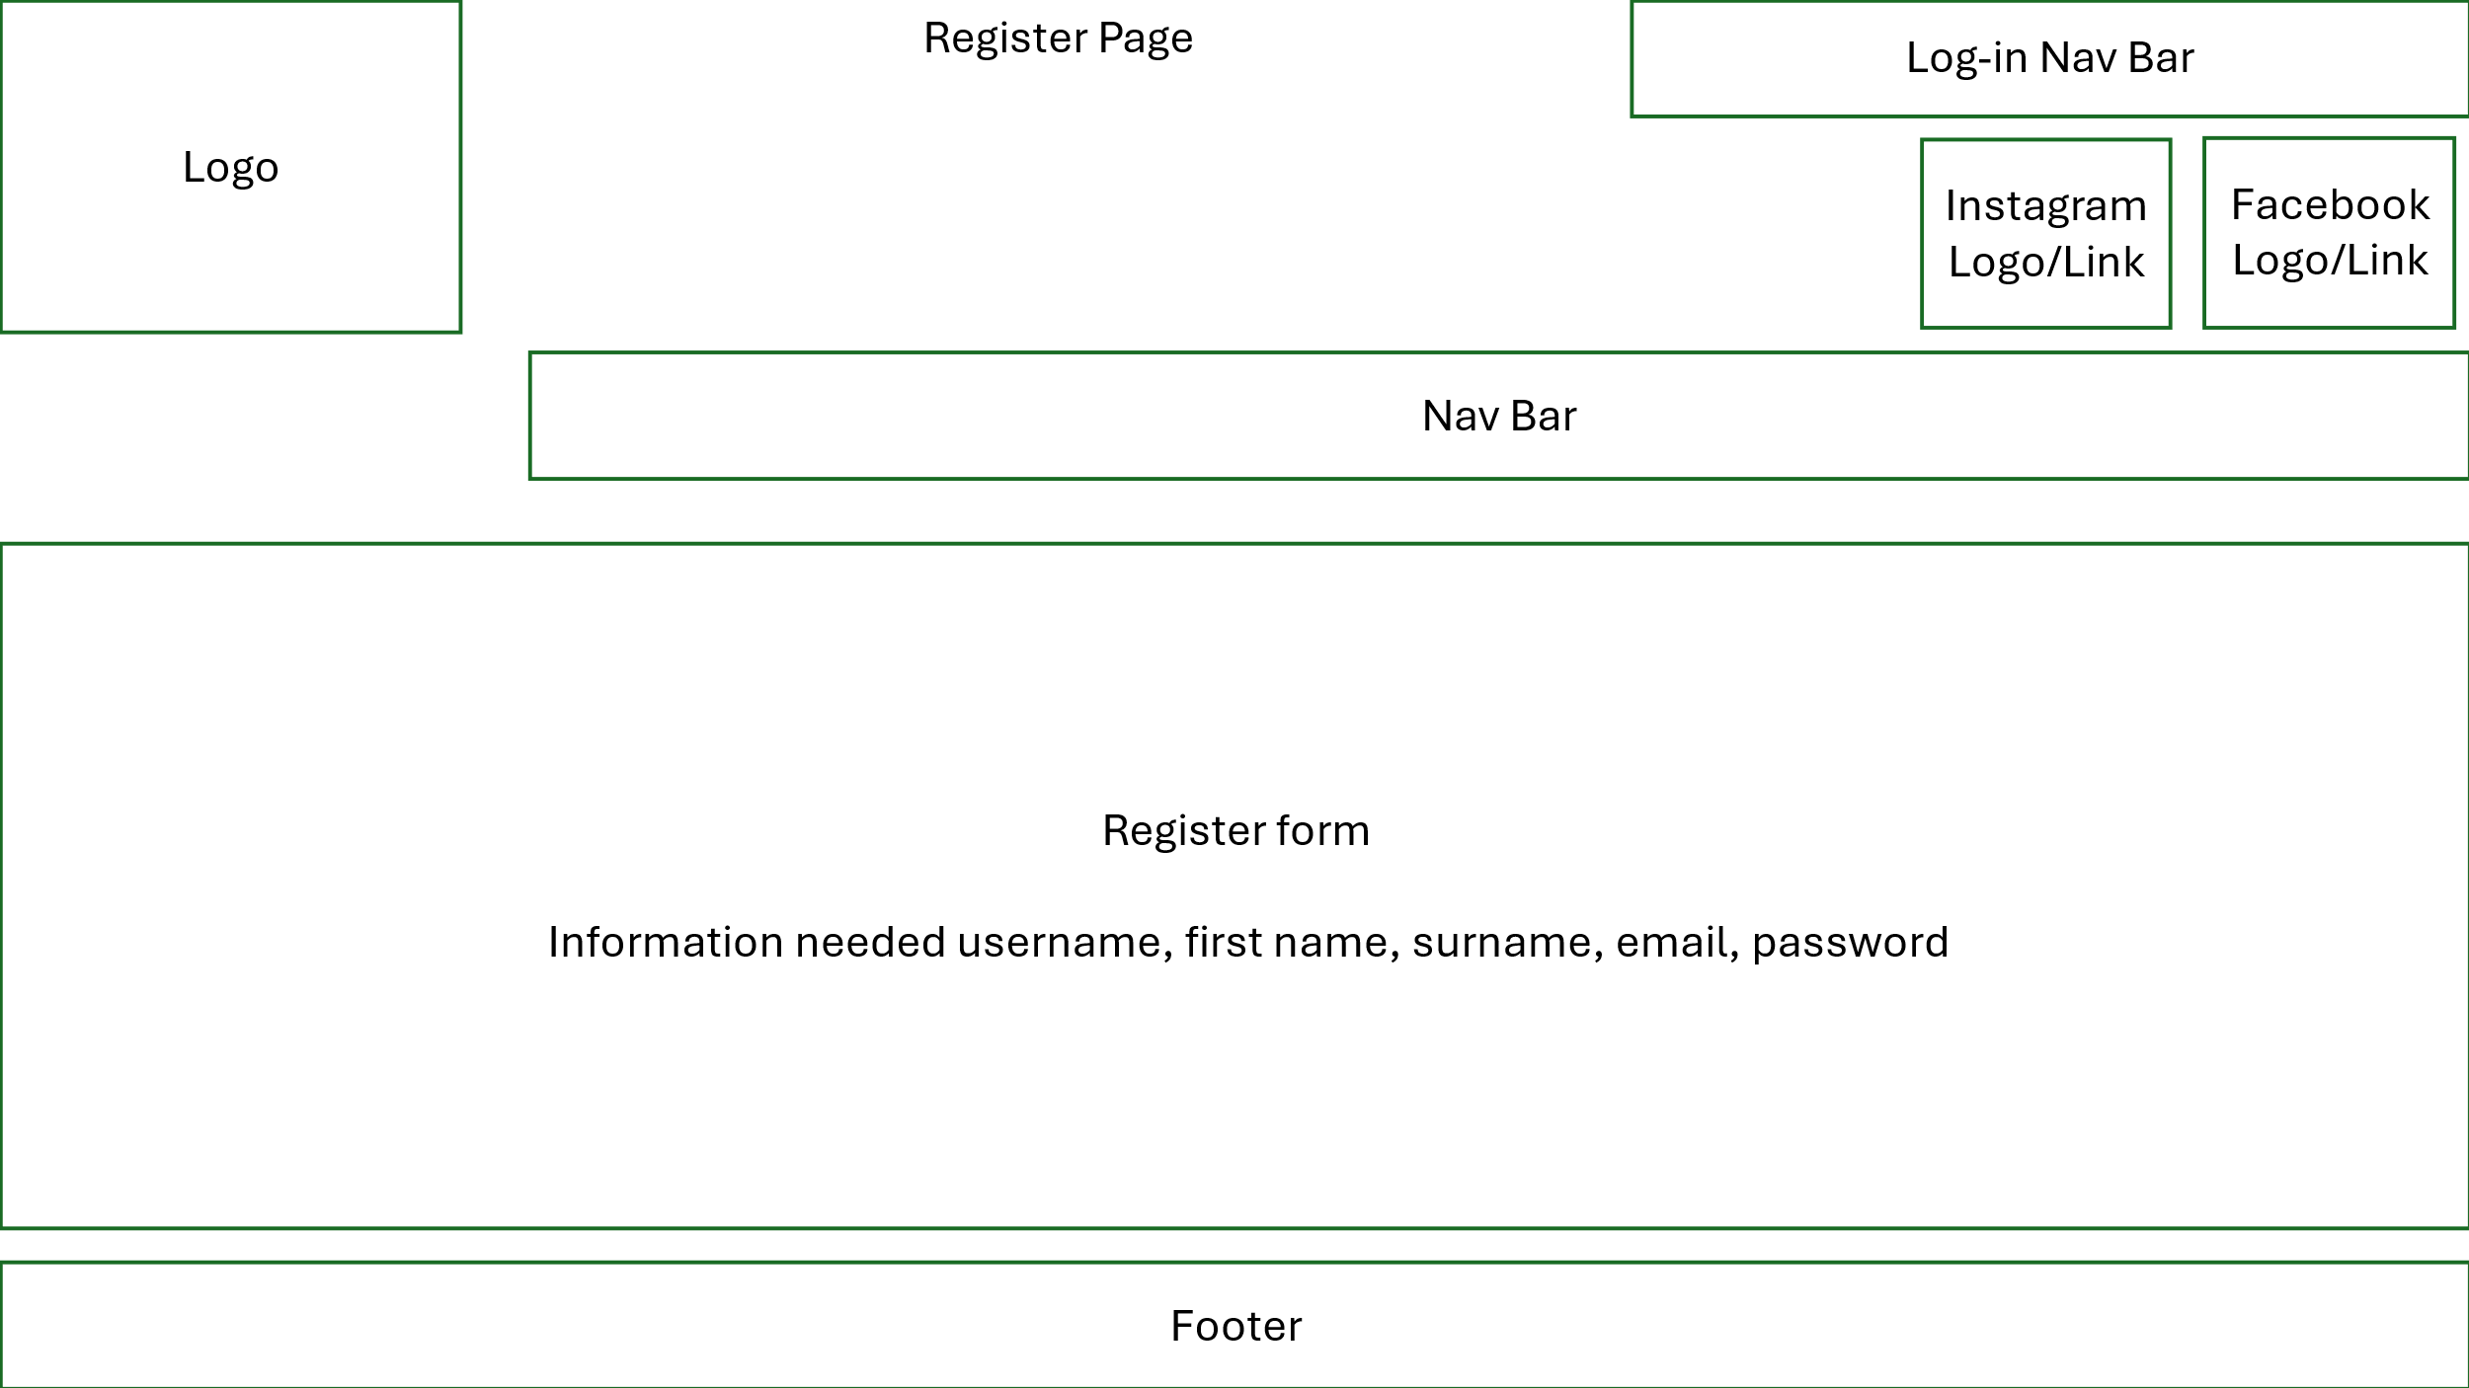
Figure 21 - wireframe of the register page

Colour schemes Ideas
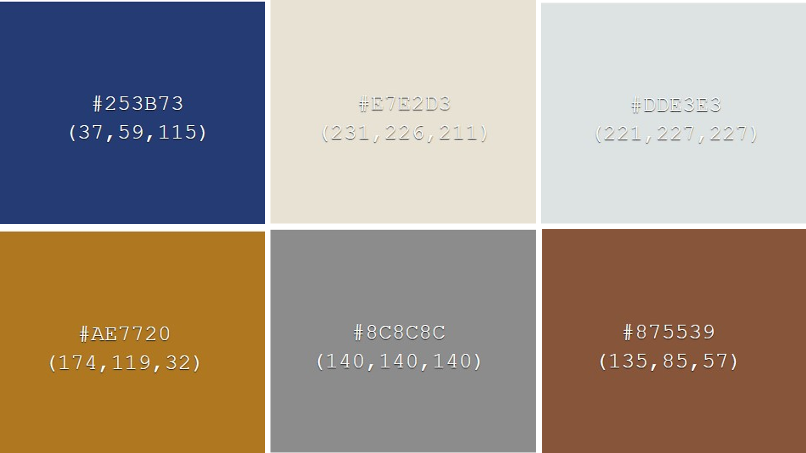
Figure 22 - colour scheme one
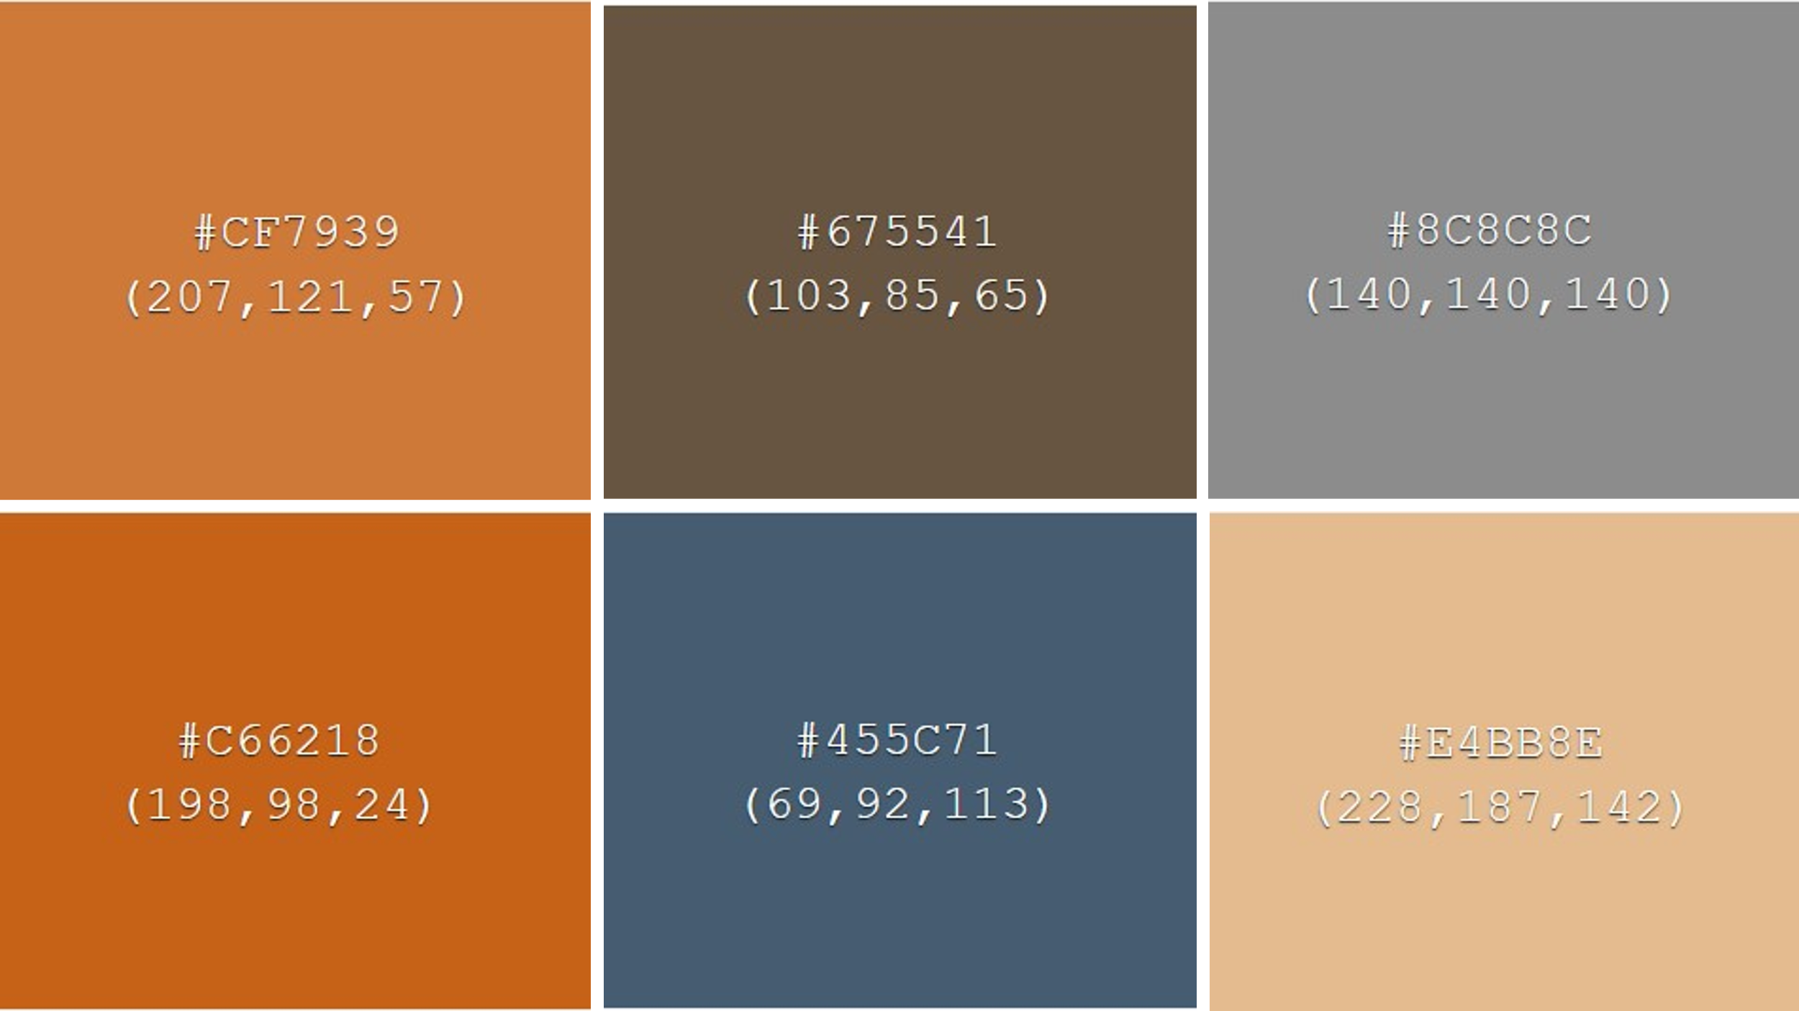
Figure 23 - Colour scheme Two
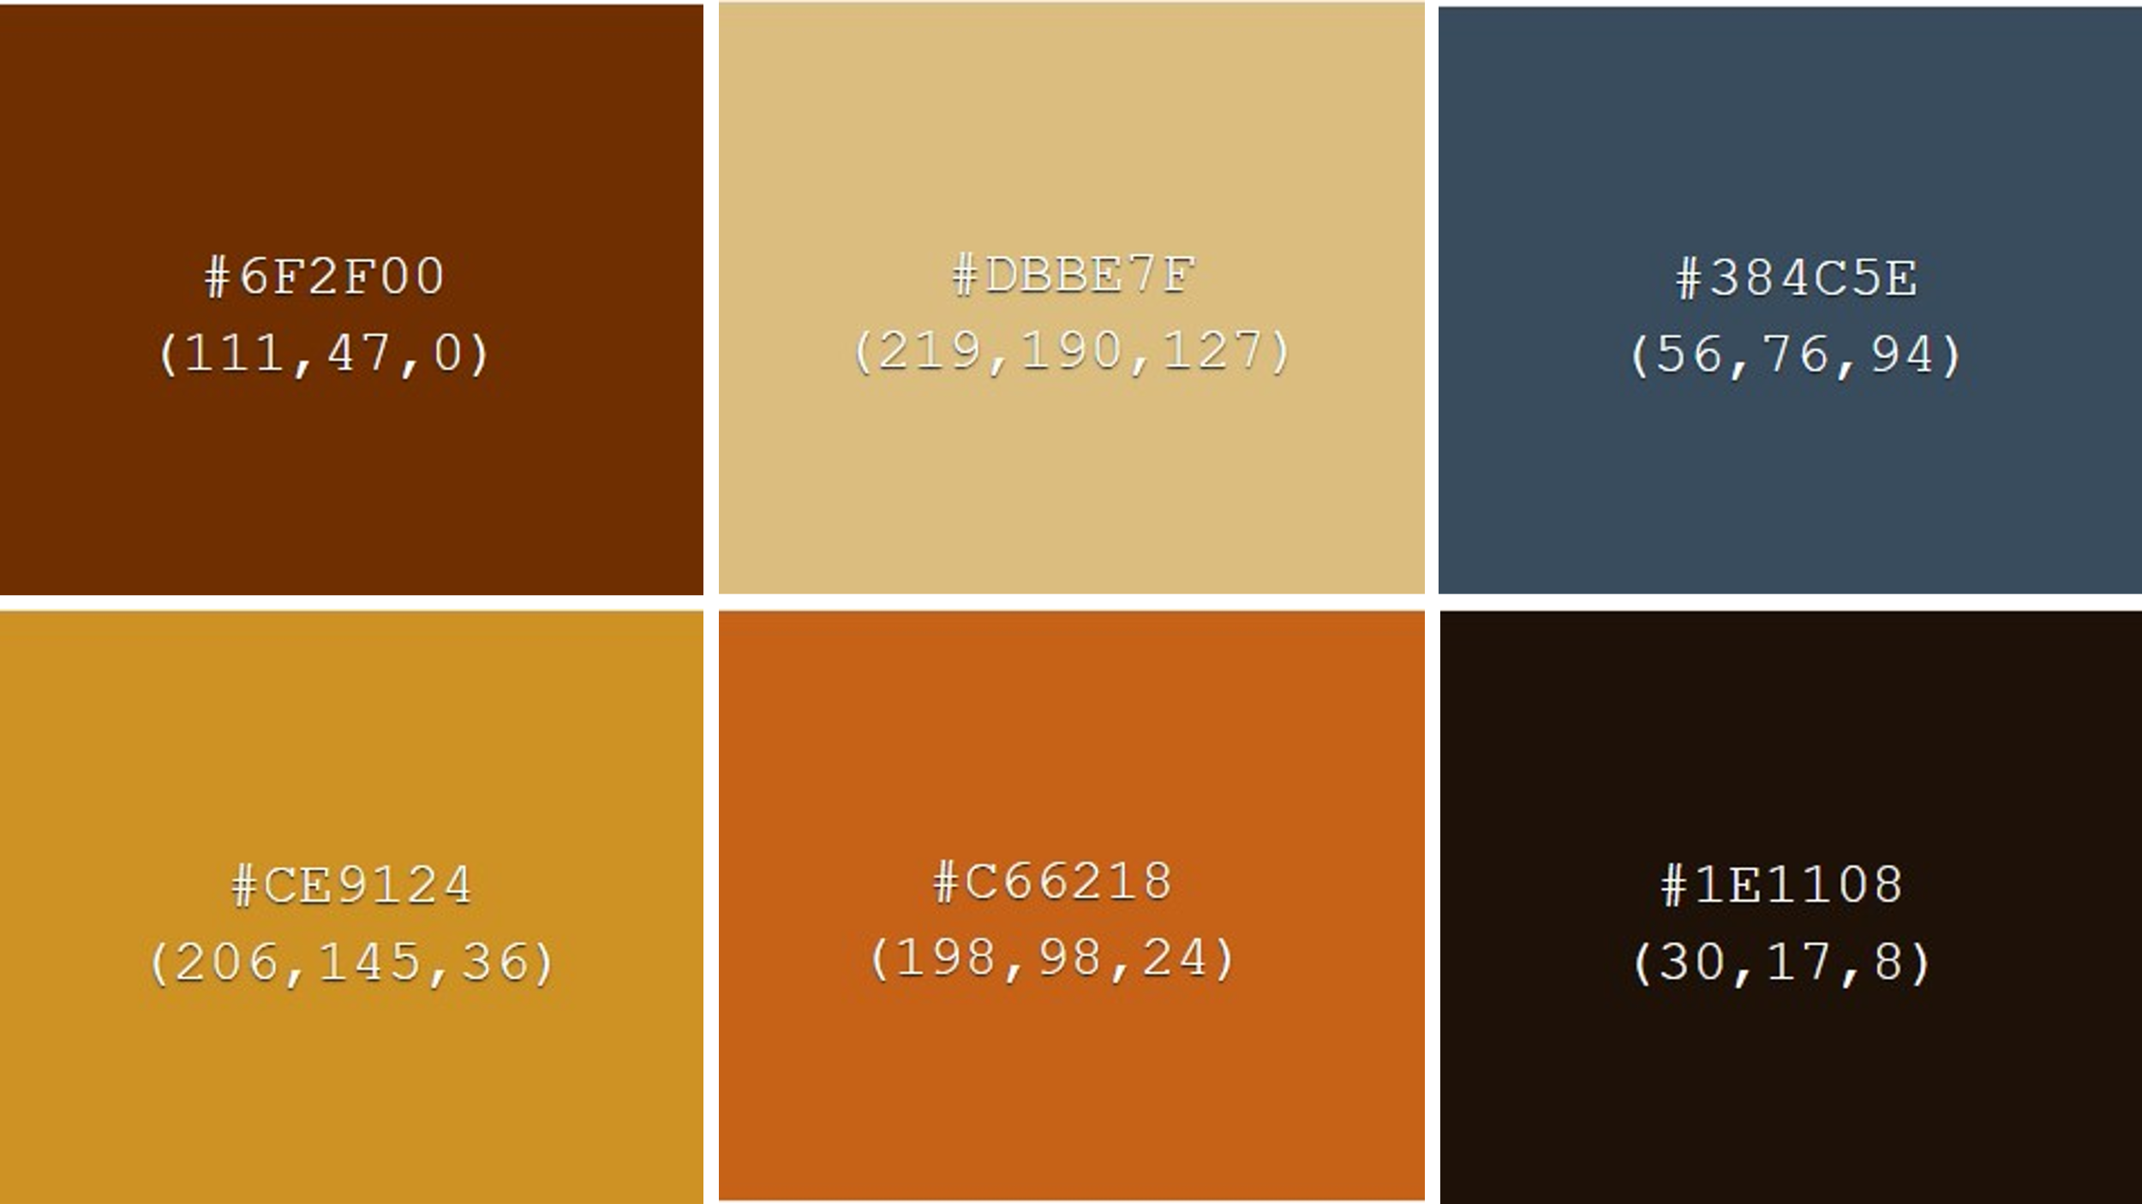
Figure 24 - Colour Scheme Three
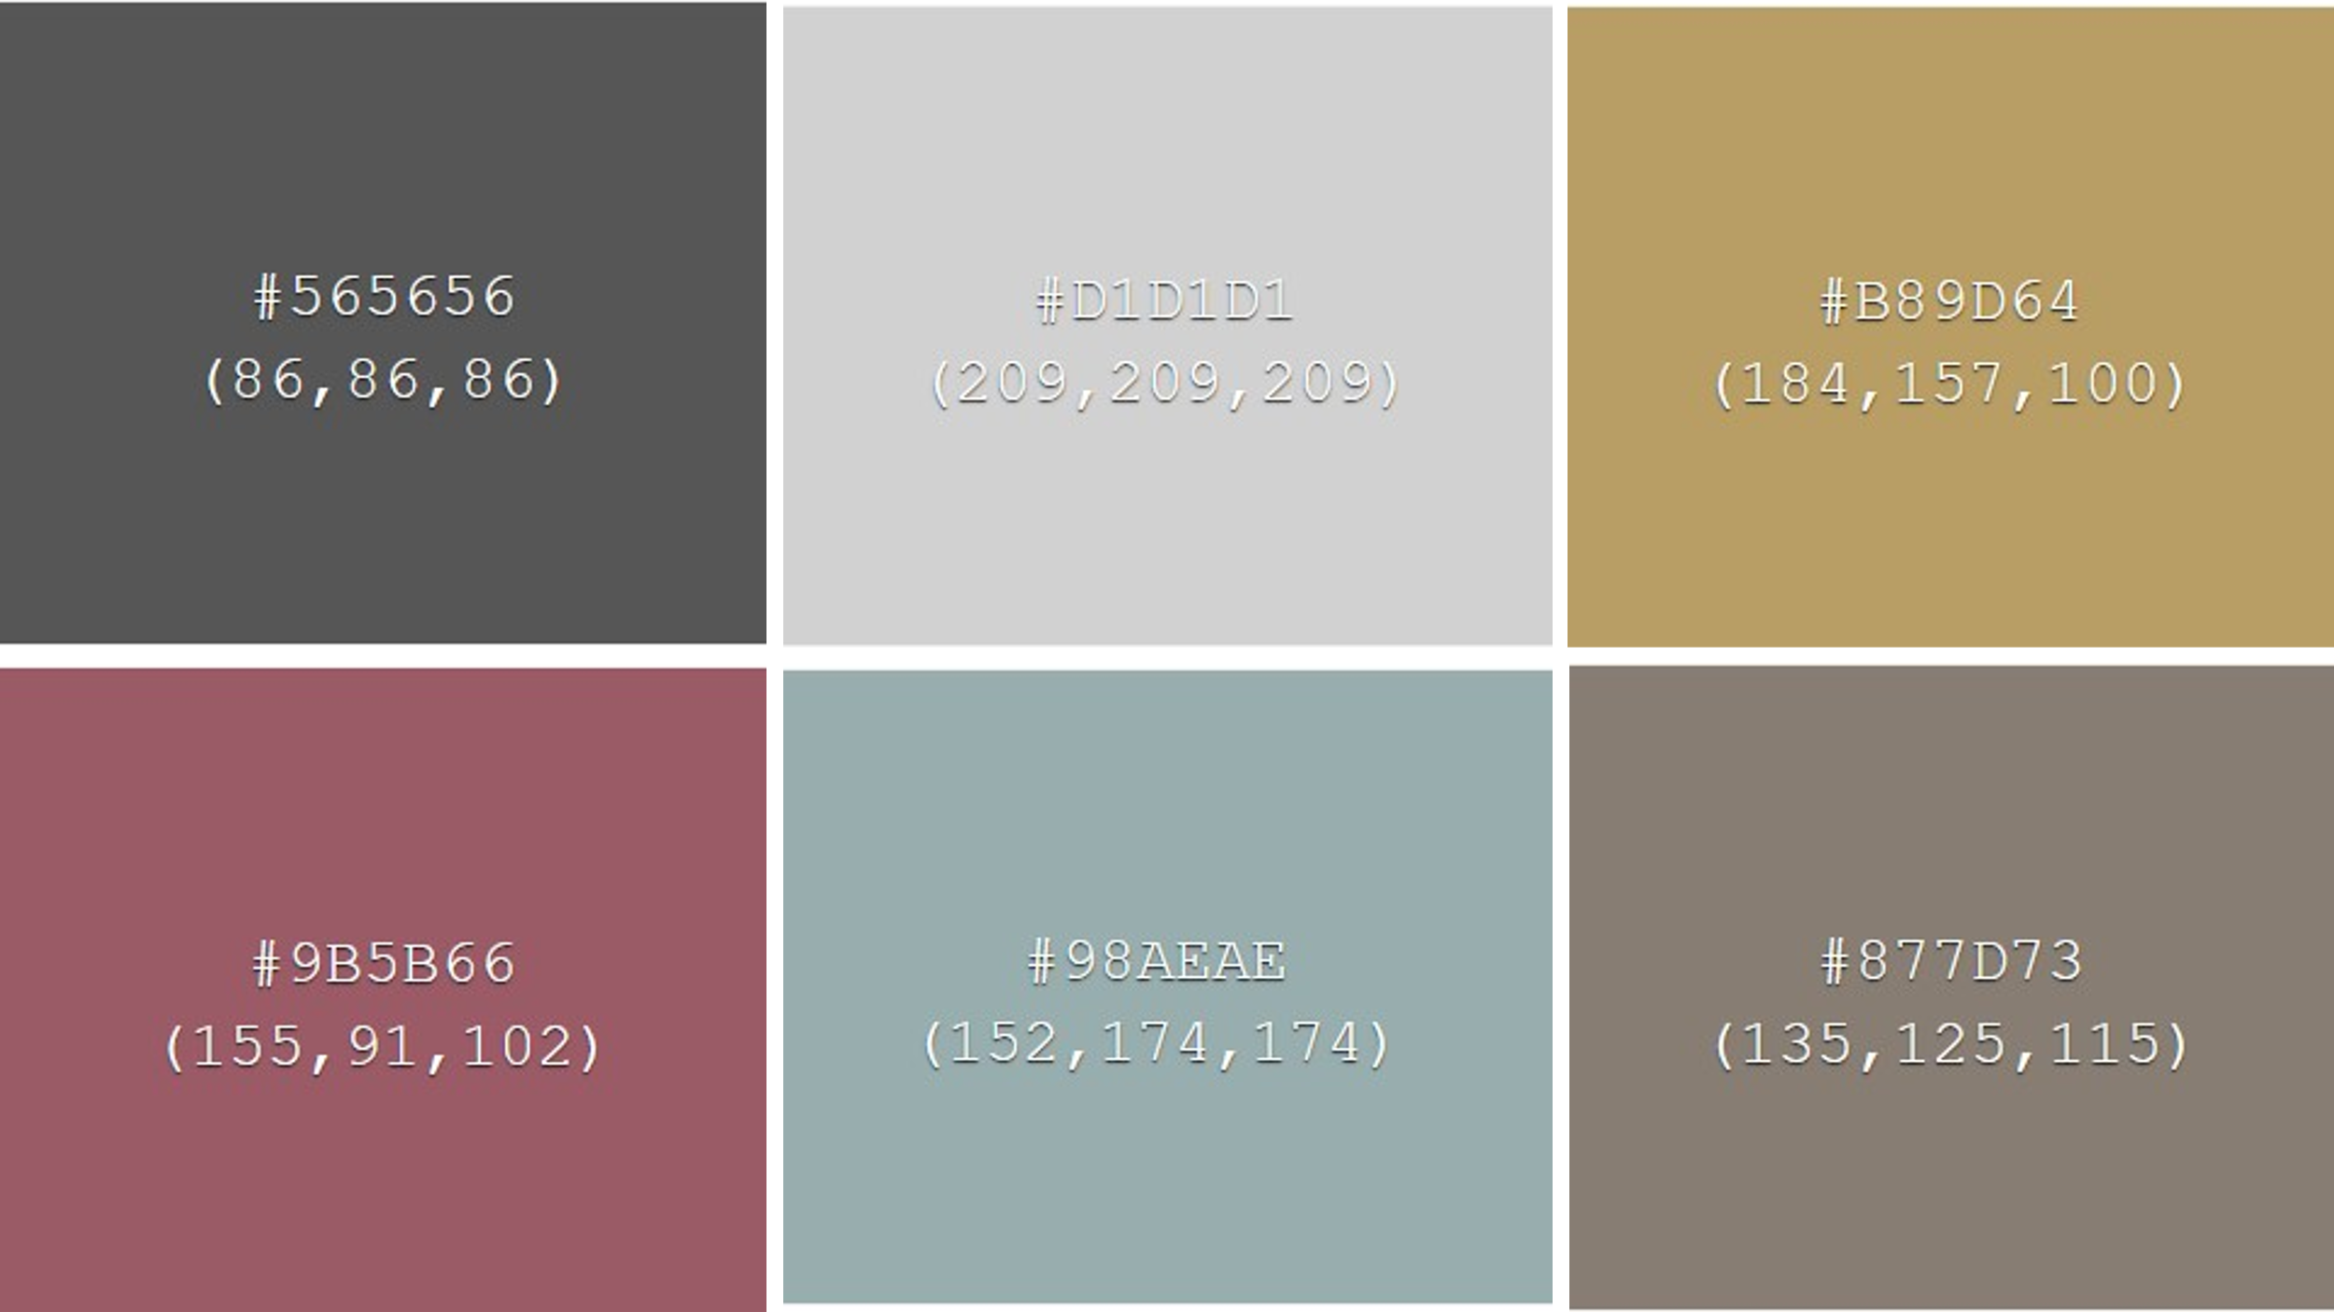
Figure 25 - Colour Sceme Five

Error message
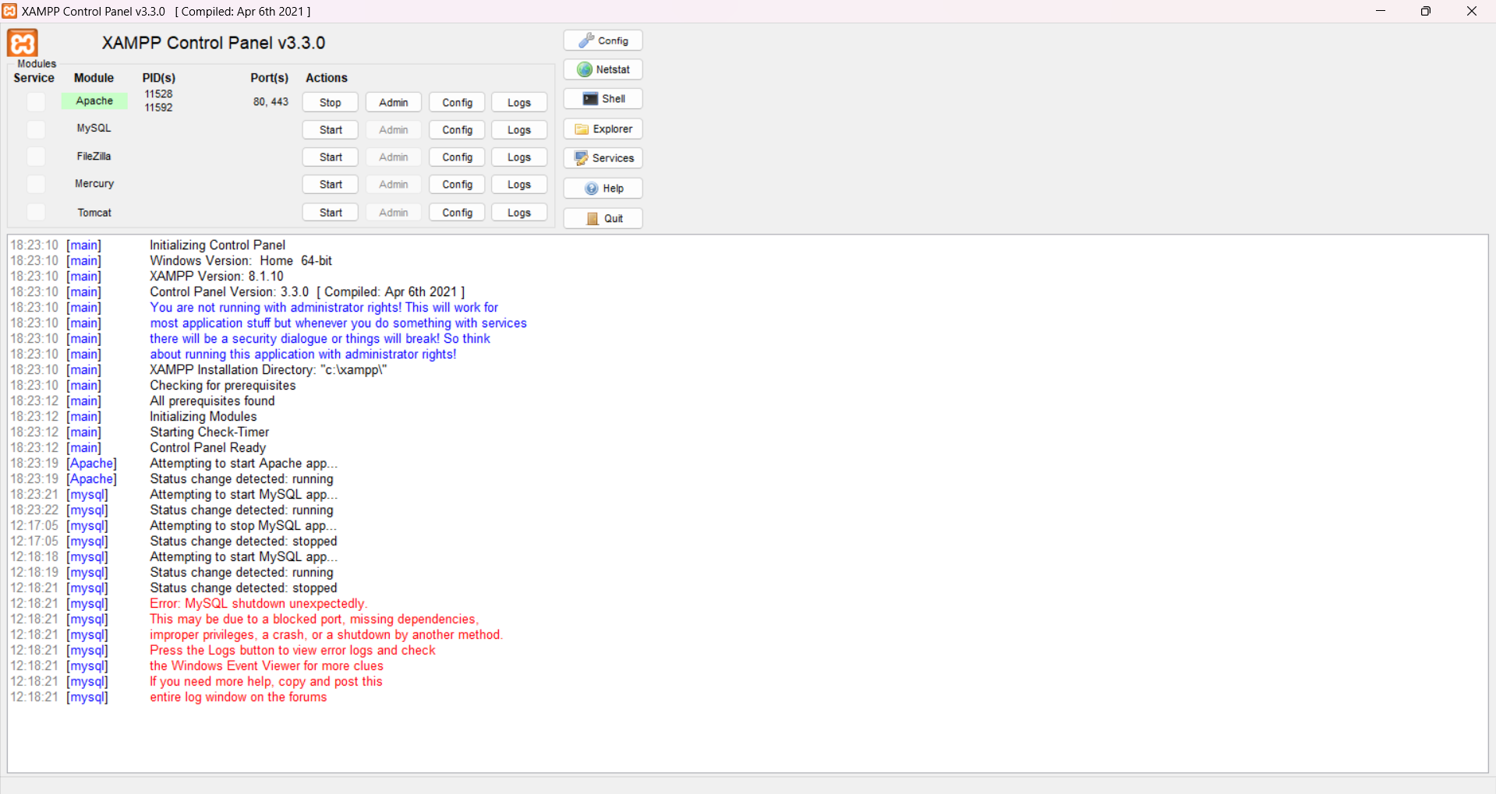
Figure 26 - Error message on XAMPP
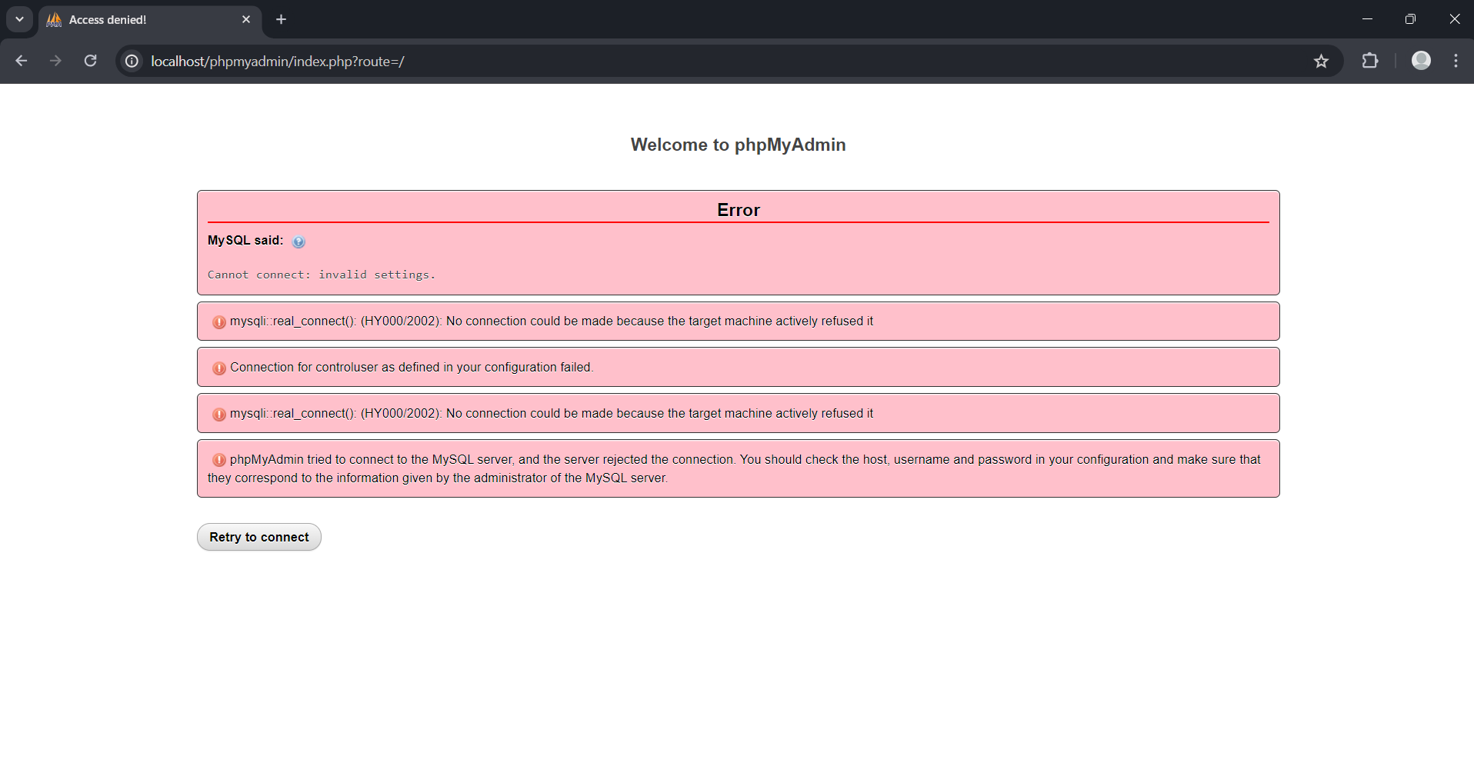
Figure 27 - Error message from phpmyadmin
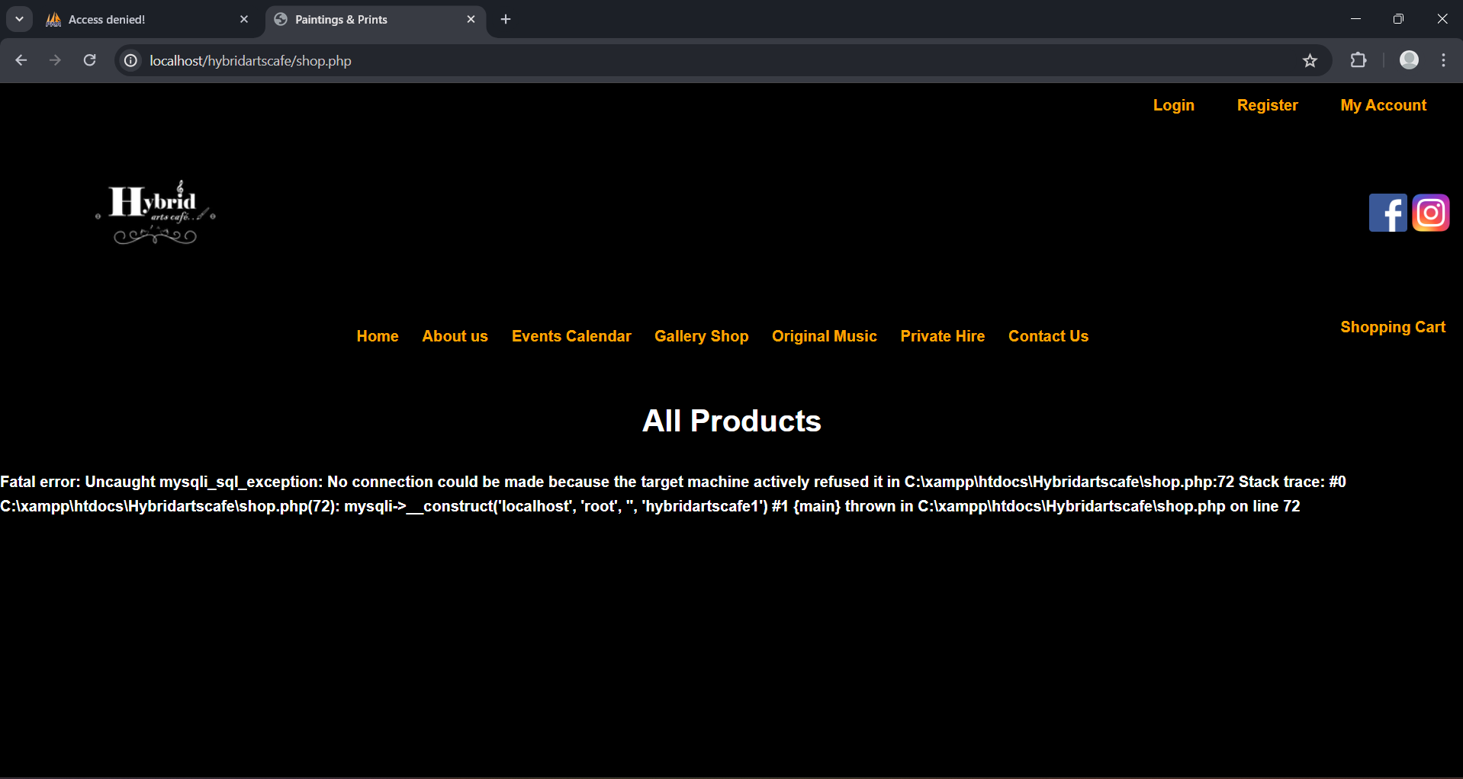
Figure 28 - Error message from all product page on my website

Self developed PHP Site
Figure 29 - Screenshot of the website looks like on the jewellery page

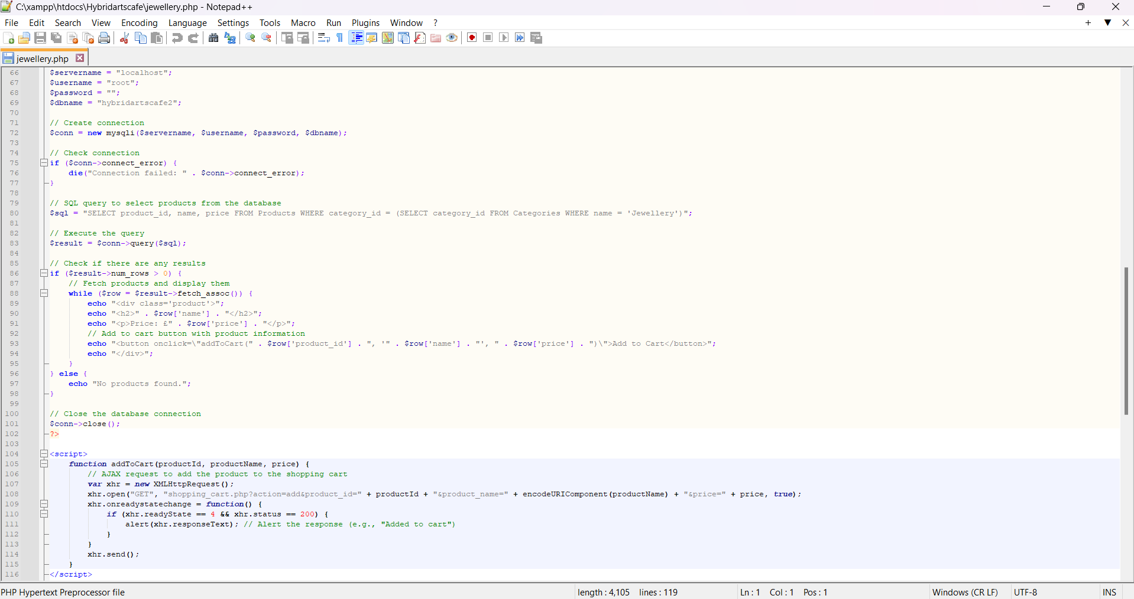
Figure 30 - Screenshot of the code for the jewellery page
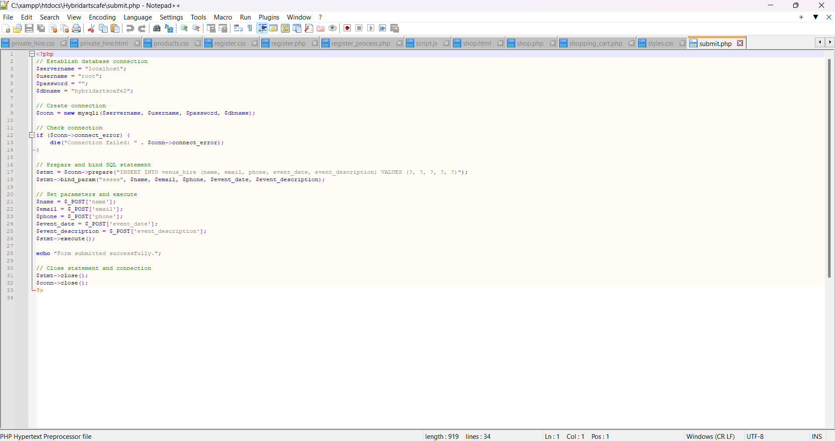
Figure 31 - Screenshot of the submit php form
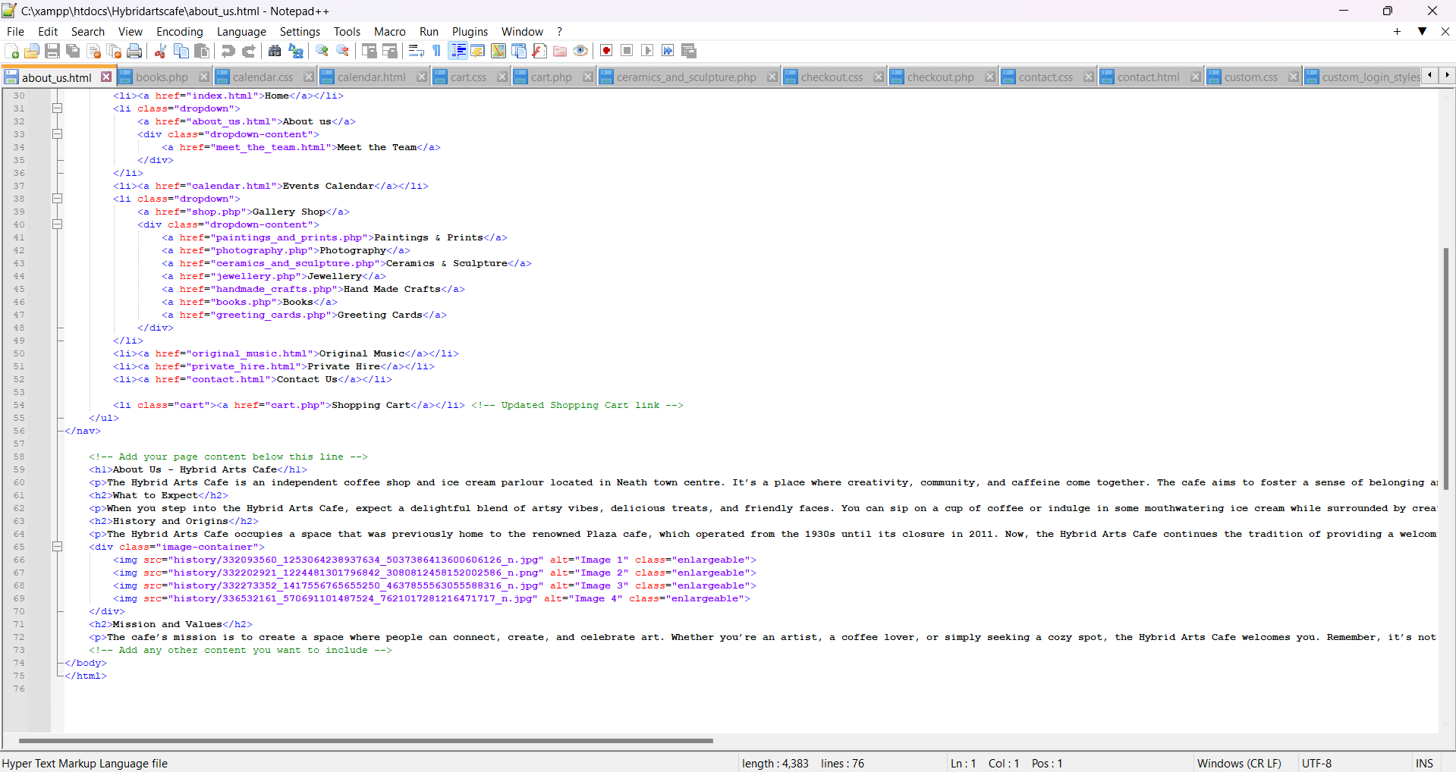
Figure 32 - Screenshot of the about us code
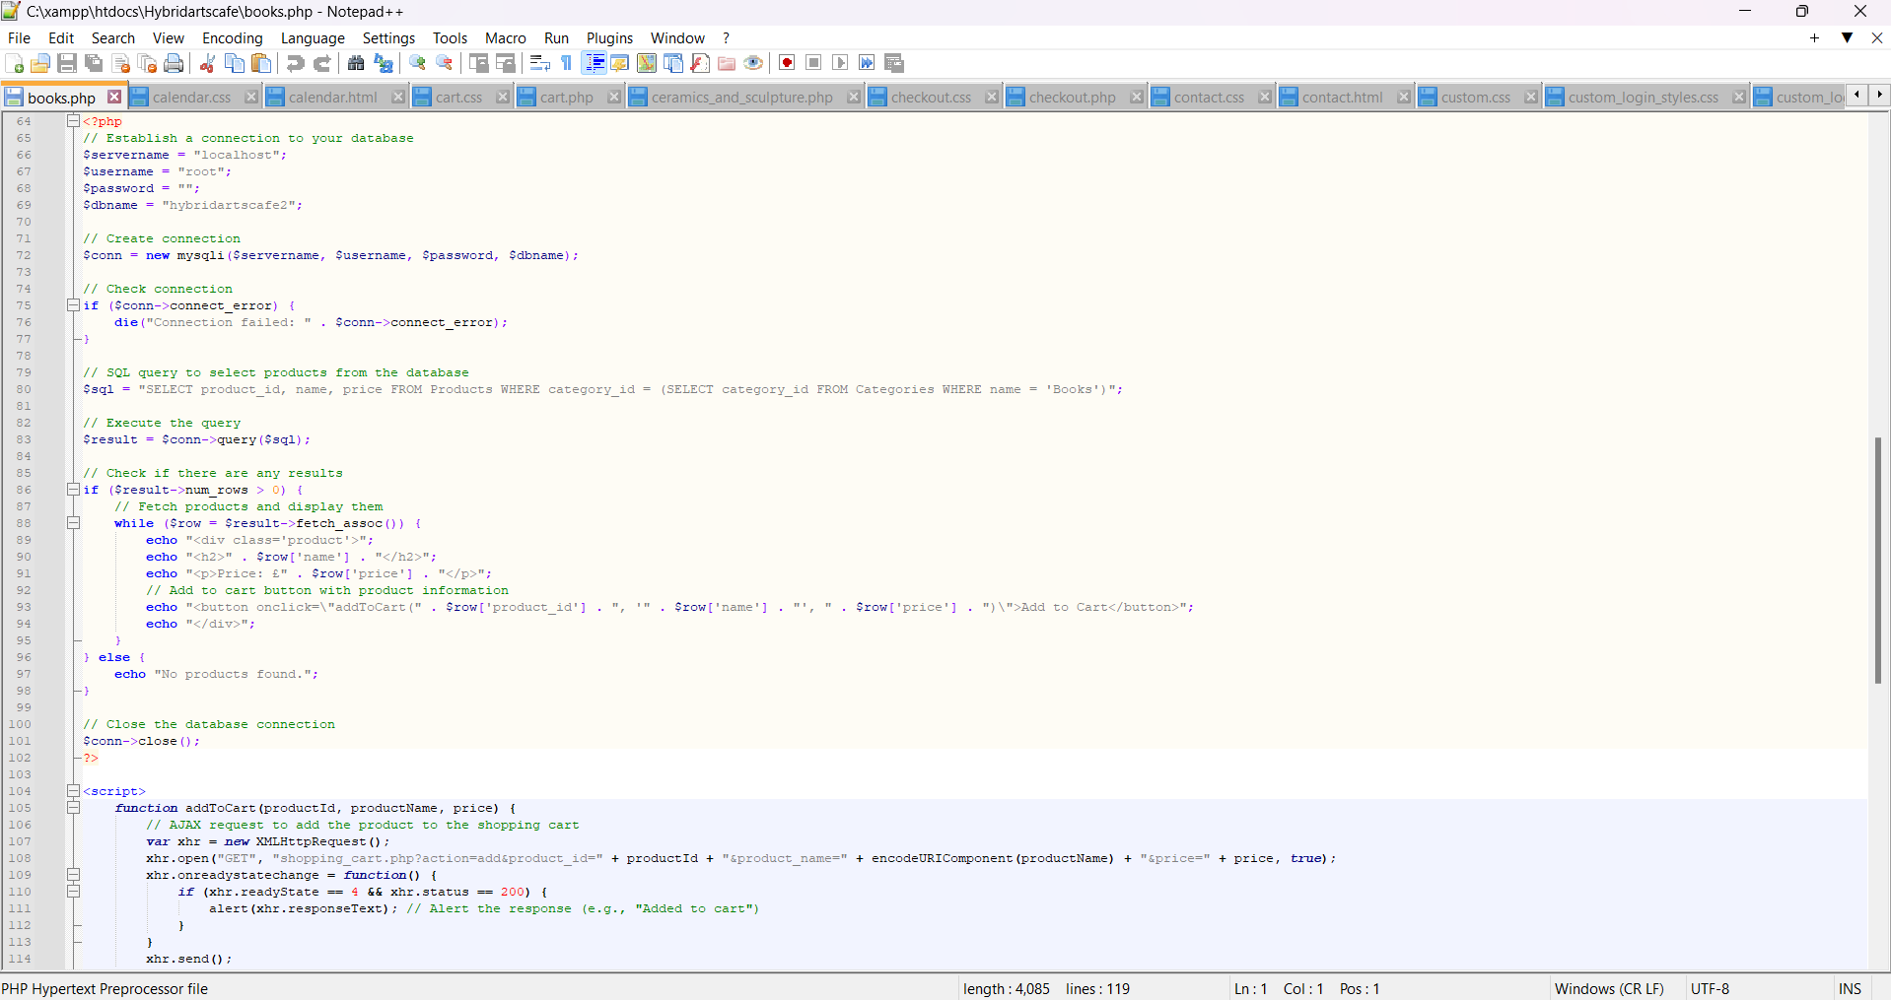
Figure 33 - Screenshot of book.php code
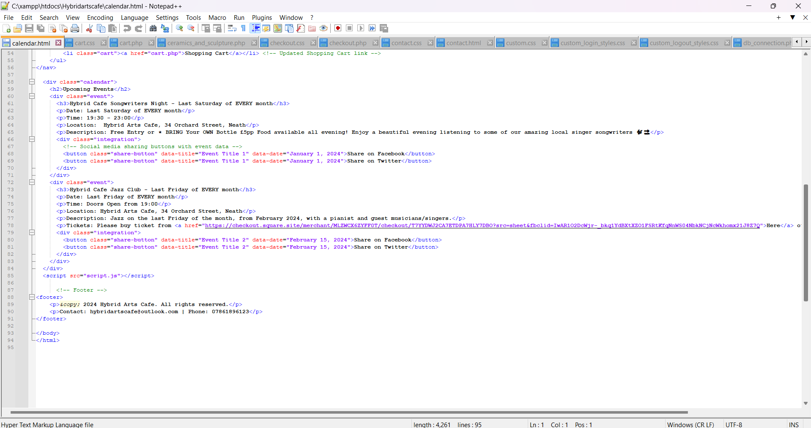Figure 34 - screenshot of calandar.html code
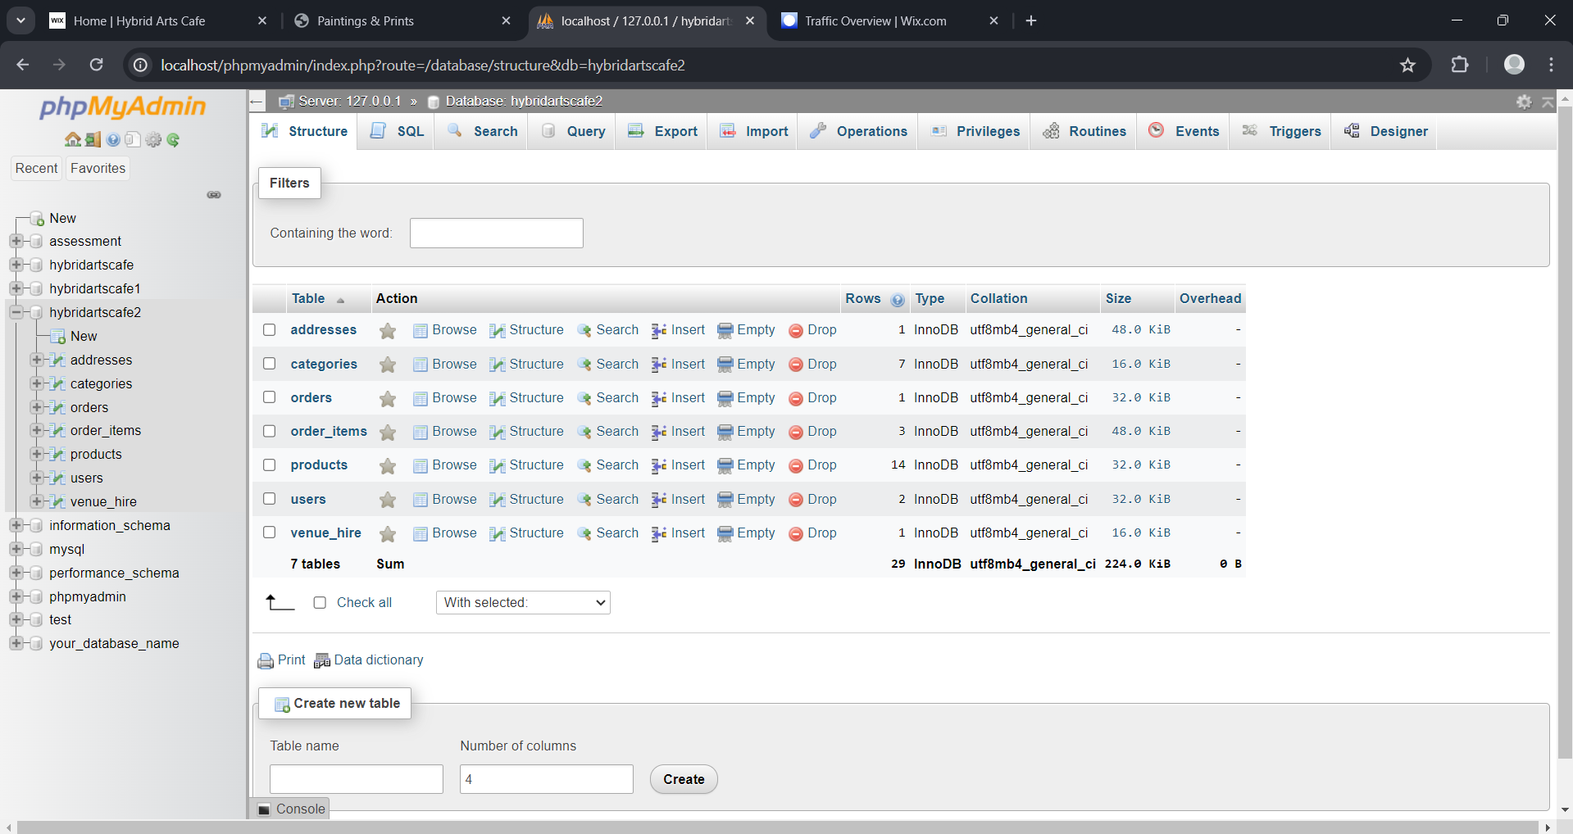
Figure 35 - overview of database

