

M5X01283
Multi-Criteria Decision Analysis
G Orr

Contents

- Multi-Criteria Decision Analysis introduction

- Group work Analysis

- Individual Sensitivity Analysis
- Sensitivity Analysis 1
- Sensitivity Analysis 2
- Sensitivity Analysis 3

- How can MCDA be used in Logistics?

- Conclusion of sensitivity Analysis

Executive Summary
The following report will highlight MCDA it's very helpful function in everyday life whether it beat home or at work. Where Multi-Criteria Decision Analysis originated from and from whom. Enclosed in this report will discuss a groups effort at using MCDA when analysing potential dishwashers to buy as an everyday appliance which most consumers have or have purchased. First they decide where to look and find out about the appliances before moving onto using the MCDA as a tool to further review the potential models. Desired or the most usual characteristics that would be found when purchasing a dishwasher will be chosen before allocating point based on specification and then an importance weighting. Lastly documented in this report will be an individual’s take on sensitivity analysis upon the dishwashers which will definitively decide which dishwasher is best with an evaluation as to why. In addition to this the report will also include another example of where MCDA can be used in logistics.

1 Introduction to Multi-Criteria Decision Analysis
So Multi-Criteria Decision Analysis. It’s extremely useful to... Well everyone whether you're purchasing something for yourself or on behalf of someone else or even for the workplace. Multi-Criteria Decision Analysis is an extremely useful tool when it comes to comparing items specifications to evaluate the best personal option. According to Project Multi-Criteria Decision Analysis is “an extremely useful tool that we can apply to many complex decisions”. The page also goes on to state that MCDA “is most applicable to solving problems that characterised as a choice among alternatives” (Projects.nscu.edu, 2017) MCDA allows users to identify the most important factors thy want to be included within he analysis and comes across very logically in terms of the decision making process. Simplistically broken down Multi-Criteria Decision Analysis allows the decision to be broken down into more manageable pieces in terms of understanding the characteristics desired. These smaller parts are further analysed ad the mot desired are re-integrated back into the equation in order to finalize the end point MCDA. When the decision has been made. MCDA is also extremely useful when used within group work exactly like this document will show, as it will allow the group to solve their problem, as it enables everyone to consider all possible views and opinions which may lead to more ideas and new criteria to be interpreted later on. In addition to the new criteria it an also provide alternative routes to answering the existing problem.

2 Group work
First of all it was decided that the group were to halve themselves, The two sub-groups brainstormed together as to which feature’s they were to record when analysing the dishwashers which would be selected at near enough random. The following criteria were set in no particular order and were what the group expected as standard of a dishwasher advert to require. They included water use, energy rating, capacity, reputation based on average review rating, how much warranty the dishwashers came with, price, the number if programmes it had, its noise level, colour choice, if it had a child lock feature and whether there were a digital display on it.

Then both sub-groups went away to research three potential dishwashers; one of great reliability and as expected higher priced and another of a lower price In addition to this they also fund one around the middle range of reliability and price. As expected with the lower price dishwashers there will more than likely be less functionality and even reliableness. Although it will not be stated whether the lower priced dishwashers are to be less functional or reliable but this is just the presumption that modern day consumers have with cheaper products as the saying goes `` you only get what you pay for``. To gain the desired information relatively quickly and simply It was determined that both groups were to look on specified websites to make the tester dishwashers fair so in this case the group stuck to Curry’s PC world and AO.com. All of the criteria were placed into a table on excel which you can see below in figure one.

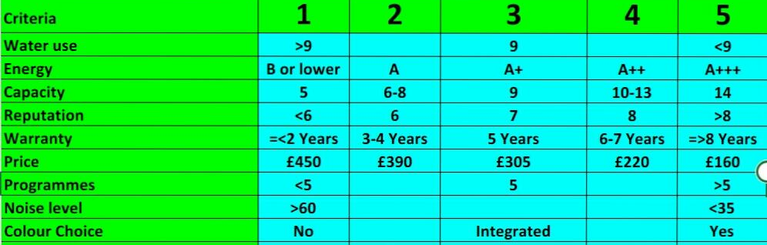
Fig1
As above you can see the groups scoring table which has already been set up and data has already been implemented. Each criteria set has its own way of scoring with five being the best and one the worst. For example if the dishwasher used more than nine litres of water it was considered pretty bad but if used less than nine it would either receive a scoring four or five. The reason the group came to this conclusion was because of the majority of the dishwashers they had looked up all on average used nine litres of water. Likewise with the way the scoring as judged on the warranty due to again the majority of dishwashers coming with around two years manufacturer warranty which by law are the basics, so if they had two years this would mean a poor score of one and if a greater warranty was set then the dishwasher would score higher depending on how many more years of warranty.
A few of the criteria set were based on a lot of numerical values and so were set accordingly for example noise level, which obviously the quieter the more happier the customer, and so mid points were set in between the lowest and highest decibel sound readings found during research. This was also likewise for programmes, price, capacity, reputation and a few others.

2.1 Criteria Scorecard

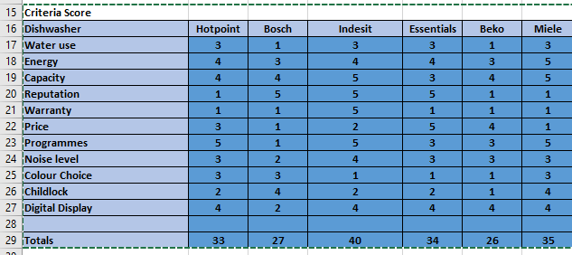
Fig2
As you can see above after finishing the scoring table of the present dishwashers its clear to see after all the criteria has been added up that the best dishwasher happens to be the Indesit with a total of forty points and the worst being the Miele, score wise anyhow. The main criteria that enabled the Indesit to come out on top were its capacity, reputation and warranty as well as its programmes due to each of these criteria earning five points each. In opposition to this Miele’s downfall in criteria were its reputation, warranty and undoubtedly its price, due to being a relatively expensive brand, however they’re very reliable and last very long.

2.2 Percentage Weighting
Once the group were satisfied with the criteria they had chosen for their dishwashers and the scoring system with the desired requirements they then proceeded to the next step of MCDA. Which is where they produce a performance weighting table for their set criteria and is shown below in figure two. The performance weighting is based on what the user thinks is the most important to them when purchasing an item, Its just like purchasing a new phone people always want it to have an awesome specification. and in this case for the group it was as follows in figure three as to what thy have liked from a dishwasher

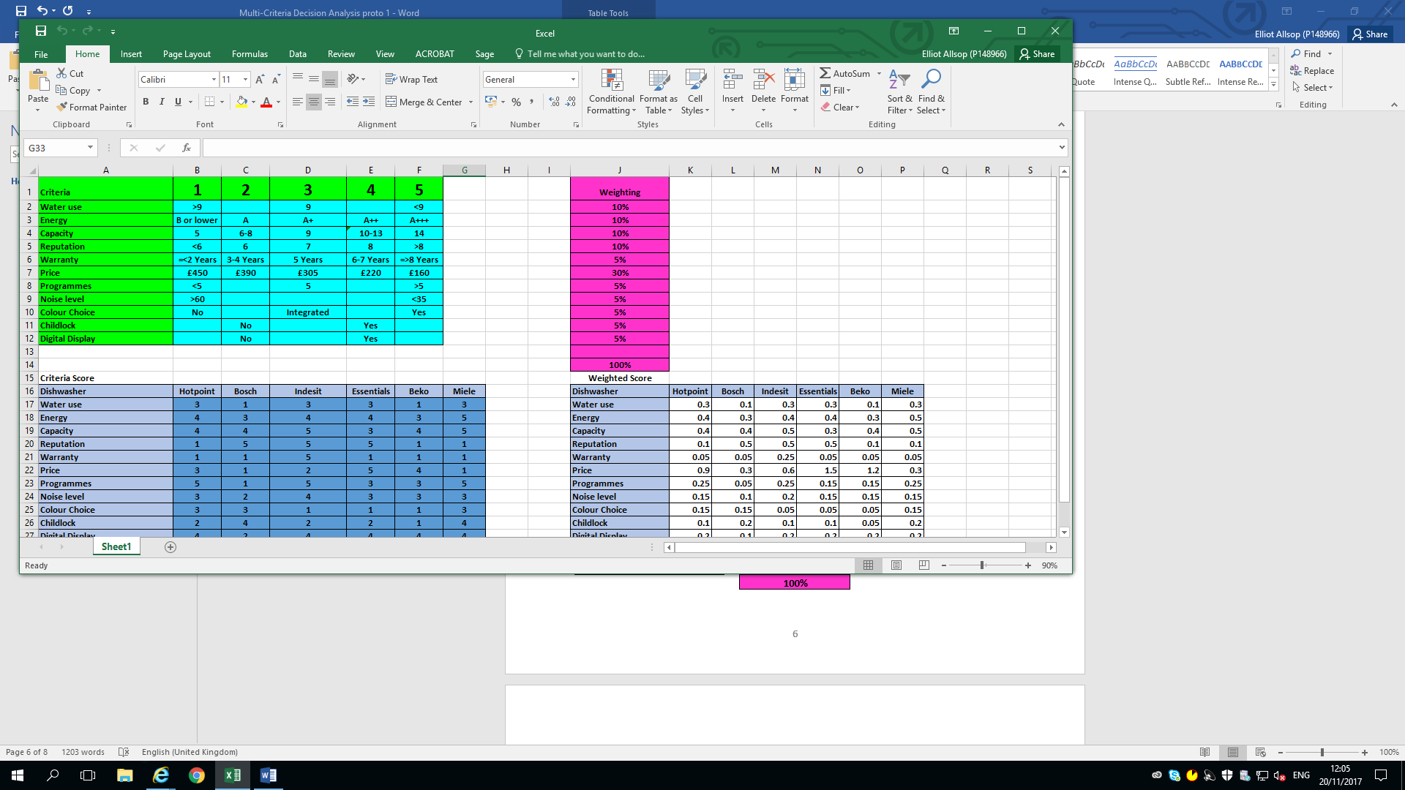

Fig 3

So as above It’s shown that the most desired criteria was weighted at thirty percent and that was the price, as it is a group of students that seems justifiable. Whereas there were a lot of criteria which were less concerning to the students which were noise level, colour choice, child lock, digital display and warranty which were all weighted at five percent? There could be many reasons as to why these criteria were all weighted lowest as everyone different and so circumstances change. Also all the criteria weighting should total to one hundred percent.

3 Sensitivity Analysis 1
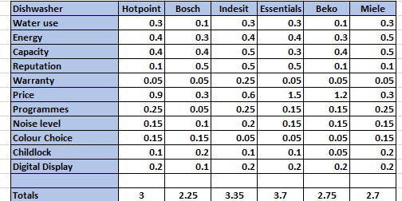
Fig4
So these are the scores at present before any sensitivity analysis took place and as seen above in figure four, Essentials is in the lead with a score of 3.7 and Bosch are losing with a score of 2.25.

After the group MCDA was carried out it was stated that each member must carry out their won sensitivity analysis due to each person having their own circumstances and so each would have a different perspective and come up with different criteria. After analysing the existing criteria within the table it was decided colour choice as a criteria due to that majority of dishwashers will either come in black, white or silver or even be integrated and so as a consumer they’ll always be able to purchase the colour variant they want to match their other appliances. In addition to this as it’s a student, the colour doesn’t matter that much its more that it functions properly and looks somewhat suitable with the rest of their kitchen.
So after removing the colour choice from the table the essentials dishwasher is still the best with a score of 3.9 and Bosch are still at the bottom of the scoreboard with a score of 2.15. Also all the other potential dishwashers have still followed suit as they remain in the same rank order. The remaining five percent as been added onto the price due to the student making it a higher priority which is very understandable.
3.1 Sensitivity Analysis 2
The next criteria feature to remove is the child lock due to the individual believing this to be rather unusual and having no kids around during the time of operation of the machine. In addition to this if there are any children around then they cans simply learn earlier on how to do the dishes some may say. Two birds with one stone. To no surprise again that the essentials dishwasher is still coming out on top and again Indesit following in second place. Also consistent is the order of the following dishwashers ranking with Hotpoint next best, then Beko, then Miele and of course Bosch last. The left over percentage weighting has been selected to go onto the remainder of the warranty due to that being another crucial criteria for the student a they dent want to receive stupendous fixing bills if the dishwasher were to break down unexpectedly.

3.2 Sensitivity Analysis 3
The next piece of criteria the student wanted to remove was the noise level as most of the time the student wouldn’t be there when the dishwasher was set on a programme. Even when the student would be there would more than likely be music playing which would drown out the noise created by the dishwasher anyhow a so is not really of any relevance. Again surprisingly the Essential dishwasher still came out with the mot points at 3.85 with Indesit following second. Again there was no change in the order of the other dishwashers. The remaining percentage was added onto the water usage criteria as the student wanted the dishwasher to be somewhat efficient at leaning the dishes and not to increase the water bill.

3.4 Sensitivity Analysis 4
Lastly the student wanted to remove one more criteria which was programmes as the student really mind how many programmes the dishwasher came with as long as it washed the dishes properly and was easy enough to use, the way the student interpreted it was that the less programmes it had the less hassle it was to wash dishes. Which in itself is a very simple chore but with the help of a dishwasher the easier life is. The five percent weighting feed by removing the programmes was allocated to the reputation of the dishwasher, this was because these days every little purchase is normally backed up by review reading first. As consumers want to know whether the product they are about to buy is worth while or a waste of time and money. So as some may have guessed the Essentials dishwasher still came out on top rather randomly. Which can be seen in figure five below what can also be seen is that Indesit still follows second followed by Hotpoint, Beko, Miele and lastly Bosch.

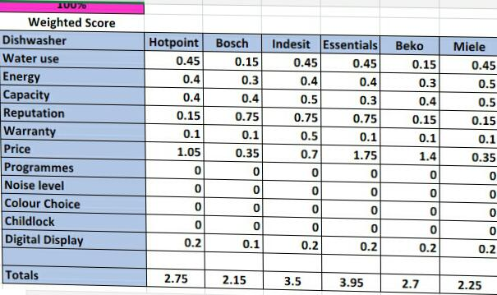
Fig 5

4 How can MCDA be used in Logistics?
Multi-Criteria Decision Analysis could be used in logistics for a whole bunch of things especially when deciding to purchase items. For example trucks, it can be used to analyse the specification of trucks by researching factors such as speed, acceleration, strength, reliableness and cost obviously. In addition to this they could also extremely consider what type euro engine they contain which would have a massive affect on the whole analysis and could discount many trucks. The main stakeholders for this scenario would be the Boss of the company looking to purchase a new truck as well as the driver. These two stakeholders would be very interested as thy would like a bit of each stated criteria above at its best. For example they would like loads of power, great reliability and a relatively strong engine in terms of cruising speeds and they would both like it for a fraction of the real price.
5 Conclusion
It is pretty obvious right now to state that Multi-Criteria Decision Analysis is an extremely useful business tool for analysing potential products to purchase. It can be used for petty much anything if you like from everyday shopping such as supermarkets by adding up the pros and cons and then applying own criteria to make it more personally worth it. Or it can be used to more professionally for more expensive and luxurious items such as vehicles or household appliances. Where cost may place a relatively large factor of the criteria or not. Although it can sometimes be a long drafted process it simply is worth every step as it allows users to et to an end point based on the criteria more importantly chosen. Although the Essentials dishwasher always came out on top it can be easily changed by removing the price as this was one of its strong scoring points as well as reputation too surprisingly.

References
Ao.com. (2017). Dishwashers | Integrated | Slimline | ao.com. [online] Available at: http://ao.com/dishwashers [Accessed 20 Nov. 2017].
Currys.co.uk. (2017). Dishwashers - Cheap Dishwashers Deals | Currys. [online] Available at: https://www.currys.co.uk/gbuk/household-appliances/dishwashing/dishwashers/350_4035_31762_xx_xx/xx-criteria.html [Accessed 20 Nov. 2017].
Gov.uk. (2017). Cite a Website - Cite This For Me. [online] Available at: https://www.gov.uk/government/uploads/system/uploads/attachment_data/file/7612/1132618.pdf [Accessed 20 Nov. 2017].
Projects.ncsu.edu. (2017). MCDA. [online] Available at: https://projects.ncsu.edu/nrli/decision-making/MCDA.php [Accessed 20 Nov. 2017].

