LCLM4002_BIRM Digital Skills
Task 3 Website Evaluation
Student Number | Eva De Jesus Fatima Martins | Student Name | 2528903
Website Chosen | Cleaners of London
Insert hyperlink to website | https://www.cleanersoflondon.co.uk/
Evaluation
Respond to each question
Section 1 – Usability
(75 words maximum for each answer)
Question 1a - How quickly and easily does the website load?
Answer:
The website loads quickly and the homepage content appears within a few seconds. The design is simple and not overloaded with large graphics, which helps the site run smoothly. Key information such as the booking system and services are displayed immediately when the page opens. In essence, it allows customers to quickly start browsing the website or booking services, making the entire process easier.

Question 1b - Does the website contain many sub-pages? How does a prospective customer navigate these?
Answer:
The website includes several sub-pages such as services, prices, booking, frequently asked questions, and contact information. All the key information is mainly located in the top menu. There are large buttons that contain the most important words, including: Get Instant Price and Book Now, which lead the users to the booking page. That navigation system allows future customers to find the information they seek at the quickly and efficiently.
Question 1c - Can a customer make a booking via the webpage?
Answer:
It is true that the customers are enabled to make bookings directly on the site. The site provides an online booking system where users can enter their postcode, select the type of cleaning service, and customize their requirements. Customers can choose the date, time, and property size before confirming the booking. This process provides customers with real-time price details and allows them to book services quickly and easily online. (see Figure 4).
Question 1d - What improvements could be made to the usability of the website?
Answer:
Although the website is easy to use, some improvements could enhance usability. As an example, the inclusion of more direct inter-page links between service pages may allow the customers to go through alternative options knowing that they can do it even more easily. The website could also include short videos explaining how the booking system works. These changes would make the website even more user-friendly, particularly for first-time visitors who may not be familiar with the services.
Section 2 – Pleasure – Customer Experience
(75 words maximum for each answer)
Question 2a – How pleasant does the webpage look? Are there any differences in appearance on a mobile phone versus a computer?
Answer:
The webpage looks clean, professional and well organised. The structure is also designed with clear headings and properly-organized sections that facilitate reading. The website automatically adjusts to mobile screens, ensuring that text, images and buttons remain clear and easy to read. The same appearance on mobile and desktop platforms helps to create a positive user experience.
Question 2b - How does the website use imagery, video and color?
Answer:
The website uses images of clean homes and professional cleaners to visually represent the services offered. The images allow customers to quickly understand the types of services provided. The color scheme mainly uses white and blue tones, which create a clean and trustworthy appearance. Icons are also used to explain the booking process. However, the website mainly relies on images and graphics rather than video content.
Question 2c – Has the website made use of an online chat tool on the website? How effective is this to enquire about the product or service?
Answer:
The website mainly encourages customers to contact the company by phone or email rather than through a live chat tool. This allows customers to speak directly with a member of staff who can answer questions about cleaning services or bookings. While this approach is helpful, adding a live chat feature could improve customer convenience by providing faster responses to questions (see Figure 4).
Question 2d – How effective are the social media links on the website?
Answer:
Social media links allow customers to connect with the company outside the main website. These connections allow the customers to see the updates, reviews, and connections with peers. Social media platforms can increase trust because potential customers can observe feedback from previous clients. They also provide another way for the company to communicate with customers and promote their services online.

Section 3 – Perceived Value
(75 words maximum for each answer)
Question 3a - How are the services offered by the company made clear to customers?
Answer:
The website clearly explains the services through dedicated sections and descriptions. Customers can view different cleaning options such as domestic cleaning, deep cleaning, one-off cleaning, end-of-tenancy cleaning, and carpet cleaning. All the services include a brief explanation of what it includes and when it happens to be best. This well-organized presentation could help customers to learn more about what the company has to offer and to choose the most suitable one (see Figure 2).
Question 3b - How are customer reviews made available? Are these up to date?
Answer:
Customer reviews are shown on the website through ratings and feedback from previous clients. The homepage highlights positive reviews and high customer satisfaction. Such reviews would help to prove that there is a significant number of customers who have effectively used the service. Displaying recent customer feedback helps potential customers feel more confident when choosing the company’s cleaning services.
Question 3c – How is the service presented as high quality? For what reasons would you
Use the company’s service or recommend to a friend or family member?
Answer:
The website presents the service as high quality by highlighting experienced and professional cleaners. The company explains that cleaners are vetted, insured and identity-checked. In addition, it emphasises reliability and customer satisfaction, which helps create a trustworthy company image. I would recommend the service because the website is easy to use, clearly explains the services and provides a convenient online booking system.
Question 3d - Are prices made clear to customers? If yes, do the prices reflect the quality of service shown? If no, why do you think the company has chosen not to include prices?
Answer:
Yes, the website provides pricing information for different cleaning services. Depending on the type of service and the size of the property, different prices are stated, but a client can see approximate prices per hour and receive instant quote through the booking form. This approach allows the company to provide accurate prices based on each customer’s specific requirements (see Figure 4).
Section 4 – Searchability
Question 4a - What three words would you type into Google to find this type of service? | 1. London cleaning services
 | 2. house cleaners London
 | 3. domestic cleaning London
Question 4b - When you type these words into Google, does the company’s website
appear in the top ten websites?
Answer:
When searching for cleaning services in London, the company’s website often appears within the first page of search results. This suggests that the website has good search engine optimization (SEO). Exposure at the top of search results enhances the likelihood of potential consumers seeing the site when online searching cleaning services.
Section 5 – Reflection and conclusion
(120 words maximum for each answer)
Question 5a - Do you feel that websites still have relevance in modern UK business? Explain your answer.
Answer:
Yes, websites remain very important in modern UK business. Many customers search online before selecting a service provider. A well-designed website allows businesses to present their services, prices and contact details to a wide audience. It also allows customers to compare different companies and make bookings online. A web site can provide a convenient opportunity in the context of service-based businesses, specifically cleaning companies, where a customer can quickly find out more about services and make an appointment. Websites therefore remain a key marketing and communication tool for businesses in the digital economy. Websites also increase the business credibility and provide a customer with an opportunity to compare before making a purchase decision.
Question 5b - If you were to make one recommendation about how to improve the website of your chosen company, what would it be? Why have you suggested this improvement?
Answer:
One recommendation would be to add a live chat feature to the website. Inclusion of a live chat would allow the customers to ask questions and get immediate answers with regards to services or reservations. This would improve customer support and make the website more interactive. It would also help customers who prefer quick online communication instead of making a phone call. The interactive features will be improved, and this is likely to improve customer engagement and thus customer experience to the whole.

Reference List
Cleaners of London (2025) Professional House Cleaning Services in London. Available at: https://www.cleanersoflondon.co.uk/

Statista (2025). Topic: Online search market in the United Kingdom. [online] Statista. Available at: https://www.statista.com/topics/6590/search-engines-in-the-uk/?srsltid=AfmBOoqqCHOPYnRkCEzEnb0x2RjCH5Ep8UM1v6GAL39clKZil7HhLfpy

Appendix

Figure 1: Homepage of Cleaners of London showing the booking system and main service information.

The homepage of the Cleaners of London website showing the main service information and the instant booking system.
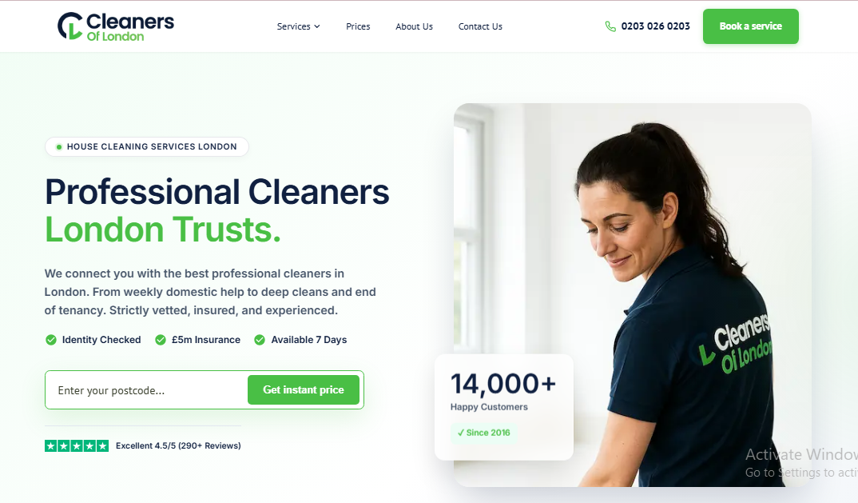
Source: Cleaners of London website

Figure 2: Cleaning services offered on the Cleaners of London website.

The services page showing the different cleaning options offered by the company including domestic cleaning, deep cleaning and end-of-tenancy cleaning. This figure shows the different cleaning services available to customers.
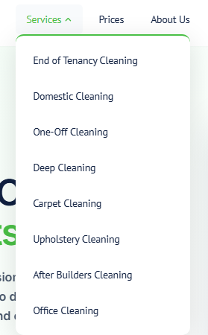
Source: Cleaners of London website

Figure 3: Example pricing information displayed on the Cleaners of London website.

Example pricing information displayed on the Cleaners of London website showing estimated costs for different cleaning services.

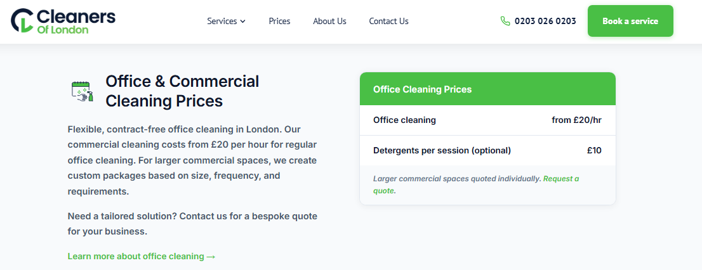
Source: Cleaners of London website

Figure 4: Online booking system used to schedule cleaning services.

The online booking system where customers can select the type of service, date and property details before confirming a booking. This figure shows the step-by-step booking system where customers can select property details, customise services, and receive an instant price.
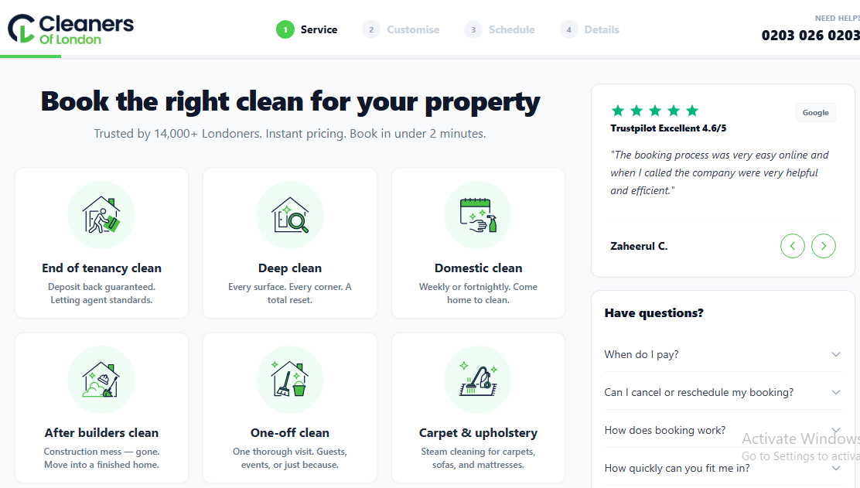
Source: Cleaners of London website

