Material Science and Building Services

Lighting Layout and Sound Index calculation

Task A
A production area in a factory measures 60 metres x 24 metres x 8 metres in height.
The factory’s work benches are set at a height of 1m above the floor level.
The area’s reflectances are 0.3 for the ceiling and 0.5 for the walls.
The Lighting design specifies Fluorescent lamps in recessed louvre with DLOR of 50%.
(The actual size for the luminaires is 1200mm (1.2m) in length and 200mm (0.2m) wide.)

A Lighting Design Lumen (LDL) output of 18,000 lumens is required.

The illumination required for the factory area is 200 lux at the working plane.
Light Loss Factor = 0.75

1: Calculate:
1) The Room Index
2) The Utilisation Factor (from tables)
3) The Number of lamps required
4) A suitable layout (value of S) for the lamp fittings

1)
Room index
RI= (L x W) / (Hm (L + W))

L = 60 W= 24 Hm= 7

RI= (60 x 24) / (7(60 + 24))
RI= 1440 / 588
RI= 2.449
RI= 2.5
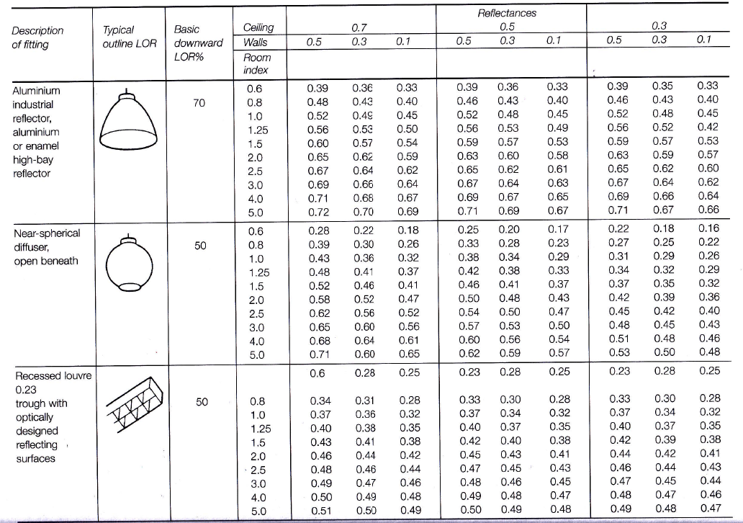
2)

Utilisation Factor = 0.46 (from table)

3) Number of lamps

N= E x A
F x UF x LLF

E= 200
A= 60 x 24
F=18,000
UF= 0.46
LLF= 0.75

Number of lamps = 46.3768
Lamps needed = 47
Lamps used = 48

4) Suitable layout

Smax = 1.5 x Hm
Smax = 1.5 x 7
Smax = 10.5

2)

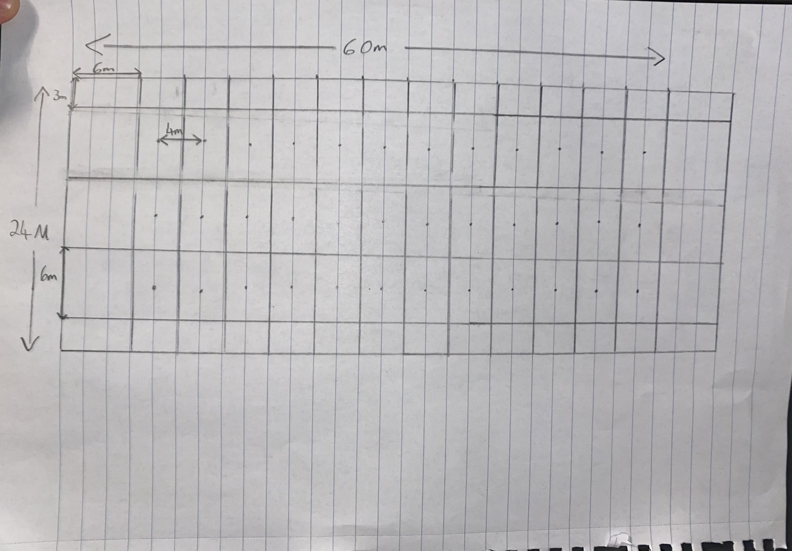

The Smax value is 10.5 as calculated. The largest gap of no lighting in this layout is 8m meaning this, 4 rows of 12 lights is a suitable layout.
The typical gap between the centre of each light in a row is 4m (1.6cm on paper) and 6m between each row (2.4c on paper).

Task B
- A brick wall of area 20m² contains a window of area 4m².

The values of sound reduction indexes are:
50dB for the brickwork and 10dB for the window.
Calculate the overall sound reduction index for the entire wall.

- Discuss the implications of frequency and wavelength in internal sound management,
partition wall construction technique and insulation choice. (500 words)

- Overall sound reduction index

SRI = 10 x (log10(1/T))

Brickwork
50 = 10 x (log10(1/T))
5 = log10 (1/T1)
1/T1 = 10^5

1/10^5 = T1
T1 = 10^-5
=0.00001

Window
10 = 10 x (log10 (1/T2))
1 = log10 (1/T2)
1/T2 = 10^1
T2 = 1/10^1
T2 = 10^-1
T2 = 0.1

To = (T1 x A1 ) + (T2 X A2)
A1 + A2

To = (0.00001 x 16) + (0.1 x 4)
16 + 4

To = 0.2

SRI = 10 x (log10(1/T))
= 10 x (log10 (1 / .02)
= 17 dB

2)

Insulation Choice

Sound insulation is the main method of controlling sound movement in buildings. It is when sound energy is reduced, meaning airborne sounds such as people, traffic and wildlife are heard quieter inside a building.
Weight impacts the level of sound proofing. Generally the heavier a construction is, the better the insulation is. Heavyweight construction offers good insulation because sound waves are vibrations and the heavier something is, the harder it is to vibrate. Minimising airgaps in structures improves the insulation of a building. This is because gaps allow air to pass through and the sound waves aren’t absorbed at those points such as key holes and air vents.

Partition wall Technique

When it comes to the separation of rooms, a minimal amount of contact between two surfaces provides the best insulation. Therefore a glass fibre gap would be more impactful than a rigid stud link where there is a large amount of physical contact.

For timber or metal stud frame partition walls there is typically one layer of lightweight plasterboard on either side of the studs and a hollow inside. This means that sound that gets into the hollow void, it causes ‘the drum effect’ where the sound echo’s and amplifies. Also airborne sounds such as vibrations of footfall or falling objects can only be reduced by mass. Therefore the lightweight plasterboard has very little effect on the airborne sounds.

Typically then acoustic grade plasterboard (15mm) is far more effective than standard 12.5mm plasterboard, due to it’s increase in mass.

The hollow void on the inside, causing the drum effect can be remediated by installing a 60 kg rock wall acoustic mineral wall into the frame, absorbing the sound that enters and cancelling the drum effect.

Soundboards can be added to the plasterboard, adding mass to the structure and thus reduce the airborne sounds. These soundboard fixings must be fixed to the timber studs and not just the plasterboard because these soundboards are very heavy.

