

Student name: Krisha Jayesh Ahir
Student ID: 2515386
Programme: MSc Public Health and Social care in practice
Topic: Inflammatory Bowel Disease
(Crohn’s Disease and Ulcerative Colitis)
Module Community care and management of long-term condition
Module Code: LCHS7003
Assignment Title: Component 1- information booklet of long-term condition
Lecturer: Dr. Raheela Shaikh


Table of Contents
Introduction 4
Definition of inflammatory bowel disease 5
Overview of IBD 5
Crohn’s disease 5
Ulcerative colitis 6
Global And Uk Burden and Prevalence 6
Risk factors 8
Non-modifiable determinants 8
Modifiable determinants 8
Signs and symptoms 8
Crohn’s disease 8
Ulcerative colitis 9
Aetiology 10
Physical, Psychological and Social Impact 11
Evidence-based management in the UK (NHS) 13
House of Care Model 14
Chronic Care Model 14
Summary 15
Reference list 16

Figure 1: Crohn and ulcerative colitis 5
Figure 2: Global burden of inflammatory bowel disease in the elderly: trends from 1990 to 2021 6
Figure 3: IBD severely impacts physical morbidity 8
Figure 4: Step-up treatment pathway for IBD 10
Figure 5: British Society of Gastroenterology guidelines on colorectal surveillance in inflammatory bowel 12
Figure 6: The British Society of Gastroenterology (BSG) Clinical Guidelines 13

Introduction
IBD (inflammatory bowel disease) refers to Crohn disease, ulcerative colitis, chronic relapsing inflammatory gastrointestinal tract diseases that are associated with immune dysregulation and remission and flare (Moran et al., 2025; Long, 2024).
IBD is burdening the world, and the epidemiological forecasts show that both high-income and newly industrialising countries are increasing and persisting in rise owing to the demographic shift in the population and environment (Kaplan, 2025; Wang et al., 2023; Heydari et al., 2025).
In the United Kingdom, in-practice populations of primary care, incidence and prevalence levels remain high, and new data show a significant geographical disparity in the geographical distribution of disease and demand in the area (Freeman et al., 2021; Veral et al., 2025).
IBD is linked with excess mortality and severe chronic complications, such as stricturing disease, fistula and high risk of colorectal cancer with necessitated structured follow-up (Li et al., 2023; Moran et al., 2025).
In addition to the gastrointestinal pathology, patients often face the issue of psychological distress, a decrease in their resilience, and extensive self-care demands affecting the quality of life and long-term outcomes (Napolitano et al., 2025; Anders-Rumsey et al., 2025).
Pharmacological, surgical and biologic treatments are also evidence-based, but the problems of inequity in access, time lags in diagnosis and variation in availability across regions remain prevalent to the care delivery in the NHS (Moran et al., 2025; Vuyyuru et al., 2024; Crohn’s & Colitis UK, 2022).
Both national standards and benchmarking initiatives are designed to help to minimise unnecessary variation and foster standard and person-centred IBD management throughout the UK services (IBD UK, 2024; British Society of Gastroenterology, 2025).

Definition of inflammatory bowel disease
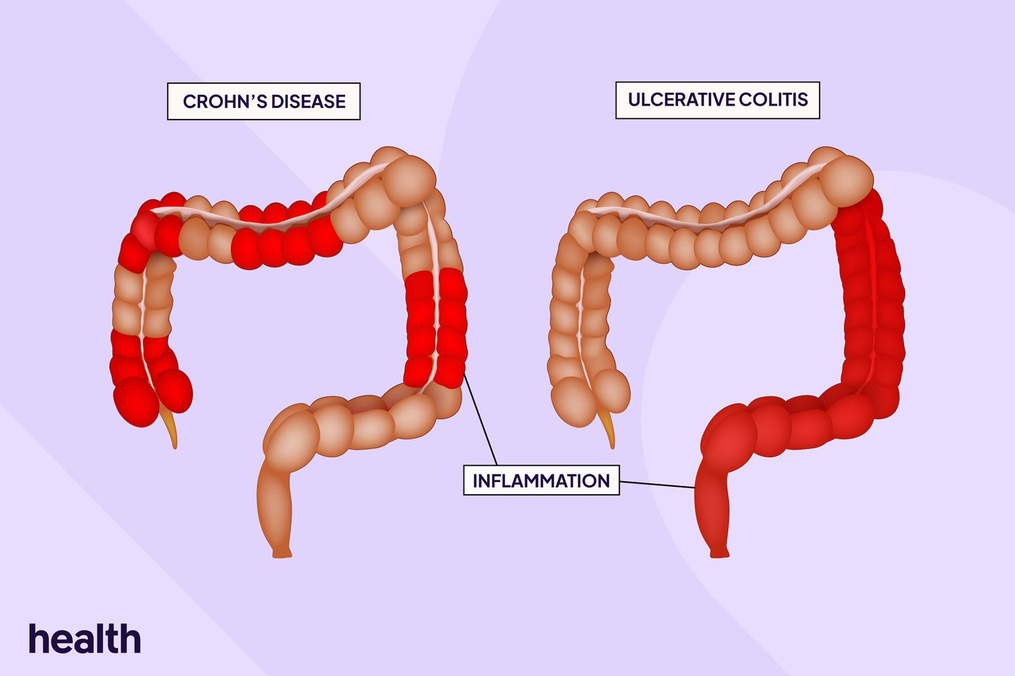

Figure 1: Crohn and ulcerative colitis

Overview of IBD
- Inflammatory bowel disease (IBD) is a chronic immune-mediated disorder, the inflammatory process of the gastrointestinal tract, manifested by relapsing and remitting inflammation, caused by dysregulation of immune responses in genetically vulnerable people (Long, 2024; Rajapakse, 2021).
- It is a chronic condition that periodically has an active phase of the disease (flares) and a remission that cannot be eliminated without proper follow-up and long-term treatment in special services.
- IBD is a diverse disease that involves two main clinical entities, Crohn's disease and ulcerative colitis, which are unique in their anatomical location and extent of inflammation as well as depth of complications.
- It also has systemic effects not just in intestinal inflammation since the condition is poorly understood in terms of its immunological and inflammatory mechanisms (Kaplan, 2025).

Crohn’s disease
- Crohn disease may involve a mouth to anus gastrointestinal tract and is pathologically characterised by transmural (full-thickness) inflammation (Long, 2024).
- Transmural inflammation poses a risk in the occurrence of complications like strictures, abscesses and fistula formation especially in late or fistulising types of inflammation (Vuyyuru et al., 2024).
- The manifestation of the disease is heterogeneous and can be located differently, depending on severity and response to treatment, which makes it problematic to conduct an individualised treatment plan.

Ulcerative colitis
- Ulcerative colitis confines itself to the colon and rectum and it can be characterized by ongoing inflammation of the mucosal layer that commences in the rectum and moves forwards (Lee, 2020; Long, 2024).
- The inflammation, which occurs in Crohn’s disease, is superficial and limited to the mucosal layer, but with the course of the disease, the risk of colorectal cancer also rises.
- The clinical manifestation is between mild distal disease and widespread colitis, which necessitates gradual increase in the therapeutic intervention based on the intensity of disease activity.

Global And Uk Burden and Prevalence
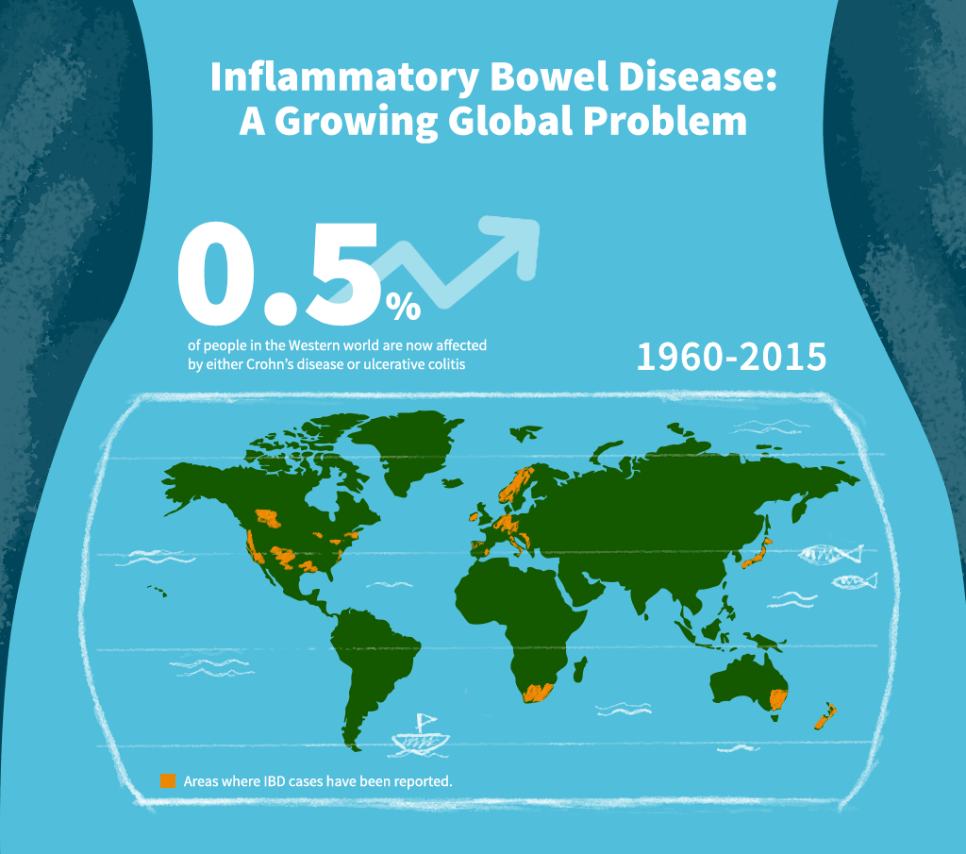

Figure 2: Global prevalence of inflammatory bowel disease (IBD)
- Over the past decades, the inflammatory bowel disease (IBD) has become a significant global issue, with Global Burden of Disease (GBD) reports showing both its growth in high-income areas and rapid rise in the incidence of the disease within newly industrialising nations (Alatab et al., 2020; Wang et al., 2023).
- Recent systematic reviews confirm the fact that both incidence and prevalence are still high at global level which was a result of the demographic changes, urbanisation, and shifting environmental exposures (Heydari et al., 2025).
- Epidemiological forecasts indicate that the prevalence rates of IBD will keep growing until 2045 due to the ageing of the population, rising survival and prevalent environmental risk factors, which may create even a greater global health issue (Kaplan, 2025).
- In the United Kingdom, a high and persistent incidence and prevalence rate are reported in studies of large-scale primary care databases, which supports the IBD as a significant long-term condition in the NHS services (Freeman et al., 2021).
- Spatial analyses also reveal significant geographic unequal distribution in the regions of the UK, meaning that there is unequal distribution of disease burden and possibly unequal access to expertise services (Veral et al., 2025).
- UK Biobank mortality data indicate that IBD is linked to higher all-cause and cause-specific mortality, which points to the systemic (long-term) impacts of chronic inflammation and comorbidity (Li et al., 2023).
- The increasing age of the UK population will probably increase the clinical and financial pressure of IBD because geriatric patients have multimorbidity, polypharmacy, and increased complexity in addressing them (Kaplan, 2025; Freeman et al., 2021).
- Increased prevalence means that there will be continuous endoscopy demand, biologic interventions and specialist nurses, which will place additional strain on NHS services that are already strained by waiting-time backlog (Wang et al., 2023; Kaplan, 2025).
- The socioeconomic deprivation and regional disparities can affect the outcomes of the disease and access to care as geographic clustering implies that patient experience may be different depending on service structure and workforce available in a particular geographic area (Veral et al., 2025; Li et al., 2023).
- All of these data suggest that IBD can be both a clinical and increasing burden and a growing public health and service-planning stressor that requires the allocation of resources strategically and even distribution of the existence of equitable service provision within the UK healthcare system (Kaplan, 2025; Wang et al., 2023).

Risk factors

Non-modifiable determinants
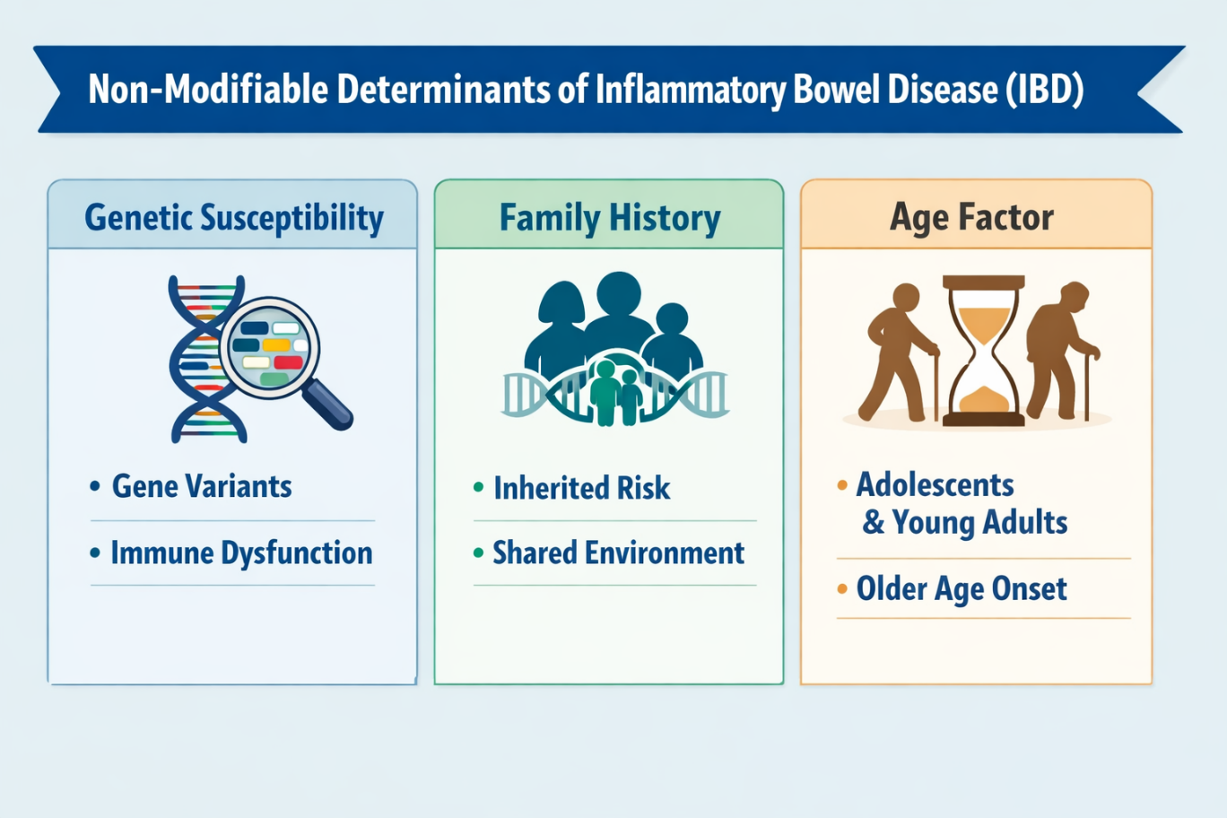
Figure 3: Non-modifiable factors of IBD
- In inflammatory bowel disease, genetic susceptibility is a dominant trait, and genome-wide association studies conducted have identified numerous risk factors associated with immune regulation and epithelial barrier activity (Huber, 2016; Kaplan, 2025).
- A family history with a positive result highly predisposes the chance of contracting IBD, which is a manifestation of hereditary immune hyperactivity and a shared environmental impact (Rajapakse, 2021).
- Another determinant is age since IBD is typical in adolescence and young adulthood, with a second surge of incidence having been observed in older age groups, adding to the growing burden in healthcare (Freeman et al., 2021; Kaplan, 2025).

Modifiable determinants
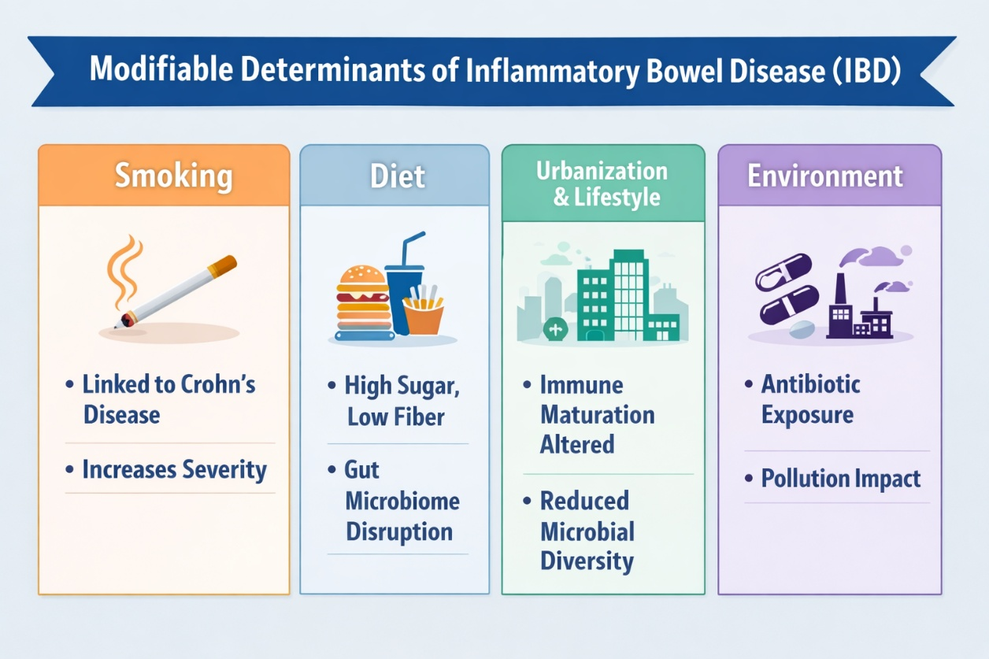
Figure 4: Modifiable factors of IBD
- The prevalence of cigarette smoking is closely linked with the onset of Crohn disease, augmenting the severity of the disease, clinical revival and surgeries, whereas, with ulcerative colitis it is more intermingling (Long, 2024).
- Sugar food consumption and low levels of fibre are temporary eating habits associated with disruption of the microbiome of the gut and increased prevalence in industrialised areas (Catalan-Serra and Sebastian, 2025; Kaplan, 2025).
- Environmental changes that are linked to urbanisation and westernised way of life lead to the alteration of immune maturation and microbial diversity that has the potential to induce the onset of diseases in individuals with genetic predisposition before onset (Kaplan, 2025).
- Greater exposure to the environment, such as the use of antibiotics and pollution, can produce additional effects of immune imbalance and dysbiosis, but the causal pathways are still being studied (Huber, 2016; Catalan-Serra and Sebastian, 2025).

Signs and symptoms

Crohn’s disease
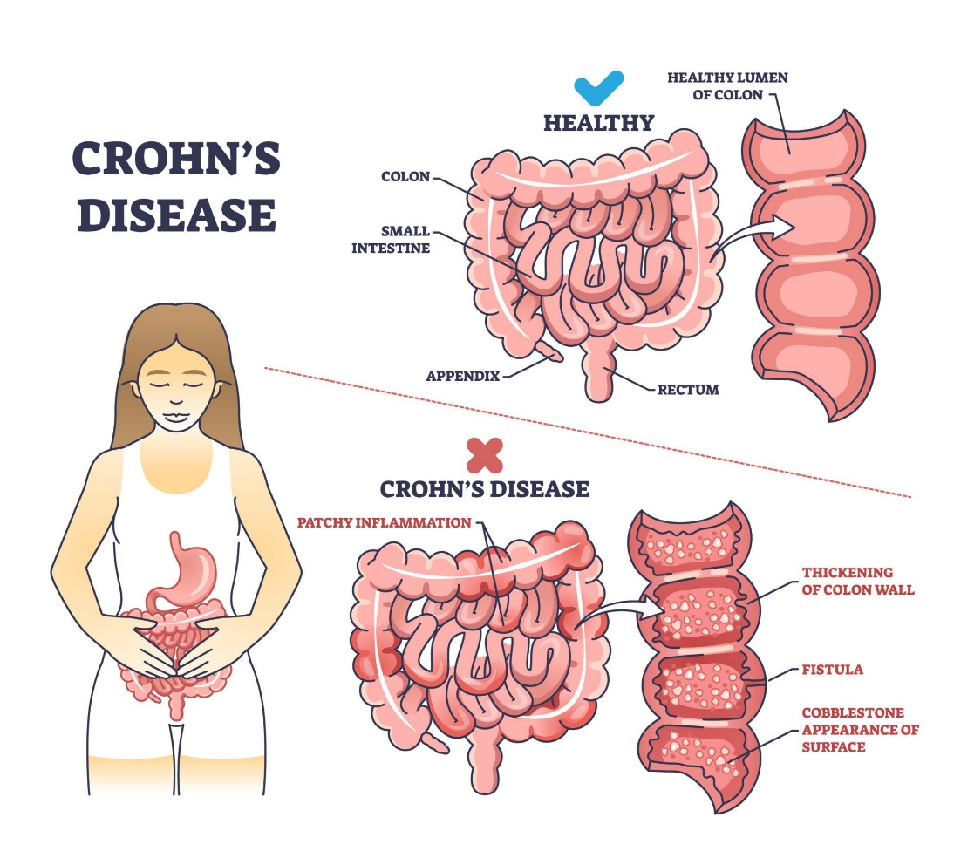
Figure 5: Crohn’s disease
- Crohn disease exhibits varying gastrointestinal conditions with the location of the disease, and abdominal pains and persistent diarrhoea are the most common manifestations (Long, 2024).
- The symptoms of transmural inflammation could include complications like strictures, formation of fistulas and abscess which could often cause obstructive symptoms, discharge of the perianus or frequent infections (Vuyyuru et al., 2024).
- Chronic inflammatory activity and malabsorption are manifested in systemic symptoms such as fatigue, loss of weight and low-grade fever (Moran et al., 2025).
- They can also have extraintestinal manifestations that include joint pains, skin abscesses and eye inflammation proving the systemic immune system of the case (Rajapakse, 2021).
- Frames of relapse and remission are used to define the level of severity of the disease, which adds to the element of unpredictability and impaired functioning.

Ulcerative colitis
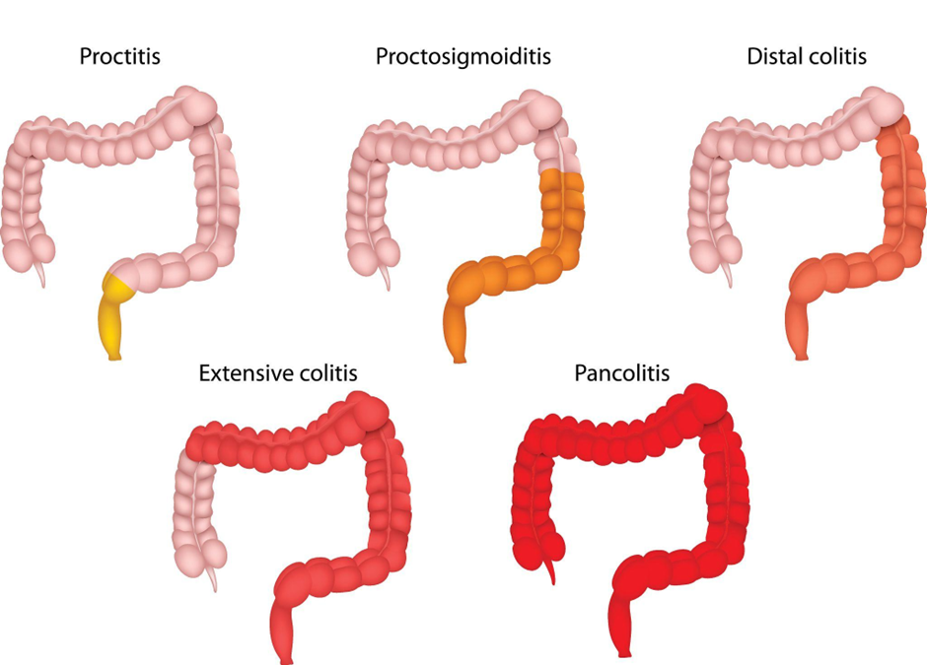
Figure 6: Types of Ulcerative Colitis
- The symptoms of ulcerative colitis are usually bloody diarrhoea, rectal bleeding and urgency with constant inflammatory processes in the mucosa starting in the rectum (Lee, 2020; Long, 2024).
- Patients often experience abdominal cramping, tenesmus and a high stool frequency especially in case of active flares (Moran et al., 2025).
- Critical illness can result in anaemia, dehydration and, in extreme situations, toxic megacolon, which is a medical emergency (Lee, 2020).
- Prolonged inflammation is a risk factor with an impact on colorectal cancer, which requires organized surveillance colonoscopy in the long-term care pathways (Moran et al., 2025).

Aetiology
- IBD aetiology is complex and includes or entails multi-factorial interaction among genetic vulnerability, maladjustment of the immune system, environmental exposures and changes within the intestinal microbiome (Huber, 2016; Kaplan, 2025).
- Persistent inflammation of the intestines and defective elements of the epithelial barrier are genetically determined and manifest themselves in abnormal immune reactions to commensal microbiota in the gut (Baumgart and Baumgart, 2017; Rajapakse, 2021).
- The defective cytokine signalling systems, such as tumour necrosis factor (TNF) and other inflammatory products, maintain damage at the mucosal layers and continue inflammatory loops (Long, 2024).
- The onset of diseases in vulnerable populations is believed to be caused by environmental factors, including Westernised food behaviour and pattern and lifestyle change as well as exposure to antibiotics, which has increased the incidence of diseases worldwide (Kaplan, 2025; Catalan-Serra and Sebastian, 2025).
- Immune activation is further enhanced by microbiome abnormalities, commonly known as dysbiosis, but no universal microbial or immunological pathway can fully account for disease pathogenesis.
- This diversity of disease manifestations, including fistulising Crohn’s disease, is due to the lack of a single pathogenesis and complexity in prevention measures (Vuyyuru et al., 2024).

Physical, Psychological and Social Impact
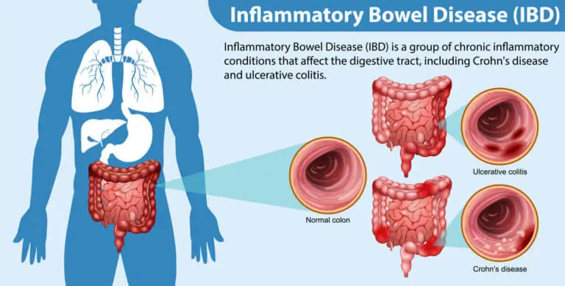

Figure 7: Physical impact of IBD
- Flares of inflammatory bowel disease (IBD) severely impact physical morbidity, mainly in the form of abdominal pain and diarrhoea, rectal bleeding and general fatigue, which may develop into stricturing and penetrating complications (especially in Crohn’s disease), (Vuyyuru et al., 2024).
- The condition of fistulising Crohn’s disease is a severity type of inflammatory disease that involves immunomodulatory or biologic therapy and, in certain instances, surgical intervention, which is the complexity of transmural inflammation (Vuyyuru et al., 2024).
- Even with the advancement of pharmacological therapy, a significant number of patients need surgical treatment, which can be bowel resection or colectomy, which have associated operative risks, stoma formation, and lasting effects on the quality of life (Moran et al., 2025).
- The risk of colorectal cancer is also linked to chronic inflammation of the intestine, which should be evaluated using the structured surveillance colonoscopy programme and risk stratification in the long-term care pathways (Moran et al., 2025).
- Population-based evidence goes further to show all-cause and cause-specific mortality that includes more people with IBD with the importance of the systemic and life-course implication (Li et al., 2023).
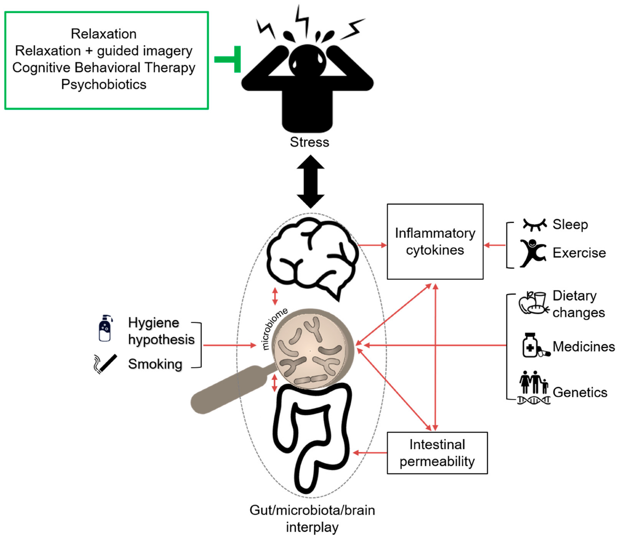
Figure 8: Psychological Impact of inflammatory bowel disease (IBD)
- In addition to its physical manifestation, IBD has a significant psychological burden. The concept of resilience differs between individuals, and the capacity to cope is a major determinant of determining the perception of diseases, adherence and quality of life to treatments (Napolitano et al., 2025b).
- Patients have also been facing significant self-management burdens and lack of control over their health condition (medications), symptom management and lifestyle change, which can be emotionally stressful and lead to decision fatigue (Napolitano et al., 2025a; Anders-Rumsey et al., 2025).
- The long-term chronic uncertainty about the recurrence of flares, hospitalisation and persistence effects, can prove to be a lower perceived self-efficacy, but a structured chronic care process has shown positive outcomes in self-management confidence and health-related quality of life (Shahrezai et al., 2025).
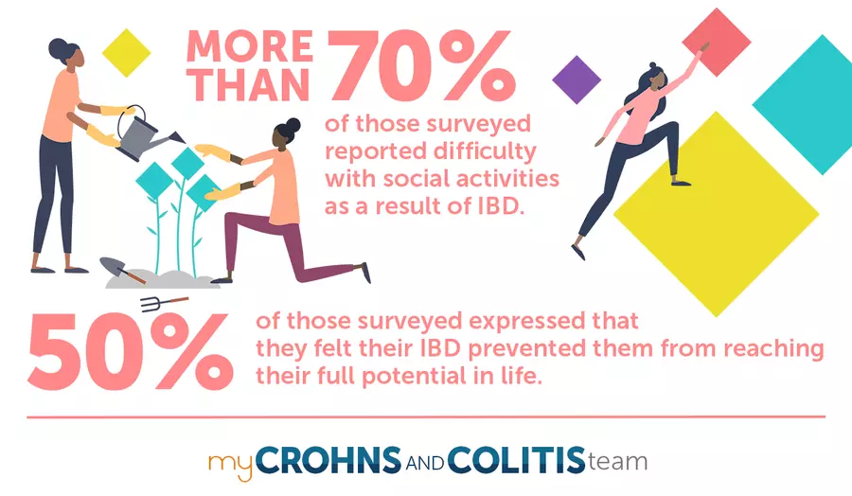
Figure 9: Social Impact of inflammatory bowel disease (IBD)
- Unpredictable symptoms IBD can interfere with work, school and productivity because of absence of planning results in fatigue and healthcare visits, leading to financial and occupational insecurity.
- Delays in the diagnosis and treatment, which are aggravated by NHS waiting-time preparation, further aggravate patient suffering and can aggravate clinical outcomes (Crohn’s & Colitis UK, 2022).
- Reports on national benchmarking indicate that there is a regional difference in the access to specialist services and multidisciplinary assistance, supporting inequity in patient experience and continuity of care (British Society of Gastroenterology, 2025).
- Well-organized self-management systems are thus necessary to promote patient autonomy and co-ordinated care, though they are not consistently introduced over services (Napolitano et al., 2024).
- All these results affirm that IBD is essentially a biopsychosocial disease, but service provision in the NHS is generally biomedical, which calls into question the significance of more integrated and patient-centred care models.

Evidence-based management in the UK (NHS)
- British Society of Gastroenterology clinical guidelines guide the management of inflammatory bowel disease in the UK and recommend a step-based process with the use of aminosalicylates, corticosteroids and immunomodulators depending on the severity and phenotype of the disease (Moran et al., 2025; Gordon et al., 2023; Okobi et al., 2021).
- Strategies of escalation are intended to accomplish the state of remission and sustain it promptly with limited chances of steroid dependence, yet the disparity in the availability and delivery still exists among healthcare systems (Okobi et al., 2021; NHS, 2025).
- Biologic therapy, such as anti-TNF therapy and targeted therapy, has revolutionized intermediate-to-severe clinical outcomes and increased mucosal healing, as well as reducing the relapse rate (Banerjee et al., 2020; Moran et al., 2025).
- Systematic review evidence indicates that biologic therapy helps in fistulising Crohn disease, and combination therapy and surgical intervention is frequently needed to maintain remission (Vuyyuru et al., 2024).
- The high acquisition costs, in spite of its effectiveness, provide issues of sustainability and equity in NHS commissioning structures (Banerjee et al., 2020).
- Refractory disease and complications or dysplasia still require surgical intervention, so the multidisciplinary contribution to coordination and planned postoperative follow-up are needed (Moran et al., 2025).
- To minimize the risk of colorectal cancer, risk-stratified evaluations of the colonoscopy surveillance to the long-term effects of colitis are advised, as they are included in organized long-term follow-up approaches (Moran et al., 2025).
- Timely referral and monitoring are emphasized under the national standards; nevertheless, the backlog of waiting-time still postpones the investigation process and administration of treatment (IBD UK, 2024; Crohn’s and Colitis UK, 2022).
- Programmes of structured self-management enhance both symptom control, resilience and health-related quality of life during combination with pharmacological management (Napolitano et al., 2025a; Anders-Rumsey et al., 2025).
- A case in point is digital and clinician-led systems of data like CCCare that show how technology can be implemented to improve monitoring and coordinated care delivery (Petch et al., 2026).

House of Care Model
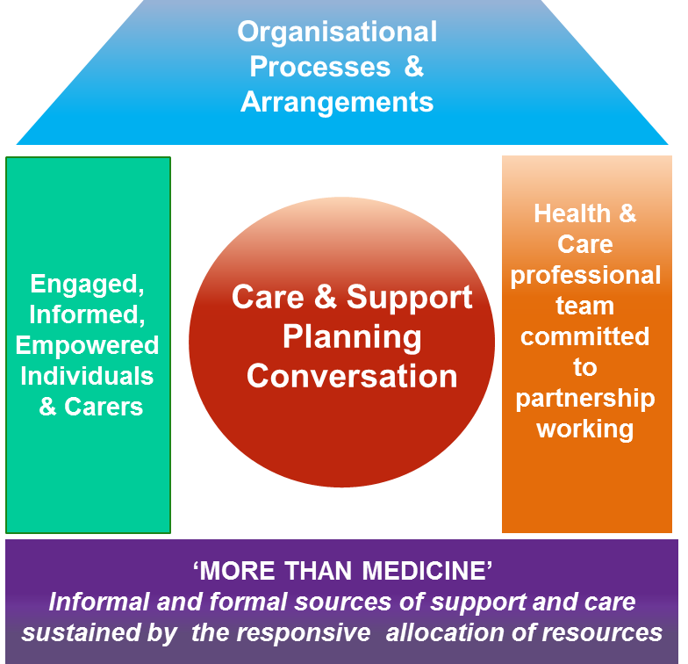
Figure 10: House of Care Model
- Since the House of Care model encourages joint planning of care, patient activation and multidisciplinary input, it is compliant with IBD UK Standards of person-centred pathway delivery (IBD UK, 2024; British Society of Gastroenterology, 2025).
- The difference in workforce variability in regions, and disparities in service design make it difficult to implement uniformly across Integrated Care Systems (NHS England, 2024).

Chronic Care Model
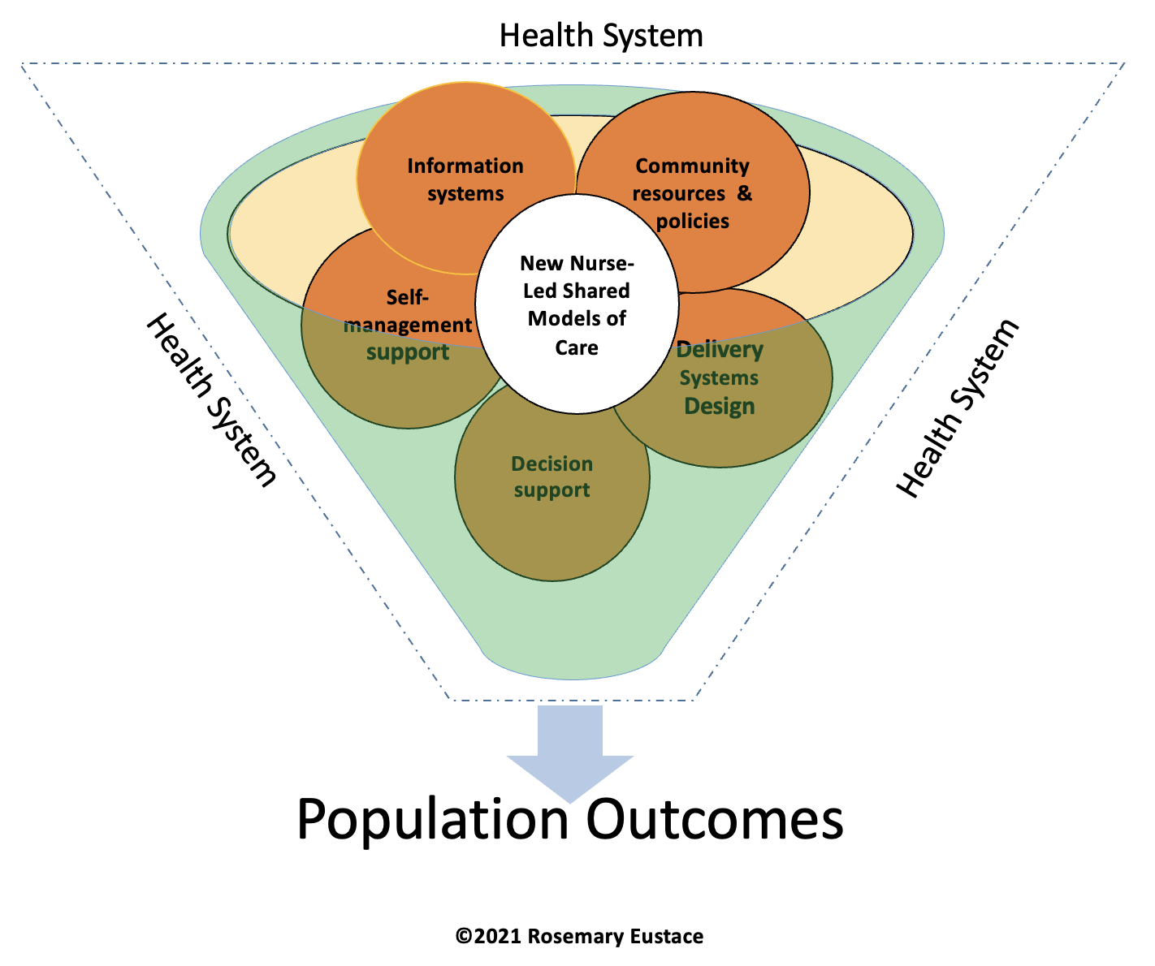
Figure 11: Chronic Care Model
- The Chronic Care Model focuses on proactive and collaborative care, behavioural support and community involvement and it deals with psychosocial aspects of chronic conditions.
- Evidence presented in randomised trials shows that the application of CCM-based interventions leads to a better self-efficacy and quality of life in the context of ulcerative colitis (Shahrezai et al., 2025).
- However, the problem of workforce shortages and resource pressures leads to an existing policy-practice mismatch between the goals of guidelines and the fair delivery of services (British Society of Gastroenterology, 2025; Moran et al., 2025).

Summary
The inflammatory bowel disease (IBD) which includes both Crohn's disease and ulcerative colitis is becoming a severe health concern across the globe, and its prevalence will only continue to rise in future in high-income countries, and is expected to do so even more in the next decades (Kaplan, 2025; Wang et al., 2023).
IBD as a major long-term condition needs long-term investment in the United Kingdom due to high prevalence, geographical disparity, and high mortality rate (Freeman et al., 2021; Li et al., 2023).
In addition to gastrointestinal inflammation, IBD is essentially biopsychosocial, with its elements encompassing physical complications, psychological burden and massive self-care necessities that affect quality of life and prolonged outcomes (Napolitano et al., 2025a; Anders-Rumsey et al., 2025).
Although there are elaborate country-wide guidelines and standards, service variation and workforce issues, as well as diagnostic delays have been identified as consistent and continuing considerations in terms of benchmarking data and reports provided by patients (British Society of Gastroenterology, 2025; Crohn’s and Colitis UK, 2022).
Enhancing integrated, person-centred models of care, which integrate timely access, multidiscipline and coordination and structured self-management support, should therefore be viewed as essential to the improvement of equity and long-term outcomes in UK IBD services (IBD UK, 2024; Moran et al., 2025).

More Information
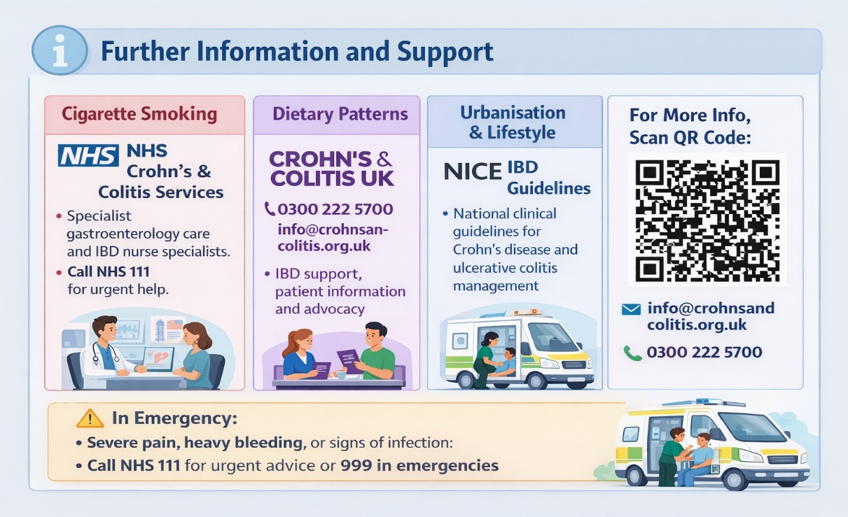

Reference list
Alatab, S., Sepanlou, S.G., Ikuta, K., Vahedi, H., Bisignano, C., Safiri, S., Sadeghi, A., Nixon, M.R., Abdoli, A., Abolhassani, H. and Alipour, V., 2020. The global, regional, and national burden of inflammatory bowel disease in 195 countries and territories, 1990–2017: a systematic analysis for the Global Burden of Disease Study 2017. The Lancet gastroenterology & hepatology, 5(1), pp.17-30. https://www.thelancet.com/pdfs/journals/langas/PIIS2468-1253(19)30333-4.pdf
Anders-Rumsey, J., Kasmikha, L., Chiang, M., Hodish, G., Sheehan, J., Golbus, J.R., Wickman, U.L., Admon, A., Resnicow, K., Sturgeon, J. and Cohen-Mekelburg, S., 2025. Inflammatory Bowel Disease Self-Care Behaviors in Context of Psychosocial Factors. Digestive Diseases and Sciences, 70(10), pp.3289-3296. https://link.springer.com/content/pdf/10.1007/s10620-025-09326-y.pdf
Banerjee, R., Ali, R.A.R., Wei, S.C. and Adsul, S., 2020. Biologics for the management of inflammatory bowel disease: a review in tuberculosis-endemic countries. Gut and liver, 14(6), p.685. https://pmc.ncbi.nlm.nih.gov/articles/PMC7667923/pdf/GNL-14-685.pdf
Baumgart, D. and Baumgart, D.C., 2017. Crohn's disease and ulcerative colitis. Springer.
British Society of Gastroenterology, 2025. IBD UK report and press release: The State of IBD Care in the UK. Available at: https://www.bsg.org.uk/news/ibd-uk-report-and-press-release/ (Accessed: 23 February 2026).
Catalan‐Serra, I. and Sebastian, S., 2025. Global inflammatory bowel disease: opportunities and challenges for a new era. United European Gastroenterology Journal, 13(8), pp.1410-1417. https://onlinelibrary.wiley.com/doi/pdf/10.1002/ueg2.70075
Crohn’s & Colitis UK, 2022. Impact of the waiting times backlog on people with Crohn’s and Colitis: Report to the Senedd Health and Social Care Committee. Available at: https://crohnsandcolitis.org.uk/media/ysroexpu/crohns-colitis-uk-impact-of-the-waiting-times-backlog-senedd-health-and-social-care-committee-inquiry-jan-2022.pdf (Accessed: 23 February 2026).
Crohn's & Colitis UK, 2026. Information and support for Crohn's Disease and Ulcerative Colitis. Available at: https://www.crohnsandcolitis.org.uk/ (Accessed: 23 February 2026).
Freeman, K., Ryan, R., Parsons, N., Taylor-Phillips, S., Willis, B.H. and Clarke, A., 2021. The incidence and prevalence of inflammatory bowel disease in UK primary care: a retrospective cohort study of the IQVIA Medical Research Database. BMC gastroenterology, 21(1), p.139. https://link.springer.com/content/pdf/10.1186/s12876-021-01716-6.pdf
Gordon, M., Darie, A.M., Sinopoulou, V., Verma, A., Kok, K.B., Patel, K.V., Limdi, J., Arebi, N., Smith, P., Din, S. and Din, S., 2023. BSG 2024 IBD guidelines protocol (standard operating procedures). BMJ open gastroenterology, 10(1). https://bmjopengastro.bmj.com/content/bmjgast/10/1/e001067.full.pdf
Heydari, K., Rahnavard, M., Ghahramani, S., Hoseini, A., Alizadeh-Navaei, R., Rafati, S., Raei, M., Vahidipour, M., Salehi, F., Motafeghi, F. and Neshat, S., 2025. Global prevalence and incidence of inflammatory bowel disease: a systematic review and meta-analysis of population-based studies. Gastroenterology and Hepatology from Bed to Bench, 18(2), p.132. https://pmc.ncbi.nlm.nih.gov/articles/PMC12421925/
Huber, S. ed., 2016. New insights into inflammatory bowel disease. BoD–Books on Demand.
IBD UK (2024) Timeframe for referral: IBD Standards — pre-diagnosis. Available at: https://ibduk.org/ibd-standards/pre-diagnosis/timeframe-for-referral/ (Accessed: 23 February 2026).
Kaplan, G.G., 2025. The global burden of inflammatory bowel disease: from 2025 to 2045. Nature Reviews Gastroenterology & Hepatology, 22(10), pp.708-720. https://www.nature.com/articles/s41575-025-01097-1
Lee, S. ed., 2020. Ulcerative Colitis, An Issue of Gastroenterology Clinics of North America, E-Book: Ulcerative Colitis, An Issue of Gastroenterology Clinics of North America, E-Book (Vol. 49, No. 4). Elsevier Health Sciences.
Li, F., Ramirez, Y., Yano, Y., Daniel, C.R., Sharma, S.V., Brown, E.L., Li, R., Moshiree, B., Loftfield, E., Lan, Q. and Sinha, R., 2023. The association between inflammatory bowel disease and all-cause and cause-specific mortality in the UK Biobank. Annals of epidemiology, 88, pp.15-22. https://www.sciencedirect.com/science/article/am/pii/S1047279723001977
Long, D., 2024. Crohn’s disease and ulcerative colitis: from pathophysiology to novel therapeutic approaches. Biomedicines, 12(3), p.689. https://www.mdpi.com/2227-9059/12/3/689
Moran, G.W., Gordon, M., Sinopolou, V., Radford, S.J., Darie, A.M., Vuyyuru, S.K., Alrubaiy, L., Arebi, N., Blackwell, J., Butler, T.D. and Chew, T., 2025. British Society of Gastroenterology guidelines on inflammatory bowel disease in adults: 2025. Gut, 74(Suppl 2), pp.s1-s101. https://gut.bmj.com/content/gutjnl/74/Suppl_2/s1.full.pdf
Napolitano, D., Bozzetti, M., Lo Cascio, A., De Stefano, G., Orgiana, N., Lopetuso, L.R., D’Onofrio, A.M., Camardese, G., Papa, A., Scaldaferri, F. and Cocchieri, A., 2025. Resilience and self-care in patients with inflammatory bowel disease: A multicentre cross-sectional study in outpatient settings. Journal of Clinical Medicine, 14(11), p.3868. https://www.mdpi.com/2077-0383/14/11/3868
Napolitano, D., Cilluffo, S., Amatucci, V., Bartoli, D., Biagioli, V., Martella, P., Monaci, A., Cocchieri, A. and Vellone, E., 2025. Self-care in patients with Inflammatory Bowel Disease: a descriptive cross-sectional multicenter study. Crohns & Colitis 360, 7(4), p.otaf061. https://academic.oup.com/crohnscolitis360/advance-article-pdf/doi/10.1093/crocol/otaf061/64923895/otaf061.pdf
Napolitano, D., Vellone, E., Iovino, P., Scaldaferri, F. and Cocchieri, A., 2024. Self-care in patients affected by inflammatory bowel disease and caregiver contribution to self-care (IBD-SELF): a protocol for a longitudinal observational study. BMJ Open Gastroenterology, 11(1). https://bmjopengastro.bmj.com/content/bmjgast/11/1/e001510.full.pdf
NHS England, 2024. Hannah’s story: Inflammatory bowel disease. Available at: https://www.england.nhs.uk/long-read/hannahs-story-inflammatory-bowel-disease/ (Accessed: 23 February 2026).
NHS, 2025. Inflammatory bowel disease. Available at: https://www.nhs.uk/conditions/inflammatory-bowel-disease/ (Accessed: 23 February 2026).
Okobi, O.E., Udoete, I.O., Fasehun, O.O., Okobi, T., Evbayekha, E.O., Ekabua, J.J., Elukeme, H., Ebong, I.L., Ajayi, O.O., Olateju, I.V. and Taiwo, A., 2021. A review of four practice guidelines of inflammatory bowel disease. Cureus, 13(8). https://www.cureus.com/articles/64322-a-review-of-four-practice-guidelines-of-inflammatory-bowel-disease.pdf
Petch, B., Carter, D., Connor, S.J., Andrews, J.M., Gearry, R.B., Walsh, A., Lawrance, I.C. and Whitfield, C., 2026. P1254 CCCare: A clinician-led, people-centric model for scalable data-driven Improvement in Inflammatory Bowel Disease care. Journal of Crohn’s and Colitis, 20(Supplement_1), pp.jjaf231-1435. https://academic.oup.com/ecco-jcc/article-abstract/20/Supplement_1/jjaf231.1435/8434370
Rajapakse, R. ed., 2021. Inflammatory Bowel Disease: Pathogenesis, Diagnosis and Management. Springer Nature.
Shahrezai, Z.S., Emami, M.H., Farzi, S. and Tarrahi, M.J., 2025. The effect of chronic care model on self-efficacy and health-related quality of life of patients with ulcerative colitis: A randomized controlled trial. Journal of Education and Health Promotion, 14(1), p.469. https://journals.lww.com/jehp/_layouts/15/oaks.journals/downloadpdf.aspx?an=01679914-202511280-00469
Veral, M.A., Pickup, R.W., Roy, M., Sanderson, J., Agrawal, G. and Atkinson, P.M., 2025. Geographic distribution of inflammatory bowel disease in the UK: A spatially explicit survey. PLoS One, 20(8), p.e0329317. https://journals.plos.org/plosone/article/file?id=10.1371/journal.pone.0329317&type=printable
Vuyyuru, S.K., Solitano, V., Narula, N., Lee, M.J., MacDonald, J.K., McCurdy, J.D., Singh, S., Ma, C. and Jairath, V., 2024. Pharmacological therapies for the management of fistulizing Crohn’s disease: a systematic review and meta-analysis. Journal of Crohn's and Colitis, 18(4), pp.589-603. https://academic.oup.com/ecco-jcc/article-abstract/18/4/589/7337607
Wang, R., Li, Z., Liu, S. and Zhang, D., 2023. Global, regional and national burden of inflammatory bowel disease in 204 countries and territories from 1990 to 2019: a systematic analysis based on the Global Burden of Disease Study 2019. BMJ open, 13(3), p.e065186. https://bmjopen.bmj.com/content/bmjopen/13/3/e065186.full.pdf

