Foundations of Engineering: Safety, Ethics, Problem-Solving and Personal Development
Workshop and practice [ACHA4011]

Oscar Price
1909682
1/12/2024

Contents

1.Contents……………………………………………………………………………………….2
2.Introduction…………………………………………………………………………………..3
3.Health & safety……………………………………………………………………………….4
4.Engineers role in society…………………………………………………………………..5
5.Problem solving………………………………………………………………………………6/6.1
6.Team structure………………………………………………………………………………..7/7.1
7.Personal development plan………………………………………………………………8/8.1
8.Conclusion…………………………………………………………………………………….9
9.References…………………………………………………………………………………….10

Introduction
Engineering applies scientific principles to solve real world problems and develop new systems and technologies. With an emphasis on health and safety, ethical responsibilities, problem solving, teamwork, and professional development, this report explores key aspects of engineering practice. This report is divided into five key sections, each addressing a critical aspect of engineering practice. It starts by discussing the significance of health and safety in the engineering industry and emphasising the need for strict compliance to regulations to ensure workplace safety. The role of engineers in society is then discussed, emphasising their responsibility to maintain a professional code of conduct, particularly in relation to ethical and sustainable practices. The report then discusses the approaches engineers take to problem solving during the development of new products, highlighting strategies for overcoming technical challenges. Finally, the report concludes with a Personal Development Plan, outlining short term and long-term career goals and provides insights into future aspirations and professional growth.

Chapter 2 – Health and Safety with Risk Assessments
Health and safety are paramount considerations during practical tasks within the field of motorsport engineering. A notable example of this is a laboratory experiment focused on suspension systems undertaken by students as part of the university course. This task required the manipulation of vehicle components, the operation of hydraulic equipment, and the utilisation of tools as such as a dial test indicator to analyse the performance and characteristics of a suspension system. Given the risks associated with this laboratory session, it is crucial to adhere to relevant health and safety regulations and implement effective risk control measures.
A key element of UK law that regulates the health and safety requirements in most sectors of engineering, including motorsport engineering, is the Health and Safety at work act 1974(HSWA). Under the act, employers and workers must make sure every operation is carried out by minimising risks to health and safety of both you and others that are impacted by the operation, this also includes spectators, competitors, and contractors during a race weekend or event.
In order to respond quickly to incidents, HSWA also advocates the usage of personal protective equipment (PPE) and the implantation of emergency procedures. For example, to safeguard yourself from mechanical and chemical hazards, experts and students working in motorsport workshops/Labs are required to wear gloves, safety goggles, and fire-resistant clothing depending on which job is at hand.
Motorsport engineers play a major role ensuring that their work not only improves performance of the vehicle but also maintains the highest standards of safety for everyone involved by abiding to the HSWA’s criteria.
Risk assessment matrix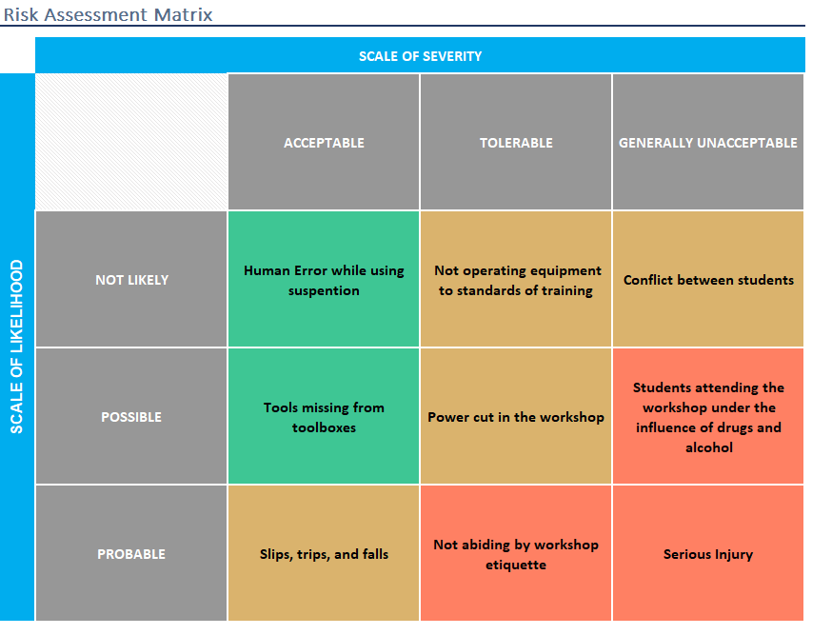Figure 1 – Risk Assessment Matrix
Chapter 3 – Engineers Role in Society
Chartered engineers, especially those working within the motorsport industry, are expected to adhere to high ethical standards due to their role in advancing technology, ensuring safety, and promoting sustainability. The Institute of Mechanical Engineers (IMechE) and the Engineering Council (ECUK) are two prominent organisations that establish these standards. They provide code of conduct that outline the professional behaviour and responsibilities of engineers, including their duties toward sustainability and environmental impact.
IMechE has established a comprehensive code of conduct that emphasises the importance of professional integrity, sustainability, and environmental awareness among engineers. This code of conduct expects engineers to consider the long-term environmental impact of their work, with a particular focus on developing technologies that minimise harm to the planet (ImechE, 2019). In motorsport, this responsibility includes addressing fuel efficiency, reducing emissions, and developing alternative powertrain technologies, such as electric or hybrid systems to align with sustainability goals. As outlined by recent research, the adoption of electric powertrains in motorsport not only reduces emissions on the track but also acts as a testing ground for technologies that impact consumer markets, such as increased fuel efficiency and reduced environmental impact (Skeete, 2019).
Sustainability is also emphasised in the code of conduct of the Engineering Council UK, which is the regulatory body for engineering in the UK. The council’s guidelines require engineers to take proactive measures to ensure that their work promotes sustainability and minimises negative environmental impacts. This includes using environmentally friendly products and encouraging the development of technologies that support a sustainable future (Engineering Council, n.d.). In motorsport, this could involve implementing green technologies, like lowering vehicle carbon emissions or switching to alternative fuels, ensuring that engineers contribute to both the creation of new approaches and the broader goal of environmental responsibility (Sturm et al., 2024).

Chapter 4 – Problem Solving
To manage the challenges that arise throughout the development, manufacturing, market release, and production of a new product, engineers must possess strong problem-solving abilities. Each phase of the process presents unique challenges that require tailored strategies and methodologies to effectively address and resolve them. Engineering challenges are often complex and require an integrated approach. As a result, developing diverse problem solving and critical skills within engineering education is crucial for preparing future engineers (Petko Stoev and Stoeva, 2024).

- Development issues
Technical problems, such as poor design or inefficient performance, often emerge during the development phase of production. Engineers commonly use methods like the Plan-Do-Check-Act (PDCA) cycle to address these issues (Realyvasquez-Vargas et al., 2018). This approach allows for implementing solutions, evaluating their effectiveness, and ensuring that successful strategies are integrated into the development process for long term improvements. Additionally, Root Cause Analysis (RCA) is utilised to guarantee correct measurements are in place to deal with the core problem (Papageorgiou et al., 2022).
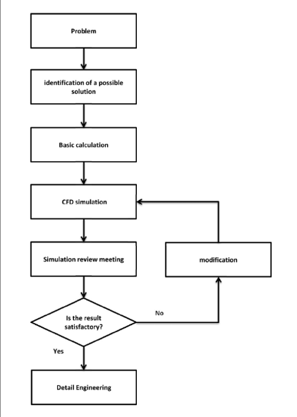

Figure 2 – Flow Diagram
- Issues found once on market
Customer feedback and product performance reviews can reveal flaws or weaknesses in a product after its market release. Identifying and addressing these issues is crucial for maintaining the products performance. One method for managing these challenges is Failure Mode and Effects Analysis (FMEA), which helps identify potential failures and assess their impact, allowing teams to prioritise risks and implement solutions to prevent reoccurring issues (Spreafico, Russo, and Rizzi, 2017). By setting priorities, engineers can minimise risks and address underlying problems, improving the overall product quality.

- Supply issues in production
Supply chain disruptions, such as delays or inconsistent product quality from suppliers, can significantly impact production processes. To mitigate these risks, engineers often use Supplier Relationship Management (SRM) and Lean Manufacturing principles. SRM focuses on developing collaborative relationships with suppliers to ensure consistent product quality (Forkmann et al., 2016). Meanwhile, Lean Manufacturing emphasises minimising waste and optimising production processes to improve efficiency. By identifying the issue quickly and directly contacting the supplier, engineers can address the problem more effectively and speed up production.

Chapter 5 – Team Structure
Working at a titanium manufacturing plant that produced parts for Rolls-Royce and Boeing provided me with the opportunity to experience working in a functional team environment. In this structure, the business was split up into multiple departments – production, machining, design, and quality control – each of which was primarily responsible for its own tasks with minimal crossover. While this structure allowed for specialisation and clear roles, it also presented challenges in terms of communication, coordination, and adaptability.
One of the primary disadvantages of the functional structure was its siloed nature, which frequently caused delays in addressing cross – departmental problems (Indeed, 2023). For example, formal means of communication were required if a design error was identified during machining, which delayed the process of rectifying the issue. This lack of synergy between departments led to inefficiencies when quick decisions were necessary to manage quality issues.
An alternative structure which may have been more suitable is the matrix structure, which combines functional expertise with project – based collaboration. Employees from a matrix structure report to both the functional manager and the project manager, resulting in greater departmental communication (Indeed, 2023). To accelerate the production of specific components within the plant, a matrix team in the aerospace industry could be formed of engineers, machinists, and quality inspectors that collaborate and report to a project manager. As mentioned, this improves cross – functional cooperation and quickens problem solving.
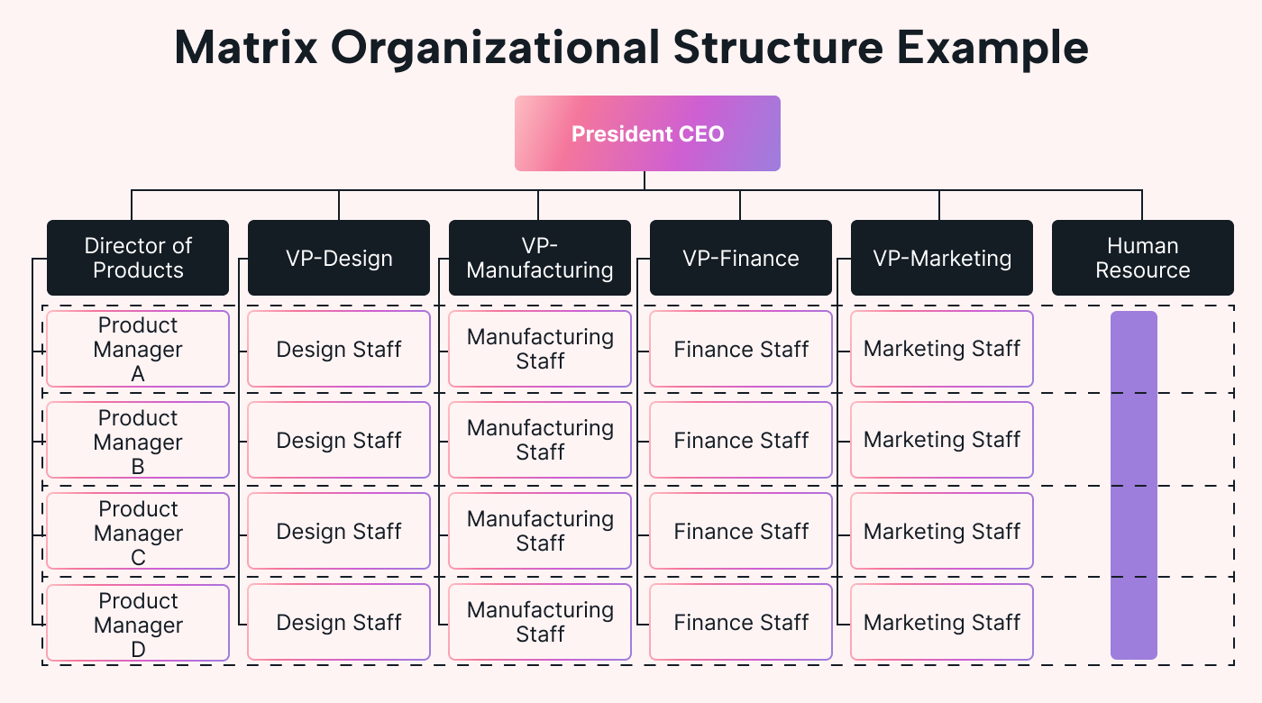
Additionally, the matrix structure encourages flexibility by allowing resource allocation in line with project specifications. For example, if an issue occurs, the project manager can rapidly organise a team from other departments handle it, minimising downtime and enhancing overall performance and efficiency. However, a matrix structure may present additional drawbacks, as such as power conflicts and higher workload due to two lines of reporting (He, 2022). It is essential to establish effective communication and accurately designate roles.
Figure 3 – Matrix Structure
In conclusion, despite occasional communication and teamwork challenges, the titanium plant’s functional structure ensured precision and high quality through role specialisation. By enabling a matrix structure, interaction between departments and management could be beneficial to addressing these issues and enhance aerospace manufacturing’s productivity and development.

Chapter 6 - Personal Development Plan

Name - Oscar Price
Degree – Motorsport Engineering
Previous Qualifications – EAL level 3 Engineering Technology
Previous Experience – N/A

Long Term Goals (5 to 10 years)
Secure a position in Formula 1
Short Term Goals (0 to 5 years)
Graduate with a first-class degree
Improve CAD Skills
Participate in a Motorsport Project
Goal | Objective | Resources Required | Measurement | Target Date
Secure a position in Formula 1 | Gain hands on experience in motorsport engineering | Internship/placement with motorsport teams/university projects | Securing a placement | 36 months
Secure a position in Formula 1 | Build a professional network within the motorsport industry | Attend networking events, join motorsport organisations | Contacts made; event participation | Ongoing
Graduate with a first-class degree | Achieve high grades in all modules | Course materials, academic support, time management tools | Coursework/module grades and final classification | 36 months
Improve CAD Skills | Master features of SolidWorks | Access to CAD software, online tutorials | Completion of CAD design projects in coursework to a high standard | Ongoing
Participate in a Motorsport Project | Contribute to MCR 2000 Team | Access to team resources, mentorship | Completion of a meaningful project role – repair, design, testing etc | 24 months

Conclusion
This report has highlighted the fundamental aspects of engineering practice, with a focus on how technical proficiency, ethical responsibilities, and teamwork can be integrated to solving challenging issues. The analysis of health and safety protocols during a motorsport suspension lab demonstrated how crucial risk management and adherence to legislative standards are to maintaining a safe working environment.
The discussion on the role of engineers in society emphasised their responsibility toward sustainability, particularly in the motorsport industry where reducing environmental impact is essential. To demonstrate how engineers address technical difficulties throughout the product lifecycle, a variety of problem-solving techniques were explored, including FMEA and PDCA methods.
Additionally, a personal experience within a team also highlighted how significant team structures are to the success of a project. The personal development plan specified objectives and goals for ongoing professional growth, reflecting the commitment necessary to succeed in the engineering industry.

References
Engineering Council (n.d.). Engineering Council. [online] www.engc.org.uk. Available at: https://www.engc.org.uk/sustainability.
He, G. (2022). Matrix Organizational Structure: Advantages & Disadvantages. [online] teambuilding.com. Available at: https://teambuilding.com/blog/matrix-organizational-structure.
ImechE (2019). Institution of Mechanical Engineers - IMechE. [online] Imeche.org. Available at: https://www.imeche.org/.
Indeed (2023). Your Guide to Functional Structure for Business: Advantages and Disadvantages. [online] Indeed Career Guide. Available at: https://www.indeed.com/career-advice/career-development/functional-structure.
Papageorgiou, K., Theodosiou, T., Rapti, A., Papageorgiou, E.I., Dimitriou, N., Tzovaras, D. and Margetis, G. (2022). A systematic review on machine learning methods for root cause analysis towards zero-defect manufacturing. Frontiers in Manufacturing Technology, 2. doi:https://doi.org/10.3389/fmtec.2022.972712.
Petko Stoev and Stoeva, M. (2024). Methodology for complex thinking in solving problems in engineering training. IFAC-PapersOnLine, 58(3), pp.100–105. doi:https://doi.org/10.1016/j.ifacol.2024.07.133.
Skeete, J.-P. (2019). The obscure link between motorsport and energy efficient, low-carbon innovation: Evidence from the UK and European Union. Journal of Cleaner Production, 214, pp.674–684. doi:https://doi.org/10.1016/j.jclepro.2019.01.048
Spreafico, C., Russo, D. and Rizzi, C. (2017). A state-of-the-art review of FMEA/FMECA including patents. Computer Science Review, 25, pp.19–28. doi:https://doi.org/10.1016/j.cosrev.2017.05.002.
Sturm, D., Andrews, D.L., Miller, T. and Bustad, J. (2024). Green light or black flag? Greenwashing environmental sustainability in Formula One and Formula E. Annals of leisure research./Annals of leisure research, pp.1–20. doi:https://doi.org/10.1080/11745398.2024.2376754.
Realyvásquez-Vargas, A., Arredondo-Soto, K., Carrillo-Gutiérrez, T. and Ravelo, G. (2018). Applying the Plan-Do-Check-Act (PDCA) Cycle to Reduce the Defects in the Manufacturing Industry. A Case Study. Applied Sciences, [online] 8(11), p.2181. doi:https://doi.org/10.3390/app8112181.
Forkmann, S., Henneberg, S.C., Naudé, P. and Mitrega, M. (2016). Supplier relationship management capability: a qualification and extension. Industrial Marketing Management, 57(2016), pp.185–200. doi:https://doi.org/10.1016/j.indmarman.2016.02.003.

