
42%
APPENDIX GA36b

LEVEL 5 ASSESSMENT SPECIFICATION

Student name: | William Tomos John Bowen | Student ID number: | BOW16832669
Programme: | HND LEVEL 5
Module: | MECHANICAL PRINCIPLES
Module code: | M5X00926 | Contribution to Overall Module Assessment (%): | 25%
Lecturer: | EMILY NYATHI | Internal Verifier: | EDWARD HORNAGOLD
Assignment Title: | COMPLEX LOADING II | Word count (or equivalent): | (NOMINAL 3000)
Submission deadline: | 24/01/2020 | Return date of provisional marks & written feedback: | 04/02/2020
Submission method: | All written assessments, where practical and possible, must be submitted via Turnitin unless otherwise instructed by the Lecturer. (Please DO NOT put this assessment specification into Turnitin or it will match many similarities with other students’ submissions.)  Alternative submission method (if applicable):  Late submission of the assessment will result in a late penalty mark. Penalties for late submission: Up to one-week late, maximum mark of 40%. Over one week late, 0%. Only the Extenuating Circumstances Panel may approve a change to submission dates.
Academic honesty / referencing: | Academic honesty is required. In the main body of your submission you must give credit to authors on whose research and ideas your work is based. Append to your submission a reference list that indicates the books, articles, etc. that you have used, cited or quoted in order to complete this assessment.

Module Learning Outcomes
(From module syllabus)
LO1. Determine the behavioural characteristics of materials subjected to complex loading systems.

Student FEEDBACK FORM

Generic Assessment Criteria | Marks available | Marks  awarded
1. Engagement with Literature Skills
.
Poor engagement with essential reading. The quality of referencing needs to improve. |  | 9
 | 25 | 9
2. Knowledge and Understanding Skills

Task 2 Q1a You did not represent your values on a stress element.  Task 3 ii. You used the wrong radius for your calculation, and this has affected the value of our pressure.  But in general, your knowledge of pressure vessels governing equations is reasonably detailed and accurate. |  | 16
 | 30 | 16
3. Cognitive and Intellectual Skills

Some critical evaluation and analysis of concepts and principles, though descriptive in parts |  | 13
 | 25 | 13
4. Practical Application Skills

You have shown a good and appropriate application of established methods, materials, tools and/or techniques. |  | 8
 | 15 | 8
5. Transferable Skills for Life and Professional Practice

Demonstrates the basic skills for employment requiring the exercise of personal responsibility and decision-making, with some areas of minor errors. | 5 | 2

Assessment Mark (Assessment marks are subject to ratification at the Exam Board. These comments and marks are to give feedback on module work and are for guidance only until they are confirmed. ) | Late Submission Penalties (tick if appropriate) |  | 42%
 | Up to 1 week late (40% Max) |  | 42%
 | Over 1 week late (0%) |  | 42%



(UWTSD, 2018)

Complex Loading 2
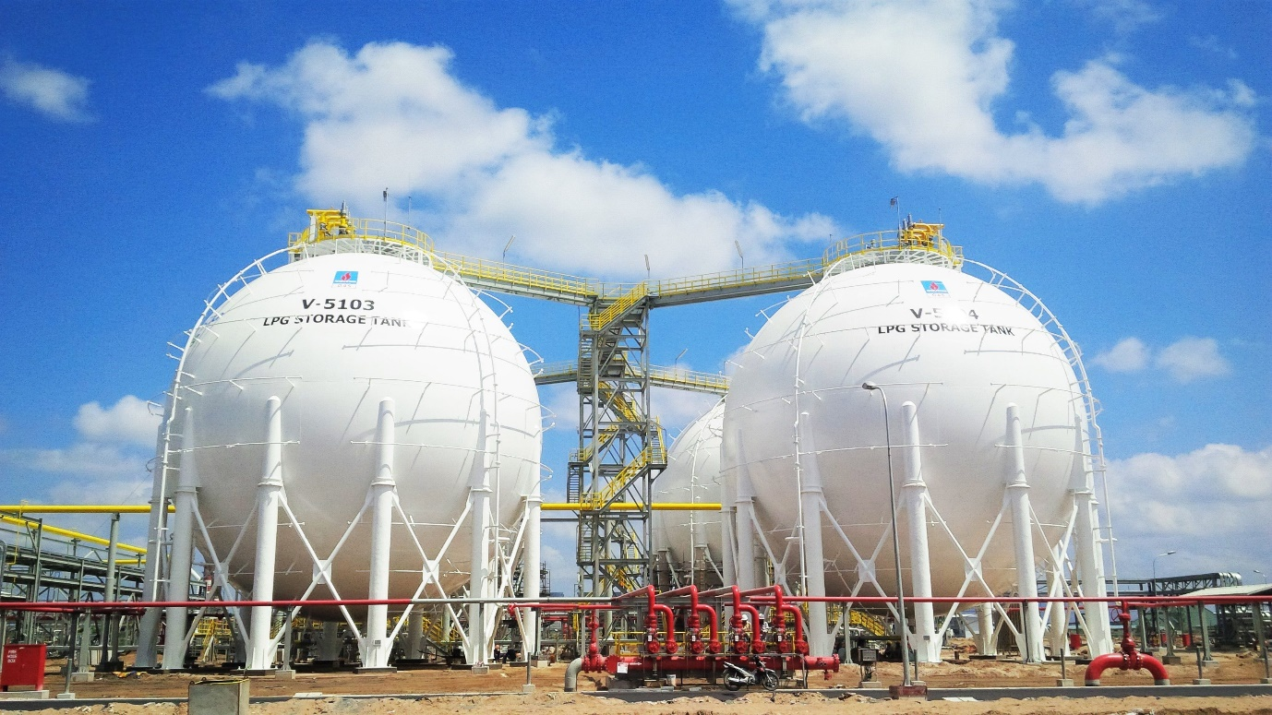
(CNI, 2020)
William Tomos John Bowen
BOW16832669
21/03/2020

Contents
1) Task 1 3
2) Task 2 5
3) Task 3 12
4) Task 4 17
5) Reference List 21

task 1
What are pressure vessels?
Pressure vessels are containers that are designed to contain liquids or gases that are at a different pressure from the outside pressure surrounding the vessel. Many pressure vessels are individual as they all have limits and are designed for their specific purpose. All vessels are built with a design pressure and design temperature in mind so that they can meet the desired outcome. Exceeding or misusing the vessel other than for its intended purpose could result in catastrophic explosion.

What is the purpose for pressure vessels?
There are many uses for pressure vessels; pressure vessels are all around in today’s circuity. A pressure vessel come in many shapes are sizes, take a kettle for instance. The objective of a kettle is to increaser the temperature of the fluid within it. The kettle would heat the fluid and contain the fluid until the personnel empties the condense, once the desired temperature has been met. Another example of a pressure vessel is an asthma pump. The purpose of the pump is to contain air molecules and release them once the person has placed enough pressure to activate the release valve. Pressure vessels can be used for various reasons and solutions; whether is for cooling, heating or containing.

Manufacturing process
Pressure vessels are constructed from various types of materials. Pressure vessels are most company constructed out of either carbon steel or stainless steel. Brass is also used in order to create pressure vessels; however, it could become costly. In the petrochemical industry pressure vessels are created by rolling large metal sheets to their desired radius and then welded together. This is done for both cylindrical and spherical pressure vessels. Specialised machinery is required to manufacture a spherical pressure vessel unlike a cylindrical pressure vessel.

Design considerations
There are many factors that are required to be considered when designing a pressure vessel. This such things are:
- Desired outcome of vessel
- Location of final product
- Height of vessel from the ground floor
- Elements surrounding the vessel e.g. wind loading, vibration of machinery etc
- Internal and external pressures
- Ambient and operational temperatures
- Stresses acting upon and against the vessel
- Substance passing through or surrounding the vessel
- Material quality
- Fatigue
- Corrosion

Task 2
Part A:
Given information:
Internal diameter: 560mm
Material thickness (t): 6.4mm
Internal pressure (p): 620 KPa

Letter Index:
Hoop Stress ($σ_{h}$)
Longitudinal Stress ($σ_{l}$)
Radius (r)

The first thing I must do is to determine if the cylindrical vessel is a thin or thick wall pressure vessel. The ratio in order to check if it’s a thin or thick pressure vessel is:
$$\frac{r}{t} ≥ 10$$
There for in order to calculate the radius (r) I must divide the diameter (d) by 2.
$$\frac{(\frac{560}{2})}{6.4}= 43.75$$
$$43.75≥ 10$$
Due to the number being higher than 10 we now know that this is a thin-walled cylindrical pressure vessel. Now knowing this I can now use hoop and longitudinal equations for a cylindrical pressure vessel to calculate the stresses acting on point ‘A’ of the vessel. The equation for both stresses is:
$$σ_{h}=\frac{p×r}{t}$$
$$σ_{l}=\frac{p×r}{2 ×t}$$
Therefore, the stress for hoop on point ‘A’ is:
$$σ_{h}=\frac{620×{10}^{3}× 280}{6.4}$$
$$σ_{h}= 27125000 Pa$$
$$σ_{h}= 27.125 MPa (3dp)$$

Therefore, the stress for longitudinal on point ‘A’ is:
$$σ_{l}=\frac{620×{10}^{3}× 280}{2 ×6.4}$$
$$σ_{l}= 13562500 Pa$$
$$σ_{l}= 13.563 MPa (3dp)$$

Part B:
Now that both stresses have been calculated at point ‘A’, I now must plot the directions of the stresses on a stress element diagram. The diagram below illiterates how the stresses are acting in a two-dimensional section cut on section ‘A’. The hoop stress is acting on the vertical axis also known as the ‘y’ axis. The longitudinal stress is acting on the horizontal axis also known as the ‘x’ axis.
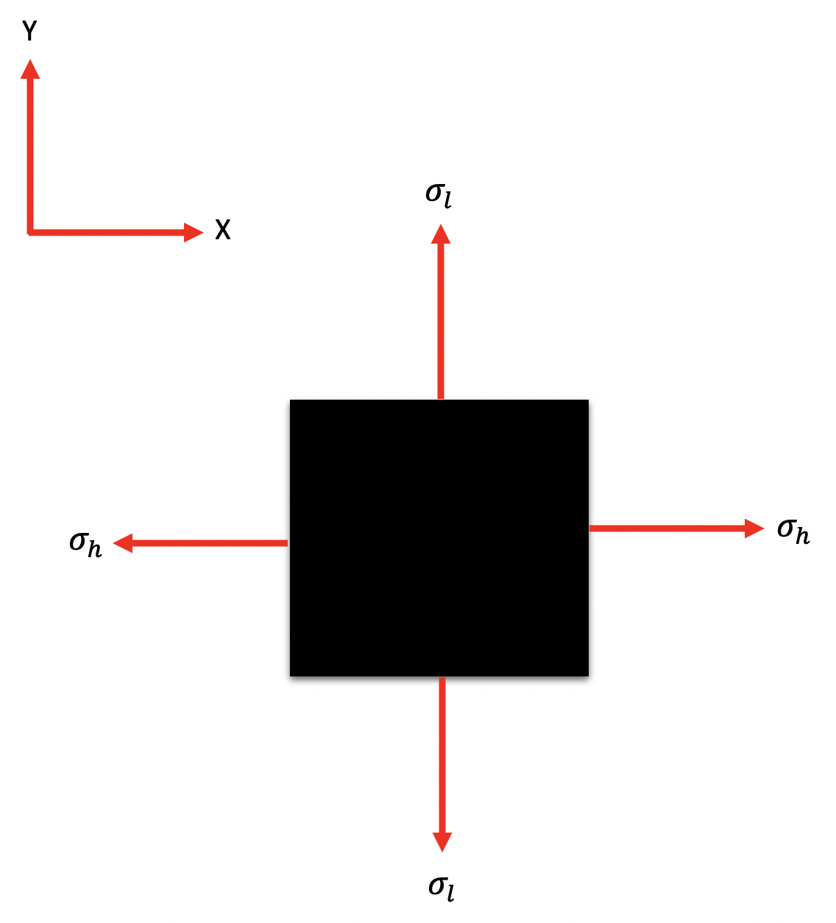

Part C:
Given information Part C:
Internal diameter: 560mm
Material thickness (t): 6.4mm
Max stress ($σ$): 27.125 MPa

$$σ =\frac{p×r}{2 ×t}$$

$$p= \frac{σ × 2 × t }{r}$$
$$p= \frac{27.125×{10}^{6} × 2 × 6.4 }{280}$$
$$p= 1240000 Pa$$
$$p= 1.24 MPa$$

Part D:
Given information Part D:
Internal diameter: 1200mm
Material thickness (t): 12mm
Max stress ($σ$): 140 MPa

The first thing I must do is to determine if the cylindrical vessel is a thin or thick wall pressure vessel. The ratio in order to check if it’s a thin or thick pressure vessel is:
$$\frac{r}{t} ≥ 10$$
There for in order to calculate the radius (r) I must divide the diameter (d) by 2.
$$\frac{(\frac{600}{2})}{12}= 100$$
$$100≥ 10$$
Due to the number being higher than 10 we now know that this is a thin-walled cylindrical pressure vessel. Now knowing this I can now use hoop and longitudinal equations for a cylindrical pressure vessel to calculate the stresses acting on point ‘A’ of the vessel. The equation for both stresses is:
$$σ_{h} =\frac{p×r}{t}$$

$$p= \frac{σ_{h} × t }{r}$$
$$p= \frac{140×{10}^{6} × 12 }{600}$$
$$p= 2800000 Pa$$
$$p= 2.8 MPa$$

$$σ_{l} =\frac{p×r}{2 ×t}$$

$$p= \frac{σ_{l} × 2 × t }{r}$$
$$p= \frac{140×{10}^{6} × 2 × 12 }{600}$$
$$p= 5600000 Pa$$
$$p= 5.6 MPa$$

Part E:
Using the results from parts A’ and ‘C’ from both cylindrical and spherical pressure vessels and using the knowledge and experience dealing with pressure vessels in my opinion I would recommend the cylindrical pressure vessel.

The results show that the spherical pressure vessel can withstand double the amount of pressure compared to the cylindrical vessel when both vessels have the identical promotors.

However, when manufacturing the vessels, the spherical pressure vessels require specialised machinery in order to manufacture them, resulting in skilled workers need. Therefore, the cost in experientially larger than a cylindrical pressure vessel.

Another reason why I have selected the cylindrical vessel is because in my opinion I believe they are more aesthetically pleasing than the spherical pressure vessels.

To conclude I believe the cylindrical pressure vessel is overall better in comparison to the spherical pressure vessels. However, if money was no object and all I require was a vessel that could contain a large amount of volume at pressure then I would select the spherical pressure vessel.

Task 3
Given information:
Internal diameter of barrel: 610mm
A-36 ring internal diameter: 609.5mm
Outside temperature (T): 65$\text{℉}$
Wall thickness (t): 6.35mm
A-36 ring height: 25.4mm
A-36 ring thickness: 6.4mm

Letter Index:
Circumference ($∁$)
Celsius ($℃$)
Fahrenheit ($℉)$
Diameter (D)
Pi ($π)$
Growth of density ($δ)$
Linear coefficient of thermal expansion ($∝$)
Change in temperature ($∆T$)
Modulus of elasticity (∈)

The first thing I must do is convert Fahrenheit to Celsius. The equation for converting the temperature is:
$$℃=\left(℉-32\right) × \frac{5}{9}$$
$$℃=\left(65-32\right) × \frac{5}{9}$$
$$℃=18.33…$$
Now that I have converted the temperature, I must now calculate the circumference of the barrel and A-36 ring. The equation for the circumference is:
$$∁ =D × π$$
There for circumference of the barrel (C1) is:
$$∁_{1} =D × π$$
$$∁_{1}= 610 × π$$
$$∁_{1} =1916.371519mm^{2}$$
There for circumference of the A-36 ring (C2) is:
$$∁_{2} =D × π$$
$$∁_{2} =609.5 × π$$
$$∁_{2} =1914.800722mm^{2}$$
To calculate the required size of the A-36 ring I will need to subtract the circumference of the barrel away from the circumference of the ring to get the growth of density.
$$δ= ∁_{1}-∁_{2}$$
$$δ= 1916.371519-1914.800722$$
$$δ=1.570797mm^{2}$$
Now that required length has been calculated I must now calculate the change in length with heat applied. However, the equation for is as follows:
$$δ= ∝ × ∆T ×L$$
The equation must be rearranged to make TL the subject of the equation:
$$TF = \frac{δ}{∝ × ∁_{1}}+ T$$
$$TF = \frac{1.5770797}{11.7×{10}^{-6} ×(610 × π) }+18.33$$
$$TF = 88.35℃ (2dp)$$
The change in temperature is 70.02 degree Celsius. This was calculated by taking the current outside temperature away from the required temperature.
$$∆T=TF-T$$
$$∆T=88.35-18.33$$
$$∆T=70.02℃$$
It is a known fact that the modulus of elasticity is 200 GPa
$$\frac{P ×L}{A × ∈}= ∝ × ∆T ×L$$
Prior to calculating P I first must calculate the area. The equation for area is:
$$A=L ×W$$
$$A=25.4×{10}^{-3} ×6.4×{10}^{-3}$$
$$A=0.16256×{10}^{-3}m^{2}$$
Now that the area of the ring has been calculated, I can now substitute the calculated and know figures into the equation.
$$P= \left(A × ∈\right)× ∝ × ∆T ×L$$
$$P= \left(0.13256×{10}^{-3} × 200×{10}^{9}\right)× 11.7×{10}^{-6} × 70.02$$
$$P= 26634.93581 Pa$$
Using Youngs modules equation and transposing the equation to substitute pressure in force.
$$σ=\frac{P}{A}$$
$$\frac{P}{A}=\frac{F}{A}$$
Therefor using the figures already calculated I can now transpose the results into the equation.
$$σ=\frac{F}{A}$$
$$σ=\frac{26634.93581}{0.16256×{10}^{-3}}$$
$$σ=163846800 Pa$$

The equation below must be rearranged in order to make P the subject of the equation.
$$σ=\frac{P ×r}{t}$$
$$P=\frac{σ ×t}{r}$$
$$P=\frac{163846800 ×6.4}{255}$$
$$P=4112233.412$$
$$P=4.11 MPa$$
The pressure calculated is the pressure acting on the barrel once the A-36 ring has cooled.

Task 4
Part A:
Given information:
Material: SISI 501 OQT 1100
Outer sphere diameter (D): 500mm
Material thickness (t): 40mm
Design factor (N): 4

Letter Index:
Inner radius ($r_{i}$)
Outer radius ($r_{o}$)
Pressure (p)
Yield strength (YS)

The first thing I must do is to determine if the sphere is a thin or thick wall pressure vessel. The ratio in order to check if it’s a thin or thick pressure vessel is:
$$\frac{r}{t} ≥ 10$$
There for in order to calculate the radius (r) I must divide the diameter by 2.
$$\frac{(\frac{500}{2})}{40}= 6.25$$
$$6.25≥ 10$$
Due to the number being less than 10 we now know that this is a thick-walled spherical pressure vessel. I now must use the governing equations for a thick-walled spherical pressure vessel. The equation for a sphere is:
$$σ_{1}= σ_{2}=\frac{p\left(r_{O}^{3}+2r_{i}^{3}\right)}{2(r_{O}^{3}+r_{i}^{3})}$$
It is a known fact that the yield strength (YT) for the material is 931 MPa.
Now that we know the YT I must now rearrange the equation to make p the subject of the equation. The equation for max yield strength is as follows:
$$σ=\frac{Yield Strength}{Design Factor}$$
There for combining the max yield strength and spherical equation together.
$$\frac{YS}{4}=\frac{p\left(r_{O}^{3}+2r_{i}^{3}\right)}{2(r_{O}^{3}+r_{i}^{3})}$$
Prior to calculating the pressure, I first must calculate the internal radius for the sphere.
$$r_{i}=r_{o}-t$$
$$r_{i}=250-40$$
$$r_{i}=210mm$$
Now that the internal radius has been calculated the pressure can now be calculated.
$$\frac{YS}{4}=\frac{p\left(r_{O}^{3}+2r_{i}^{3}\right)}{2 (r_{O}^{3}+r_{i}^{3})}$$
$$p=\frac{YT × 2(r_{O}^{3}+2r_{i}^{3})}{4 × \left(r_{O}^{3}+r_{i}^{3}\right)}$$
$$p=\frac{931×{10}^{6}× 2({250}^{3}-{210}^{3})}{4 × \left({250}^{3}+2 x {210}^{3}\right)}$$
$$p=86.76 MPa (2dp)$$
To ensure the sphere is safe, the max pressure that the sphere can take before exploding needs to be calculated.
$$σ=\frac{YS}{4}$$
$$σ=\frac{931 × {10}^{6}}{4}$$
$$σ=232.75 MPa$$
The calculations show that the working pressure is significantly less than the max pressure the sphere can handle. The working pressure is 2.7 approximately less than max pressure.

Part B:
There are many failure criteria that could come into effect on a spherical pressure vessel. It can be confirmed that the material and thickness of the material is more than adequate due to it having a safety factor of approximately 2.7. Within the petrochemical industry when hydrotesting a pressure vessel, the vessel would be test at 1.5 its working pressure. This shows its more than adequate to contain the pressure.

However, a failure could accrue due to the quality of the material. Most companies in the petrochemical industry like Phillip’s 66 and Dow corning only accept material from certified suppliers. Accepting material from non-certified could result in material being used that may have microscopic cracks resulting in the pressure vessel failing and exploding.

Another reason the vessel could fail is due to the welding on the vessel. If the welding isn’t up to standard the liquid or gas within the vessel could leak or decrease the vessels deign life. Using the correct welds or weld sticks would have a hug impact on how the vessel will coup when under pressure resulting in the vessel passing or failing its intended purpose.

Reference List
CNI, 2020. Pressure Vessel. [Image]. Available from: https://cnipvc.com [Accessed: 21/03/2020]

UWTSD, 2018. UWTSD Home/ University of Wales Trinity Saint David Logo. [Image]. Available from: http://www.uwtsd.ac.uk/ [Accessed: 10/03/2020]

