CONTENTS
Journalistic Article Pitch | 452 words
Advance Information Sheet | 338 words
Author Questionnaire (excluding questions) | 732 words
Agent Approach Letter | 885 words
TOTAL | 2,407 words

JOURNALISTIC ARTICLE PITCH
Dear Positive News,
I would like to pitch an article about stray cats, their plights, and the cat colonies that are addressing their problems. Most media surrounding stray animals consists of black and white footage of sickly kittens, malnourished puppies, and veterinary staff desperately attempting to save critical animals’ lives. While these animal charities do good work and are necessary for the more serious cases of feral or neglected cats, there are hundreds of good people working to keep their feral cat colonies happy and healthy without the use of soft piano music and hushed voices asking for “just two pounds a month.”

The primary focus of the article would be Poets Square Cat Colony in Tucson, Arizona. Courtney’s home is host to a colony of feral cats. Despite affectionate names like ‘Sad Boy’ and ‘Monkey King’, these cats are not pets, having never lived inside a home and many of them being too old and/or too streetwise to be socialised. However, Courtney feeds the cats, has an Amazon wish list filled with toys and beds for them, and spends part of her days filming the cats for her TikTok audience (@poetssquarecats). Courtney is part of a network of others that care for their own cat colonies, as well as others in her city who she helps to Trap, Neuter, and Release (TNR) other stray cats in the area. My article would consist of interviews with Courtney and her network of animal advocates as they shine a light on the alternative to overcrowded animal shelters with strict euthanization policies.

I believe that this story, while not hard-hitting political content, is important to our understanding of stray animals and how we can help them. Hundreds of cats a year are put down simply because they cannot be socialised into household pets. Many of these animals suffer arduous, painful lives – and our current solution is pulling the animals away from the only life they have ever known to a cage where they are unable to socialise and are killed instead of being re-released. Moreover, stray cats who are not spayed or neutered maintain the cycle of suffering. TNR programs like the one in Tucson are one of the most humane ways of helping curb the stray population without culling these animals. I believe a story like this, one of hope and understanding – how ever minor – is one that would most definitely fit into your publication’s ideology, and I believe through interviews with Courtney at Poets Square and her network that this will be a journalistically sound piece while maintaining the positive outlook you strive for.

I hope to hear from you soon, and I look forward to working with you.
Kind regards,
Rose Cornwell.

ADVANCE INFORMATION SHEET
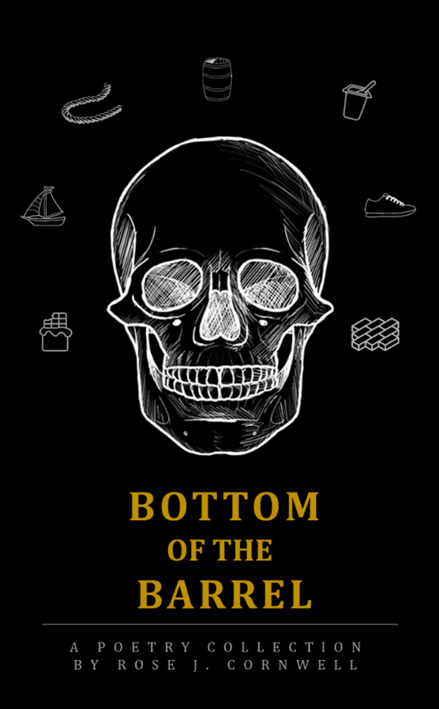  Market: Poetry, True Crime  Published: XX/XX/20XX  Binding: Paperback  ISBN: 123-4-567890  Price: £7.99  Available for Sale Worldwide  Manufactured in the UK | BOTTOM OF THE BARREL  Rose J. Cornwell  Author of ‘A Grieving Garden’  Heather can’t play hopscotch,  Instead, I hold her close, hug her tight,  Hope that the worms and the moles are company enough,  Lest another be put to rest in my arms.  Bundy’s boat, Gacy’s rope, and Dahmer’s titular barrel. ‘Bottom of the Barrel’ takes a unique perspective on true crimes, giving insight into the crime scenes from the items that were there.  A harrowing, heinous, and at times heart-wrenching exploration of perspective, narration, and poetic form.  “Evocative, thoughtful, and surprisingly personal.”  - First-Name Jonas  “A unique concept executed with equal gentleness and gore. A must-read for true crime enthusiasts”  - Marcus Lastname of Crime Publication
ABOUT THE AUTHOR:  Rose J. Cornwell was born in 2000 and grew up in rural Essex before graduating from the University of Wales, Trinity Saint David with a degree in English and Creative Writing.  Having written for most of her life, she has published multiple short stories and poems in journals and collections since 20XX. Her first short poetry collection was published with Company in 20XX and was shortlisted for the Surname Prize that same year.  When not writing, Rose can be found illustrating, gardening, and caring for her cats in her home in South Wales. | KEY MARKETING AND PUBLICITY POINTS:  - Award-shortlisted (Surname Prize) author.  - Cornwell has an established poetry audience from her previous publication, ‘A Grieving Garden’.  - Author will be releasing an accompanying podcast, detailing the criminal cases utilised within the collection. Each episode will feature excerpt readings from the collection.  - Exploring possibility of partnering with other true crime podcasts for cross promotion.  - Utilises a mixture of traditional and modern poetic form and influence to create an abstracted, but accessible collection.  - Appealing to readers of Sally Wen Mao and Amanda Lovelace, modern female poets writing from introspective and unique perspectives.  - True crime is currently extremely popular, making the market very lucrative.

AUTHOR QUESTIONNAIRE

- Full name including degrees and professional qualifications (please indicate how you wish your name to appear on the book and in publicity material and catalogues).
Rose Julia Cornwell, appearing as Rose J. Cornwell.
BA English Literature and Creative Writing from University of Wales, Trinity Saint David.

- Place and date of birth.
Born 29th May 2000 in Exeter, Devon. Raised in rural Essex. Living in South Wales.

- Private contact address and telephone number.
10 Address Street,
City Town,
County,
AB1 2CD
07123456789

- Are you a social media user? Please list any relevant accounts.
@RoseJCornwell on Instagram and Twitter. Blog can be found at rosejcornwell.com. Trailer for accompanying podcast can be found under the title ‘Bottom of the Barrel’ on all podcast providers and linked on blog.

- Previous books (with publishers’ names and year of publication), and/or journal or magazine articles
‘A Grieving Garden’, short poetry collection, published with Company in 20XX.
‘River Bank: A Diptych’, short story, published in Journal, Nov 20XX.
‘Mapping’, poem, published in Zine, Aug 20XX
‘Bea and Byron’, short story, published in Collection, Jan 20XX.

- Please write a short biographical piece that we can use, with details of education, academic qualifications, appointments, travel, awards, interests and any other relevant information about yourself.
Born in 2000, Rose J. Cornwell has been writing for the majority of her life.
Raised in rural Essex, she moved cross-country age 19 to study in Wales. After graduating from the University of Wales, Trinity Saint David with a degree in English and Creative Writing, she began to submit her work for publication in zines, journals, and collections. Finding success in this field, Rose’s first poetry collection, ‘A Grieving Garden’, was published by Company in 20XX and was shortlisted for the Surname Prize that summer.
Aside from writing, Rose also illustrated her first collection to much acclaim.
When not writing, she can be found illustrating for friends and family, tending to her garden, and caring for her two cats.
- Please write a brief description (in about 200 words) of your book to be used as a basis for publicity material – the book’s cover or jacket, leaflets and catalogues.
‘Bottom of the Barrel’ explores true crime from the unique perspective of items from the crime scenes. See through the eyes of items like Richard Ramirez’s shoes, the chocolate at Dean Corrl’s candy factory, and the titular barrels found in Jeffrey Dahmer’s home. This collection pulls focus away from the killers and back onto their crimes, taking an action based, victim focused view on moments most would shy away from. Each poem seeks to shine a light on the realities of these harrowing scenes and creates an emotionally charged snapshot in time. While not for the faint of heart, the stories told are important to understand, and ‘Bottom of the Barrel’ seeks to tell those stories in a new way.

- Is there an intended audience for your book?
The intended audience consists predominantly of young women, as they are the target demographic for most true crime content. However, there is a large portion of the general population who are interested in both literature and true crime, and marrying these topics is both unique enough and sought-after enough to corner the market.

- Please give details of any forthcoming events relevant to your book, such as conferences, readings, concert tours and soon, both in Britain and abroad.
A book launch in Book Shop has been scheduled with guest speakers from both the world of poetry and the world of true crime podcasting. In addition, there will be an accompanying podcast series, available online, which will include in depth explorations of the crimes highlighted in the collection and excerpt readings from many of the poems.

- Are there any towns or areas where you would recommend special promotion such as a local bookshop or local media?
My local media in City Town, as well as the local media in my hometown are both interested in interviews and spotlighting the collection. Additionally, I would like to reach out to local libraries to organise readings and/or signings in their locations as I feel supporting libraries is incredibly important.

- Does your book have any news value to help us secure the interest of the mainstream media? Is there an interesting backstory to your project? What was your point of inspiration for the project?
My collection was inspired by my life-long fascination with true crime. I feel that, within much true crime media, there is too much emphasis on the criminal themselves. I have focused in my collection primarily on murderers and serial killers, as those are the cases most sensationalised. In many cases, killers are portrayed as intelligent, conniving, evil members of society who evaded police using their wits and cunning. Additionally, their lives are written so abstracted from the common man that there is no element of humanity left within them. I am of the opinion that violent criminals are unsettlingly human. They are not hyper-intelligent outsiders, they are average men and women who fly under the radar every day, and evaded capture due to a mix of sheer luck and simple lack of investigation. I wrote this collection primarily to remove the focus from the killers, and to re-focus on the crimes they committed. Many of my poems feature the names and stories of victims, and all of the victims’ names are listed in the acknowledgements. Abstracting the criminal and focusing on the act subverts the norms of the genre, and I feel that, as the market becomes more and more saturated with criminal-focused content, this is a fresh perspective on the subject of true crime.

AGENT APPROACH LETTER
Dear Ms. Agent,
My name is Rose Cornwell, I am a young writer living and working in South Wales, and I think your agency would be interested in my Re-Animator (1985) inspired, horror-romance novel, tentatively titled Under Your Skin.
Under Your Skin follows mortuary apprentice Nomi West as she discovers the line between life and death is much thinner than she first expected. While working, Nomi is introduced to Doctor Tanda Nez, a former professor recently employed to perform autopsies at the funeral home. Intrigued and infatuated with the enigmatic Nez, Nomi falls under the Doctor’s wing and takes up the role of assistant in her autopsies. As the pair grow closer, Nez begins to allude to her unceremonious firing from her previous teaching position and the controversial research she was undertaking at the time. Before she can divulge the details of her research, Nomi is horrified to find Nez on her slab.
Nomi reads the doctor’s autopsy notes and concludes that she did not die naturally and was either killed accidentally or murdered. Her concerns are dismissed by her employers, but Nomi vows to discover the truth of her beloved doctor’s demise. Breaking into Tanda’s flat, Nomi finds her desk ransacked, her bookshelves cleared, and her house turned upside down. Remembering previous conversations, West finds Nez’s research notes tucked away, untouched by the apparent looter. Nomi pours over the notes and discovers that Tanda was experimenting with sustaining life after death. and that her experimentation had been successful. In the notebook, Nez names a former colleague who seemed to be ‘in on’ the experimentation.
After returning to Tanda’s previous place of work and speaking to the aforementioned co-worker, she discovers that Dr Nez had been experimenting on the donated bodies in the morgue, and that she had been stripped of her titles and position after she was discovered tampering with the bodies. While there, West discovers papers containing Tanda’s ‘Recipe for Life’ and begins experimenting. Overnight, she puts together the ‘Recipe’ and successfully kills and resurrects a series of animals, including a mouse brought in by her pet cat, and the cat itself.
The next day, she administers the serum to Tanda, and is delighted when the Doctor awakes, groggy and confused, but very much alive. Tanda is delighted, both that her recipe has worked, and that it was Nomi who brought her back. Dr Nez explains that, in order to stop her body from deteriorating again, she will need frequent injections of the serum, and that she was creating a more permanent solution when she was killed. The pair move experimentation to Nomi’s basement and begin administering experimental solutions to the various animals previously captured by Nomi.
The women also begin piecing together how Tanda died. Nomi is shocked and disconcerted when Tanda seems relatively uninterested in her own death, focusing instead on maintaining her eternal life. Eventually, she reveals that she has three suspects, but does not want to name them for fear they will target Nomi next. Following a series of confessions, the two become romantically involved.
The next night, Nomi is attacked as she returns home from work and is killed. Surprised by her own emotional reaction, Tanda resurrects Nomi and tells her she knows who killed them. The co-worker was the person who got her fired. He had been interested in her theory and research but had become appalled at her experimentation. He is the only suspect aware of Nomi’s interest in the ‘Recipe for Life’, and therefore the only one who would target her.
The pair inject themselves with the most recent serum and set off to exact their revenge.
My writing has been called lyrical, evocative, and image focused. I believe that this work will be a welcome addition to your portfolio, and I am confident that readers of novels like A Certain Hunger (Summers) and Tender is the Flesh (Bazterrica) will also enjoy Under Your Skin. Moreover, I believe that this novel has market potential as both of the previously mentioned books, as well as numerous other anatomy-focused horror novels, have gained notoriety online for their female protagonists and gory contents. My novel, following these conventions, has potential to be added to this roster of ‘disturbing books’.
As a queer woman, I am incredibly aware of the lack of queer characters represented in the horror genre. The majority of queer persons within horror are the villains, becoming the focus of homo- and transphobic rhetoric through the ‘othering’ and vilifying of queer identity (see Buffalo Bill in Harris’ Silence of the Lambs). I wanted to write a novel that marries the increased interest in gore and body-horror with the need and want for queer representation. As a part of the community, I have noted that many woman-loving-women (WLW) are interested in horror as a genre but find the heteronormativity and hypermasculinity of the genre unsettling and unsatisfying. I believe my novel’s centring of a WLW relationship will serve this market greatly, and appeal to readers searching for this niche.
I really look forward to hearing from you, and to potentially working with you on this project. Attached you will find the first two chapters of the novel. I hope that they properly convey my writing style, and the story that will unfold.
Kind regards,
Rose Cornwell.

I do not feel comfortable giving my real address, phone number, or real social media handles.
This is an umbrella term encompassing people who identify as female who are attracted to others who present femininely, including lesbians, bisexuals, pansexuals, etc.

