Slide One:
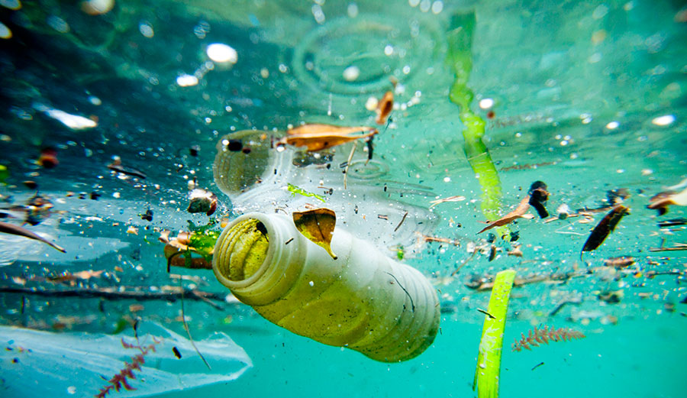
(Fair Planet, 2019)

- The National History Museum (2022) explained how climate change and plastic pollution are both global issues which are interlinked, by solving one the other will be solved, plastics release greenhouse gas emissions which contribute to Global warming.
- Eriksen at al (2014) explained how plastic pollution is globally distributed across all oceans due to the buoyancy and durability of plastic, Plastic pollution is therefore a global issue which is affecting all aspects of life including marine life and human health, (UN, n.d. and IUCN, 2021),
- National Ocean Service (n.d.) highlighted how Plastic is a very damaging material when in the ocean, unlike other forms of materials, plastic doesn’t decompose or breakdown, therefore plastic can stay in the ocean forever damaging the ecosystems.
- The UNESCO (2022) explained how majority of plastic pollution in the ocean is caused by us littering, through not disposing plastic materials correctly, which results in them ending up in the waterways, then in our oceans which is having life changing affects as plastic doesn’t decompose or breakdown (National Ocean Service, n.d.).

Slide Two:

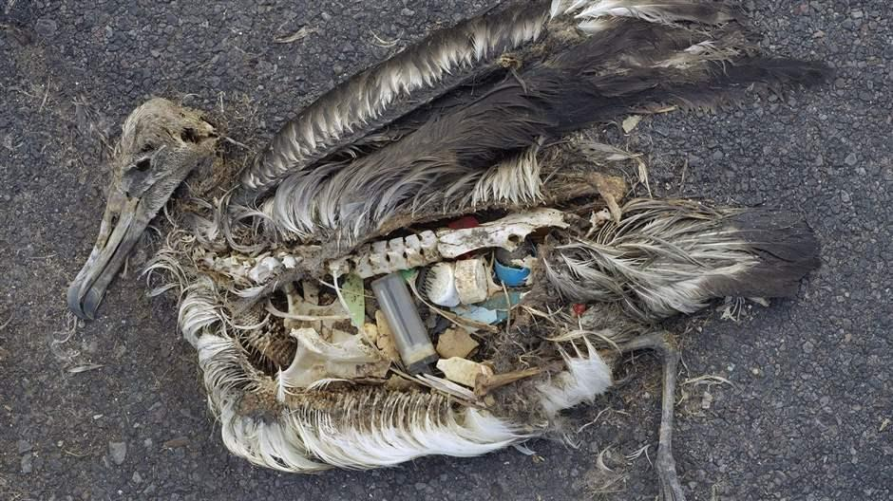
(The Pew Charitable Trusts, 2018)

- Climate change has been such a significant issue that it has become a global issue with conferences such as COP27 in 2022 being held with more than 100 Heads of state and governments attending, in hope that a whole world approach can work together to help reduce climate change (UN, n.d.).
- Welsh Government, (2022) since the COP27 conference in 2022 have supported the whole world approach and have passed a range of bills, one bill was passed in 2022 on the banning of supply of commonly littered single use plastic products, in a bid to help reduce producing single use plastic which have no use and leave a toxic legacy for the future generation as majority of single use plastic ends up being littered or in the oceans.
- It is estimated that around eight million tonnes of plastic end up in the sea each year, this is not only affecting marine life but also beginning to affect human life with small fragments of plastic found in our oceans are being found making their way into our food and water from our Marine Life (WWF, n.d.).
- The UK Government, (2017) explained how not only marine life are affected by plastic pollution but human wellbeing and the economy are too.
- Wright and Kelly (2017, p. 141 cited in Lundebye et al,2022) explained that there can be potential biological affects to humans being exposed to microplastics which can lead to issues such as tissue damaged and fibrosis,
- However, currently life is heavily impacted by plastic, due to marine life being caught or digesting plastic over 270 species including seabirds, turtles and fish have experienced movement issues, lack of food or death (Laist, 1997, Wabnitz and Nichols, 2010 cited in Sigler, 2014). Plastics mainly affect marine life through digestion and by species being caught and tangled in plastics (Anastasopoulou and Fortibuoni 2019). Each Year plastic is the cause of death for a million sea birds and 100,000 sea mammals, turtles, and fish, unless we act upon this these shocking figures will continue to rise (Keep Britain Tidy, n.d.).

Slide Three:

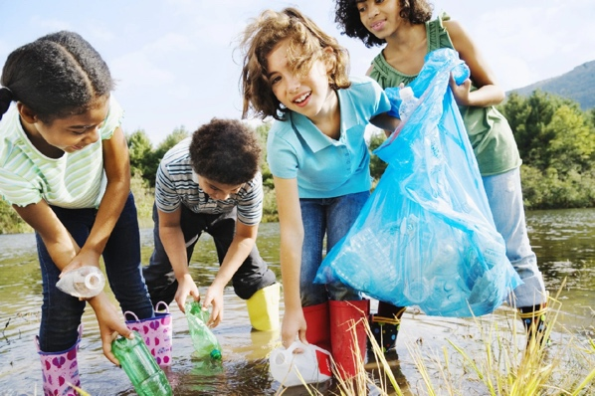
(National Geographic Kids, n.d.)

- UNICEF, (n.d.) have explained how 95% of children out of a report of 46,045 are concerned about global issues such as climate change and plastic pollution with the biggest concerns being to animal and plant extinction and human health. Therefore, it is important that children are educated on the issues concerning climate change correctly.
- Therefore, many organisations have put together activities to educate children on the damage of plastic pollution from littering to help reduce the effects of climate change.
- Therefore, the WWF (n.d.) have put together a range of classroom activities such as quizzes, create your own mind maps and fact sheets on the significance of our oceans and why we need to look after them. Having children look at these issues and seeing the facts and the pictures it allows them to realise the importance of keeping our seas clean for themselves.
- Keep Wales Tidy (n.d.) like WWF have also put together a range of activities to help educate children on plastic pollution, keep Wales Tidy have put together a range of videos to allow children to see the actual footage of the damage that plastic is doing to our oceans. This has direct links to the curriculum ensuing that children are ethical and informed citizens who can be educated on real world issues and show their commitment to the sustainability of the planet.

Slide Four:

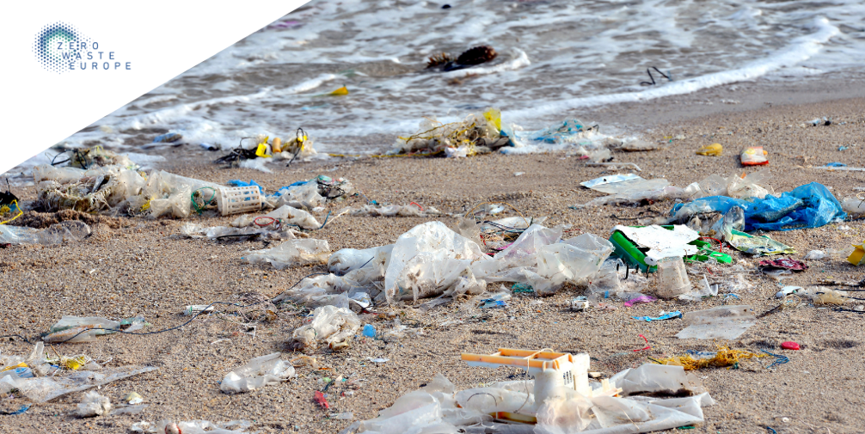
(Zero Waste Europe, 2020)

- Plastic is distributed in the ecosystem in a variety of different forms and sizes, yet regardless of its size it will have a very damaging affect (Thushari and Senvirathna, 2020).
- Bucci et al (2019) supported this and founded evidence that regardless of the size or shape of the plastic it will affect all living organisms across all the levels of the biological organization. Therefore, whatever the form of plastic no matter how small it will have an effect.
- (UNESCO, 2022 and UK Government,2022) would agree with Bucci emphasising how important it is that we recycle our plastics correctly so even the smallest number of plastics do not end up in our seas

Definite statements: therefore, the issue we will be attempting to solve is plastic pollution in our oceans as it is one of the most pressing issues facing our natural environment to this day, not only affecting our marline life, but it has begun starting to have an effect on us as human beings, therefore we must change our ways, reduce littering and educate the younger generations in order to solve this issue before it becomes out of our control and affects our future generations.

Reference list:

Anastasopoulou, A. and Fortibuoni, T. (2019) ‘Impact of Plastic Pollution on Marine Life in the Mediterranean Sea’, In Plastics in the Aquatic Environment- Part One: Current Status and Challenges, (pp.135-196). Edinburgh Cham: Springer International Publishing.

Bucci, K., Tulio, M. and Rochman, C. (2019) ‘What is Known and Unknown about the Effects of Plastic Pollution: A Meta-Analysis and Systemic Review.’, The Ecological Society of America, Vol. 30(2).

Eriksen, M., Lebreton, L., Carson, H., Thielk, M., Moore, C., Borerro, J., Galgani, F., Ryan, P., and Reisser, J. (2014) ‘Plastic Pollution in the World’s Oceans: More than 5 Trillion Plastic Pieces Weighing over 250,000 Tons Afloat at sea.’ PLOS, Vol. 9(12) PP.1-15.

Fair Planet. (2019) The Top 10 Items that are Polluting our Oceans. Available at: https://www.fairplanet.org/story/the-top-10-items-that-are-polluting-our-oceans/ (Accessed: 28th March 2023).

International Union for Conservation of Nature. (2021) Marine Plastic Pollution. Available at: https://www.iucn.org/resources/issues-brief/marine-plastic-pollution (Accessed: 29th March 2023).

Keep Wales Tidy. (n.d.) Plastic Pollution. Available at: https://keepwalestidy.cymru/wp-content/uploads/2022/05/Plastic-Pollution-Lesson-Plan_ENG.pdf (Accessed: 22nd March 2023).

Keep Britain Tidy. (n.d.) Plastic’s Impact on Wildlife. Available at: https://www.keepbritaintidy.org/get-involved/support-our-campaigns/plastic-challenge/impact-wildlife (Accessed: 29th March 2023).

Lundebye, A.K., Lusher, A. and Bank, M. (2022)’ Marine Microplastics and seafood: Implications for Food security’, in Bank, M. (ed.) Microplastic in the Environment: Pattern and Process. Amherst: Springer.

National Ocean Service. (n.d.) A Guide to Plastic in the Ocean. Available at: https://oceanservice.noaa.gov/hazards/marinedebris/plastics-in-the-ocean.html (Accessed: 21st March 2023).

National Geographic Kids. (n.d.) Plastic Pollution. Available at: https://kids.nationalgeographic.com/nature/kids-vs-plastic/article/pollution-1 (Accessed: 22nd March 2023).

Natural History Museum. (2022) The Solutions to Climate change and Plastic pollution are linked. Available at: (Accessed: 22nd March 2023).

Sigler, M. (2014) ‘The Effects of Plastic Pollution on Aquatic Wildlife: Current Situations and Future Solution’, Water, Air and Soil Pollution 225, 2184.

The Pew Charitable Trusts. (2018) Plastic Pollution Affects Sea Life Throughout the Ocean. Available at: https://www.pewtrusts.org/en/research-and-analysis/articles/2018/09/24/plastic-pollution-affects-sea-life-throughout-the-ocean (Accessed: 28th March 2023).

Thushari, G. and Senevirathna. J. (2020) ‘Plastic Pollution in the Marine Environment’, Heliyon, 6 (8), p.e047090.

UNICEF. (n.d.) 9 in 10 are worried about Climate Change find new report. Available at: https://www.unicef.org.uk/press-releases/9-in-10-children-are-worried-about-climate-change-finds-new-report-from-votesforschools-and-uk-committee-for-unicef-unicef-uk-2/ (Accessed: 22nd March 2023).

United Nations. (n.d.) Plastic Pollution. Available at: https://www.unep.org/plastic-pollution (accessed: 21st March 2023).

United Nations. (n.d.) COP27. Available at: https://www.un.org/en/climatechange/cop27 (Accessed: 22nd March 2023).

UNESCO. (2022) Ocean Plastic Pollution an Overview: Data and Statistics. Available at: (Accessed: 22nd March 2023).

UK Government, (2017) Future of the Sea: Plastic Pollution. Available at: https://assets.publishing.service.gov.uk/government/uploads/system/uploads/attachment_data/file/634433/Future_of_the_sea_-_plastic_pollution_final.pdf (Accessed: 21st March 2023).

Welsh Government. (2022) Written Statement: Introduction of the Environmental Protection (Single-use Plastic products) (Wakes) Bill. Available at: https://www.gov.wales/written-statement-introduction-environmental-protection-single-use-plastic-products-wales-bill (Accessed: 21st March 2023).

WWF. (n.d.) Plastic Pollution. Available at: https://www.wwf.org.uk/where-we-work/oceans (Accessed: 21st March 2023).

WWF. (n.d.) Oceans and Plastic Pollution. Available at: https://www.wwf.org.uk/get-involved/schools/oceans-and-plastics (Accessed: 22nd March 2023).

Zero Waste Europe. (2020) No Time to Waste: Plastic Pollution and the Climate Crisis. Available at: https://zerowasteeurope.eu/2020/09/no-time-to-waste-plastic-pollution-and-the-climate-crisis/ (Accessed: 28th March 2023).

