Are nonhuman animals deserving of justice?

In this essay it will be argued that nonhuman animals are deserving of justice, and that theories that may allow the exclusion of nonhuman animals from justice are not adequate. This should give rise to a new theory of justice that does not allow the exclusion of nonhuman animals. The question ‘are nonhuman animals deserving of justice?’ will be answered by discussing what is meant by justice, through analysis of theories of justice, including the one that is most used by the general public.

The Cambridge dictionary defines the term ‘justice’ as, “fairness in the way that people are dealt with”. There are potentially two implications from this definition, the first being that justice should involve treating others equally to ensure fairness. The second implication is that by using the word ‘people’ the current definition of justice would make it seem like it is only humans who can receive justice, thus nonhuman animals may not deserve justice. However, it could be argued that the definition of justice using the word ‘people’ does not rule out nonhuman animals from being able to receive justice, as some philosophers would argue animals have personage, which means they could be included under the word ‘people’. For example, Gary Francione argues for animals to have personhood status in the philosophical and legal senses of the word. Francione argues that animals should have philosophical personhood by pointing out that animals can have subjective experiences, which could be seen as a qualifier for personhood.
A good example of a particular subjective experience of nonhuman animals is the qualia, the conscious experience to the world that a sentient being has which is unique to them, such as bats having a particular qualia related to their sonar and echolocation abilities, which humans lack. Francione argues that animals should have legal personhood by critiquing primarily the United States’ legal framework, but his critiques may also apply to some other countries’ legal frameworks as well. In particular Francione pointed out that the legal status of nonhuman animals as property allows for the interests of nonhuman animals to be overridden by human desires, and he argues that if there was a paradigm shift that moved nonhuman animals’ legal status into personhood, then their interests would be protected just as human interests are meant to be. Therefore, it could be said that nonhuman animals are deserving of justice as having this could protect their interests.

One theory of justice is the Libertarian theory, which is based upon the ideas in John Rawls’ book, A Theory of Justice (1999). The main ideas behind Rawls’ theory of justice are ‘the original position’, in which a group of people are expected to come up with just rules for a new society, and the ‘veil of ignorance’, which means that none of these people know what their position will be in this society. For example, once the veil of ignorance is lifted, one member of this group of people could find out that they are disabled, but not have known this when making the rules for this society. The idea behind the veil of ignorance is that through the members not knowing what their position in this society will be, they will choose to protect any group they might end up being. Therefore, just in case one of them ends up being disabled, they will choose to add rules about accessibility into the new society.

Mark Rowlands argues that nonhuman animals can be included in justice by using the veil of ignorance as a type of entrance. Rowlands does this by making the point that, since the members of this group do not know what their position in this next society will be, one of them could end up being an animal in factory farm. If this could happen to one of the members, one of the first things they would want to do is protect themselves by making rules against factory farming practices. Thus, using Rowlands’ development of Rawls’ theory of justice, animals could be seen as deserving of justice. However, as Rawls’ theory of justice does not explicitly put animals in justice, but rather in ethics, it could be argued that considering animals in the veil of ignorance is just a part of Rowlands’ interpretation of the ‘moral good’, rather than something that the members coming up with the rules for this society are obligated to do. Thus, nonhuman animals may not be deserving of justice under Rawls’ theory of justice.

Furthermore, Rawls’ theory of justice makes a distinction between things based on emotions and things based on logic. For example, things such as mercy and compassion are seen as part of ethics rather than justice, and things such as logic, reason and social contracts are seen as part of justice instead of just ethics.
Morality

Emotions/Emotional
Mercy
Compassion
Subjective

Justice
Logic/Logical
Social contracts
Objective

(Diagram created by using Word to be a visual aid explaining the Libertarian view of morality and justice)
One reason why Rawls’ theory of justice excludes nonhuman animals is that compared to humans they are seen as lacking the same mental capabilities to reason, and thus are not considered rational agents, and therefore would not be able to make social contracts like humans can. However, philosophers such as Peter Singer would make a case against these claims by using the argument from marginal cases. For example, there are mental illnesses that cause hallucinations and delusions, such as schizophrenia, that may hinder the ability of a person with this illness to be a rational agent. If this is the case, then under the argument for excluding animals from justice, people with schizophrenia should also be excluded. However, the idea that people with schizophrenia should be excluded from justice would be rejected by many as it seems to be discriminatory towards people with this mental illness. Thus, it could also be seen as speciesism to exclude nonhuman animals from justice on the grounds of them not being as capable at being rational agents compared to humans.

Now that the Libertarian theory of justice has been explored in relation to the question, ‘Are Nonhuman Animals Deserving of Justice?’, and it has been shown that this theory may be inadequate as it allows for nonhuman animals to be excluded, it is time to explore some other theories of justice to established whether nonhuman animals can be included in these theories of justice. One theory of justice that could include nonhuman animals is Utilitarianism; this theory in its most basic form states that the morally right and just thing to do in any situation is whatever action will maximise the overall pleasure for everyone. Nonhuman animals may deserve justice under Utilitarianism, as the argument from suffering, as made by Singer, attempts to demonstrate. The argument states that many nonhuman animals are sentient beings capable of pain and suffering. Recognising the sentient nature of these nonhuman animals means acknowledging the moral significance of their suffering. Singer argues that actions causing unnecessary suffering to animals are immoral. Thus, nonhuman animals may be deserving of justice under Utilitarian theories of justice.

However, there may be some issues with trying to include animals as recipients of justice under the Utilitarian theory. One issue is that using this theory is difficult to ensure nonhuman animals would be treated fairly under ‘Act Utilitarianism’, the form of this theory developed by Jeremy Betham The reason for this is because this form of Utilitarianism is purely about choosing the actions that will lead to the maximum amount of happiness for everyone, which means that individuals and minority groups’ pleasure often gets sacrificed for the happiness of a larger groups. This could be exploited by some to exclude nonhuman animals from being recipients of justice under Act Utilitarianism, as they can make an argument that it is more important to maximise the happiness of the larger group of humans over smaller nonhuman animal groups. Therefore, nonhuman animals may not be deserving of justice under ‘Act Utilitarianism’.

However, it is possible that nonhuman animals may still be able to be included under ‘Rule Utilitarianism’; this form was developed by John Stuart Mill. Rule Utilitarianism is the idea that there are higher and lower forms of pleasure, and Mill would argue that a group of people sacrificing the happiness of an individual to gain the most amount of pleasure for their group is immoral and unjust, as they are only achieving a lower sense of pleasure while possibly causing someone else pain. This might stop people from being able to exploit Utilitarianism to prioritise human pleasure over the happiness of smaller, nonhuman animal groups. However, it is still possible to exploit Rule Utilitarianism to exclude animals from justice, as this theory has speciesism built into it. For instance, the distinction between higher and lower pleasures that this theory creates often put activities that are associated with humans into the higher (and by extension moral and just) category, while putting activities often associated with nonhuman animals into the lower, (and by extension immoral) category. For example, engaging in philosophical debates and discourse is often seen as a higher pleasure, as it is thought that this allows humans to exercise faculties ‘unique’ to them, such as ‘reason’, ‘creativity’ and ‘a sense of morality’. This is already problematic when it comes to nonhuman animals; as previously discussed in this essay it could be seen as speciesism to claim there are faculties that only humans have and that nonhuman animals supposedly do not. A further example is that Mill, in relation to higher and lower pleasures, said “It is better to be a human being dissatisfied than a pig satisfied”. This implies that Mill would have thought of animals in a very low sense and thus show that speciesism may be built into his theories. Therefore, nonhuman animals may not be deserving of justice under Rule Utilitarianism.

Now that Utilitarianism has been considered in relation to the question, ‘Are Nonhuman Animals Deserving of Justice?’, and it has been shown that this theory may be inadequate as it allows for nonhuman animals to be excluded, it is now important to consider another theory. It is important to note that the next theory that will be considered will present an unconventional approach, as it is an economic theory rather than a theory of justice, but due to some of the contents within it could be seen as a sort of theory of justice, especially in relation to justice for nonhuman animals. This theory is Doughnut Economics, which was proposed by Kate Raworth in her book, Doughnut Economics: Seven Ways to think like a 21st century Economist 2017, and the theory aims to challenge traditional economic theories that only prioritise infinite financial growth. Doughnut economics is presented as an alternative to these traditional theories, as unlike these other theories it advocates for an economy that meets human needs within a planetary boundary. The aspect of Doughnut Economics that could be used as a kind of theory of justice is the doughnut diagram.
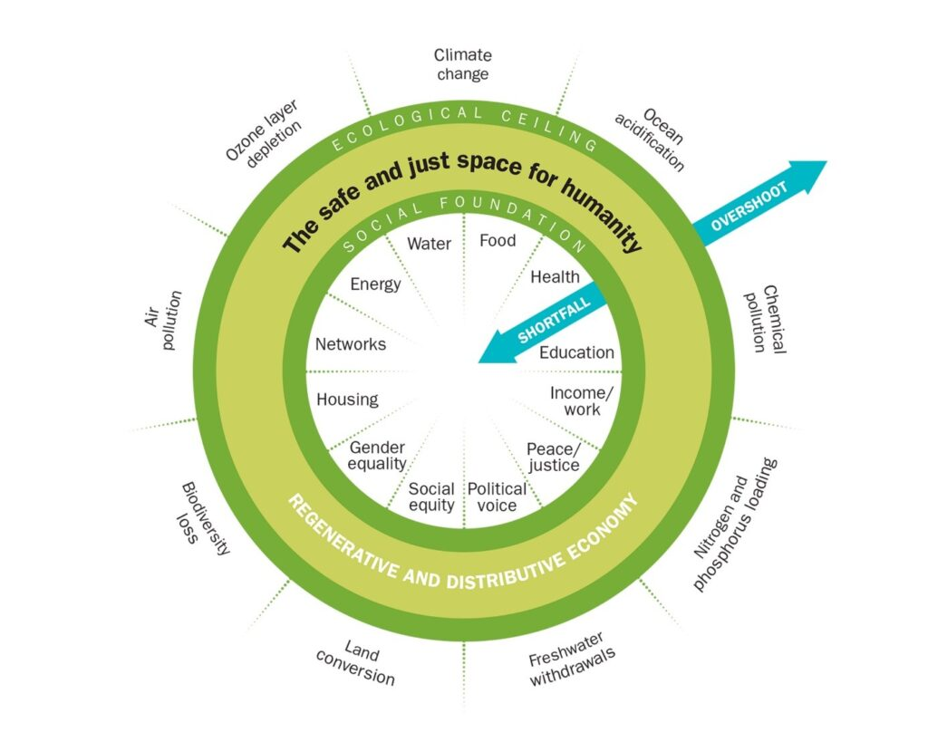(Doughnut Economics Diagram to be a visual aid to the main goal of Doughnut Economics)

The core idea behind this diagram is that it can be used to as a tool to show where countries and businesses are falling short of the safe and just amount of these needs for humanity, and where they are overshooting. The goal for all countries and businesses in Doughnut Economics is to grow beyond the social foundation, but to never go beyond the ecological ceiling, so that they can end up in the safe and just space for humanity. This could be applied to justice for nonhuman animals as both meat and feed crops are being overproduced by factory farming practices, which are exploiting animals in multiple ways. Just one example of this exploitation can be found in the factory farmers keeping too many animals in very small, overcrowded spaces. Doughnut economics could be able to promote more sustainable farms, as under this theory factory farms would need to reduce the amount of feed crops and meat they produce, so that they can end up back in the safe and just space for humanity. It is also important to note that the practical implementation that Doughnut Economics allows is a strength of this theory over both the Libertarian theory of Justice and Utilitarianism, as these two theories were highly theoretical and significantly lacking in ways to practically implement their ideas, especially when it comes to justice for nonhuman animals. Therefore, nonhuman animals may be deserving of justice under Doughnut Economics due to the practicality of the Doughnut Diagram. However, nonhuman animals may not be deserving of justice under Doughnut Economics, because this theory is primarily human centric. The reason Doughnut Economics is human centric is because the theory is primarily concerned with humanity having enough resources for their entire species to share while distributing these resources evenly, without humankind producing more than they need. The human centric nature of Doughnut Economics means when this theory causes something morally good to happen to nonhuman animals such as factory farming practices being reduced and sustainable farming being encouraged the only motivating factor was the benefit for humans, as it allows them to be in the safe and just space, which means that animals are not recipients of justice they are recipients of the moral good that trickles down from humans receiving justice. In this sense Doughnut Economics could be seen as holding an enlighten anthropomorphism. Thus, it could be said that nonhuman animals may not be deserving of justice under Doughnut Economics due to its human centric nature. However, Doughnut Economics could be developed as a theory to include nonhuman. The way this theory could be developed is by meeting the social foundation of the various aspects of the doughnut diagram and avoiding exceeding the ecological ceiling for humans and nonhuman animals, thus creating a just and safe space for both. For example, one of the aspects of the doughnut diagram governments should aim for, if they want to implement Doughnut Economics is to produce enough food for humans and nonhuman animals to share without making an excess amount. This would bring the food aspect into a safe and just place for humans and nonhuman animals. Therefore, animals do deserve justice under a develop version of doughnut economics.

Additionally, another unconventional theory of justice will be proposed as it could include nonhuman animals; this theory will be based on some Christian ideas, in particularly the Christian conception of justice and agape (unconditional love). The reason animals could be included in a Chistian sense of just is for two reasons. The first reason is that unlike the Libertarian view of justice things based on emotions such as mercy and compassion are part of justice as they are the things that motivate us into taking just actions. The second reason is as Mennonite Revend Erica Lea-Simka points out in her theology of Place, the commandment in Christianity to show agape towards our neighbour does not just include other humans, but also includes nonhuman animals, and even things like water and trees, as they are living things on an organism level as well as part of an ecosystem. Therefore, nonhumans animals could be deserving of justice under a new theory of justice based on Christian ideas about the concept of justice, theology of Place, and agape. However, nonhuman animals may not be deserving of justice under this new theory of justice based on Christian ideas, as some Christians, such as many Catholics would argue that only humans have a soul thus, they are unique to God, which means the commandment to show agape love to our neighbour only applies to other humans. Therefore, nonhuman animals may not be deserving of justice under this new theory based on Christian ideas. However, nonhuman animals still may be deserving of justice under this theory based on Christian ideas, because even if nonhuman animals do not have souls that does not mean that God would not care about God’s creation. Thus, God would want humans to show agape towards nonhuman animals. Furthermore, there are some denominations of Christianity that believe animals have a soul. For example, Quakers believe that nonhuman have a soul as like humans they have ‘that of God’ within them. Thus, to a Quaker if nonhuman animals are not deserving of justice, it would be the same as saying God is not deserving of justice, which would not make sense snice God is meant to be just. Therefore, nonhuman animals are deserving of justice under this new theory based on Christian ideas.

In conclusion, nonhuman animals are deserving of justice under a developed form of Doughnut Economics and a new theory that is based on some Christian ideas.

Bible, Matthew 22:36-40, NRSV, https://www.biblegateway.com/passage/?search=Matthew%2022%3A36-40&version=NRSVUE edn, 2025 vols (a) <https://www.biblegateway.com/passage/?search=Matthew%2022%3A36-40&version=NRSVUE> [accessed 18th March 2025]
Doughnut Economics Image, https://www.resilience.org/wp-content/uploads/2023/10/image001-1024x819.jpg edn, 2025 vols (b) <https://www.resilience.org/wp-content/uploads/2023/10/image001-1024x819.jpg> [accessed 19th March 2025]
Augustine, On the Soul and its Origin [accessed 18th March 2025]
Bentham, Jeremy, J. H. (J Burns and H. L. A. (H Hart, An Introduction to the Principles of Morals and Legislation (London: Athlone Press, 1970) [accessed 5th March 2025]
Bounding Over Our Steps, Veganism and Quakerism, https://www.boundingoveroursteps.com/quakerism-and-veganism/ edn, 2025 vols (2025) <https://www.boundingoveroursteps.com/quakerism-and-veganism/> [accessed 17th March 2025]
Cambridge Dictionary, Justice, https://dictionary.cambridge.org/dictionary/english/justice edn, 2025 vols (2024) <https://dictionary.cambridge.org/dictionary/english/justice> [accessed 12th March 2025]
Crimmins, James, Jeremy Bentham, https://plato.stanford.edu/entries/bentham/ edn, 2025 vols (2021) <https://plato.stanford.edu/entries/bentham/> [accessed 15th March 2025]
Francione L. Gary, Animals as Persons: Essays on the Abolition of Animal Exploitation (2008) [accessed 12 March 2025]
Macleod, Christopher, John Stuart Mill, https://plato.stanford.edu/entries/mill/ edn, 2025 vols (2016) <https://plato.stanford.edu/entries/mill/> [accessed 7th March 2025]
Mill, John S. and Aberystwyth former location United Theological College, Utilitarianism, 4th edn (London: Longmans, Green, Reader, and Dyer, 1871) [accessed 7th March 2025]
Nagel, Thomas, What is it Like to be a Bat? (1974) [accessed 2nd December 2024]
Q Christian Fellowship and Erica Lea-Simka, Thirsting in the Desert, https://www.youtube.com/watch?v=CJ52Pb86uVQ edn, 2025 vols (2022) <https://www.youtube.com/watch?v=CJ52Pb86uVQ> [accessed 17th March 2025]
Rawls, John, A Theory of Justice (Cambridge, Mass: Belknap Press of Harvard University Press, 1999) [accessed 28th February 2025]
Raworth, Kate, Doughnut Economics: Seven Ways to Think Like a 21st-Century Economist (2017) [accessed 7th March 2025]
Singer, Peter, Animal Liberation (London: The Bodley Head, 2015) [accessed 5th March 2025]
---Practical Ethics, 3rd edn (Cambridge: Cambridge University Press, 2011) [accessed 6th March 2025]
The Religious Society of Friends (Quakers) in Britain, Quaker Faith and Practice 5th Edition (2013) [accessed 17th March 2025]

