

Matt Claridge

Work Based Group Project

UWTSD
Ordnance, Munitions & Explosives

BEng Degree Apprenticeship
Academic Year: 2025 - 2026

Lecturer: Dave Holley
July 2026
Table of Contents
List of Figures iii
List of Abbreviations iii
1 Introduction 1
2 Research Informed Literature 2
3 Knowledge and Understanding of Subject 3
4 Analysis 5
5 Practical Application and Deployment 8
6 Skills for Professional Practice / Conclusion 9

List of Figures
Figure 3-1 Waste Stream Management Plan 4
Figure 4-1 Requirements 5
Figure 4-2 Pairwise 6
Figure 4-3 Function Means Analysis 6
Figure 4-4 P Diagram 7

List of Abbreviations
AOP | Allied Ordnance Publication
COSHH | Control of Substances Hazardous to Health
DE&S | Defence Equipment and Support
Def Stan | Defence Standard
DSA | Defence Safety Authority
FMA | Function Means Analysis
GPR | Ground Penetrating Radar
IR | Infrared
JSP | Joint Service Publications
MANPADS | Man-Portable Air-Defence Systems
MoD | Ministry of Defence
OME | Ordnance, Munitions and Explosives
QFD | Quality Function Deployment
REACH | Registration, Evaluation, Authorisation and Restriction of Chemicals
RoHS | Restriction of Hazardous Substances
WEE | Waste Electrical and Electronic Equipment

Introduction
The goal of this project was to work as a team with a group of selected individuals with varied experience and skills, using a systems engineering tool set to solve a problem statement. The problem statement was to design system capable of detecting, communicating and neutralising OZM-72 anti-personnel mines and M15 anti-tank mines to allow medical supplies to pass through a steep walled desert pass. Use of helicopters is unviable due to threat of MANPADS. The solution needs to be portable by Land Rover or Hi-Lux. Python is not an authorised solution due to vulnerability to bullet/ fragment attack.
Specific roles were assigned to the members of the design team. They were assigned a random and the roles given were; Research and Development – Uwais Patel and Emma Hughes, Manufacturing and Procurement – Tegan Ingram, Test and Evaluation – Henry Whittington, Safety and Legislation – Emma Biggs, and Breakdown and Disposal – Matt Claridge.

Research Informed Literature
With a design focus on breakdown and disposal there were several key standards and regulations to be considered. The decommissioning of military systems requires compliance with UK Ministry of Defence (MoD) policy and statutory environmental legislation.
System acquisition and safety assurance are governed by [1] DSA 03 OME Pt1, which establishes safety management requirements across the entire lifecycle of Ordnance, Munitions and Explosives. [2] AOP-4518 provides guidelines to ensure that the disposal of munitions has been considered throughout the systems lifetime. [3] JSP 418 regulates waste disposal, hazardous materials and pollution. [4] ASEMs S&EP Leaflet 20/2024 “Responsibility for Waste in DE&S Acquisition” provides guidance on legal waste obligations. It defines waste, who is responsible for it, establishes the need to document waste and prioritises a reduction of waste.
[5] Waste Electrical and Electronic Equipment (WEEE) is a framework of regulations designed to reduce waste and promote recycling. [6] Environmental Protection Act 1990 is UK legislation defining a structure for pollution control and waste management. [7] Restriction of Hazardous Substances (RoHS) is a directive which restricts the use of specific hazardous materials in electrical and electronic equipment such as Lead, Mercury and Cadmium. [8] Control of Substances Hazardous to Health (COSHH) requires employers to protect its employees and others from hazards of exposure to dangerous materials. [9] Registration, Evaluation, Authorisation and Restriction of Chemicals (REACH) is a safety regulation covering the handling of chemicals in the workplace and covering the entire supply chain.

Knowledge and Understanding of Subject
The role of breakdown and disposal needs to ensure that the system can be safely decommissioned, dismantled into manageable components and disposed of in accordance with all relevant legislations. This includes minimising environmental impact, preventing hazardous waste generation, and ensuring that end of life considerations has been embedded from the earlies design phase.
Although the roles were assigned early in the design process the breakdown and disposal role increased in influence as the design matured, particularly when material and concept choices began shaping the waste profile. Disposal had direct impact on early concept selection. An early design change from an explosive mine neutralisation to Thermite was suggested, which strongly appealed due its significantly reduced disposal hazards compared to alternatives. Thermite leaves only an inert slag rather than using an explosive which would leave hazardous chemicals damaging the environment. Collaboration with Research and Development, Manufacturing and Testing was essential, as their decisions governed the nature and volume of waste requiring disposal.
Team communication was maintained through scheduled in person meetings using booked rooms, supported by WhatsApp group messaging for fast responses, and Microsoft Teams was used for group file sharing. This ensured that formal records and informal discussion were accessible and documented. Disposal constraints were introduced proactively during meetings, particularly when early design decisions risked generating hazardous or non-compliant waste streams.
All roles contributed to each stage of the design decision making. Requirements, QFD’s and early concepts were developed collaboratively before design team members separated to conduct focused research, later regrouping to refine and challenge emerging ideas. During the FMA and Pugh matrix activities, the system was divided into subsystems, with each member responsible for analysing a designated subsystem. Within the Breakdown and Disposal function, a waste stream management plan was produced in alignment with Def Stan 00-051.
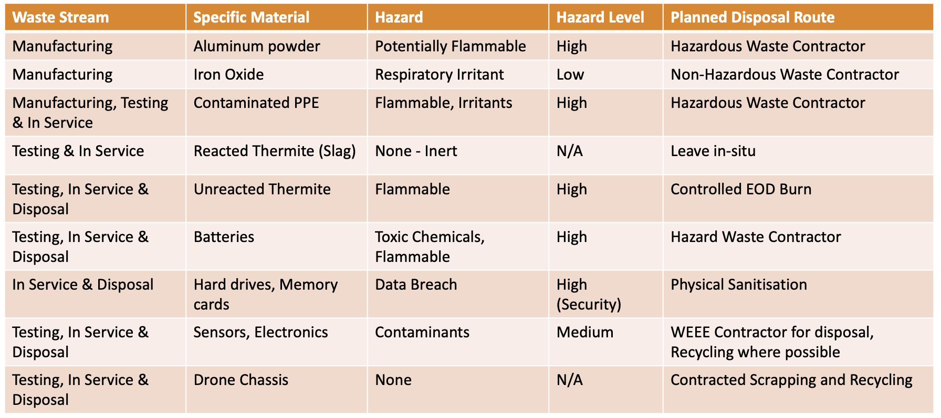
Figure 3-1 Waste Stream Management Plan
This process required structured communication with other roles to identify waste outputs across each life-cycle phase. Through these discussions the associated hazards, hazard levels, and planned disposal routes were established for formal documentation.
Disposal considerations were integrated throughout the design process. At the requirements stage, the user requirement for a system which was simple to use informed the development of a solution which also had to be simple to dispose of. Environmental impact requirements directed the team away from an explosive-based concept and towards alternatives which reduced waste hazards. Requirements relating to disposal in accordance with relevant standards shaped the approach of manufacturing to disposal planning. Disposal implications were examined further during concept development, where a modular system with reusable and replaceable components emerged as a key design decision. Elements which were unable to be designed out – such as batteries and unreacted thermite – were assigned defined disposal plans to ensure safe removal in accordance with regulatory expectations.

Analysis
The initial problem defined a scenario involving a civilian medical convoy navigating a steep walled desert pass containing anti-personnel mines and anti-tank mines. These constraints established the need for a system capable of precise detection, neutralisation and reliable operation in harsh environmental conditions. The design team worked individually, using the experience from different roles to list stakeholder requirements, Figure 4-1. The requirements were put into a large list before being reduced to the sixteen most valued requirements.
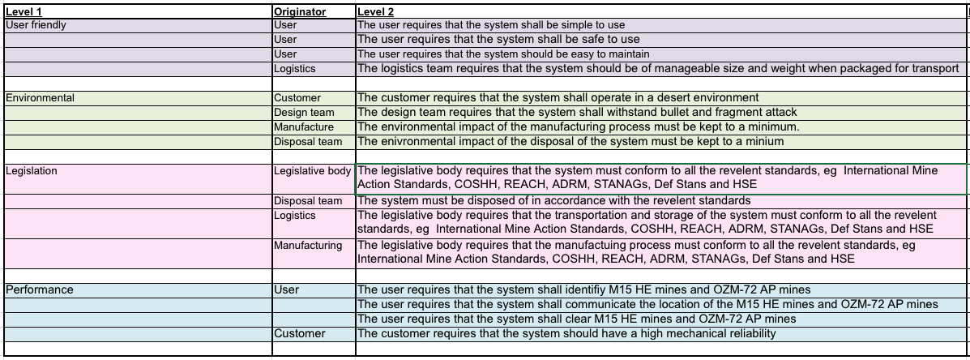
Figure 4-1 Requirements
The requirements were then translated into pairwise comparison, Figure 4-2, which ranked the importance of each requirement by assessing them against each other. This was a team process where scores were discussed and then voted on. The disposal requirements scored highly in the pairwise comparison.
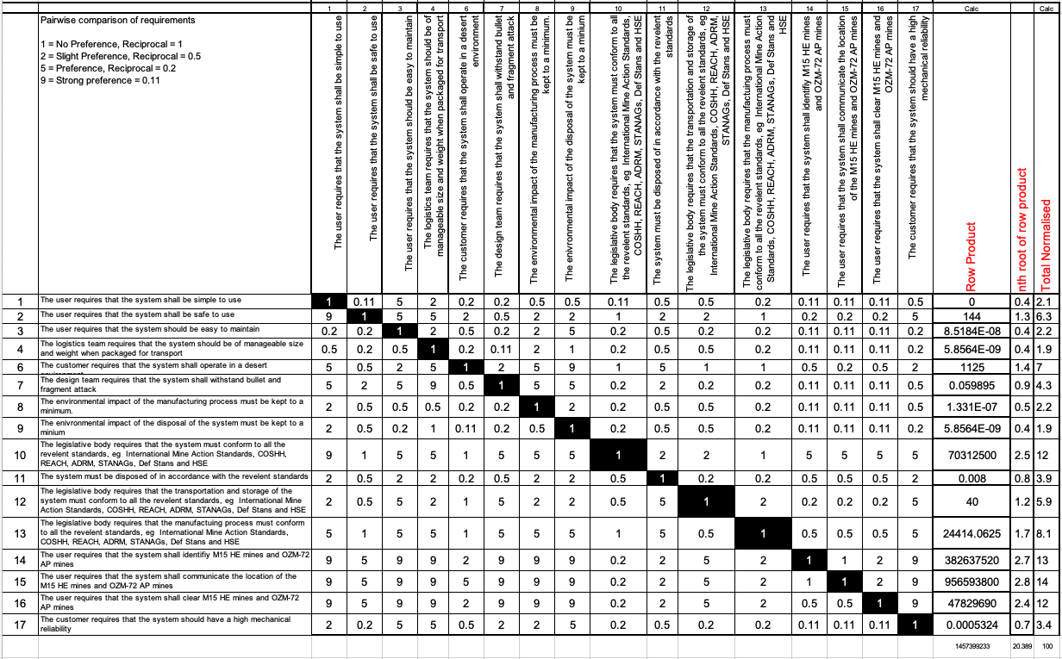
Figure 4-2 Pairwise
The requirements were then transferred into functions and normalised using QFD 1. With the functions now identified the design team began work on different concept ideas. A Function Mean Analysis (FMA), Figure 4-3, was conducted as a Team, which identified a range of solutions for each function. Individually the design team then conducted their own FMA with a specific goal in mind, for example a FMA for safest disposal.
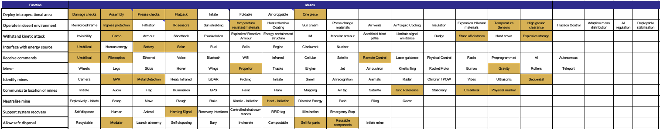
Figure 4-3 Function Means Analysis
FMA helped to direct the design team towards the end concept, which was a drone system using thermite to neutralise the target. The team used a system pugh to assess this solution versus an alternative unmanned ground system, a 4x4 plough system and the baseline solider with a metal detector. The results were promising suggesting that the proposed solution was an improvement with a weighted score of 50.08, significantly outperforming the other options. QFD 2 was conducted as a group as before, which ranked each design solution against each function to identify key components of the system. Each team member then conducted a P Diagram, Figure 4-4, on a different subsystem to identify noise factors and control factors.
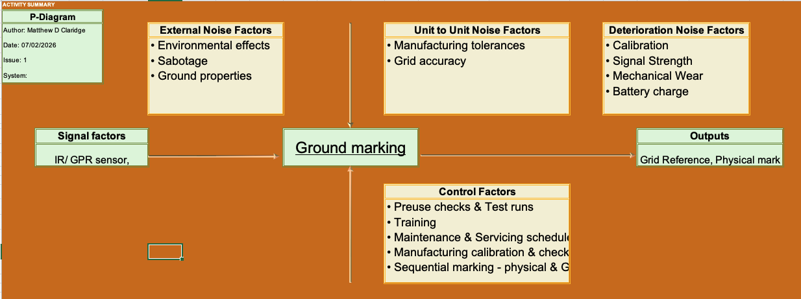
Figure 4-4 P Diagram
The design solution integrates three core subsystems: navigation, detection, and neutralisation. The navigation subsystem employs georeferenced positioning, downward-facing radar, IR imaging, and a fibre-optic umbilical to ensure stable operation in desert conditions and maintain communication integrity. The detection subsystem combines Ground Penetrating Radar and a magnetometer, selected through comparative assessment of commercial off-the-shelf technologies. The Zond Aero 500 GPR and MagNIMBUS magnetometer were identified as suitable due to their compatibility with the DJI Matrice 350 RTK platform and their demonstrated ability to detect both metallic threat types.
Neutralisation is achieved through a thermite-based system designed to safely burn through mine casings without producing fragmentation or blast effects. The thermite mixture, consisting of aluminium and iron oxide in a 3:1 ratio, was selected for reliability, stability, and environmental benignity. Manufacturing considerations emphasised controlled powder handling, contamination prevention, and compliance with hazardous materials legislation. The disposal analysis confirmed that reacted thermite produces inert slag, while unreacted material can be safely destroyed through controlled burns in accordance with AOP-4518.

Practical Application and Deployment
The team demonstrated strong collaborative performance throughout the project, supported by a range of experience that contributed to balanced decision-making and steady progress. Communication remained consistently effective, with regular discussions, shared planning, and clearly defined deadlines ensuring that the work advanced without last-minute pressure. This structured approach enabled each member to contribute meaningfully to their allocated responsibilities and supported the development of a coherent final design solution.
Despite these strengths, several areas for improvement became evident. The distribution of specialist roles was not fully optimised, as multiple members possessed similar safety-focused backgrounds. A more diverse alignment of expertise would have strengthened technical depth within certain areas.
During the final presentation, timing issues emerged despite prior rehearsal. Several team members delivered content that differed from the practice run, resulting in sections overrunning and compressing the time available for later speakers. This created a degree of avoidable disruption, including reliance on printed notes when on-screen prompts could not be accessed, followed by the accidental loss of those notes mid-presentation.
Although the team had maintained composure and delivered the required material, these issues highlighted the importance of stricter adherence to rehearsed timings and more robust contingency planning for presentation aids.

Skills for Professional Practice / Conclusion
The project successfully delivered a coherent systems-engineering solution to the challenge of detecting, communicating, and neutralising OZM-72 and M15 mines within a constrained desert pass. The final concept, a drone-based thermite neutralisation system, was developed through structured requirements analysis, systems engineering tools, and design team collaboration.
Disposal considerations were embedded from the earliest design stages, ensuring compliance with MoD policy, environmental legislation, and munitions-specific disposal standards. Lifecycle considerations were constantly integrated throughout the design process, shaping concept selection, subsystem development, and final evaluation with respect to breakdown and disposal requirements. The resulting system achieved operational effectiveness, environmental responsibility, and regulatory compliance, supported by clear documentation and structured communication across the team.
Team collaboration remained consistently effective throughout the project. Scheduled meetings, WhatsApp communication, and Microsoft Teams file sharing ensured that both formal records and informal discussions were accessible and well-coordinated.
Early integration of disposal constraints positively influenced concept development, steering the team away from explosive neutralisation and towards a thermite-based approach that significantly reduced hazardous waste. The use of structured tools such as QFD, Function Means Analysis, pairwise comparison, and P-Diagrams, supported evidence-based decision making and enabled each role to contribute meaningfully to subsystem refinement. The final concept scored strongly in the system Pugh matrix, demonstrating clear advantages over alternative solutions. The team’s ability to maintain steady progress, meet deadlines, and adapt to emerging design constraints reflected a mature and disciplined engineering approach.
Several areas for improvement became apparent during the project. The distribution of specialist roles was not fully optimised, with multiple members possessing similar safety backgrounds. A more diverse level of expertise would have strengthened technical depth in areas such as research and development and breakdown and disposal. Presentation delivery revealed weaknesses in timing discipline and contingency planning. Despite rehearsal, deviations from the practised structure led to overruns and reduced delivery time for later speakers. Reliance on printed notes created vulnerability when those notes were misplaced mid-presentation. More robust preparation such as technical familiarity, stricter adherence to rehearsed timings, and clearer role-to-slide alignment, would have mitigated these issues.

7 Works Cited
[1] | Defence Safety Authority, “DSA03 OME: part 1 OME Acquisition,” 18 June 2020. [Online]. Available: https://www.gov.uk/government/publications/dsa03-ome-part-1-ome-acquisition. [Accessed 23 July 2026].
[2] | Nato, “AOP-4518 SAFE DISPOSAL OF MUNITIONS, DESIGN PRINCIPLES AND REQUIREMENTS, AND SAFETY ASSESSMENT,” 24 May 2018. [Online]. Available: https://standards.globalspec.com/std/10387465/aop-4518. [Accessed 23 July 2026].
[3] | M. o. Defence, “Management of environmental protection in defence,” 30 January 2026. [Online]. Available: https://www.gov.uk/government/publications/jsp-418-mod-corporate-environmental-protection-manual. [Accessed 23 July 2026].
[4] | DE&S, “DE&S SAFETY AND ENVIRONMENTAL PROTECTION LEAFLET 20/2024,” May 2024. [Online]. Available: https://www.asems.mod.uk/sites/default/files/documents/SEP%20Leaflets/GMP00/20240529%20-%20S%26EP%20Leaflet%2020%202024%20-%20O.pdf. [Accessed 23 July 2026].
[5] | Office for Product Safety and Standards and Department for Environment, Food & Rural Affairs, “Regulations: Waste Electrical and Electronic Equipment (WEEE),” 12 August 2025. [Online]. Available: https://www.gov.uk/guidance/regulations-waste-electrical-and-electronic-equipment. [Accessed 23 July 2026].
[6] | Department of the Environment, “ Environmental Protection Act 1990,” 05 June 2026. [Online]. Available: https://www.legislation.gov.uk/ukpga/1990/43/contents. [Accessed 23 July 2026].
[7] | European Union Office for Product Safety and Standards, Department for Business and Trade and Department for Environment, Food & Rural Affairs, “Regulations: restriction of hazardous substances (RoHS),” 22 July 2025. [Online]. Available: https://www.gov.uk/guidance/rohs-compliance-and-guidance. [Accessed 23 July 2026].
[8] | Health and Safety Executive, “Control of Substances Hazardous to Health (COSHH),” 14 October 2025. [Online]. Available: https://www.hse.gov.uk/coshh/. [Accessed 23 July 2026].
[9] | European Union, “REACH Regulation,” 2025. [Online]. Available: https://environment.ec.europa.eu/topics/chemicals/reach-regulation_en. [Accessed 23 July 2026].

