
Master of Business Administration

Marketing Management (LCMB7024)

Assessment component 2: Marketing Strategies Portfolio

Lecturer: Laila Maazouz

Student Name: Panchal Avani Dilipbhai
Student ID: 2527582

Table of Contents
Element 1: Brand Extension Poster Presentation 3
Element 2: STDP Analysis 4
2.1 Market Segmentation 4
2.2 Target Market Selection 5
2.3 Differentiation Strategy 5
Element 3: Marketing Mix (4Ps) 7
3.1 Product 7
3.2 Price 9
3.3 Place 10
3.4 Promotion 11
Element 4: Reflection 11
Reference List 14

Element 1: Brand Extension Poster Presentation
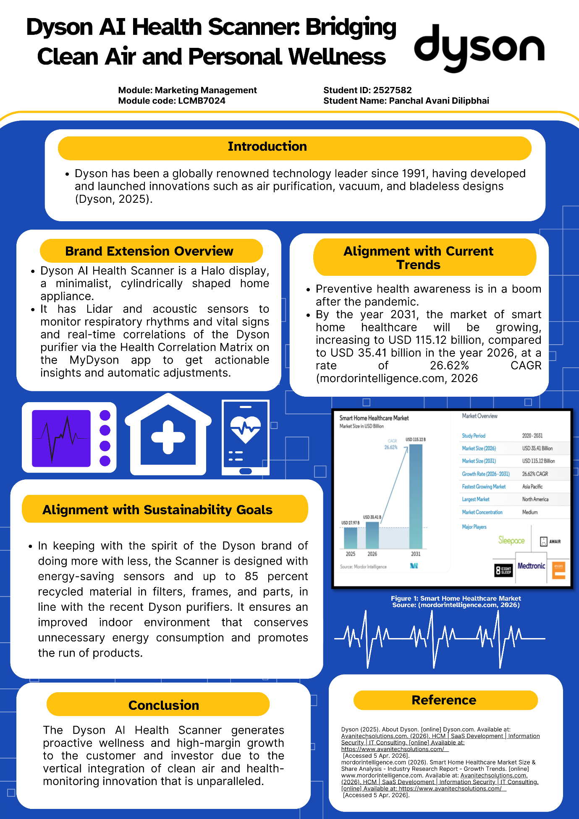

Element 2: STDP Analysis

2.1 Market Segmentation
Market segmentation of the Dyson AI Health Scanner revolves around separating the consumers into the meaningful groups of individuals with a common trait, thus allowing flexible delivery of value to each. Segmentation is important because it enables companies to understand customer demands and package them to meet these needs, particularly in the fast-paced technology-orientated markets that are characterised by changing consumer expectations (Clarke, Freytag and Cortez, 2024).
Geographically, the product will focus on urban areas, highly populated cities with the growth of pollution rates and health awareness, which are already covered by markets of Dyson products used in air purification (Dyson.ae, 2022). The key demographics will be middle-to-high-income professional individuals between 25 and 55 who are more likely to purchase the premium smart home health equipment. These are consumers who usually are highly educated and understand the risks to the environment and to personal health.
Psychographic segmentation is not the least applicable because the device will be appealing to the health-conscious and tech-savvy audience, including those who value innovativeness, preventative healthcare and smart living (Mintel.com, 2025). According to research findings by Bhat et al. (2025), the psychographic variables like lifestyle, attitudes, and values have a strong impact on consumer reactions in the context of marketing strategies. This works alongside its image of a luxury, innovation-focused brand, which Dyson is.
Last but not least, behavioural segmentation targets the users that are interested in providing integrated solutions, in other words, the users that already have air purifiers, wearable health technologies, or smart home systems in place. Segmenting the market is usually based on geographic, demographic, psychographic, and behavioural factors, where homogeneous segments with similar needs are formed (Mehta and Sharma, 2023). Such a combination will make the Dyson AI Health Scanner a useful tool in addressing the gap between environmental and personal health management.

2.2 Target Market Selection
The Dyson AI Health Scanner mainly focuses on the urban, health-conscious homes segment, particularly adults (25-55 years old) with middle-to-high incomes who appreciate smart home technology and preventive care. This segment can be used since the product positions it as a high-end AI-powered home wellness product that incorporates air purification and health tracking. According to the research by Deloitte.com (2022), smartphone adoption and use of connected devices in India are growing very fast, which favours the need for app-based technologies related to health at home. Kemp (2022) also noted that in 2022, India had 658 million users of the internet, which provided a significant digitally engaged population to use smart wellness products.
This target customer is appealing, as it is better placed to embrace products that provide convenience, safety and lifestyle advantages. According to Mogaji (2025), successful targeting is subject to the size of the segment, ease of reach, and the fit with brand capabilities. On the same note, Duarte, Till and Hafeez (2024) note that the target markets to be chosen are those where the need of the consumers' purchases is close to the firm's value proposition. The Dyson extension fits under this logic, as it targets a consumer with a desire to breathe better, discover personalised insights of wellness, and have a smart home that is sustainable. Thus, the brand extension can be focused on adopting high-end urban families and professionals who are ready to invest in highly developed health-orientated technology.

2.3 Differentiation Strategy
The Dyson AI Health Scanner differentiation strategy will involve developing a higher-end, science-based wellness device to provide air purification and personalised health data. Dyson needs to be perceived by customers as the most innovative and trustworthy home-health brand, and smart monitoring, beautiful design, and sustainability in a single product (IBEF, 2022).
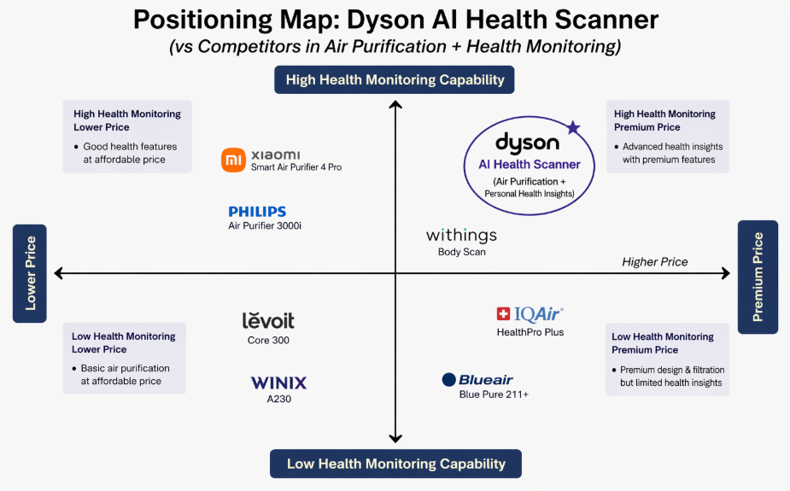
Figure 1: Positioning Map
(Source: Self-Created)
This Figure 1 positioning map coincides with the map, as Dyson occupies the high-health monitoring, high-price segment with brands like Xiaomi, Philips and Levoit positioned above the line, either lower-priced purification or less health information. Dyson has value propositions that it is not merely cleaning the air but also changing home wellness into a data-driven and proactive one. This is also consistent with the trend of the present-day 2022 market logic, which encompasses consumers of health tech becoming more attentive to connected, preventive, and personalised solutions (Deloitte.com, 2022).
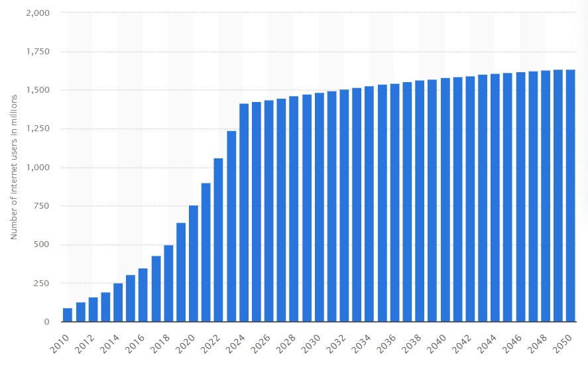
Figure 2: Number of internet users in India from 2010 to 2023
(Source: Statista.com, 2025)
There are some real statistics that substantiate this stance. As Figure 2 and Statista.com (2025) data indicate, by 2023, there are already 1.2 billion internet users in India, which will provide a solid foundation to the application of smart devices connected to the app. According to Buchter, Cordina and Eckroate (2024), there was a robust growth in smartphone adoption, indicating that consumers feel more at ease with connected health technologies. Thus, Dyson ought to market the scanner as a prestigious wellness device among high-income urban families in need of higher quality performances, a healthier lifestyle and intelligent design.

Element 3: Marketing Mix (4Ps)

3.1 Product
The “Product” component of the Dyson AI Health Scanner must aim at providing a high-end, intelligent and sustainable home wellness product that unites air purification with personal health data. It also fits into the brand extension strategy of Dyson by applying its name of being an engineer to preventative health by designing a functional yet aspirational product (Sharma, 2019).
Dyson must market the scanner as a premium, AI-powered, sensor-powered, app-enabled device that allows customers to check the indoor air quality and personal wellbeing by using sensors, app connectivity, and real-time feedback. This reinforces the brand image of Dyson as being innovative, scientifically advanced, and design-led. The product is also to be made with recycled materials and energy-saving capabilities to augment sustainability, which is becoming more demanded in the high-quality technology markets.
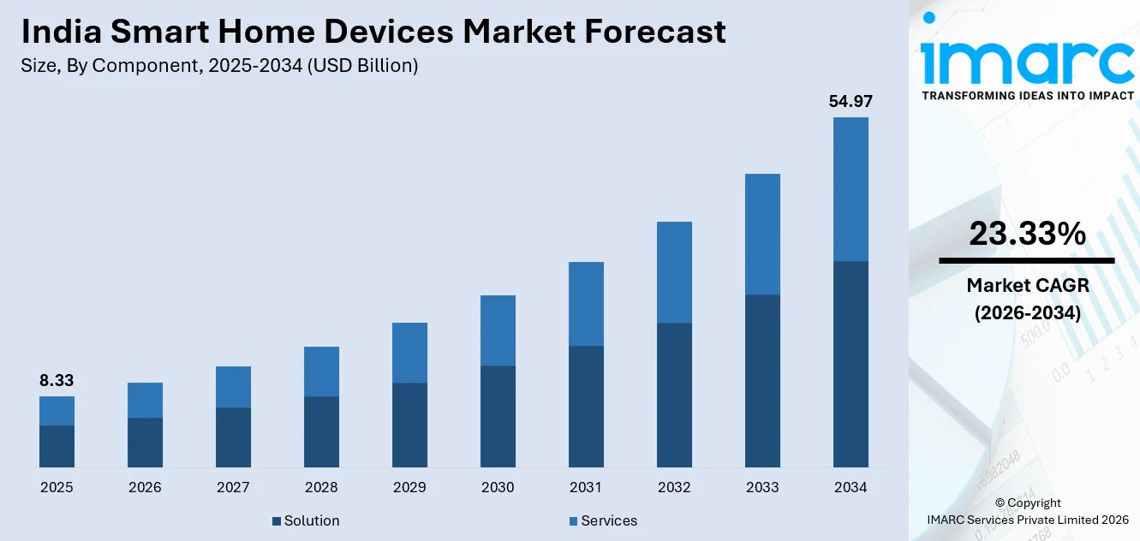
Figure 3: India Smart Home Device Market
(Source: Imarcgroup.com, 2025)
According to Imarcgroup.com (2025), in 2022, connected-device adoption and smartphone adoption in India were still growing and meant that it was highly prepared to receive products that integrate apps into the smart-home environment and that the industry had reached an 8.33 billion number in 2025, as is illustrated in Figure 3. An additional observation that was made in Figure 2 was that India has 1.2 billion internet users in 2023, which has opened a broad digital platform of connected health technologies (Statista.com, 2025).
The two schools of thought in product strategy contend that effective differentiation can be as an answer to an evident problem in the customers with better features and a brand with a trusted fit. In the case of Dyson, however, what the product should do in addition to being able to purify air should include proactive health data and uninterrupted functionality. This forms a great value proposition to health-conscious urban families.

3.2 Price
The ‘Price’ element for the Dyson AI Health Scanner should use a premium, value-based pricing strategy that reinforces Dyson’s innovative and luxury brand image. The price should indicate high technology, custom health information, and high design, reflecting on which it should be positioned in the high-end quadrant of the market as opposed to competing with a low price (Majka, 2024).
This strategy fits the brand extension since the premium pricing assists the customers to value the product as a scientifically developed and exclusive product and not a simple purifier. The use of a value-based approach is pertinent since the scanner has both advantages in a single system: purification of air and health examination. Nagle, Müller and Gruyaert (2023) claim that perceived value should be reflected in pricing, and Jahan et al. (2024) mention that when the meaning of the product aligns with customer expectations, prices can be significantly higher when the products belong to strong brands. Additionally, two 2022 online publications have indicated that high-quality health-technical products can be embraced when they are easier, believed in, and proven to be beneficial.
As of 2023, India had 1.2 billion internet users, and the use of smartphones was ever-growing, which means that consumers are now more prepared to use connected wellness products that are available in the form of an app. This online preparedness warrants this premium since consumers are buying an intelligent integrated experience as opposed to a detached product. As such, Dyson must not use discounting but keep the controlled premium price to ensure the brand equity, recover the cost of the R&D, and continue the long-term differentiation.

3.3 Place
This “Place” strategy of the Dyson AI Health Scanner needs a selective omnichannel model to balance affordability and exclusivity. Dyson is advised to sell both on the official site and flagship store and authorised premium electronics and health retailers, providing, in addition, assisted digital purchasing possibilities and after-sales service. This nests the brand extension as Shankar (2025) explained that the product is all-premium and technology-orientated so distribution needs to safeguard brand control yet still effortlessly guide the experience of experiencing and purchasing the device.
Ang et al. (2023) discovered that consumers purchasing a health-monitoring item frequently desire verbal feedback. Live demonstrations, professional assistance, service assurance, its own stores and the Internet are the most popular lead channels of Dyson. This aligns with 2022 brand-management thought that high-end products excel by paying close attention to the brand experience being tightly controlled across touchpoints (Baidya, Maity and Goswami, 2023). It is also indicative of the broader shift towards integrated retail and smooth buying experiences.
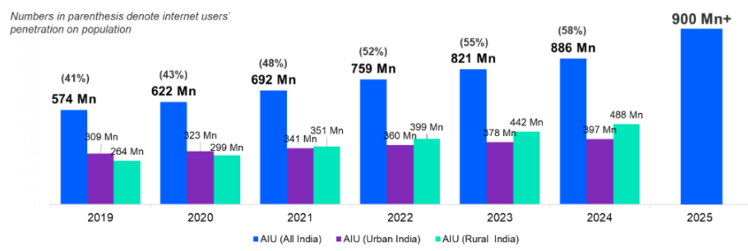
Figure 4: Internet User in India
(Source: Communicationstoday.co.in, 2025)
According to ETtech (2025), the digital commerce ecosystem in India is growing at a break-neck pace, and the nation is expected to have more than 900 million internet users by 2025, which further enhances the argument of a digital-first method of distribution. Also, disruption via digital and increasing demands for curated experiences are boosting premium retail, which justifies the selective placement strategy of Dyson. As such, Dyson ought to focus on direct-to-consumer and luxury experiential retail and not mass retail.

3.4 Promotion
The Dyson AI Health Scanner promotion must be framed around an education-based campaign, which is primarily digital-derived and supported by Dyson ethos of high-quality product manufacturing positioning on a strong science basis. Since the product is a hybrid of air purification and personal health data, it should not be promoted via mass media only but backed by such short-form video, influencer demos, health-technology-themed webinars, and social media posts to persuade persons about the usefulness of the scanner and gain their trust.
Such a strategy helps the brand extension strategy since the high-end health-tech consumers will require a proper demonstration of utility, rather than familiarity (Kekäläinen, 2023). According to Alexandrescu and Milandru (2018), promotion must reinforce brand meaning and convey consistent value proposition, whereas Brugliera (2024) portray the effectiveness of digital channels in promoting a brand through the integration of education, evidence, and one-on-one interaction. Dyson may thus market the scanner as an active health precautionary approach and not a commodity.
In 2022, India had 658 million internet users demonstrating the presence of a very large audience on which to target product communication (Kemp, 2022). Moreover, Breuer et al. (2021) confirmed that qualified leads in case of agile testing and multi-channel message can be highly positive in digital marketing in the sphere of medtech. Dyson, therefore, needs to advertise via high-end online advertisements, product demonstrations and professionally or expert-based content to prearrange trust and need.

Element 4: Reflection
This project was turned into a helpful sequence of action, contemplating, and fixing with the help of the Kolb’s Learning Styles and Experiential Learning Cycle (Figure 5).
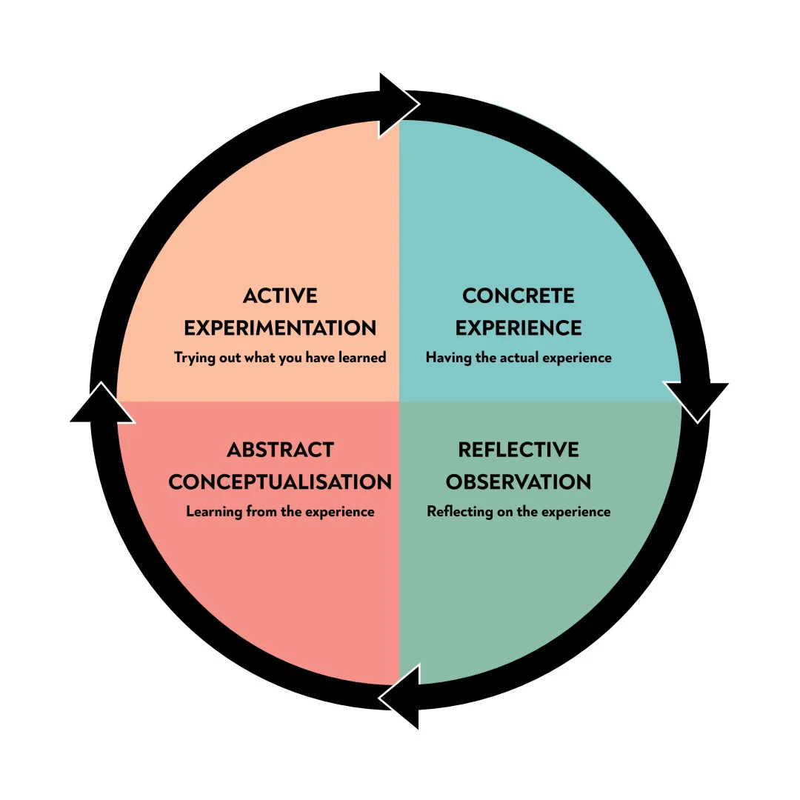
Figure 5: Kolb’s Experiential Learning Model
(Source: Mcleod, 2025)
During the stage that was focused on concrete experience, I created the Dyson AI Health Scanner as a brand extension and turned a complicated concept into a one-sheet poster. This made me be creative in my reasoning on how the current Dyson brand image in engineering, design and innovation can be replicated for personal wellness. As it was stated by Peng et al. (2023), the key to successful brand extension is the presence of a high fit between the parent brand and the new offering, and that is why I was able to estimate the feasibility of the idea presented, making it look credible to the customers. One more aspect that Wong (2024) brought to my attention is that brand meaning must be the same, and this is why I have reached the goal of premium positioning and sustainability.
During the reflective observation stage, I realised that the poster format needed to be clear, simple and have visual hierarchy. I needed to reduce the excessive information and analyse the most appealing points: relevancy of the market, trend in health tech, and sustainable design. The exercise of preparing and presenting the presentation enhanced my ability to communicate even in the time-constrained state. It also taught me that I should be cautious about what evidence I use since all statements made needed to justify the strategic direction as a whole and not just define the product.
As part of the abstract conceptualisation step, I linked the theory to practice by segmenting, targeting, and differentiating the marketing mix to a real brand extension. This proved my strength in strategic thinking and made me see how consumers' needs, brand equity and market trends interact. During the active experimentation phase, I narrowed down the wording, layout and structure of the poster in order to make the message more convincing and professional.
On the whole, this project enhanced my research, critical and presentation skills. At the work level, it helped me to develop the theoretical academic knowledge into a working marketing proposal. To improve on my performance in the future, I would gather more competitor information earlier on, practise the poster with other people prior to handing it in, and practise the presentation more methodically. Such actions would enable me to write more effective arguments and a better final presentation.

Reference List
Alexandrescu, M.-B. and Milandru, M. (2018). Promotion as a form of Communication of the Marketing Strategy. [online] ResearchGate. Available at: https://www.researchgate.net/publication/330877117_Promotion_as_a_form_of_Communication_of_the_Marketing_Strategy [Accessed 21 Apr. 2026].
Ang, J.-Y., Ooi, G.S., Aziz, F.Abd. and Tong, S.F. (2023). Risk-taking in consumers’ online purchases of health supplements and natural products: a grounded theory approach. Journal of Pharmaceutical Policy and Practice, [online] 16(1). doi:https://doi.org/10.1186/s40545-023-00645-x.
Baidya, M.K., Maity, B. and Goswami, S. (2023). A value-driven touchpoints strategy for managing the customer experience process. Business Process Management Journal, [online] 29(7), pp.2147–2166. doi:https://doi.org/10.1108/bpmj-02-2023-0093.
Bhat, Mr.S., Jarad, Dr.R., Bhavsar, Dr.D., Yadav, Dr.M., Suryavanshi, Dr.P. and Moholkar, Dr.N. . (2025). The Role of Psychographic Segmentation in Advertising. International Journal of Research Publication and Reviews, [online] 6(4), pp.8792–8797. doi:https://doi.org/10.55248/gengpi.6.0425.1566.
Breuer, R., Guenther, E., Motiwala, R. and Zerbi, C. (2021). The rise of digital marketing in medtech | McKinsey. [online] www.mckinsey.com. Available at: https://www.mckinsey.com/industries/life-sciences/our-insights/the-rise-of-digital-marketing-in-medtech [Accessed 21 Apr. 2026].
Brugliera, P. (2024). The Effectiveness of Digital Learning Platforms in Enhancing Student Engagement and Academic Performance. Journal of Education, Humanities, and Social Research, [online] 1(1), pp.26–36. doi:https://doi.org/10.70088/xq3gy756.
Buchter, J., Cordina, J. and Eckroate, J. (2024). Capturing growth with a consumer centric healthcare experience | McKinsey. [online] www.mckinsey.com. Available at: https://www.mckinsey.com/industries/healthcare/our-insights/consumers-rule-driving-healthcare-growth-with-a-consumer-led-strategy [Accessed 21 Apr. 2026].
Clarke, A.H., Freytag, P.V. and Cortez, R.M. (2024). Revisiting the Strategic Role of Market segmentation: Five Themes for Future Research. Industrial Marketing Management, [online] 121, pp.A7–A10. doi:https://doi.org/10.1016/j.indmarman.2024.07.012.
Communicationstoday.co.in (2025). Internet users in India set to cross 900 million | Communications Today. [online] Communications Today. Available at: https://www.communicationstoday.co.in/internet-users-in-india-set-to-cross-900-million/ [Accessed 21 Apr. 2026].
Deloitte.com (2022). Big bets on smartphones, semiconductors, and streaming service. [online] Deloitte. Available at: https://www.deloitte.com/in/en/about/press-room/big-bets-on-smartphones-semiconductors-and-streaming-service.html [Accessed 21 Apr. 2026].
Duarte, A., Till, B. and Hafeez, K. (2024). Strategies for Brand Communications and Management Bridging Academia and Practice. [online] pp.86–115. Available at: https://www.gbppublications.com/_files/ugd/5e526c_c3bf3b6cf4554b91a722de8e7c512c9a.pdf#page=99 [Accessed 21 Apr. 2026].
Dyson.ae (2022). Dyson air purifiers research in UAE and KSA. [online] Dyson.ae. Available at: https://www.dyson.ae/en-AE/newsroom/dyson-air-purifiers-research-in-uae-and-ksa?srsltid=AfmBOopq8M-zZVuDgO97JBOt876p86WNYqydHxXSTOzXMZOeOlkD7nfX [Accessed 21 Apr. 2026].
ETtech (2025). India to have over 900 million internet users in 2025: report. [online] The Economic Times. Available at: https://economictimes.indiatimes.com/tech/technology/india-to-cross-900-million-internet-users-this-year-says-iamai-report/articleshow/117290089.cms?from=mdr [Accessed 21 Apr. 2026].
IBEF (2022). Dyson marks India as a global priority market, plans product and retail expansion: APAC president | IBEF. [online] India Brand Equity Foundation. Available at: https://www.ibef.org/news/dyson-marks-india-as-a-global-priority-market-plans-product-and-retail-expansion-apac-president [Accessed 21 Apr. 2026].
Imarcgroup.com (2025). Smart Home Devices Market in India - Size & Forecast 2034. [online] Imarcgroup.com. Available at: https://www.imarcgroup.com/india-smart-home-devices-market [Accessed 21 Apr. 2026].
Jahan, T., Jahan, A., Pallavi, M., Alekhya, M. and Lakshmi, M.S. (2024). A Study on Importance of Branding and Its Effects on Products in Business. International Research Journal on Advanced Engineering and Management (IRJAEM), [online] 2(04), pp.656–661. doi:https://doi.org/10.47392/IRJAEM.2024.0091.
Kekäläinen, S.-P. (2023). Building consumer trust during the productization phase of a new, smart health tech consumer product. Urn.fi. [online] doi:https://oulurepo.oulu.fi/handle/10024/43137.
Kemp, S. (2022). Digital 2022: India. [online] DataReportal – Global Digital Insights. Available at: https://datareportal.com/reports/digital-2022-india [Accessed 21 Apr. 2026].
Majka, M. (2024). Competitive Pricing: Staying Ahead in a Crowded Market. [online] researchgate.net. Available at: https://www.researchgate.net/profile/Marcin-Majka-2/publication/386063409_Competitive_Pricing_Staying_Ahead_in_a_Crowded_Market/links/6741901c868c966b9326129b/Competitive-Pricing-Staying-Ahead-in-a-Crowded-Market.pdf [Accessed 20 Apr. 2026].
Mcleod, S. (2025). Kolb’s Learning Styles and Experiential Learning Cycle. [online] Simply Psychology. Available at: https://www.simplypsychology.org/learning-kolb.html [Accessed 18 Apr. 2026].
Mehta, M. and Sharma, A. (2023). MARKET SEGMENTATION AND TARGETING. International Journal of Recent Research and Review, [online] XVI(2). Available at: https://www.ijrrr.com/papers16-2/paper33-Market%20Segmentation%20and%20Targeting.pdf [Accessed 21 Apr. 2026].
Mintel.com (2025). Health-Conscious Consumer Trends Drive CPG Market Innovation. [online] Mintel. Available at: https://www.mintel.com/insights/consumer-research/health-conscious-consumer-trends-drive-cpg-market-innovation/ [Accessed 19 Apr. 2026].
Mogaji, E. (2025). Market Segmentation, Targeting, and Positioning. Strategic Marketing Management, [online] pp.103–133. doi:https://doi.org/10.1007/978-3-031-99367-1_5.
Nagle, T.T., Müller, G. and Gruyaert, E. (2023). The Strategy and Tactics of Pricing. [online] Routledge. doi:https://doi.org/10.4324/9781003179566.
Peng, C., Bijmolt, T.H.A., Völckner, F. and Zhao, H. (2023). A meta-analysis of brand extension success: The effects of parent brand equity and extension fit. Journal of Marketing, [online] 87(6), p.002224292311646. doi:https://doi.org/10.1177/00222429231164654.
Shankar, V. (2025). Marketing of technology-intensive products: An AI-driven approach. Marketing Strategy Journal, [online] 2, p.100008. doi:https://doi.org/10.1016/j.msj.2025.100008.
Sharma, S. (2019). Strategy design for Dyson. [online] ResearchGate. Available at: https://www.researchgate.net/publication/309406637_Strategy_design_for_Dyson [Accessed 20 Apr. 2026].
Statista.com (2025). India: number of internet users 2050| Statista. [online] Statista. Available at: https://www.statista.com/statistics/255146/number-of-internet-users-in-india/?srsltid=AfmBOopfJUpZAM2PGK-04mmj8UPHn9c2-rRWuiYjvGTc5baYcmjXcn0U [Accessed 20 Apr. 2026].
Wong, J. (2024). The Importance Of Consistency In Branding. Forbes. [online] 30 Dec. Available at: https://www.forbes.com/councils/forbescommunicationscouncil/2024/12/30/the-importance-of-consistency-in-branding/ [Accessed 21 Apr. 2026].

